**Confidential**

**CRM**

**Modification Records**

|  |  |  |  |
| --- | --- | --- | --- |
| **Version** | **Date** | **Modifier** | **Comments** |
| CRM_Alpha | 2018-02-10 | Derek | Creation |
| CRM_ Beta | 2018-03-11 | Allen | Add general architecture design picture , database structure table design and crm development environment content |

**Table of Contents**

1 Business Objectives .................................................................................................................3

2 CRM Basic Requirements Breakdown .....................................................................................4

3 General Architecture Design ...................................................................................................6

4 CRM Development ..................................................................................................................7

5 CRM Development Environment ............................................................................................8

6 CRM Deployment Environment ..............................................................................................9

7 CRM Operation Environment Requirement ......................................................................... 10

8 CRM Level-0 Testing Cases ....................................................................................................11

9 CRM Acceptance Procedure ..................................................................................................12

# 1 Business Objectives

The objectiveof CRM is to achieve a software service which allow our customers to be able to register, (email verification), login and logout, also it should support manager to be able to do customers creation, deletion and modifications, lastly but not the least, some simple privilege management of the managers and customers.

With the Alpha version, after our customer successfully registered the account and enabled by the manager, the first operation he or she can perform would be Peer to Peer Chat, in the future we are going to add more services and operations for our customers to perform, e.g. trading, deposit/withdraw and so on.

# 2 CRM Basic Requirements Breakdowns

## On Customer Side

|  |  |  |
| --- | --- | --- |
| **1** | Register Account | A customer who has a valid email address should be able to register an account with our CRM. |
| **2** | Email Verification | CRM require customer to verify their own email address in order to activate the account with us. |
| **3** | Login Access | Account valid and activated, customer should be able to login with username and passwords |
| **4** | Logout Access | After login, customer should be able to logout themselves from the system. |
| **5** | Change Passwords | After success login, customer should be able to change his or her passwords |
| **6** | Forgot Passwords | if customer forgot his or her passwords, this functionality should be able to help him or her to reset the passwords. |
| **7** | Modification of Customer Details | Once customer has login, he or she should be able to modify his or her own contact details and other information s beside login ID. |

## On Manager Side

|  |  |  |
| --- | --- | --- |
| **8** | Manager Login | Account valid and activated, manager should be able to login with username and passwords |
| **9** | Manager Logout | After login, manager should be able to logout themselves from the system. |
| **10** | Manager Change Passwords | After success login, manager should be able to change his or her passwords |
| **11** | Manager Forgot Passwords | if manager forgot his or her passwords, this functionality should be able to help him or her to reset the passwords. |
| **12** | Manager Create Customer | After Manager Login, if he/she has the privilege then, he/she should be able to create customer account. |
| **13** | Manager Delete Customer* | After Manager Login, if he/she has the privilege then, he/she should be able to delete customer account. (if customer has not yet done any trading operations, if not just frozen the account ) |
| **14** | Manager Modify Customer’s Contact Information | After Manager Login, if he/she has the privilege then, he/she should be able to modify customer’s contact information. |
| **15** | Manager Reset Customer’s Passwords | After Manager Login, if he/she has the privilege then, he/she should be able to trigger customer’s passwords reset function. |
| **16** | Manager Modify Customer’s Passwords | After Manager Login, if he/she has the privilege then, he/she should be able to modify customer’s contact information. |
| **17** | Managers Privilege Management | Different Manager should have different privileges, some can modify customers’ passwords some can not, there is one type of manager can change other manger’s privilege. |
|  |  |  |

## On Peer to Peer Chat

|  |  |  |
| --- | --- | --- |
| **P1** | Chat Backend Logs Records | Two Peers’ chat logs records should be stored in the system |
| **P2** | Chat Backend Logs Queries | Two Peers’ chat logs should be able to be fetched by each Peer. |
|  |  |  |

# 3 General Architecture Design

## Picture1, General Architecture Design

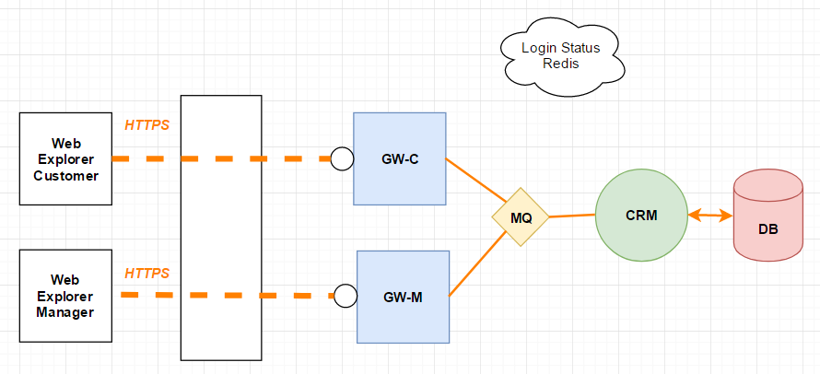

The General Architecture Design is shown above, customers or managers access APIs services through Gateways (GW-C , GW-M) using HTTPS. GW-C and GW-M are two different HTTP servers, the port that they have bind are different.

All requests sending from customers or managers, will go through GW-C/GW-M before reaching CRM services. The main tasks of GW-C/GW-M is to perform encoding and decoding. Allow legal access and stop invalid requests. It may also have local cache to store temporary customer status.

All Gateways (GW-C, GW-M) share one comment cloud redis to store customers’ login status. Gateways also need to maintain session IDs.

As Picture 1 shows that CRM is one entity, however it can be a set of services, and separate read and write access. CRM is the software service mainly process and reply all the customers’ requests. And it is the only services which having database access.

Picture2, General Architecture Design (by Allen , need review @Derek)



**crm model ingores time delay , and http protocol can satisfy business .**

**if we want to extend system to increase a trade system , we should lead into mq to ensure business safety .**

# 4 CRM Development

Deadline: 1st March

Developers: 1 Java developer --- Mr Bao Chaolumen

Technology: Java Spring Boot/Mybatis/ MySQL/Nginx/RabbitMQ

Message Protocols: JSON

Communication Protocols: HTTPS/HTTP/AMQP

Database structure:

**table:** **CUSTOMER**

|  |  |  |
| --- | --- | --- |
| **property** | **type** | **comment** |
| **ID** | **bigint** | **Primary key , auto increment** |
| **USERNAME** | **varchar(50)** | **Login name** |
| **PASSWORD** | **varchar(200)** | **Login password** |
| **MOBILE** | **varchar(15)** | **Contact mobile** |
| **IDENTIFICATION** | **varchar(20)** | **identification** |
| **EMAIL** | **varchar(50)** | **email** |
| **IS_EMAIL_VERIFY** | **varchar(1)** | **Whether the mailbox verification** |
| **IS_FROZEN** | **varchar(1)** | **Check frozen status** |
| **IS_ENABLE** | **varchar(1)** | **Check enable status** |
| **CREATE_TIME** | **timestamp** | **Create time** |
| **UPDATE_TIME** | **timestamp** | **Update time** |

**table:** **MANAGER**

|  |  |  |
| --- | --- | --- |
| **property** | **type** | **comment** |
| **ID** | **Bigint** | **Primary key , auto increment** |
| **USERNAME** | **varchar(32)** | **Login name** |
| **PASSWORD** | **varchar(200)** | **Login password** |
| **REALNAME** | **varchar(32)** | **Real name** |
| **EMPLOYEE_ID** | **int** | **Employee id , foreign key** |
| **IS_ENABLE** | **varchar(1)** | **Enable status** |
| **CREATE_TIME** | **timestamp** | **Create time** |

# 5 CRM Development Environment

**/** A full set of environmental standards**

**1.** **Java SE Development Kit (jdk version 1.8)**

**2.maven(version 3.3.9)**

**3.nexus(Maven Repository)**

**4.nginx (installed on linux , version 1.2.9)**

**5.mysql(version 5.7)**

**6.rabbitmq**

**7.redis**

**\*/**

**simple development environment**

**1. Java SE Development Kit (jdk version 1.8)**

**2. mysql(version 5.7)**

**3.maven(version 3.3.9)**

# 6 CRM Deployment Environment

**Xiuya MM please fill in**

# 7 CRM Operation Environment Requirement

**Xiuya MM please fill in**

# 8 CRM Level-0 Testing Cases

**Xiuya MM please fill in**

**E.g.**

|  |  |  |  |
| --- | --- | --- | --- |
| **X03_001** | **C_LOGIN_01** | **CID Correct / PASSWD Correct** | **EXPECT_PASS** |
| **X03_002** | **C_LOGIN_02** | **CID Correct / PASSWD Wrong** | **EXPECT_FAILED** |
| **X03_003** | **C_LOGIN_03** | **CID Wrong/ PASSWD Correct** | **EXPECT_FAILED** |
| **X03_004** | **C_LOGIN_04** | **CID Wrong/ PASSWD Wrong** | **EXPECT_FAILED** |

# 9 CRM Acceptance Procedure

**Xiuya MM please fill in**

**All rights reserved**