Genesys Cloud Platform Smoke Dashboard Redesign Guide
A build template for alert evidence, operational triage, dashboard design, and domain drilldowns.

1. Design intent
The redesigned dashboard should stop behaving like a collection of charts and start behaving like an incident commander. Its first job is to answer: Is something wrong, where is it happening, how bad is it, who is affected, and what evidence supports the alert?
- Prioritize status, alert evidence, scope, correlation, and runbook action over raw metric density.
- Every alertable visualization must display its threshold, baseline, current value, and operational interpretation.
- Use domain pages for deeper investigation, not as the first place an engineer has to hunt for smoke.
- Make data freshness visible so a quiet dashboard does not get mistaken for a healthy platform.

2. Mockup - Command Center
Default landing page. Shows the overall verdict, domain health, active smoke candidates, and dataset freshness.
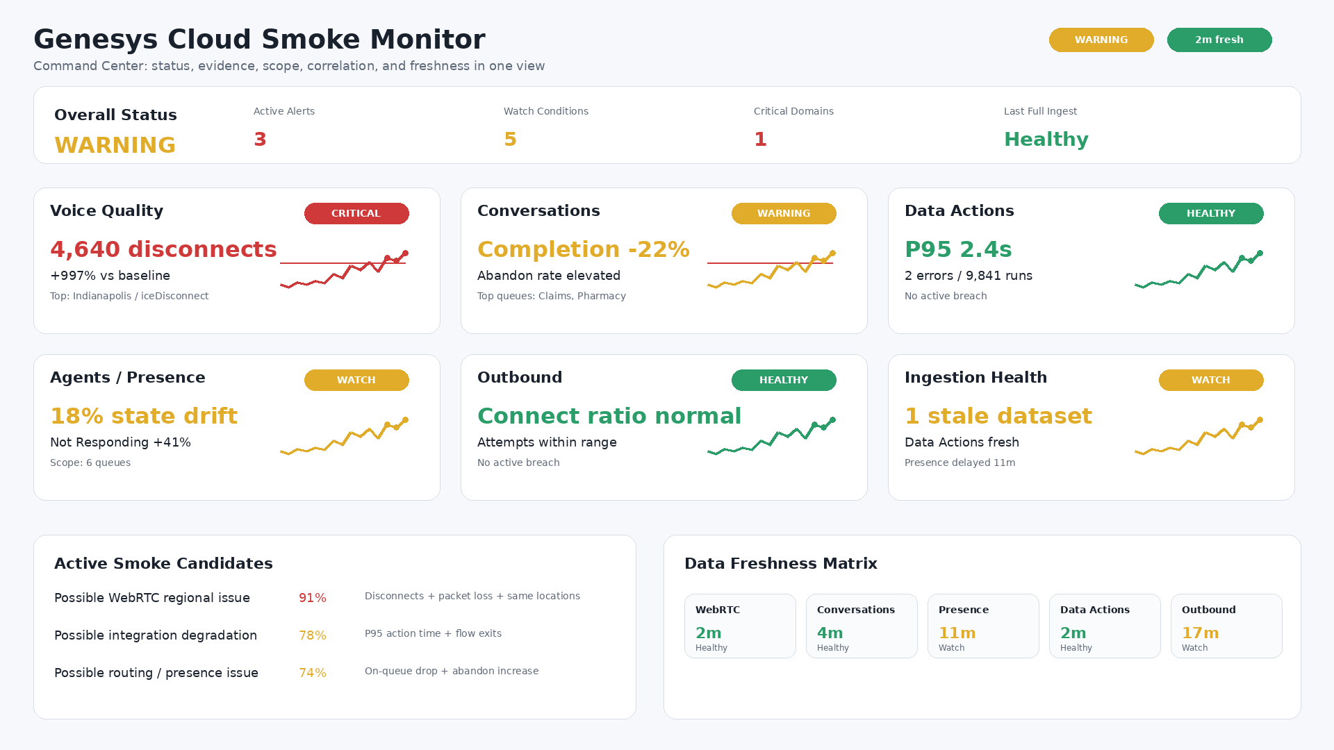

3. Mockup - Active Alert Evidence
This page is the evidence record for active alerts. It explains why the alert fired and what to check next.
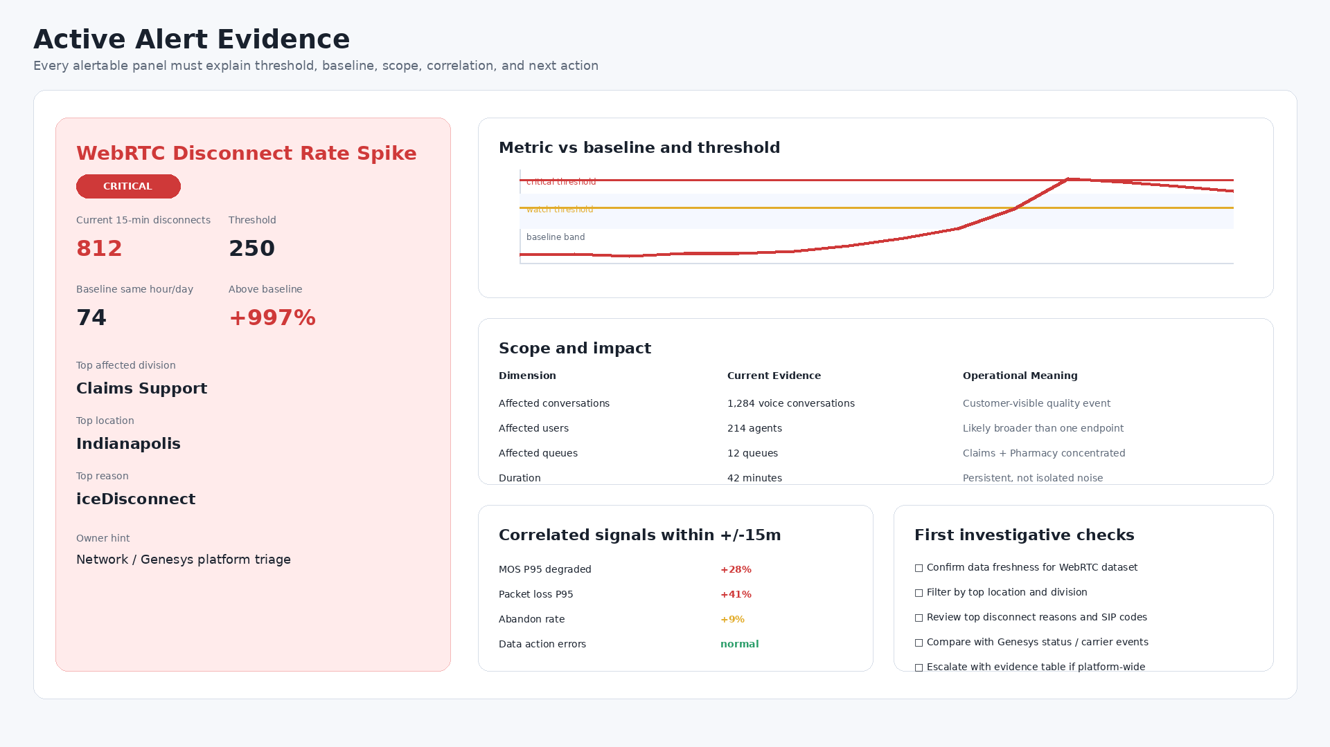

4. Mockup - Domain Drilldown
Domain pages are organized by operational question: outcome, quality, root-cause hints, top offenders, and drilldown controls.
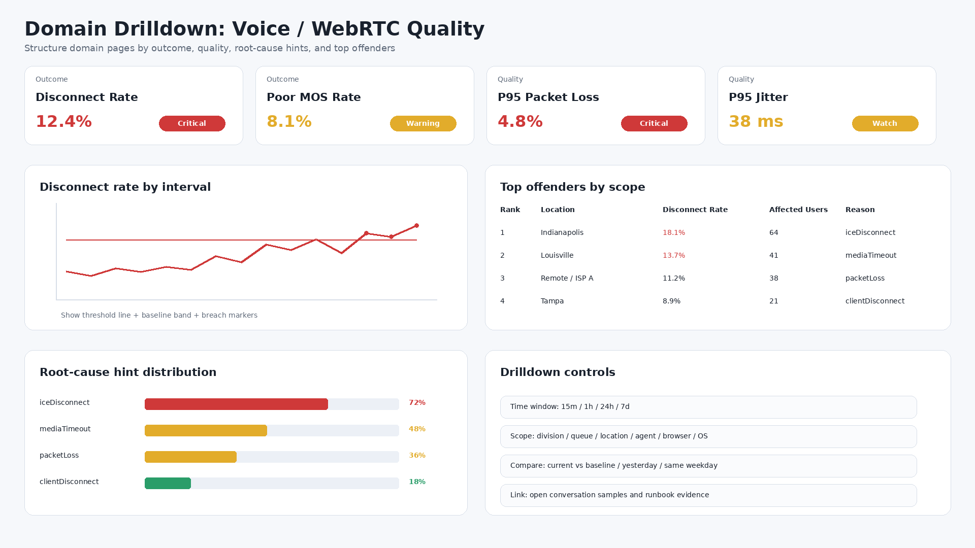

5. Recommended dashboard structure
Page | Purpose | Primary user question | Key panels
Command Center | Executive/engineer landing page | What is wrong right now? | Overall status, domain health cards, active smoke candidates, data freshness
Active Smoke / Alert Evidence | Alert justification and triage | Why did this alert fire? | Threshold, baseline, scope, correlation, owner hint, first checks
Voice / WebRTC Quality | Call quality investigation | Are users/customers experiencing quality failures? | Disconnect rate, poor MOS rate, jitter, packet loss, top reasons, locations
Conversation Survivability | Customer journey health | Are conversations successfully reaching the intended destination? | Offered vs connected, abandon rate, short-call rate, transfer failure, flow errors
Data Actions / Integrations | Integration reliability | Are flows failing because integrations are slow or broken? | Error rate, timeout count, P95 duration, downstream status, affected flows
Agents / Presence | Staffing and routing health | Are agents in usable states for traffic? | On-queue, available, not responding, state drift, staffing vs demand
Platform / Ingestion Health | Monitoring trust layer | Can we trust the dashboard? | Dataset freshness, ingest failures, API latency, rate limits, missing intervals

6. Alert evidence contract
Use this shape for every alert. The same fields should appear in the alert payload, dashboard panel, and runbook entry.
alert_name: WebRTC Disconnect Rate Spike
domain: Voice Quality
severity: Warning | Critical
metric: disconnect_rate
current_value: 12.4%
threshold: 5%
baseline: 1.2%
minimum_volume: 100 conversations
time_window: 15 minutes
scope:
divisions: [Claims Support]
locations: [Indianapolis]
queues: [Claims, Pharmacy]
evidence:
- disconnect_count
- total_conversations
- top_disconnect_reason
- mos_p95
- packet_loss_p95
runbook:
first_checks:
- Confirm dataset freshness
- Filter by top location and division
- Review disconnect reasons and SIP/WebRTC codes
- Compare with Genesys status and carrier events

7. Metric inventory to add or strengthen
Domain | Metrics | Why it matters
Voice / WebRTC | Disconnect rate, poor MOS rate, P95 packet loss, P95 jitter, P95 latency, affected users, top reason | Separates volume spikes from true quality degradation and provides root-cause hints.
Conversations | Offered vs connected delta, abandon rate, short-call rate, transfer failure, flow error exits | Shows whether customers survive the journey from entry to agent/resolution.
Data Actions | Error rate by action, timeout count, P95 duration, affected flows, downstream HTTP status | Makes integration failures measurable and ties them to customer-impacting flows.
Agents / Presence | On-queue drop, not responding spike, available-to-offered ratio, presence drift | Detects routing, client, staffing, or state synchronization problems.
Ingestion Health | Dataset freshness, API failures, rate-limit hits, missing intervals, latest record age | Prevents false confidence when the monitoring pipeline is stale or partially blind.

8. Build checklist
☐ Create a Command Center landing page with an overall status verdict and domain cards.
☐ Create an Active Smoke / Alert Evidence page that shows only active/recent alert candidates.
☐ Move data dictionaries and field explanations out of the operational view into documentation or tooltips.
☐ Add threshold lines and baseline bands to all alertable time-series charts.
☐ Convert raw counts to rates wherever possible: disconnect rate, abandon rate, error rate, short-call rate.
☐ Add top-N offender tables by division, queue, location, agent, reason, and action.
☐ Add a correlation section that compares signals within +/-15 minutes of alert start.
☐ Add a Platform / Ingestion Health page so stale data is visible.
☐ Define an owner hint and first-check runbook for every alert type.
☐ Ensure every panel answers one of five questions: status, evidence, scope, correlation, or next action.

9. Success criteria
- An engineer can understand the highest-risk smoke candidate within 30 seconds.
- An alert recipient can see exactly why the alert fired without opening a separate query.
- Each domain has rate-based, baseline-aware metrics rather than only raw counts.
- The dashboard clearly distinguishes healthy, watch, warning, critical, no-data, and stale-data states.
- The dashboard provides evidence suitable for escalation to Genesys, network, carrier, integration, or operations teams.

