PROJECT_POWERBI_001 : Maven Toys

This project is based on LinkedIn course: Build an Interactive Business KPI Dashboard with Power BI (Guided Project)

As a data analyst for Maven Toys, a toy store chain with multiple store locations in Mexico.

-The goal: is to build a simple, interactive report that the leadership team can use to monitor key business metrics and high-level trends.

-The data: transactional records from January 2022 to September 2023, along with info about products and store locations

-The development:

. Connect and profile the data
Notes: some issues due to data format and decimal format due to USA vs EU standards.

. Create a relational model
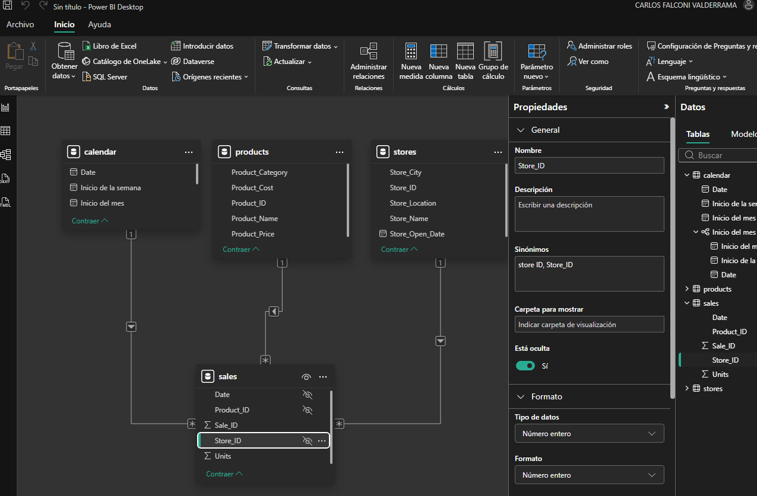

. Add Calculated measures and fields

On Sales table, new columns were created using:
Revenue = sales[Units] * sales[Price]
Profit = sales[Revenue] - (sales[Cost] * sales[Units])
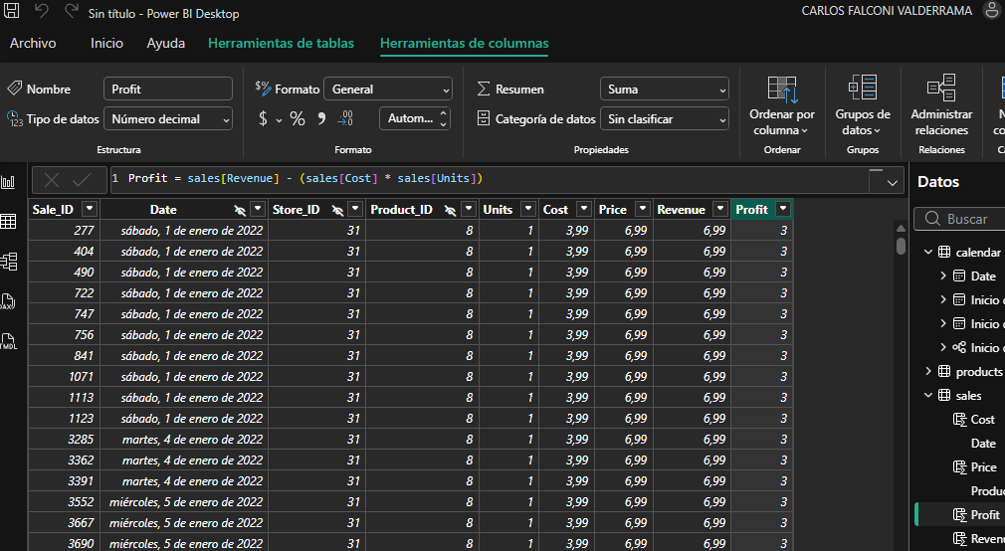

On report view, cards were added and linked to new variables:

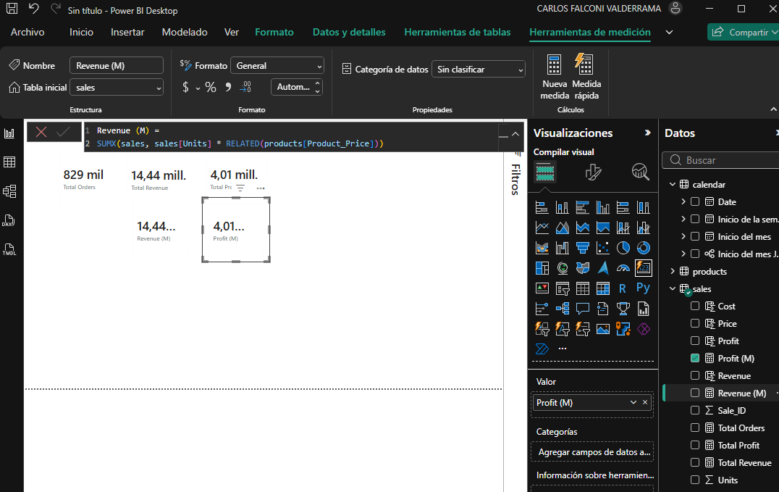

. Build an interactive report:

