

EDB Postgres™ Advanced Server
.NET Connector Guide

Connectors Release 9.6.0.3
.NET 4.0 Connector Version 2.2.4.4
.NET 4.5 Connector Version 3.1.9.0
April 3, 2017
EDB Postgres™ Advanced Server .NET Connector Guide
by EnterpriseDB® Corporation
Copyright © 2009 - 2017 EnterpriseDB Corporation. All rights reserved.

EnterpriseDB Corporation, 34 Crosby Drive Suite 100, Bedford, MA 01730, USA
T +1 781 357 3390 F +1 978 467 1307 E info@enterprisedb.com www.enterprisedb.com

Table of Contents
1 Introduction 4
1.1 What’s New 4
1.2 Typographical Conventions Used in this Guide 5
2 The Advanced Server .NET Connector - Overview 6
2.1 The .NET Class Hierarchy 6
2.2 Installing the .NET Connector 7
3 Configuring the .NET Connector 11
3.1 General Instructions 11
3.2 .NET Framework 4.0 12
3.3 .NET Framework 4.5.1 12
3.4 Entity Framework 6 12
3.5 EDBDdexProvider for Visual Studio 14
4 Using the .NET Connector 17
4.1 Opening a Database Connection 17
4.1.1 Connection String Parameters 18
4.1.2 Example - Opening a Database Connection using ASP.NET 21
4.1.3 Example - Opening a Database Connection from a Console Application 22
4.1.4 Example - Opening a Database Connection from a Windows Form Application 24
4.2 Retrieving Database Records 26
4.2.1 Retrieving a Single Database Record 28
4.3 Parameterized Queries 29
4.4 Inserting Records in a Database 31
4.5 Deleting Records in a Database 33
4.6 Using SPL Stored Procedures in your .NET Application 35
4.6.1 Example - Executing a Stored Procedure without Parameters 36
4.6.2 Example - Executing a Stored Procedure with IN Parameters 38
4.6.3 Example - Executing a Stored Procedure with IN, OUT, and INOUT Parameters 41
4.7 Using a Ref Cursor in a .NET Application 45

Introduction
The EDB Postgres™ Advanced Server .NET Connector distributed with EDB Postgres™ Advanced Server (Advanced Server) provides connectivity between a .NET client application and an Advanced Server database server. This guide provides installation instructions, usage instructions, and examples that demonstrate the functionality of the Advanced Server .NET Connector:
- How to connect to an instance of Advanced Server.
- How to retrieve information from an Advanced Server database.
- How to update information stored on an Advanced Server database.
This document assumes that you have a solid working knowledge of both C# and .NET. The Advanced Server .NET Connector functionality is built on the core functionality of the Npgsql open source project. The Npgsql User's Manual is available online at:
http://www.npgsql.org/doc/index.html

What’s New
The following features have been added to the Advanced Server .NET Connector 9.6.0.2 to produce Advanced Server .NET Connector 9.6.0.3:
- The .NET Connector now provides access to Advanced Server databases from Microsoft Visual Studio with the EDBDdexProvider component. Thus, the features of Visual Studio can now be used with Advanced Server as the external data source. For more information, see Section 3.5.
- The .NET Connector is now based on .NET Framework version 4.5.1. If there are existing applications based on .NET Framework 4.5, they need to be upgraded to 4.5.1.

Typographical Conventions Used in this Guide
Certain typographical conventions are used in this manual to clarify the meaning and usage of various commands, statements, programs, examples, etc. This section provides a summary of these conventions.
In the following descriptions a term refers to any word or group of words that are language keywords, user-supplied values, literals, etc. A term’s exact meaning depends upon the context in which it is used.
- Italic font introduces a new term, typically, in the sentence that defines it for the first time.
- Fixed-width (mono-spaced) font is used for terms that must be given literally such as SQL commands, specific table and column names used in the examples, programming language keywords, etc. For example, SELECT * FROM emp;
- Italic fixed-width font is used for terms for which the user must substitute values in actual usage. For example, DELETE FROM table_name;
- A vertical pipe | denotes a choice between the terms on either side of the pipe. A vertical pipe is used to separate two or more alternative terms within square brackets (optional choices) or braces (one mandatory choice).
- Square brackets [ ] denote that one or none of the enclosed term(s) may be substituted. For example, [ a | b ], means choose one of “a” or “b” or neither of the two.
- Braces {} denote that exactly one of the enclosed alternatives must be specified. For example, { a | b }, means exactly one of “a” or “b” must be specified.
- Ellipses ... denote that the proceeding term may be repeated. For example, [ a | b ] ... means that you may have the sequence, “b a a b a”.

The Advanced Server .NET Connector - Overview
The Advanced Server .NET Connector is a .NET data provider that allows a client application to connect to a database stored on an Advanced Server host. The .NET Connector accesses the data directly, allowing the client application optimal performance, a broad spectrum of functionality, and access to Advanced Server features.
The .NET Connector supports .NET Framework versions 4.0 and 4.5.1, and Entity Framework 6.

The .NET Class Hierarchy
The .NET Class Hierarchy contains a number of classes that you can use to create objects that control a connection to the Advanced Server database and manipulate the data stored on the server. The following are just a few of the most commonly used object classes:
EDBConnection
The EDBConnection class represents a connection to Advanced Server. An EDBConnection object contains a ConnectionString that instructs the .NET client how to connect to an Advanced Server database.
EDBCommand
An EDBCommand object contains an SQL command that the client will execute against Advanced Server. Before you can execute an EDBCommand object, you must link it to an EDBConnection object.
EDBDataReader
An EDBDataReader object provides a way to read an Advanced Server result set. You can use an EDBDataReader object to step through one row at a time, forward-only.
EDBDataAdapter
An EDBDataAdapter object links a result set to the Advanced Server database. You can modify values and use the EDBDataAdapter class to update the data stored in an Advanced Server database.

Installing the .NET Connector
By default, the Advanced Server graphical installer for Windows installs the .NET Connector when you install Advanced Server. To ensure that the .NET Connector is installed during an Advanced Server installation, confirm that the check box next to Connectors is checked on the Select Components window of the installation wizard (see Figure 2.1).
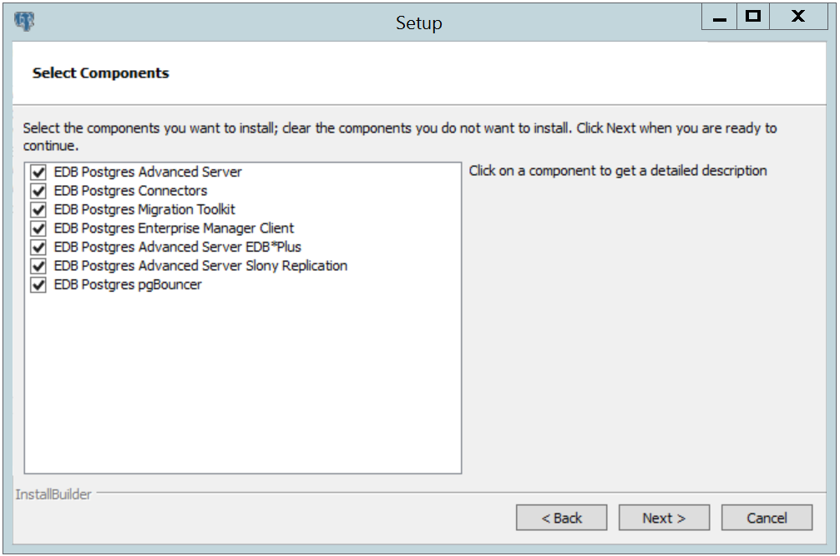
Figure 2.1 - The Select Components dialog.

You can also use the EnterpriseDB Connectors Installation wizard to add the .NET Connector to your system; the installer is available at:
www.enterprisedb.com
After downloading the installer, right-click on the installer icon, and select Run As Administrator from the context menu. The installation wizard opens as shown in Figure 2.2.
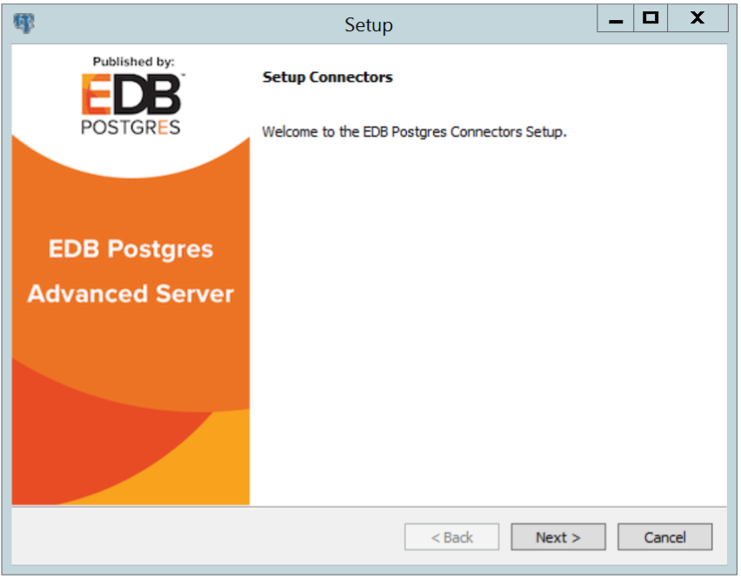
Figure 2.2 - The Connectors Installation wizard.
Click Next to continue.
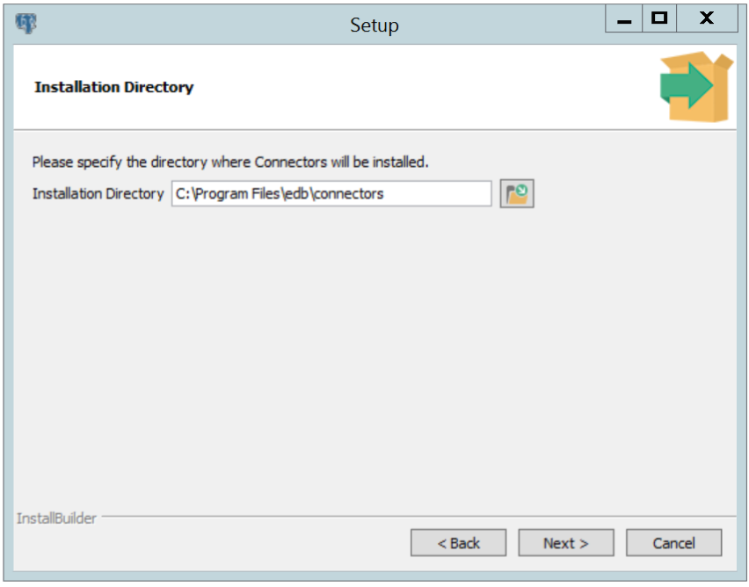
Figure 2.3- The Installation dialog.
Use the Installation Directory dialog (see Figure 2.3) to specify the directory in which the connector will be installed, and click Next to continue.
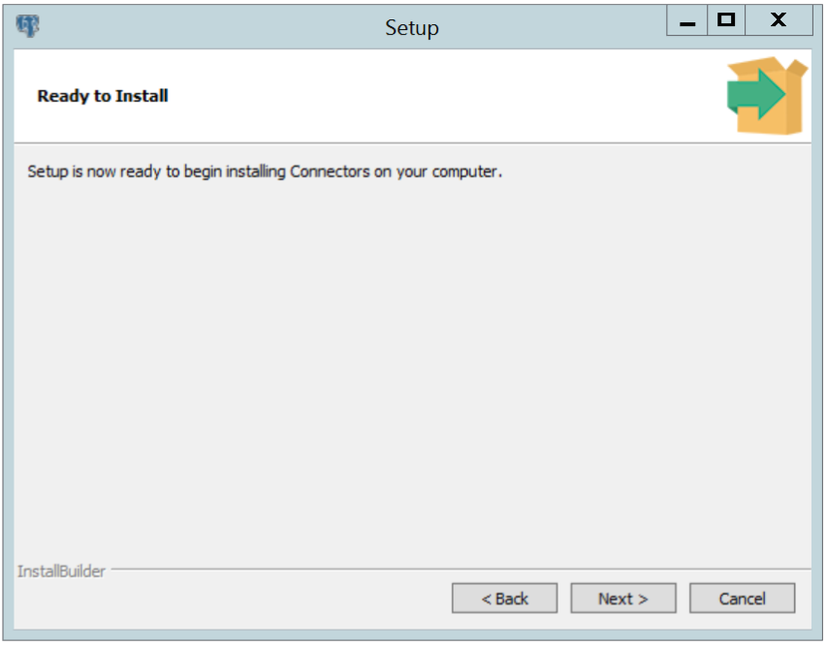
Figure 2.4- The Ready to Install dialog.
Click Next on the Ready to Install dialog (see Figure 2.4) to start the installation; popup dialogs confirm the progress of the installation wizard.
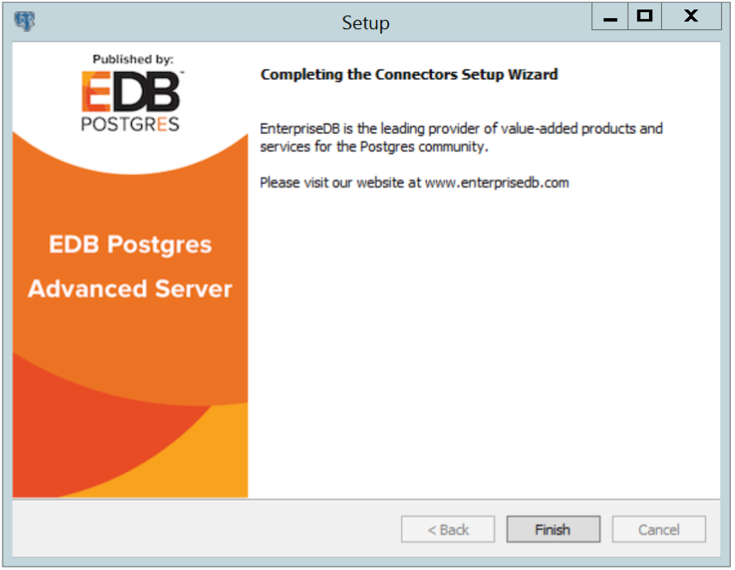
Figure 2.5 - The installation is complete.
When the wizard informs you that it has completed the setup, click the Finish button to exit the dialog (see Figure 2.5).
You can use StackBuilder Plus to add or update the connector on an existing Advanced Server installation; to open StackBuilder Plus, select StackBuilder Plus from the Windows Apps menu (see Figure 2.6).
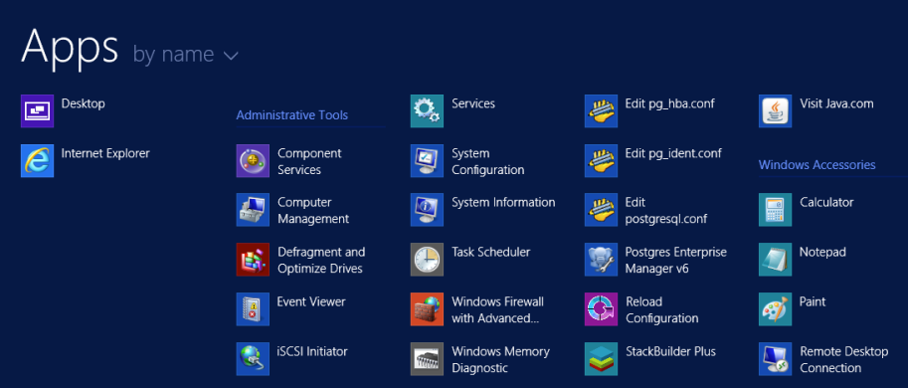
Figure 2.6 - Starting StackBuilder Plus.
When StackBuilder Plus opens, follow the onscreen instructions, selecting the EnterpriseDB Connectors option from the Database Drivers node of the tree control (see Figure 2.7).
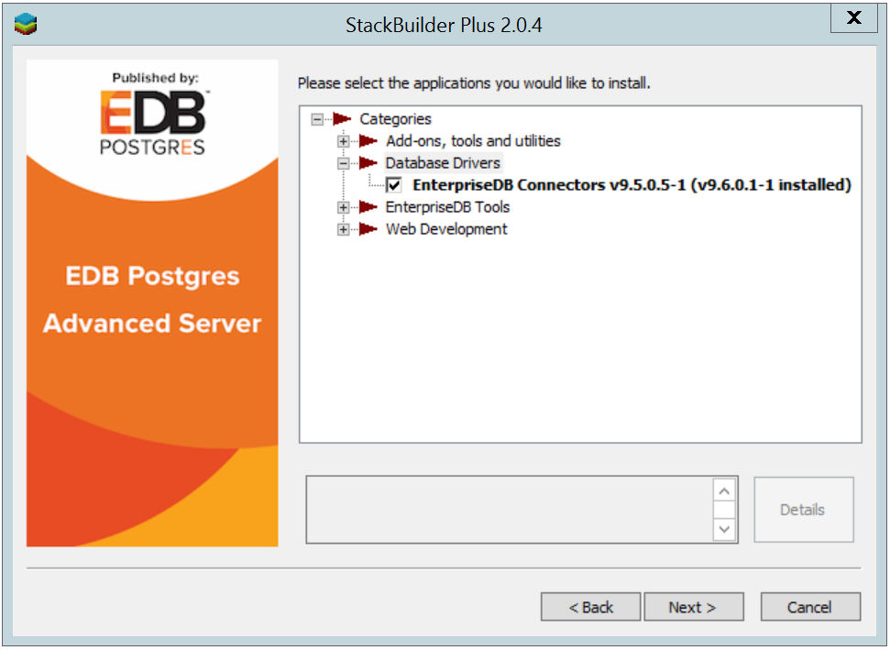
Figure 2.7 - Selecting the Connectors installer.
Follow the directions of the onscreen wizard to add or update an installation of the EnterpriseDB Connectors.

Configuring the .NET Connector
The following sections describe how to configure the .NET Connector depending upon the framework version to be used:
- General Instructions. General instructional information applicable to all components
- .NET Framework 4.0. Instructions for configuring for usage with .NET Framework 4.0
- .NET Framework 4.5.1. Instructions for configuring for usage with .NET Framework 4.5.1
- Entity Framework 6. Instructions for configuring for usage with Entity Framework 6
- EDBDdexProvider. Instructions for configuring for usage with EDBDdexProvider

General Instructions
To reference library files using Microsoft Visual Studio:
- Select the project in the Solution Explorer.
- Select Add Reference from the Project menu.
- When the Add Reference dialog box opens, browse to select the appropriate library files.
Optionally, the library files can be copied to the specified location.
Before you can use an Advanced Server .NET class, you must import the namespace into your program. Importing a namespace makes the compiler aware of the classes available within the namespace. The namespace is the following:
EnterpriseDB.EDBClient
If you are using Entity Framework 6, the additional namespace is the following:
EntityFramework6.EntepriseDB.EDBClient
The method you use to include the namespace varies by the type of application you are writing. For example, the following command imports a namespace into an ASP.NET page:
<% import namespace="EnterpriseDB.EDBClient" %>
To import a namespace into a C# application, write:
using EnterpriseDB.EDBClient;

.NET Framework 4.0
To set up .NET Connector for usage with .NET Framework 4.0, reference the shared library files located in the following directory:
C:\Program Files\edb\connectors\dotnet\4.0\
The shared library files are the following:
EDBDataProvider.2.0.2.dll
Mono.Security.dll
See Section 3.1 for information on referencing library files.
Depending upon the type of application, import the namespace into the source code (see Section 3.1).

.NET Framework 4.5.1
Note: If you are using .NET Framework version 4.5, you must first upgrade to .NET Framework 4.5.1.
To set up .NET Connector for usage with .NET Framework 4.5.1, reference the shared library file located in the following directory:
C:\Program Files\edb\connectors\dotnet\4.5\
The shared library file is the following:
EnterpriseDB.EDBClient.dll
See Section 3.1 for information on referencing library files.
Depending upon the type of application, import the namespace into the source code (see Section 3.1).

Entity Framework 6
To set up .NET Connector for usage with Entity Framework 6, reference the shared library files located in the following directory:
C:\Program Files\edb\connectors\dotnet\4.5\
The shared library files are the following:
EnterpriseDB.EDBClient.dll
EntityFramework6.EnterpriseDB.EDBClient.dll
See Section 3.1 for information on referencing library files.
Add the <DbProviderFactories> entries for the ADO.NET driver of EDB Postgres in the app.config file. The following are the entries:
<add name="EnterpriseDB.EDBClient"
invariant="EnterpriseDB.EDBClient"
description=".NET Data Provider for EnterpriseDB PostgreSQL”
type="EnterpriseDB.EDBClient.EDBFactory, EnterpriseDB.EDBClient, Version=3.1.9.0, Culture=neutral, PublicKeyToken=5d8b90d52f46fda7"
support="FF"/>
In the project’s app.config file add the following entry for provider services under the EntityFramework/providers tag.
<provider invariantName="EnterpriseDB.EDBClient"
type="EnterpriseDB.EDBClient.EDBServices, EntityFramework6.EnterpriseDB.EDBClient">
</provider>
The following is an example of the app.config file.
<?xml version="1.0" encoding="utf-8" ?>
<configuration>
<configSections>
<section name="entityFramework" type="System.Data.Entity.Internal.ConfigFile.EntityFrameworkSection, EntityFramework, Version=6.0.0.0, Culture=neutral, PublicKeyToken=b77a5c561934e089" requirePermission="false"/>
</configSections>

<startup>
<supportedRuntime version="v4.0" sku=".NETFramework,Version=v4.5" />
</startup>

<entityFramework>
<providers>
<provider invariantName="EnterpriseDB.EDBClient" type="EnterpriseDB.EDBClient.EDBServices, EntityFramework6.EnterpriseDB.EDBClient"></provider>
</providers>
</entityFramework>

<system.data>
<DbProviderFactories>
<remove invariant="EnterpriseDB.EDBClient"/>
<add name="EnterpriseDB Data Provider" invariant="EnterpriseDB.EDBClient" support="FF" description=".Net Framework Data Provider for Postgresql" type="EnterpriseDB.EDBClient.EDBFactory, EnterpriseDB.EDBClient"/>
</DbProviderFactories>
</system.data>

</configuration>
Depending upon the type of application, import the namespace into the source code (see Section 3.1).
For usage of the features of Entity Framework 6, refer to the Microsoft documentation.

EDBDdexProvider for Visual Studio
EDB Data Designer Extensibility Provider (EDBDdexProvider) is a component, which integrates Advanced Server database access into Visual Studio, thus providing Visual Studio integrated features.
It allows connecting to Advanced Server from within Visual Studio's Server Explorer, creating a model from an existing database, etc. Therefore, if Visual Studio features are desired, then EDBDdexProvider must be utilized.
The following are the steps to install and configure EDBDdexProvider.
Step 1: Install EDBDdexProvider with the EDBDdexProvider-x.x.x.vsix installer.
Step 2: Install the ADO.NET data provider EnterpriseDB.EDBClient.dll, which is a component installed as part of the EDB Postgres Connectors.
Step 3: Install EntityFramwork.EnterprisDB.EDBClient.dll, which is also a component installed as part of the EDB Postgres Connectors.
Step 4: Add the following assemblies in the global assembly cache (GAC) with the gacutil utility using the Visual Studio Developers Command line:
- EnterpriseDB.EDBClient.dll
- EntityFramework5.EnterpriseDB.EDBClient.dll
- EntityFramework6.EnterpriseDB.EDBClient.dll
For example:
> gacutil.exe /i EnterpriseDB.EDBClient.dll
Step 5: Add the <DbProviderFactories> entries for the ADO.NET driver of EDB Postgres in the machine.config file. The following are the entries:
<add name="EnterpriseDB.EDBClient"
invariant="EnterpriseDB.EDBClient"
description=".NET Data Provider for EnterpriseDB PostgreSQL”
type="EnterpriseDB.EDBClient.EDBFactory, EnterpriseDB.EDBClient, Version=3.1.9.0, Culture=neutral, PublicKeyToken=5d8b90d52f46fda7"
support="FF"/>
Note: For the attribute-value pairs, the double-quoted strings should not contain excess white space characters, but be configured on a single line. The examples shown in this section may be split on multiple lines for clarity, but should actually be configured within a single line such as the following:
description=".NET Data Provider for EnterpriseDB PostgreSQL”
For 64-bit Windows, the machine.config file is in the following location:
C:\Windows\Microsoft.NET\Framework64\v4.0.30319\
Config\machine.config
For 32-bit Windows, the machine.config file is in the following location:
C:\Windows\Microsoft.NET\Framework\v4.0.30319\
Config\machine.config
Step 6: Place the DDL generation template SSDLToPgSQL.tt in the Visual Studio EntityFramework Tools\DBGen\ folder as in the following example:
C:\Program Files (x86)\Microsoft Visual Studio 14.0\
Common7\IDE\Extensions\Microsoft\EntityFramework Tools\DBGen\
Note: Select this template SSDLToPgSQL.tt in your EDMX file properties.
Step 7: Relaunch Visual Studio and verify from Tools > Extentions and Updates… menu that the EDBDdexProvider extension is installed.
Step 8: From Server Explorer, right-click on Data Connections, click Add Connection, and verify the Enterprisedb Postgres Database data source is available.
Step 9: Add files EnterpriseDB.EDBClient.dll and EntityFramework6.EnterpriseDB.EDBClient.dll in project references. See Section 3.1 for information on referencing library files.
Step 10: In the project’s app.config file add the following entry for provider services under the EntityFramework/providers tag.
<provider invariantName="EnterpriseDB.EDBClient"
type="EnterpriseDB.EDBClient.EDBServices, EntityFramework6.EnterpriseDB.EDBClient">
</provider>
The following is an example of the app.config file.
<?xml version="1.0" encoding="utf-8" ?>
<configuration>
<configSections>
<section name="entityFramework" type="System.Data.Entity.Internal.ConfigFile.EntityFrameworkSection, EntityFramework, Version=6.0.0.0, Culture=neutral, PublicKeyToken=b77a5c561934e089" requirePermission="false"/>
</configSections>

<startup>
<supportedRuntime version="v4.0" sku=".NETFramework,Version=v4.5" />
</startup>

<entityFramework>
<providers>
<provider invariantName="EnterpriseDB.EDBClient" type="EnterpriseDB.EDBClient.EDBServices, EntityFramework6.EnterpriseDB.EDBClient"></provider>
</providers>
</entityFramework>

<system.data>
<DbProviderFactories>
<remove invariant="EnterpriseDB.EDBClient"/>
<add name="EnterpriseDB Data Provider" invariant="EnterpriseDB.EDBClient" support="FF" description=".Net Framework Data Provider for EDB Postgres" type="EnterpriseDB.EDBClient.EDBFactory, EnterpriseDB.EDBClient"/>
</DbProviderFactories>
</system.data>

</configuration>

Using the .NET Connector
The sections that follow provide examples that demonstrate using the EDB object classes that are provided by the Advanced Server .NET Connector that allow a .NET application to connect to and interact with an Advanced Server database.
To use the examples in this guide, place the .NET library files in the same directory as the compiled form of your application. All of the examples are written in C# and each is embedded in an ASP.NET page; the same logic and code would be applicable with other .NET applications (WinForm or console applications, for example).
Please create and save the following web.config file in the same directory as the sample code. The examples make use of the DB_CONN_STRING key from this configuration file to return a connection string from the Advanced Server host.
<?xml version="1.0" encoding="utf-8"?>
<configuration>
<appSettings>
<add key="DB_CONN_STRING" value="Server=127.0.0.1;Port=5444;
User Id=enterprisedb;Password=enterprisedb;Database=edb" />
</appSettings>
</configuration>
An Advanced Server connection string for an ASP.NET web application is stored in the web.config file. If you are writing an application that does not use ASP.NET, provide the connection information in an application configuration file (such as app.config).

Opening a Database Connection
An EDBConnection object is responsible for handling the communication between an instance of Advanced Server and a .NET application. Before you can access data stored in an Advanced Server database, you must create and open an EDBConnection.
The examples that follow demonstrate the basic steps for connecting to an instance of Advanced Server. You must:
- Import the namespace EnterpriseDB.EDBClient.
- Create an instance of EDBConnection.
- Initialize the EDBConnection object by passing a connection string as a parameter to the constructor for the EDBConnection class.
- Call the Open method of the EDBConnection object to open the connection.

Connection String Parameters
A valid connection string should specify location and authentication information for an Advanced Server instance. You must provide the connection string before opening the connection. A connection string must contain:
- The name or IP address of the server
- The name of the Advanced Server database
- The name of an Advanced Server user
- The password associated with that user
The following parameters may be included in the connection string:
CommandTimeout
CommandTimeout specifies the length of time (in seconds) to wait for a command to finish execution before throwing an exception. The default value is 20.
ConnectionLifeTime
Use ConnectionLifeTime to specify the length of time (in seconds) to wait before closing unused connections in the pool. The default value is 15.
Database
Use the Database parameter to specify the name of the database to which the application should connect. If a database name is not specified, the database name will default to the name of the connecting user.
Encoding
The Encoding parameter is obsolete; the parameter always returns the string unicode, and silently ignores attempts to set it.
Integrated Security
By default, Integrated Security is set to false, and Windows Integrated Security is disabled. Specify a value of true to use Windows Integrated Security.
MaxPoolSize
MaxPoolSize instructs EDBConnection to dispose of pooled connections when the pool exceeds the specified number of connections. The default value is 20.
MinPoolSize
MinPoolSize instructs EDBConnection to pre-allocate the specified number of connections with the server. The default value is 1.
Password
When using clear text authentication, specify the password that will be used to establish a connection with the server.
Pooling
By default, Pooling is set to true to enable connection pooling. Specify a value of false to disable connection pooling.
Port
The Port parameter specifies the port to which the application should connect.
Protocol
The specific protocol version to use (instead of automatic); specify an integer value of 2 or 3.
SearchPath
Use the SearchPath parameter to change the search path to named and public schemas.
Server
The name or IP address of the Advanced Server host.
SSL
By default, SSL is set to false; specify a value of true to attempt a secure connection.
sslmode
Use sslmode to specify an SSL connection control preference. sslmode can be:
prefer - Use SSL if possible.
require - Throw an exception if an SSL connection cannot be established.
allow - Connect without SSL. This parameter is not supported.
disable - Do not attempt an SSL connection. This is the default behavior.
SyncNotification
Use the SyncNotification parameter to specify that EDBDataprovider should use synchronous notifications. The default value is false.
Timeout
Timeout specifies the length of time (in seconds) to wait for an open connection. The default value is 15.
User Id
The User Id parameter specifies the user name that should be used for the connection.

Example - Opening a Database Connection using ASP.NET
The following example demonstrates how to open a connection to an instance of Advanced Server and then close the connection. The connection is established using the credentials specified in the DB_CONN_STRING configuration parameter (see Section 2.3, The web.config File).
<% @ Page Language="C#" %>
<% @Import Namespace="EnterpriseDB.EDBClient" %>
<% @Import Namespace="System.Configuration" %>

<script language="C#" runat="server">

private void Page_Load(object sender, System.EventArgs e)
{
string strConnectionString = ConfigurationSettings.AppSettings
["DB_CONN_STRING"];

EDBConnection conn = new EDBConnection(strConnectionString);

try
{
conn.Open();
Response.Write("Connection opened successfully");
}

catch(EDBException exp)
{
exp.ToString();
}

finally
{
conn.Close();
}
}

</script>
If the connection is successful, a browser will display the following:
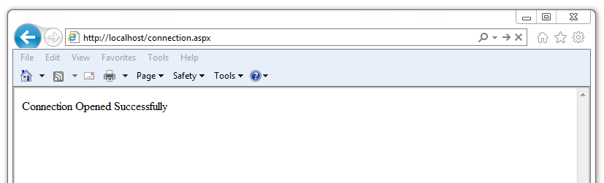

Example - Opening a Database Connection from a Console Application
The following example opens a connection with an Advanced Server database using a console-based application.
Before writing the code for the console application, create an app.config file that stores the connection string to the database. Using a configuration file makes it convenient to update the connection string if the information changes.
<?xml version="1.0" encoding="utf-8" ?>
<configuration>
<appSettings>
<add key="DB_CONN_STRING" value = "Server=127.0.0.1;Port=5444;
User Id=enterprisedb;Password=enterprisedb;Database=edb"/>
</appSettings>
</configuration>
Using your text editor of choice, enter the following code sample into a file:
using System;
using System.Data;
using EnterpriseDB.EDBClient;
using System.Configuration;

namespace EnterpriseDB
{

class EDB
{

static void Main(string[] args)
{
string strConnectionString = ConfigurationSettings.AppSettings
["DB_CONN_STRING"];

EDBConnection conn = new EDBConnection(strConnectionString);

try
{
conn.Open();
Console.WriteLine("Connection Opened Successfully");
}

catch(Exception exp)
{
throw new Exception(exp.ToString());
}

finally
{
conn.Close();
}
}
}
}
Save the file as EDBConnection-Sample.cs and compile it with the following command:
csc /r:EDBDataProvider.dll /out:Console.exe EDBConnection-Sample.cs
Compiling the sample should generate a Console.exe file; you can execute the sample code by entering Console.exe. When executed, the console should verify that the:
Connection Opened Successfully

Example - Opening a Database Connection from a Windows Form Application
The following example demonstrates opening a database connection using a .NET WinForm application. To use the example, save the following code as WinForm-Example.cs in a directory that contains the library files.
using System;
using System.Windows.Forms;
using System.Drawing;
using EnterpriseDB.EDBClient;

namespace EDBTestClient
{

class Win_Conn
{
static void Main(string[] args)
{
Form frmMain = new Form();
Button btnConn = new Button();
btnConn.Location = new System.Drawing.Point(104, 64);
btnConn.Name = "btnConn";
btnConn.Text = "Open Connection";
btnConn.Click += new System.EventHandler(btnConn_Click);

frmMain.Controls.Add(btnConn);
frmMain.Text = "EnterpriseDB";

Application.Run(frmMain);
}

private static void btnConn_Click(object sender, System.EventArgs e)
{
EDBConnection conn = null;
try
{
string connectionString = "Server=10.90.1.29;port=5444;
username=edb;password=edb;database=edb";
conn = new EDBConnection(connectionString);
conn.Open();
MessageBox.Show("Connection Open");
}
catch(EDBException exp)
{
MessageBox.Show(exp.ToString());
}
finally
{
conn.Close();
}
}
}
}
Note that you must change the database connection string to point to the database that you want to connect to before compiling the file with the following command:
csc /r:EDBDataProvider.dll /out:WinForm.exe WinForm-Example.cs
This command should generate a WinForm.exe file within the same folder that the executable was compiled under. Invoking the executable will display:
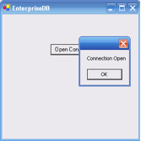

Retrieving Database Records
You can use a SELECT statement to retrieve records from the database via a SELECT command. To execute a SELECT statement you must:
- Create and open a database connection.
- Create an EDBCommand object that represents the SELECT statement.
- Execute the command with the ExecuteReader() method of the EDBCommand object returning a EDBDataReader
- Loop through the EDBDataReader displaying the results or binding the EDBDataReader to some control.
An EDBDataReader object represents a forward-only and read-only stream of database records, presented one record at a time. To view a subsequent record in the stream, you must call the Read() method of the EDBDataReader object.
The example that follows:
- Imports the Advanced Server namespace: EnterpriseDB.EDBClient
- Initializes an EDBCommand object with a SELECT statement.
- Opens a connection to the database.
- Executes the EDBCommand by calling the ExecuteReader method of the EDBCommand object.
The results of the SQL statement are retrieved into an EDBDataReader object.
- Loops through the contents of the EDBDataReader object to display the records returned by the query within a WHILE loop.
The Read() method advances to the next record (if a record exists) and returns true if a record exists, or false to indicate that the EDBDataReader has reached the end of the result set.
<% @ Page Language="C#" %>
<% @Import Namespace="EnterpriseDB.EDBClient" %>
<% @Import Namespace="System.Data" %>
<% @Import Namespace="System.Configuration" %>

<script language="C#" runat="server">

private void Page_Load(object sender, System.EventArgs e)
{
string strConnectionString = ConfigurationSettings.AppSettings
["DB_CONN_STRING"];
EDBConnection conn = new EDBConnection(strConnectionString);

try
{
conn.Open();
EDBCommand cmdSelect = new EDBCommand("SELECT * FROM dept",conn);
cmdSelect.CommandType = CommandType.Text;
EDBDataReader drDept = cmdSelect.ExecuteReader();

while(drDept.Read())
{
Response.Write("Department Number: " + drDept["deptno"]);
Response.Write("\tDepartment Name: " + drDept["dname"]);
Response.Write("\tDepartment Location: " + drDept["loc"]);
Response.Write("<br>");
}

}

catch(Exception exp)
{
Response.Write(exp.ToString());
}
finally
{
conn.Close();
}
}
</script>

To exercise the sample code, save the code in your default web root directory in a file named:
selectEmployees.aspx
To invoke the program, open a web-browser, and browse to:
http://localhost/selectEmployees.aspx.

Retrieving a Single Database Record
To retrieve a single result from a query, use the ExecuteScalar() method of the EDBCommand object. The ExecuteScalar() method returns the first value of the first column of the first row of the DataSet generated by the specified query.
<% @ Page Language="C#" %>
<% @Import Namespace="EnterpriseDB.EDBClient" %>
<% @Import Namespace="System.Data" %>
<% @Import Namespace="System.Configuration" %>

<script language="C#" runat="server">

private void Page_Load(object sender, System.EventArgs e)
{
string strConnectionString = ConfigurationSettings.AppSettings
["DB_CONN_STRING"];
EDBConnection conn = new EDBConnection(strConnectionString);
try
{
conn.Open();
EDBCommand cmd = new EDBCommand("SELECT MAX(sal) FROM emp",conn);

cmd.CommandType = CommandType.Text;
int maxSal = Convert.ToInt32(cmd.ExecuteScalar());

Response.Write("Emp Number: " + maxSal);

}
catch(Exception exp)
{
Response.Write(exp.ToString());
}
finally
{
conn.Close();
}
}
</script>
Save the sample code in a file in a web root directory named:
selectscalar.aspx
To invoke the sample code, open a web-browser, and browse to:
http://localhost/selectScalar.aspx
Please note that the sample includes an explicit conversion of the value returned by the ExecuteScalar() method. The ExecuteScalar() method returns an object; to view the object, you must convert it into an integer value by using the Convert.ToInt32 method.

Parameterized Queries
A parameterized query is a query with one or more parameter markers embedded in the SQL statement. Before executing a parameterized query, you must supply a value for each marker found in the text of the SQL statement.
Parameterized queries are useful when you don't know the complete text of a query at the time you write your code. For example, the value referenced in a WHERE clause may be calculated from user input.
As demonstrated in the following example, you must declare the data type of each parameter specified in the parameterized query by creating an EDBParameter object and adding that object to the command's parameter collection. Then, you must specify a value for each parameter by calling the parameter's Value() function.
The example demonstrates use of a parameterized query with an UPDATE statement that increases an employee salary:
<% @ Page Language="C#" Debug="true"%>
<% @Import Namespace="EnterpriseDB.EDBClient" %>
<% @Import Namespace="System.Data" %>
<% @Import Namespace="System.Configuration" %>

<script language="C#" runat="server" >

private void Page_Load(object sender, System.EventArgs e)
{
string strConnectionString = ConfigurationSettings.AppSettings
["DB_CONN_STRING"];
EDBConnection conn = new EDBConnection(strConnectionString);

string updateQuery = "UPDATE emp SET sal = sal+500 where empno = :ID";

try {
conn.Open();

EDBCommand cmdUpdate = new EDBCommand(updateQuery,conn);

cmdUpdate.Parameters.Add
(new EDBParameter(":ID", EDBTypes.EDBDbType.Integer));

cmdUpdate.Parameters[0].Value = 7788;

cmdUpdate.ExecuteNonQuery();

Response.Write("Record Updated");

}
catch(Exception exp) {
Response.Write(exp.ToString());
}
finally {
conn.Close();
}
}
</script>
Save the sample code in a file in a web root directory named:
updateSalary.aspx
To invoke the sample code, open a web-browser, and browse to:
http://localhost/updateSalary.aspx

Inserting Records in a Database
You can use the ExecuteNonQuery() method of EDBCommand to add records to a database stored on an Advanced Server host with an Insert command.
In the example that follows, the insert command is stored in the variable cmd. The values prefixed with a colon (:) are placeholders for EDBParameters that are instantiated, assigned values, and then added to the insert command's parameter collection in the statements that follow. The insert command is executed by the ExecuteNonQuery() method of the cmdInsert object.
The example adds a new employee to the emp table:
<% @ Page Language="C#" Debug="true"%>
<% @Import Namespace="EnterpriseDB.EDBClient" %>
<% @Import Namespace="System.Data" %>
<% @Import Namespace="System.Configuration" %>

<script language="C#" runat="server" >

private void Page_Load(object sender, System.EventArgs e)
{
string strConnectionString = ConfigurationSettings.AppSettings
["DB_CONN_STRING"];
EDBConnection conn = new EDBConnection(strConnectionString);

try
{
conn.Open();

string cmd = "INSERT INTO emp(empno,ename) VALUES(:EmpNo, :EName)";

EDBCommand cmdInsert = new EDBCommand(cmd,conn);

cmdInsert.Parameters.Add(new EDBParameter(":EmpNo",
EDBTypes.EDBDbType.Integer));

cmdInsert.Parameters[0].Value = 1234;

cmdInsert.Parameters.Add(new EDBParameter(":EName",
EDBTypes.EDBDbType.Text));

cmdInsert.Parameters[1].Value = "Lola";

cmdInsert.ExecuteNonQuery();
Response.Write("Record inserted successfully");
}

catch(Exception exp)
{
Response.Write(exp.ToString());
}
finally
{
conn.Close();
}
}
</script>
Save the sample code in a file in a web root directory named:
insertEmployee.aspx
To invoke the sample code, open a web-browser, and browse to:
http://localhost/insertEmployee.aspx

Deleting Records in a Database
You can use the ExecuteNonQuery() method of EDBCommand to delete records from a database stored on an Advanced Server host with a Delete statement.
In the example that follows, the delete command is stored in the variable strDeleteQuery. The code passes the employee number to the Delete command (specified by :EmpNo). The command is then executed using the ExecuteNonQuery() method. The following example deletes the employee inserted in the previous example:
<% @ Page Language="C#" Debug="true"%>
<% @Import Namespace="EnterpriseDB.EDBClient" %>
<% @Import Namespace="System.Data" %>
<% @Import Namespace="System.Configuration" %>

<script language="C#" runat="server" >

private void Page_Load(object sender, System.EventArgs e)
{
string strConnectionString = ConfigurationSettings.AppSettings
["DB_CONN_STRING"];

EDBConnection conn = new EDBConnection(strConnectionString);

string strDeleteQuery = "DELETE FROM emp WHERE empno = :ID";

try
{
conn.Open();

EDBCommand deleteCommand = new EDBCommand(strDeleteQuery,conn);

deleteCommand.Parameters.Add
(new EDBParameter(":ID", EDBTypes.EDBDbType.Integer));

deleteCommand.Parameters[0].Value = 1234;

deleteCommand.ExecuteNonQuery();

Response.Write("Record Deleted");

}

catch(Exception exp)
{

Response.Write(exp.ToString());

}

finally
{

conn.Close();

}
}
</script>
Save the sample code in a file in a web root directory named:
deleteEmployee.aspx
To invoke the sample code, open a web-browser, and browse to:
http://localhost/deleteEmployee.aspx

Using SPL Stored Procedures in your .NET Application
You can include SQL statements in an application in two ways:
- By adding the SQL statements directly in the .NET application code.
- By packaging the SQL statements in a stored procedure, and executing the stored procedure from the .NET application.
In some cases, a stored procedure can provide advantages over embedded SQL statements. Stored procedures support complex conditional and looping constructs that are difficult to duplicate with SQL statements embedded directly in an application.
You can also see a significant improvement in performance by using stored procedures; a stored procedure only needs to be parsed, compiled and optimized once on the server side, while a SQL statement that is included in an application may be parsed, compiled and optimized each time it is executed from a .NET application.
To use a stored procedure in your .NET application you must:
- Create an SPL stored procedure on the Advanced Server host.
- Import the EnterpriseDB.EDBClient namespace.
- Pass the name of the stored procedure to the instance of the EDBCommand.
- Change the EDBCommand.CommandType to CommandType.StoredProcedure.
- Prepare() the command.
- Execute the command.

Example - Executing a Stored Procedure without Parameters
Our sample procedure prints the name of department 10; the procedure takes no parameters, and returns no parameters. To create the sample procedure, invoke EDB-PSQL and connect to the Advanced Server host database. Enter the following SPL code at the command line:
CREATE OR REPLACE PROCEDURE list_dept10
IS
v_deptname VARCHAR2(30);
BEGIN
DBMS_OUTPUT.PUT_LINE('Dept No: 10');
SELECT dname INTO v_deptname FROM dept WHERE deptno = 10;
DBMS_OUTPUT.PUT_LINE('Dept Name: ' || v_deptname);
END;
When Advanced Server has validated the stored procedure it will echo CREATE PROCEDURE.
Using the EDBCommand Object to Execute a Stored Procedure
The CommandType property of the EDBCommand object is used to indicate the type of command being executed. The CommandType property is set to one of three possible CommandType enumeration values:
- Use the default Text value when passing a SQL string for execution.
- Use the StoredProcedure value, passing the name of a stored procedure for execution.
- Use the TableDirect value when passing a table name. This value passes back all records in the specified table.
The CommandText property must contain a SQL string, stored procedure name, or table name depending on the value of the CommandType property.
The following example executes the stored procedure:
<% @ Page Language="C#" Debug="true"%>
<% @Import Namespace="EnterpriseDB.EDBClient" %>
<% @Import Namespace="System.Data" %>
<% @Import Namespace="System.Configuration" %>

<script language="C#" runat="server" >

private void Page_Load(object sender, System.EventArgs e)
{
string strConnectionString = ConfigurationSettings.AppSettings
["DB_CONN_STRING"];
EDBConnection conn = new EDBConnection(strConnectionString);

try
{
conn.Open();

EDBCommand cmdStoredProc = new EDBCommand("list_dept10",conn);
cmdStoredProc.CommandType = CommandType.StoredProcedure;

cmdStoredProc.Prepare();
cmdStoredProc.ExecuteNonQuery();

Response.Write("Stored Procedure Executed Successfully");

}
catch(Exception exp)
{
Response.Write(exp.ToString());
}
finally
{
conn.Close();
}
}
</script>

Save the sample code in a file in a web root directory named:
storedProc.aspx
To invoke the sample code, open a web-browser, and browse to:
http://localhost/storedProc.aspx

Example - Executing a Stored Procedure with IN Parameters
The following example demonstrates calling a stored procedure that includes IN parameters. To create the sample procedure, invoke EDB-PSQL and connect to the Advanced Server host database. Enter the following SPL code at the command line:
CREATE OR REPLACE PROCEDURE
EMP_INSERT
(
pENAME IN VARCHAR,
pJOB IN VARCHAR,
pSAL IN FLOAT4,
pCOMM IN FLOAT4,
pDEPTNO IN INTEGER,
pMgr IN INTEGER
)
AS
DECLARE
CURSOR TESTCUR IS SELECT MAX(EMPNO) FROM EMP;
MAX_EMPNO INTEGER := 10;
BEGIN

OPEN TESTCUR;
FETCH TESTCUR INTO MAX_EMPNO;
INSERT INTO EMP(EMPNO,ENAME,JOB,SAL,COMM,DEPTNO,MGR)
VALUES(MAX_EMPNO+1,pENAME,pJOB,pSAL,pCOMM,pDEPTNO,pMgr);
CLOSE testcur;
END;
When Advanced Server has validated the stored procedure it will echo CREATE PROCEDURE.
Passing Input values to a Stored Procedure
Calling a stored procedure that contains parameters is very similar to executing a stored procedure without parameters. The major difference is that when calling a parameterized stored procedure you must use the EDBParameter collection of the EDBCommand object. When the EDBParameter is added to the EDBCommand collection, properties such as ParameterName, DbType, Direction, Size, and Value are set.
The following example demonstrates the process of executing a parameterized stored procedure from a C#.
<% @ Page Language="C#" Debug="true"%>
<% @Import Namespace="EnterpriseDB.EDBClient" %>
<% @Import Namespace="System.Data" %>
<% @Import Namespace="System.Configuration" %>

<script language="C#" runat="server" >

private void Page_Load(object sender, System.EventArgs e)
{
string strConnectionString = ConfigurationSettings.AppSettings
["DB_CONN_STRING"];
EDBConnection conn = new EDBConnection(strConnectionString);

string empName = "EDB";
string empJob = "Manager";
double salary = 1000;
double commission = 0.0;
int deptno = 20;
int manager = 7839;

try
{
conn.Open();

EDBCommand cmdStoredProc = new EDBCommand
("emp_insert(:EmpName,:Job,:Salary,:Commission,:DeptNo,
:Manager)",conn);
cmdStoredProc.CommandType = CommandType.StoredProcedure;

cmdStoredProc.Parameters.Add(new EDBParameter
("EmpName", EDBTypes.EDBDbType.Varchar));
cmdStoredProc.Parameters[0].Value = empName;

cmdStoredProc.Parameters.Add(new EDBParameter
("Job", EDBTypes.EDBDbType.Varchar));
cmdStoredProc.Parameters[1].Value = empJob;

cmdStoredProc.Parameters.Add(new EDBParameter
("Salary", EDBTypes.EDBDbType.Float));
cmdStoredProc.Parameters[2].Value = salary;

cmdStoredProc.Parameters.Add(new EDBParameter
("Commission", EDBTypes.EDBDbType.Float));
cmdStoredProc.Parameters[3].Value = commission;

cmdStoredProc.Parameters.Add(new EDBParameter
("DeptNo", EDBTypes.EDBDbType.Integer));
cmdStoredProc.Parameters[4].Value = deptno;

cmdStoredProc.Parameters.Add
(new EDBParameter("Manager", EDBTypes.EDBDbType.Integer));
cmdStoredProc.Parameters[5].Value = manager;

cmdStoredProc.Prepare();

cmdStoredProc.ExecuteNonQuery();

Response.Write("Following Information Inserted Successfully
<br>");
string empInfo = "Employee Name: " + empName + "<br>";
empInfo += "Job: " + empJob + "<br>";
empInfo += "Salary: " + salary + "<br>";
empInfo += "Commission: " + commission + "<br>";
empInfo += "Manager: " + manager + "<br>";

Response.Write(empInfo);

}

catch(Exception exp)
{
Response.Write(exp.ToString());
}
finally
{
conn.Close();
}
}

</script>

</script>

Save the sample code in a file in a web root directory named:
storedProcInParam.aspx
To invoke the sample code, open a web-browser, and browse to:
http://localhost/storedProcInParam.aspx
In the example, the body of the Page_Load method declares and instantiates an EDBConnection object. The sample then creates an EDBCommand object with the properties needed to execute the stored procedure.
The example then uses the Add method of the EDBCommand Parameter collection to add six input parameters.
EDBCommand cmdStoredProc = new EDBCommand
("emp_insert(:EmpName,:Job,:Salary,:Commission,:DeptNo,:Manager)",conn);
cmdStoredProc.CommandType = CommandType.StoredProcedure;
It assigns a value to each parameter before passing them to the EMP_INSERT stored procedure
The Prepare() method prepares the statement before calling the ExecuteNonQuery() method.
The ExecuteNonQuery method of the EDBCommand object executes the stored procedure. After the stored procedure has executed, a test record is inserted into the emp table and the values inserted are displayed on the webpage.

Example - Executing a Stored Procedure with IN, OUT, and INOUT Parameters
The previous example demonstrated how to pass IN parameters to a stored procedure; the following examples demonstrate how to pass IN values and return OUT values from a stored procedure.
Creating the Stored Procedure
The following stored procedure passes the department number, and returns the corresponding location and department name. To create the sample procedure, open the EDB-PSQL command line, and connect to the Advanced Server host database. Enter the following SPL code at the command line:
CREATE OR REPLACE PROCEDURE
DEPT_SELECT
(
pDEPTNO IN INTEGER,
pDNAME OUT VARCHAR,
pLOC OUT VARCHAR
)
AS
DECLARE
CURSOR TESTCUR IS SELECT DNAME,LOC FROM DEPT;
REC RECORD;
BEGIN

OPEN TESTCUR;
FETCH TESTCUR INTO REC;

pDNAME := REC.DNAME;
pLOC := REC.LOC;

CLOSE testcur;
END;
When Advanced Server has validated the stored procedure it will echo CREATE PROCEDURE.
Receiving Output values from a Stored Procedure
When retrieving values from OUT parameters you must explicitly specify the direction of out parameters as Output. You can retrieve the values from Output parameters in two ways:
- Call the ExecuteReader method of the EDBCommand and explicitly loop through the returned EDBDataReader, searching for the values of OUT parameters.
- Call the ExecuteNonQuery method of EDBCommand and explicitly get the value of a declared Output parameter by calling that EDBParameter value property.
In each method, you must declare each parameter, indicating the direction of the parameter (ParameterDirection.Input, ParameterDirection.Output or ParameterDirection.InputOutput). Before invoking the procedure, you must provide a value for each IN and INOUT parameter. After the procedure returns, you may retrieve the OUT and INOUT parameter values from the command.Parameters[] array.
The following code listing demonstrates using the ExecuteReader method to retrieve a result set:
<% @ Page Language="C#" Debug="true"%>
<% @Import Namespace="EnterpriseDB.EDBClient" %>
<% @Import Namespace="System.Data" %>
<% @Import Namespace="System.Configuration" %>

<script language="C#" runat="server" >

private void Page_Load(object sender, System.EventArgs e)
{
string strConnectionString =
ConfigurationSettings.AppSettings["DB_CONN_STRING"];
EDBConnection conn = new EDBConnection(strConnectionString);

try
{

conn.Open();
EDBCommand command = new EDBCommand("DEPT_SELECT
(:pDEPTNO,:pDNAME,:pLOC)", conn);
command.CommandType = CommandType.StoredProcedure;

command.Parameters.Add(new EDBParameter("pDEPTNO",
EDBTypes.EDBDbType.Integer,10,"pDEPTNO",
ParameterDirection.Input,false ,2,2,
System.Data.DataRowVersion.Current,1));

command.Parameters.Add(new EDBParameter("pDNAME",
EDBTypes.EDBDbType.Varchar,10,"pDNAME",
ParameterDirection.Output,false ,2,2,
System.Data.DataRowVersion.Current,1));

command.Parameters.Add(new EDBParameter("pLOC",
EDBTypes.EDBDbType.Varchar,10,"pLOC",
ParameterDirection.Output,false ,2,2,
System.Data.DataRowVersion.Current,1));

command.Prepare();

command.Parameters[0].Value = 10;
EDBDataReader result = command.ExecuteReader();

int fc = result.FieldCount;

while(result.Read())
{
for(int i = 0;i < fc; i++)
{
Response.Write("RESULT["+i+"]="+ Convert.ToString
(command.Parameters[i].Value));
Response.Write("<br>");
}
}

}

catch(EDBException exp)
{
Response.Write(exp.ToString());
}
finally
{
conn.Close();
}
}

</script>

The following code listing demonstrates using the ExecuteNonQuery method to retrieve a result set:
<% @ Page Language="C#" Debug="true"%>
<% @Import Namespace="EnterpriseDB.EDBClient" %>
<% @Import Namespace="System.Data" %>
<% @Import Namespace="System.Configuration" %>

<script language="C#" runat="server" >

private void Page_Load(object sender, System.EventArgs e)
{
string strConnectionString = ConfigurationSettings.AppSettings
["DB_CONN_STRING"];
EDBConnection conn = new EDBConnection(strConnectionString);

try
{

conn.Open();
EDBCommand command = new EDBCommand("DEPT_SELECT
(:pDEPTNO,:pDNAME,:pLOC)", conn);
command.CommandType = CommandType.StoredProcedure;

command.Parameters.Add(new EDBParameter("pDEPTNO",
EDBTypes.EDBDbType.Integer,10,"pDEPTNO",
ParameterDirection.Input,false ,2,2,
System.Data.DataRowVersion.Current,1));

command.Parameters.Add(new EDBParameter("pDNAME",
EDBTypes.EDBDbType.Varchar,10,"pDNAME",
ParameterDirection.Output,false ,2,2,
System.Data.DataRowVersion.Current,1));

command.Parameters.Add(new EDBParameter("pLOC",
EDBTypes.EDBDbType.Varchar,10,"pLOC",
ParameterDirection.Output,false ,2,2,
System.Data.DataRowVersion.Current,1));

command.Prepare();
command.Parameters[0].Value = 10;
command.ExecuteNonQuery();

Response.Write(command.Parameters["pDNAME"].Value.ToString());
Response.Write(command.Parameters["pLOC"].Value.ToString());
}

catch(EDBException exp)
{
Response.Write(exp.ToString());
}
finally
{
conn.Close();
}
}
</script>

Using a Ref Cursor in a .NET Application
A ref cursor is a cursor variable that contains a pointer to a query result set. The result set is determined by the execution of the OPEN FOR statement using the cursor variable. A cursor variable is not tied to a particular query like a static cursor. The same cursor variable may be opened a number of times with the OPEN FOR statement containing different queries and each time, a new result set will be created for that query and made available via the cursor variable. There are two ways to declare a cursor variable:
- Use the SYS_REFCURSOR built-in data type to declare a weakly-typed ref cursor.
- Define a strongly-typed ref cursor that declares a variable of that type.
SYS_REFCURSOR is a ref cursor type that allows any result set to be associated with it. This is known as a weakly-typed ref cursor. The following example is a declaration of a weakly-typed ref cursor:
name SYS_REFCURSOR;
Following is an example of a strongly-typed ref cursor:
TYPE cursor_type_name IS REF CURSOR RETURN emp%ROWTYPE;
Creating the Stored Procedure
The following sample code creates a stored procedure called refcur_inout_callee. To create the sample procedure, invoke EDB-PSQL and connect to the Advanced Server host database. Enter the following SPL code at the command line:
CREATE OR REPLACE PROCEDURE
refcur_inout_callee(v_refcur IN OUT SYS_REFCURSOR)
IS
BEGIN
OPEN v_refcur FOR SELECT ename FROM emp;
END;

To use the above defined procedure from .NET code, you must specify the data type of the ref cursor being passed as an IN parameter, as shown in the above script.
The following C# code uses the stored procedure to retrieve employee names from the emp table:
using System;
using System.Data;
using EnterpriseDB.EDBClient;
using System.Configuration;

namespace EDBRefCursor
{
class EmpRefcursor
{
[STAThread]
static void Main(string[] args)
{
string strConnectionString =
ConfigurationSettings.AppSettings["DB_CONN_STRING"];
EDBConnection conn = new EDBConnection(strConnectionString);

conn.Open();
EDBTransaction tran = conn.BeginTransaction();

try
{
EDBCommand command = new EDBCommand("refcur_inout_callee
(:refCursor)", conn);
command.CommandType = CommandType.StoredProcedure;
command.Transaction = tran;

command.Parameters.Add(new EDBParameter(
"refCursor",EDBTypes.EDBDbType.RefCursor,10,"refCursor",
ParameterDirection.InputOutput,false,
2,2,System.Data.DataRowVersion.Current,null));
command.Prepare();
command.Parameters[0].Value = null;

EDBDataReader result =
command.ExecuteReader(CommandBehavior.SequentialAccess);

EDBDataReader reader = (EDBDataReader)command.Parameters[0].Value;

int fc = reader.FieldCount;

while(reader.Read())
{
for(int i = 0;i < fc; i++)
{
Console.WriteLine(reader.GetString(i));
}
}
result.Close();
Console.ReadLine();
}
catch(Exception ex)
{
Console.WriteLine(ex.Message.ToString());
}
}
}
}
The following .NET code snippet displays the result on the console:
for(int i = 0;i < fc; i++)
{
Console.WriteLine(reader.GetString(i));
}
Please note that you must bind the EDBDbType.RefCursor type in EDBParameter() if you are using a ref cursor parameter.

