XIAOFANG JIANG(912794828)

*Training set and testing set data are generated randomly, outcome will change for different compiling.

**Question 1:**

The answer for question will automatically loaded after compiling the ECS171HW1.py file.

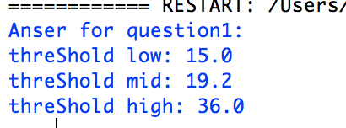

**Question 2:**

Command: question2()

* The plot won’t showing for all python version. Also, there will be a time delay for displaying the plot. Here is how the plot should look like.

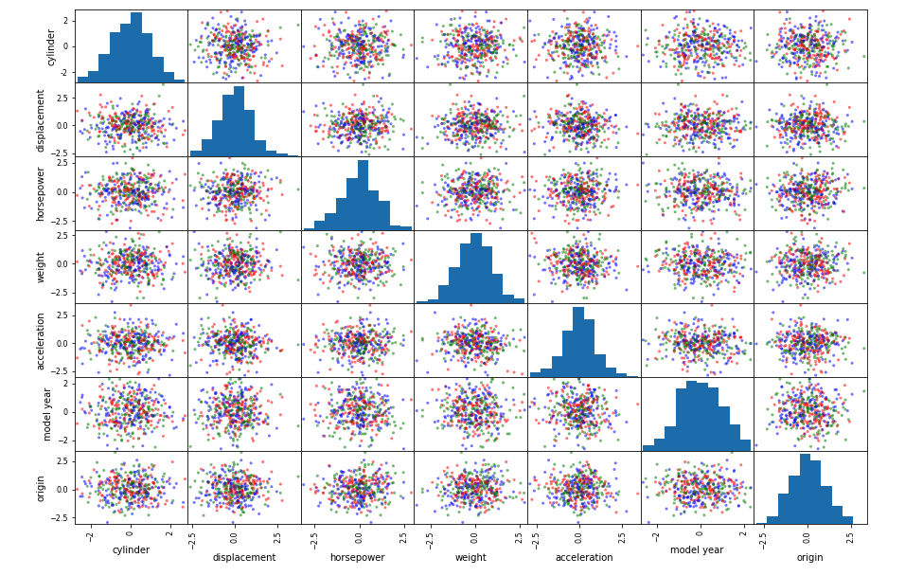

**Question 3:**

Since there is no value will be returned by just calling function “question3()”, so here is the source code for question3().

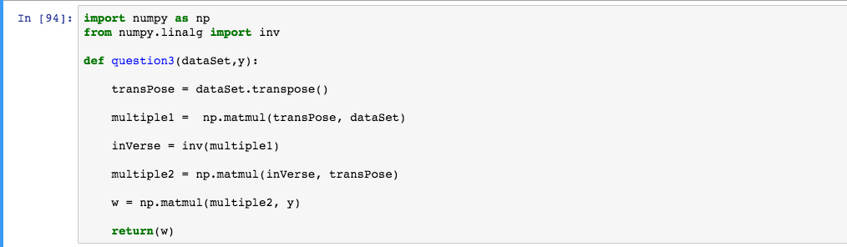

This function implements the RSS equation which is RSS =. The returned value will be a vector which is W.

**Question 4:**

The result will be printed separately for each feature. Plots will display automatically.

Because I’m generating the 200 training set and 192 testing set randomly, the result might change for different compilation. The following results are examples of one compiling.

Command: feature1()

Returns: w0,w1,w2,w3 for feature ‘cylinders’. MSE for 0th to 3rd order

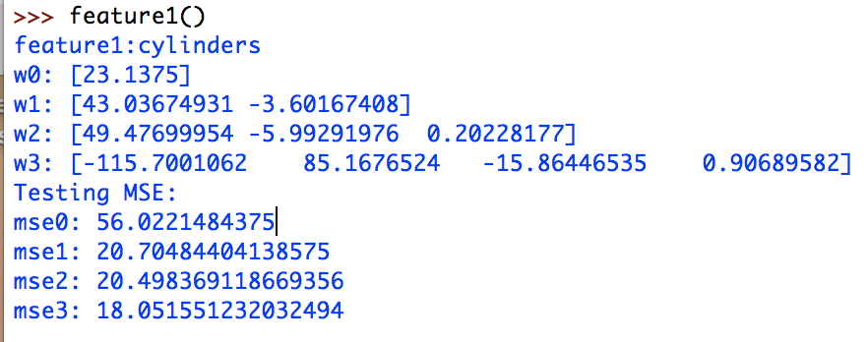

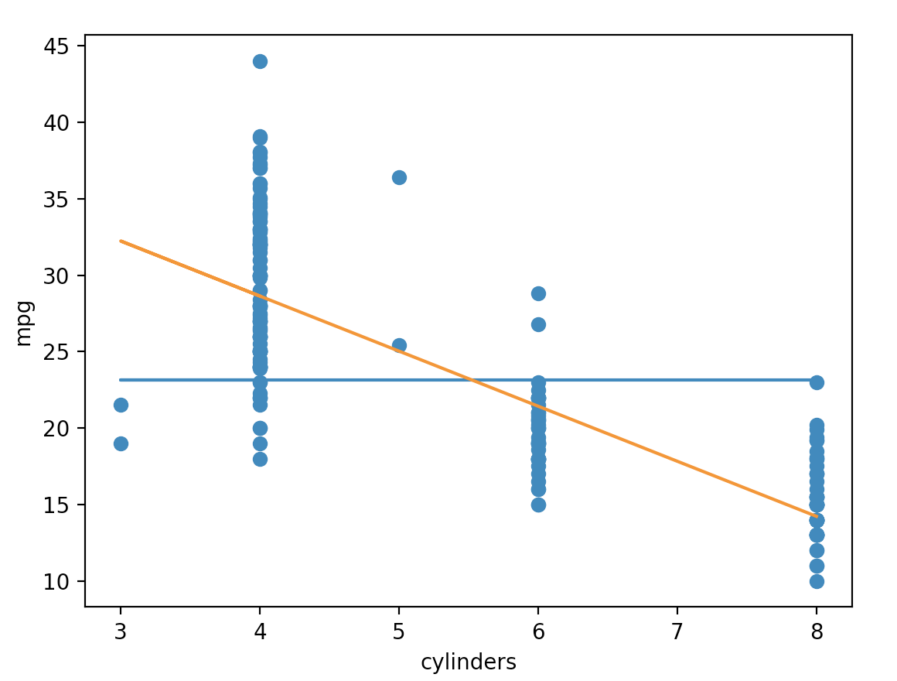

Command: feature2()

Returns: w0,w1,w2,w3 for feature ‘displacement’. MSE for 0th to 3rd order

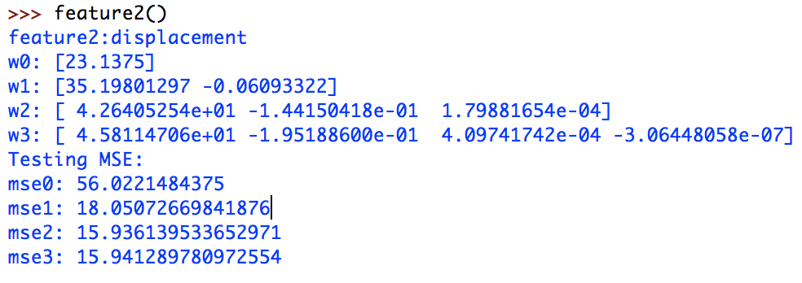

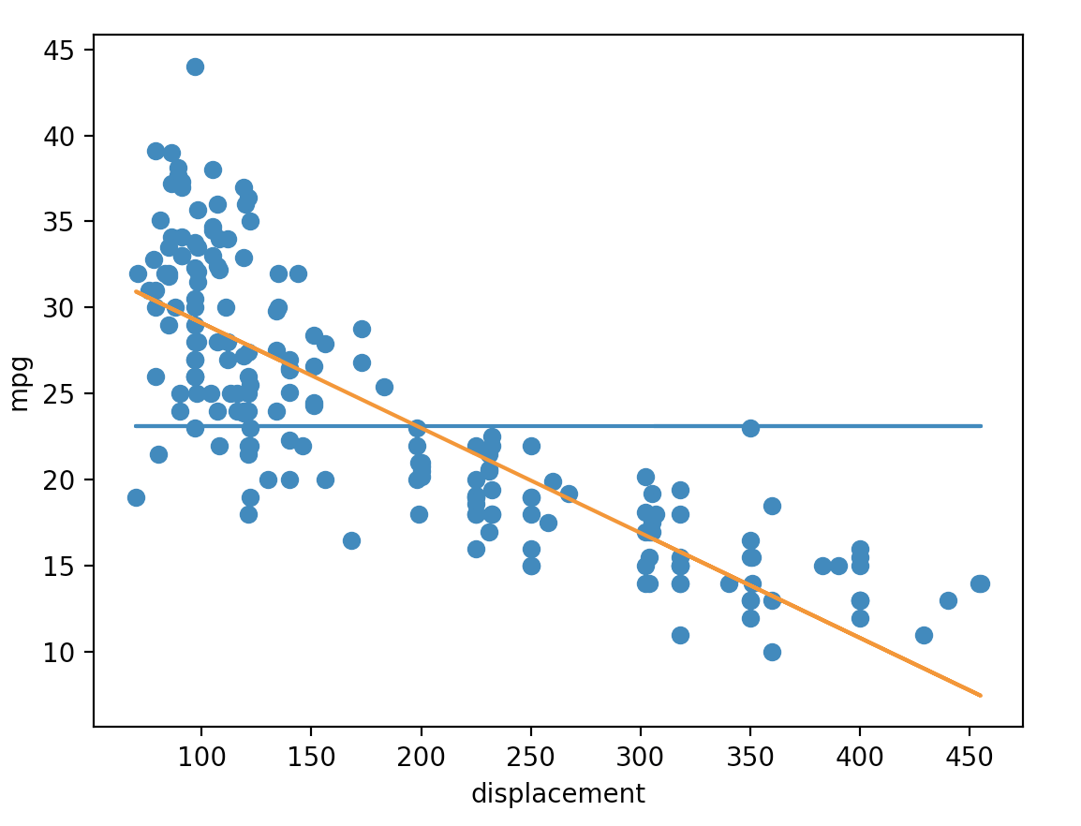

Command: feature3()

Returns: w0,w1,w2,w3 for feature ‘displacement’. MSE for 0th to 3rd order

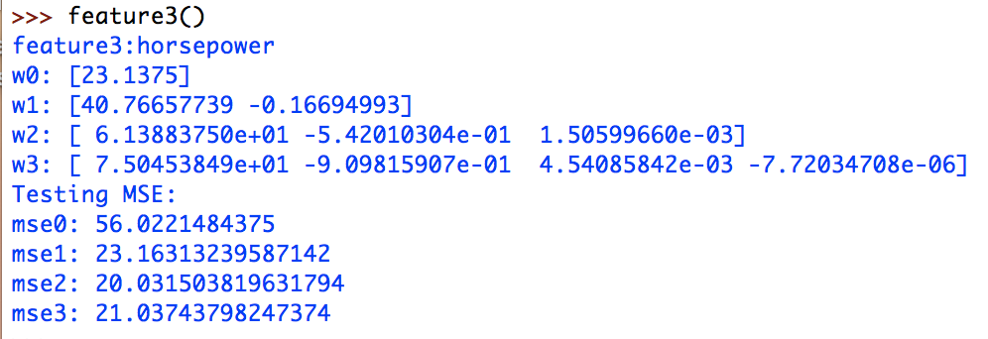

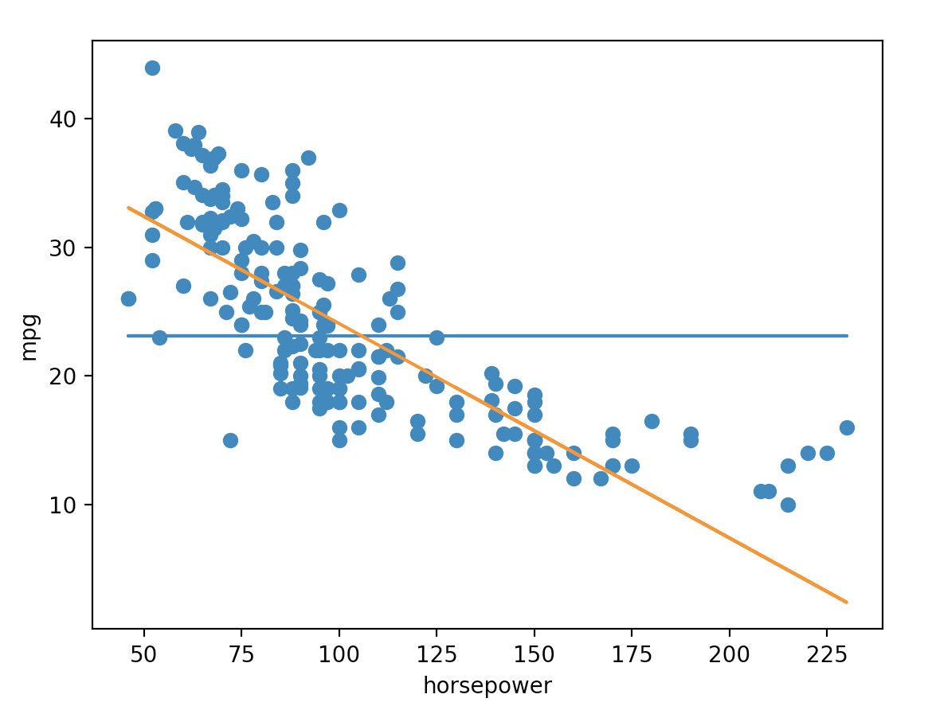

Command: feature4()

Returns: w0,w1,w2,w3 for feature ‘weight’. MSE for 0th to 3rd order

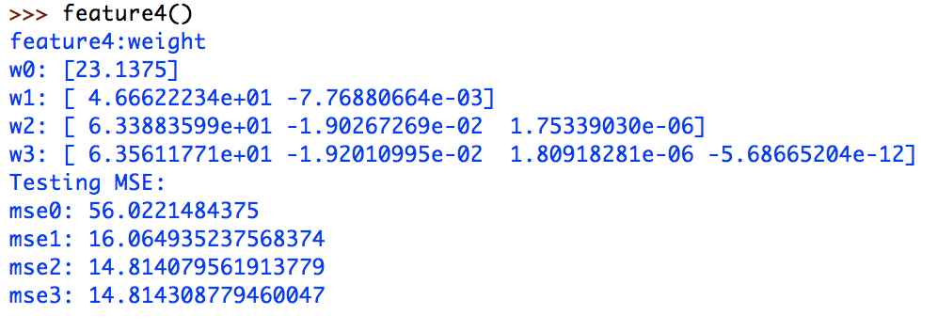

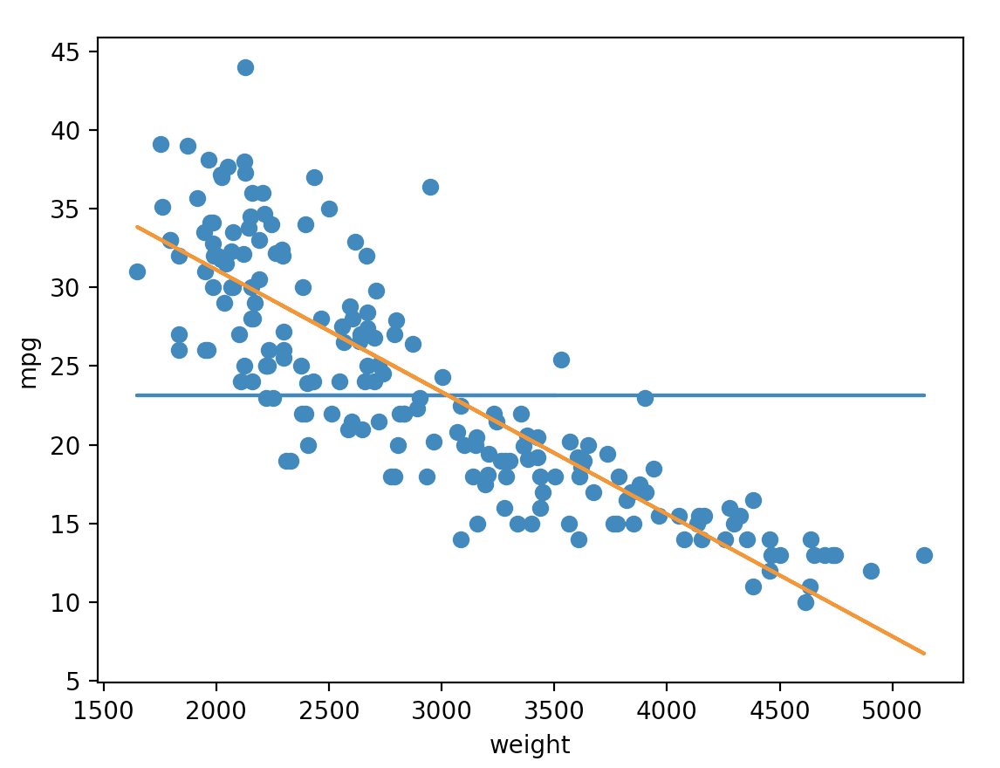

Command: feature5()

Returns: w0,w1,w2,w3 for feature ‘accelerationt’. MSE for 0th to 3rd order

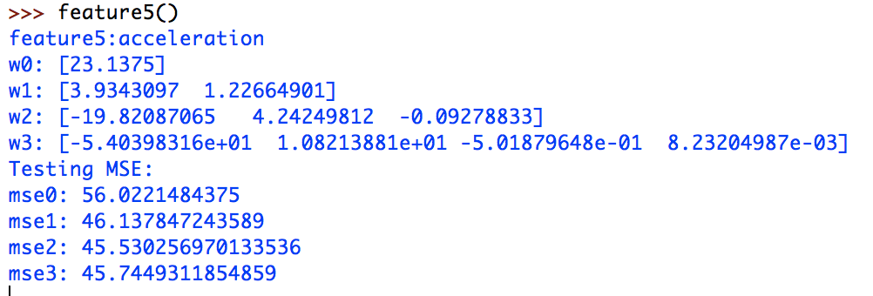

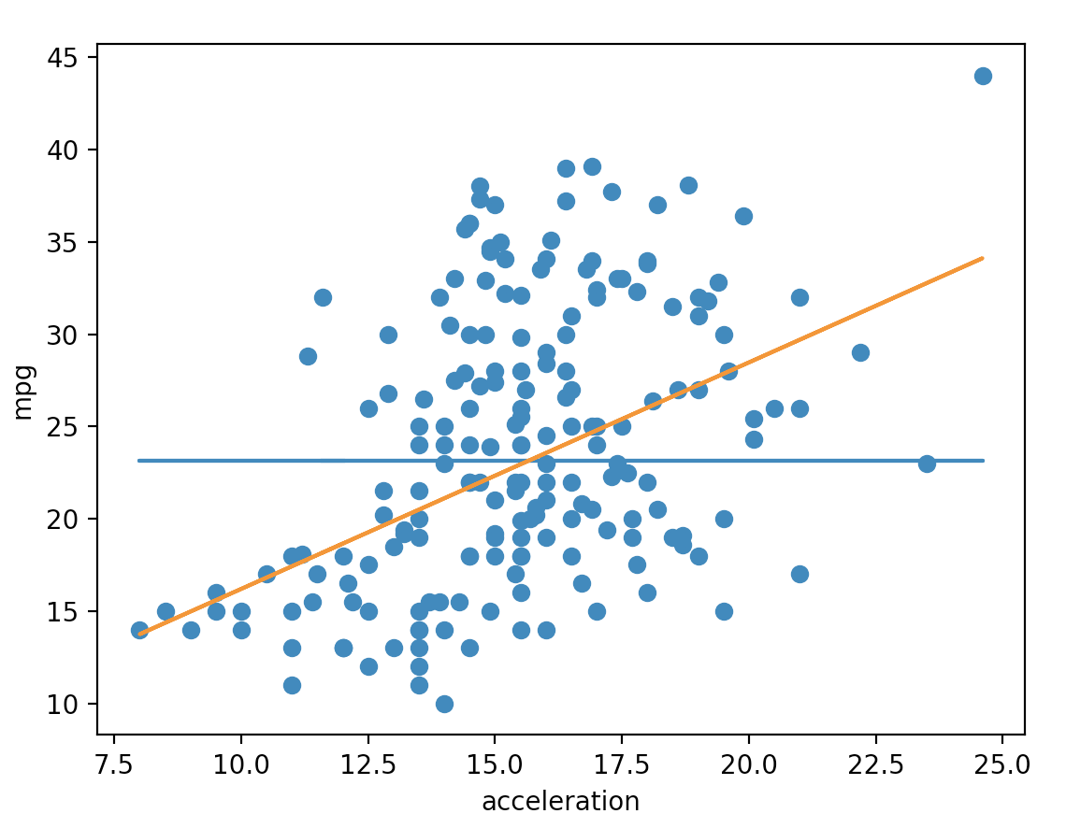

Command: feature6()

Returns: w0,w1,w2,w3 for feature ‘model yeart’. MSE for 0th to 3rd order

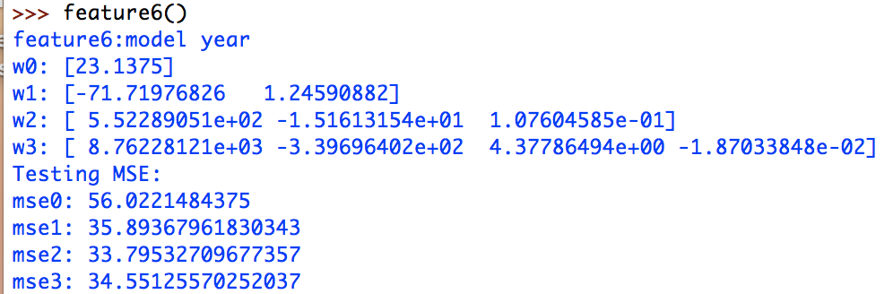

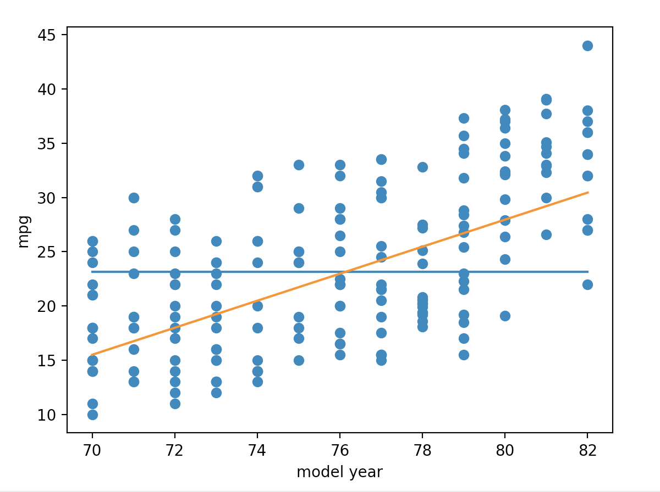

Command: feature7()

Returns: w0,w1,w2,w3 for feature ‘origin’. MSE for 0th to 3rd order

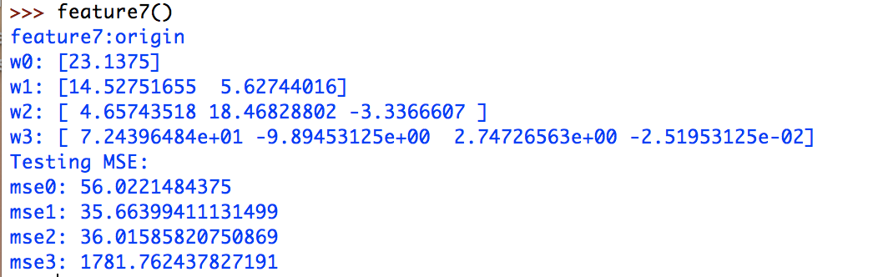

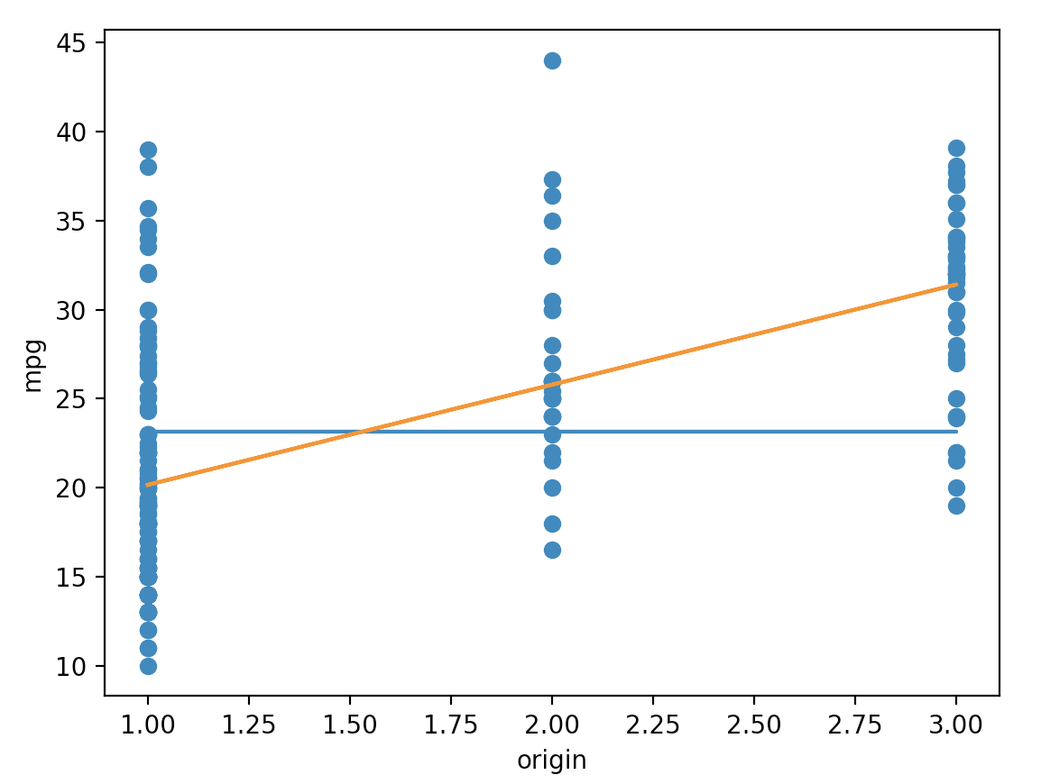

**Question 5:**

Command: question5()

Returns: w0,w1,w2,w3 for all 7 features . MSE for 0th to 2nd order

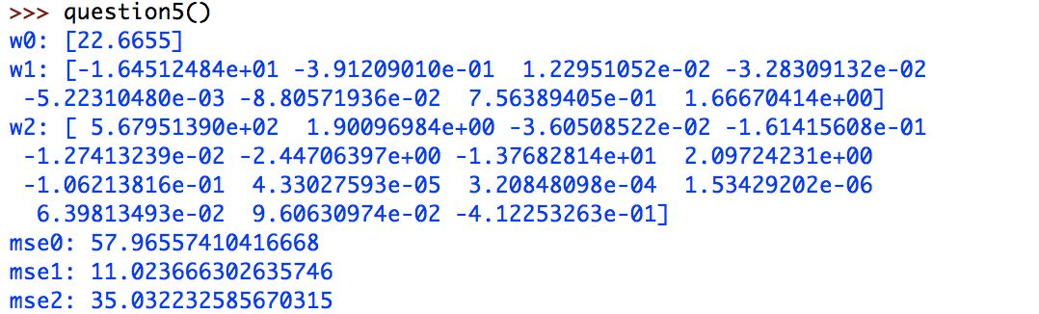

**Question 6:**

Command: question6()

Returns: 2 precision for training set and test set

*Because of the function used for calculating logistic regression, sometimes an error message will shown, but the result is printed correctly. This error message is not because of the wrong implementation of code.

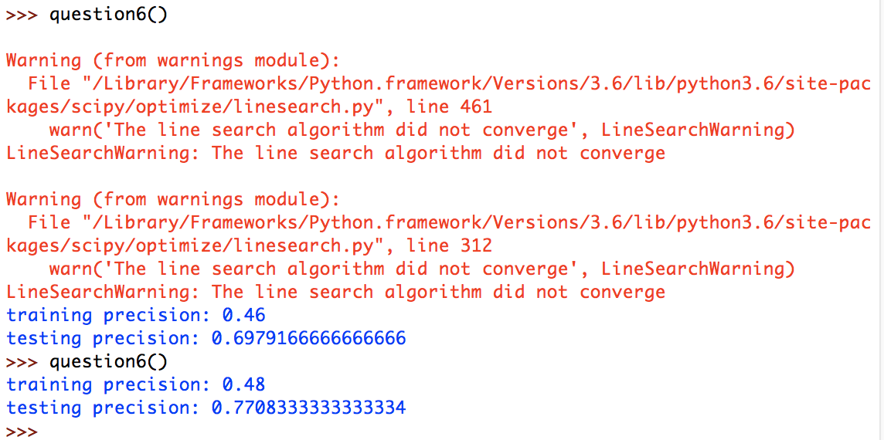

**Question 7:**

Command: question7()

The result will be printed automatically , the answer will include the answer for question5. The answer for question 7 appears at the last line.

