

Safety Plan Lane Assistance

**Document Version: [Version]**

**Template Version 1.0, Released on 2017-06-21**



# Document history

**[Instructions: Fill in the date, version and description fields. You can fill out the Editor field with your name if you want to do so. Keep track of your editing as if this were a real world project.**

**For example, if this were your first draft or first submission, you might say version 1.0. If this is a second submission attempt, then you'd add a second line with a new date and version 2.0]**

|  |  |  |  |
| --- | --- | --- | --- |
| Date | Version | Editor | Description |
| 9/1/2017 | 1.0 | Xu fuqiang | submit version |
|  |  |  |  |
|  |  |  |  |
|  |  |  |  |
|  |  |  |  |

# Table of Contents

**[Instructions: We have provided a table of contents. If the table of contents is not showing up correctly in your word processor of choice, please update it. The table of contents should show each section of the document and page numbers or links. Most word processors can do this for you. In** [**Google Docs**](https://support.google.com/docs/answer/116338?co=GENIE.Platform%3DDesktop&hl=en)**, you can use headings for each section and then go to Insert > Table of Contents.** [**Microsoft Word**](https://support.microsoft.com/en-us/help/285059/how-to-create-a-table-of-contents-by-marking-text-in-word) **has similar capabilities]**

Document history

Table of Contents

Introduction

Purpose of the Safety Plan

Scope of the Project

Deliverables of the Project

Item Definition

Goals and Measures

Goals

Measures

Safety Culture

Safety Lifecycle Tailoring

Roles

Development Interface Agreement

Confirmation Measures

# Introduction

## Purpose of the Safety Plan

**[Instructions: Answer what is the purpose of a safety plan?]**

The safety plan gives an overview of how you are going to achieve a safe system, and defines safety roles and responsibilities involved in the project.

## Scope of the Project

**[Instructions: Nothing to do here. This is for your information.]**

For the lane assistance project, the following safety lifecycle phases are in scope:

Concept phase

Product Development at the System Level

Product Development at the Software Level

The following phases are out of scope:

Product Development at the Hardware Level

Production and Operation

## Deliverables of the Project

**[Instructions: Nothing to do here. This is for your information.]**

The deliverables of the project are:

Safety Plan

Hazard Analysis and Risk Assessment

Functional Safety Concept

Technical Safety Concept

Software Safety Requirements and Architecture

# Item Definition

**[Instructions:**

**REQUIRED**

**Discuss these key points about the system:**

**What is the item in question, and what does the item do?**

**What are its two main functions? How do they work?**

**Which subsystems are responsible for each function?**

**What are the boundaries of the item? What subsystems are inside the item? What elements or subsystems are outside of the item?**

**OPTIONAL**

**Optionally, include information about these points as well. These were not included in the lectures, but you might be able to find this information online:**

* **Operational and Environmental Constraints. This could especially be limited to camera performance; lane lines are difficult to detect in snow, fog, etc**
* **Legal requirements in your country for lane assistance technology**
* **National and International Standards Related to the Item**
* **Records of previously known safety-related incidents or behavioral shortfalls**

**]**

The item in question is Lane Assistance item.

Lane Assistance item alerts the driver that the vehicle has accidentally departed its lane, and attempts to steer the vehicle back towards the center of the lane.

Two main functions:

1. Lane departure warning
2. Lane keeping assistance

The lane departure warning function shall apply an oscillating steering torque to provide the driver a haptic feedback.

The lane keeping assistance function shall apply the steering torque when active in order to stay in ego lane

Three subsystems:

1. Camera system
2. Electronic Power Steering system
3. Car Display system

Camera system is responsible for detecting lane lines and determining whether the vehicle leaves the lane by mistake.

Electronic power steering system is responsible for measuring the torque provided by the driver and then adding an appropriate amount of torque based on a lane assistance system torque request.

Car display system is responsible for turning on a warning light in the car display dashboard to make sure the driver knows that the lane assistance system is active.

The boundaries of the item are shown below diagram.

There are Camera subsystem, Electronic power steering subsystem and Car display subsystem inside of item.

The element Steering wheel is outside of item.

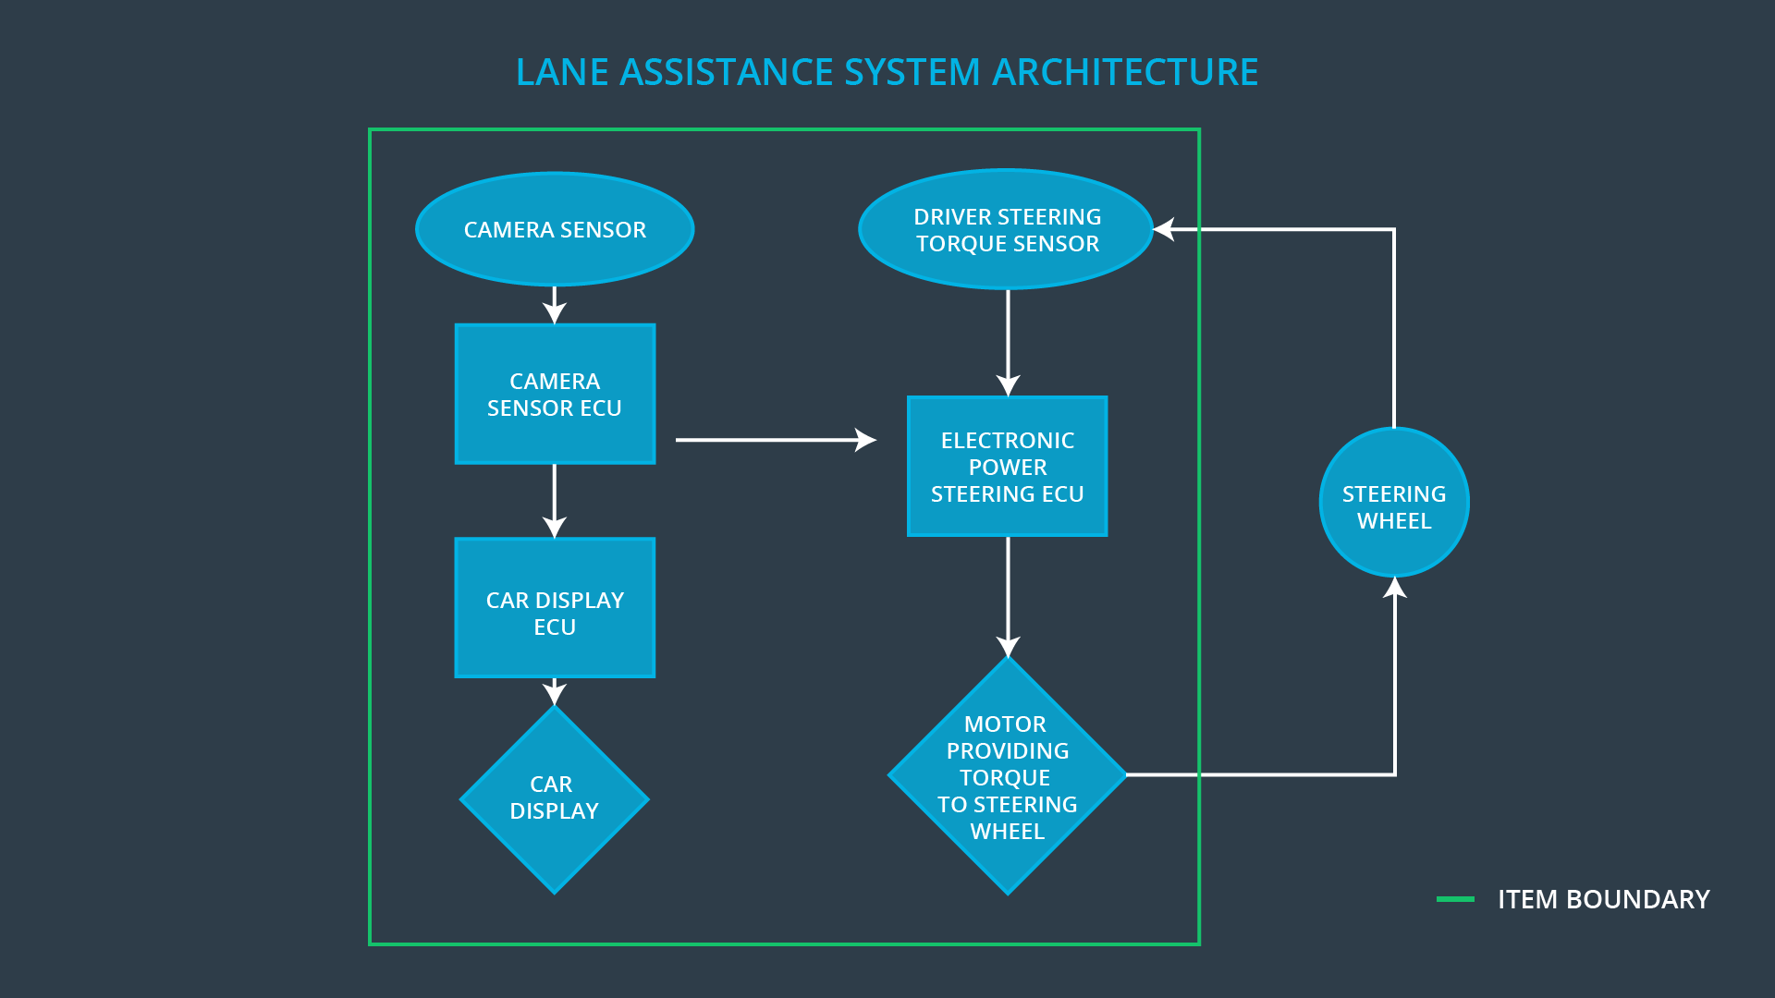

# Goals and Measures

## Goals

**[Instructions:**

**Describe the major goal of this project; what are we trying to accomplish by analyzing the lane assistance functions with ISO 26262?]**

The major goal of this project is to reduce risk identified for Lane Assistance system to acceptable levels by society and provide evidence that your project has made the vehicle safer.

## Measures

**[Instructions:**

**Fill in who will be responsible for each measure or activity. Hint: The lesson on Safety Management Roles and Responsibilities.**

**The options are:**

**All Team Members**

**Safety Manager**

**Project Manager**

**Safety Auditor**

**Safety Assessor**

**]**

|  |  |  |
| --- | --- | --- |
| Measures and Activities | Responsibility | Timeline |
| Follow safety processes | All Team Member | Constantly |
| Create and sustain a safety culture | All Team Member | Constantly |
| Coordinate and document the planned safety activities | Safety Manager | Constantly |
| Allocate resources with adequate functional safety competency | Project Manager | Within 2 weeks of start of project |
| Tailor the safety lifecycle | Safety Manager | Within 4 weeks of start of project |
| Plan the safety activities of the safety lifecycle | Safety Manager | Within 4 weeks of start of project |
| Perform regular functional safety audits | Safety Auditor | Once every 2 months |
| Perform functional safety pre-assessment prior to audit by external functional safety assessor | Safety Manager | 3 months prior to main assessment |
| Perform functional safety assessment | Safety Assessor | Conclusion of functional safety activities |

# Safety Culture

**[Instructions:**

**Describe the characteristics of your company's safety culture. How do these characteristics help maintain your safety culture. Hint: See the lesson about Safety Culture**

**]**

High priority: safety has the highest priority among competing constraints like cost and productivity

Accountability: processes ensure accountability such that design decisions are traceable back to the people and teams who made the decisions

Rewards: the organization motivates and supports the achievement of functional safety

Penalties: the organization penalizes shortcuts that jeopardize safety or quality

Independence: teams who design and develop a product should be independent from the teams who audit the work

Well defined processes: company design and management processes should be clearly defined

Resources: projects have necessary resources including people with appropriate skills

Diversity: intellectual diversity is sought after, valued and integrated into processes

Communication: communication channels encourage disclosure of problems

The most critical issues to make Lane Assistance system popular is gaining customer’s trust that LA is really improve safety and will not lead to any unexpected accidence.

This is same for autonomous driving technology development.

The only solution is to establish safety culture and bring up safety branding from beginning.

# Safety Lifecycle Tailoring

**[Instructions:**

**Describe which phases of the safety lifecycle are in scope and which are out of scope for this particular project. Hint: See the** **Intro section** **of this document**

**]**

According to Scope of Projects above, for the lane assistance project, the following safety lifecycle phases are in scope:

Concept phase

Product Development at the System Level

Product Development at the Software Level

The following phases are out of scope:

Product Development at the Hardware Level

Production and Operation

# Roles

**[Instructions:**

**This section is here for your reference. You do not need to do anything here. It is provided to help with filling out the development interface agreement section.**

**]**

|  |  |
| --- | --- |
| Role | Org |
| Functional Safety Manager- Item Level | OEM |
| Functional Safety Engineer- Item Level | OEM |
| Project Manager - Item Level | OEM |
| Functional Safety Manager- Component Level | Tier-1 |
| Functional Safety Engineer- Component Level | Tier-1 |
| Functional Safety Auditor | OEM or external |
| Functional Safety Assessor | OEM or external |

# Development Interface Agreement

**[Instructions:**

**Assume in this project that you work for the tier-1 organization as described in the above roles table. You are taking on the role of both the functional safety manager and functional safety engineer.**

**Please answer the following questions:**

1. **What is the purpose of a development interface agreement?**
2. **What will be the responsibilities of your company versus the responsibilities of the OEM? Hint: In this project, the OEM is supplying a functioning lane assistance system. Your company needs to analyze and modify the various sub-systems from a functional safety viewpoint.**

**]**

A DIA (development interface agreement) defines the roles and responsibilities between companies involved in developing a product, also specifies what evidence and work products each party will provide to prove that work was done according to the agreement.

The ultimate goal of DIA is to ensure that all parties are developing safe vehicles in compliance with ISO 26262.

The OEM’s responsibilities cover the lane assistance system while my company’s responsibilities only cover related Tie1 sub-systems. Our company will not responsible for whole lane assistance system and other sub-systems.

DIA defines the roles and responsibilities between OEM, Tie1 and Tie2 in order to avoid dispute and make easy to find who should fix safety issues if there are some safety issues.

# Confirmation Measures

**[Instructions:**

**Please answer the following questions:**

1. **What is the main purpose of confirmation measures?**
2. **What is a confirmation review?**
3. **What is a functional safety audit?**
4. **What is a functional safety assessment?**

**]**

Main purposes:

1. Process complies with safety standard, e.g. ISO 26262
2. Project follows the safety plan
3. Design really does improve safety

Confirmation Review Ensures an independent person would review the work to make sure ISO 26262 is being followed.

Functional safety audit makes sure that the actual implementation of the project conforms to the safety plan

Functional safety assessment confirms that plans, designs and developed products actually achieve functional safety

A safety plan could have other sections that we are not including here. For example, a safety plan would probably contain a complete project schedule.

There might also be a "Supporting Process Management" section that would cover "Part 8: Supporting Processes" of the ISO 26262 functional safety standard. This would include descriptions of how the company handles requirements management, change management, configuration management, documentation management, and software tool usage and confidence.

Similarly, a confirmation measures section would go into more detail about how each confirmation will be carried out.