1. 仿真电路图

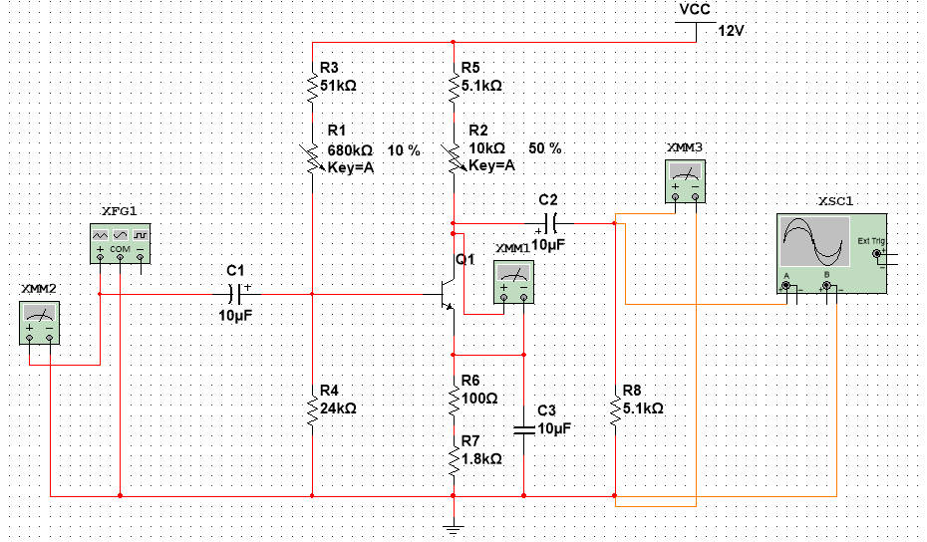

1. 静态工作点仿真结果

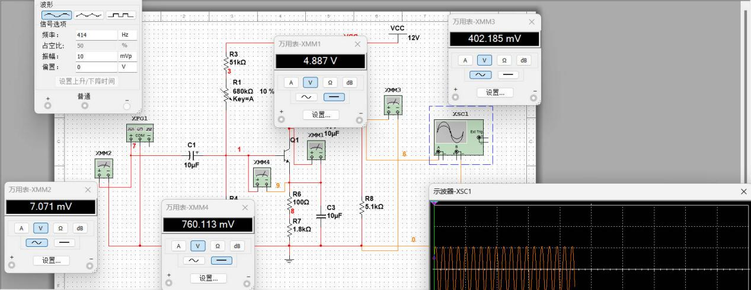

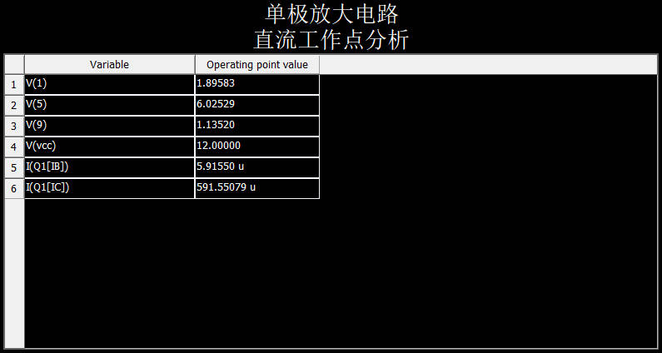

1. 电压放大倍数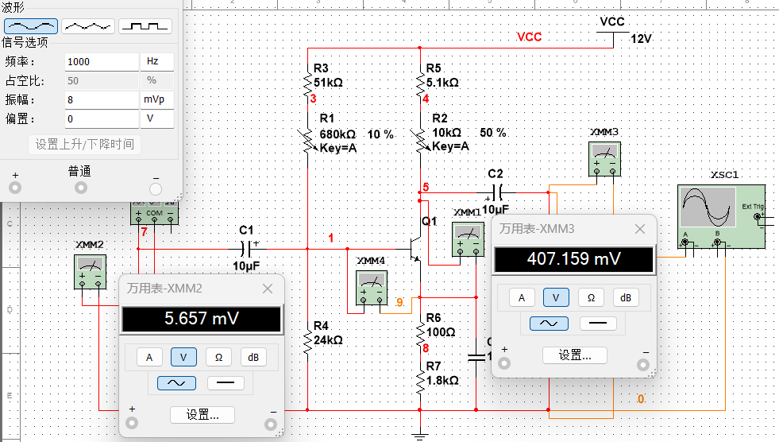

|  |  |  |
| --- | --- | --- |
| Ui | Uo | Au |
| 5.657m | 407.459m | 72.027 |
| 7.071m | 506.939m | 71.693 |
| 10.607m | 750.22m | 70.729 |
|  |  | 71.498 |

1. 输入输出电阻
   1. 输入电阻

|  |  |  |  |
| --- | --- | --- | --- |
| Ui | Us | Rs | Ri |
| 315.60m | 504.57m | 5.109k | 8.5326k |

* 1. 输出电阻

|  |  |  |  |
| --- | --- | --- | --- |
| Uo | Uol | Rl | Ro |
| 1.0063 | 363.97m | 5.0808 | 8.9665k |

1. 幅频特性曲线

