1. 实验电路

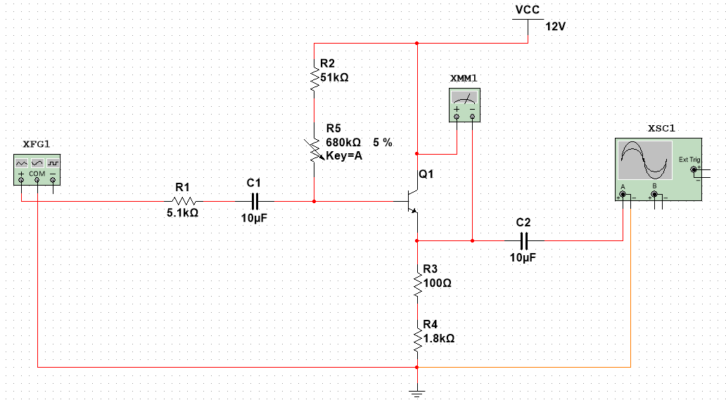

1. 直流工作点

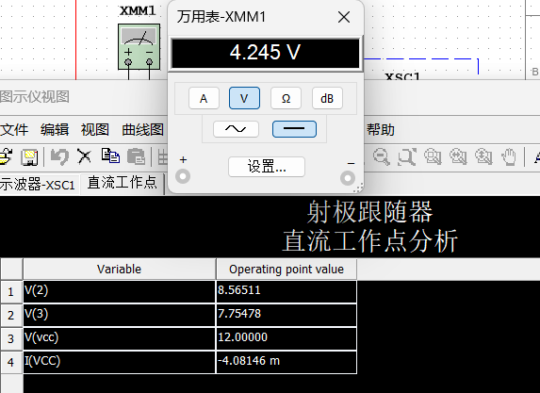

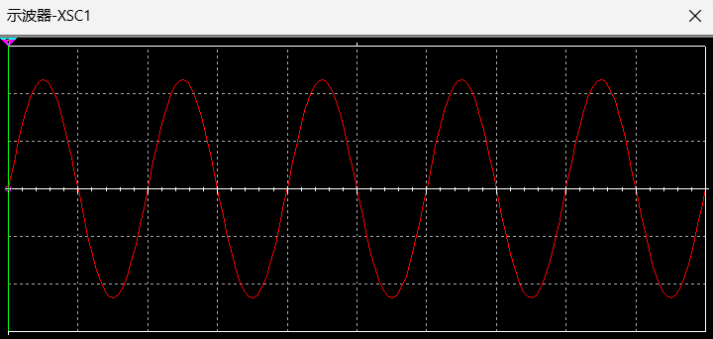

1. 电压放大倍数

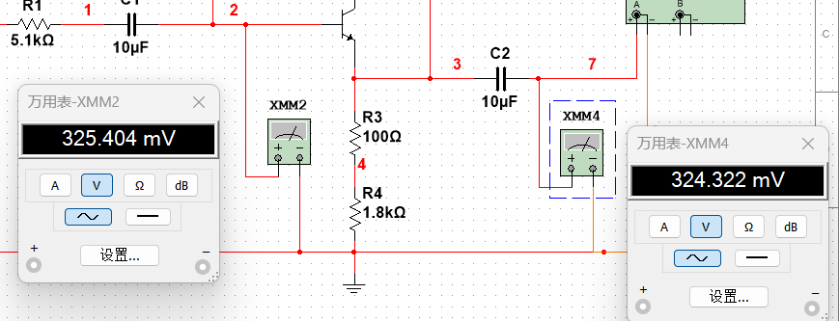

|  |  |  |
| --- | --- | --- |
| Ai | Uo | Au |
| 325.404 | 324.322 | 0.99667 |

1. 测量输出电阻

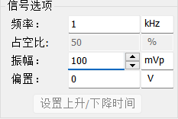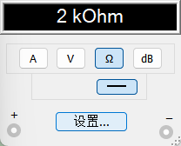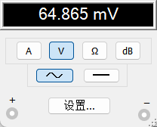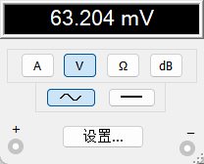

|  |  |  |  |
| --- | --- | --- | --- |
| Uo | Ul | Rl | Ro |
| 64.865m | 63.204m | 2000 | 52.55996 |

1. 测量放大器输入电阻

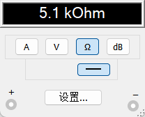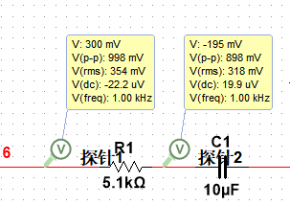

|  |  |  |  |
| --- | --- | --- | --- |
| Ua | Ub | R1 | Ri |
| 998m | 898m | 5.1k | 45.798k |

1. 测量射极跟随器的跟随特性并测量输出电压峰峰值

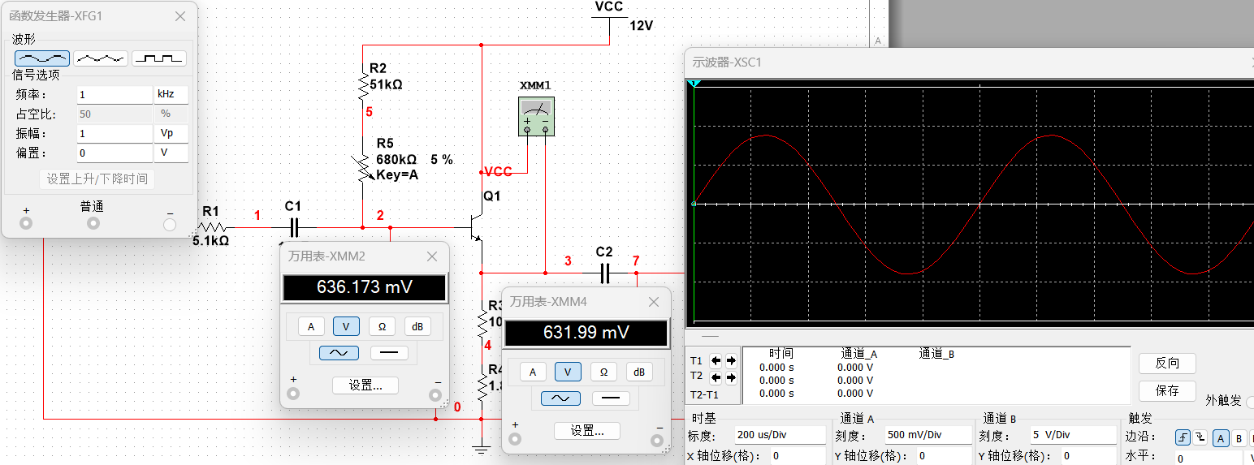

|  |  |  |  |
| --- | --- | --- | --- |
| Ui | Ul | Upp | Au |
| 636.173m | 631.99m | 0.89 | 0.993424745 |
| 1.272 | 1.264 | 1.785 | 0.993710692 |
| 1.909 | 1.894 | 2.675 | 0.992142483 |
| 2.545 | 2.522 | 3.555 | 0.990962672 |

1. 幅频特性曲线

