1. 调整静态工作点

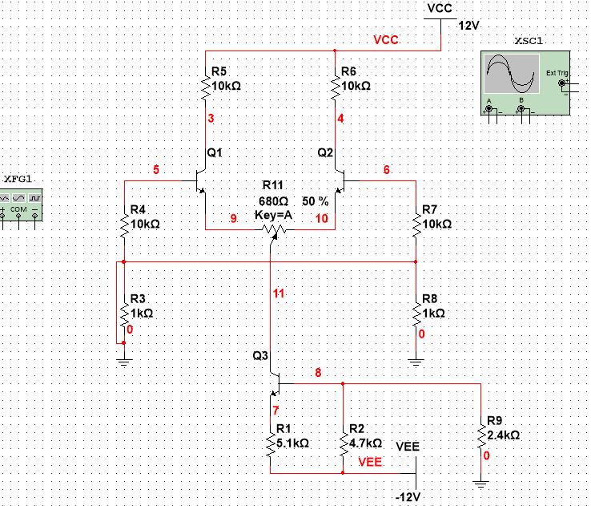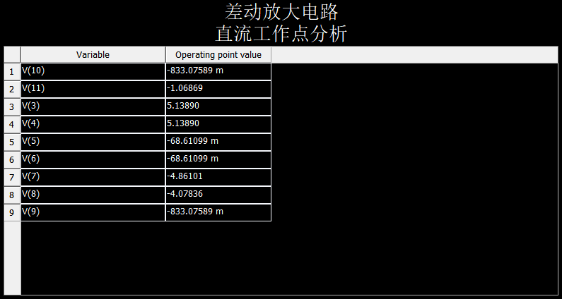

1. 测量差模放大倍数

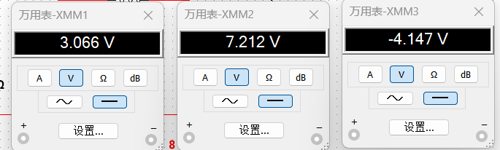

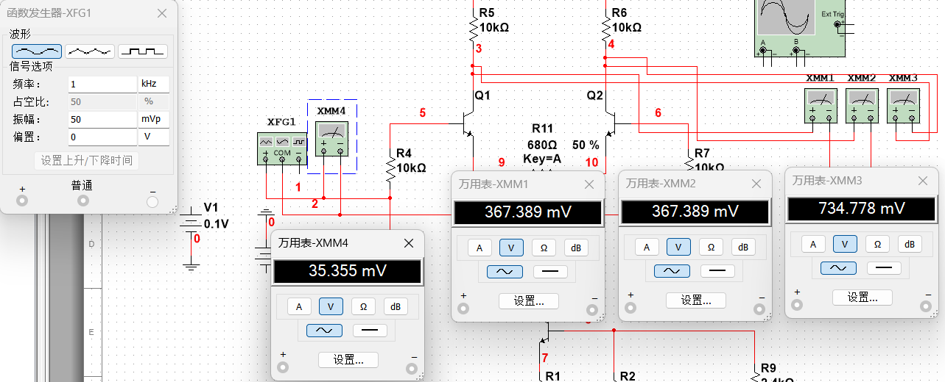

|  |  |  |  |  |  |  |
| --- | --- | --- | --- | --- | --- | --- |
| 输入信号 | Uc1 | Uc2 | Uo | Ad1 | Ad2 | Ad |
| +-0.1V | 3.066 | 7.212 | -4.147 | -10.3645 | 10.3655 | -20.735 |
| 正弦信号 | 367.389m | -367.389m | 734.778m | 10.3914 | -10.3914 | 20.78286 |

1. 测量共模放大倍数

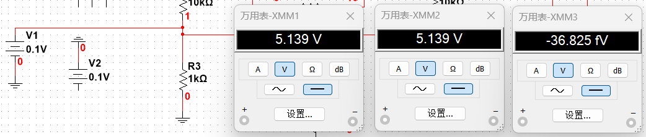

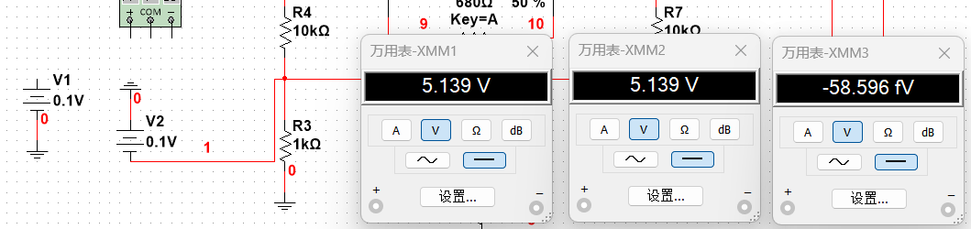

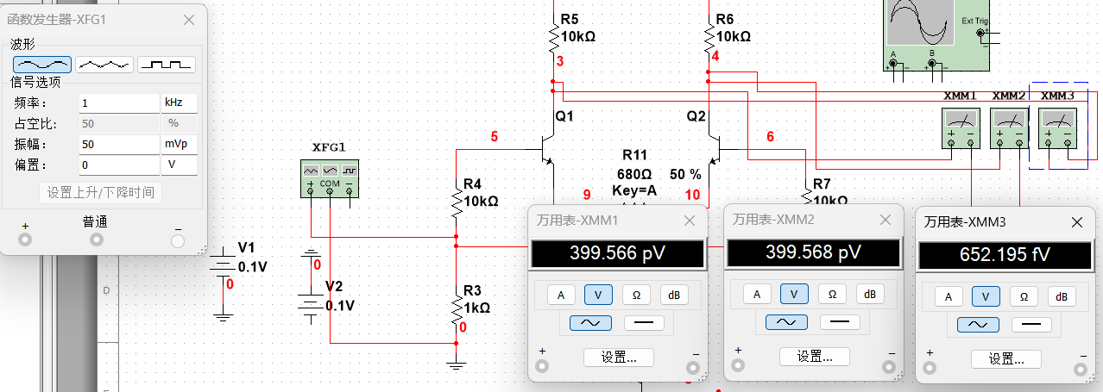

|  |  |  |  |  |  |  |
| --- | --- | --- | --- | --- | --- | --- |
| 输入信号 | Uc1 | Uc2 | Uo | Ad1 | Ad2 | Ad |
| +0.1V | 5.139 | 5.139 | -36.825f | 0.0005 | -0.0005 | -1.84125e-13 |
| -0.1V | 5.139 | 5.139 | -58.596f | 0.0005 | -0.0005 | -2.9298e-13 |
| 正弦信号 | 399.566p | 399.568p | 652.195f | 1.3015e-11 | 1.13016e-11 | 1.8447e-14 |

1. 共模抑制比

|  |  |
| --- | --- |
| 直流 | 交流 |
| 1.12614E+14 | 1.12663E+15 |