1. 实验电路图

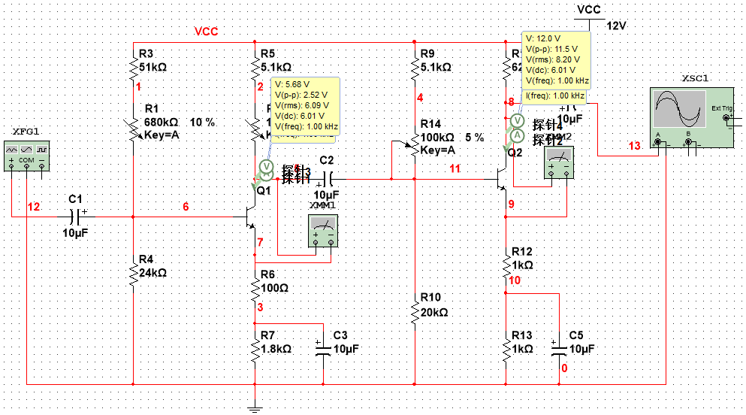

1. 静态工作点

|  |  |  |  |  |  |
| --- | --- | --- | --- | --- | --- |
| Ic1 | Uce1 | Uc1 | Ic2 | Uce2 | Uc2 |
| 0.886m | 4.876 | 6.581 | 1.01m | 4.941 | 6.675 |

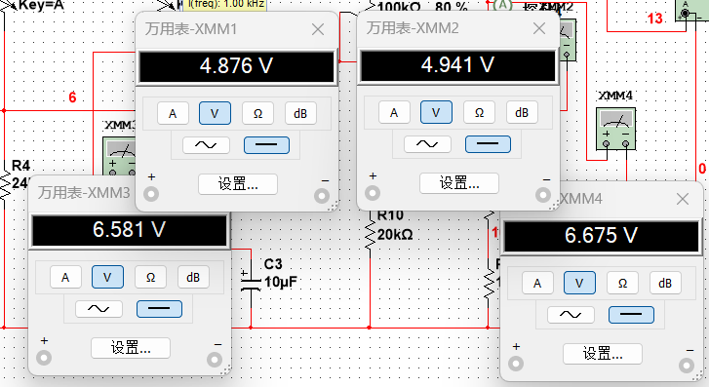

1. 电压放大倍数

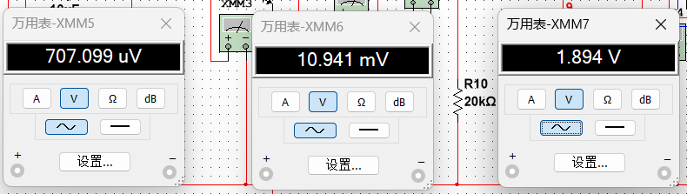

|  |  |  |  |  |  |  |
| --- | --- | --- | --- | --- | --- | --- |
|  | Ui | Uo1 | Uo2 | Au1 | Au2 | Au |
| 空载 | 0.707m | 10.941m | 1.984 | 15.47525 | 181.33626 | 2806.224 |

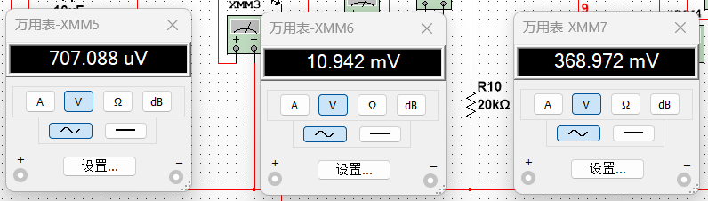

|  |  |  |  |  |  |  |
| --- | --- | --- | --- | --- | --- | --- |
|  | Ui | Uo1 | Uo2 | Au1 | Au2 | Au |
| 加载 | 0.707m | 10.942m | 368.972m | 15.4738 | 33.7207 | 521.7874 |

1. 幅频特性

