1. 实验电路图

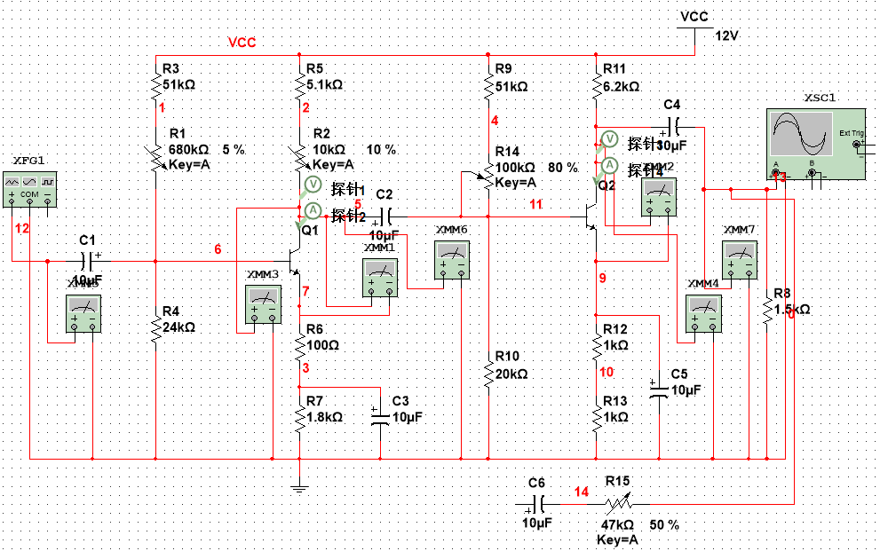

1. 静态工作点

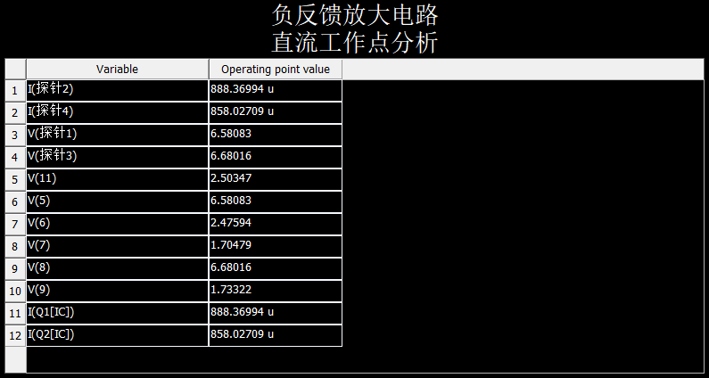

|  |  |  |  |
| --- | --- | --- | --- |
| Ic1 | Uce1 | Ic2 | Uce2 |
| 0.888m | 4.876 | 0.858m | 4.94 |

1. 开环及闭环放大倍数测试

|  |  |  |  |  |
| --- | --- | --- | --- | --- |
|  | Rl | Ui | Uo | Auf |
| 开环 | ∞ | 0.707m | 1.894 | 2678.925 |
| 1.5k | 0.707m | 368.952 | 521.8557 |
| 闭环 | ∞ | 0.707m | 16.595 | 23.4724 |
| 1.5k | 0.707m | 16.053 | 22.7058 |

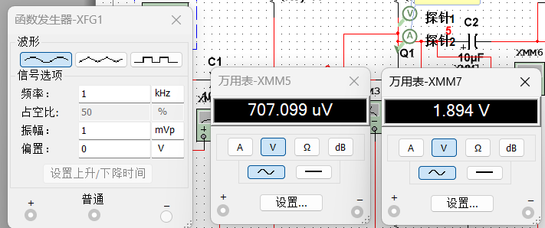

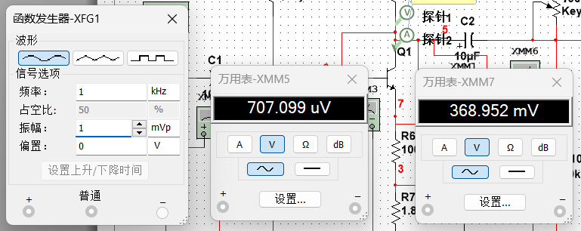

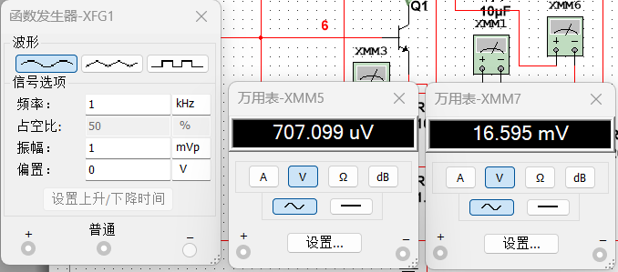

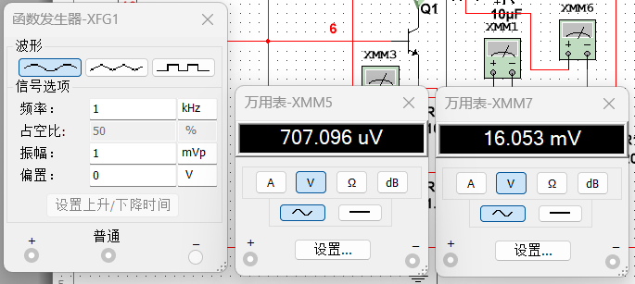

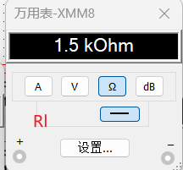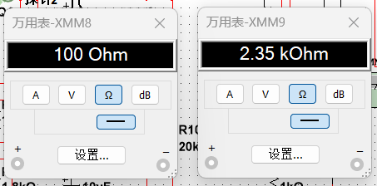

Ro=6.2001886424250308983282378195538k

Ro闭=50.64473930106522145393384414125

F=0.040816326530612244897959183673469

Auf=1/F=24.5

1. 观察负反馈电路对非线性失真的反馈

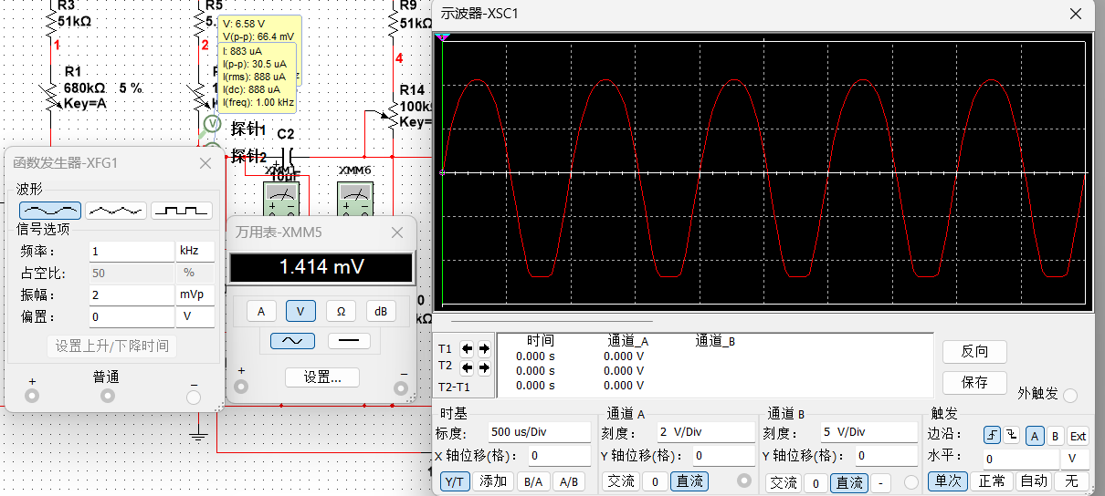

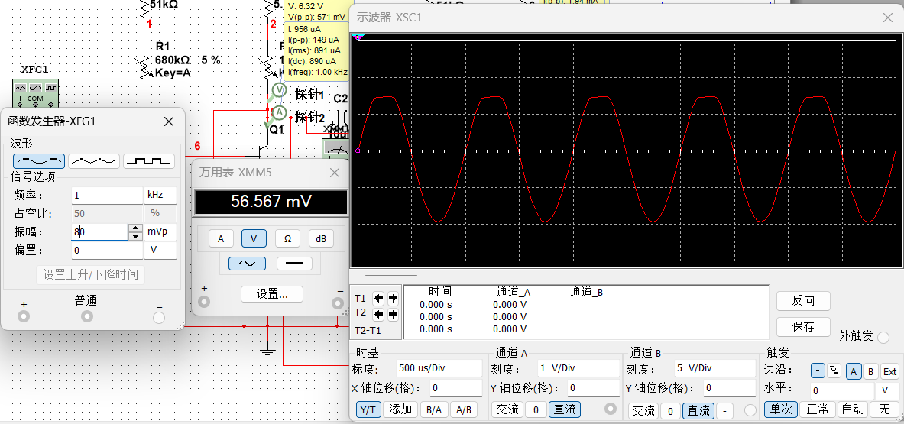

可以看到在达到接近开环时输出信号失真幅度时的输入电压远大于开环时说明付反馈可以改善电路的非线性失真。

1. 负反馈对输入输出电阻的影响

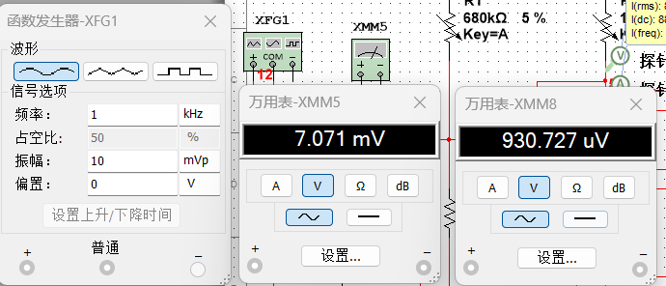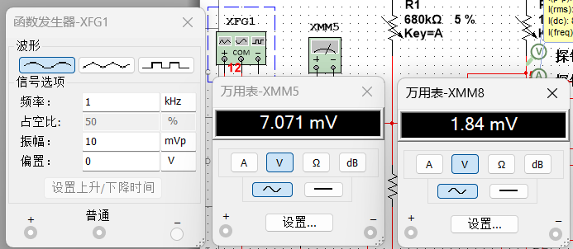

|  |  |  |  |
| --- | --- | --- | --- |
|  | Us | Ui | Ri |
| 开环 | 7.071m | 0.93m | 7.7235k |
| 闭环 | 7.071m | 1.84m | 17.939k |

1. 放大器的频率特性

