电压跟随器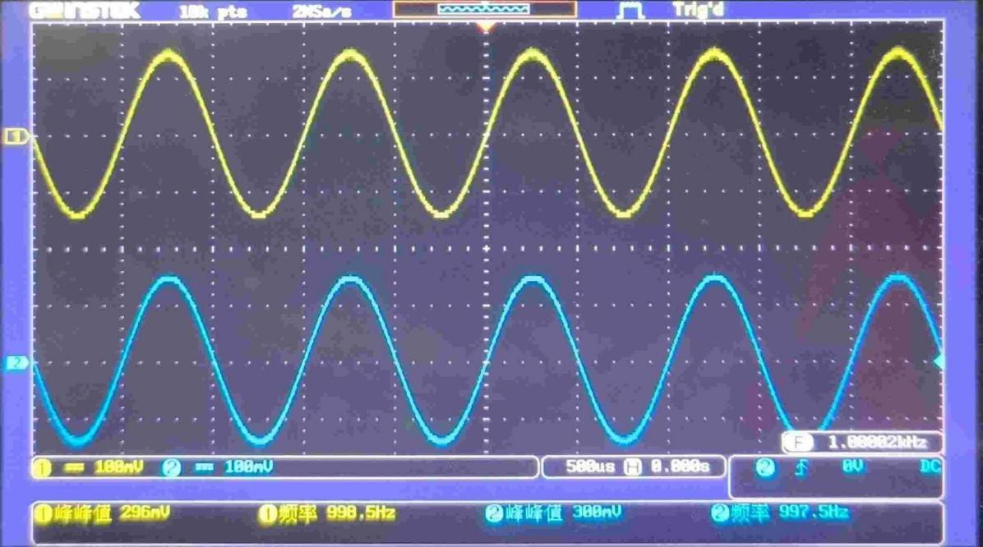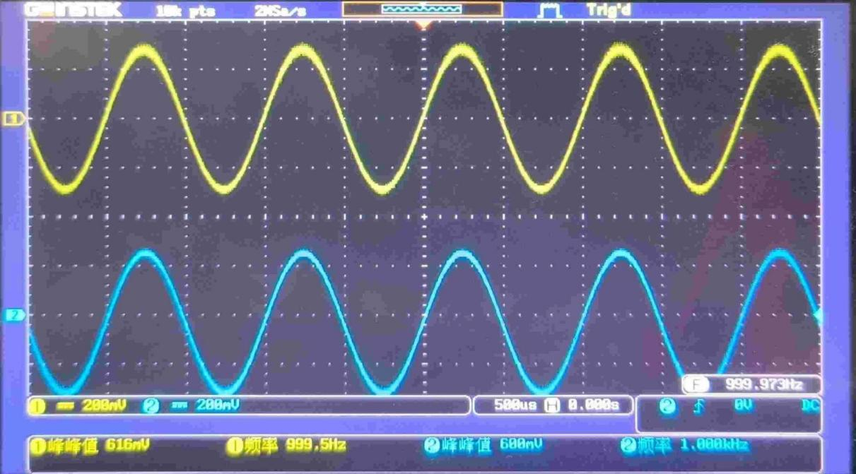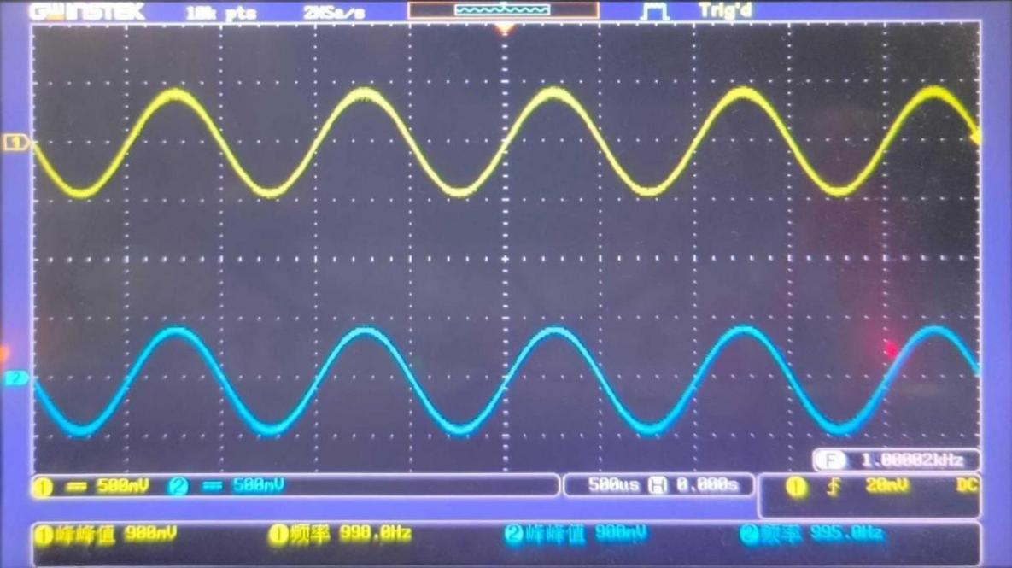

反相比例放大器

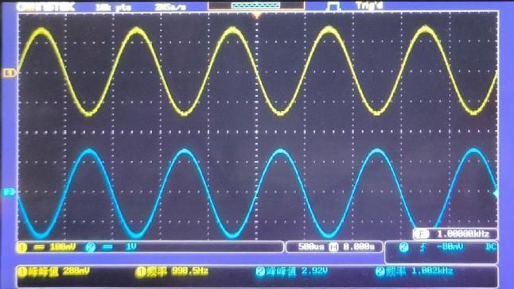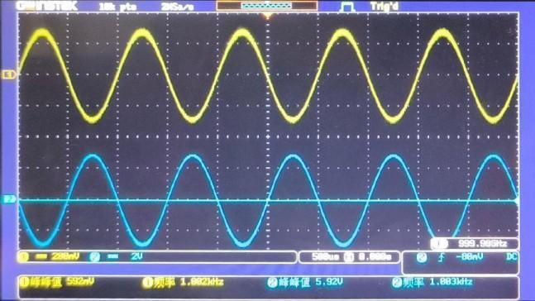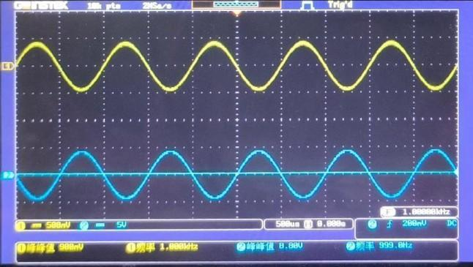

同相比例放大器

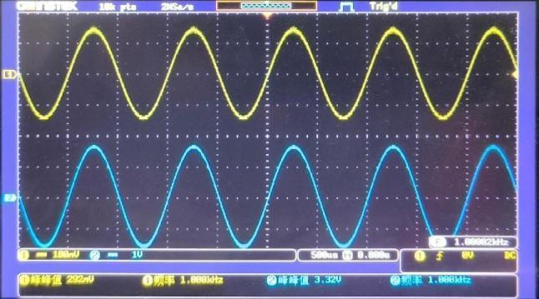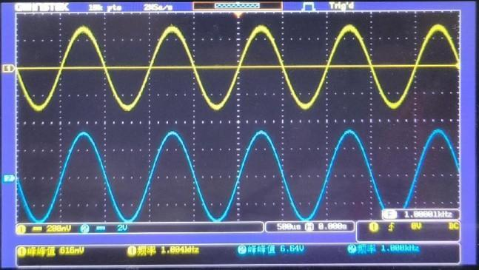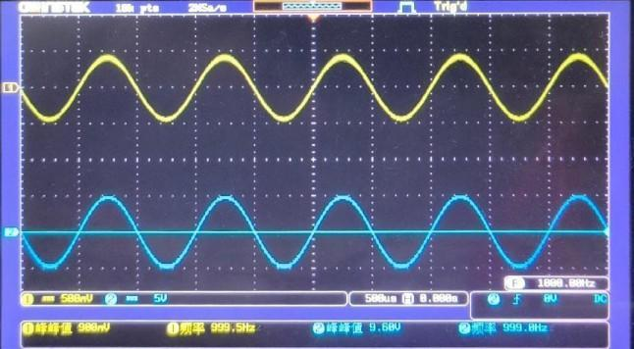

反相求和放大电路

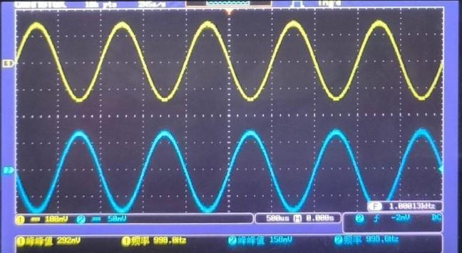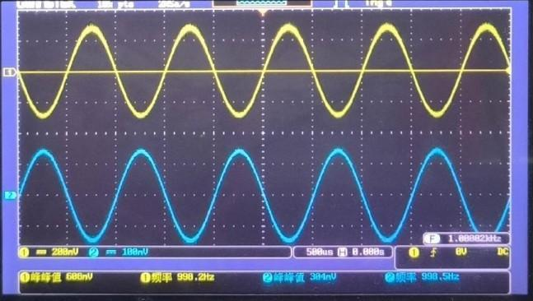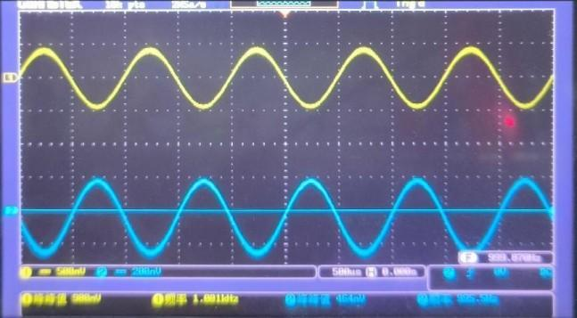

双端输入求和放大电路

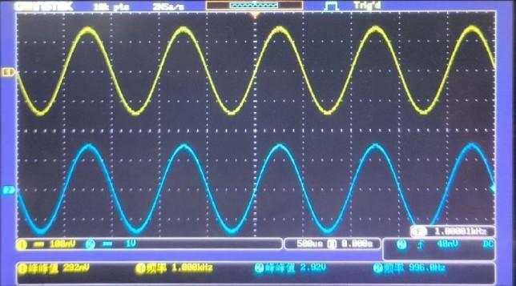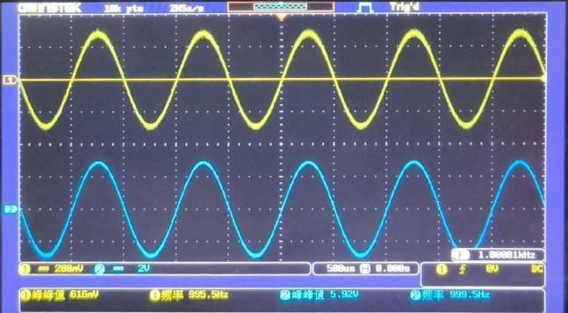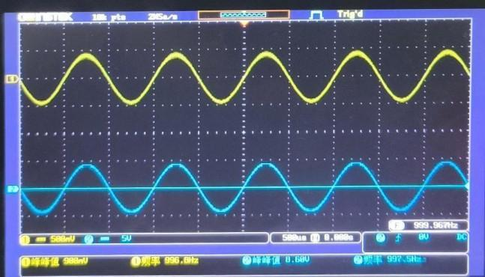

1. 电压跟随器

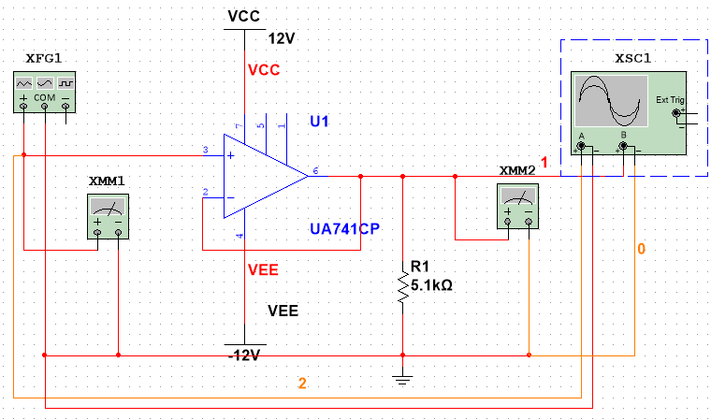

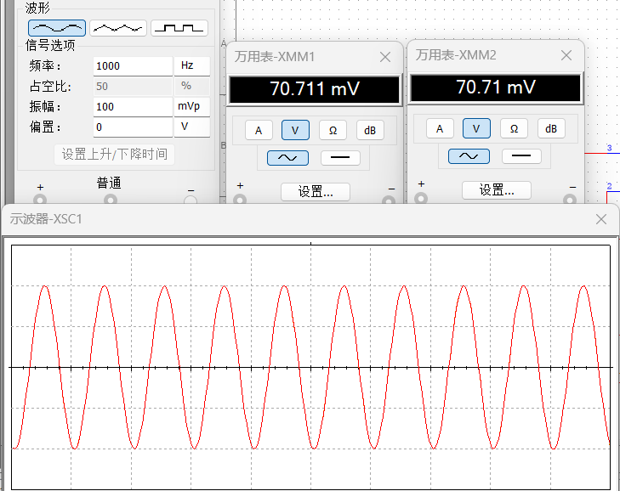

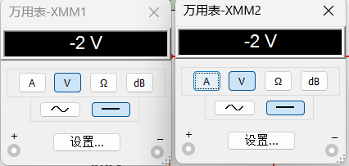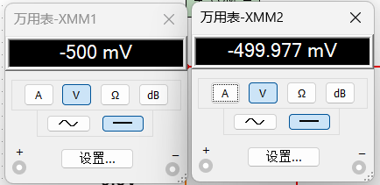

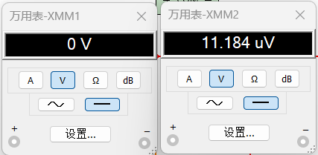

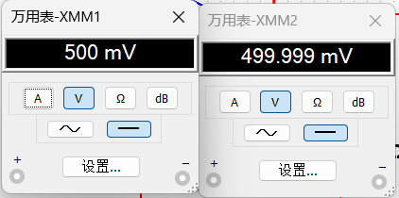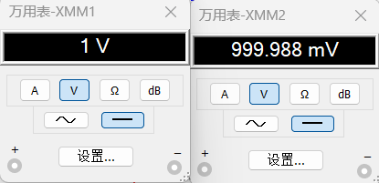

|  |  |  |  |  |  |
| --- | --- | --- | --- | --- | --- |
| Ui | -2 | -0.5 | 0 | 0.5 | 1 |
| Uo | -2 | -0.499977 | 11.184u | 0.499999 | 0.999988 |

1. 反相比例放大器

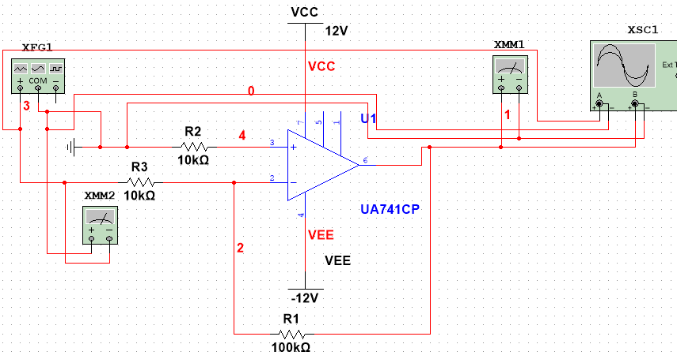

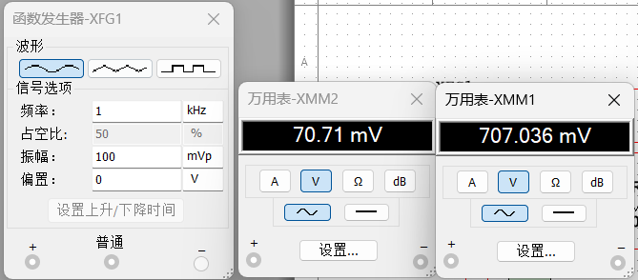

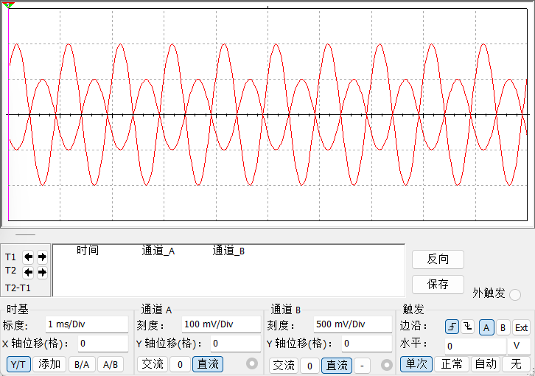

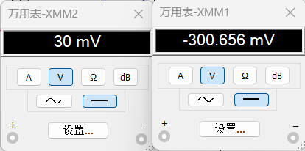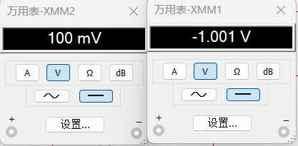

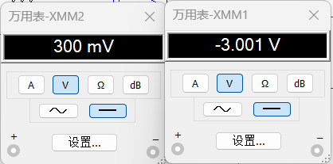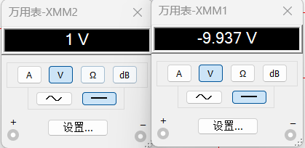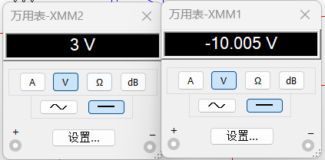

|  |  |  |  |  |  |
| --- | --- | --- | --- | --- | --- |
| Ui | 0.03 | 0.1 | 0.3 | 1 | 3 |
| 理论 | -0.3 | -1 | -3 | -10 | -30 |
| 实测 | -0.300656 | -1.001 | -3.001 | -9.937 | -10.005 |
| 误差 | -0.000656 | -0.001 | -0.001 | 0.063 | 19.995 |

1. 同相比例放大器

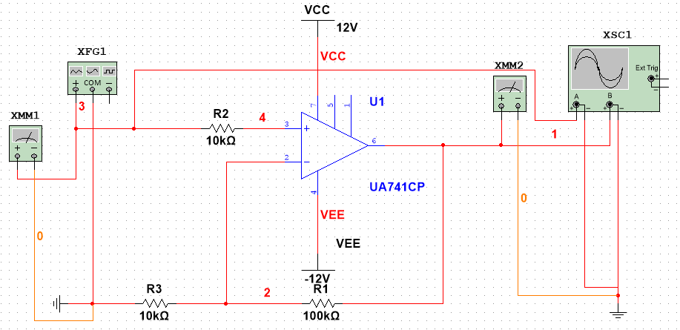

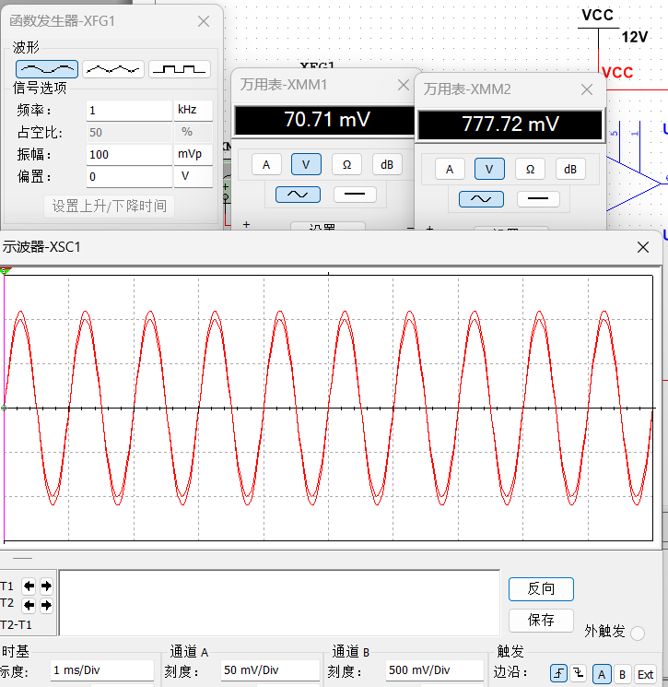

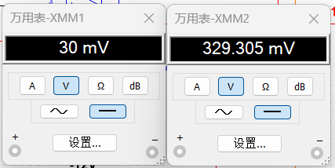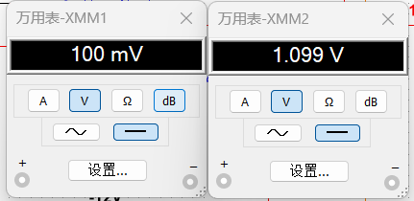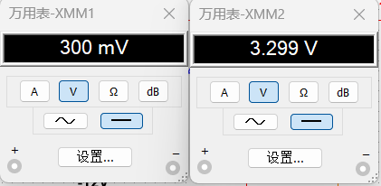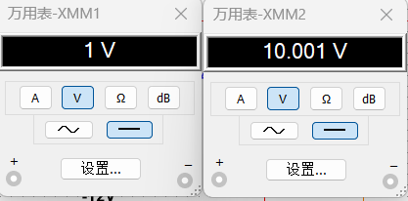

|  |  |  |  |  |
| --- | --- | --- | --- | --- |
| Ui | 0.03 | 0.1 | 0.3 | 1 |
| 理论 | 0.3 | 1 | 3 | 10 |
| 实际 | 0.329305 | 1.099 | 3.299 | 10.001 |
| 误差 | 0.029305 | 0.099 | 0.299 | 0.001 |

1. 反相求和放大电路

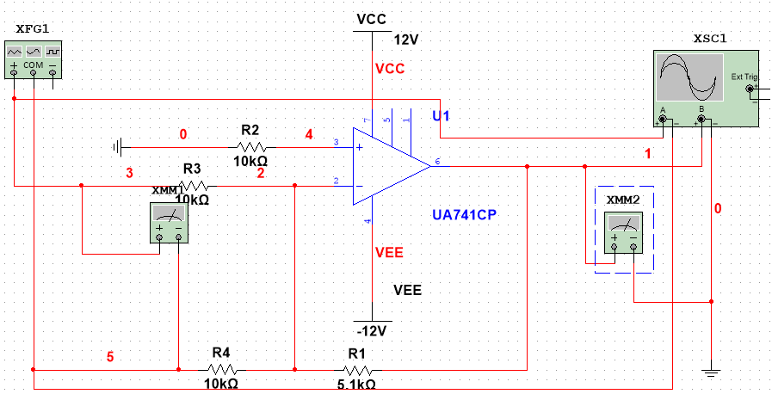

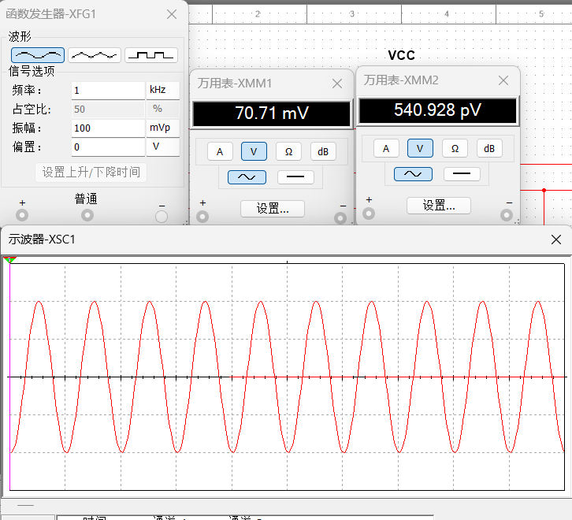

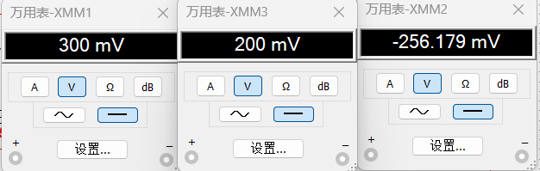

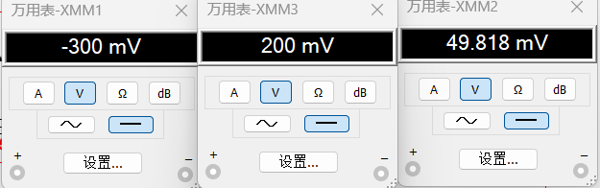

|  |  |  |
| --- | --- | --- |
| Ui1 | 0.3 | -0.3 |
| Ui2 | 0.2 | 0.2 |
| Uo | -0.256179 | 0.049818 |

1. 双端输入求和放大电路

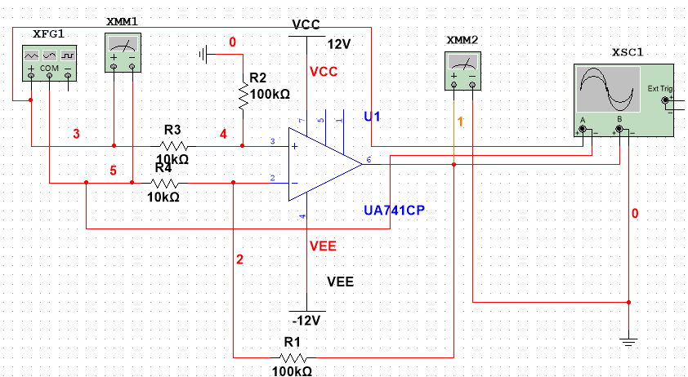

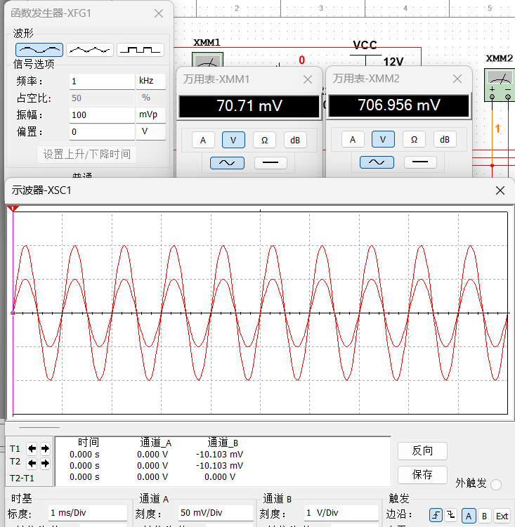

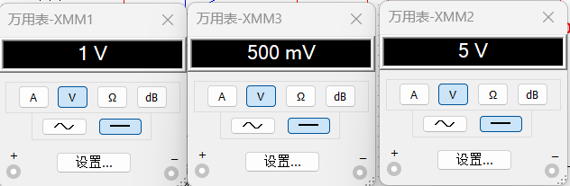

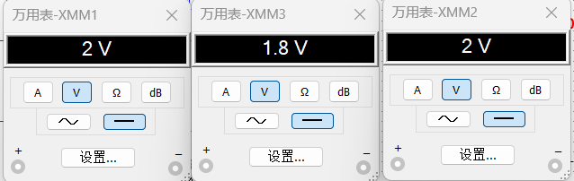

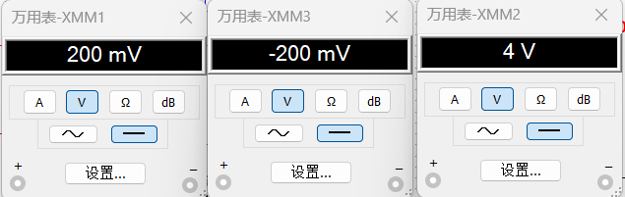

|  |  |  |  |
| --- | --- | --- | --- |
| Ui1 | 1 | 2 | 0.2 |
| Ui2 | 0.5 | 1.8 | -0.2 |
| Uo | 5 | 2 | 4 |