1. 方波发生电路

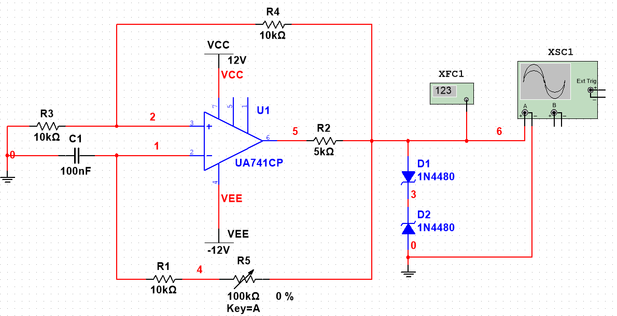

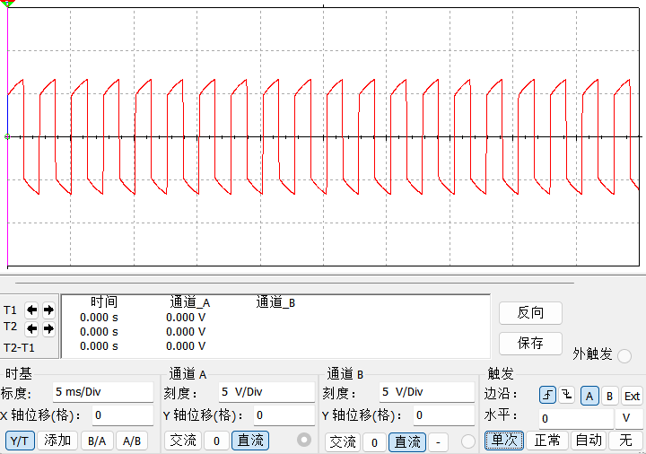

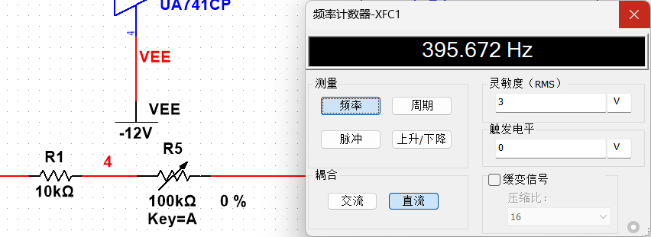

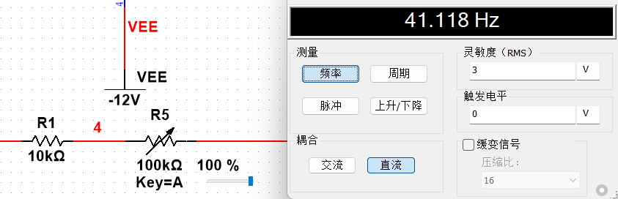

|  |  |  |
| --- | --- | --- |
| R=R1+Rp | 10k | 110k |
| F(Hz) | 395.672 | 41.118 |
| Vpp(V) | 13.3 | 15.7 |

1. 占空比可调的矩形波发生电路

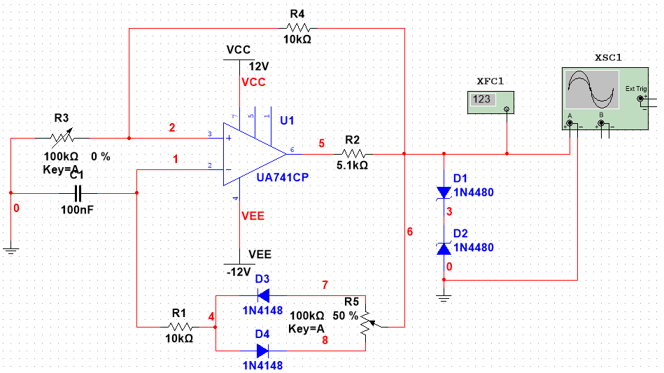

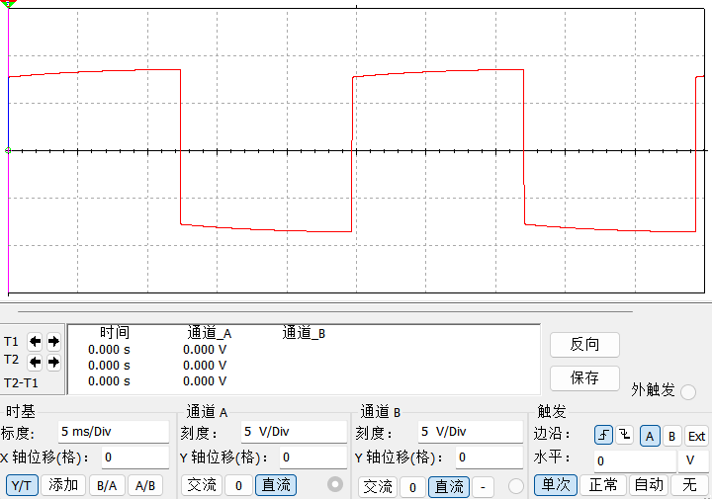

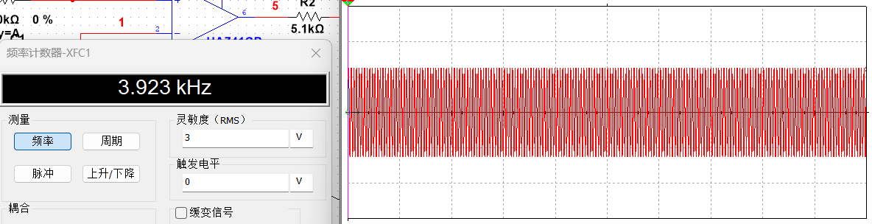

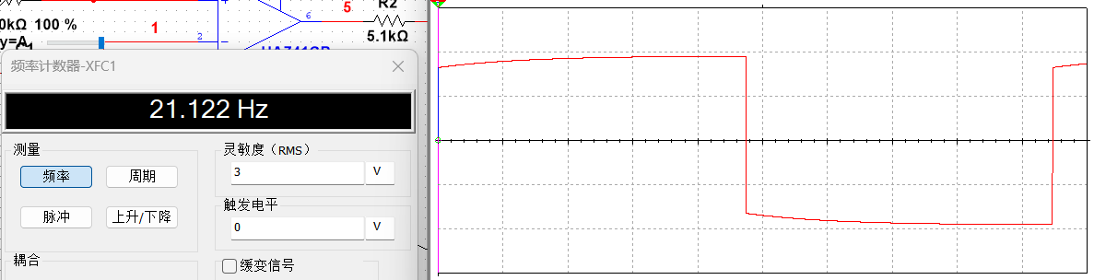

|  |  |  |
| --- | --- | --- |
| Rp | 0 | 100k |
| F(Hz) | 3.923k | 21.122 |
| Vpp(V) | 12.5 | 19.0 |

1. 三角波发生电路

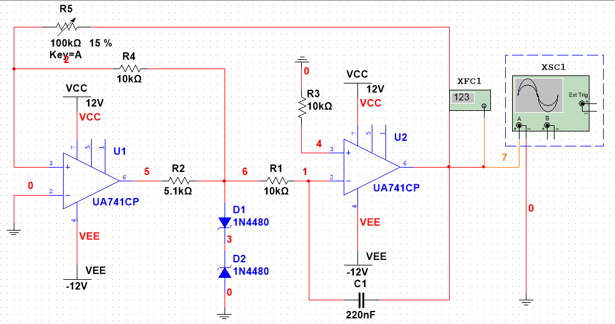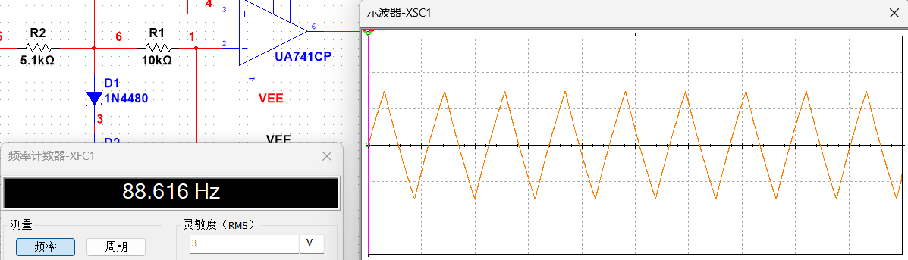

增大Rp2，输出波形幅度变大，频率降低，反之幅度变小，频率升高。

1. 锯齿波发生电路

