**实验八 有源滤波器**

**2015117208 电子信息类一班 杨思佳**

实验目的

1.熟悉有源滤波器构成与其特性



2.学会测量有源滤波器幅频特性

实验仪器



1. 模拟示波器
2. 信号发生器
3. 数字万用表
4. 交流信号源
5. 直流稳压电源

实验内容及步骤

1.低通滤波器

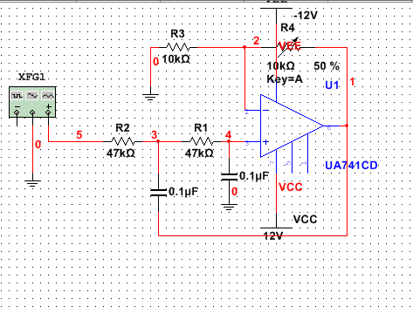

按图连接电路，接通电源，将信号发生器的输出接入实验电路的输入，并使其输出为1V的正弦信号，按表的要求改变输入信号的频率，用交流毫伏表测出输出电压值Vo并记录，从而测试出电路的幅频特性。在测量过程中，要保持输入电压1V不变。（输入电压为有效值1V）



|  |  |  |  |  |  |  |  |  |  |  |
| --- | --- | --- | --- | --- | --- | --- | --- | --- | --- | --- |
| Vi(V) | 1 | 1 | 1 | 1 | 1 | 1 | 1 | 1 | 1 | 1 |
| f(Hz) | 5 | 10 | 15 | 30 | 40 | 45 | 50 | 55 | 58 | 59 |
| Vo(V) | 1.41 | 1.53 | 1.59 | 1.92 | 2.31 | 2.52 | 2.64 | 2.58 | 2.43 | 2.35 |

|  |  |  |  |  |  |  |  |  |  |
| --- | --- | --- | --- | --- | --- | --- | --- | --- | --- |
| Vi(V) | 1 | 1 | 1 | 1 | 1 | 1 | 1 | 1 | 1 |
| f(Hz) | 60 | 63 | 65 | 68 | 70 | 75 | 78 | 79 | 80 |
| Vo(V) | 2.25 | 2.08 | 1.93 | 1.74 | 1.62 | 1.35 | 1.23 | 1.17 | 1.13 |

|  |  |  |  |  |  |  |
| --- | --- | --- | --- | --- | --- | --- |
| Vi(V) | 1 | 1 | 1 | 1 | 1 | 1 |
| f(Hz) | 85 | 100 | 150 | 200 | 300 | 400 |
| Vo(V) | 0.96 | 0.63 | 0.24 | 0.13 | 0.058 | 0.033 |

理论计算： $Au=1+\frac{Rf}{R10}=1.57$

截止频率为： $f0=\frac{1}{2πRC}=79.6Hz$



根据实验得，f0约为80Hz。

交流分析得幅频特性曲线为：

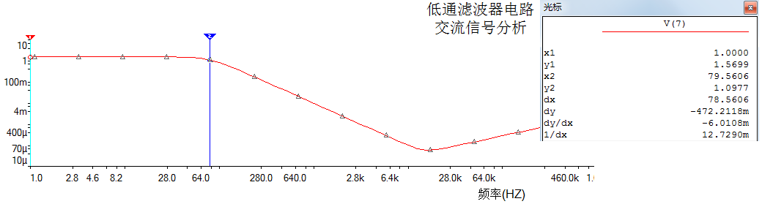

2.高通滤波器



实验电路如图：

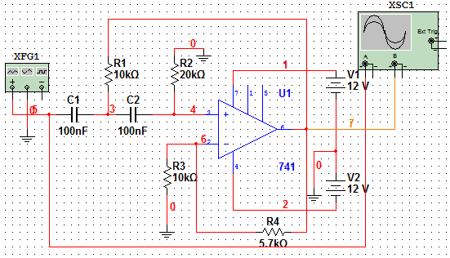



按照实验内容1的测量方法，按表测量高通滤波器的幅频特性。

|  |  |  |  |  |  |  |  |  |  |
| --- | --- | --- | --- | --- | --- | --- | --- | --- | --- |
| Vi(V) | 1 | 1 | 1 | 1 | 1 | 1 | 1 | 1 | 1 |
| f(Hz) | 100 | 120 | 130 | 135 | 140 | 150 | 155 | 158 | 159 |
| Vo(V) | 0.58 | 0.77 | 0.87 | 0.92 | 0.96 | 1.02 | 1.035 | 1.05 | 1.065 |

|  |  |  |  |  |  |  |  |  |  |  |
| --- | --- | --- | --- | --- | --- | --- | --- | --- | --- | --- |
| Vi(V) | 1 | 1 | 1 | 1 | 1 | 1 | 1 | 1 | 1 | 1 |
| f(Hz) | 160 | 165 | 170 | 180 | 500 | 1k | 10k | 20k | 30k | 40k |
| Vo(V) | 1.065 | 1.095 | 1.14 | 1.185 | 1.47 | 1.49 | 1.49 | 1.49 | 1.49 | 1.49 |

理论计算： $Au=1+\frac{Rf}{R10}=1.57$

截止频率为： $f0=\frac{1}{2πRC}=159.2Hz$



根据实验数据，截止频率约为165Hz。



交流分析得幅频特性曲线：



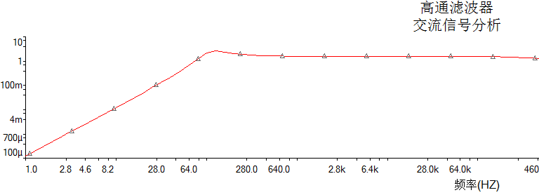



3.带阻滤波器



实验电路如图：



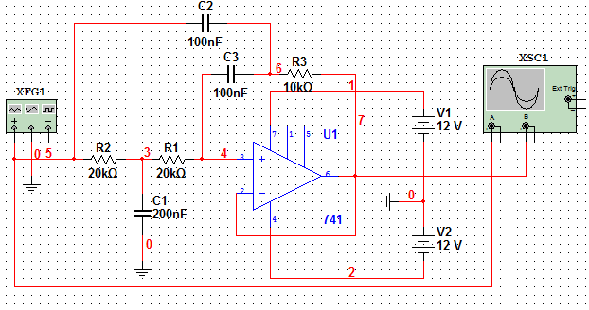



测量图中电路的中心频率

实验测得，中心频率约为60Hz左右。



以实测中心频率为中心，测出电路的幅频特性曲线。

|  |  |  |  |  |  |  |  |  |  |  |  |  |
| --- | --- | --- | --- | --- | --- | --- | --- | --- | --- | --- | --- | --- |
| Vi(V) | 1 | 1 | 1 | 1 | 1 | 1 | 1 | 1 | 1 | 1 | 1 | 1 |
| f(Hz) | 35 | 40 | 45 | 50 | 55 | 60 | 61 | 65 | 70 | 75 | 80 | 85 |
| Vo(V) | 0.58 | 0.45 | 0.36 | 0.24 | 0.18 | 0.125 | 0.12 | 0.13 | 0.18 | 0.22 | 0.26 | 0.32 |

交流分析得幅频特性曲线：

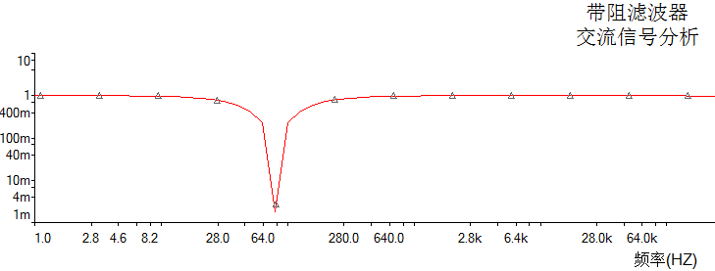

4.设计带通滤波器。中心频率为300Hz，带宽为200Hz。

设计过程：



$fbw=\left|3-Auf\right|*f0=\frac{f0}{Q}$ 得：Auf=7/3，Aup=3.5

取C1=C2=C，R1=R，R2=2R



$f0=\frac{1}{2πRC}$ 选取C=100nF，得R=5.3K，查手册可知，取R=5.1K。

$Auf=1+\frac{Rf}{R1}$ 可得，Rf=7KHz。

经计算得fL=217.2Hz，fH=415.2Hz。

根据上述计算的参数，连接电路得：



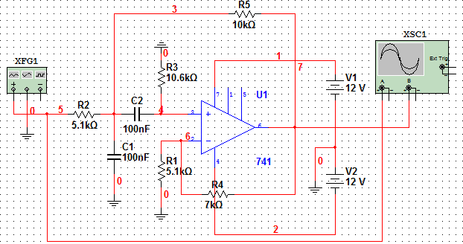

实验测得数据如下：

|  |  |  |  |  |  |  |  |  |  |  |  |
| --- | --- | --- | --- | --- | --- | --- | --- | --- | --- | --- | --- |
| Vi(V) | 1 | 1 | 1 | 1 | 1 | 1 | 1 | 1 | 1 | 1 | 1 |
| f(Hz) | 130 | 180 | 190 | 200 | 230 | 250 | 270 | 280 | 290 | 300 | 310 |
| Vo(V) | 1.235 | 1.56 | 1.6 | 1.635 | 1.695 | 1.739 | 1.749 | 1.74 | 1.74 | 1.734 | 1.71 |

|  |  |  |  |  |  |  |  |  |  |  |
| --- | --- | --- | --- | --- | --- | --- | --- | --- | --- | --- |
| Vi(V) | 1 | 1 | 1 | 1 | 1 | 1 | 1 | 1 | 1 | 1 |
| f(Hz) | 320 | 325 | 330 | 360 | 380 | 400 | 415 | 420 | 425 | 527 |
| Vo(V) | 1.695 | 1.68 | 1.675 | 1.64 | 1.575 | 1.515 | 1.5 | 1.49 | 1.47 | 1.23 |

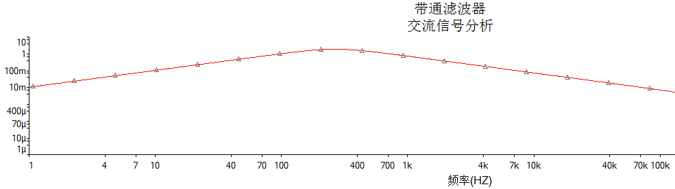

根据实验，中心频率约为300Hz，上下限截止频率有偏移，约为130Hz和500Hz。