《计算机视觉》实验报告

# 实验07：图像融合

|  |  |  |  |
| --- | --- | --- | --- |
| 姓名 | 庞晓宇 | 学号 | 2020118100 |
| 实验地点 | 信息学院310 | 实验日期 | 2023年10月20日 |

**一、实验内容**

【1】选两张合适的图片，自定义mask，通过简单代数运算融合图片，融合可在HSL等颜色空间进行。需选择合适的代数运算，使得融合效果较好。

【2】将实验【1】的图片通过拉普拉斯金字塔分解进行多分辨率融合。

【3】将实验【1】的图片通过泊松融合方法进行融合。

1. **实验过程以及结果分析**

图像融合 (Image Fusion) 是指综合多幅输入图像的信息，以获得更高质量输出图 像的过程与融合前的多幅图像相比，融合后的图像应更加适于进一步的观察或处理。作用主要包括：扩展图像在空间域或时间域的覆盖范围，减少信息冗余 和不确定性，压缩存储空间等。

本次实验运用了灰度融合、频域融合、蒙版融合、频域复数分解融合、直方图融合、金字塔融合、泊松融合、小波融合。

在实验中，我们选择了两张合适的图片，并自定义了一个mask。通过简单的代数运算，我们将这两张图片进行了融合。为了得到更好的融合效果，我们选择在HSL颜色空间进行融合。

本次实验选用下面的一些图片： 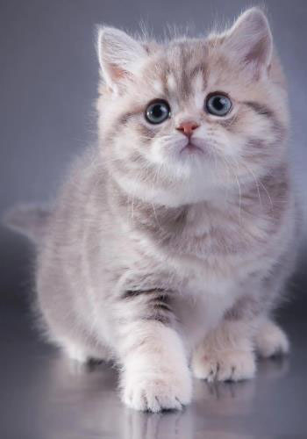 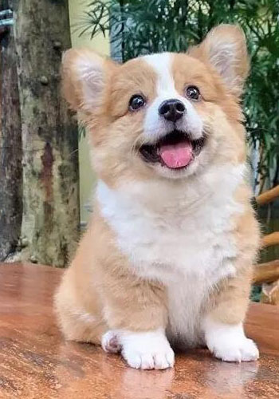

解决了若干报错后的工具函数包：

import matplotlib.pyplot as plt  
import numpy as np  
import cv2  
import pywt  
  
  
# 灰度融合  
def alphaBlend(x, y, A):  
 return A * x + (1 - A) * y  
  
  
def subtractBlend(x, y, A):  
 new = (1 + A) * x - A * y  
 return (new - new.min()) / (new.max() - new.min()) * 255  
  
  
def multiplyBlend(x, y, A):  
 new = x * (y + A * 255.0)  
 return (new - new.min()) / (new.max() - new.min()) * 255  
  
  
def multiplyBlend0(x, y, A):  
 new = (x * (y + A * 255.0)) ** 2  
 return (new - new.min()) / (new.max() - new.min()) * 255  
  
  
def divideBlend(x, y, A):  
 new = x / (y + A * 255 + 0.81)  
 return (new - new.min()) / (new.max() - new.min()) * 255  
  
  
def maxBlend(x, y, A):  
 new = np.amax([(1 - A / 2) * x, (0.25 + A / 2) * y], axis=0)  
 return (new - new.min()) / (new.max() - new.min()) * 255  
  
  
def minBlend(x, y, A):  
 new = np.amin([(1 - A / 2) * x, (0.25 + A / 2) * y], axis=0)  
 return (new - new.min()) / (new.max() - new.min()) * 255  
  
  
def multiplyBlend1(x, y, A):  
 new = (  
 x.astype(float)  
 * y.astype(float)  
 / (np.amax([(1 - A / 2) * x, (0.25 + A / 2) * y], axis=0) + 0.01)  
 )  
 return (new - new.min()) / (new.max() - new.min()) * 255  
  
  
def multiplyBlend2(x, y, A):  
 new = x * (255.0 - y + A * 255.0)  
 return (new - new.min()) / (new.max() - new.min()) * 255  
  
  
# 灰度变换  
# 线性变换  
def TwoSegment0(x, A, B, C):  
 xcp = x.copy()  
 xcp = np.where(x <= B, 127.0 * ((x - A) / (B - A + 0.0001)), xcp)  
 xcp = np.where(x > B, 127.0 + 128.0 * ((x - B) / (C - B + 0.0001)), xcp)  
 return np.clip(xcp, 0, 255)  
  
  
def FourSegment0(x, A, B, C):  
 # xcp = x.copy(x)  
 # TypeError: order must be str, not numpy.ndarray  
 xcp = x.copy()  
 xcp = np.where(x <= A, 0.0 + 63.0 * ((x - 0) / (A - 0 + 0.0001)), xcp)  
 xcp = np.where((x > A) & (x <= B), 63.0 + 64.0 * ((x - A) / (B - A + 0.0001)), xcp)  
 xcp = np.where((x > B) & (x <= C), 127.0 + 64.0 * ((x - B) / (C - B + 0.0001)), xcp)  
 xcp = np.where(x > C, 191.0 + 64.0 * ((x - C) / (255 - C + 0.0001)), xcp)  
 return np.clip(xcp, 0, 255)  
  
  
# 灰度融合RGB  
def cvBGRBlend0(imData1, imData2, saveName, f=multiplyBlend, channel="rgb"):  
 # 定义回调函数，比程序无需回调，所以Pass即可  
 def callback(object):  
 pass  
  
 MAX_VALUE = 100 # 滑动条最大值  
 MIN_VALUE = 0 # 滑动条最小值  
 # if f == TwoSegment0: a0, b0, c0 = [0, 127, 255]  
 # if f == FourSegment0: a0, b0, c0 = [63, 127, 191]  
 a0 = 0  
 cv2.namedWindow("cvAdjust", cv2.WINDOW_GUI_NORMAL)  
 # cv2.resizewindow("resized", imData1.shape[0], imData1.shape[1])  
 cv2.resizeWindow("cvAdjust", imData1.shape[1], imData1.shape[0])  
 imData2 = cv2.resize(imData2, (imData1.shape[1], imData1.shape[0]))  
 cv2.createTrackbar("a", "cvAdjust", MIN_VALUE, MAX_VALUE, callback)  
 # cv2.createTrackbar("b", "cvAdjust", MIN_VALUE, MAX_VALUE, callback)  
 # cv2.createTrackbar("c", "cvAdjust", MIN_VALUE, MAX_VALUE, callback)  
 cv2.setTrackbarPos("a", "cvAdjust", a0)  
 # cv2.setTrackbarPos("b", "cvAdjust", b0)  
 # cv2.setTrackbarPos("c", "cvAdjust", c0)  
 while True:  
 A = cv2.getTrackbarPos("a", "cvAdjust") / 100.0  
 # B = cv2.getTrackbarPos("b", "cvAdjust")  
 # C = cv2.getTrackbarPos("c", "cvAdjust")  
 b1, g1, r1 = cv2.split(imData1)  
 b2, g2, r2 = cv2.split(imData2)  
 if "b" in channel:  
 b = f(b1, b2, A)  
 if "g" in channel:  
 g = f(g1, g2, A)  
 if "r" in channel:  
 r = f(r1, r2, A)  
 imBGR = cv2.merge(np.uint8([b, g, r]))  
 cv2.imshow("cvAdjust", imBGR)  
 ch = cv2.waitKey(5) # 按EsC键s键退出  
 # if ch == 27 or ch == ord("s") or cv2.getwindowProperty("cvAdjust", 0) == -1:  
 # cv2.imwrite(saveName + "-Blended.jpg", imBGR) # 保存图片并退出  
 # break  
 if (  
 ch == 27  
 or ch == ord("s")  
 or cv2.getWindowProperty("cvAdjust", cv2.WND_PROP_VISIBLE) == 0  
 ):  
 cv2.imwrite(saveName + "-Blended.jpg", imBGR) # 保存图片并退出  
 break  
 cv2.destroyAllWindows() # 关闭所有的窗口  
  
  
# 灰度融合HSL  
def cvHLSBlend0(imData1, imData2, saveName, f=multiplyBlend, channel="ls"):  
 # 定义回调函数，比程序无需回调，所以Pass即可  
 def callback(object):  
 pass  
  
 MAX_VALUE = 100 # 滑动条最大值  
 MIN_VALUE = 0 # 滑动条最小值  
 # if f == TwoSegment0: a0, b0, c0 = [0, 127, 255]  
 # if f == FourSegment0: a0, b0, c0 = [63, 127, 191]  
 a0 = 0  
 cv2.namedWindow("cvAdjust", cv2.WINDOW_GUI_NORMAL)  
 # cv2.resizewindow("resized", imData1.shape[0], imData1.shape[1])  
 cv2.resizeWindow("cvAdjust", imData1.shape[1], imData1.shape[0])  
 imData2 = cv2.resize(imData2, (imData1.shape[1], imData1.shape[0]))  
 cv2.createTrackbar("a", "cvAdjust", MIN_VALUE, MAX_VALUE, callback)  
 # cv2.createTrackbar("b", "cvAdjust", MIN_VALUE, MAX_VALUE, callback)  
 # cv2.createTrackbar("c", "cvAdjust", MIN_VALUE, MAX_VALUE, callback)  
 cv2.setTrackbarPos("a", "cvAdjust", a0)  
 hls1 = cv2.cvtColor(imData1, cv2.COLOR_BGR2HLS)  
 hls2 = cv2.cvtColor(imData2, cv2.COLOR_BGR2HLS)  
 while True:  
 A = cv2.getTrackbarPos("a", "cvAdjust") / 100.0  
 # B = cv2.getTrackbarPos("b", "cvAdjust")  
 # C = cv2.getTrackbarPos("c", "cvAdjust")  
 b1, g1, r1 = cv2.split(hls1)  
 b2, g2, r2 = cv2.split(hls2)  
 if "h" in channel:  
 b = f(b1, b2, A)  
 b = np.mod(b, 180) # 色相  
 else:  
 b = b2  
 if "l" in channel:  
 g = f(g1, g2, A)  
 if "s" in channel:  
 r = f(r1, r2, A)  
 imBGR = cv2.cvtColor(cv2.merge(np.uint8([b, g, r])), cv2.COLOR_HLS2BGR)  
 # HLS2BGR  
 cv2.imshow("cvAdjust", imBGR)  
 ch = cv2.waitKey(5) # 按EsC键s键退出  
 # if ch == 27 or ch == ord("s") or cv2.getwindowProperty("cvAdjust", 0) == -1:  
 # cv2.imwrite(saveName + "-Blended.jpg", imBGR) # 保存图片并退出  
 # break  
 if (  
 ch == 27  
 or ch == ord("s")  
 or cv2.getWindowProperty("cvAdjust", cv2.WND_PROP_VISIBLE) == 0  
 ):  
 cv2.imwrite(saveName + "-Blended.jpg", imBGR) # 保存图片并退出  
 break  
 cv2.destroyAllWindows() # 关闭所有的窗口  
  
  
# 灰度融合Lab  
def cvLABBlend0(imData1, imData2, saveName, f=alphaBlend, channel="lab"):  
 # 定义回调函数，比程序无需回调，所以Pa5s即可  
 def callback(object):  
 pass  
  
 MAX_VALUE = 100 # 滑动条最大值  
 MIN_VALUE = 0 # 滑动条最小值  
 # if f == TwoSegment0: a0, b0, c0 = [0, 127, 255]  
 # if f == FourSegment0: a0, b0, c0 = [63, 127, 191]  
 a0 = 0  
 cv2.namedWindow("cvAdjust", cv2.WINDOW_GUI_NORMAL)  
 # cv2.resizewindow("resized",imData1.shape[0],imData1.shape[1])  
 cv2.resizeWindow("cvAdjust", imData1.shape[1], imData1.shape[0])  
 imData2 = cv2.resize(imData2, (imData1.shape[1], imData1.shape[0]))  
 cv2.createTrackbar("a", "cvAdjust", MIN_VALUE, MAX_VALUE, callback)  
 # cv2.createTrackbar("b", "cvAdjust", MIN_VALUE, MAX_VALUE, callback)  
 # cv2.createTrackbar("c", "cvAdjust", MIN_VALUE, MAX_VALUE, callback)  
 cv2.setTrackbarPos("a", "cvAdjust", a0)  
 hls1 = cv2.cvtColor(imData1, cv2.COLOR_BGR2LAB)  
 hls2 = cv2.cvtColor(imData2, cv2.COLOR_BGR2LAB)  
 while True:  
 A = cv2.getTrackbarPos("a", "cvAdjust") / 100.0  
 # B = cv2.getTrackbarPos("b", "cvAdjust")  
 # C = cv2.getTrackbarPos("c", "cvAdjust")  
 b1, g1, r1 = cv2.split(hls1)  
 b2, g2, r2 = cv2.split(hls2)  
 if "l" in channel:  
 b = f(b1, b2, A)  
 if "a" in channel:  
 g = f(g1, g2, A)  
 if "b" in channel:  
 r = f(r1, r2, A)  
 imBGR = cv2.cvtColor(  
 cv2.merge(np.uint8([b, g, r])), cv2.COLOR_LAB2BGR  
 ) # HLS2BGR  
 cv2.imshow("cvAdjust", imBGR)  
 ch = cv2.waitKey(5) # ESC 键s键退出  
 # if ch == 27 or ch == ord("s") or cv2.getwindowProperty("cvAdjust", 0) == -1:  
 # cv2.imwrite(saveName + -"-Blended.jpg", imBGR) # 保存图片并退出  
 # break  
 if (  
 ch == 27  
 or ch == ord("s")  
 or cv2.getWindowProperty("cvAdjust", cv2.WND_PROP_VISIBLE) == 0  
 ):  
 cv2.imwrite(saveName + "-Blended.jpg", imBGR) # 保存图片并退出  
 break  
 cv2.destroyAllWindows() # 关闭所有的窗口  
  
  
# 频域融合  
def spectrum_show(img, logarithm=True): # 定义一个用于计算频谱图并显示的函数  
 gray = np.expand_dims(img, axis=-1) if img.ndim == 2 else img  
 f_img = np.zeros(gray.shape)  
 for i in range(gray.shape[2]):  
 fimg = np.fft.fft2(gray[:, :, i]) # 快速傅里叶变换算法得到频率分布  
 fimg = np.fft.fftshift(fimg) # 将图像中的低频部分移动到图像的中心，默认是在左上角  
 fimg = np.abs(fimg) # fft结果是复数，其绝对值结果是振幅  
 # fimg np.angle(fshift) #相位  
 f_img[:, :, i] = fimg  
 if logarithm:  
 f_img = np.log(1 + f_img)  
 # 取对数的目的是使较小值也能显示  
 f_img = f_img / np.amax(f_img)  
 if img.ndim == 2:  
 new_img = np.squeeze(f_img, -1)  
 else:  
 img = img[:, :, [2, 1, 0]]  
 f_img = f_img[:, :, [2, 1, 0]]  
 # print(np.amax(f_img),np.amin(f_img))  
 # 展示结果  
 plt.subplot(121), plt.imshow(img, "gray"), plt.title("Original Image")  
 plt.axis("off")  
 plt.subplot(122), plt.imshow(f_img, "gray"), plt.title("Fourier Image")  
 plt.axis("off")  
 plt.show()  
  
  
# 频域融合  
def cal_distance(pa, pb): # 欧拉距离计算函数的定义  
 return np.sqrt((pa[0] - pb[0]) ** 2 + (pa[1] - pb[1]) ** 2)  
  
  
def IdealLowPass(dis, d, n): # 理想低通滤波n为无效参数  
 return np.where(dis > d, 0.0, 1.0)  
  
  
def ButterworthLowPass(dis, d, n): # 巴特沃斯低通滤波  
 return 1 / (1 + (dis / d) ** (2.0 * n))  
  
  
def GaussianLowPass(dis, d, n): # 高斯低通滤波  
 return np.exp(-(dis**2) / d**2 / 2)  
  
  
def IdealhighPass(dis, d, n): # 理想高通滤波n为无效参数  
 return np.where(dis < d, 0.0, 1.0)  
  
  
def ButterworthhighPass(dis, d, n): # 巴特沃斯高通滤波  
 return 1 / (1 + (d / dis) ** (2.0 * n))  
  
  
def GaussianhighPass(dis, d, n): # 高斯高通滤波  
 return 1 - np.exp(-(dis**2) / d**2 / 2)  
  
  
def GaussianhighPassEmphasize(dis, d, n): # 高斯高通高频强调  
 return 1 - np.exp(-(dis**2) / d**2 / 2) + 0.12  
  
  
def _spectralBlend(fftImg1, fftImg2, f, d, n):  
 nx, ny = fftImg1.shape[0], fftImg1.shape[1]  
 pos_matrix = np.mgrid[0:nx, 0:ny] # 位置  
 center_point = tuple(map(lambda x: (x - 1) / 2, fftImg1.shape)) # 中心点  
 dis = cal_distance(pos_matrix, center_point)  
 passVal = f(dis, d, n)  
 # spectrum_show(passval)  
 return fftImg1 * passVal + (1 - passVal) * fftImg2  
  
  
def spectralBlend(img1, img2, f=GaussianLowPass, d=25, n=5):  
 # img=cv2.cvtColor(img,cv2.COLOR BGR2GRAY)  
 gray1 = np.expand_dims(img1, axis=-1) if img1.ndim == 2 else img1  
 gray2 = np.expand_dims(img1, axis=-1) if img2.ndim == 2 else img2  
 new_img = np.zeros(gray1.shape)  
 for i in range(gray1.shape[2]):  
 fImg1 = np.fft.fft2(gray1[:, :, i]) # 快速傅里叶变换算法得到频率分布  
 fImg1 = np.fft.fftshift(fImg1) # 将图像中的低频部分移动到图像的中心，默认是在左上角  
 fImg2 = np.fft.fft2(gray2[:, :, i]) # 快速傅里叶变换算法得到频率分布  
 fImg2 = np.fft.fftshift(fImg2) # 将图像中的低频部分移动到图像的中心，默认是在左上角  
 fImg = _spectralBlend(fImg1, fImg2, f, d, n)  
 new_img[:, :, i] = np.abs(np.fft.ifft2(np.fft.ifftshift(fImg))) # 生成新图  
 new_img = np.uint8(new_img / np.amax(new_img) * 255)  
 if img1.ndim == 2:  
 new_img = np.squeeze(new_img, -1)  
 spectrum_show(new_img)  
 return new_img  
  
  
# 蒙版融合  
def getMaskByf(img, d, n, f=GaussianLowPass):  
 nx, ny = img.shape[0], img.shape[1]  
 pos_matrix = np.mgrid[0:nx, 0:ny]  
 # 位置  
 center_point = tuple(map(lambda x: (x - 1) / 2, img.shape)) #  
 center_point = (center_point[0] - 120, center_point[1] + 45)  
 dis = cal_distance(pos_matrix, center_point + (30, -120))  
 # passVal= f(dis,d,n)  
 mask = f(dis, d, n)  
 return mask  
  
  
def getMaskBy0(img):  
 nx, ny = img.shape[0], img.shape[1]  
 mask = np.zeros((nx, ny))  
 mask[0::2, 1::2] = 1  
 mask[1::2, 0::2] = 1  
 return mask  
  
  
def maskBlend(img1, img2, mask=None, f=alphaBlend):  
 gray1 = np.expand_dims(img1, axis=-1) if img1.ndim == 2 else img1  
 gray2 = np.expand_dims(img2, axis=-1) if img2.ndim == 2 else img2  
 new_img = np.zeros(gray1.shape)  
 mask = getMaskByf(new_img, 120, 15)  
 mask = getMaskBy0(new_img)  
 spectrum_show(mask)  
 for i in range(gray1.shape[2]):  
 new_img[:, :, i] = f(gray1[:, :, i], gray2[:, :, i], mask) # 生成新图  
 new_img = np.uint8(new_img / np.amax(new_img) * 255)  
 if img1.ndim == 2:  
 new_img = np.squeeze(new_img, -1)  
 spectrum_show(new_img)  
 return new_img  
  
  
# 频域复数分解融合  
def _complexBlend(fftImg1, fftImg2):  
 fftImg = fftImg1.real + 1j * fftImg2.imag  
 absv = -np.abs(fftImg1) # -np.abs(fftImg2)*1.5  
 angle = np.angle(fftImg2) # +np.angle(fftImg2)  
 fftImg = absv * np.exp(1.0j * angle)  
 # rows, cols = fftImg1.shape[0], fftImg1.shape[1]  
 # fftImg = np.hstack((fftImg1[:, cols // 2], fftImg2[:, cols // 2 :]))  
 return fftImg  
  
  
def complexBlend(img1, img2):  
 gray1 = np.expand_dims(img1, axis=-1) if img1.ndim == 2 else img1  
 gray2 = np.expand_dims(img2, axis=-1) if img2.ndim == 2 else img2  
 new_img = np.zeros(gray1.shape)  
 for i in range(gray1.shape[2]):  
 fImg1 = np.fft.fft2(gray1[:, :, i]) # 快速傅里叶变换算法得到频率分布  
 fImg1 = np.fft.fftshift(fImg1) # 将图像中的低频部分移动到图像的中心，默认是在左上角  
 fImg2 = np.fft.fft2(gray2[:, :, i]) # 快速傅里叶变换算法得到频率分布  
 fImg2 = np.fft.fftshift(fImg2) # 将图像中的低频部分移动到图像的中心，默认是在左上角  
 fImg = _complexBlend(fImg1, fImg2)  
 new_img[::, i] = np.abs(np.fft.ifft2(np.fft.ifftshift(fImg))) #  
 new_img = np.uint8(new_img / np.amax(new_img) * 255)  
 if img1.ndim == 2:  
 new_img = np.squeeze(new_img, -1)  
 spectrum_show(new_img)  
 return new_img  
  
  
# 直方图融合  
def histBlend(img1, img2):  
 gray1 = np.expand_dims(img1, axis=-1) if img1.ndim == 2 else img1  
 gray2 = np.expand_dims(img2, axis=-1) if img2.ndim == 2 else img2  
 new = np.zeros(gray1.shape)  
 for i in range(gray1.shape[2]):  
 mean1 = np.mean(gray1[:, :, i])  
 std1 = np.std(gray1[:, :, i])  
 mean2 = np.mean(gray2[:, :, i])  
 std2 = np.std(gray2[:, :, i])  
 new[:, :, i](gray1[:, :, i] - mean1) * (std2 / std1) ** 1.0 + mean2  
 # new_img = np.uint8(((new - new.min()) / (new.max() - new.min())) * 255)  
 # print(np.amax(new), np.amin(new))  
 new_img = np.uint8(np.clip(new, 0, 255))  
 if img1.ndim == 2:  
 new_img = np.squeeze(new_img, -1)  
 spectrum_show(new_img)  
 return new_img  
  
  
def histBlend_HLS(img1, img2):  
 gray1 = np.expand_dims(img1, axis=-1) if img1.ndim == 2 else img1  
 gray2 = np.expand_dims(img2, axis=-1) if img2.ndim == 2 else img2  
 new = np.zeros(gray1.shape)  
 gray1 = cv2.cvtColor(img1, cv2.COLOR_BGR2HLS)  
 gray2 = cv2.cvtColor(img2, cv2.COLOR_BGR2HLS)  
 new[:, i, 0] = gray1[:, :, 8]  
 for i in [1, 2]:  
 mean1 = np.mean(gray1[:, :, i])  
 std1 = np.std(gray1[:, :, i])  
 mean2 = np.mean(gray2[:, :, i])  
 std2 = np.std(gray2[:, :, i])  
 new[:, :, i](gray1[:, :, i] - mean1) * (std2 / std1) ** 1.0 + mean2  
 # new_img = np.uint8(((new - new.min()) / (new.max() - new.min())) * 255)  
 # print(np.amax(new), np.amin(new))  
 new_img = np.uint8(np.clip(new, 0, 255))  
 new_img = cv2.cvtColor(new_img, cv2.COLOR_HLS2BGR)  
 if img1.ndim == 2:  
 new_img = np.squeeze(new_img, -1)  
 spectrum_show(new_img)  
 return new_img  
  
  
# 金字塔融合  
def cv_show(image, message="crane"):  
 cv2.imshow(message, image)  
 cv2.waitKey(0)  
 cv2.destroyAllWindows()  
  
  
ksize = 7  
sigma = 0.15 * ksize + 0.35  
# print(sigma)  
  
  
def build_gaussi_pyramid(high_res, layers):  
 this_flash = [high_res]  
 for i in range(1, layers):  
 # 先对当前权重做高斯模糊，然后下采样3*sigma+1  
 blurred = cv2.GaussianBlur(this_flash[i - 1], (ksize, ksize), sigma)  
 blurred = blurred[::2, ::2]  
 this_flash.append(blurred)  
 return this_flash  
  
  
# generated code  
def build_laplacian_pyramaid(gaussi_pyramid, layers):  
 laplacian_pyramid = []  
 for i in range(layers - 1):  
 # 当前层减去上一层上采样的结果  
 size = (gaussi_pyramid[i].shape[1], gaussi_pyramid[i].shape[0])  
 upsampled = cv2.resize(gaussi_pyramid[i + 1], size)  
 laplacian = gaussi_pyramid[i] - upsampled  
 laplacian_pyramid.append(laplacian)  
 laplacian_pyramid.append(gaussi_pyramid[layers - 1])  
 return laplacian_pyramid  
  
  
def laplacian_fusion(sequence, layers_num=5, scale=2.0):  
 # 转化成f1oat数据  
 sequence = sequence / 255.0  
 S = len(sequence)  
 origin_fusion = sequence[0] * sequence[2] + sequence[1] * (1 - sequence[2])  
 origin_fusion = np.uint8(origin_fusion * 255)  
 results = {"naive": origin_fusion}  
 blurredmask = cv2.GaussianBlur(sequence[2], (81, 81), 15)  
 smoothed_fusion = np.uint8(  
 (sequence[0] * blurredmask + sequence[1] * (1 - blurredmask)) * 255  
 )  
 results.update({"gaussi_smoothed": smoothed_fusion})  
 # 求每张图的高斯金字塔，以求laplacian  
 sequence_gaussi_pyramids = [  
 build_gaussi_pyramid(sequence[s], layers_num) for s in range(S)  
 ]  
 # 求每张图的laplacian金字塔  
 sequence_laplacian_pyramids = [  
 build_laplacian_pyramaid(sequence_gaussi_pyramids[s], layers_num)  
 for s in range(S)  
 ]  
 # 每一个尺度，融合一系列图像的的laplacian细节，得到一个融合的laplacian金字塔  
 sequence_gaussi_pyramids[2][0] = cv2.GaussianBlur(  
 sequence_gaussi_pyramids[2][0], (ksize, ksize), sigma  
 )  
 fused_laplacian_pyramid = [  
 sequence_laplacian_pyramids[0][n] * sequence_gaussi_pyramids[2][n]  
 + sequence_laplacian_pyramids[1][n] * (1 - sequence_gaussi_pyramids[2][n])  
 for n in range(layers_num)  
 ]  
 # 先从最底层的图像开始，每次上采样都加上同等尺度的laplacian细节  
 start = fused_laplacian_pyramid[layers_num - 1]  
 for i in np.arange(layers_num):  
 # cv2.imwrite(os.path.join(save_dir,"1f%d.png"%(i)),np.uint8(start 255),[cv2.IMWRITE_PNG_COMPRESSION,0])  
 # cv2.imwrite(os.path.join(save_dir,"1fm%d.png"(i)),np.uint8(sequence_gaussi_pyramids[2][i]*255),[cv2.IMWRITE_PNG_COMPRESSION,0])  
 pass  
 for i in np.arange(layers_num - 2, -1, -1):  
 upsampled = cv2.resize(  
 start,  
 (fused_laplacian_pyramid[i].shape[1], fused_laplacian_pyramid[i].shape[0]),  
 )  
 start = fused_laplacian_pyramid[i] + upsampled  
 # 灰度值截断在0-255之间  
 start = np.clip(start * 255, 0, 255).astype("uint8")  
 # 放到结果列表中  
 results.update({"laplacian_pyramid": start})  
 return results  
  
  
# #读取图片  
# images_list= ['dlrb.jpg','palm.jpg','mask1.jpg']  
# sequence =np.stack([cv2.imread(name)for name in images_list])  
# #拉普拉斯融合  
# fused_results= laplacian_fusion(sequence,layers_num=7)  
  
  
# 泊松融合  
# Read images src image will be cloned into dst  
# obj=cv2.imread("dog.jpg")  
# dst =cv2.imread("cat.jpg")  
# mask= cv2.imread("mask.jpg")  
# center=(205,125)  
  
# obj = cv2.imread("dog.jpg")  
# dst = cv2.imread("cat.jpg")  
# mask = cv2.imread("maskd.jpg")  
# center = (220, 150)  
  
# mask[mask >128]=255  
# mask[mask <=128]=0  
# cv2.imwrite("maskd.jpg",mask)  
# obj= np.uint8(obj*(mask/255.0)+255*(1-mask/255.0))  
  
# The location of the center of the src in the dst  
# width, height, channels = dst.shape  
  
# center= (int(height/2),int(width/2))  
# print(center)  
# center=(220,150)  
# center=(205,125)  
  
# Seamlessly clone src into dst and put the results in output  
# normal_clone = cv2.seamlessClone(obj, dst, mask, center, cv2.NORMAL_CLONE)  
# mixed_clone = cv2.seamlessClone(obj, dst, mask, center, cv2.MIXED_CLONE)  
# Write results  
# cv2.imwrite("normal-clone.jpg", normal_clone)  
# cv2.imwrite("mixed-clone.jpg", mixed_clone)  
  
  
# 小波融合  
def spectrum_show(img, logarithm=True): # 定义一个用于计算频谱图并显示的函数  
 gray = np.expand_dims(img, axis=-1) if img.ndim == 2 else img  
 f_img = np.zeros(gray.shape)  
 for i in range(gray.shape[2]):  
 fimg = np.fft.fft2(gray[:, :, i]) # 快速傅里叶变换算法得到频率分布  
 fimg = np.fft.fftshift(fimg) # 将图像中的低频部分移动到图像的中心，默认是在左上角  
 fimg = np.abs(fimg) # 仟t结果是复数，其绝对值结果是振幅  
 # fimg = np.angle(fshift)  
 # 相位  
 f_img[:, :, i] = fimg  
 if logarithm:  
 f_img = np.log(1 + f_img)  
 # 取对数的目的是使较小值也能显示  
 f_img = f_img / np.amax(f_img)  
 if img.ndim == 2:  
 new_img = np.squeeze(f_img, -1)  
 else:  
 img = img[:, :, [2, 1, 0]]  
 f_img = f_img[:, :, [2, 1, 0]]  
 # print(np.amax(f_img),np.amin(f_img))  
 # 展示结果  
 plt.subplot(121), plt.imshow(img, "gray"), plt.title("Original Image")  
 plt.axis("off")  
 plt.subplot(122), plt.imshow(f_img, "gray"), plt.title("Fourier Image")  
 plt.axis("off")  
 plt.show()  
  
  
def fuseCoeff_mask(  
 cooef1,  
 cooef2,  
 mask=None,  
 method=None,  
):  
 if not mask is None:  
 ksize = 5  
 sigma = 0.15 * ksize + 0.35  
 mask = cv2.resize(mask, (cooef1.shape[1], cooef1.shape[0]))  
 mask = cv2.GaussianBlur(mask, (ksize, ksize), sigma)  
 if method and ("grad" in method):  
 ksize = 3  
 sigma = 0.15 * ksize + 0.35  
 grad1 = np.gradient(cooef1)  
 grad1 = (grad1[0] ** 2 + grad1[1] ** 2) ** 0.5  
 grad2 = np.gradient(cooef2)  
 grad2 = (grad2[0] ** 2 + grad2[1] ** 2) ** 0.5  
 # grad1 = cv2.GaussianBlur(grad1, (ksize, ksize), sigma)  
 # grad2 = cv2.GaussianBlur(grad2, (ksize, ksize), sigma)  
 maskg = np.where(grad1 > grad2, 1.0, 0.0)  
 maskg = cv2.GaussianBlur(maskg, (ksize, ksize), sigma)  
 if method == "mean":  
 cooef2 = (cooef1 + cooef2) / 2  
 elif method == "min":  
 cooef2 = np.minimum(cooef1, cooef2)  
 elif method == "max":  
 cooef2 = np.maximum(cooef1, cooef2)  
 elif method == "gradmax":  
 cooef2 = cooef1 * maskg + cooef2 * (1 - maskg)  
 elif method == "gradmin":  
 cooef2 = cooef2 * maskg + cooef1 * (1 - maskg)  
 else:  
 pass  
 return cooef2 * mask + cooef1 * (1 - mask) if not mask is None else cooef2  
  
  
def mixed_pywtfuse_mask(  
 obj, dst, mask=None, mixstart=2, l=5, w="haar", FUSION_METHOD="gradmax", c=1.1  
):  
 # w 小波基的类型 bior1.5 bior1.5 print(pywt,wavelist('db') l变换层次  
 # ['haar','db','sym','coif','bior','rbio','dmey','gaus', 'mexh','morl','cgau','shan','fbsp','cmor']  
 # FUSION METHOD 'gradmax'#None 'mean''max''min' 'gradmax' gradmin'mixed_METHOD 'high' 'low'  
 dst = np.expand_dims(dst, axis=-1) if dst.ndim == 2 else dst  
 obj = np.expand_dims(obj, axis=-1) if obj.ndim == 2 else obj  
 new_img = np.zeros(dst.shape)  
 if not mask is None:  
 mask = mask[:, :, 0] / 255.0  
 for i in [0, 1, 2]:  
 cooef1 = pywt.wavedec2(dst[:, :, i], wavelet=w, level=l) # 对图像进行小波分解  
 cooef2 = pywt.wavedec2(obj[:, :, i], wavelet=w, level=l) # 对图像进行小波分解  
 fusedCooef = []  
 for j in range(len(cooef1)):  
 fm = FUSION_METHOD if j >= mixstart else None  
 if j == 0: # 顶层一幅图  
 fusedCooef.append(fuseCoeff_mask(cooef1[0], cooef2[0], mask, fm))  
 # fusedCooef.append(cooef1[0])  
 else: # 其他层三幅图  
 c1 = fuseCoeff_mask(cooef1[j][0], cooef2[j][0], mask, fm) * c**j  
 c2 = fuseCoeff_mask(cooef1[j][1], cooef2[j][1], mask, fm) * c**j  
 c3 = fuseCoeff_mask(cooef1[j][2], cooef2[j][2], mask, fm) * c**j  
 # 无法访问与值不关联的局部变量“c1”  
 # print(c1, c2, c3)  
 fusedCooef.append((c1, c2, c3))  
 fused_img = pywt.waverec2(fusedCooef, wavelet=w)  
 # if i == 0: fused_img = np.mod(fused_img, 180)  
 new_img[:, :, i] = fused_img  
 new_img = np.uint8(np.clip(new_img, 0, 255))  
 if dst.ndim == 2:  
 new_img = np.squeeze(new_img, -1)  
 # print(new_img.shape)  
 cv2.imwrite("pywt_fusion.jpg", new_img)  
 return new_img

测试代码及部分结果：

from util import *  
import cv2  
  
# 【1】选两张合适的图片，自定义mask，通过简单代数运算融合图片，融合可在HSL等颜色空间进行。需选择合适的代数运算，使得融合效果较好。  
catImg = cv2.imread("./imgs/cat.jpg")  
dogImg = cv2.imread("./imgs/dog.jpg")  
  
# alphaBlend  
# subtractBlend  
# multiplyBlend  
# multiplyBlend0  
# divideBlend  
# maxBlend  
# minBlend  
# multiplyBlend1  
# multiplyBlend2  
cvBGRBlend0(catImg, dogImg, "cvBGRBlend0-alphaBlend", f=alphaBlend)  
cvBGRBlend0(catImg, dogImg, "cvBGRBlend0-subtractBlend", f=subtractBlend)  
cvBGRBlend0(catImg, dogImg, "cvBGRBlend0-multiplyBlend", f=multiplyBlend)  
cvBGRBlend0(catImg, dogImg, "cvBGRBlend0-multiplyBlend0", f=multiplyBlend0)  
cvBGRBlend0(catImg, dogImg, "cvBGRBlend0-divideBlend", f=divideBlend)  
cvBGRBlend0(catImg, dogImg, "cvBGRBlend0-maxBlend", f=maxBlend)  
cvBGRBlend0(catImg, dogImg, "cvBGRBlend0-minBlend", f=minBlend)  
cvBGRBlend0(catImg, dogImg, "cvBGRBlend0-multiplyBlend1", f=multiplyBlend1)  
cvBGRBlend0(catImg, dogImg, "cvBGRBlend0-multiplyBlend2", f=multiplyBlend2)  
  
cvBGRBlend0(dogImg, catImg, "cvBGRBlend0-alphaBlend-r", f=alphaBlend)  
cvBGRBlend0(dogImg, catImg, "cvBGRBlend0-subtractBlend-r", f=subtractBlend)  
cvBGRBlend0(dogImg, catImg, "cvBGRBlend0-multiplyBlend-r", f=multiplyBlend)  
cvBGRBlend0(dogImg, catImg, "cvBGRBlend0-multiplyBlend0-r", f=multiplyBlend0)  
cvBGRBlend0(dogImg, catImg, "cvBGRBlend0-divideBlend-r", f=divideBlend)  
cvBGRBlend0(dogImg, catImg, "cvBGRBlend0-maxBlend-r", f=maxBlend)  
cvBGRBlend0(dogImg, catImg, "cvBGRBlend0-minBlend-r", f=minBlend)  
cvBGRBlend0(dogImg, catImg, "cvBGRBlend0-multiplyBlend1-r", f=multiplyBlend1)  
cvBGRBlend0(dogImg, catImg, "cvBGRBlend0-multiplyBlend2-r", f=multiplyBlend2)  
  
cvHLSBlend0(catImg, dogImg, "cvHLSBlend0-alphaBlend", f=alphaBlend)  
cvHLSBlend0(catImg, dogImg, "cvHLSBlend0-subtractBlend", f=subtractBlend)  
cvHLSBlend0(catImg, dogImg, "cvHLSBlend0-multiplyBlend", f=multiplyBlend)  
cvHLSBlend0(catImg, dogImg, "cvHLSBlend0-multiplyBlend0", f=multiplyBlend0)  
cvHLSBlend0(catImg, dogImg, "cvHLSBlend0-divideBlend", f=divideBlend)  
cvHLSBlend0(catImg, dogImg, "cvHLSBlend0-maxBlend", f=maxBlend)  
cvHLSBlend0(catImg, dogImg, "cvHLSBlend0-minBlend", f=minBlend)  
cvHLSBlend0(catImg, dogImg, "cvHLSBlend0-multiplyBlend1", f=multiplyBlend1)  
cvHLSBlend0(catImg, dogImg, "cvHLSBlend0-multiplyBlend2", f=multiplyBlend2)  
  
cvLABBlend0(catImg, dogImg, "cvLABBlend0-alphaBlend", f=alphaBlend)  
cvLABBlend0(catImg, dogImg, "cvLABBlend0-subtractBlend", f=subtractBlend)  
cvLABBlend0(catImg, dogImg, "cvLABBlend0-multiplyBlend", f=multiplyBlend)  
cvLABBlend0(catImg, dogImg, "cvLABBlend0-multiplyBlend0", f=multiplyBlend0)  
cvLABBlend0(catImg, dogImg, "cvLABBlend0-divideBlend", f=divideBlend)  
cvLABBlend0(catImg, dogImg, "cvLABBlend0-maxBlend", f=maxBlend)  
cvLABBlend0(catImg, dogImg, "cvLABBlend0-minBlend", f=minBlend)  
cvLABBlend0(catImg, dogImg, "cvLABBlend0-multiplyBlend1", f=multiplyBlend1)  
cvLABBlend0(catImg, dogImg, "cvLABBlend0-multiplyBlend2", f=multiplyBlend2)

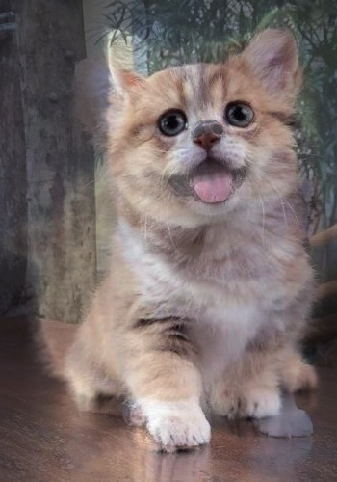

张着嘴巴的猫

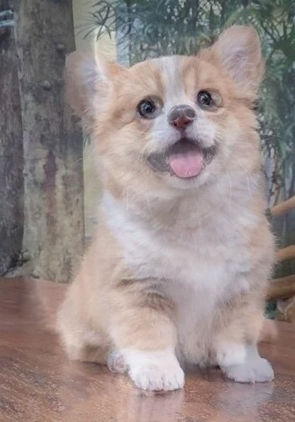  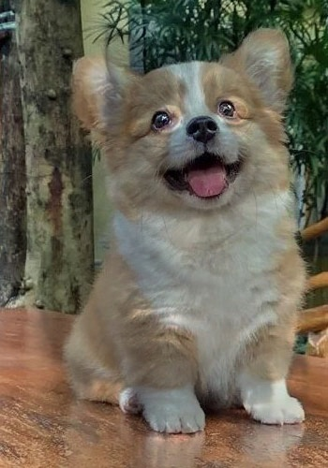 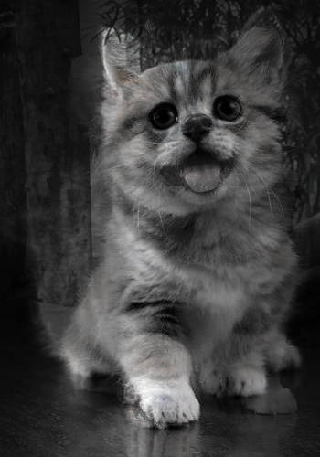 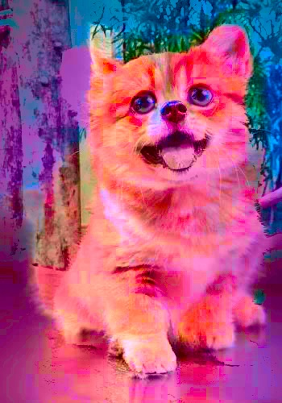 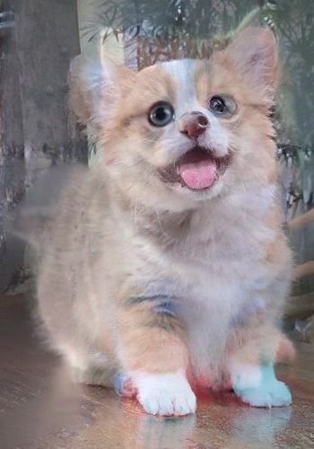 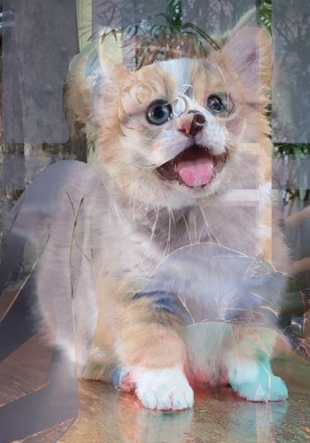 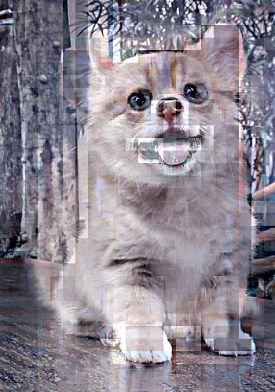

更多结果见”./*.jpg”

cvBGRBlend0-alphaBlend-Blended.jpg  
cvBGRBlend0-alphaBlend-r-Blended.jpg  
cvBGRBlend0-divideBlend-Blended.jpg  
cvBGRBlend0-divideBlend-r-Blended.jpg  
cvBGRBlend0-maxBlend-Blended.jpg  
cvBGRBlend0-maxBlend-r-Blended.jpg  
cvBGRBlend0-minBlend-Blended.jpg  
cvBGRBlend0-minBlend-r-Blended.jpg  
cvBGRBlend0-multiplyBlend-Blended-1.jpg  
cvBGRBlend0-multiplyBlend-Blended.jpg  
cvBGRBlend0-multiplyBlend-r-Blended.jpg  
cvBGRBlend0-multiplyBlend0-Blended.jpg  
cvBGRBlend0-multiplyBlend0-r-Blended.jpg  
cvBGRBlend0-multiplyBlend1-Blended.jpg  
cvBGRBlend0-multiplyBlend1-r-Blended.jpg  
cvBGRBlend0-multiplyBlend2-Blended.jpg  
cvBGRBlend0-multiplyBlend2-r-Blended.jpg  
cvBGRBlend0-subtractBlend-Blended.jpg  
cvBGRBlend0-subtractBlend-r-Blended.jpg  
cvHLSBlend0-alphaBlend-Blended.jpg  
cvHLSBlend0-divideBlend-Blended.jpg  
cvHLSBlend0-maxBlend-Blended.jpg  
cvHLSBlend0-minBlend-Blended.jpg  
cvHLSBlend0-multiplyBlend-Blended.jpg  
cvHLSBlend0-multiplyBlend0-Blended.jpg  
cvHLSBlend0-multiplyBlend1-Blended.jpg  
cvHLSBlend0-multiplyBlend2-Blended.jpg  
cvHLSBlend0-subtractBlend-Blended.jpg  
cvLABBlend0-alphaBlend-Blended.jpg  
cvLABBlend0-divideBlend-Blended.jpg  
cvLABBlend0-maxBlend-Blended.jpg  
cvLABBlend0-minBlend-Blended.jpg  
cvLABBlend0-multiplyBlend-Blended.jpg  
cvLABBlend0-multiplyBlend0-Blended.jpg  
cvLABBlend0-multiplyBlend1-Blended.jpg  
cvLABBlend0-multiplyBlend2-Blended.jpg  
cvLABBlend0-subtractBlend-Blended.jpg  
gaussi_smoothed.jpg  
gaussi_smoothed1.jpg  
gaussi_smoothed4.jpg  
gaussi_smoothed7.jpg  
gaussi_smoothed31.jpg  
gaussi_smoothed61.jpg  
gaussi_smoothed91.jpg  
laplacian_pyramid.jpg  
laplacian_pyramid1.jpg  
laplacian_pyramid4.jpg  
laplacian_pyramid7.jpg  
laplacian_pyramid31.jpg  
laplacian_pyramid61.jpg  
laplacian_pyramid91.jpg  
naive.jpg  
naive1.jpg  
naive4.jpg  
naive7.jpg  
naive31.jpg  
naive61.jpg  
naive91.jpg  
pywt_fusion.jpg

图像频谱图： 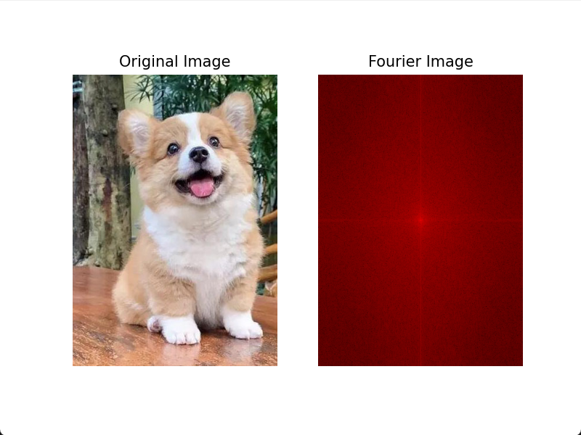 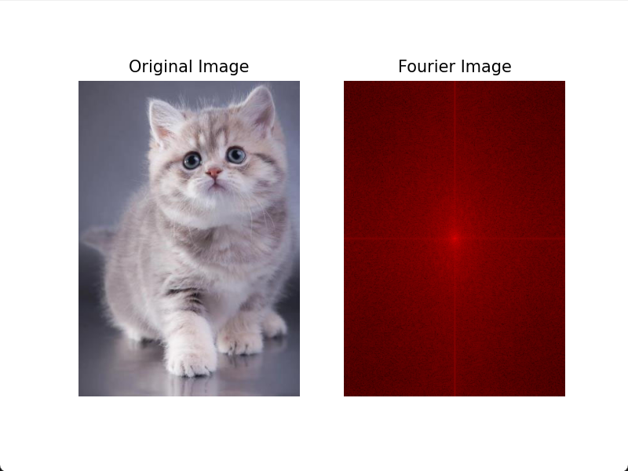

1. **实验总结**

图像融合 (Image Fusion) 是指综合多幅输入图像的信息，以获得更高质量输出图 像的过程与融合前的多幅图像相比，融合后的图像应更加适于进一步的观察或处理。作用主要包括：扩展图像在空间域或时间域的覆盖范围，减少信息冗余 和不确定性，压缩存储空间等。

本次实验运用了灰度融合、频域融合、蒙版融合、频域复数分解融合、直方图融合、金字塔融合、泊松融合、小波融合。

在实验中，我们选择了两张合适的图片，并自定义了一个mask。通过简单的代数运算，我们将这两张图片进行了融合。为了得到更好的融合效果，我们选择在HSL颜色空间进行融合。

在HSL颜色空间中，我们可以通过调整色调（Hue）、饱和度（Saturation）和亮度（Lightness）来改变图像的颜色。我们可以选择将两张图片的色调、饱和度和亮度进行加权平均，以实现融合效果。

在选择代数运算时，我们可以尝试不同的权重分配方法，例如使用线性插值或者根据像素值的大小进行加权平均。通过多次尝试和比较，我们可以找到一种合适的代数运算方法，使得融合效果较好。

之后将实验【1】的图片通过拉普拉斯金字塔分解进行了多分辨率融合。拉普拉斯金字塔是一种常用的图像分解方法，可以将图像分解为不同分辨率的子图。

首先，我们对原始图像进行高斯模糊处理，以降低图像的噪声。然后，我们使用拉普拉斯算子对图像进行卷积操作，得到拉普拉斯金字塔的底层图像。接下来，我们对底层图像进行上采样操作，以得到与原始图像相同大小的图像。最后，我们将上采样后的图像与原始图像进行叠加，得到融合后的图像。

通过多次迭代上述过程，我们可以逐步提高融合效果。最终，我们可以得到一个具有更好细节和清晰度的融合图像。

最后将实验【1】的图片通过泊松融合方法进行了融合。泊松融合是一种基于图像统计信息的融合方法，可以有效地保留图像的细节信息。

首先，我们对原始图像进行泊松融合参数的估计。泊松融合参数包括平滑因子和权重因子，用于控制融合效果和保留细节的程度。我们可以通过计算图像的梯度信息来估计这些参数。

然后，我们使用估计得到的参数对原始图像进行泊松融合操作。具体地，我们将原始图像与目标图像进行加权平均，其中权重因子根据泊松分布来确定。这样，我们可以有效地保留原始图像的细节信息，并减少融合过程中的失真。

通过多次迭代上述过程，我们可以逐步提高融合效果。最终，我们可以得到一个具有较好细节保留和清晰度的融合图像。

1. **材料提交**

1.实验要求内容完备(实验代码、实验结果及分析)、格式规范、排版美观。

2.实验过程中遇到问题需记录具体问题和解决方法；

3.把相关材料(包括实验报告、实验代码、实验使用到的图片等数据)压缩打包为“计算机视觉实验07_学号_姓名.zip”，提交到邮箱pengshenglin@nwu.edu.cn；

4.截止时间为实验课当周周日24点前(如实验课在周六周日，截止时间为下周周二24点前)。

5.不要迟交，不要抄袭(迟交当次作业最多70分，抄袭整个课程记0分！)。实验报告整体雷同且存在以下情况判为抄袭：程序仅有极少字符与变量的不同且；程序仅有空格和分行的不同；存在从网页复制导致的乱码，全角符号，非ASCII符号，&nbsp;等；代码高度相似并且程序存在完全相同的错误。(重复教材上的代码不计入抄袭)