**姓名： _____庞晓宇_______**

**学号： ____2020118100____**

**时间：_2021年10月29日_**

**编号：__________________**

**Project: Alarm Clock**

**问题描述：**

Description: Create a program which shows the current time using a label. Allow the user to select a given time and specify a message. When the clock reaches that time, have it pop up a message to the user reminding them of their message and/or play a specific sound file. Tips: You will need to be able to get the current time and display it to the user. You will also need a mechanism for saving an “event” which has a specific time and an associated message. Try creating a custom class to hold this information. On each tick of the clock, compare the time to each of the saved scheduled events. If one matches, show the associated message. Be sure to check for multiple events for a given time and possibly throw away any old events (expired) in the system if they are not needed. Added Difficulty: Make the clock display graphical using pictures for the numbers. You could also integrate a database to keep track of multiple events much easier. Add an icon to your messages and possibly specify which sound file is to played as the alarm. Remind the user if an event is “overdue” and by how long.

**设计:**

UML类图：见./UML.pdf

UI

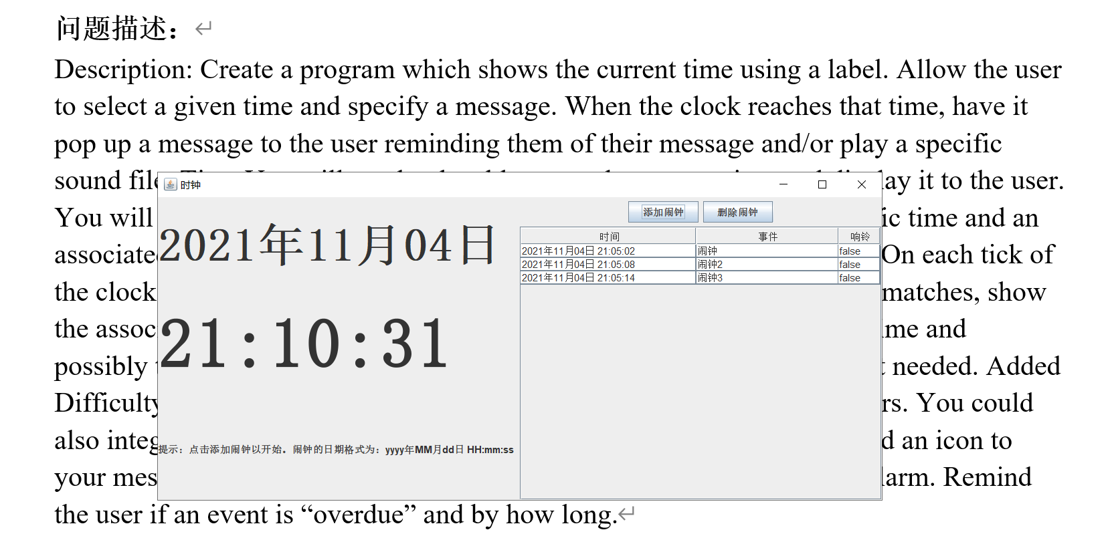

**代码:**

│ a.dat：数据文件

│ AlarmClock.docx：本文件

│ fileTree.txt：目录清单

│ README.md

│ UML.pdf：uml类图

│

├───.vscode

│ settings.json：配置文件

│

├───bin：字节码文件

│ └───com

│ └───xftxyz

│ └───clock

│ ├───domain

│ │ ClockEventItem.class

│ │

│ ├───service

│ │ XFGlobal.class

│ │

│ ├───utils

│ │ XFFileUtil$1.class

│ │ XFFileUtil.class

│ │

│ └───view

│ AlarmClock.class

│ AlarmClockView$1.class

│ AlarmClockView.class

│ ClockEventDialog$1.class

│ ClockEventDialog$2.class

│ ClockEventDialog.class

│ ClockListPanel$1.class

│ ClockListPanel$2.class

│ ClockListPanel.class

│ DateTimePanel$1.class

│ DateTimePanel.class

│ EventsTableModel$1.class

│ EventsTableModel$2.class

│ EventsTableModel.class

│

├───lib

└───src

└───com

└───xftxyz

└───clock

├───domain：

│ ClockEventItem.java：一条提醒

│

├───service

│ XFGlobal.java：一些常量

│

├───utils

│ XFFileUtil.java：文件读写工具类

│

└───view

AlarmClock.java：运行类

AlarmClockView.java：主窗体

ClockEventDialog.java：添加闹钟的自定义对话框

ClockListPanel.java：闹钟列表

DateTimePanel.java：时钟

EventsTableModel.java：闹钟列表数据对象

另外以附件形式提交源代码

**运行程序的屏幕截图：**



**自我评价：**

程序测试部分截图如下，程序能够正常的显示日期和时间，并按照系统时钟更新。

到达闹钟设定的时间就会弹出窗口提醒用户。

如果再程序没有运行的时候达到提醒时间，等到再次运行程序时，会提示过期 的事件。

程序拥有比较强的健壮性，再多数形况下能够对用户错误的输入进行合理的处理。

再程序关闭的时候，会提示用户确认。

整体来说，实现的不错。但是界面没有使用其他的颜色装饰。而且数据没有使用数据库存储，存在数据丢失的风险。

