**姓名： _____庞晓宇_______**

**学号： ____2020118100____**

**时间：_2021年10月29日_**

**编号：__________________**

**Project: BankAccountManager**

**问题描述：**

Description: Design a program which acts as an ATM machine. The user can specify a PIN and it shows them a menu of their account types (checking and savings). Allow the user to deposit or withdraw money from a selected account type. Be sure to check that they can’t withdraw more money than they have or if they deposit more than $10k dollars, it lets the user know it will have to contact the bank manager to clear the deposit and won’t let them then withdraw any of that money. Tips: This is a classic example of class inheritance. Create an Account class which will serve as the basis of both types of accounts. A checking and savings account are both accounts right? They will inherit from the base Account class. Keep basic functionality in the base class like deposit() and withdraw() and then override them in the specific account types. A savings account may also have things like interest applied or a penalty for withdrawing any money. Take this into account when you override those methods. The variable “balance” would also be a protected member of the base class. Added Difficulty: Allow the checking account to go into negative and apply an overdraft fee of $10. Don’t let the user go into overdraft protection more than $100. You could also prevent the user from making multiple withdraws if they are already overdrawn.

**设计:**

UML类图：见./UML.pdf

UI

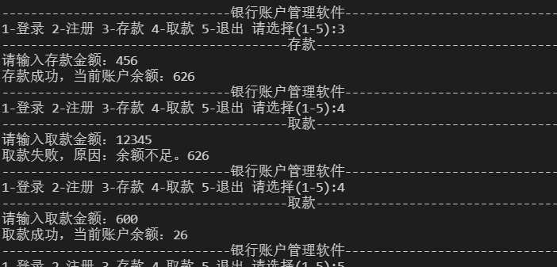

**代码:**

│ bank.dat：数据文件

│ BankAccountManager.docx：本说明文档

│ fileTree.out：目录结构

│ README.md

│

├───.vscode

│ settings.json

│

├───bin

│ └───com

│ └───xftxyz

│ └───bank

│ ├───domain

│ │ Account.class

│ │ CheckingAccount.class

│ │ SavingsAccount.class

│ │

│ ├───service

│ │ AccountService.class

│ │ BankException.class

│ │

│ ├───utils

│ │ MyFileReader.class

│ │ XFConstant.class

│ │

│ └───view

│ BAMUtility.class

│ BankView.class

│

├───lib

└───src

└───com

└───xftxyz

└───bank

├───domain：账户类设计

│ Account.java

│ CheckingAccount.java

│ SavingsAccount.java

│

├───service

│ AccountService.java：管理类

│ BankException.java：自定义异常

│

├───utils

│ MyFileReader.java：文件存取工具类

│ XFConstant.java：常量

│

└───view

BAMUtility.java：控制台输入工具类

BankView.java：主视图代码

另外以附件形式提交源代码

**运行程序的屏幕截图：**

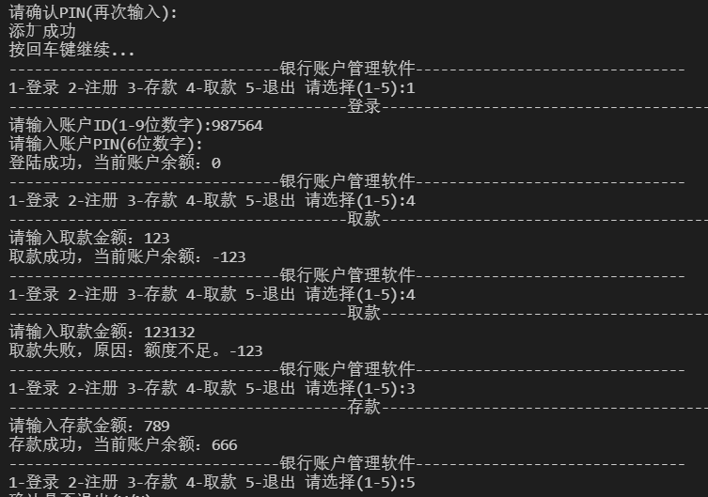

**自我评价：**

测试结果；功能；界面；……

通过测试来看，程序能够较好的实现注册、登录以及存取款功能，以及数据持久化

对用户的不合法输入进行了良好的处理，如密码输入错误，存取款负值等

设计了Account和它的两个子类，实现了信用卡和储蓄卡的简单功能

由于时间和能力不足，没有使用图形化的界面和数据库，还是有些遗憾的。