**姓名： _____庞晓宇_______**

**学号： ____2020118100____**

**时间：_2021年10月29日_**

**编号：__________________**

**Project: Text Editor**

**问题描述：**

Description: Make a simple notepad style editor that the user can use to create, open and edit simple text based files. Provide functionality found in your typical editor including saving, copy/paste and printing capability. Tips: Start with something simple and work your way up. Create the application to first be able to open a window that will allow the user to type into it and save. This window may contain a multiline textbox or textarea (if you are doing a web app), a toolbar and a status bar. Think about how you would read the file into this new window and write it back out. Once you have the basics of reading in and writing out done, you will be able to then do your saving and opening dialogs and from there to copy/paste and printing. Think about how your editor may react if someone tries to open a file which is not text based. Added Difficulty: Add in formatting options like bolding, italics and underline. You can also add in a tabbed interface that will allow the user to open multiple text documents at the same time and edit them individually.

**设计:**

UML类图：见./UML.pdf

UI

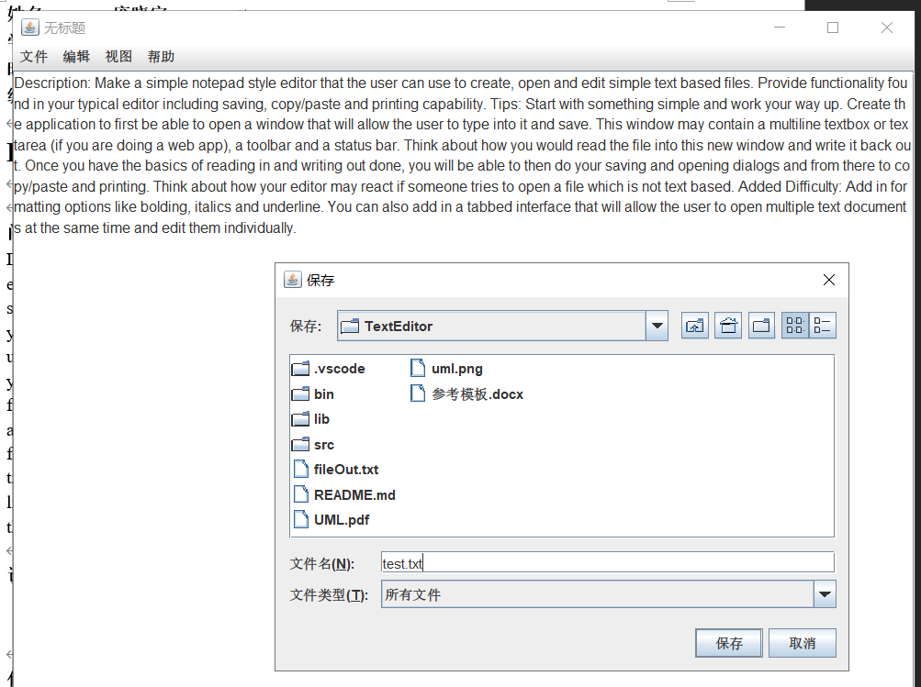

**代码:**

D:.

│ fileOut.txt

│ README.md

│ UML.pdf

│ uml.png

│ 参考模板.docx

│

├─.vscode

│ settings.json

│

├─bin

│ └─com

│ └─xftxyz

│ └─mynotepad

│ ├─adapter

│ │ AboutHelpMenuActionListener.class

│ │ AddFontSizeMenuItemActionListener.class

│ │ CopyMenuItemActionListener.class

│ │ ExitMenuItemActionListener.class

│ │ NewMenuItemActionListener.class

│ │ OpenButtonActionListener.class

│ │ OpenMenuItemActionListener.class

│ │ PasteMenuItemActionListener.class

│ │ SaveAsMenuItemActionListener.class

│ │ SaveButtonActionListener.class

│ │ SaveMenuItemActionListener.class

│ │ StatisticsMenuItemActionListener.class

│ │ SubFontSizeMenuItemActionListener.class

│ │ ViewHelpMenuItemActionListener.class

│ │

│ ├─menu

│ │ XFEditMenu.class

│ │ XFFileMenu.class

│ │ XFHelpMenu.class

│ │ XFMenuBar.class

│ │ XFViewMenu.class

│ │

│ ├─service

│ │ XFGlobal.class

│ │

│ ├─utils

│ │ ClipboardUtil.class

│ │ XFFileUtil.class

│ │

│ └─view

│ NoteBook.class

│ OpenFrame$1.class

│ OpenFrame.class

│ SaveFrame$1.class

│ SaveFrame.class

│ StatisticsFrame$1.class

│ StatisticsFrame.class

│ TextEditor.class

│

├─lib

└─src

└─com

└─xftxyz

└─mynotepad

├─adapter：按钮的监听器

│ AboutHelpMenuActionListener.java

│ AddFontSizeMenuItemActionListener.java

│ CopyMenuItemActionListener.java

│ ExitMenuItemActionListener.java

│ NewMenuItemActionListener.java

│ OpenButtonActionListener.java

│ OpenMenuItemActionListener.java

│ PasteMenuItemActionListener.java

│ SaveAsMenuItemActionListener.java

│ SaveButtonActionListener.java

│ SaveMenuItemActionListener.java

│ StatisticsMenuItemActionListener.java

│ SubFontSizeMenuItemActionListener.java

│ ViewHelpMenuItemActionListener.java

│

├─menu

│ XFEditMenu.java：编辑菜单

│ XFFileMenu.java：文件菜单

│ XFHelpMenu.java：帮助菜单

│ XFMenuBar.java：菜单

│ XFViewMenu.java：视图菜单

│

├─service

│ XFGlobal.java：一些常量

│

├─utils

│ ClipboardUtil.java：剪切板工具类

│ XFFileUtil.java：文件读写工具类

│

└─view

NoteBook.java：运行文件

OpenFrame.java：打开文件的窗体，弃用

SaveFrame.java：保存文件的窗体，弃用

StatisticsFrame.java：统计窗体

TextEditor.java：文本主窗口

另外以附件形式提交源代码

**运行程序的屏幕截图：**

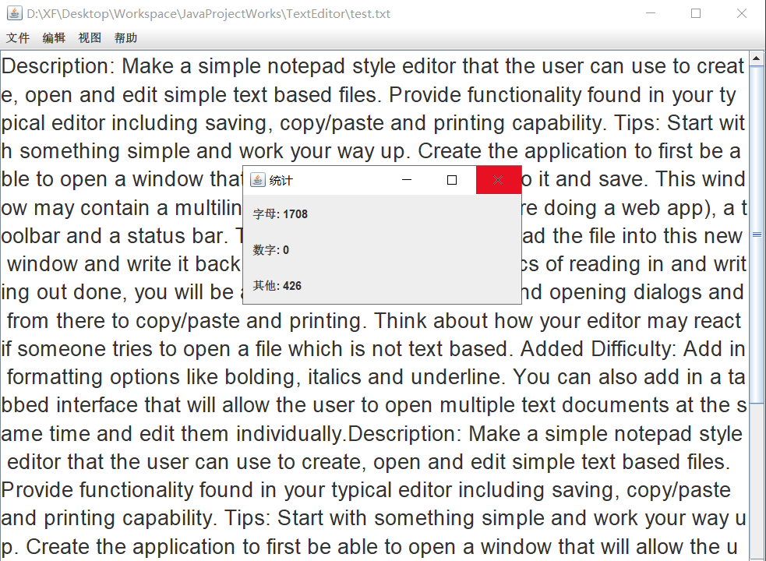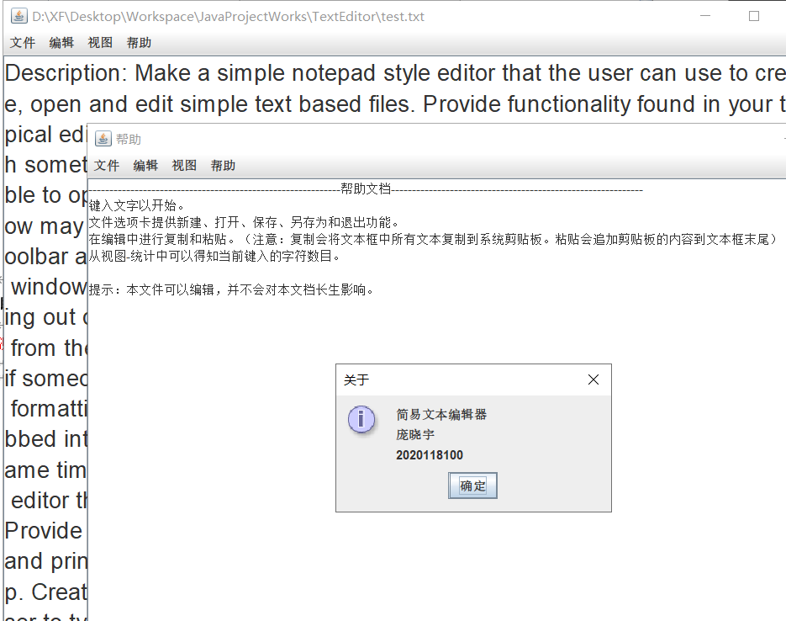

**自我评价：**

本程序实现了一个简易的图形界面文本编辑器，可以实现简单的文本编辑，

新建文件，打开文件，保存以及另存为也是使用了人性化设计。新建文件未保存时，第一次保存提示选择保存位置。

编辑菜单提供了复制和粘贴功能，以及字号的改变

视图窗口提供了字符数目统计功能

提供了帮助以及关于页面。

程序整体表现良好，经过多次实验没有出现导致程序出现异常。

但是程序并没有实现文件未保存时退出的情况。即用户在编辑文件没有保存而退出程序时，程序不会提示用户保存文件，也算是一点遗憾了。