**姓名： _____庞晓宇_______**

**学号： ____2020118100____**

**时间：_2021年10月29日_**

**编号：__________________**

**Project: Turtle Graphics**

**问题描述：**

Description: Make an application that instructs a turtle icon on the screen to draw various shapes based on user input. For instance, if the user issues the command “drop pen” the turtle will start a line. If the user then issues the command “move to 1,1” it will then draw that line from its current position to coordinates 1,1... which then makes a line. The user can then tell the turtle to “lift pen” where it will then end the line. The program should allow the user to instruct the turtle how to draw lines, move to various coordinates and drop or lift its pen. Tips: This type of program is great if you wish to learn how to take in user instructions, parse them and then translate them into actions the turtle on screen does. So the first part is to come up with a syntax for commands that the program can parse. For instance, perhaps the command is “DROP” and the object is “PEN” in which case you can tell the turtle to drop its pen. If the user enters “DROP MARKER” it would see “DROP” and understand it, but would not understand “MARKER” so it would issue an error. Once you have a function that can parse various commands, all that is left is to instruct the turtle what to do. It is suggested that you create various functions that you can call to control the turtle. You could even make a Turtle class and have various methods to control it. Added Difficulty: Have the turtle draw a star from its current location with one command

**设计:**

UML类图：见./UML.pdf

UI

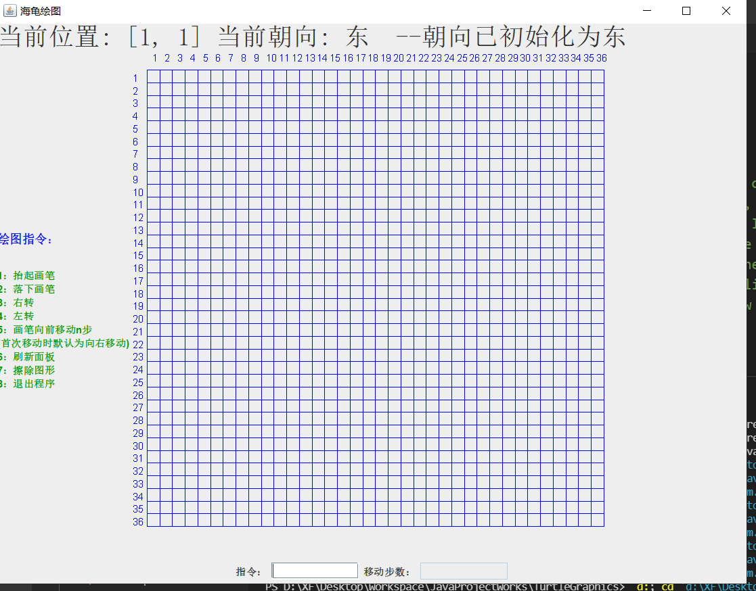

**代码:**

│ fileTree.txt：目录清单

│ README.md

│ TurtleGraphics.docx：本文件

│

├───.vscode

│ settings.json

│

├───bin

│ └───com

│ └───xftxyz

│ └───turtle

│ ├───service

│ │ XFDirection.class

│ │ XFGlobal.class

│ │

│ ├───test

│ │ XFTest.class

│ │

│ └───view

│ Main.class

│ TurtleGraphicsJPanel.class

│ TurtleGraphicsView$1.class

│ TurtleGraphicsView$2.class

│ TurtleGraphicsView.class

│

├───lib

└───src

└───com

└───xftxyz

└───turtle

├───service

│ XFDirection.java：方向枚举类

│ XFGlobal.java：全局常量

│

├───test

│ XFTest.java

│

└───view

Main.java：主函数

TurtleGraphicsJPanel.java：海龟画板

TurtleGraphicsView.java：主窗体

另外以附件形式提交源代码

**运行程序的屏幕截图：**

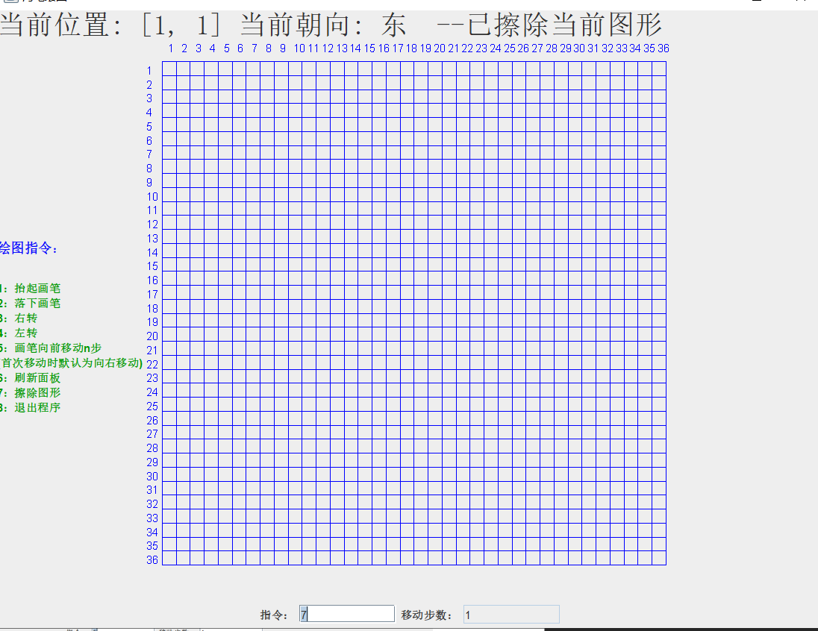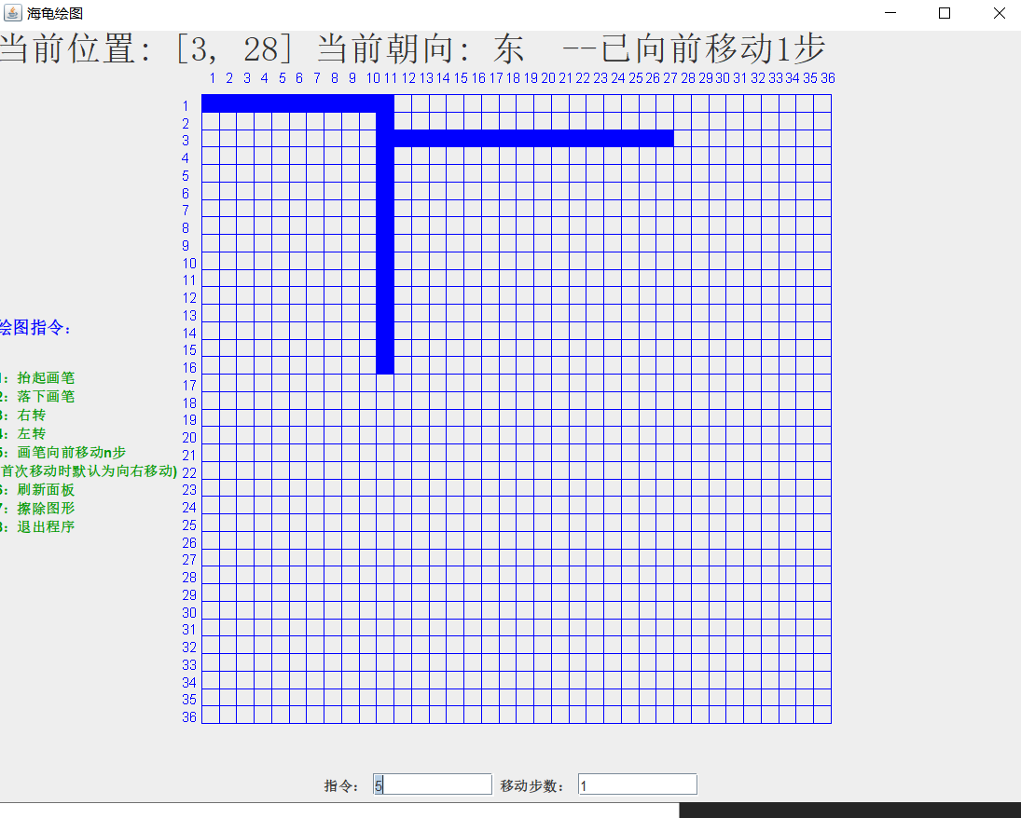

**自我评价：**

程序使用swing Graphics2D等实现了一个简单的海龟绘图小样例，能够实现抬起笔，放下笔，转向，移动来绘制图案。

其中文本框的监听使用了自动获取焦点，移动命令按回车会切换到步数的输入文本框，比较方便。

程序使用了简单的布局，其中北方是状态栏，用于指示当前的龟头位置和朝向，以及刚刚完成的动作。

西方是使用帮助，使用html来实现的分行显示。

南方就是程序的指令输入，中间是海龟绘图的画板。

整体来看，程序比较成功的实现了题目的部分要求，但是还是有很多不足的地方，比如多次重复指令可能会导致卡顿，以及边界的处理不是很好。