实现将Bootloader固定在0x0080-0x3ff,中断向量表在0x0-0x7f,指向0x400开始的中断向量表副本。应用程序从0x400开始。
中断向量表副本由编译器将中断起始地址设置在0x400开始产生(Release版本也需要将中断起始地址设置在0x400开始)。中断跳转说明，以串口中断为例。串口中断产生时，硬件控制程序指针转向0x0023处，而Bootloader已经在程序存储器0x0023处放置了一个长跳转指令，指向0x0400+0x23处。而通过设置编译选项编译器已经将中断向量服务地址放入了0x0400+0x23处。这样，串口中断发生后，可以跳到0x0400+0x23，再从这跳到串口中断服务程序。
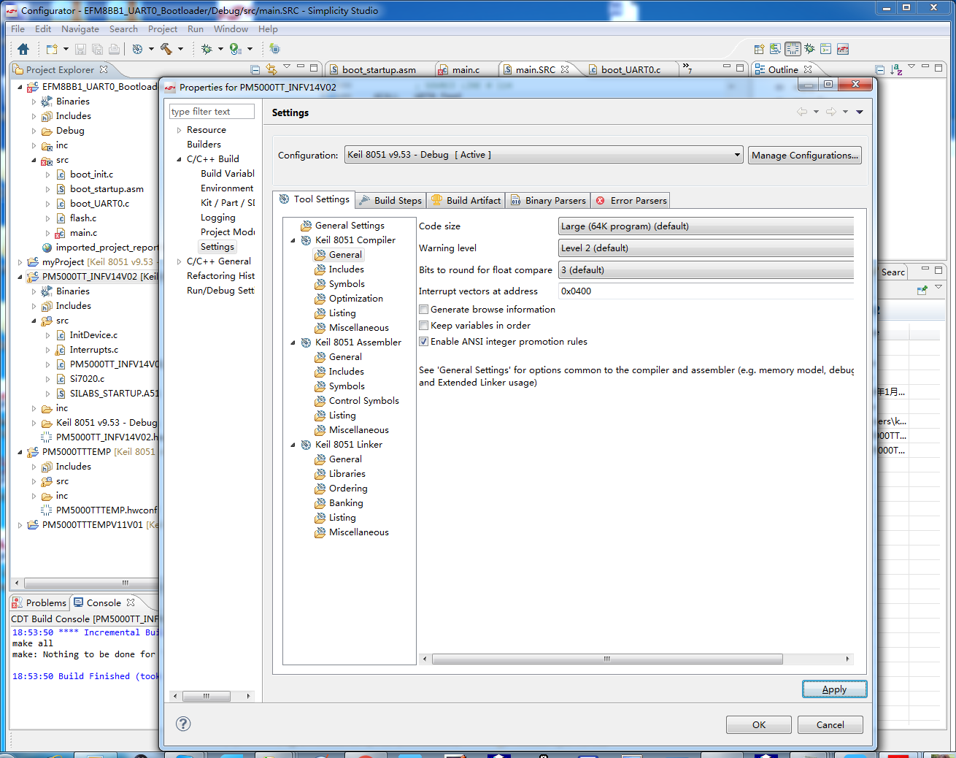
为了实现固定代码的功能，可以编写链接器控制脚本。
APPLink.txt中内容：PRINT (.\PM5000TT_INFV14V02.m51) PAGEWIDTH (120) PAGELENGTH (65) CLASSES (CODE (C:0X0400-C:0X1FFF), CONST (C:0X0400-C:0X1FFF), ECODE (C:0X0400-C:0X1FFF), HCONST (C:0X0400-C:0X1FFF), XDATA (X:0X0-X:0XFF), HDATA (X:0X0-X:0XFF))
BootLink.txt中内容：PRINT(.\EFM8BB1_UART0_Bootloader.m51) PAGEWIDTH (120) PAGELENGTH (65) SEGMENTS(?BL_START, ?PR?*) CLASSES( CODE(C:0x80 - C:0x2ff), CONST(C:0x80 - C:0x2ff), ECODE(C:0x80 - C:0x2ff), HCONST(C:0x80 - C:0x2ff), XDATA(X:0x0 - X:0xff), HDATA(X:0x0 - X:0xff))
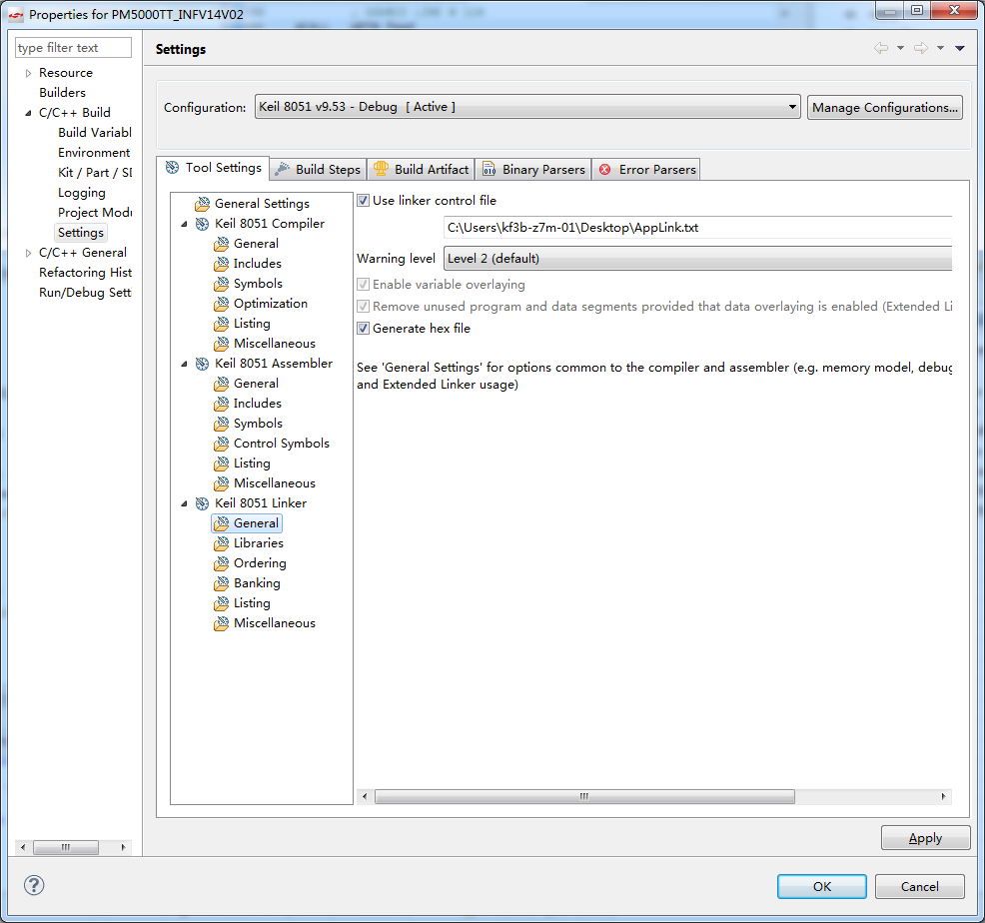
Bootloader中汇编部分：
$NOMOD51
;
; Copyright (c) 2015 by Silicon Laboratories Inc. All rights reserved.
;
; http://developer.silabs.com/legal/version/v11/Silicon_Labs_Software_License_Agreement.txt
;

#include "efm8_device.h"

#define AppStartAddress 0x400
#define BL_SIGNATURE 0xA5

NAME BOOT_STARTUP

PUBLIC boot_otp
PUBLIC ?C_STARTUP
EXTRN CODE (?C_START)

; Declare and locate all memory segments used by the bootloader

; ?BL_EXTRA SEGMENT CODE AT BL_LIMIT_ADDRESS

?Reset_Vector SEGMENT CODE AT 0x0
?ExternalInterrupt0_Vector SEGMENT CODE AT 0x03
?Timer0Overflow_Vector SEGMENT CODE AT 0x0B
?ExternalInterrupt1_Vector SEGMENT CODE AT 0x13
?Timer1Overflow_Vector SEGMENT CODE AT 0x1B
?UART0_Vector SEGMENT CODE AT 0x23
?Timer2OverflowOrCapture_Vector SEGMENT CODE AT 0x2B
?SPI0_Vector SEGMENT CODE AT 0x33
?SMBus0_Vector SEGMENT CODE AT 0x3B
?PortMatch_Vector SEGMENT CODE AT 0x43
?ADC0WindowCompare_Vector SEGMENT CODE AT 0x4B
?ADC0EndofConversion_Vector SEGMENT CODE AT 0x53
?PCA0_Vector SEGMENT CODE AT 0x5B
?Comparator0_Vector SEGMENT CODE AT 0x63
?Comparator1_Vector SEGMENT CODE AT 0x6B
?Timer3OverflowOrCapture_Vector SEGMENT CODE AT 0x73

?BL_START SEGMENT CODE AT BL_START_ADDRESS
?BL_RSVD SEGMENT CODE AT BL_STOP_ADDRESS-2
?BL_STACK SEGMENT IDATA

; Create idata segment for stack
RSEG ?BL_STACK
DS 16

;#if (BL_LIMIT_ADDRESS != BL_START_ADDRESS)
; Create code segment for firmware that doesn't fit in security page
; RSEG ?BL_EXTRA
;boot_extra:
; LJMP ?C_STARTUP
;#endif
;应用程序中断向量表软链接，应用程序中触发中断调到相应中断向量表中，再从该表跳到应用程序中断服务函数
RSEG ?Reset_Vector
LJMP ?C_STARTUP

RSEG ?ExternalInterrupt0_Vector
LJMP AppStartAddress+0x03

RSEG ?Timer0Overflow_Vector
LJMP AppStartAddress+0x0B

RSEG ?ExternalInterrupt1_Vector
LJMP AppStartAddress+0x13

RSEG ?Timer1Overflow_Vector
LJMP AppStartAddress+0x1B

RSEG ?UART0_Vector
LJMP AppStartAddress+0x23

RSEG ?Timer2OverflowOrCapture_Vector
LJMP AppStartAddress+0x2B

RSEG ?SPI0_Vector
LJMP AppStartAddress+0x33

RSEG ?SMBus0_Vector
LJMP AppStartAddress+0x3B

RSEG ?PortMatch_Vector
LJMP AppStartAddress+0x43

RSEG ?ADC0WindowCompare_Vector
LJMP AppStartAddress+0x4B

RSEG ?ADC0EndofConversion_Vector
LJMP AppStartAddress+0x53

RSEG ?PCA0_Vector
LJMP AppStartAddress+0x5B

RSEG ?Comparator0_Vector
LJMP AppStartAddress+0x63

RSEG ?Comparator1_Vector
LJMP AppStartAddress+0x6B

RSEG ?Timer3OverflowOrCapture_Vector
LJMP AppStartAddress+0x73

; Bootloader entry point (boot_vector)
RSEG ?BL_START
?C_STARTUP:
USING 0

; Start bootloader if reset vector is not programmed
; MOV DPTR,#00H
; CLR A
; MOVC A,@A+DPTR
; CPL A
; JZ boot_start

; Start bootloader if software reset and R0 == signature
;MOV A,RSTSRC
;CJNE A,#010H,pin_test
; MOV A,R0
; XRL A,#BL_SIGNATURE
; JZ boot_start

; Start the application by jumping to the reset vector
;app_start:
; LJMP 00H

; Start bootloader if POR|Pin reset and boot pin held low
;pin_test:
; ANL A,#03H ; A = RSTSRC
; JZ app_start ; POR or PINR only
; MOV R0,#(BL_PIN_LOW_CYCLES / 7)
;?C0001: ; deglitch loop
; JB BL_START_PIN,app_start ; +3
; DJNZ R0,?C0001 ; +4 = 7 cycles per loop

; Setup the stack and jump to the bootloader
boot_start:
MOV SP, #?BL_STACK-1
LJMP ?C_START

; Reserved Bytes (bl_revision, bl_signature, lock_byte)
RSEG ?BL_RSVD
boot_rev:
DB BL_REVISION
boot_otp:
DB BL_SIGNATURE
lock_byte:
DB 0xFF

END
应用程序部分汇编：
$NOMOD51
;------------------------------------------------------------------------------
; This file is part of the C51 Compiler package
; Copyright (c) 1988-2005 Keil Elektronik GmbH and Keil Software, Inc.
; Version 8.01
;
; *** <<< Use Configuration Wizard in Context Menu >>> ***
;------------------------------------------------------------------------------
; STARTUP.A51: This code is executed after processor reset.
;
; To translate this file use A51 with the following invocation:
;
; A51 STARTUP.A51
;
; To link the modified STARTUP.OBJ file to your application use the following
; Lx51 invocation:
;
; Lx51 your object file list, STARTUP.OBJ controls
;
;------------------------------------------------------------------------------
;
; User-defined <h> Power-On Initialization of Memory
;
; With the following EQU statements the initialization of memory
; at processor reset can be defined:
;
; <o> IDATALEN: IDATA memory size <0x0-0x100>
; <i> Note: The absolute start-address of IDATA memory is always 0
; <i> The IDATA space overlaps physically the DATA and BIT areas.
IDATALEN EQU 80H
;
; <o> XDATASTART: XDATA memory start address <0x0-0xFFFF>
; <i> The absolute start address of XDATA memory
XDATASTART EQU 0
;
; <o> XDATALEN: XDATA memory size <0x0-0xFFFF>
; <i> The length of XDATA memory in bytes.
XDATALEN EQU 0
;
; <o> PDATASTART: PDATA memory start address <0x0-0xFFFF>
; <i> The absolute start address of PDATA memory
PDATASTART EQU 0H
;
; <o> PDATALEN: PDATA memory size <0x0-0xFF>
; <i> The length of PDATA memory in bytes.
PDATALEN EQU 0H
;
;</h>
;------------------------------------------------------------------------------
;
;<h> Reentrant Stack Initialization
;
; The following EQU statements define the stack pointer for reentrant
; functions and initialized it:
;
; <h> Stack Space for reentrant functions in the SMALL model.
; <q> IBPSTACK: Enable SMALL model reentrant stack
; <i> Stack space for reentrant functions in the SMALL model.
IBPSTACK EQU 0 ; set to 1 if small reentrant is used.
; <o> IBPSTACKTOP: End address of SMALL model stack <0x0-0xFF>
; <i> Set the top of the stack to the highest location.
IBPSTACKTOP EQU 0xFF +1 ; default 0FFH+1
; </h>
;
; <h> Stack Space for reentrant functions in the LARGE model.
; <q> XBPSTACK: Enable LARGE model reentrant stack
; <i> Stack space for reentrant functions in the LARGE model.
XBPSTACK EQU 0 ; set to 1 if large reentrant is used.
; <o> XBPSTACKTOP: End address of LARGE model stack <0x0-0xFFFF>
; <i> Set the top of the stack to the highest location.
XBPSTACKTOP EQU 0xFFFF +1 ; default 0FFFFH+1
; </h>
;
; <h> Stack Space for reentrant functions in the COMPACT model.
; <q> PBPSTACK: Enable COMPACT model reentrant stack
; <i> Stack space for reentrant functions in the COMPACT model.
PBPSTACK EQU 0 ; set to 1 if compact reentrant is used.
;
; <o> PBPSTACKTOP: End address of COMPACT model stack <0x0-0xFFFF>
; <i> Set the top of the stack to the highest location.
PBPSTACKTOP EQU 0xFF +1 ; default 0FFH+1
; </h>
;</h>
;------------------------------------------------------------------------------
;
; Memory Page for Using the Compact Model with 64 KByte xdata RAM
; <e>Compact Model Page Definition
;
; <i>Define the XDATA page used for PDATA variables.
; <i>PPAGE must conform with the PPAGE set in the linker invocation.
;
; Enable pdata memory page initalization
PPAGEENABLE EQU 0 ; set to 1 if pdata object are used.
;
; <o> PPAGE number <0x0-0xFF>
; <i> uppermost 256-byte address of the page used for PDATA variables.
PPAGE EQU 0
;
; <o> SFR address which supplies uppermost address byte <0x0-0xFF>
; <i> most 8051 variants use P2 as uppermost address byte
PPAGE_SFR DATA 0A0H
;
; </e>
;------------------------------------------------------------------------------
#define AppStartAddress 0x400
; Standard SFR Symbols
ACC DATA 0E0H
B DATA 0F0H
SP DATA 81H
DPL DATA 82H
DPH DATA 83H

NAME ?C_STARTUP

?APP_START SEGMENT CODE AT AppStartAddress
?C_C51STARTUP SEGMENT CODE
?STACK SEGMENT IDATA

RSEG ?STACK
DS 1

EXTRN CODE (?C_START)
PUBLIC ?C_STARTUP

RSEG ?APP_START
?C_STARTUP: LJMP STARTUP1

RSEG ?C_C51STARTUP

STARTUP1:

$IF (SILABS_STARTUP = 1)
EXTRN CODE (SiLabs_Startup)
LCALL SiLabs_Startup
$ENDIF

IF IDATALEN <> 0
MOV R0,#IDATALEN - 1
CLR A
IDATALOOP: MOV @R0,A
DJNZ R0,IDATALOOP
ENDIF

IF XDATALEN <> 0
MOV DPTR,#XDATASTART
MOV R7,#LOW (XDATALEN)
IF (LOW (XDATALEN)) <> 0
MOV R6,#(HIGH (XDATALEN)) +1
ELSE
MOV R6,#HIGH (XDATALEN)
ENDIF
CLR A
XDATALOOP: MOVX @DPTR,A
INC DPTR
DJNZ R7,XDATALOOP
DJNZ R6,XDATALOOP
ENDIF

IF PPAGEENABLE <> 0
MOV PPAGE_SFR,#PPAGE
ENDIF

IF PDATALEN <> 0
MOV R0,#LOW (PDATASTART)
MOV R7,#LOW (PDATALEN)
CLR A
PDATALOOP: MOVX @R0,A
INC R0
DJNZ R7,PDATALOOP
ENDIF

IF IBPSTACK <> 0
EXTRN DATA (?C_IBP)

MOV ?C_IBP,#LOW IBPSTACKTOP
ENDIF

IF XBPSTACK <> 0
EXTRN DATA (?C_XBP)

MOV ?C_XBP,#HIGH XBPSTACKTOP
MOV ?C_XBP+1,#LOW XBPSTACKTOP
ENDIF

IF PBPSTACK <> 0
EXTRN DATA (?C_PBP)
MOV ?C_PBP,#LOW PBPSTACKTOP
ENDIF

MOV SP,#?STACK-1

; This code is required if you use L51_BANK.A51 with Banking Mode 4
;<h> Code Banking
; <q> Select Bank 0 for L51_BANK.A51 Mode 4
$IF (USE_BANKING = 1)
; <i> Initialize bank mechanism to code bank 0 when using L51_BANK.A51 with Banking Mode 4.
EXTRN CODE (?B_SWITCH0)
CALL ?B_SWITCH0 ; init bank mechanism to code bank 0
$ENDIF
;</h>
LJMP ?C_START

END

关于.c中嵌入汇编报错：
工程目录中该.c文件右键->properties，勾选Generate assembly SRC from “.c” file
