## 餐厅小助手：机器人的简单行为预测

#### 松山鐘迪 1700094805 信息科学与技术学院智能系

#### 竹添林洋一 1700094802 信息科学与技术学院计算机系

曲威名 1700013004 信息科学与技术学院智能系

1. **课题背景介绍：**

当你完成一天辛苦的工作以后，回到家里，餐厅小助手可以帮你分担餐厅中的家务事，让你好好放松，享用晚餐。（这里配一个下面的图）



当你在家准备晚饭的时候，机器人主动接过你手上热腾腾的饭菜帮你端到餐桌上，并为你准备碗筷。当你用餐结束后，它会将你手中的剩饭剩菜放到冰箱。同时，它会从你手中接过空盘子，主动放到厨房里的水槽里。一顿丰盛的晚餐让你放下了一天的疲惫。这时，你想泡一杯咖啡了，机器人就很默契地将一杯咖啡泡好了端到你面前。（这里配下面的图）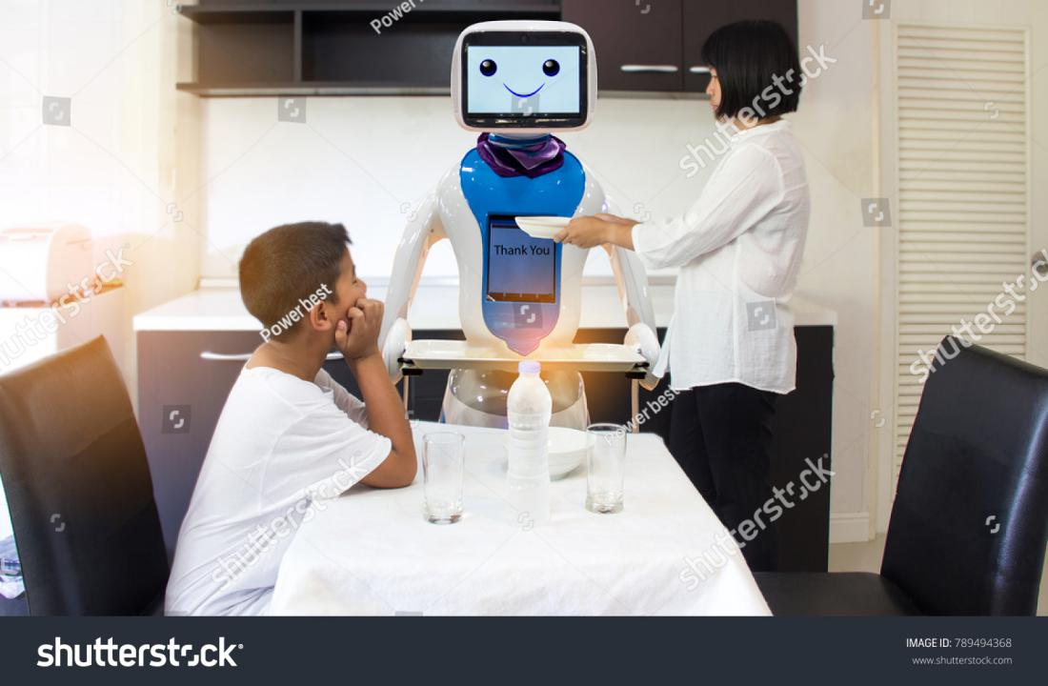

我们希望能设计出这样的一个机器人，这需要机器人能够进行简单行为预测让其更加智能。

1. **课题目标和预期成果：**

在餐厅中根据一个人的简单动作和手中的物品进行预测并协助其完成。

具体来说就是，在家里的餐厅里，机器人根据人手上的物品，比如盘子，再结合环境和人的姿态，动作序列或者运动方向等，进行准确预测并且简单实现，协助其完成。（配以下图）

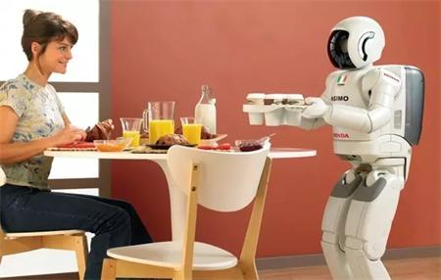

1. **实用价值和学术意义：**

事实上，早在2013年美国康奈尔大学个人机器人实验室就已经研发出行为预测机器人，但是这款机器人在10s的行为预测上准确率只有57%。而多年以来，行为预测并没有重大进展，但是就实用价值来说，行为预测一是有助从提前准备这个方向来提高机器人的反应能力；二是能够理解人类意图，对于需要合作完成的工作提供有效帮助，是人机合作的新台阶。具体来讲，在生活中能够成为生活助手，在医疗中可以高效地帮助医生手术，同时也能应用在工业等。因此从这两点可以看出，行为预测的实用性价值，特别是带有行为预测的餐厅服务型机器人。它不仅让科技贴近了生活，也让行为预测的研究更进一步。

1. **国际和国内现状：**

2013年，一款行为预测机器人由Willow Garage设计, 配备了微软的Kinect 3D摄像头, 能够分析用户的肢体运动。随后, 机器人将在家居活动数据库中进行搜索, 判断用户下一步想要干什么。

总结了人们活动的一般原则, 进而开发出了这款机器人。这一机器人对1s后用户行为预测的准确率达到82%, 对3s后和10s后用户行为预测的准确率分别为71%和57%。

下一步将要改进机器人做出预测之后的反应。他表示:“目前我们让机器人做出的反应是机械的, 但应当有一种方式, 让机器人自行了解如何做出反应。”

2014年，Our aim is to better understand the action selection process of intelligent systems by looking at their ability of internal prediction. In robotic systems, one problem is to generate meaningful robot behaviour with a very small and simple set of trained motions. An additional problem is to compensate for incomplete sensory data while generating behaviour. We propose a new predictive action selector to contribute to the solution of these problems. Our action selector predicts task–relevant feature and motion sequences, and uses the prediction results to select the robot action. We validate our implemented model on a humanoid robot. The robot generates meaningful behaviour composed out of very simple and few trained motions, and at the same time it compensates for incomplete sensory data such as temporary loss of task–relevant visual features.

2018年，For human motion prediction, collaboration with a mobile robot in the manufacturing domain requires accurate predictions over both short and long time horizons. For example, the robot must know where a person will be in the short term in order to maintain effective collision avoidance, but also must know the human’s long-term predicted path in order to plan efficient motion toward its own goal. To accommodate this requirement, we employ the Multiple-Predictor System (MPS) [6], a datadriven approach that synthesizes a high-performance predictor using a library of component prediction methods, each with a unique performance profile that varies as a function of lookahead time. The MPS enables automatic selection of the most accurate prediction approaches over both short and long time horizons.

The robot also requires a method for adapting its own behavior based on the knowledge of human behavior provided by the MPS – specifically, a planner that can leverage these predictions to generate motion for CobotSAM’s linear axis unit. For example, if the robot receives predictions indicating that a human will cross in front of it, the robot can plan to either yield the way to the human or continue moving depending upon when the cross is predicted to occur. However, the system has limited freedom to perform such adaptations due to its single-axis mobility. This necessitates an approach that can generate plans quickly while reasoning about time and predictions. Schedule considerations drive the production environment and it is also crucial that the online planning system incorporates an explicit representation of time (i.e., performs planning in time). Thus, we use the SafeInterval Path Planner (SIPP), a time-optimal search algorithm for planning in time, to plan robot trajectories [7].

SIPP generates plans under the assumption that the available predictions are fixed and accurate; however, in practice, predictions evolve as available information changes during task execution. The physical position of the robot will also change during the time-critical planning process. Hence, along with SIPP, we incorporate an algorithm to interleave prediction and planning with the execution of robot motion. The key contribution of this work are:

1. The first robot system to employ complete, time-optimal path planning in time in conjunction with a multiple predictor system for human motion. The integrated system interleaves prediction, planning, and execution to produce anticipatory robot behaviors that are derived automatically as the robot interacts with a live human.
2. The first physical demonstration of such a prediction,planning, and execution system using an arm and linear axis unit, both certified for and used in industrial settings.

3) Evaluation in simulation to assess improvements to safety and efficiency, compared to state-of-the art approaches applicable to factory environments. Results demonstrated reductions in safety-related stops, decreases in task times, and improvements in measures of fluency of interaction.

而到2018年，Predicting plausible human motion for diverse actions, however, is a challenging yet under-explored problem, because of the uncertainty of human conscious movements and the difficulty of modeling motion dynamics. Traditional approaches focus on bilinear spatio-temporal basis models [12], hidden Markov models [13], Gaussian process latent variable models [14], linear dynamic models [15], and restricted Boltzmann machines [16], [17]. More recently, driven by the advances of deep learning architectures and large-scale public datasets, various deep learning based techniques have been proposed and have significantly pushed the state of the art [4]–[5][6][7]. They formulate the task as a sequence-to-sequence problem and solve it by using recurrent neural networks (RNNs) to capture the underlying temporal dependencies in the sequential data. Despite their extensive efforts on exploring recurrent encoder-decoder architectures (e.g., encoder-recurrent-decoder (ERD) [4] and residual [6]architectures)’ they can only predict periodic actions well (e.g., walking) and show unsatisfactory performance on aperiodic actions (e.g., discussion), due to error accumulation.

In this work, we aim to address human-like motion prediction that ensures temporal coherence and fidelity of the predicted motion and that can be deployed on the robot for its interaction with humans. To achieve this, we propose a novel motion GAN model that learns to validate the motion prediction generated by the encoder-decoder network through a global discriminator in an adversarial manner.

人机协作（HRC）旨在开发机器人，在执行物理任务时为人类工作者提供帮助。这种援助以支持行为的形式出现，这些行为与任务的行动部分不同，并且旨在帮助人类工作者更有效地完成任务。学习如何提供适合人类同行的有用行为是一项艰巨的挑战。这是由于需要大量的现实世界观察形式的训练数据，其中包括有关此类偏好的信息。这些数据不仅需要编码任务的结构和进展，还需要编码不同工人在机器人应该提供何时和什么样的帮助方面的偏好。我们的工作将学习任务模型（需要大量培训数据）的挑战与学习互动的支持行为偏好的挑战分开（对我们可以访问的用户提供的演示数量有明显的限制） ）。我们首先从训练集中学习隐马尔可夫模型（HMM），该训练集由观察到的人类工作者在模拟中执行所考虑的任务组成。然后，我们使用此模型预测，在观察人类同伴时，机器人应该在整个任务中提供哪些支持行为。在隐藏的状态表示的基础上，我们的系统能够基于少数五个用户注释的演示来学习支持行为，学习个性化的支持行为模型。 18年