Trial Mode 
XMind:ZEN 
Generate the Tracking Code, Identify the Customer 
and Send the Code 
Associate the tracking code with a package and the 
delivery status from the database 
Receiver Name and Address 
Sender Name and Address 
Description of the package 
Weight of the package (Kilogram, rounded to 1 
decimal place. E.g 3.2kg) 
Declaration of dangerous goods. (Simple YIN data. 
Or True/False) 
Package delivery direction based on the destination 
address in North, South, East, West 
Accept and Calculate payments for postage 
Accept goods and ensure the dangerous goods 
disclaimer is signed 
Tag a package as either North, East, South, West 
based on the destination address 
Check status of delivery with the inclusion of 
relevant data about the package/delivery 
Track the delivery live through a map provider 
Receive a code for the delivery to access the status 
LFS Service Attendants 
Customers 
Access to the Tracking Number 
Website Clients 
Tracking Code 
Local Freight Services ( 
Database/Data 
Package/Customer Information 
Courier Information 
Tracking Number/Code 
Delivery Details 
Courier Name 
Delivery Driver Name 
Contact information of Driver/Courier 
Delivery Status (REQUESTED, DELIVERING, 
COMPLETED) 
Time and Dates of different status points and 
expected status changes (Received request, Package 
picked up, Delivery Completed) 
Name of the Courier or Relevant courier information 
Double check whether the dangerous goods 
disclaimer is signed and taking actions to get it 
signed if not 
Generate delivery lists for North, South, East, West 
Prioritizes and dispatches the generated lists of 
packages 
Change the status of a package or multiple packages 
to DELIVERING 
Delivery Dispatch Manager/Management 
Access the destination address of the assigned 
packages 
Couriers 
Change the status of a package to COMPLETED 

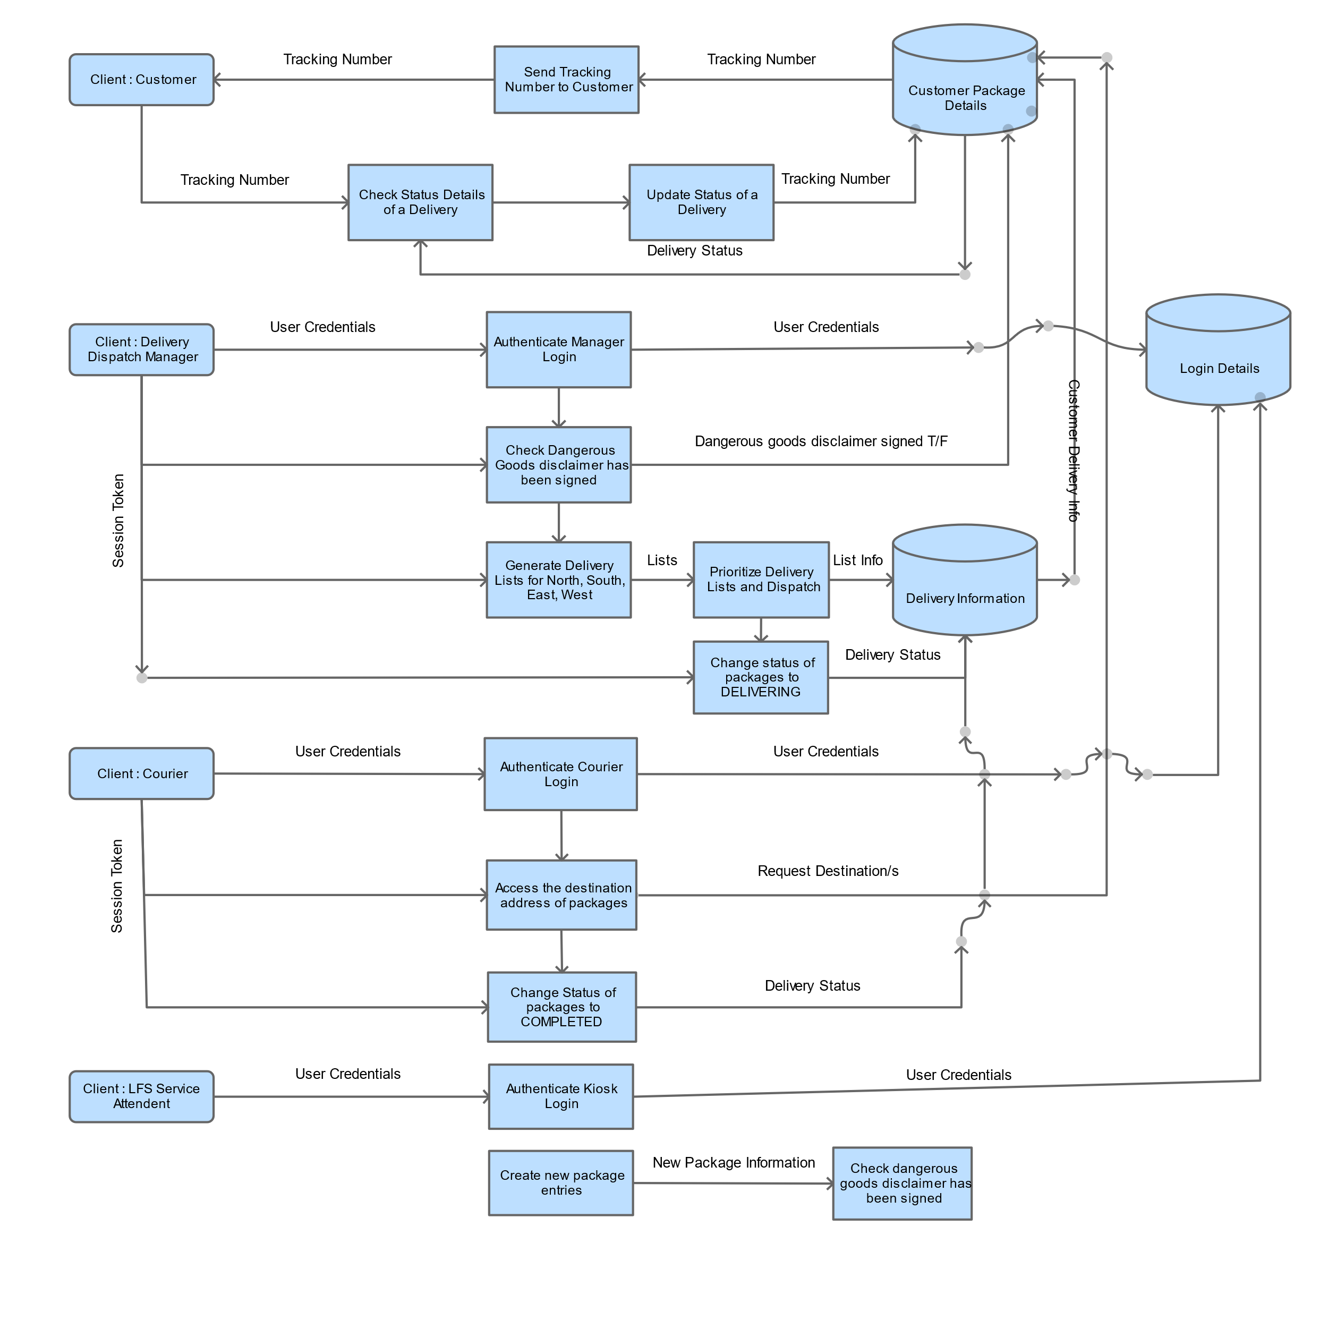

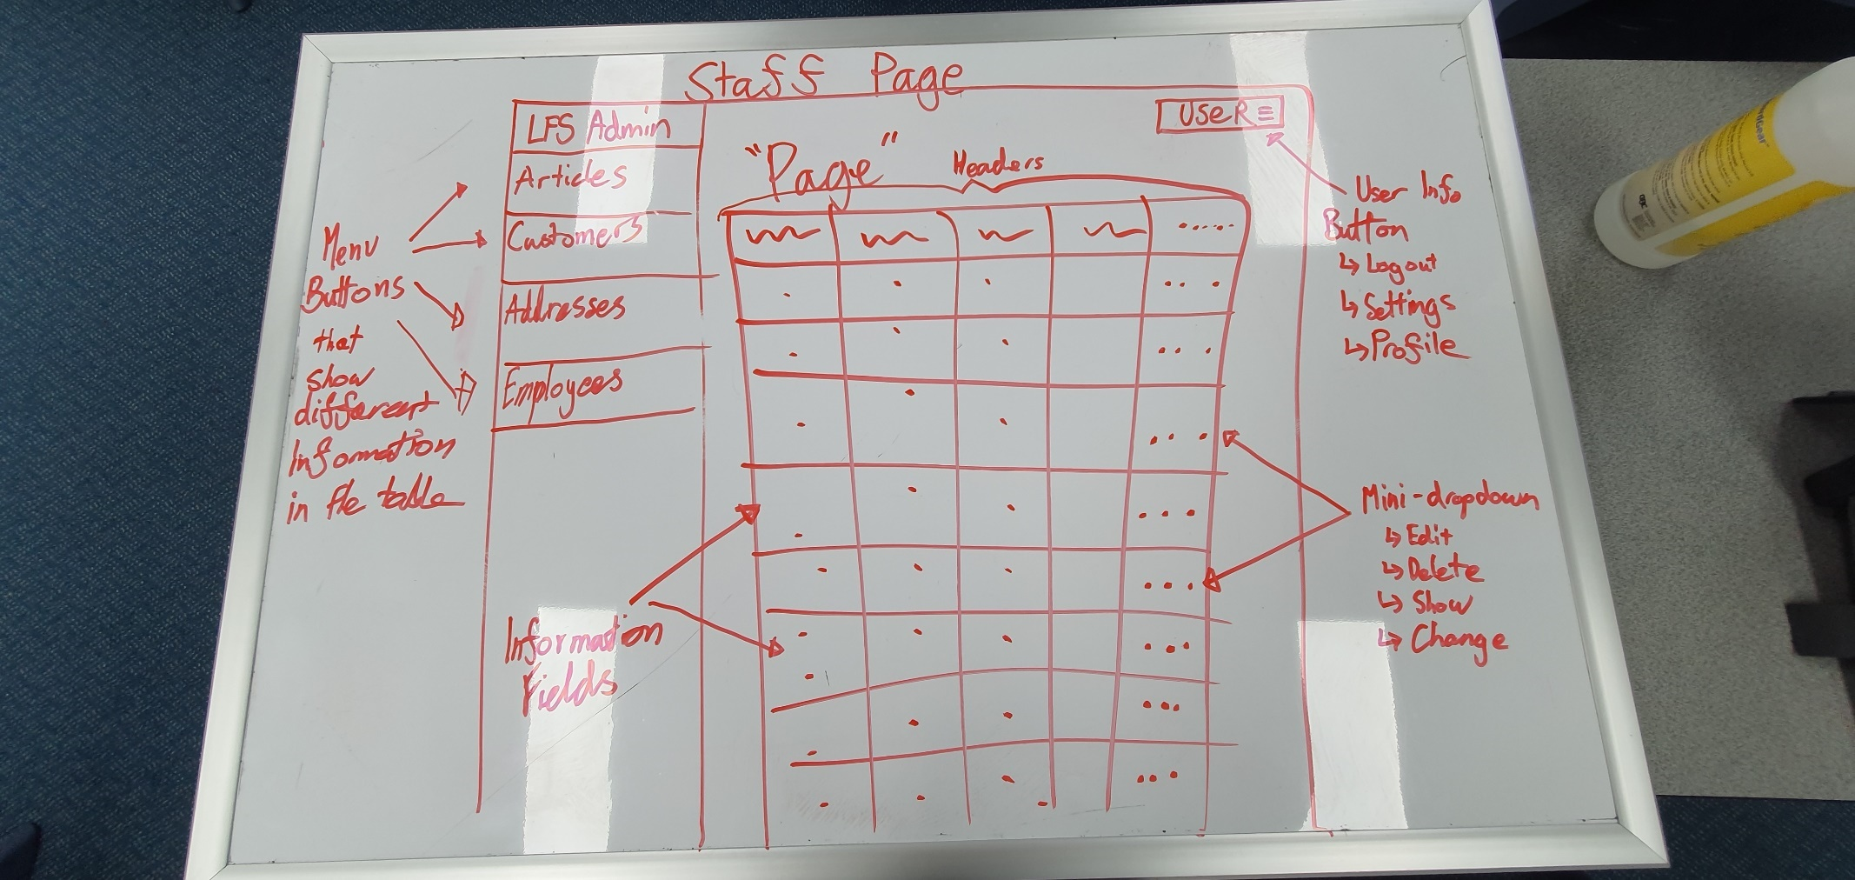

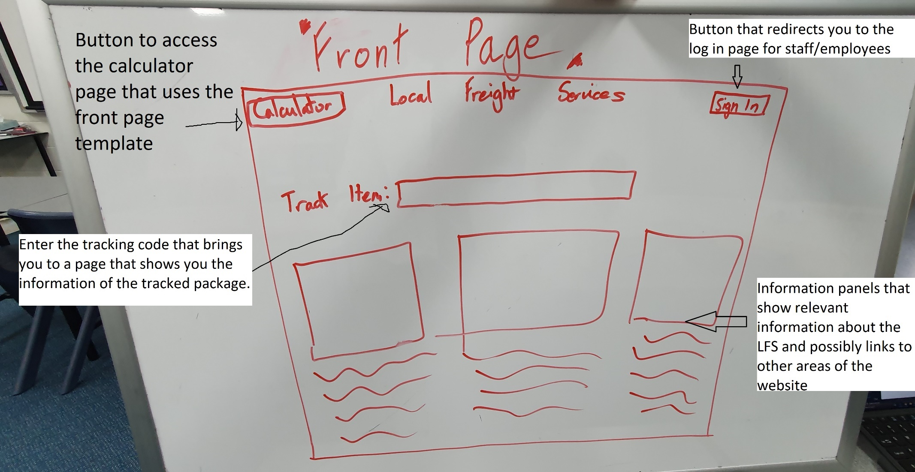

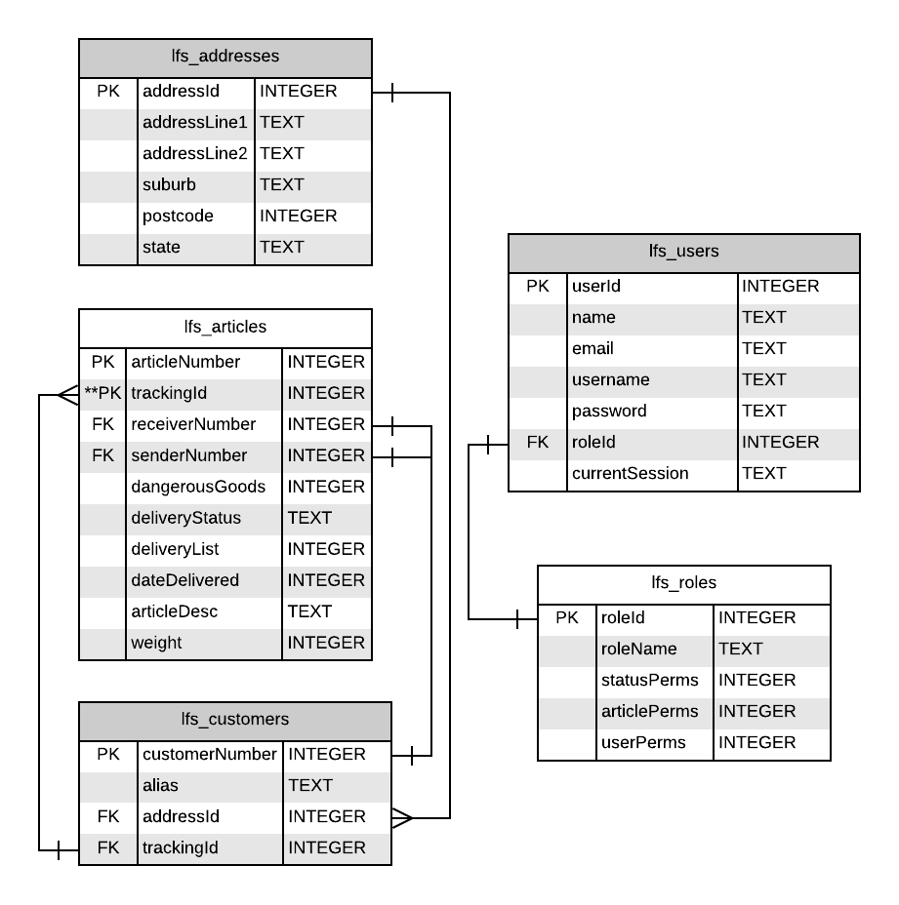

User Session Key Verification on a Staff Webpage:

SELECT * FROM lfs_users WHERE currentSession = ?

“SELECT” targets a specific, multiple or all columns that the SQL Statement is requesting. For example * would select every column and return that to the code to be used later on.  
“FROM” specifies which table the program needs to look into to select the fields from. For example, lfs_users would be the table that the program would look in to “SELECT *” (select all) from.

“WHERE” helps determine specifically which row is wanted by specifying the requirements a row must have to be returned to the code. For example, username = “Joe” would find any rows that have the column field of “Joe” in the column username; meaning that all usernames with “Joe” in it will be the ones that will be returned.

“INSERT” allows for the following parameter to be made into a new row in a table. This virtually adds a new entry into the table therefore creating new users in the case of lfs_users

“UPDATE” enables the program to update an entry in a database to allow for simple changes of a field in a row.

Example: SELECT * FROM lfs_users WHERE currentSession = 1726e9c2-ee45-11e9-ad38-9cda3e860d6b

