2020

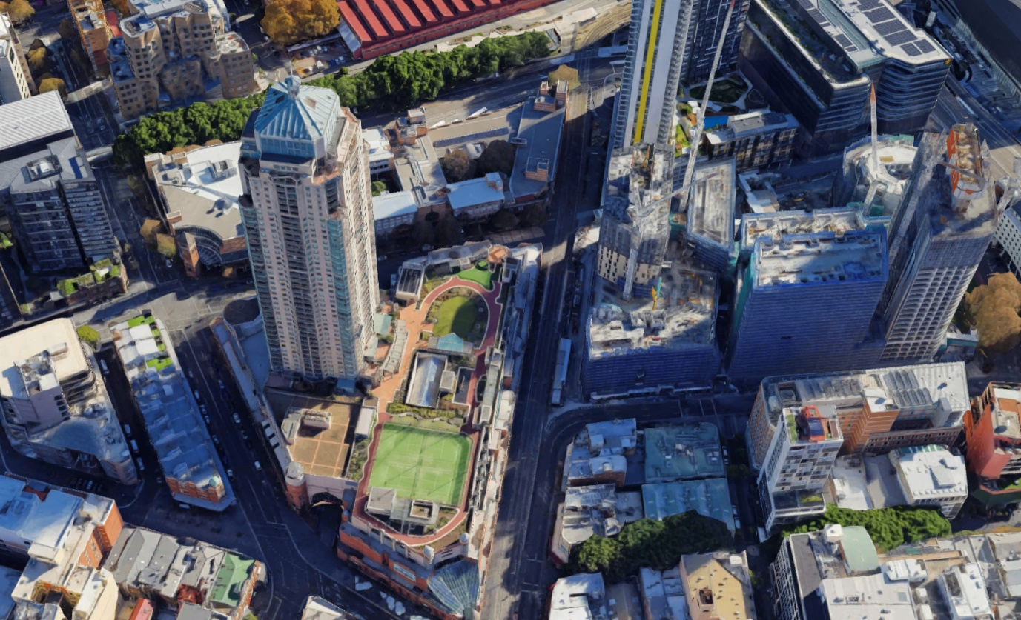

Figure 0.. - 3D Aerial Representation of Haymarket, NSW (Google Maps, 2020)

Student Life in a City

IA3: Investigation - Data report – Haymarket, NSW

Xander Gonzaga

Table of Contents

Table of Figures 1

Table of Tables 1

1 Introduction 2

2 Methodology 4

2.1 Limitations 4

3 Data Analysis 5

3.1 Population Structure 5

3.2 Income and Employment 7

3.3 Housing / Dwellings 7

4 Impacts of the Demographic Challenge 8

4.1 Housing Affordability 8

5 Conclusion and Proposed Actions 9

5.1 Third-Party Support/Funding 9

5.2 Housing In-filling/Efficiency 10

Bibliography 11

## Table of Figures

[Figure 0.1.1 - 3D Aerial Representation of Haymarket, NSW (Google Maps, 2020) 0](https://tascairns-my.sharepoint.com/personal/xg29763_tas_qld_edu_au/Documents/Geography%20-%20IA%20Assignment.docx#_Toc41411313)

[Figure 1.1 - Map of Sydney with focus on Haymarket Suburb (Google Maps, 2020) 3](https://tascairns-my.sharepoint.com/personal/xg29763_tas_qld_edu_au/Documents/Geography%20-%20IA%20Assignment.docx#_Toc41411314)

Figure 1.2 - Age Distribution Comparison Between Haymarket, NSW, and Australian statistics in 2011 and 2016 (Australian Bureau of Statistics, 2016) 3

Figure 1.3 - Haymarket, NSW, and Australian population ancestry comparison (Australian Bureau of Statistics, 2016) 4

Figure 3.1 - Haymarket and Greater Sydney Age Population Pyramid Comparison (Australian Bureau of Statistics; .id, 2016) 6

[Figure 3.2 - Haymarket, NSW, and Australian Family Composition Comparison (Australian Bureau of Statistics, 2016) 7](https://tascairns-my.sharepoint.com/personal/xg29763_tas_qld_edu_au/Documents/Geography%20-%20IA%20Assignment.docx#_Toc41411318)

Figure 3.3 - Haymarket, and Australian Population over time comparison (Australian Bureau Of Statistics, 2020) (Population Pyramid; United Nations, 2020) 7

[Figure 3.4 - Distribution of Population Attending Universities in Haymarket, NSW 8](https://tascairns-my.sharepoint.com/personal/xg29763_tas_qld_edu_au/Documents/Geography%20-%20IA%20Assignment.docx#_Toc41411320)

[Figure 3.5 - Distribution of Population Density in Haymarket, NSW 8](https://tascairns-my.sharepoint.com/personal/xg29763_tas_qld_edu_au/Documents/Geography%20-%20IA%20Assignment.docx#_Toc41411321)

[Figure 4.1 - Top Apartment listing for the Haymarket, NSW area (Domain.com.au, 2020) (Wei, 2020) 9](https://tascairns-my.sharepoint.com/personal/xg29763_tas_qld_edu_au/Documents/Geography%20-%20IA%20Assignment.docx#_Toc41411322)

[Figure 5.1 - 3D Aerial Representation of Haymarket, NSW with Highlighted Zones that could be redeveloped for apartment high-rises (Google Maps, 2020) 11](https://tascairns-my.sharepoint.com/personal/xg29763_tas_qld_edu_au/Documents/Geography%20-%20IA%20Assignment.docx#_Toc41411323)

## Table of Tables

Table 5.1 - PMI Table for the Third-Party Support/Funding Proposed Action 9

Table 5.2 - PMI Table for the Housing In-filling/Efficiency Proposed Action 10

# Introduction

Haymarket, NSW is located within Sydney’s central business district (Figure 1.1), approximately 3km south-west from the Sydney Opera House, Sydney capital’s most iconic performing arts hall. Darling Square – recently built ‘Sydney City Neighbourhood’ (Lendlease, 2020) - also resides in the Haymarket area, facilitating businesses, resturants, greenery, accomdation, and services suited for vistors and residents alike. Haymarket is also home to Sydney’s Chinatown – focus on the Chinese culture with shops, resturants, and other services – which attracts locals and visitors to the unique area, as well as the market, located near Chinatown and Darling square, which sells various items from food to clothing (Paddys Market, 2019). Easy access to nearby facilities, services, and institutes have continously enabled the local growth in student population (Figure 1.2) for domestic, and more prominently international students (figure <>) when juxtaposed against the NSW and National statistics. Housing approaching a metro area can gradually rise until you are in the heart of the CBD. Housing prices in Haymarket The cost of living in Sydney is infamously higher than most other Australian metro areas, which naturally can be difficult for students to cope with unless they receive external support in ways of funding.

Figure . - Map of Sydney with focus on Haymarket Suburb (Google Maps, 2020)

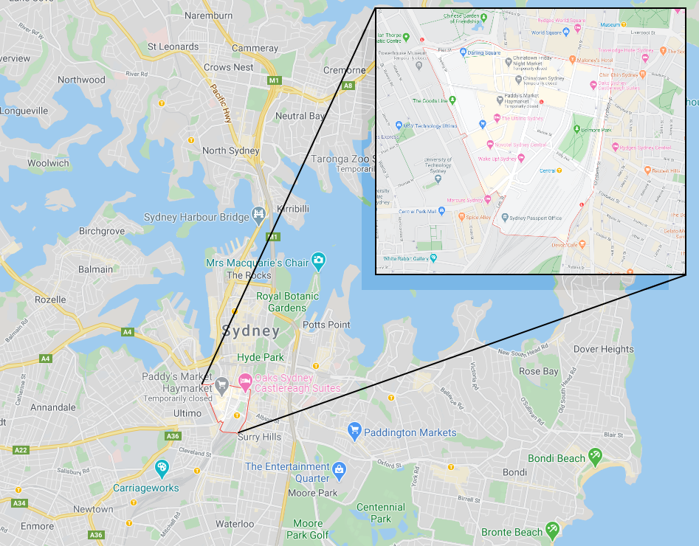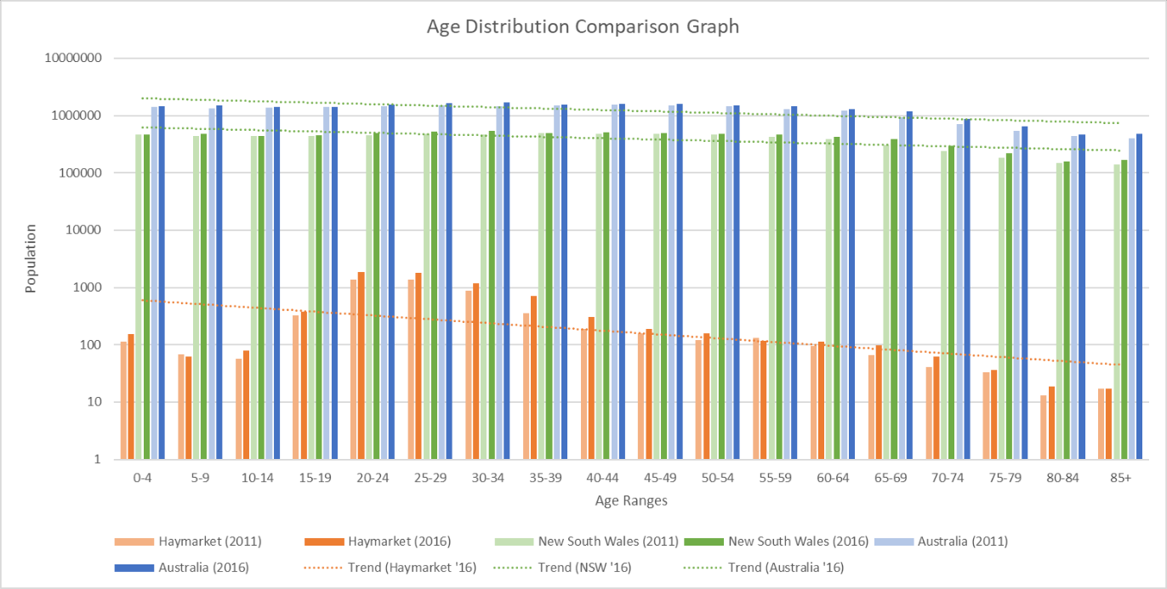

Figure . - Age Distribution Comparison Between Haymarket, NSW, and Australian statistics in 2011 and 2016 (Australian Bureau of Statistics, 2016)

Figure . - Haymarket, NSW, and Australian population ancestry comparison (Australian Bureau of Statistics, 2016)

# Methodology

This report’s data was sourced from various official and secondary sources ranging from the Australian government’s census data, text resources, and many online articles reporting on the topic. All data has been transformed in order to showcase the demographic challenges that are present in the Haymarket suburb in Sydney, NSW and propose possible solutions.

## Limitations

The limitations for this report include the lack of variety in statistics for the Haymarket suburb, time management and limit, lack of on-site data collection and surveying, old statistics and resources dating 2016 and older, and possible changes occurring between the approximately five-year gap between the latest census data and this report.

# Data Analysis

This section will analyse the demographic data for the Haymarket region in order to identify and analyse the demographic challenges in the area.

## Population Structure

Haymarket had a total population of 7,353 in 2016 living in the suburb, with a notable growth in 2011 from 5,376 persons, up 36% to 2016 (Australian Bureau of Statistics, 2016) as shown in Figure 2.3. Age ranges between 19-29 have a higher percentage compared to all the other age ranges (Figure 2.1); they represent approximately 48% of the entire Haymarket population when conglomerating ages between 19-29. The Greater Sydney region average for the aforementioned age groups are significantly lower than the local Haymarket count, as shown in figure 2.3. This is also supported by the low count of families with children in the area, which occupies around 10% of the population (Australian Bureau of Statistics, 2016), as those age categories would be comprised of primarily university students (Figure 2.2). The increasing population, both nationally and locally, will impact the age pyramid by emphasising the spike in the 19-29 age groups more than the aging, working and dependent age groups (Figure 2.1, 2.3).

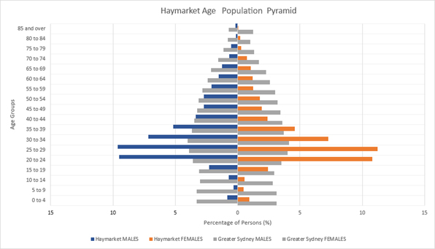

Figure . - Haymarket and Greater Sydney Age Population Pyramid Comparison (Australian Bureau of Statistics; .id, 2016)

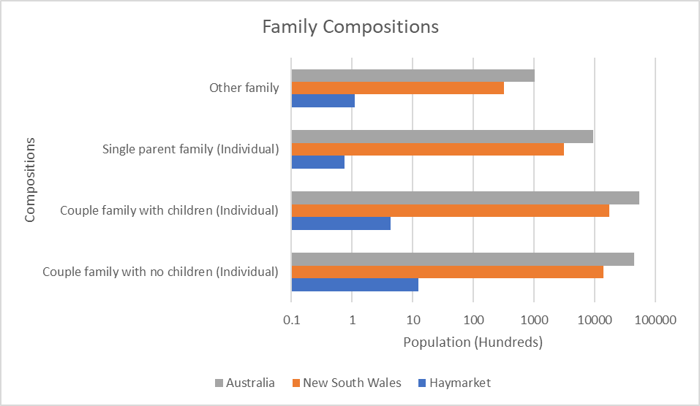

Figure . - Haymarket, NSW, and Australian Family Composition Comparison (Australian Bureau of Statistics, 2016)

Figure . - Haymarket, and Australian Population over time comparison (Australian Bureau Of Statistics, 2020) (Population Pyramid; United Nations, 2020)

## Income and Employment

With the population spiking between the ranges of 20-24 and 20-29 (Figure 1.2, 2.1), it is safe to assume the majority of the working population in this suburb are students, and unlikely to be apprentices or tradies due to the nature of the area and educational facilities in the vicinity. Majority of the population in Haymarket, when asked about their occupation, reported working in part-time jobs. Approximately 2000 residents work part-time (Australian Bureau of Statistics, 2016). It is evidently higher than the state and national average which has around double full-time workers than part timers (Australian Bureau of Statistics, 2016). Students would be more likely to apply and work at a part-time job while studying at a tertiary institute, both as an entry way to the workforce and to earn money for accommodation, food, and recreational items and activities. The most common industry that many would expect for students that is shown in the Haymarket region is in the hospitality industry (Australian Bureau of Statistics, 2016); cafes and restaurants are jobs many youth initially go for as they start working away from their parentals as it is the best way to kickstart a job in the workforce.

## Housing / Dwellings

Accommodation for university students are common within the Haymarket suburb due to its proximity to everything around the Sydney CBD, especially the Universities and libraries. Having virtually no distance between a student’s accommodation and university reduces the wasted time on travelling that many other students must take, such as students living in the western suburbs of New South Wales. Figure 2.4 shows the distribution of the local population currently attending universities while figure 2.5 shows the population density in the same local area. Sectors surrounding the University of Technology Sydney have a considerably higher population density, especially with the correlation with those attending universities living in this region (Figures 2.4, 2.5).

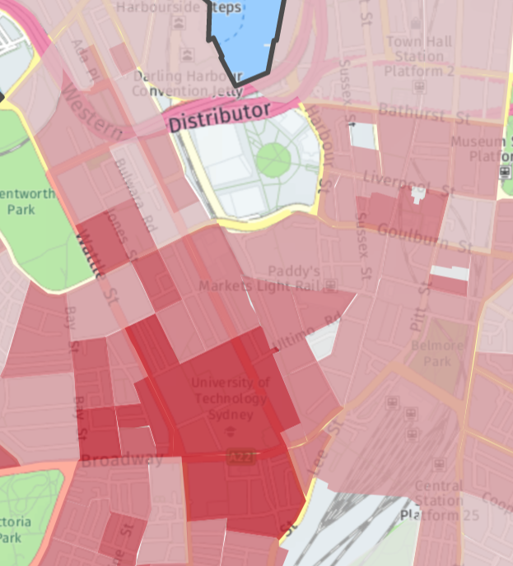

Figure . - Distribution of Population Attending Universities in Haymarket, NSW

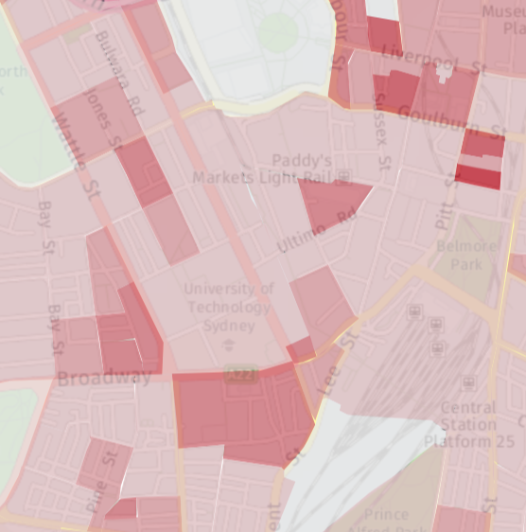

Figure . - Distribution of Population Density in Haymarket, NSW

# Impacts of the Demographic Challenge

This section will discuss the impacts caused by the demographic challenges mentioned previously.

## Housing Affordability

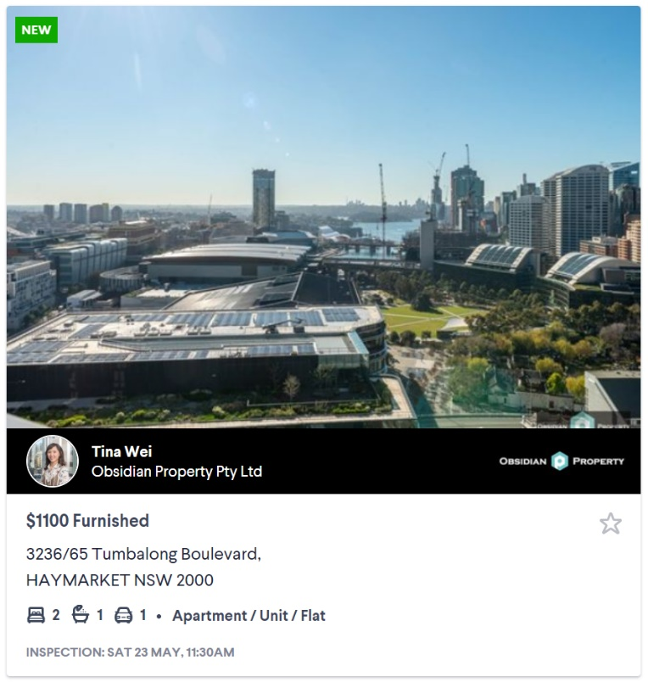Housing in the Haymarket region, and surrounding CBD suburbs, consists of many high-rise apartment buildings in an attempt to increase housing capacity in the city. Even with these attempts, the housing market has been in high demand in the CBD and surrounding regions as it would be close to all the amenities, facilities, and workplaces located in the city area. Due to this, the cost of the aforementioned apartments is above the national median cost of an apartment in Australia, excluding metro areas (Rent.com.au, 2020). Furthermore, Sydney tops the median rental cost for an apartment for similar Australian metropolitan areas: $450 national metro median compared to the $500 for Sydney. Haymarket, in particular, has a median price for a single bedroom apartment hovering around $660 (Domain.com.au, 2020). Considering the population in this area consists of primarily university students, the prices shown here on figure 3.1 for a two-bedroom apartment are exceedingly high for students to afford without external support or co-funding. Even one-bedroom apartments hover between $600-$800 which is significantly higher than most student paying jobs could afford. Without affordable housing, or third-party support, most students would find it difficult to be accommodated near the universities they are studying at.

Figure . - Top Apartment listing for the Haymarket, NSW area (Domain.com.au, 2020) (Wei, 2020)

# Conclusion and Proposed Actions

Haymarket, with its primarily student population, is a Sydney CBD suburb for students needing quick access to facilities, services, and tertiary institutes. This, however, is not normally sustainable for a student, with a typical student job, to afford, due to the natural higher cost of living in or near a metro area. Housing is especially difficult to maintain without external support, such as parental, governmental or institutional handouts; the alternative for many students would be to co-live or find accommodation further out of the city, possibly increasing travel time significantly. Without any changes, lower-income students would not be able to have equal opportunity to facilities and services.

## Third-Party Support/Funding

Supporting students through external funding or handouts could supplement students’ rental costs where necessary. Governmental agencies, tertiary institutes, or parental assistance could help supplement students with rental payments which are hard to afford with a student income. Queensland government already enables students to be eligible for the government rental expense assistance schemes (Queensland Government, 2020), which assists those who are unable to pay their rent. The application of this method to student populated metro areas will provide students with the necessary accessibility to related infrastructure, resources, services, and facilities. Avoiding exploitation of this system would be to implement fixed supplementary funds for all applicants in order to avoid students renting unnecessarily costly rental properties. Alternatively, tertiary institutes can provide scholarship programs for external housing funds if the students are renting in the vicinity of the institute, provided that the exploitation of the system is handled in a similar way as the previous method. Both methods would assist in the reduction of housing and cost of living for students with low-income jobs.

Table . - PMI Table for the Third-Party Support/Funding Proposed Action

|  |  |  |
| --- | --- | --- |
| Positive | Negative | Interesting/Other |
| * Students with low incomes will retain access to facilities, services, and resources without long commuting times or distances * Students can divert some funds towards other living essentials, or wellbeing costs * Encourages and supports rural, regional, and suburban students moving closer to tertiary institutes to take advantage of the available resources | * Funds must be diverted from another location therefore cannot be spontaneously generated * Tertiary institutes are not inclined to divert funds into fixed rental assistance compared to research and development funding * Exploitation of the system through expensive apartments or other loopholes would be unfavourable to tertiary institutes and governmental agencies * Strict rules and requirements may be unfavourable to maintain for the tertiary institutes and governmental agencies while being a nuisance for the students | * Housing prices in the Haymarket area and surrounding suburbs can and will fluctuate depending on the economy, local housing market, and local infrastructure development and accessibility. |

## Housing In-filling/Efficiency

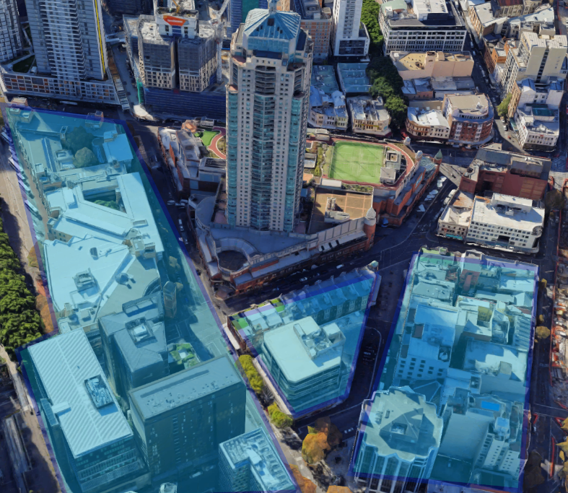The process of urban infilling is the repurposing of land within an urban environment, such as a house in Sydney being repurposed for dense housing like apartment buildings. Repurposing or greatly improving the efficiency of already existing apartments or buildings would greatly improve both capacity and pricing for Haymarket. Reconstruction of buildings, as shown in Figure <>, into apartment high-rises can significantly improve the capacity at which Haymarket can accommodate students. In-filling is a common practice for cities grappling urbanisation and its effects, primarily urban sprawling. Using in-filling and efficient land use through apartment buildings can greatly assist in the need for long distance commuting and lack of infrastructure, services, resources, and facilities.

Figure . - 3D Aerial Representation of Haymarket, NSW with Highlighted Zones that could be redeveloped for apartment high-rises (Google Maps, 2020)

Table . - PMI Table for the Housing In-filling/Efficiency Proposed Action

|  |  |  |
| --- | --- | --- |
| Positive | Negative | Interesting/Other |
| * Reduction of the local cost of living for students with low income * Limited destruction of environmental areas or greenery spaces * Increased housing capacity | * Possible destruction or inability to infill with heritage buildings, old buildings listed by the Commonwealth as protected * Existing services, facilities, and infrastructure would be hurt by the interruptions caused by reconstruction/development * Significant upfront costs for materials, workforce/labour, and permits * Cost for relocation of the affected residents | * Use of available space to increase the housing efficiency in Haymarket (as highlighted in Figure 4.1) can bring the opportunity to expand the services, and facilities provided near the Paddy’s Market and Darling Square; expansion of these areas could increase resources for students, businesses, and visitors |

## Bibliography

atlasId; Australian Bureau of Statistics. (2016). *City of Sydney Social Atlas*. Retrieved from id Community: https://atlas.id.com.au/sydney

Australian Bureau of Statistics. (2016). *2016 Census Quickstats*. Retrieved from Australian Bureau of Statistics: https://quickstats.censusdata.abs.gov.au/census_services/getproduct/census/2016/quickstat/SSC11877?opendocument

Australian Bureau Of Statistics. (2020). *Census Quickstats*. Retrieved from Australian Bureau Of Statistics: https://quickstats.censusdata.abs.gov.au/census_services/

Australian Bureau of Statistics; .id. (2016, August). *Haymarket Age-Sex Pyramid*. Retrieved from id community: https://profile.id.com.au/sydney/age-sex-pyramid?WebID=190&EndYear=2011&DataType=UR&BMID=20

Domain.com.au. (2020, May). *2839 Properties for rent in Haymarket, NSW, 2000*. Retrieved from Domain.com.au: https://www.domain.com.au/rent/haymarket-nsw-2000/

Google Maps. (2020, April). *Google Maps*. Retrieved from Google Maps: https://www.google.com/maps/

Lendlease. (2020). *Then, And Now*. Retrieved from Darling Square: https://www.darlingsq.com/stories/then-and-now/

Paddys Market. (2019). *Paddy's Haymarket* . Retrieved from Paddy's Market: https://paddysmarkets.com.au/paddys-haymarket-2/

Population Pyramid; United Nations. (2020). *Australia*. Retrieved from PopulationPyramid: https://www.populationpyramid.net/australia/

profileId. (2019). *Haymarket Area Profile*. Retrieved from idcommunity: https://profile.id.com.au/sydney/about?WebID=190

Queensland Government. (2020, Feburary 5). *Student Accomodation*. Retrieved from Queensland Government: https://www.qld.gov.au/housing/renting/student-accommodation

Rent.com.au. (2020, January 8). *Rent.com.au rental market snapshot: December 2019*. Retrieved from rent.com.au: https://www.rent.com.au/blog/rental-snapshot-december-2019

Wei, T. (2020, May). *3236/65 Tumbalong Boulevard Haymarket NSW 2000*. Retrieved from Domain.com.au: https://www.domain.com.au/3236-65-tumbalong-boulevard-haymarket-nsw-2000-13457617