Building a dictionary of synonyms by games

Juraj GEMEĽA[1]*

Slovak University of Technology in Bratislava

Faculty of Informatics and Information Technologies

Ilkovičova 2, 842 16 Bratislava, Slovakia

gemela.juraj@gmail.com

**Abstract.** In these days, building a vocabulary requires a lot of manual work by experts, because the computer still cannot recognize semantic information between words. And this type of work is also very time-consuming. Therefore, our goal is to create a game that will collect synonymous relationships between pairs of words. This game will be played by people so we will use the power of the crowd to create a dictionary.

# Introduction

In articles [1, 2], the author came up with the idea that the time spent playing games could be used to solve problems without the player realizing it. With this concept came games with purpose which combine pleasant with useful and they are designed to solve problems in a funny way.

An important aspect of making the task a fun experience is to add game features to the system where task is solved. By adding these gaming elements will make the games more attractive and this is also known as Gamification [3].

In this work, we focused on creating and evaluating synonymous relationships using voting game with purpose, as the search for semantic relationships between words is so demanding [4].

# Proposed system

Our goal is to obtain evaluation of synonymous relationships stored in vocabulary. As an input, we need a database of relationships between the words. To get this, we have created a crawler and we have filled the database with the relationship from one of the online synonymous dictionaries. We have saved only relationships and not the numeric distance between the synonyms. We do not need these distances because by evaluating these relationships by players, we want to get our own order of individual synonymous relationships. It is also possible to use a table of semantic relations where it is not guaranteed that the words are synonymous. This adjustment would require more respondents to correctly identify the synonymous relationship between words.

We have displayed the sequence of steps in diagram (Figure 1).

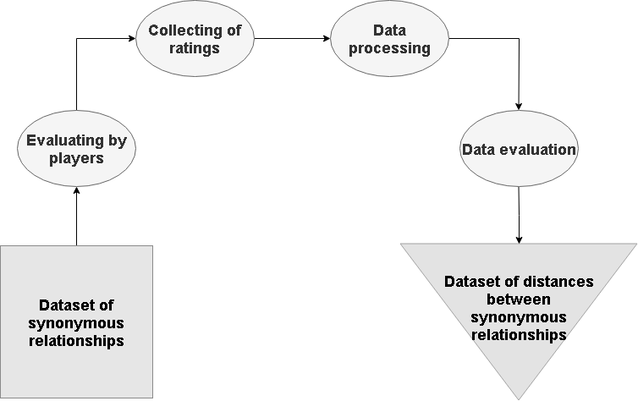

Figure 1 Process diagram for our application

To make the game more attractive, we have chosen a historical archery background for the game: player's interaction will be based on bow shooting to targets. His mission is to shoot (click) on a certain number of targets where the words will be displayed. The player has to consider which of displayed words have the strongest synonymous relationship and marked them in correct order. This task is unique for each round and it is assigned at the beginning. The player will also receive the possible words from which he will be able to choose one. The choice is then evaluated by experiences based on previous responses of other players and then the possible bonuses will be calculated.

In addition, we added more game elements to motivate the players and make the game more enjoyable:

1. Rewarding – as we already mentioned, the players get experience from selecting words, for which they increase their level.
2. Tree of skills – there are four skills, that can be improved by players based on their achieved levels. They get one point for each level, and for the five points, they can improve the level of one of the skills. Maximum level of skill is five. Here is a list of skills that are in game:
   1. Power – will determine the number of arrows in each round. At the same time, by enhancing this skill, you will get a new visual for arrows as well as successes for the collection
   2. Visibility – by upgrading, player unlocks a greater number of targets in each round. Thanks to this skill, he can also get two achievements in the collection.
   3. Stamina – this feature provides an increase of time that is given to player each round and two successes to the collection.
   4. Smartness – with this attribute, the player gets bonus points to experience from select words. He can also get two achievements to the collection.
3. Collection of achievements – players have the opportunity to get achievements for reaching the circumstances. Two of the categories are displayed along with the name of the player in the rankings using the icon. The other two are already in the rankings, so we do not want to show them implicitly. Players can get achievements in the following circumstances:
   1. achieving certain levels,
   2. getting a certain number of points per game,
   3. enhancement of attributes,
   4. achieving the specific number of synonymous evaluations.
4. Players rankings – this indicator serves as player comparison. It displays the statistics of the top five players and compares them with the statistics of currently logged player.

On the Figure 2, we can see the design of the game. Our goal was to create a simple design to achieve the best possible usability. We focused on learnability and efficiency. All major features are divided into four buttons at the top and are available in each mode. This will help players navigate quickly through all the options.

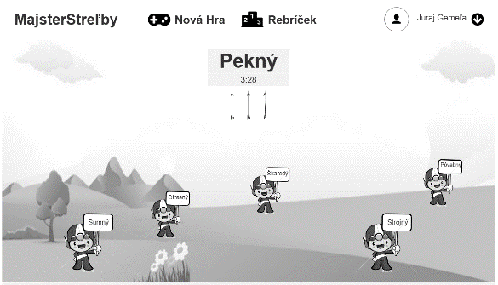

Figure 2 Design of the gaming part of the application

# Conclusions and future work

Our application focuses on evaluating and creating synonymous relationships using power of the crowd. Then we create a synonym dictionary using these data.

In the future, the game could be modified to focus not only on synonymous relationships, but to collect other word-to-word relationships. This would result in a variety of tasks and in increasing the gaming community. Even greater use is possible for game elements that are in the game. Adding further features could provide additional motivation for players.

References

1. VON AHN, Luis. Games with a purpose. Computer, 2006, 39.6: 92-94.Friedman, A.D., Menon, P.R.: Theory and Design of Switching Circuits. Computer Science Press, Inc., (1975).
2. VON AHN, Luis; DABBISH, Laura. Designing games with a purpose. Communications of the ACM, 2008, 51.8: 58-67.
3. DETERDING, Sebastian, et al. Gamification. using game-design elements in non-gaming contexts. In: CHI'11 extended abstracts on human factors in computing systems. ACM, 2011. p. 2425-2428.
4. BOLLEGALA, Danushka; MATSUO, Yutaka; ISHIZUKA, Mitsuru. Measuring semantic similarity between words using web search engines. www, 2007, 7: 757-766.

1. * Bachelor degree study programme in field: Informatics  
   Supervisor: Dr. Miroslav Blšták, Institute of Informatics, Information Systems and Software Engineering, Faculty of Informatics and Information Technologies STU in Bratislava