What are the main transistor applications, as expressed during the video?
........................................................................................................................................................................................................................................................................................................................
What had been used, before the transistor invention, to amplify electrical signals?
Why it was not fully satisfying?
........................................................................................................................................................................................................................................................................................................................
Put these images in the correct order: write the corresponding date near each photo.
1947, 1926, 1934, 1906
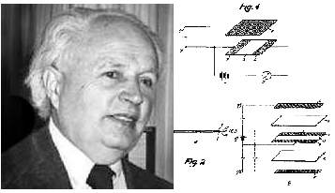
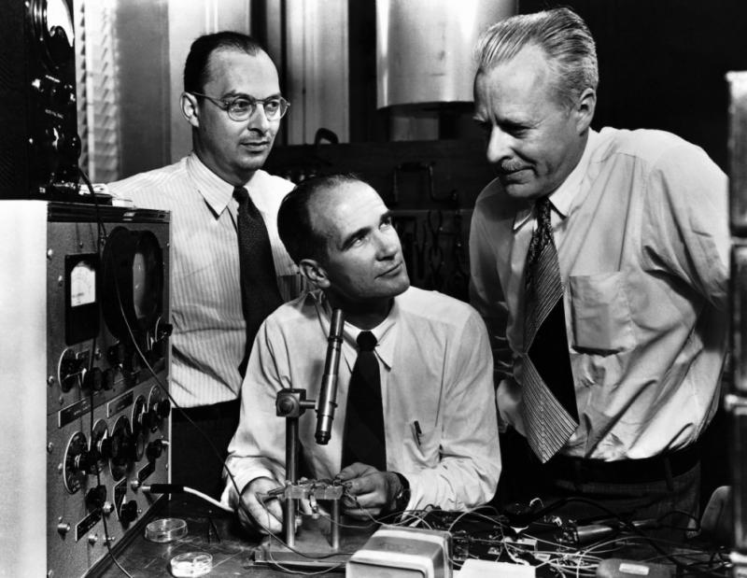

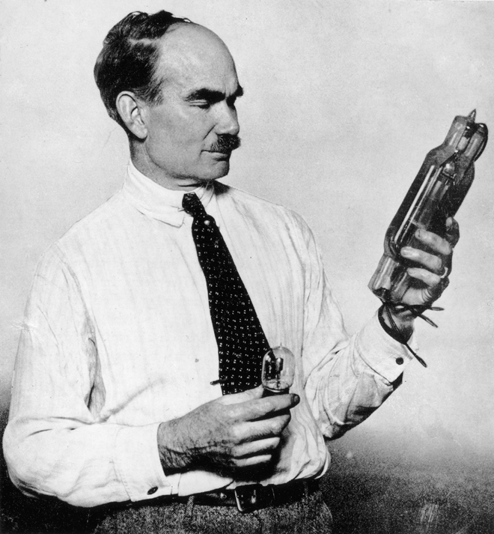
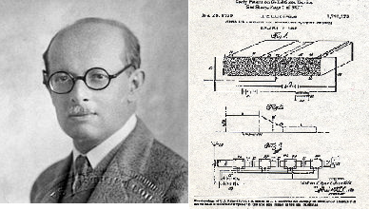
Bardeen · Shockley · Brattain Heil

Lilienfeld De Forest

Describe the different components of the original transistor:
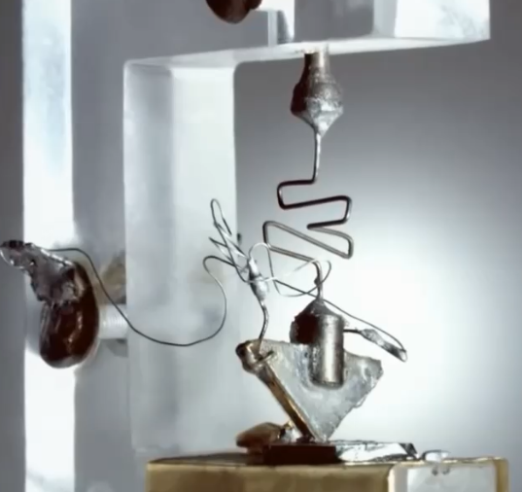
....................................................................................
....................................................................................
....................................................................................
.................................................................................... .................................................................................... .................................................................................... ....................................................................................
Transistor Structure
Complete the sketch with all the information you can remember from the video.
(holes, electrons, net charge, names, …)
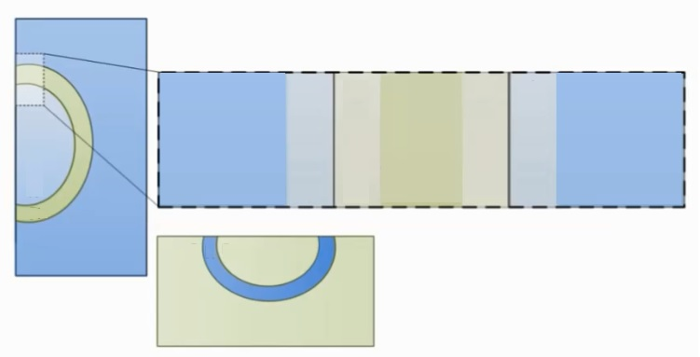

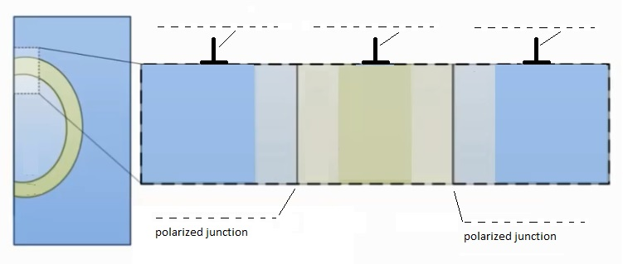
Complete with the names of the three terminals and with the way in which the junctions are biased inside the video.

Explain which paths electrons can follow inside the transistor and draw them on the sketch:
- ..................................................................................................................................................
- .................................................................................................................................................
- .................................................................................................................................................
Transistor structure and schematic symbols.
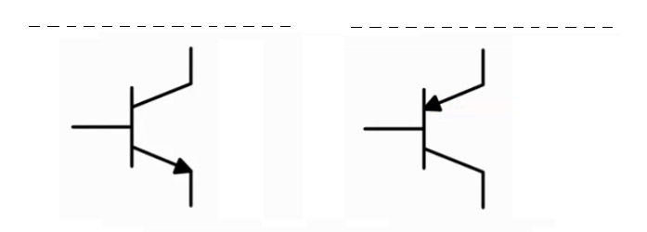
Explain the meaning of these two symbols: what the arrows stay for?
...................................................................................................................................................

Trace on the design:
- The position of N and P doped regions
- The name of each terminal
- The direction which electrons move in (blue)
- The direction which current flows in (red)

Common Emitter Circuit




