
Approved by:
Thierry GARNIER
Tel.: +33 (0)2 99 27 92 92
E-mail: thierry.garnier@iwedia.com

Written by:
Fabien Dutertre
Tel.: +33 (0)2 99 27 92 92
E-mail:fabien.dutertre@iwedia.com

Viewed by:
Philippe POHER
Tel.: +33 (0)2 99 27 92 92
E-mail: philippe.poher@iwedia.com

CHAL Porting Guide

V1.8

SUMMARY

SUMMARY 2
1 Document history 3
2 Introduction 4

2.1 Reference documents 4

2.2 Overview 6

2.3 Definitions acronyms and abbreviations 6
3 OVERVIEW 7

3.1 CHAL Definition 7

3.2 CHAL Architecture 7

3.3 CHAL Module 8
3.3.1 TBOX 8
3.3.2 TKEL 9
3.3.3 TDAL Definition 9
3.3.3.1 Modules list 9
3.3.3.2 Revisions history 12
3.3.4 Architecture 14
3.3.4.1 Overview of chal architecture STB and DRTV 15
3.3.4.2 Overview of chal architecture IDTV 16
3.3.4.3 Digital TDALs Development process 17
3.3.4.4 Analog TDALs Development process 19

3.4 Need for development 20
4 Porting Steps 21

4.1 Introduction 21

4.2 Plan 21

4.3 Adapt the makefiles and Customisation 21

4.4 Develop the TDAL modules 22
4.4.1 Introduction 22
4.4.2 The module initialization 22
4.4.3 Develop the standalone modules 22
4.4.4 Develop second-level modules 23
4.4.5 Develop the third-level modules 23
4.4.6 Develop the analog modules 23
5 Validation 24

5.1 the chalvalidator test framework 24

5.2 test along the development 24

5.3 the final test 24
6 Conclusion 25

Document history
Ver. | Date | Author | Changes
1.0 | 2006-04-24 | RME | Creation
1.1 | 2006-10-12 | DUF | Revision
1.2 | 2008-01-10 | GS | Do some reorganisation.  Update with TDAL v2.0 changes.  Replace TDAL_TSOUT by TDAL_TS.
1.3 | 2008-10-30 | TGA | Add analog TDALs
1.4 | 2008-10-31 | PPO | Add analog process  Fixe some errors
1.5 | 2009-02-06 | YP | Update TDAL_GFX, TDAL_DISP, TDAL_AV
1.6 | 2009-07-08 | TGA | Update TDALs versions ; Add TDAL_SEC
1.7 | 2009-10-13 | PPO | Add architecture for Idtv
1.8 | 2009-11-17 | TGA | Add TDAL_HDMI_CEC

Introduction

Reference documents
The following documents were used to write this document:

Document | Version | Title
[1] | 2.0 | TKEL Specifications
[2] | 2.1 | TBOX Specifications
[3] | 1.0 | Test Manager
[4] |  | TDAL Specifications
[4.1] | 1.7 | TDAL_AV Specification
[4.2] | 1.6 | TDAL_OUTPUT Specification
[4.3] | 2.0 | TDAL_AVS Specification
[4.4] | 2.3 | TDAL_DMX Specification
[4.5] | 3.1 | TDAL_DMD Specification
[4.6] | 2.0 | TDAL_FLA Specification
[4.7] | 2.2 | TDAL_GFX Specification
[4.8] | 2.0 | TDAL_KBD Specification
[4.9] | 2.1 | TDAL_FP Specification
[4.10] | 1.1 | TDAL_TS Specification
[4.11] | 2.0 | TDAL_VBI Specification
[4.12] | 2.0 | TDAL_UART Specification
[4.13] | 1.1 | TDAL_PTSM Specification
[4.14] | 1.7 | TDAL_DISP Specifications
[4.15] | 1.1 | TDAL_FS Specifications
[4.16] | 1.2 | TDAL_COMMON Specifications
[4.17] | 2.0 | TDAL_NVM Specifications
[4.18] | 2.4 | TDAL_CI Specifications
[4.19] | 1.4 | TDAL_HDMI Specifications
[4.20] | 1.4 | TDAL_RPC Specifications
[4.21] | 0.2 | TDAL_SMC Specification
[4.22] | 1.1 | TDAL_DESC Specification
[4.23] | 0.2 | TDAL_CRYPT Specification
[4.24] | 1.2 | TDAL_ANA_VID Specification
[4.25] | 1.0 | TDAL_ANA_AUD Specification
[4.26] | 1.1 | TDAL_ANA_INPUT Specification
[4.27] | 1.0 | TDAL_PANEL Specification
[4.28] | 1.0 | TDAL_SPEAKERS Specification
[4.29] | 1.0 | TDAL_VBI_SLICER Specification
[4.30] | 1.0 | TDAL_SCART_INPUT Specification
[4.31] | 1.2 | TDAL_HDMI_IN Specification
[4.32] | 1.0 | TDAL_HDMI_CEC Specification
[4.33] | 1.0 | TDAL_HDMI_SEC Specification

Overview
CHAL is the acronym of Comedia Hardware Abstraction Layer. Comedia application relies on this layer. Purpose of this documentation is to describe all information needed and detail how to develop and customize a CHAL on a new platform.
This document doesn’t replace detailed module specification (refer to the CHAL Specification [4] document). In the next overview chapter is described the whole set of document and sources you should need.
In order to help user to develop its own CHAL, this documentation describes several steps to make the process easier.

To validate each step, and the final portage, there is a Test Tool called chalvalidator . Each step can be validated with this tool. (refer to the TestManager [3] document).

Definitions acronyms and abbreviations
CHAL | Comedia Hardware Abstraction Layer
TKEL | Thin Kernel Encapsulation Layer
TBOX | ToolBox
TDAL | Thin Driver Abstraction Layer
JTAG | Joint Test Action Group is the usual name used for the IEEE 1149.1 standard entitled Standard Test Access Port and Boundary-Scan Architecture for test access ports used for testing printed circuit boards using boundary scan
OS | Operating System
PIP | Picture In Picture
PAP | Picture And Picture
STB | Set Top Box
DRTV | Digital Ready TV (DVB plug-in into analog TV) ; aka OBM
IDTV | Integrated Digital TV (one chip)
OBM | On board Module (aka DRTV)

OVERVIEW

CHAL Definition
The CHAL is the abstraction layer between the Comedia and the chipset driver software. Iwedia Technologies has defined a generic driver API so as to render the comedia core libraries portable on many hardware platform.

CHAL Architecture
CHAL is basically divided into three parts : TBOX, TKEL and TDAL.
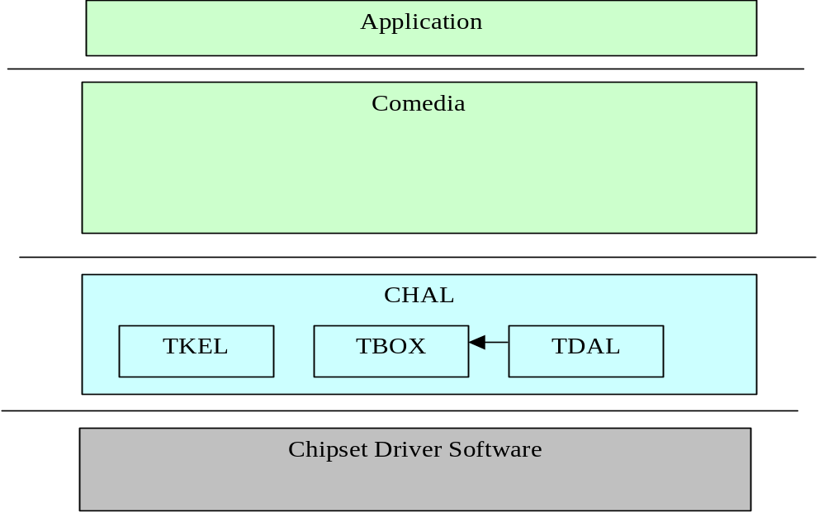
The following CHAL modules must be developed on the chipset driver software:
- TBOX: It is the toolbox part. Its purpose is to declare some helpful functions and macros, in order to log messages, measure times, etc.
- TKEL: It is an abstract layer for the runtime operation system
- TDAL: It is the abstract layer for the driver. Each functional zone (audio/video, osd, demux, tuner, etc.) is covered by one module.

CHAL Module

TBOX
TBOX is the toolbox module. It is used to add debug traces into the code and to get input from user for test applications.
It contains a set of macros used to equip in the code:
- mTBOX_SET_MODULE: at the begin of each file to indicate the module concerned
- mTBOX_FCT_ENTER: at the begin of the function
- mTBOX_RETURN: replace normal calls to return
- mTBOX_TRACE: output made of format string and variable number of arguments, associated to module and level (bitmask):
- mTBOX_INIT_MOD_TRACE: to be called at init to activate logs of given module and levels
- mTBOX_PRINT: systematic output
- mTBOX_ASSERT: if given value is not correct then print error message
Some macros are also defined to get input:
- mTBOX_GETCHAR
- mTBOX_GETSTRING

The traces are included only if the TRACE is defined in the line of the compilation (e.g. –DTRACE=1). TRACE can take two values:
- 1: output /input are made on the default port (For example, it could be the debugging JTAG port of a platform).
- UART: output/input are made on the serial port.
User API allows to define a level of trace to debug and trace all traces, or critical traces only.

(Refer to the TBOX Specifications [2] document)

TKEL
TKEL provide an OS independent kernel abstraction (exemple : OS20, OS21, Psos, Linux, …).
It covers the following API for:
- Processes and task management : the task API in TKEL
- Synchronization tools : mutex, semaphores
- Critical sections
- Communication tools: queue API
- Memory management: a TKEL_alloc and a TKEL_free function.
- Timer management : set up timer event or timer callback
- API contains a transversal notion of event, that can be sent between the TKEL tasks. These events can also be used to received queues event, or to receive timer event.
TKEL is only used by the Comedia and should not be used by the TDAL modules (they call the OS directly).
(Refer to the TKEL Specifications [1] document)

TDAL Definition
TDAL is the driver abstract layer. This API is obviously the widest. It covers all the modules needed by Comedia. These modules define an API for each functionalities found in a DVB/MPEG product (STB and DRTV) and an IDTV product supported by Comedia libraries.

Modules list
The table below lists the TDAL modules and a short description:
TDAL module | Description
tdal_av | It is the interface to control the audio/video. It Offers many functionalities, of which : display still picture, play audio sample or beep sound, play live video and audio, subscription to audio/video events, control of audio volume, audio mute, video scaling, video freeze, management of video aspect ratio.
tdal_avs | It is the layer to control the video/audio format. The drivers are used to control and route several signals coming either from internal decoder or external peripherals (VCR, TV).
tdal_dmx | It is the layer to access the demultiplexer for section and PES filtering. The driver API provides a set of functions for demultiplexing digital television streams.
tdal_common | It contains the specific driver initialisation. It offers other useful API like a hard reset or a jump for the bootloader.
tdal_dmd | It is the module for the Front End (demodulator). It allows to start a tuning or a scanning, handles the front end states and notify the client.
tdal_fla | This module describes the functions used to access Flash non-volatile memory. Refer to the manufacturer’s data sheet for a complete explanation.
tdal_nvm | This module allows access to a non volatile memory device (NVRAM) such as EEPROM device. It can emulate a non volatile memory device in a flash block device if no NVRAM present in the system.
tdal_gfx | This is the graphic interface. Its functionalities are the graphic region management, the palette management, the transparency management, the bitmap drawing.
tdal_kbd and tdal_fp | This is the interface to manage the keyboard inputs from remote control (KeyBoard) and the module to access to the Front Panel.
tdal_ts | This module is the interface to manage transport stream routing, producing and consuming stages of a set-top-box especially in a PVR context. In a non PVR context, only a minimal implementation of tdal_ts is needed.
tdal_vbi | It is the layer interface for the Teletext VBI (Vertical Blanking Insertion).
tdal_uart | This module is the standard serial port. It manages the traces on the serial port if needed.
tdal_ptsm | It is the interface for the Presentation Time Stamp Module.
tdal_output | The aim of this module is to provide a complete interface between middleware and the video output stage low level driver of a set-top-box.
tdal_disp | The aim of this module is to provide a complete interface between middleware and the video display output stage low level driver of a set-top-box.
tdal_fs | The aim of this module is to provide a complete interface between middleware and the content of storage media. Media can be hard disk or memory key plugged on IDE interface or via USB.
tdal_ci | The aim of this module is to control Common Interface driver of the product. (DVB-CI and DVB-CI plus software)
tdal_sec | The aim of this module is to provide a complete interface between middleware and the security low level driver of a set-top-box (CI Plus software)
tdal_smc | The aim of this module is to control the smartcard driver of the product. (CA software)
tdal_desc | The aim of this module is to control the descrambler of the product. (CA and CI plus software)
tdal_crypt | The aim of this module is to provide an interface with hardware secured crypto algorithms (secured CA software)
tdal_rpc | The aim of this module is to provide a complete interface between Comedia DRTV product (aka OBM) which implements the remote procedures call (RPC) being able to be called via the protocol OBM and the Analogue TV (ATV) client application who call these procedures. (DRTV product)
tdal_hdmi | This module implements the HDMI protocol which implicates high level information management. It allows the application to have a video and audio output through the HDMI interface. It provides also a software API to configure some information needed by HDMI protocol. (STB software)
tdal_hdmi_in | This module implements the HDMI protocol which implicates high level information management. It allows the application to have a video and audio input through the HDMI interface. (IDTV software)
Tdal_hdmi_cec | This module provides a complete interface to exchange CEC messages with other HDMI CEC equipments
tdal_scart_input | This module provides an interface to manage the TV analog inputs for a SCART socket (IDTV software)
tdal_speakers | This module provides an interface to manage the audio outputs through the TV speakers (IDTV software)
tdal_panel | This module provides an interface to manage the video post processing of the TV panel (IDTV software)
tdal_vbi_slicer | This module provides an interface to manage the slicing of VBI data from an analog video source (IDTV software)
tdal_ana_input | This module provides an interface to manage the audio/video analog inputs acting as an analog source selector (IDTV software)
tdal_ana_vid | This module provides an interface to manage the video analog inputs acting as a decoder (IDTV software)
tdal_ana_aud | This module provides an interface to manage the audio analog inputs acting as a decoder (IDTV software)
(Refer to the TDAL_XXX_Specifications [4.] document)

Revisions history
There are two TDAL global revisions v1.0 and v2.0.
The v2.0 was created to allow the control of high definition multi-stream decoding/outputting new platform capabilities (such as PIP/PAP functionality, PVR) and a complete IDTV platform (analog part).
The table below lists the TDAL modules and their status in each revision and their presence in the different Comedia products (STB / DRTV / IDTV).
Some of the TDALs are optional depending of add-ons: PVR, embedded CA, DVB-CI stack, …

TDAL module | v1.0 | v2.0 | STB | DRTV | IDTV
tdal_ata  tdal_av  tdal_avs  tdal_ci  tdal_common  tdal_crypt  tdal_denc  tdal_desc  tdal_dmd  tdal_dmx  tdal_fla  tdal_fp  tdal_fs  tdal_gfx  tdal_hdmi  tdal_kbd  tdal_nvm  tdal_ptsm  tdal_rpc  tdal_sec  tdal_smc  tdal_ts  tdal_tsin  tdal_tsout  tdal_uart  tdal_vbi  tdal_disp  tdal_output  tdal_ana_input  tdal_ana_aud  tdal_ana_vid  tdal_vbi_slicer  tdal_speakers  tdal_panel  tdal_hdmi_in  tdal_hdmi_cec  tdal_scart_input | X  X  X  X  X  X  X  X  X  X  X  X  X  X  X  X  X  X  X  -  X  X  X  X  X  X  -  -  -  -  -  -  -  -  -  -  - | Removed  Updated  X  Updated  X  X  Removed  X  X  Updated  X  X  X  X  X  X  X  X  X  X  X  X  Removed  Removed  X  X  Added  Added  Added  Added  Added  Added  Added  Added  Added  Added  Added | -  X  X  Opt  X  Opt  -  Opt  X  X  X  X  Opt  X  Opt  X  X  X  -  Opt  Opt  X  -  -  X  X  X  X  -  -  -  -  -  -  -  X  - | -  X  -  X  X  Opt  -  Opt  X  X  X  X  Opt  X  -  X  X  X  X  Opt  Opt  X  -  -  X  X  X  X  -  -  -  -  -  -  -  X  - | -  X  -  X  X  Opt  -  Opt  X  X  X  X  Opt  X  -  X  X  X  -  Opt  Opt  X  -  -  X  -  X  X  X  X  X  X  X  X  X  X  X

For new TDAL development, it is MANDATORY to implement TDAL v2.0: the STB/DRTV/IDTV columns are relevant only for CHAL V2.0.

IMPORTANT NOTE on tdal_tsin and tdal_ts module:
For historical reason, some previous comedia products still rely on tdal_tsin module. Now Comedia stack uses tdal_ts which provides the same functionality as tdal_tsin. For new TDAL development, it implies to develop tdal_ts module and no more tdal_tsin module.

Architecture

Overview of chal architecture STB and DRTV

Overview of CHAL architecture IDTV
TDAL_VBI
TDAL_HDMI_CECD
TDAL_GFX
TDAL_HDMI_IN
TDAL_ANA_VID
TDAL_ANA_AUD
TDAL_AV
TDAL_PTSM
TDAL_DISP
TDAL_PANEL
TDAL_Output
TDAL_DMX
TDAL_TS
TDAL_CI
TDAL_SPEAKERS

TDAL_DMD

TDAL_ANA_INPUT
TDAL_VBI_SLICER

TDAL_SCART_INPUT

TDAL_COMMON
TDAL_FLA
TDAL_NVM
TDAL_KBD
TDAL_FP
TKEL
TDAL_UART
TBOX
TDAL_SEC
TDAL_DESC

Specific IDTV tdals

Digital TDALs Development process
The next picture gives the order of TDAL porting.
These different steps are described into Chapter 4
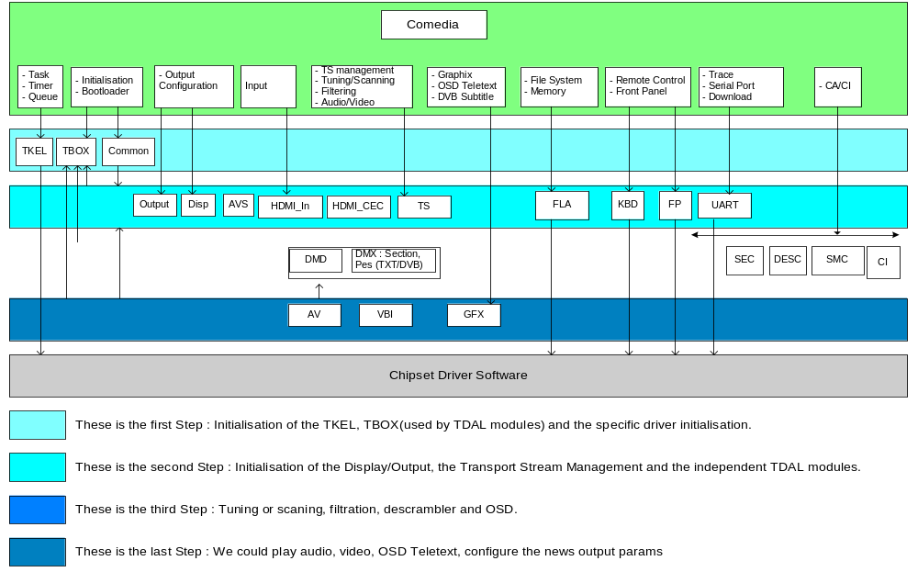

Analog TDALs Development process
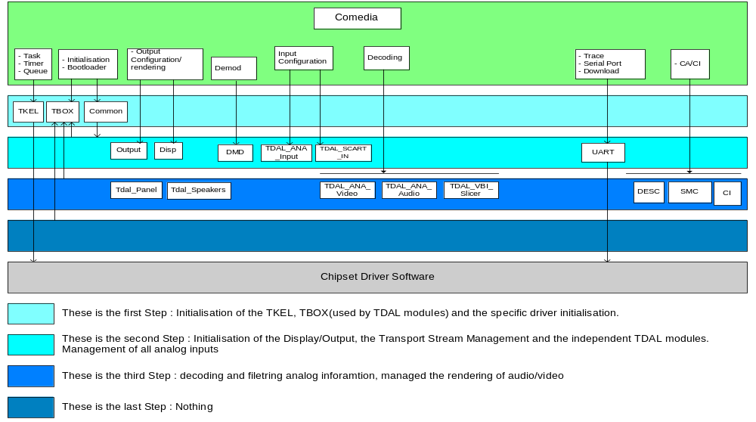

Need for development
To develop the CHAL, the CHAL API headers and the libraries of the chalvalidator are given.
- The CHAL API headers contains all the functions to implement.
- Chalvalidator libraries and makefiles containing :
- a directory named chaltests : sources of chal tests
- a directory named build : root makefiles to build products

Porting Steps

Introduction
This chapter describes the different steps to develop your CHAL.

Plan
There is an order you are advised to follow, in order to develop you CHAL :
- adaptation of makefiles in order to compile chalvalidator
- develop TBOX macros
- develop TKEL layer
- develop TDAL modules
First step is to adapt makefiles in order to compile, produce libraries and chalvalidator.
Second step is to have a TBOX header with proper traces, useful to see what happens during development.
Third step is to develop the TKEL layer.
Fourth step is to have the TDAL Modules implemented.

Adapt the makefiles and Customisation
The makefile in chaltest directory uses generic environment variables, and generic makefiles in the build directory. Adaptation should mainly consist in adapting the variable environnements to your platform (see [5] document for more detail).
From one hardware to another hardware some things may change. The memory organization may be different like the ram type (sdram, ddram), the cacheable area, the nvram settings.
The initialisation parts may be different for the uart, the tuner type / demod type…In the folder build/make, there are the *.mak files to configure the parts.

Develop the TDAL modules

Introduction
The suggested plan to develop module is to start with the most independent modules, and to complete with the ones that requires others modules to be tested properly.

The module initialization
An important thing to note is the module initialization aspect.
On some platforms, drivers are initialized at boot time, by the kernel and module configurations. In this case, most of the TDAL_xxx_Init function can be empty, or simply implements a code to initialize necessary utilitary data.
On other platforms, drivers are not initialized. It is the responsibility of the module to set up corresponding chips correctly. In this case, it can be a good idea to implement first all the TDAL_xxx_Init and TDAL_xxx_Terminate to set up the whole platform.

Develop the standalone modules
These modules are standalone, meaning they don't require other TDAL modules to be tested. They can be develop simultaneously.
The standalone modules are :
  - The UART: it could be the first one to be implemented, if it is a required output for traces.
  - The DMD/TS: the demodulator and TS routing are useful for many other tests, and particularly the DMX and AV modules.
Note: In Comedia porting environment, the TS module has got different level of implementation depending of the PVR functionality present or not in the product (see [4.10] document for more details).
- The DISPLAY/OUTPUT/HDMI: the display control and the digital encoder specifies the output encoding signal.
- The HDMI_CEC : this module allows CEC messages exchanges with other CEC equipments.
- The AVS: this module allows to route video/audio signal from digital encoders.
- The KBD/FP: these modules can be implemented alone
- The CI/DESC/SEC : the DVB-CI common interface and/or CI Plus TDALs can be implemented alone.
- The FLA/NVM: these two modules can be implemented together. They are all about non volatile memory.
Note: In Comedia porting environment, the FLA module is mandatory to flash the graphical resources that are needed by Comedia.

Develop second-level modules
The so called second level modules are those which require only standalone modules to be tested.
- The GFX: the OSD requires DENC and AVS to have proper output on TV screen. This module does not require AV.
- The DMX: the DMX requires DMD to have a signal and TS to have input stream.

Develop the third-level modules
Finally, you can develop modules which require many modules, standalone or second-level, to be tested.
- The AV: Audio/Video modules, which requires DMD, DMX, DISP, OUTPUT, AVS and TS to be properly tested.

Develop the analog modules
For IDTV product the analog TDALs can be developed together, from independent way of “digital” TDALs.

Validation

the chalvalidator test framework
Each step of development can be validated with the chalvalidator product. There is a document describing the test manager framework (refer to the TestManager [3] document).
After makefiles adaptation, the chalvalidator can be executed. Its verbose execution gives test results of each modules of the CHAL.

test along the development
All along the development, chalvalidator can be used to validate each part. The test root can be changed in order to see only the tests that are interesting for the actual development.

the final test
The final test consists in executing the whole test tree, interactively (cf TestManager [3]).

Conclusion
As said in the introduction, this document is the « overview » document, to help you start to port CHAL on a new platform in the best way.

