PayFlow Commerce: Q4 2024 Fraud Analysis

Overview
PayFlow Commerce closed Q4 2024 with $7.06M in revenue, driven by strong holiday demand. However, a critical vulnerability exposed a significant business risk. The fraud rate reached 7.03% of revenue ($496K potential exposure), resulting in $129K in actual fraud losses and reducing net margin to 5.2%.
To address this issue, I developed a fraud detection model and validated its performance through backtesting on 14,000 transactions. The model demonstrates 89% accuracy on unseen data and catches 74% of fraud cases when applied to production volumes, with projected quarterly savings of $143K that would improve net margin from 5.2% to 7.2%.

Key Risk Findings
Analysis revealed fraud activity increases 3.5x when the manual review team is offline:
Metric | Weekday | Weekend
Fraud Rate | 3.99% | 13.79%
Total Orders | 9,711 | 4,371
Fraud Count | 305 | 445

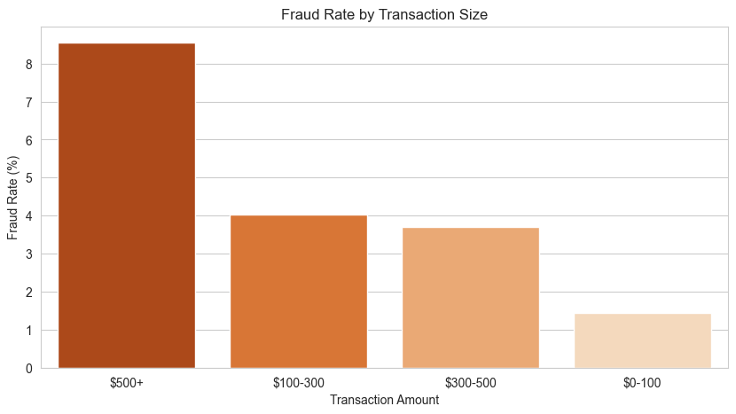

Key Insight: The weekend vulnerability drove 59% of total quarterly fraud (445 of 750 cases).
Additional Risk Factors:
New customers (<30 days) show 1.5x higher fraud probability compared to returning customers
Orders >$500 sustain 8.55% fraud rate vs 1.45% for orders <$100
Chargeback Rate: 90% of fraud cases result in chargebacks, confirming detection gaps

Machine Learning Solution
I built an XGBoost classification model to predict fraud probability at the transaction level and route high-risk orders to a manual review queue. The model uses six features: amount, weekend timing, transaction amount, customer account age, shipping-billing address mismatches, and high-value transaction flags.
Metric | Test Set (20%) | Full Dataset
Accuracy | 89.2% | 80.0%
Recall (Fraud Caught) | 41.3% | 74.0%
Transactions Flagged | 559 (20%) | 3,198 (23%)

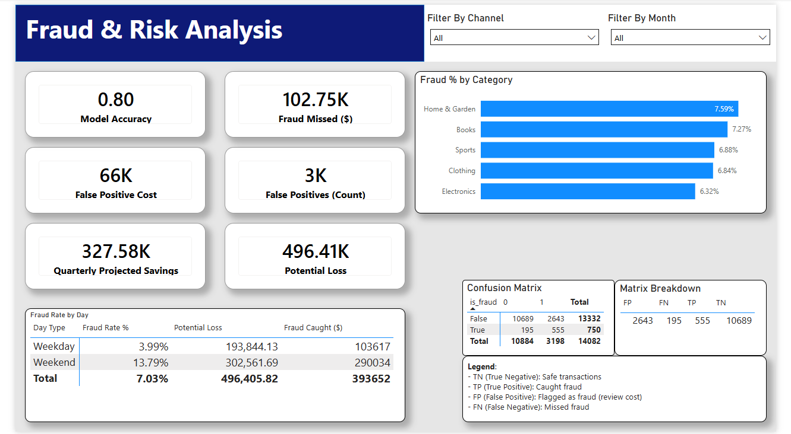

This strategy shifted from a reactive "hard block" rule to a proactive risk-based review queue. Transactions with fraud probability >50% route to analyst review. The 11.1% precision means 9 legitimate transactions are reviewed for every 1 fraud case caught. I find this acceptable given high-value fraud orders (avg $662).

Financial Impact
The model fundamentally changes fraud economics:
Metric | Value
Test Set - Fraud Detected | $41,036
Test Set - Review Cost | -$12,425
Net Test Savings | $28,611
Projected Quarterly Savings | $143,026
Annual Value Creation | $572,104

ROI: Every $1 spent on manual reviews saves $11 in fraud losses (1,000% ROI).

Recommendations
1. Deploy ML Review Queue: Implement the XGBoost model to route transactions with >50% fraud probability to dedicated analyst queue. Estimated implementation: 2-3 weeks.
2. Expand Weekend Coverage: Weekend fraud rate (13.79%) is the single largest controllable risk. Adding Saturday coverage would reduce exposure by $150K annually.

