Aedes aegypti transcriptome: resistance to fenitrothion
Xavier Grau-Bové

Experimental setup
12 samples divided in 4 groups (3 identical replicates per group). 6 fenitrothion-resistant samples from Angola (3 have been exposed to fenitrothion, 3 unexposed). 6 susceptible samples from laboratory strains (3 from New Orleans, 3 from Rockefeller). Sample classification:
Sample name | Sample group | Phenotype | Exposure | Location
s01_RUN | ResUnex | Res | Unex | Angola
s02_RUN | ResUnex | Res | Unex | Angola
s03_RUN | ResUnex | Res | Unex | Angola
s05_SNO | SusNewO | Sus | Unex | NewOrl
s06_SNO | SusNewO | Sus | Unex | NewOrl
s07_SNO | SusNewO | Sus | Unex | NewOrl
s08_SRO | SusRock | Sus | Unex | Rockef
s09_SRO | SusRock | Sus | Unex | Rockef
s10_SRO | SusRock | Sus | Unex | Rockef
s12_RFE | ResFeex | Res | Feex | Angola
s13_RFE | ResFeex | Res | Feex | Angola
s14_RFE | ResFeex | Res | Feex | Angola

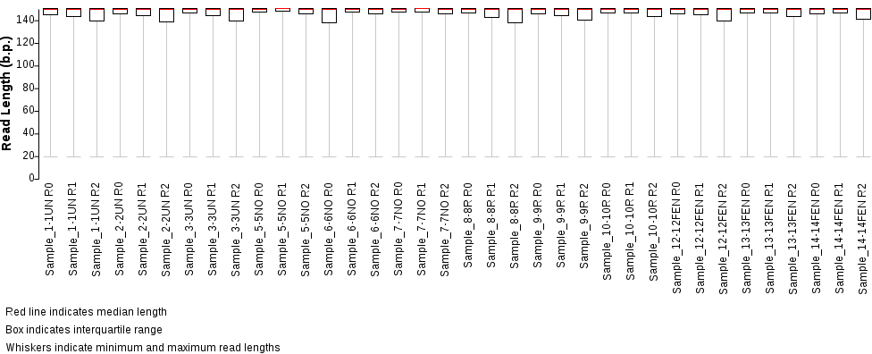
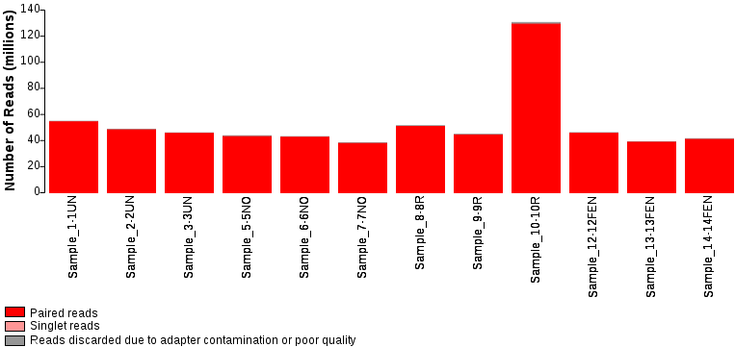
Excess of reads in s10 due to miscalculation of RNA concentration prior to library preparation. It does not seem to have an effect on final results.
Comparisons for all analyses – these:
- Independent comparisons of susceptible strains (SRO, SNO) to resistant-unexposed (RUN), to uncover genes that are constitutively differentially expressed in the resistant background (independently from specific exposure conditions).
- Analyse overlap of DE genes between SRO-RUN and SNO-RUN – same genes should appear.
- Compare resistant unexposed (RUN) – resistant exposed (RFE), to find genes that are DE upon exposure.
Insecticide info – Fenitrothion is an organophosphate. Insecticide resistance should be due to increased expression of detoxification enzymes (p450, GSTs?), or changes in acetylcholine receptors, etc.

Quantification: DE & AS
Gene expression – (i) maping of all RNA-seq samples with hisat; and (ii) quantification of expression levels of longest isoform per gene using salmon (TPM); then (iii) TPM matrix is loaded onto Deseq to produce matrix of normalized transcript counts, log2 fold-change between sample groups.
Alternative splicing – (i) same hisat mapping; (ii) assembly of sample-specific transcriptomes with isoforms using stringtie, followed by creation of pan-sample consensus assembly; (iii) quantification of expression levels using salmon (TPMs) using both all isoforms and longest isoform per gene; (iv) construction of sample-specific isoform and AS event catalogues using suppa; and (v) quantification of AS events using suppa too.

Gene expression: clustering of all samples
PCA analysis – Using the matrix of normalized transcript counts from Deseq, calculating Euclidean distances between samples. Good within-replicate clustering.
PC1 separates susceptible from resistant samples and is by far the most important. PC2 separates exposed from non-exposed. Oddly, RFE seems to be closer to susceptible samples than RUN, along PC1. PC3 highlights differences between SRO and SNO and it is not very relevant (not the focus of this analysis, although it can help contextualize the overlap differences in SRO/SNO-RUN comparisons),
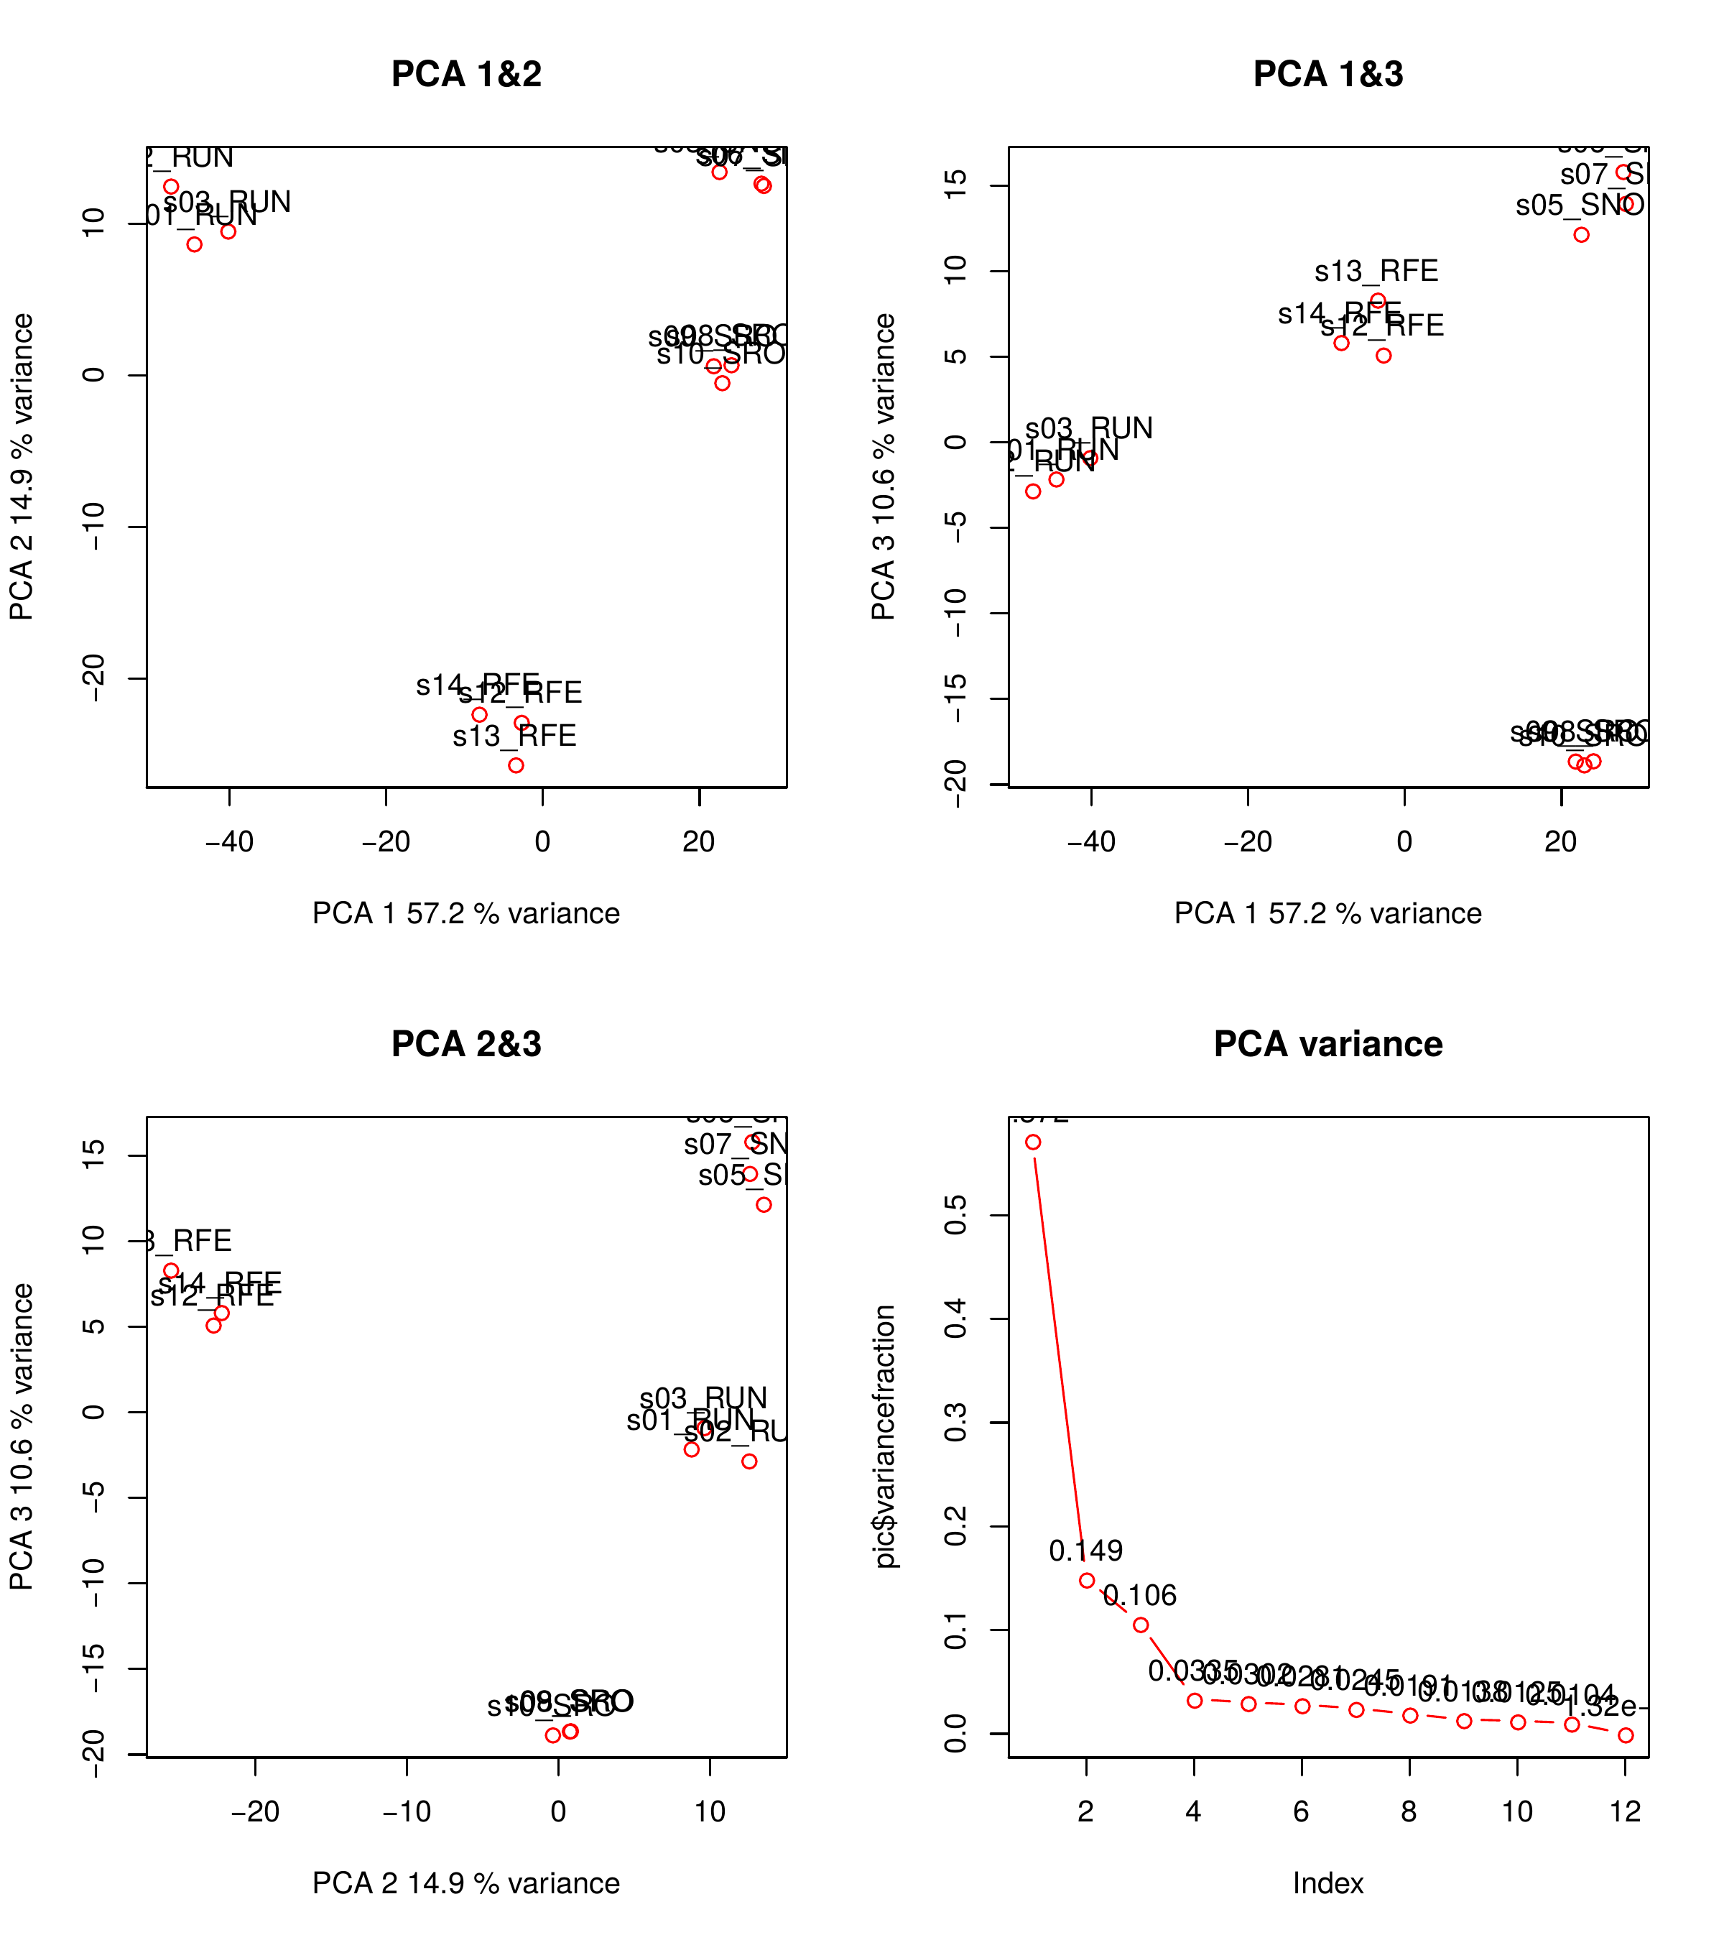
Analogous PCoA analyses show the same overall clustering (using Pearson correlation-derived distances + Ward clustering), with some more intra-replicate differences.
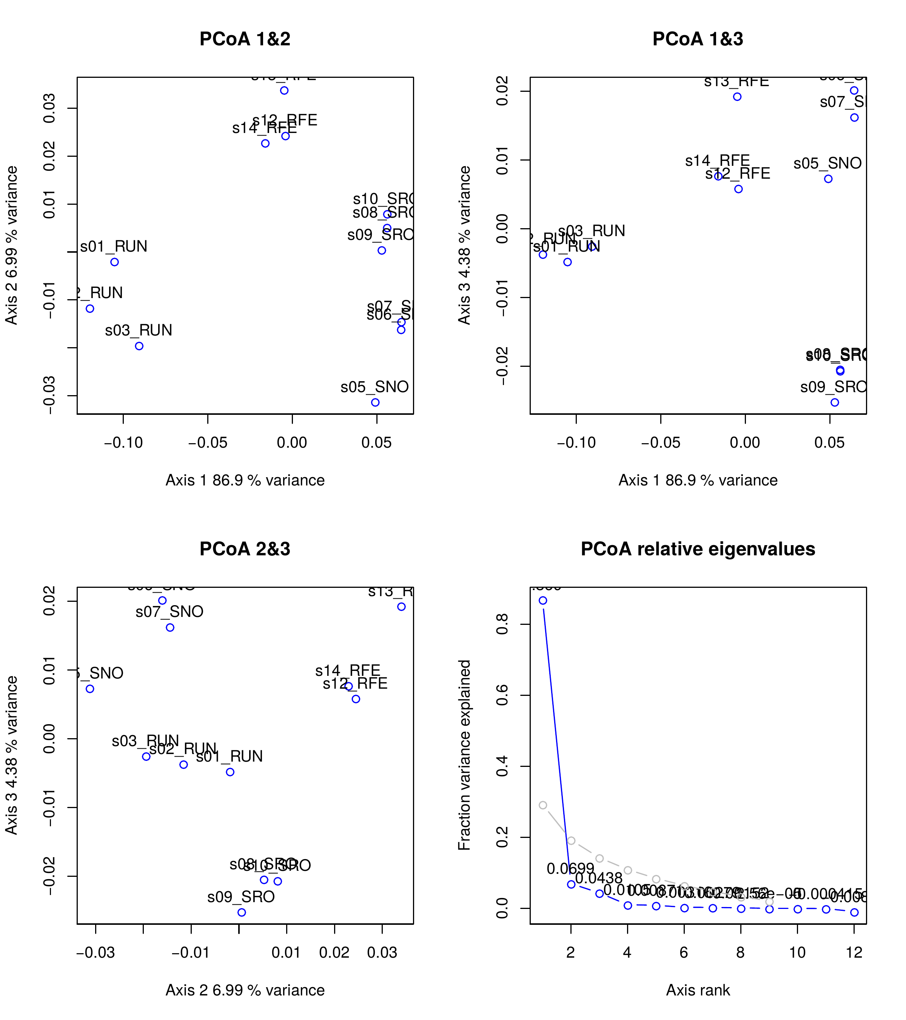

Sample clustering – Heatmap of log10 normalized transcript counts, clustering samples and transcripts by common gene expression profile (Pearson correlation-derived distances + Ward clustering). Similar to PCAs: it recovers RUN samples as being the most distant (it mostly reflects the same tendencies as PC1).
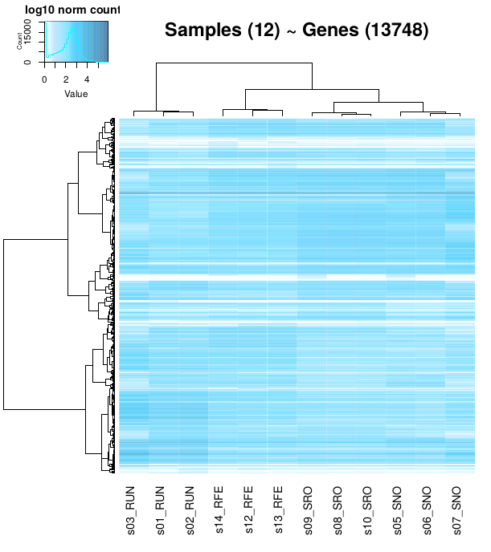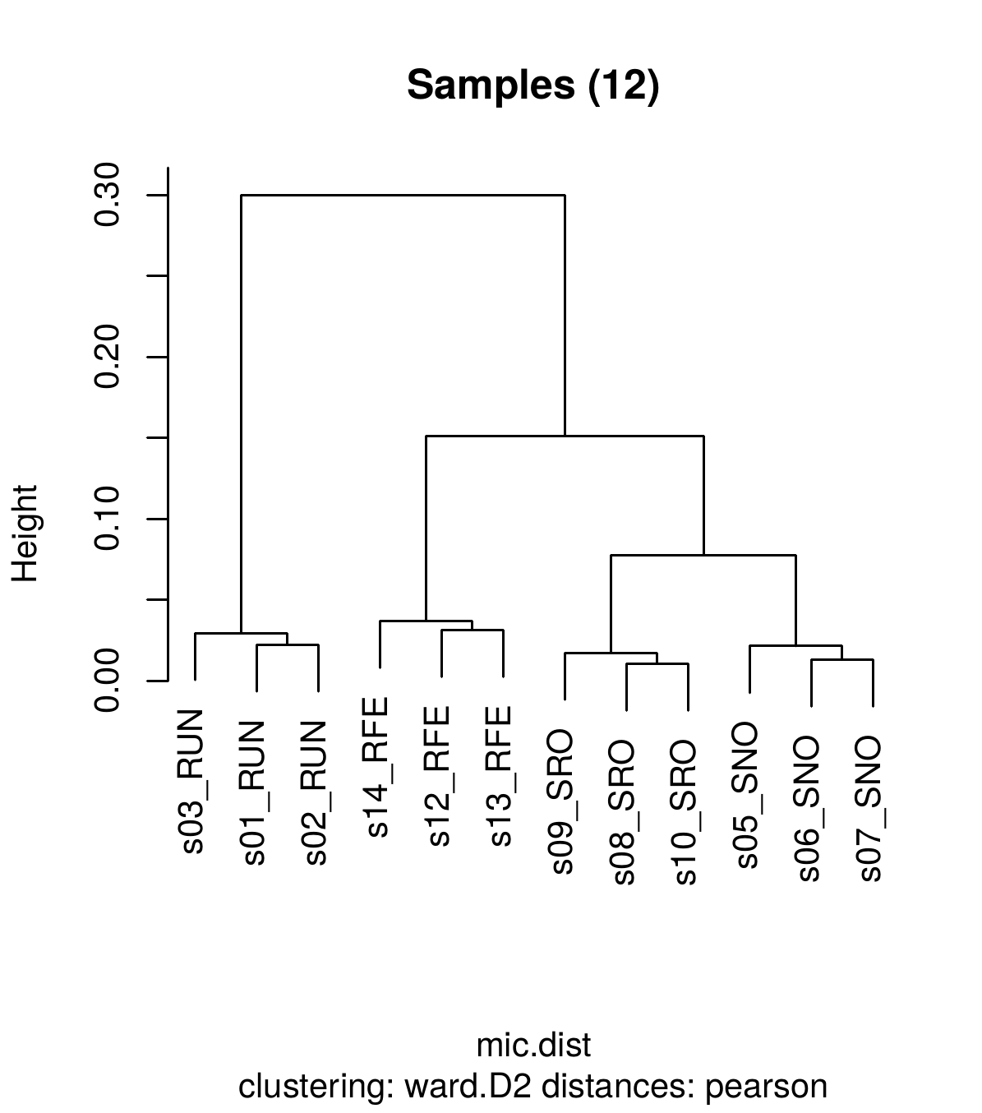
All in all, results make sense. Note that S10 (which had an excess of reads) does not seem to be weird in any analysis.

Gene clustering using k-means – A blind clustering of genes that have similar expression patterns, using various pre-defined number of clusters (k=3, 4, 5, etc.). For this analysis, log10 normalized counts are standardized (mean=0, standard deviation=1).
At low values of k, most genes are aggregated in meaningless groups, but with higher k some interesting groups may appear.
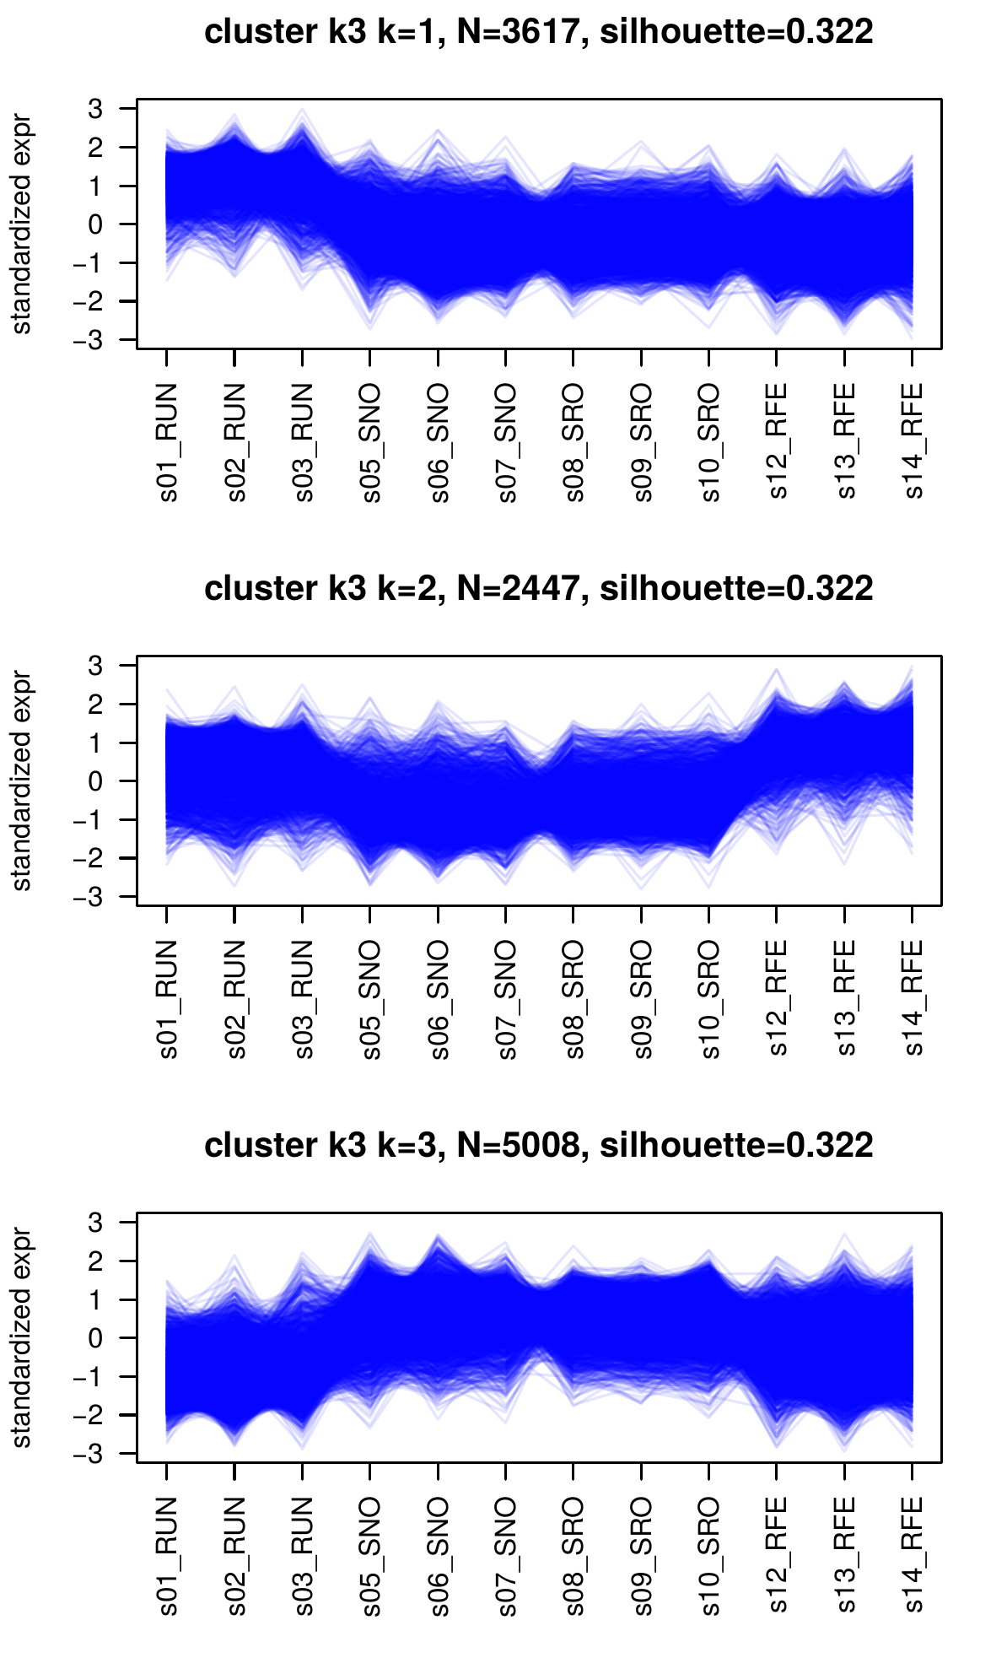
For example: at k=8, there is a cluster (3) of 1057 genes that are over-expressed in resistant samples, and RFE>RUN too:
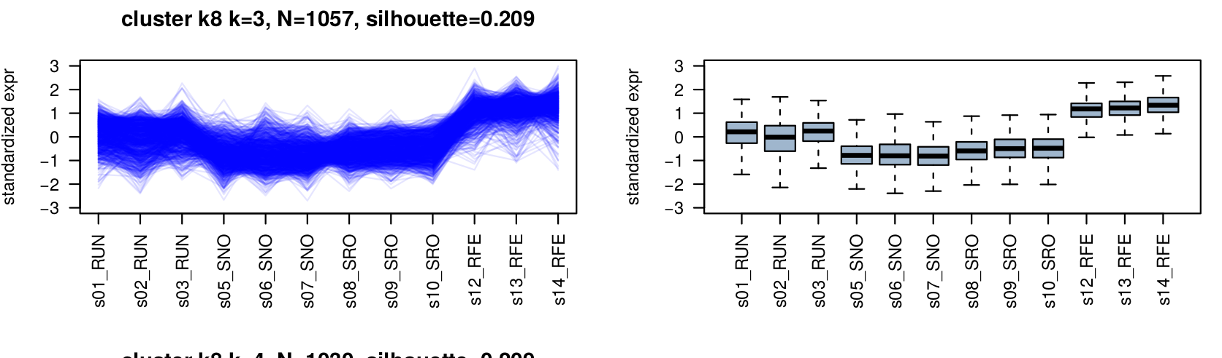
This other cluster represents genes that are under-expressed in RUN and RFE (and more under-expressed in RFE than in RUN):
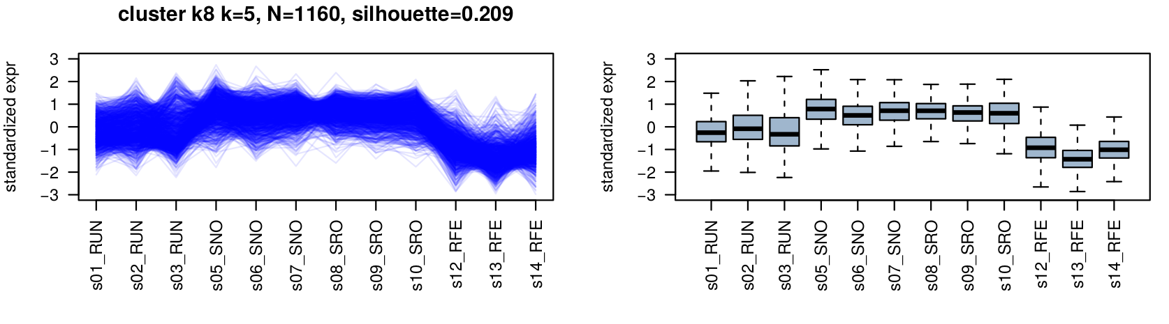
This sort of analysis is not particularly useful for gene expression analysis (formal DE is better here) but it helps visualize and quantify the amount of dynamically regulated genes. In other types of analyses such as AS, this can help to identify clusters where normal differential comparisons may fail.

Comparison of RUN (resistant unexposed) to SNO/SRO (susceptible)
In comparisons of unexposed resistant (RUN) ~ unexposed susceptible (SNO & SRO), results are quantitatively quite similar: almost 2,000 genes are overexpressed in the resistant samples, and ~1,100 are underexpressed (thresholds at p=1e-3 and FC =4). There are thousands of genes with less lower DE levels, so tuning FC looks key here.
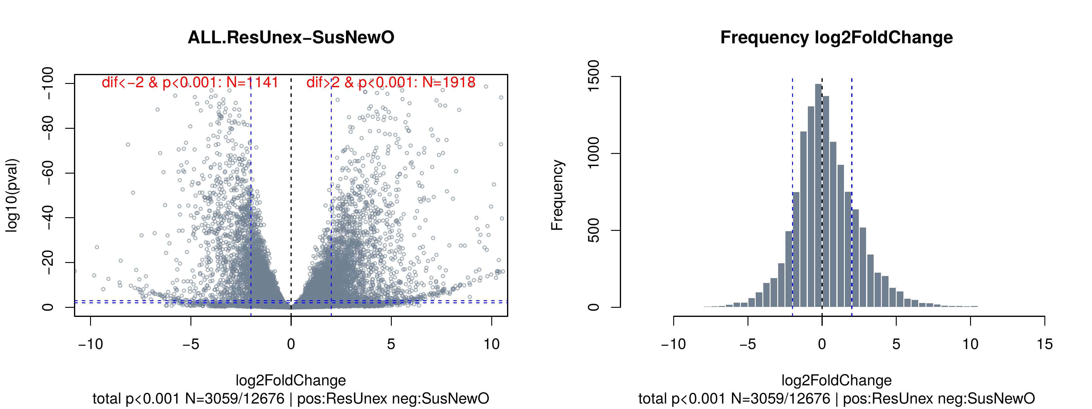
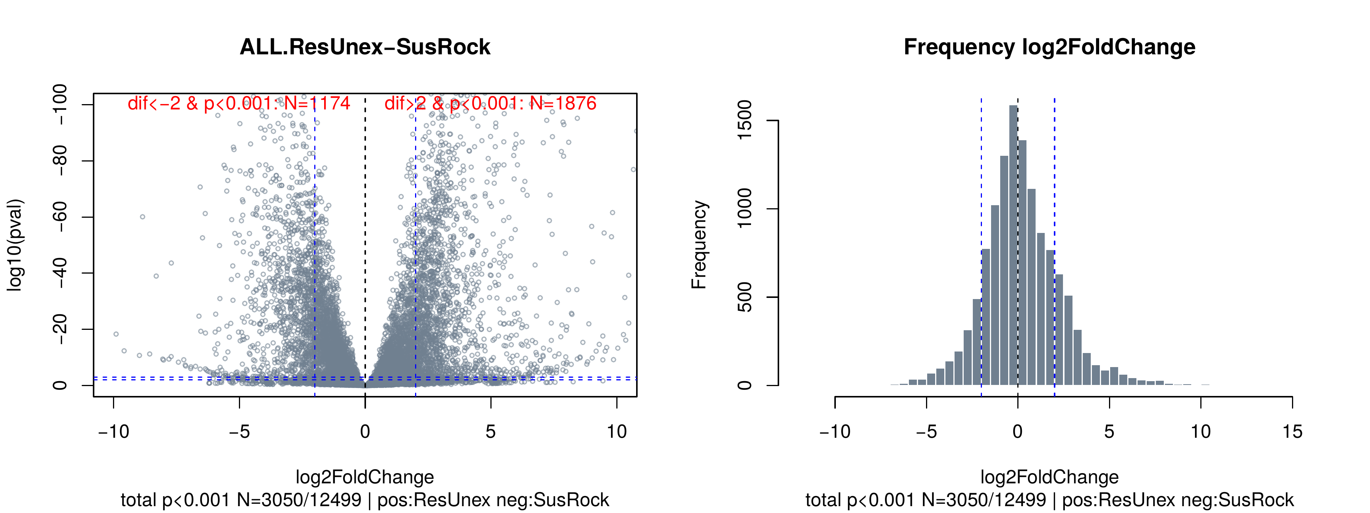

Intersection – Overlap of DE genes in both analyses is pretty good, at ~60% for both overexpressed and underexpressed genes.
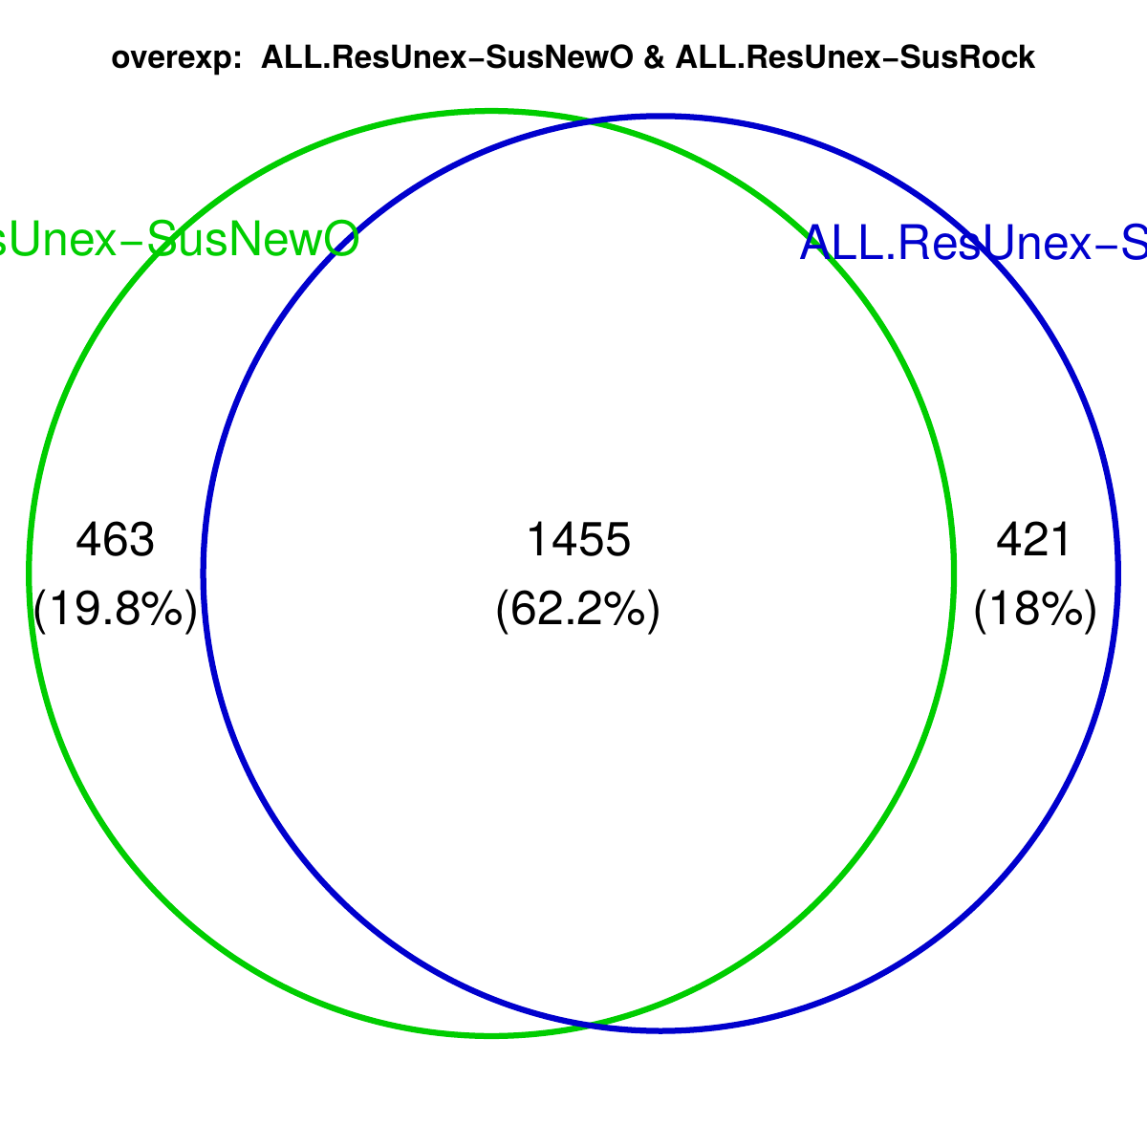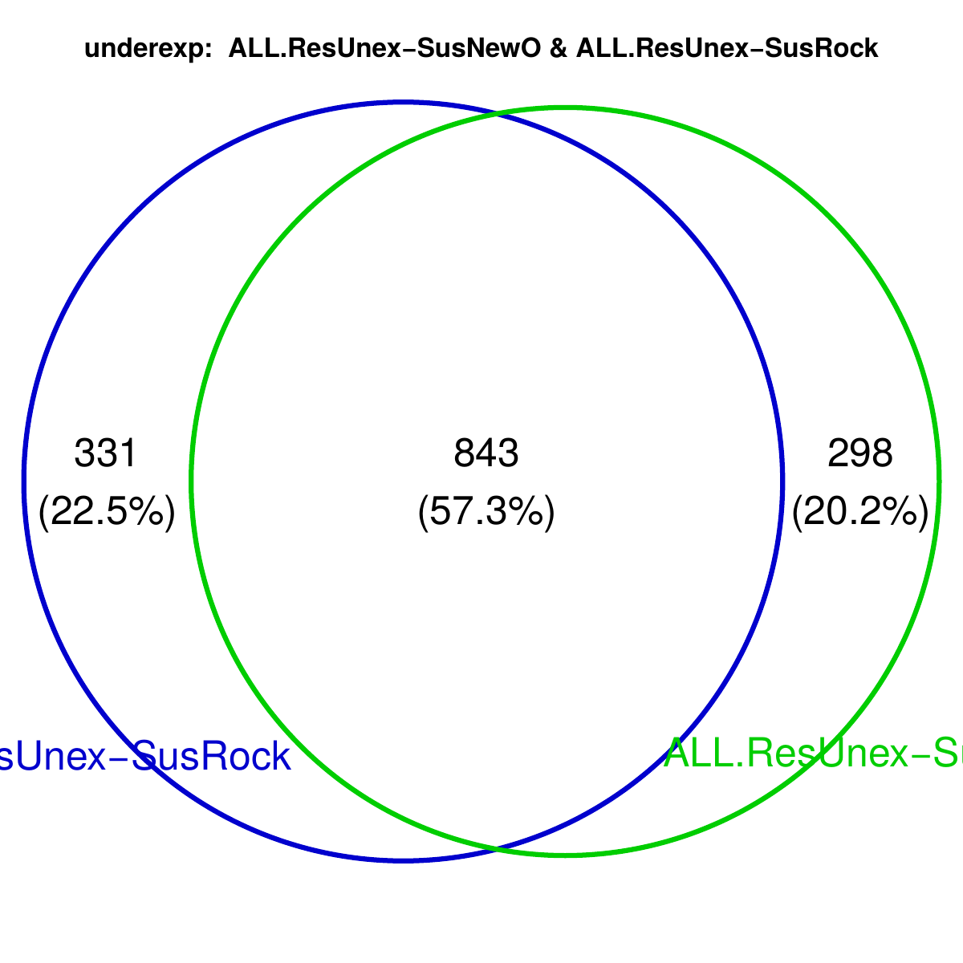

Functional enrichments – Genes that are overexpressed in resistant when compared to both susceptible strains shows some protein families involved in:
- chitin binding (Chitin_bind_4, CBM_14; confirmed in MF GO enrichments, second panel)
- cuticle thickening (Cuticle_4)
- ion transport. Neur_chan_LBD+Neur_chan_memb﻿ could be acetylcholine receptors! Ion_trans Neur_chan_LBD
- fatty acid metabolism (ELO, Sterile, confirmed in BP GO enrichments, third panel);
- signalling pathways: small G-proteins signalling (CRAL_TRIO), juvenile hormone (JHBP)
- various receptors: DOMON, I-set
- …
- There are 19 p450 genes that do not appear in the enrichments
- There are ~5 GSTs (with various domains_ GST_N, GST_C2, GST_N3…) that are not enriched either.
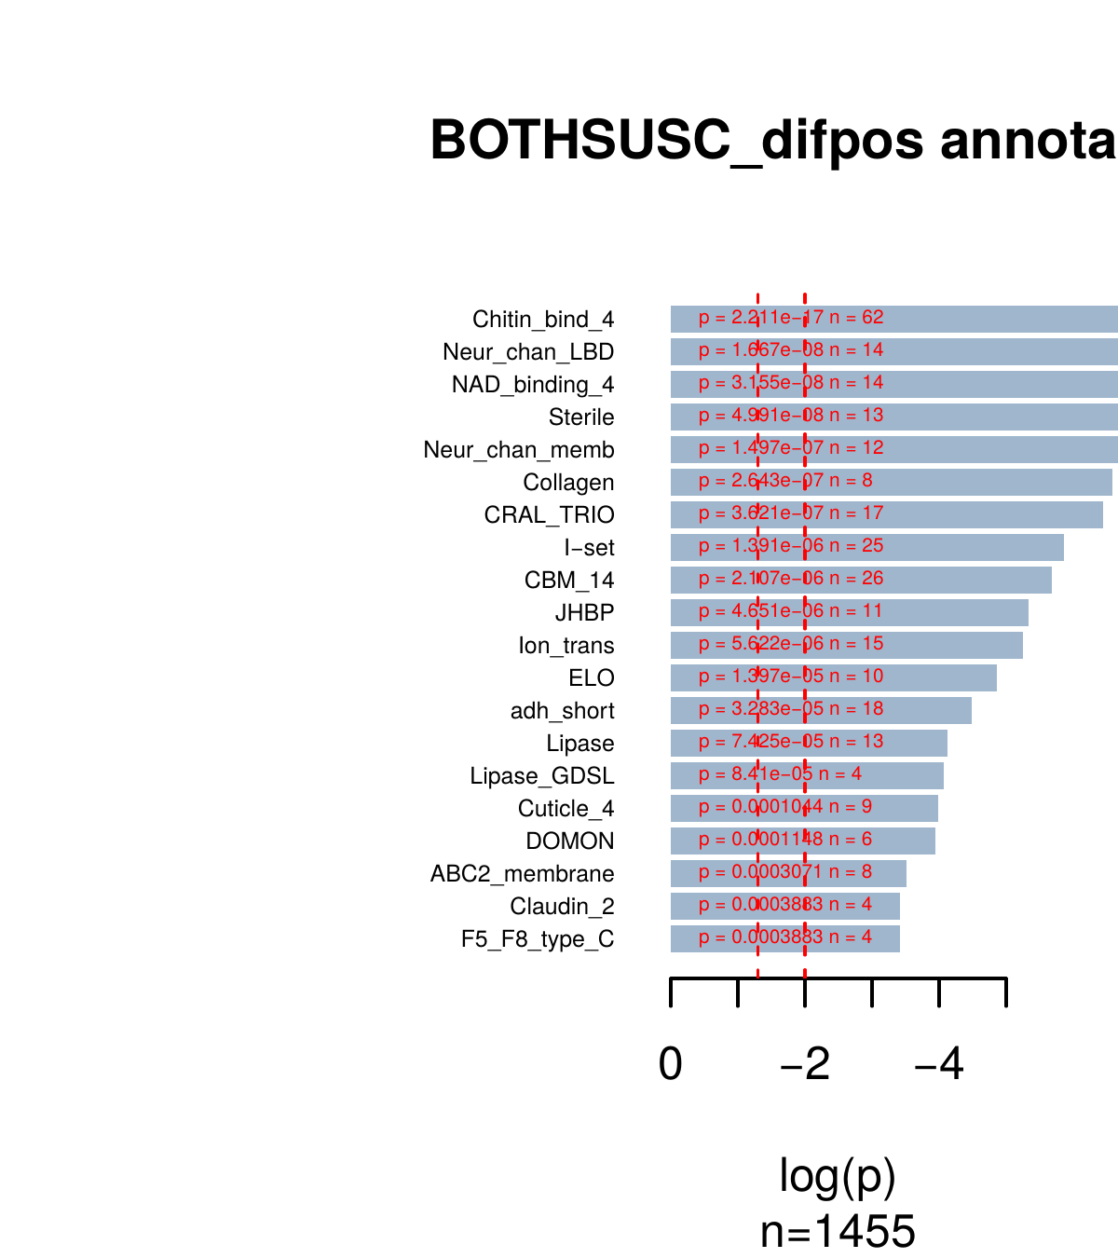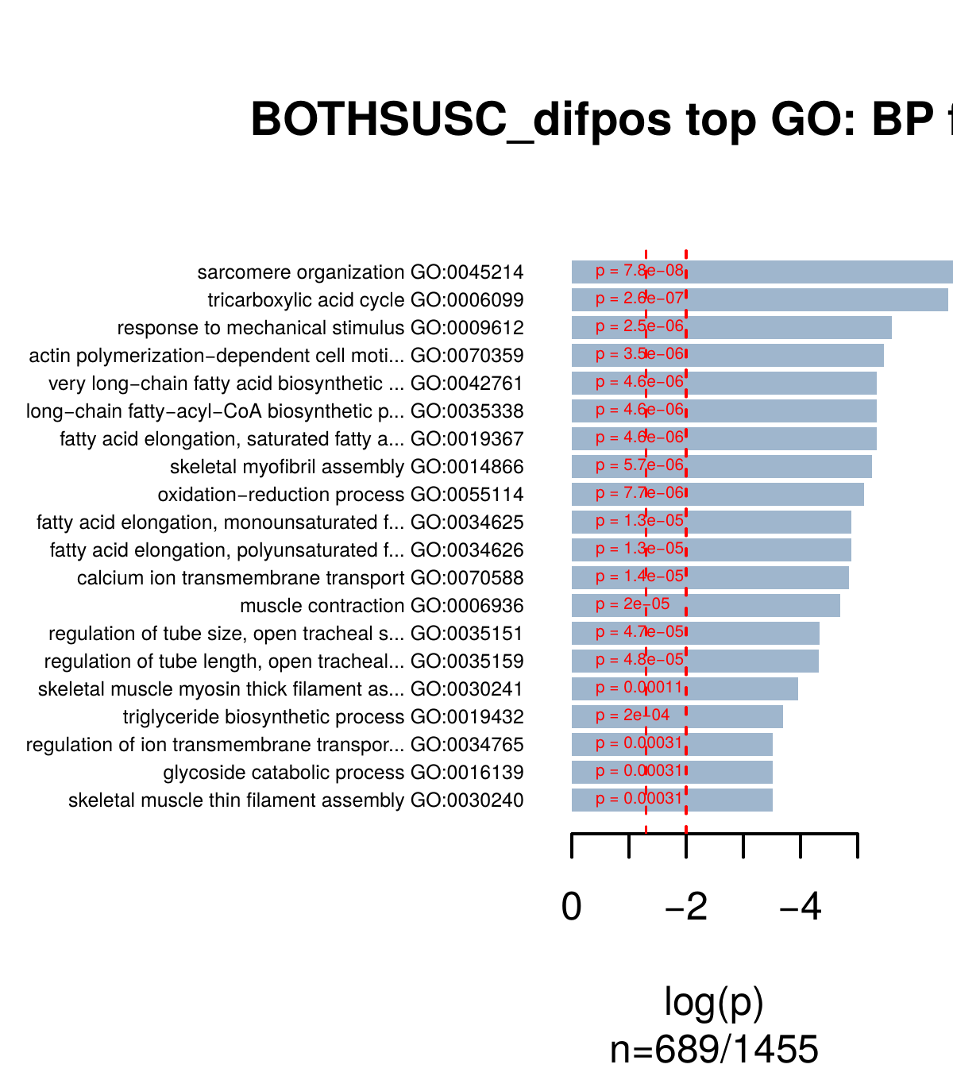
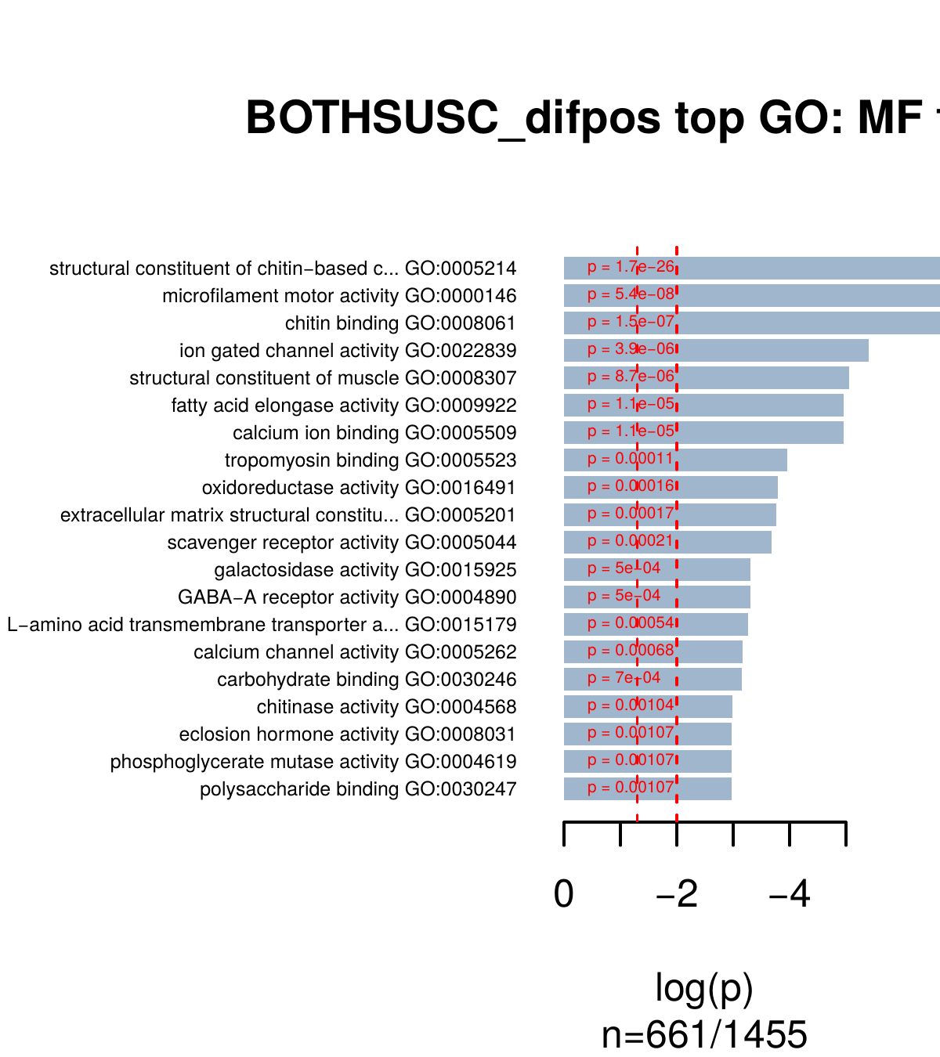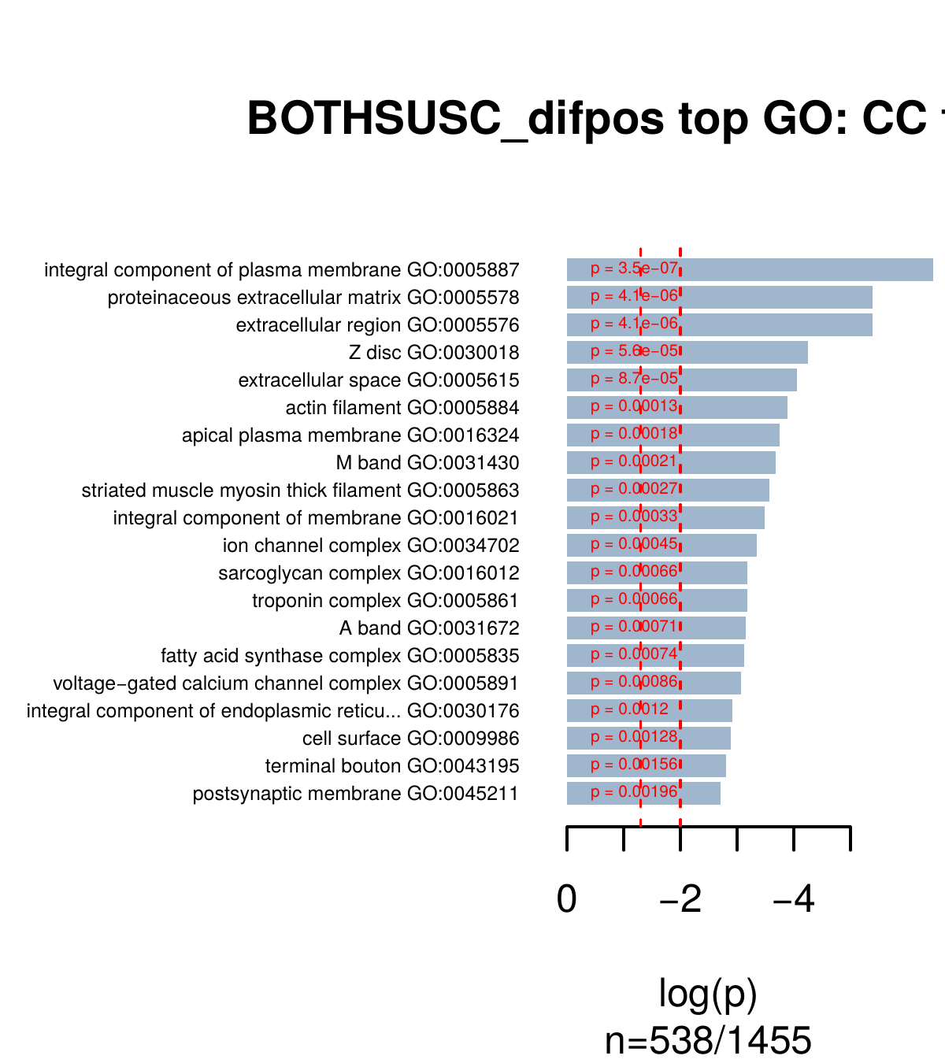
The functional enrichments in the list of overexpressed genes in the resistant compared to individual susceptible strains looks pretty similar.

Comparison of RUN (resistant unexposed) RFE (resistant exposed)
The overall differences between resistant exposed and unexposed are less strong than the differences between resistant and susceptible, with just ~1500 DE genes (instead of >3,000 in the previous comparisons). The exposed individuals seem to exhibit a slight down-regulation of gene expression, with twice as much underexpressed genes (~1000) compared to overexpressed (~500).
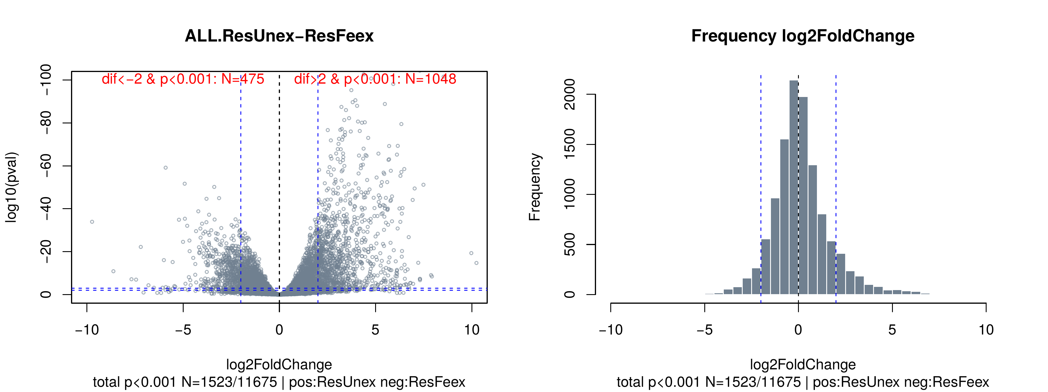

Functional enrichments – the functional enrichments of genes overexpressed in exposed compared to unexposed shows a conspicuous lack of interesting annotations (detoxification), but some stress response . Putatively interesting things are:
- A general stress response could be indicated by overexpressed Trypsins and Peptidases (C14/M19), also possibly ubiquitination enzymes (F-box-like, zf-B_box?);
- An_peroxidase?
- AAA_12? ATPases associated with diverse cellular activities
- What about DEAD+Helicase_C proteins? From Pfam: “Proteins with this domain include the DEAD and DEAH box helicases. Helicases are involved in unwinding nucleic acids. The DEAD box helicases are involved in various aspects of RNA metabolism, including nuclear transcription, pre mRNA splicing, ribosome biogenesis, nucleocytoplasmic transport, translation, RNA decay and organellar gene expression.”
- Enriched biological processes involve many cytokinesis/meiosis/mitosis/DNA polymerisation genes. This is very odd and seems to contradict the moderate signal for stress response?
This is quite odd. But enrichments are not too strong.
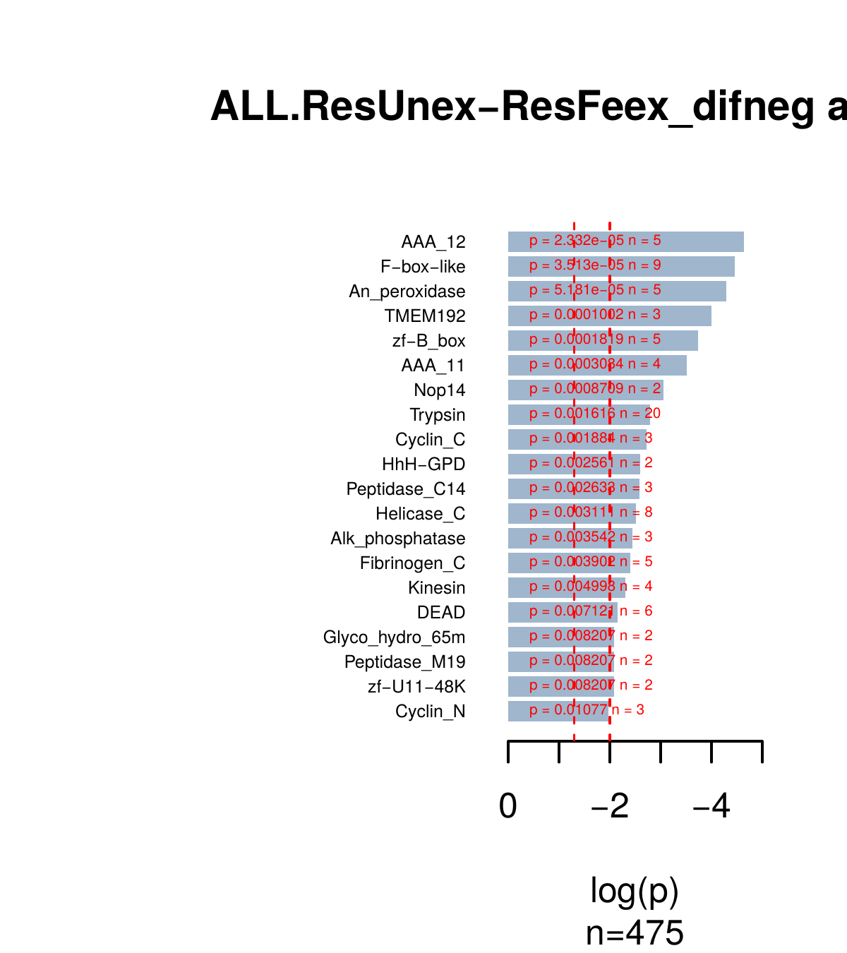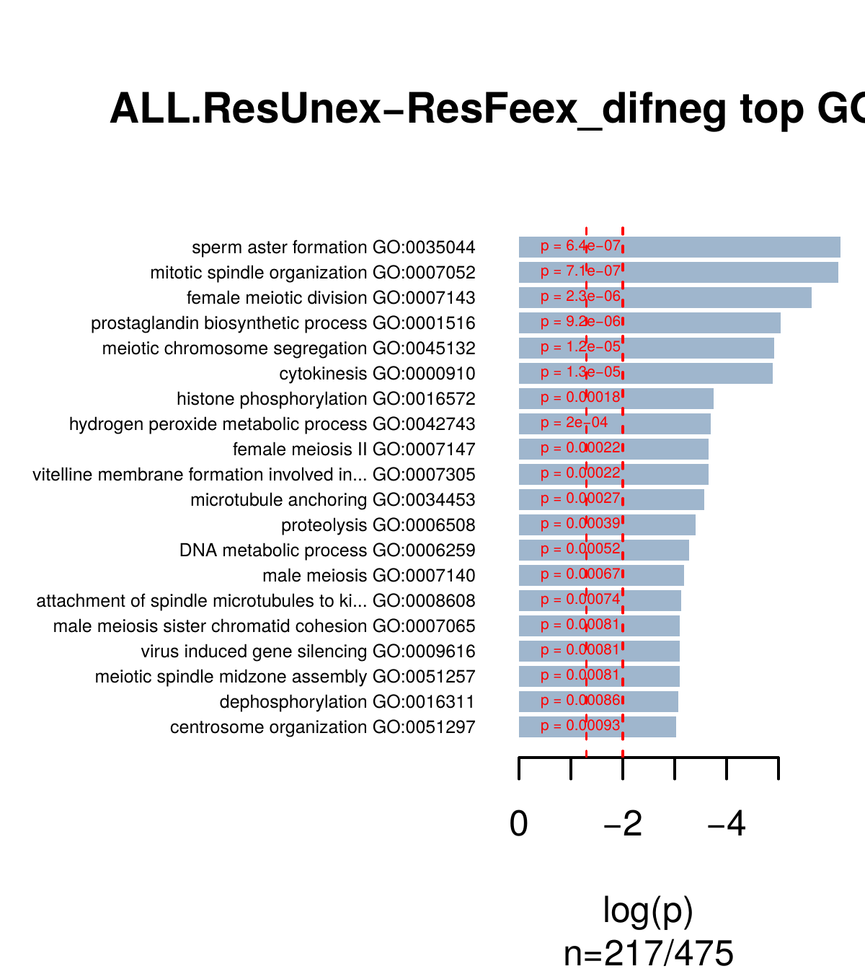
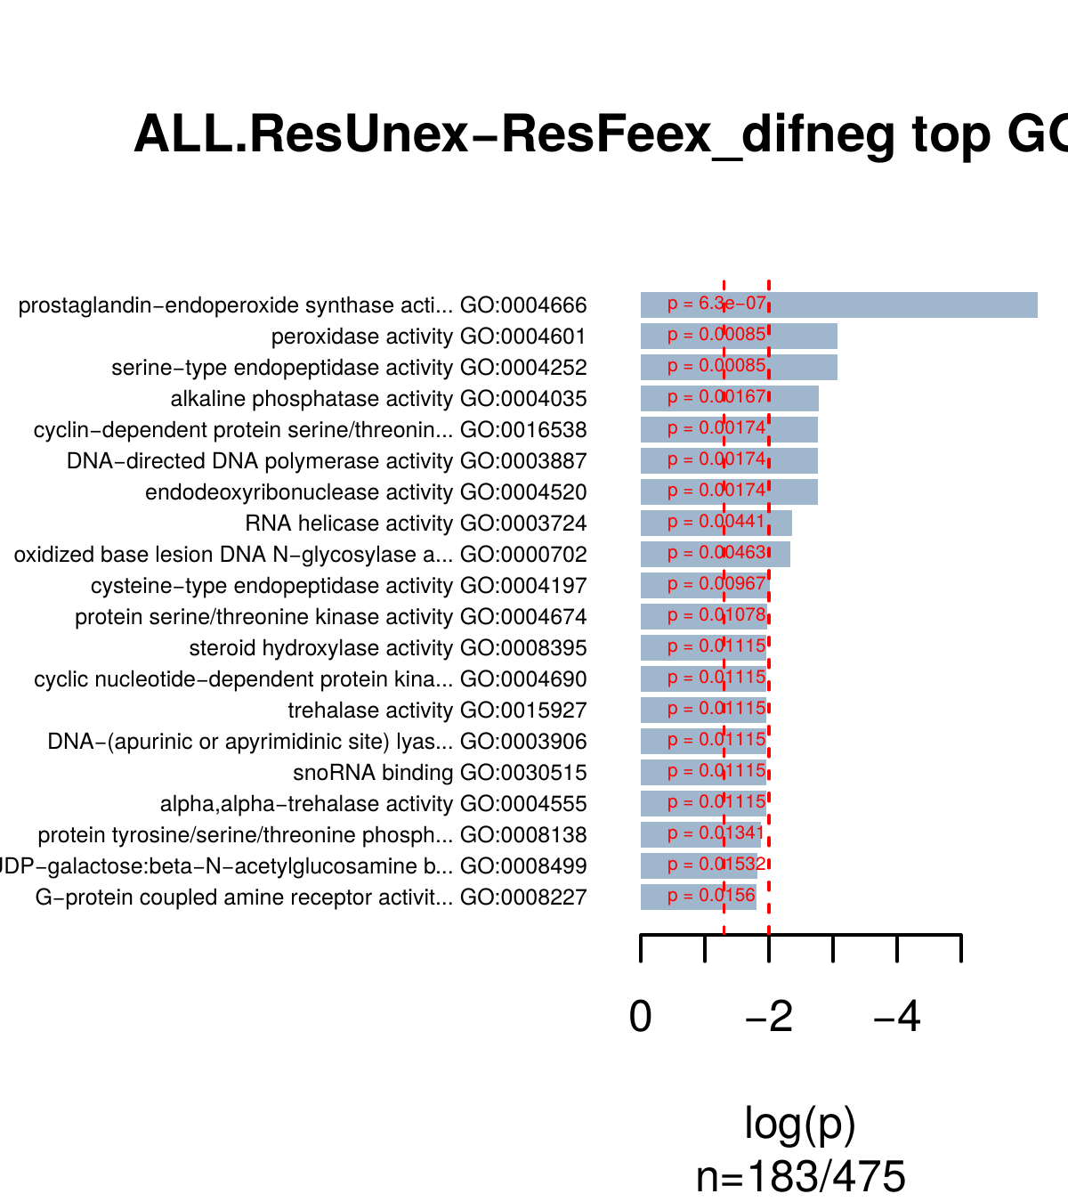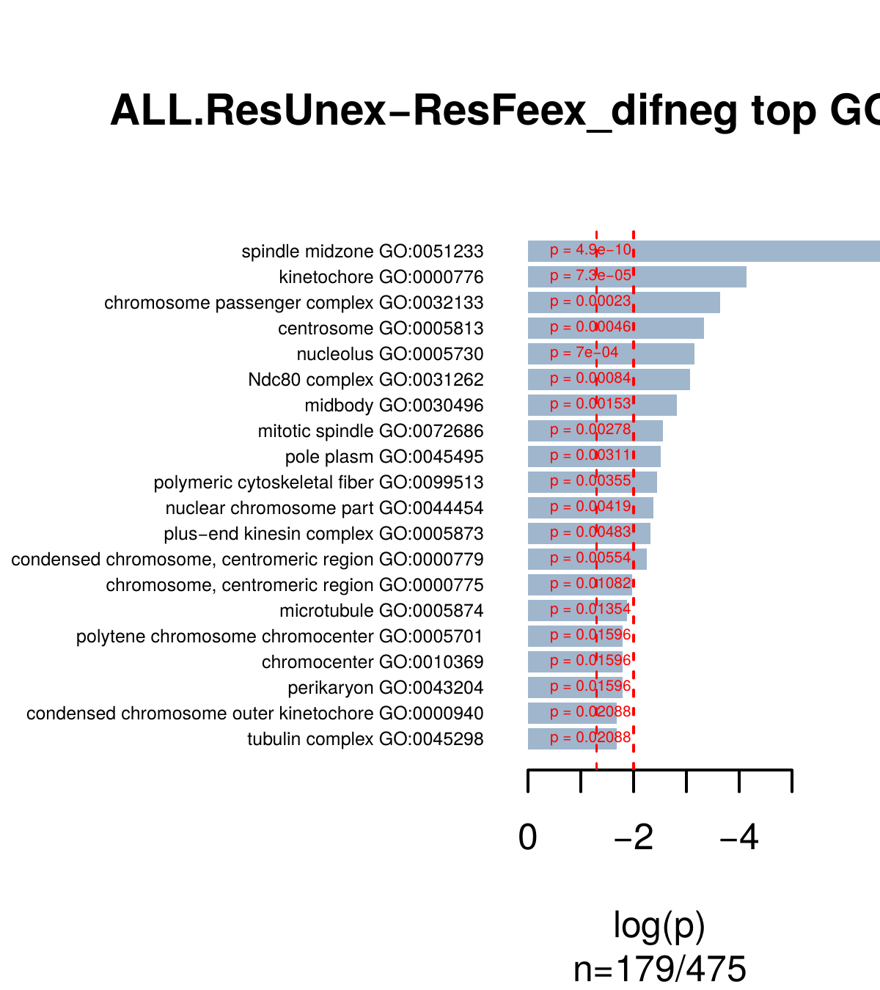

The functional enrichments of genes overexpressed in unexposed compared to exposed shows keep showing functions linked to those that appeared to be enriched in RUN compared to susceptible strains (chitin binding, fatty-acid synthesis, ion transport, etc.), with some additions (proteins with leucine-rich repeats [LRR_8]; epidermal growth factor repetitive domains [EGF, EGF_CA]).
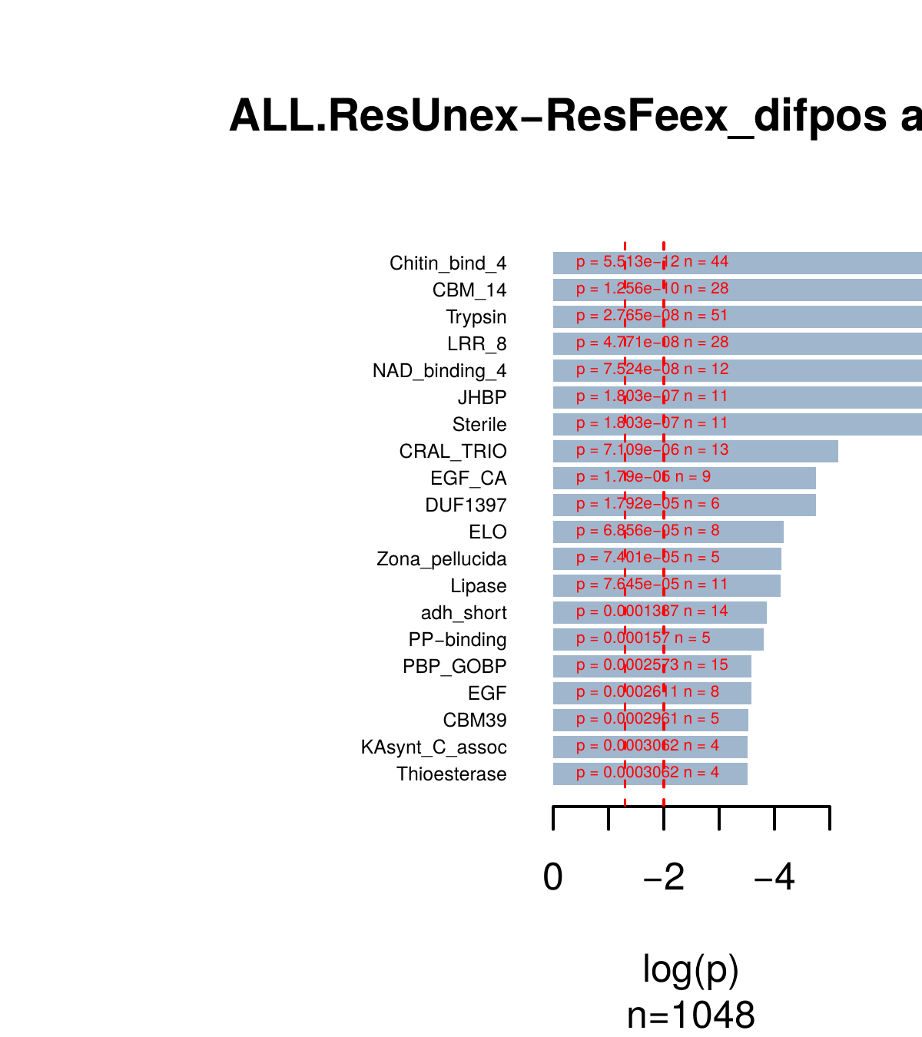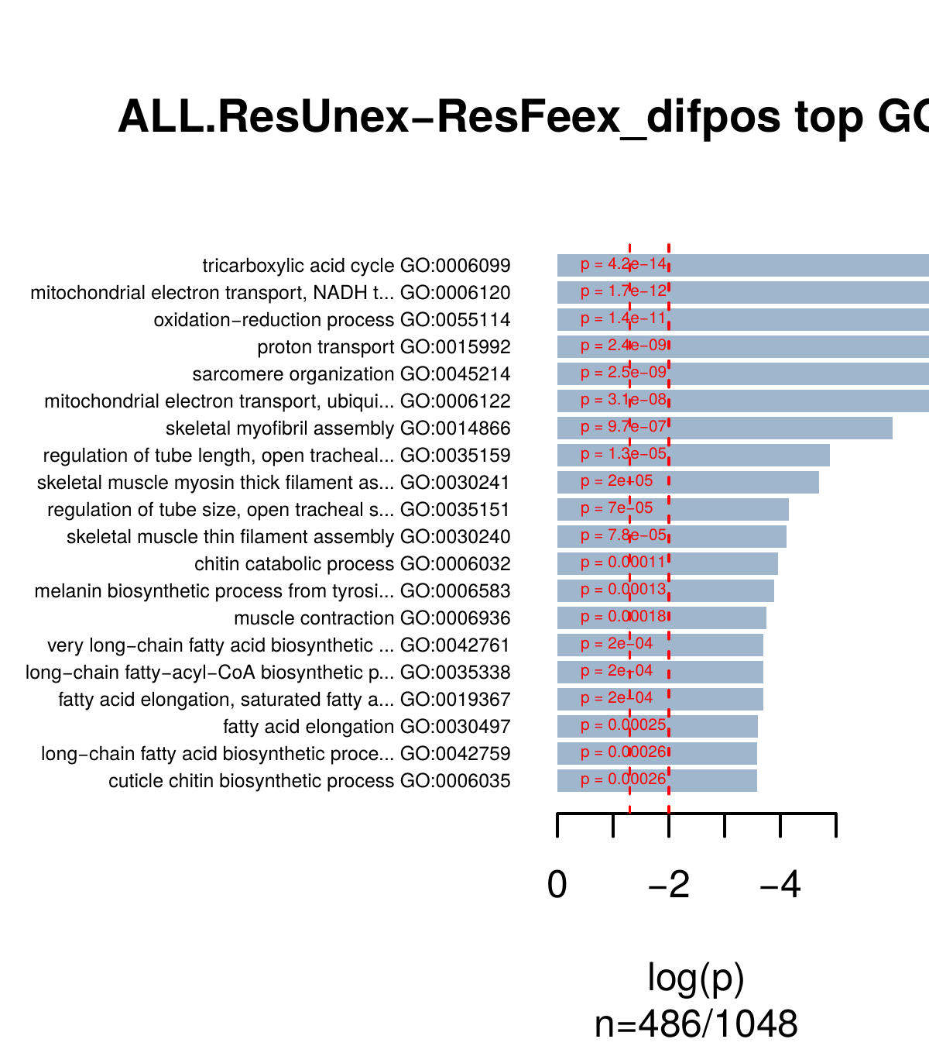
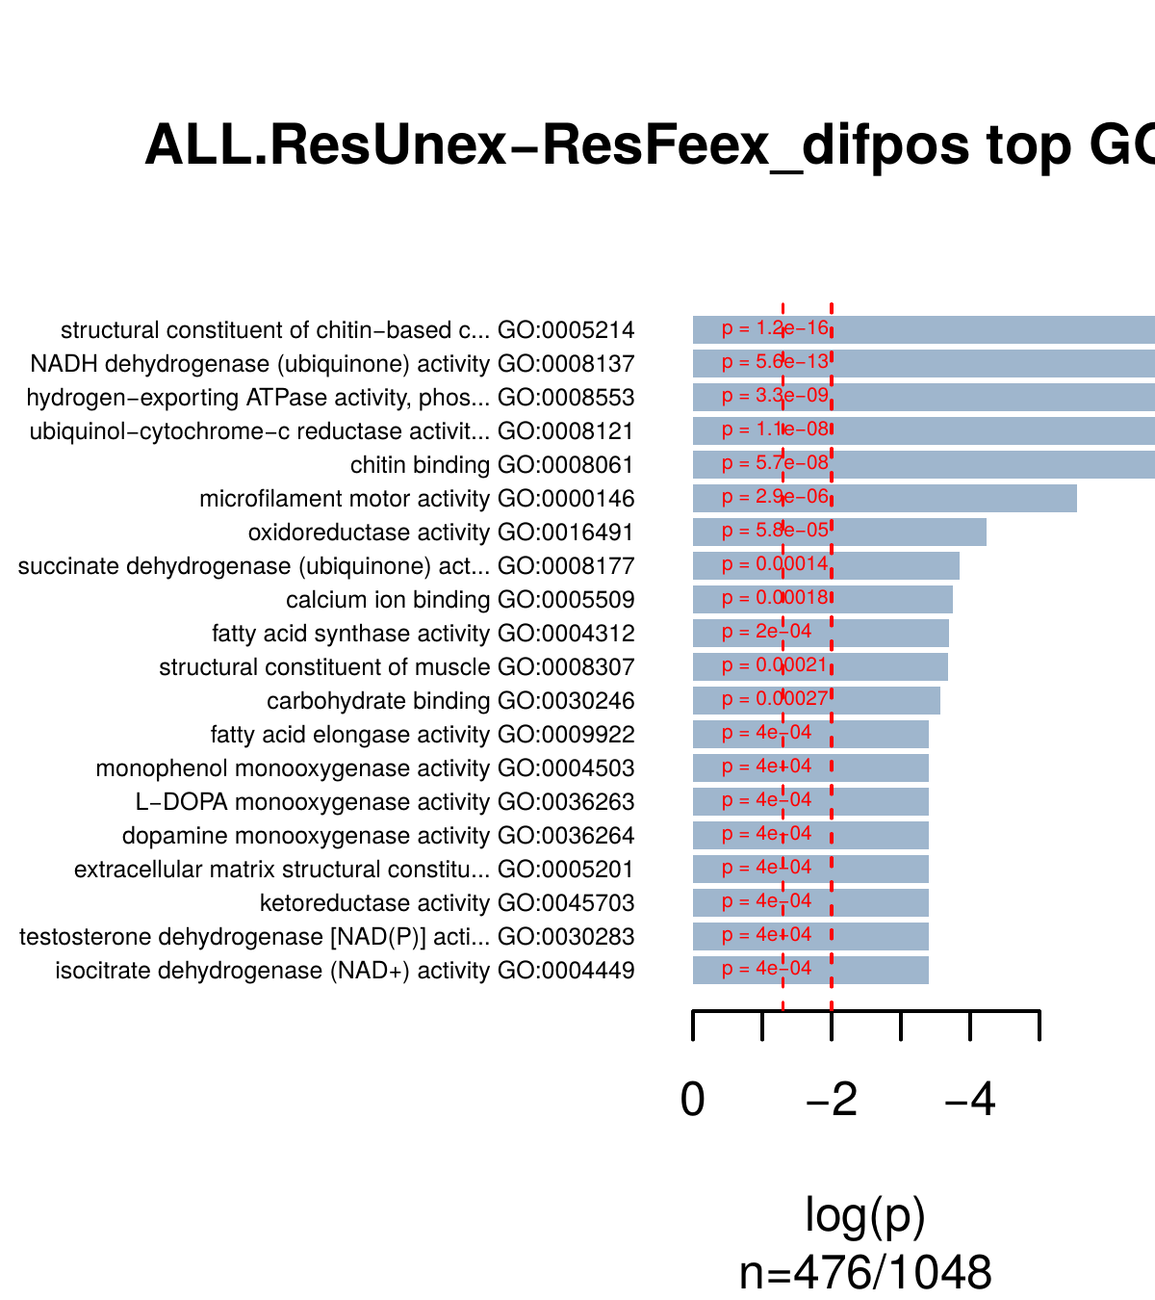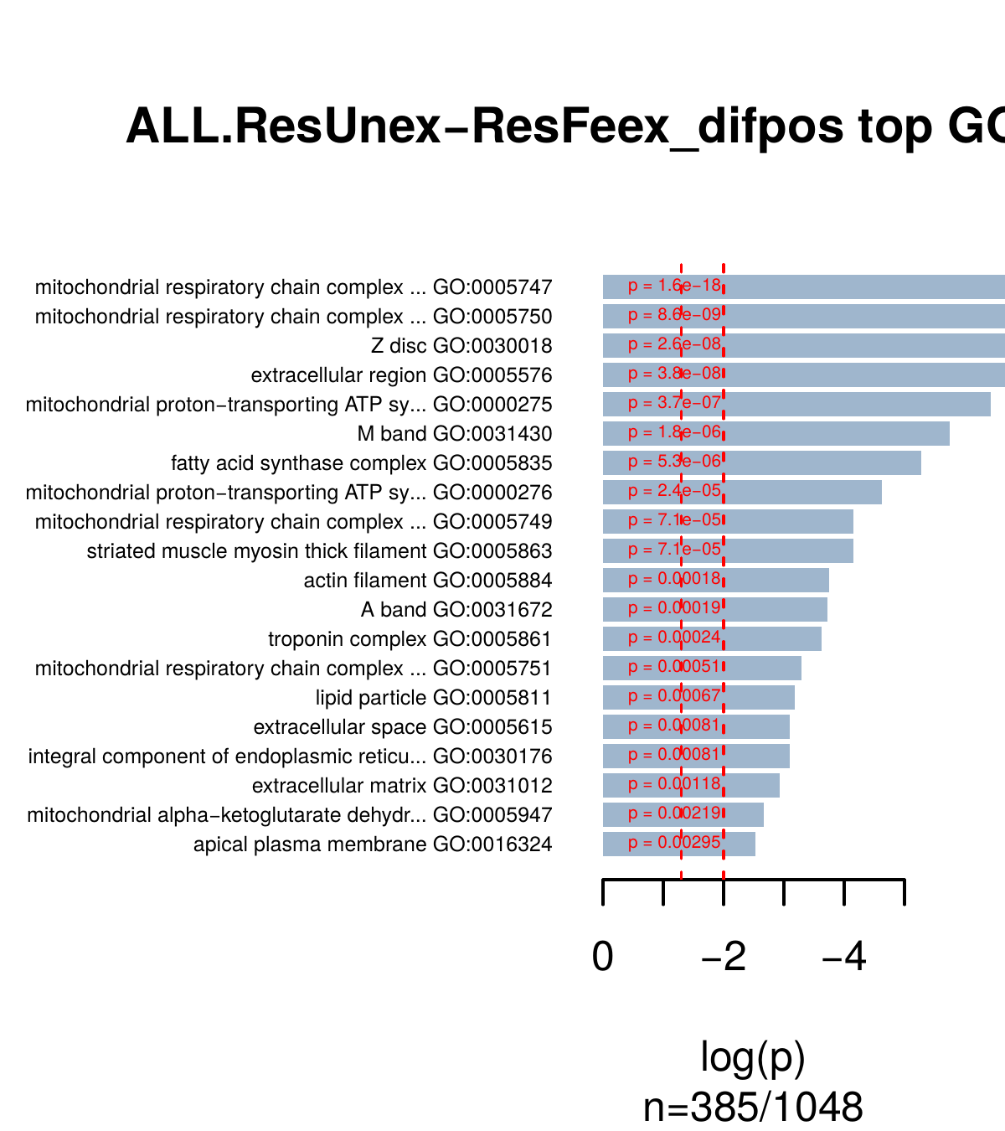

Differential expression in gene families of interest
Note: in these plots, gene expression is scaled (from log10 counts to scale at mean=0, sd=1). Differential expression is considered to be significant if FC>4 and p<0.001.
Ligand binding domains of ligand-gated ion channels – Neur_chan_LBD is the domain that defines neurotransmitter-gated ion-channels (ligand binding domain). It is present in acetylcholine receptor subunits. Resistant individuals overexpress more than a dozen genes with this particular domain. Just a couple of these genes are then over-expressed in resistant exposed vs unexposed. Colored annotation columns indicate whether a particular gene is differentially expressed in a given comparison, either over-expressed (pos) or underexpressed (neg); 0 indicates FALSE (i.e. no DE) and 1 indicates TRUE (i.e. DE).
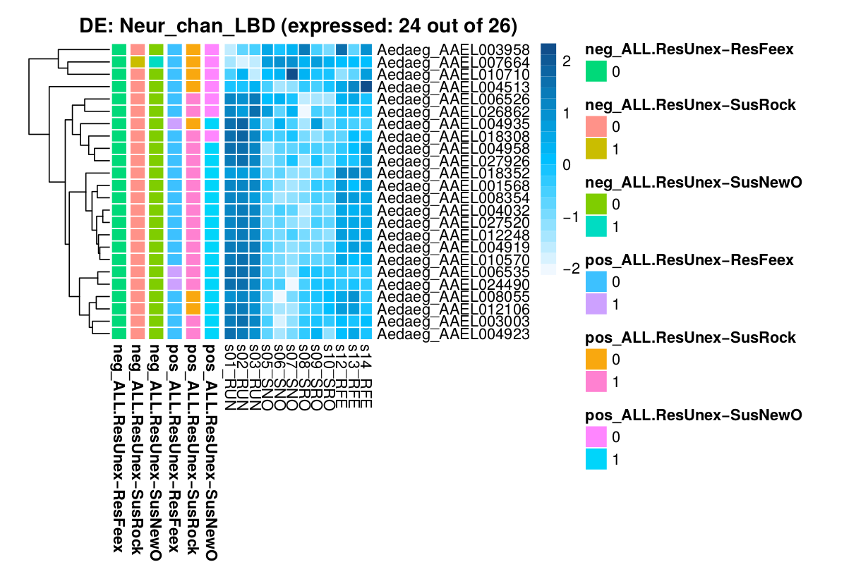
Voltage-gated ion channels – Ion_trans is a ion transport domain in voltage-gated ion channels (sodium, potassium, and calcium) – Vgsc has this domain.
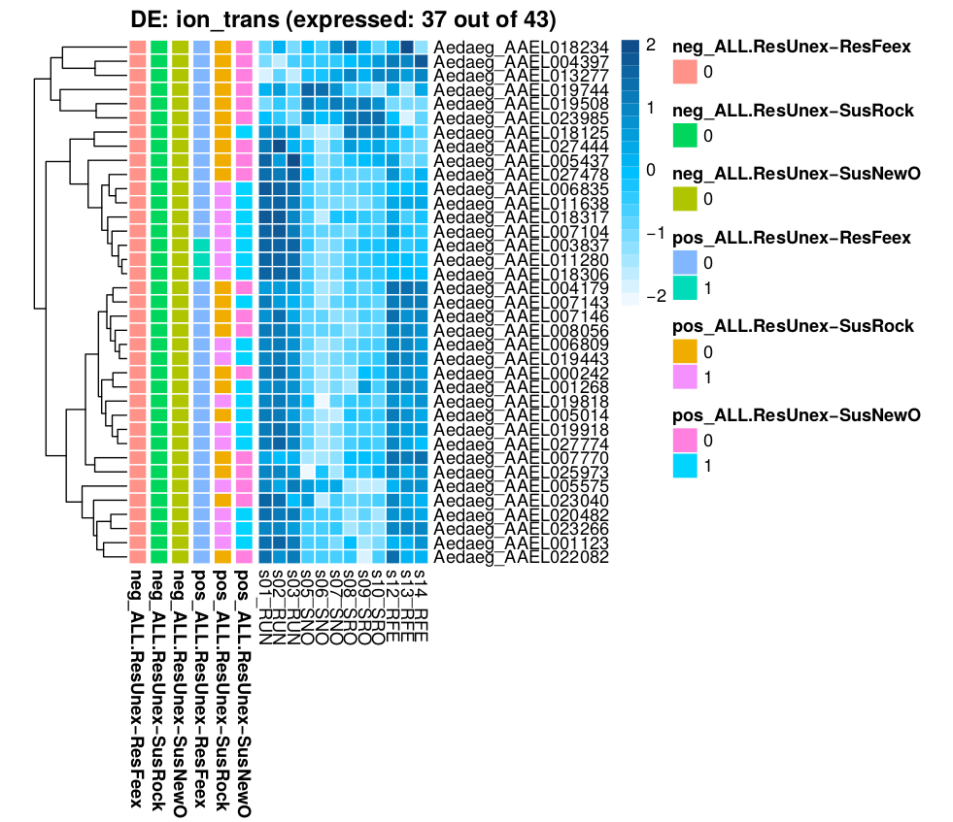
Chitin-binding proteins – with the Chitin_bind_4 domain, or the CMB_14 domain (below). There are more than 20 over-expressed genes with Chitin_bind_4 the resistant unexposed strain (not recovered when exposed).
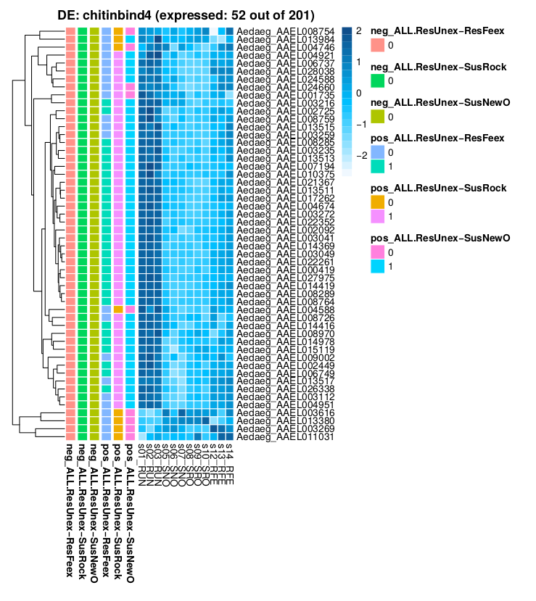
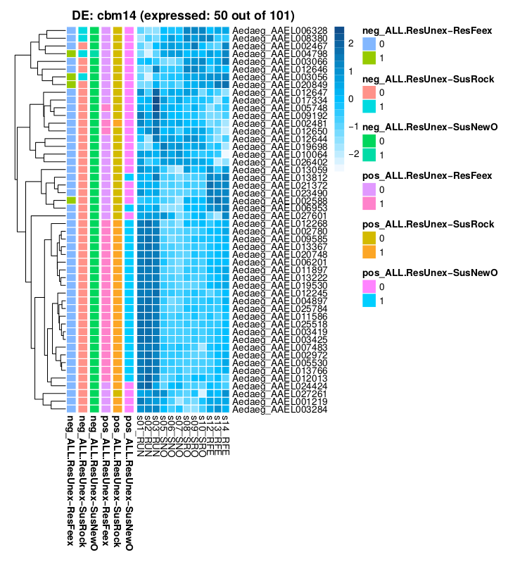
Various cuticle proteins – genes with Cuticle_4 domain or Cuticle protein CPCFC, all are overexpressed in resistant unexposed compared to susceptibles, and most of them also seem over-expressed in resistant exposed compared to susceptibles (worth checking?).
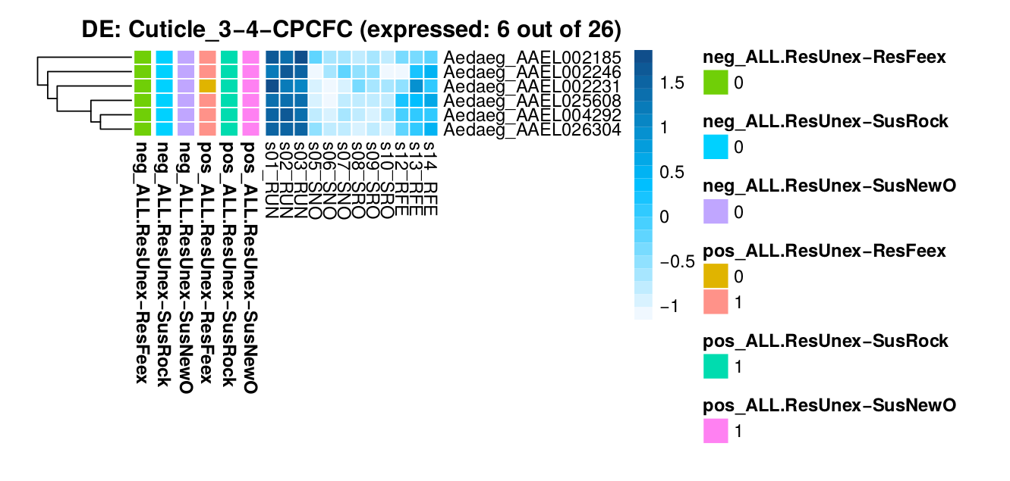
Juvenile hormone binding protein – a protein that binds to JH and protects it from hydrolysis by esterases (it’s not a receptor). Most of them are up-regulated in resistant individuals. Does it have a possible link to upregulation of Coestereases? (see below)?
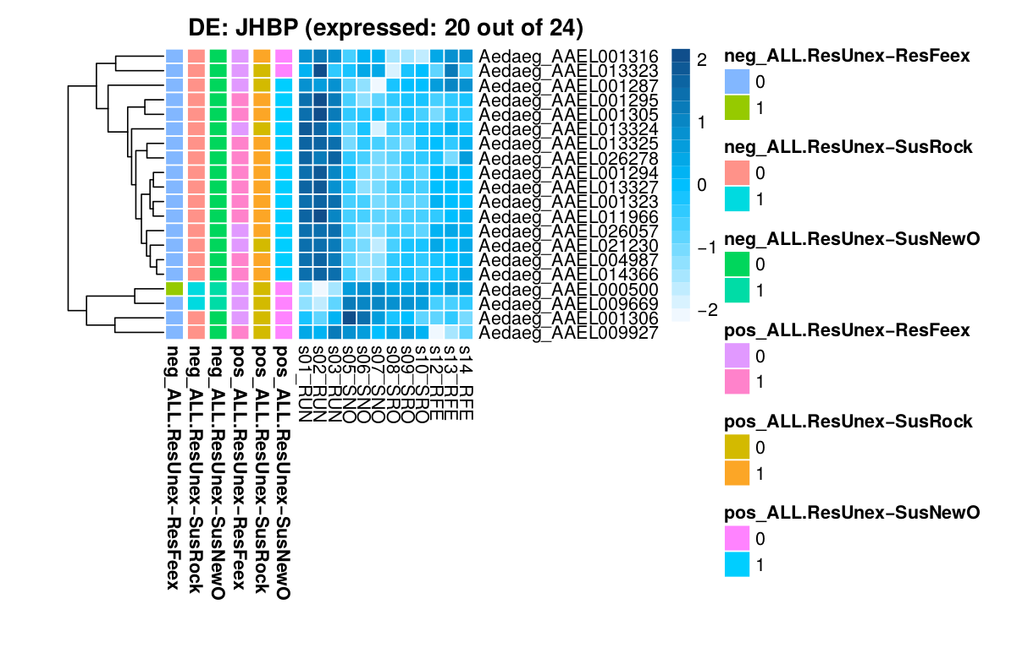
Acetylcholinesterases – including the COesterase domain. Roughly a dozen of the expressed ones are over-expressed in resistant individuals compared to susceptible, and two of them are over-expressed in resistant exposed compared to unexposed.
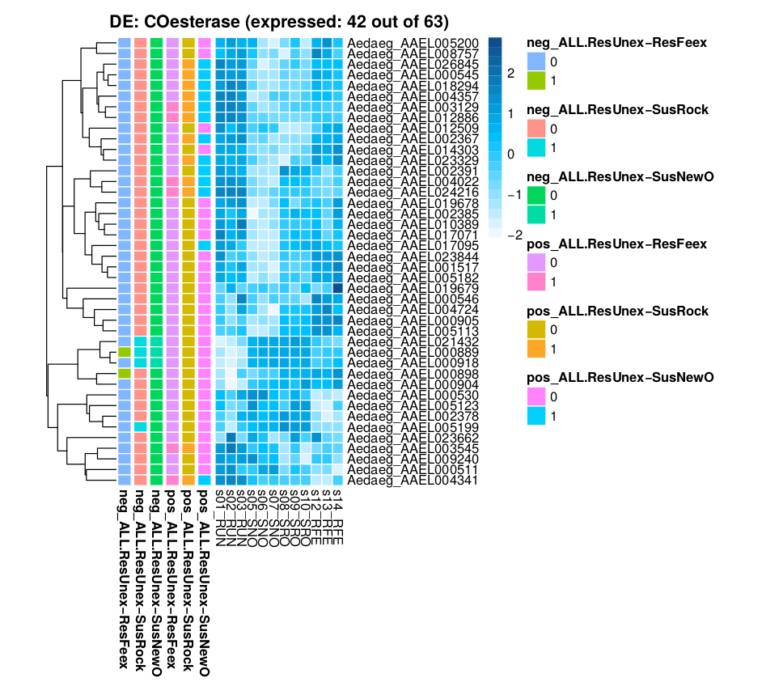
Detoxification enzymes: GSTs – all genes carrying GST-linked domains. There’s some genes at the bottom that are over-expressed in RUN compared to susceptible (4 are shared between both susceptibles).
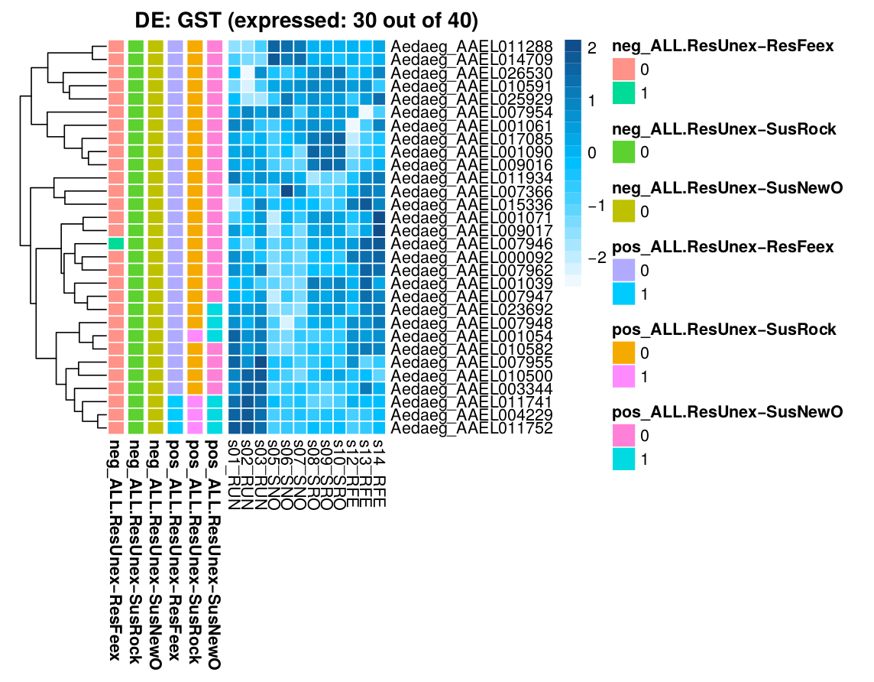
Detoxification enzymes p450 – A few p450 are overexpressed, but it does not seem to be as general as in other gene families.
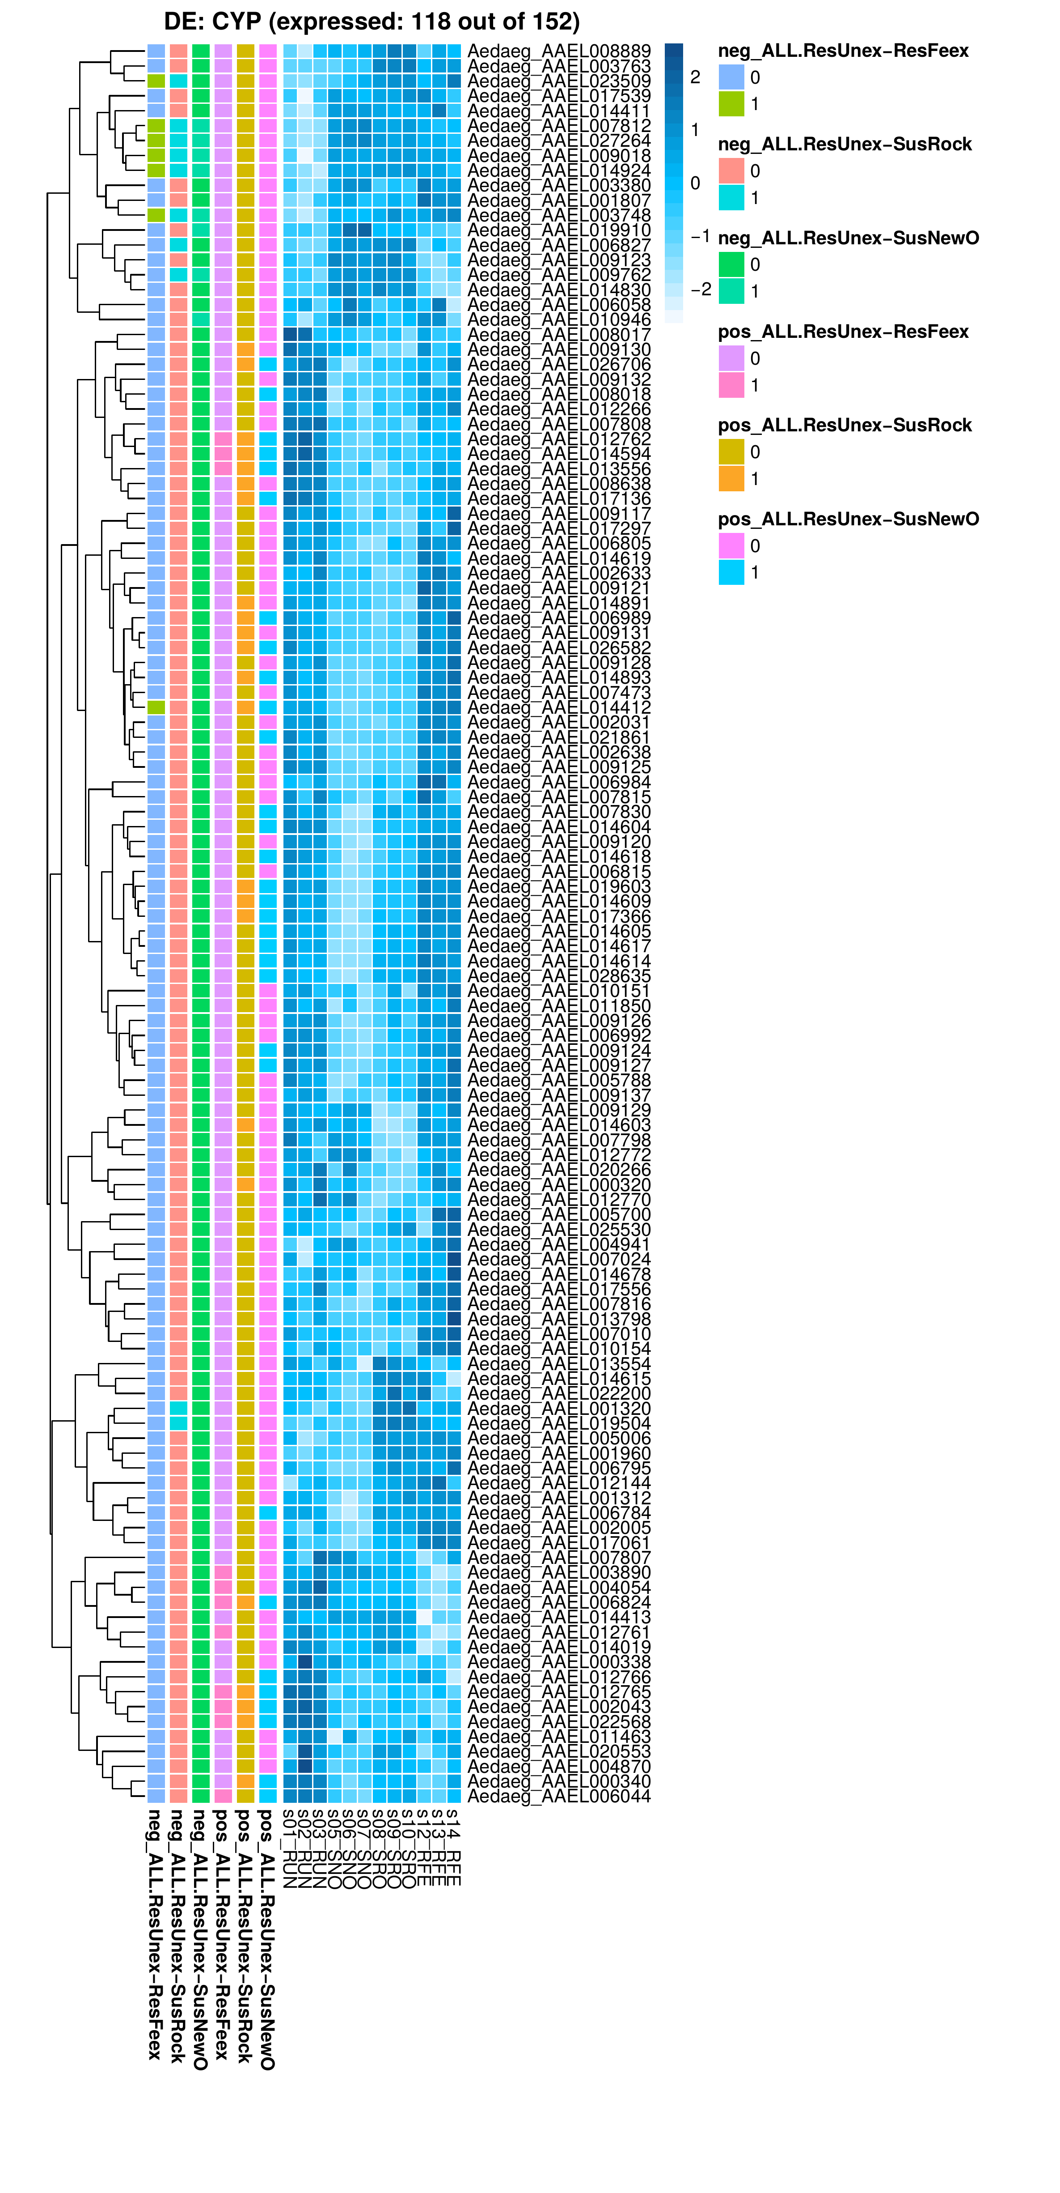

Chromosomal biases in gene expression
This analysis look at the over-representation of differentially expressed genes (up or down) along windows of 100 genes that slide along the genome (with a step of 10%). It looks at I) the fraction of over or under-expressed genes, and (ii) uses a Fisher’s test to check if there is a significant over-representation along that region. Fisher’s test result should not be taken at face-value, because .
For example, in chromosome 1, it looks like there could be three/four clusters of genes that are over-expressed in resistant samples compared to susceptible (SNO is shown, but position of clusters in SRO coincides):
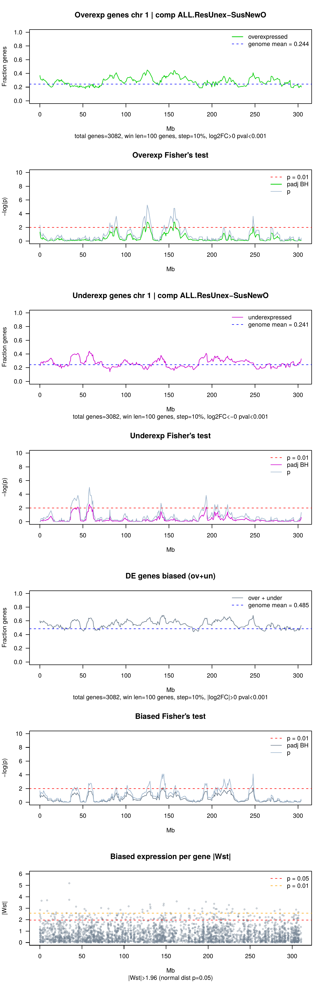

Alternative splicing
Global amounts of AS, per type (in all samples pooled together):
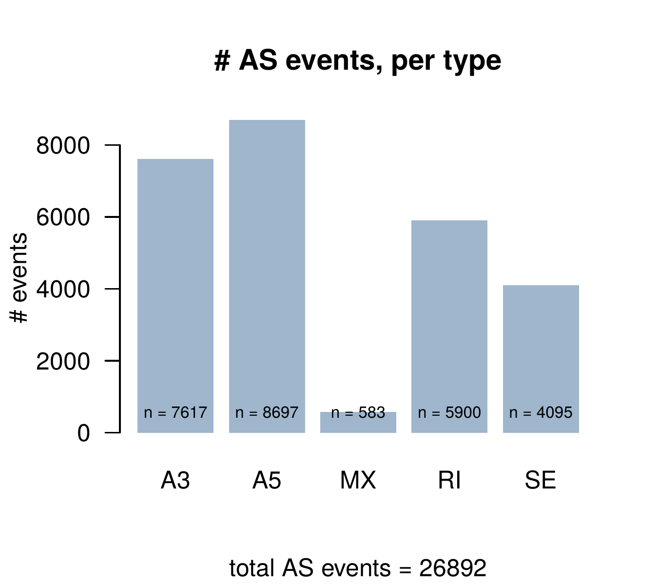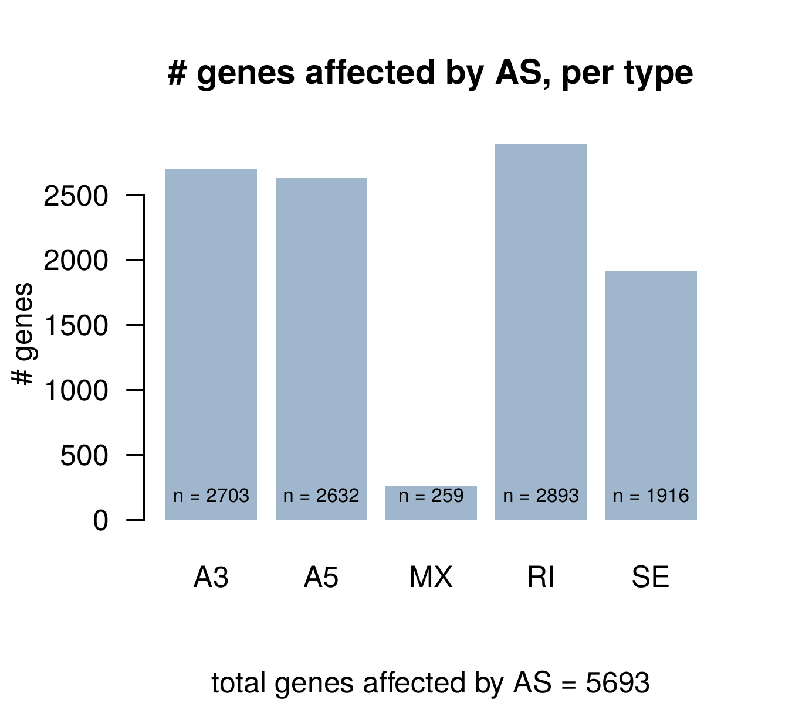
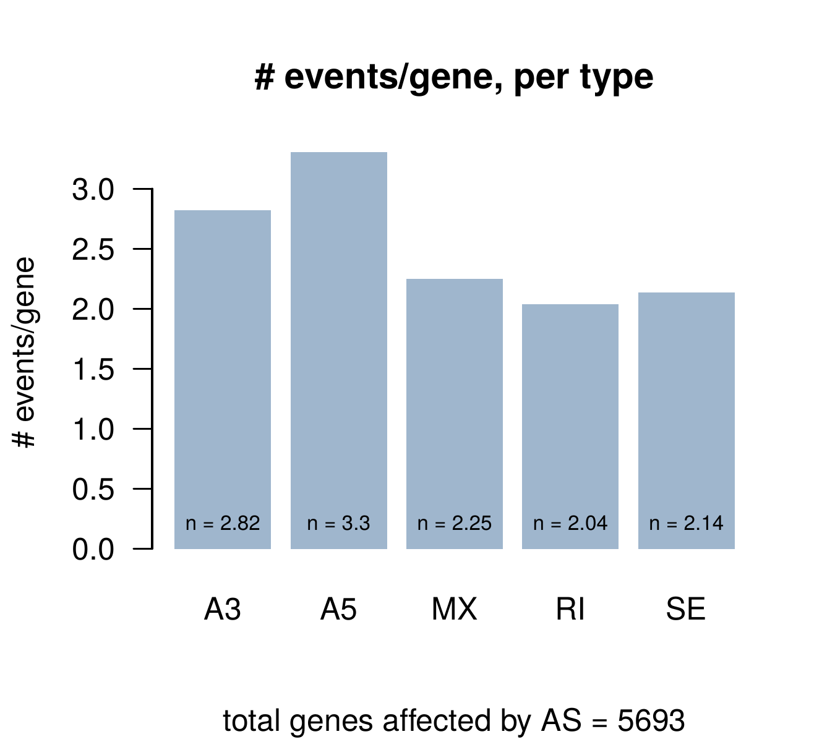
Effects of AS, per AS type – This shows that SE are enriched in frame-preserving skipped exons (~70% of the exons do not alter ORF), whereas just a tiny minority of the retained introns or other types of AS variants are frame-neutral. All good.
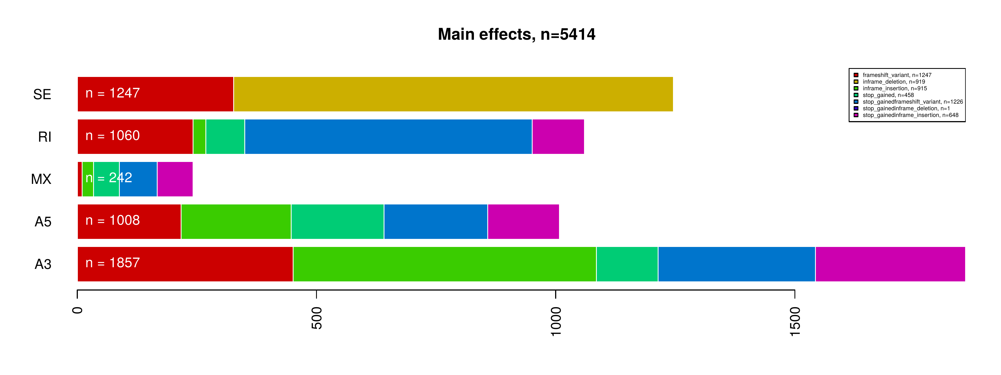

Clustering of samples according to their AS profiles – Using the PSI profiles (‘percentage spliced-in’) of exon skipping (SE) and intron retention (RI) AS events, we can build PCAs, PcoAs, etc.
With in-frame exon skipping events – it looks very similar to the PCAs done from gene expression data: PC1 separates resistant from susceptible; PC2 exposed/unexposed; and PC3 shows minor differences between susceptible samples.
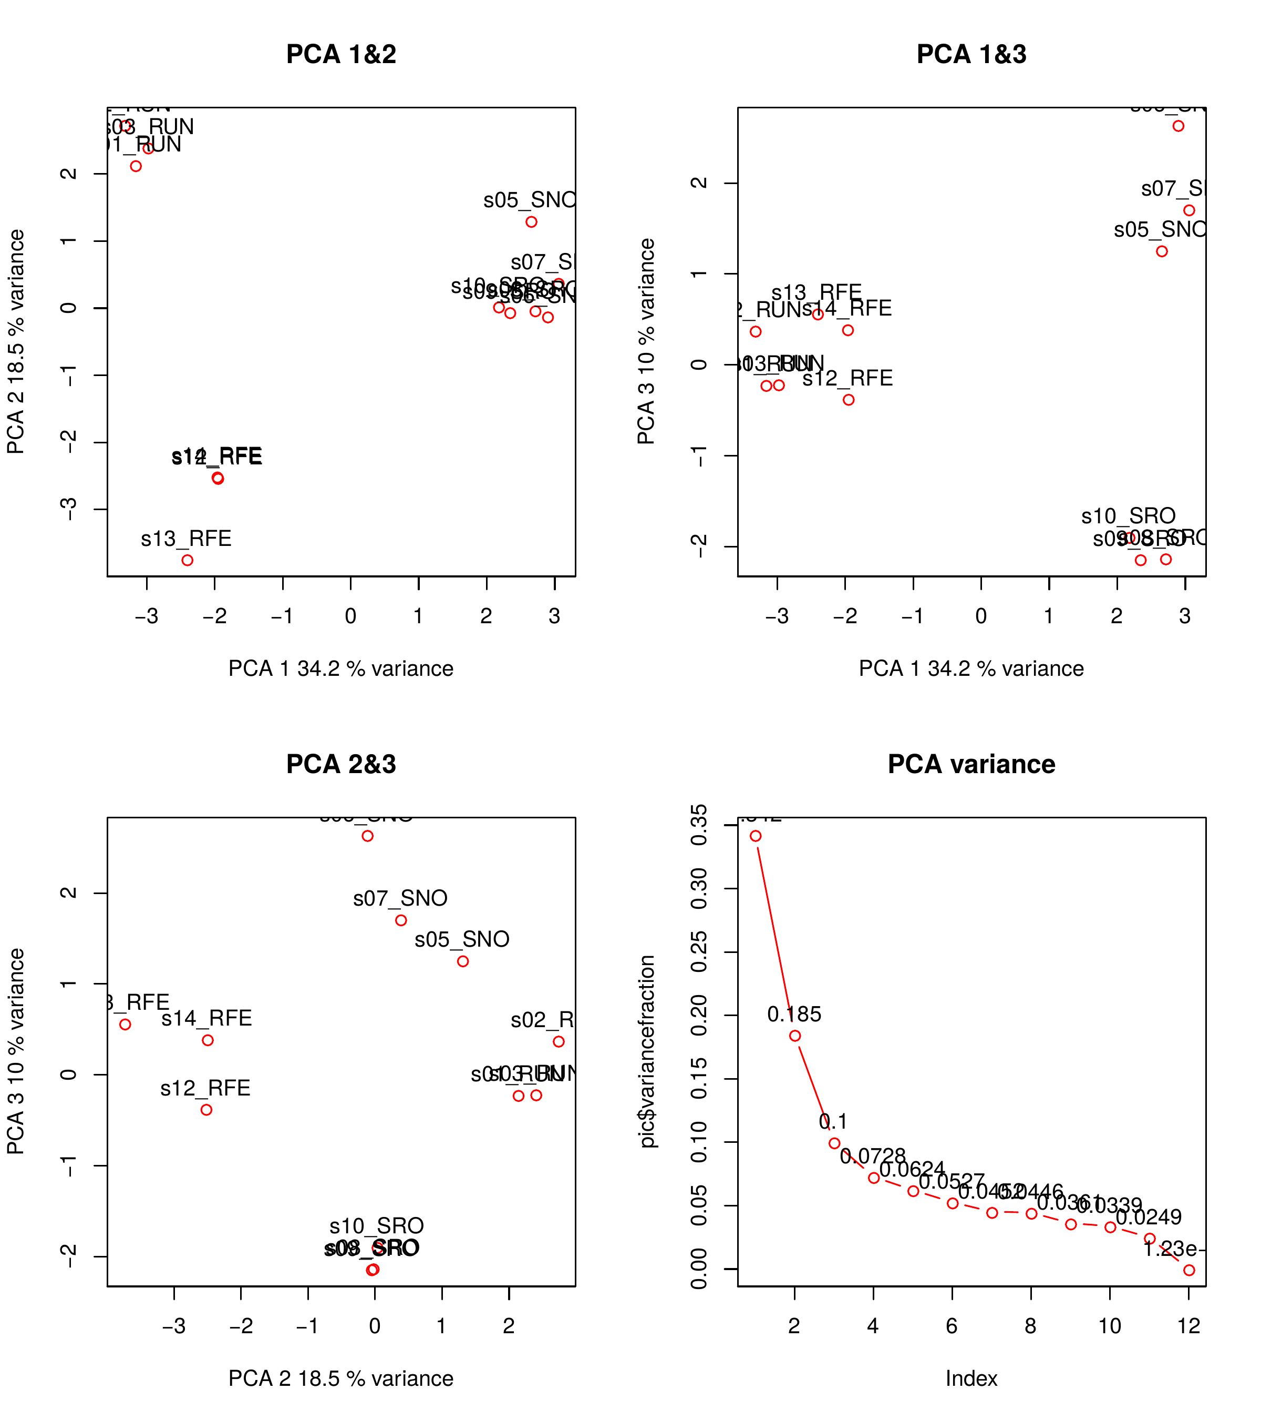
For intron retention events – quite similar, except PC2 (which does not represent exposed/unexposed, because RFE is closer to SRO/SNO – could it represent the lower expression levels in the non-RUN samples?).
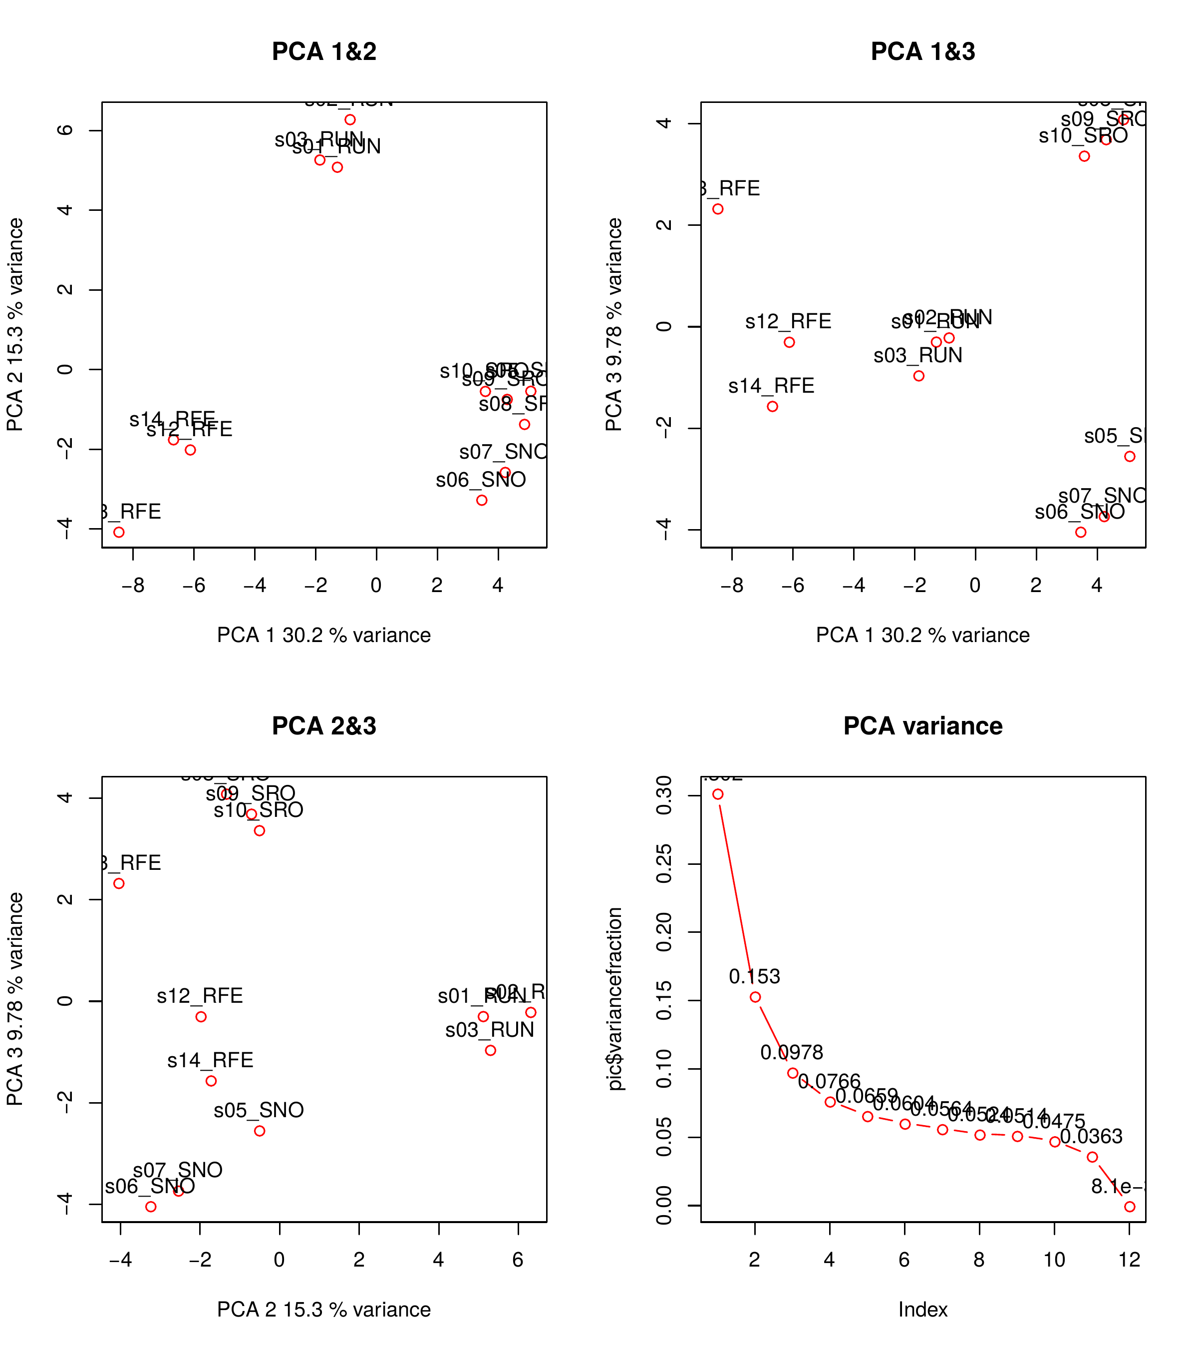

Clustering of exon skipping events using k-means – PSI values of exon skipping events represent the profile of inclusion/exclusion of individual exons in the final transcript. K-means clustering using PSIs can be used to find groups of SE events with the same inclusion profiles.
Exon skipping events with in-frame exons (3n lengths) should be enriched in ‘functional’ AS that results in protein isoforms. At k5, we see these clusters:
- k=1 are exons that are skipped in resistant samples
- k=2 seems to represent exons that more often included in resistant than in susceptible samples
- k=3 represents AS exons that are semi-constitutive (almost always included, but no differences across samples)
- k=4 are exons that are seldom included (possibly weakly defined exons, tissue-/stage-specific exons that are not visibly included in this data-set, mis-annotations, or else) but do not vary a lot across samples.
- k=5 represents exons that are not constitutive but generally not differentially spliced across samples
k=1 and k=2 are the most interesting groups of SE.
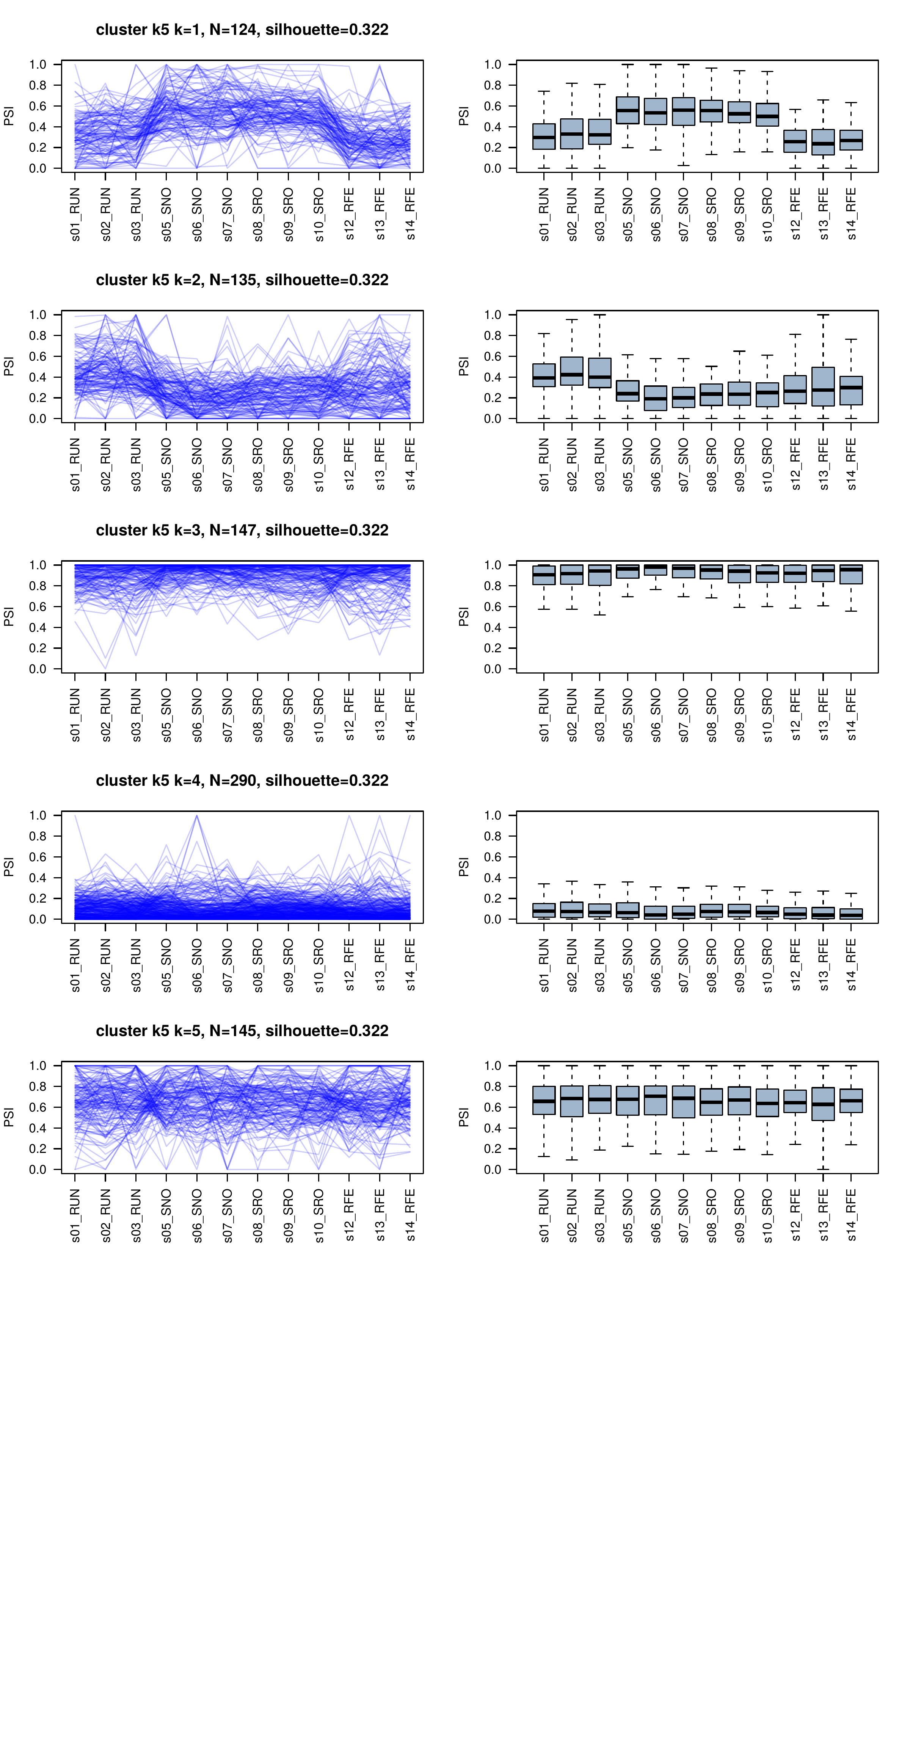
Functional enrichments – of clusters k2 and k4.
- K1 (exons skipped in resistant) genes involved in small G-protein signalling regulator (DENN, uDENN)
- k2 (exons included in resistant) also contains small G-protein signalling regulator functions (DENN, uDENN, RhoGEF), but also cell adhesion (integrin alpha).
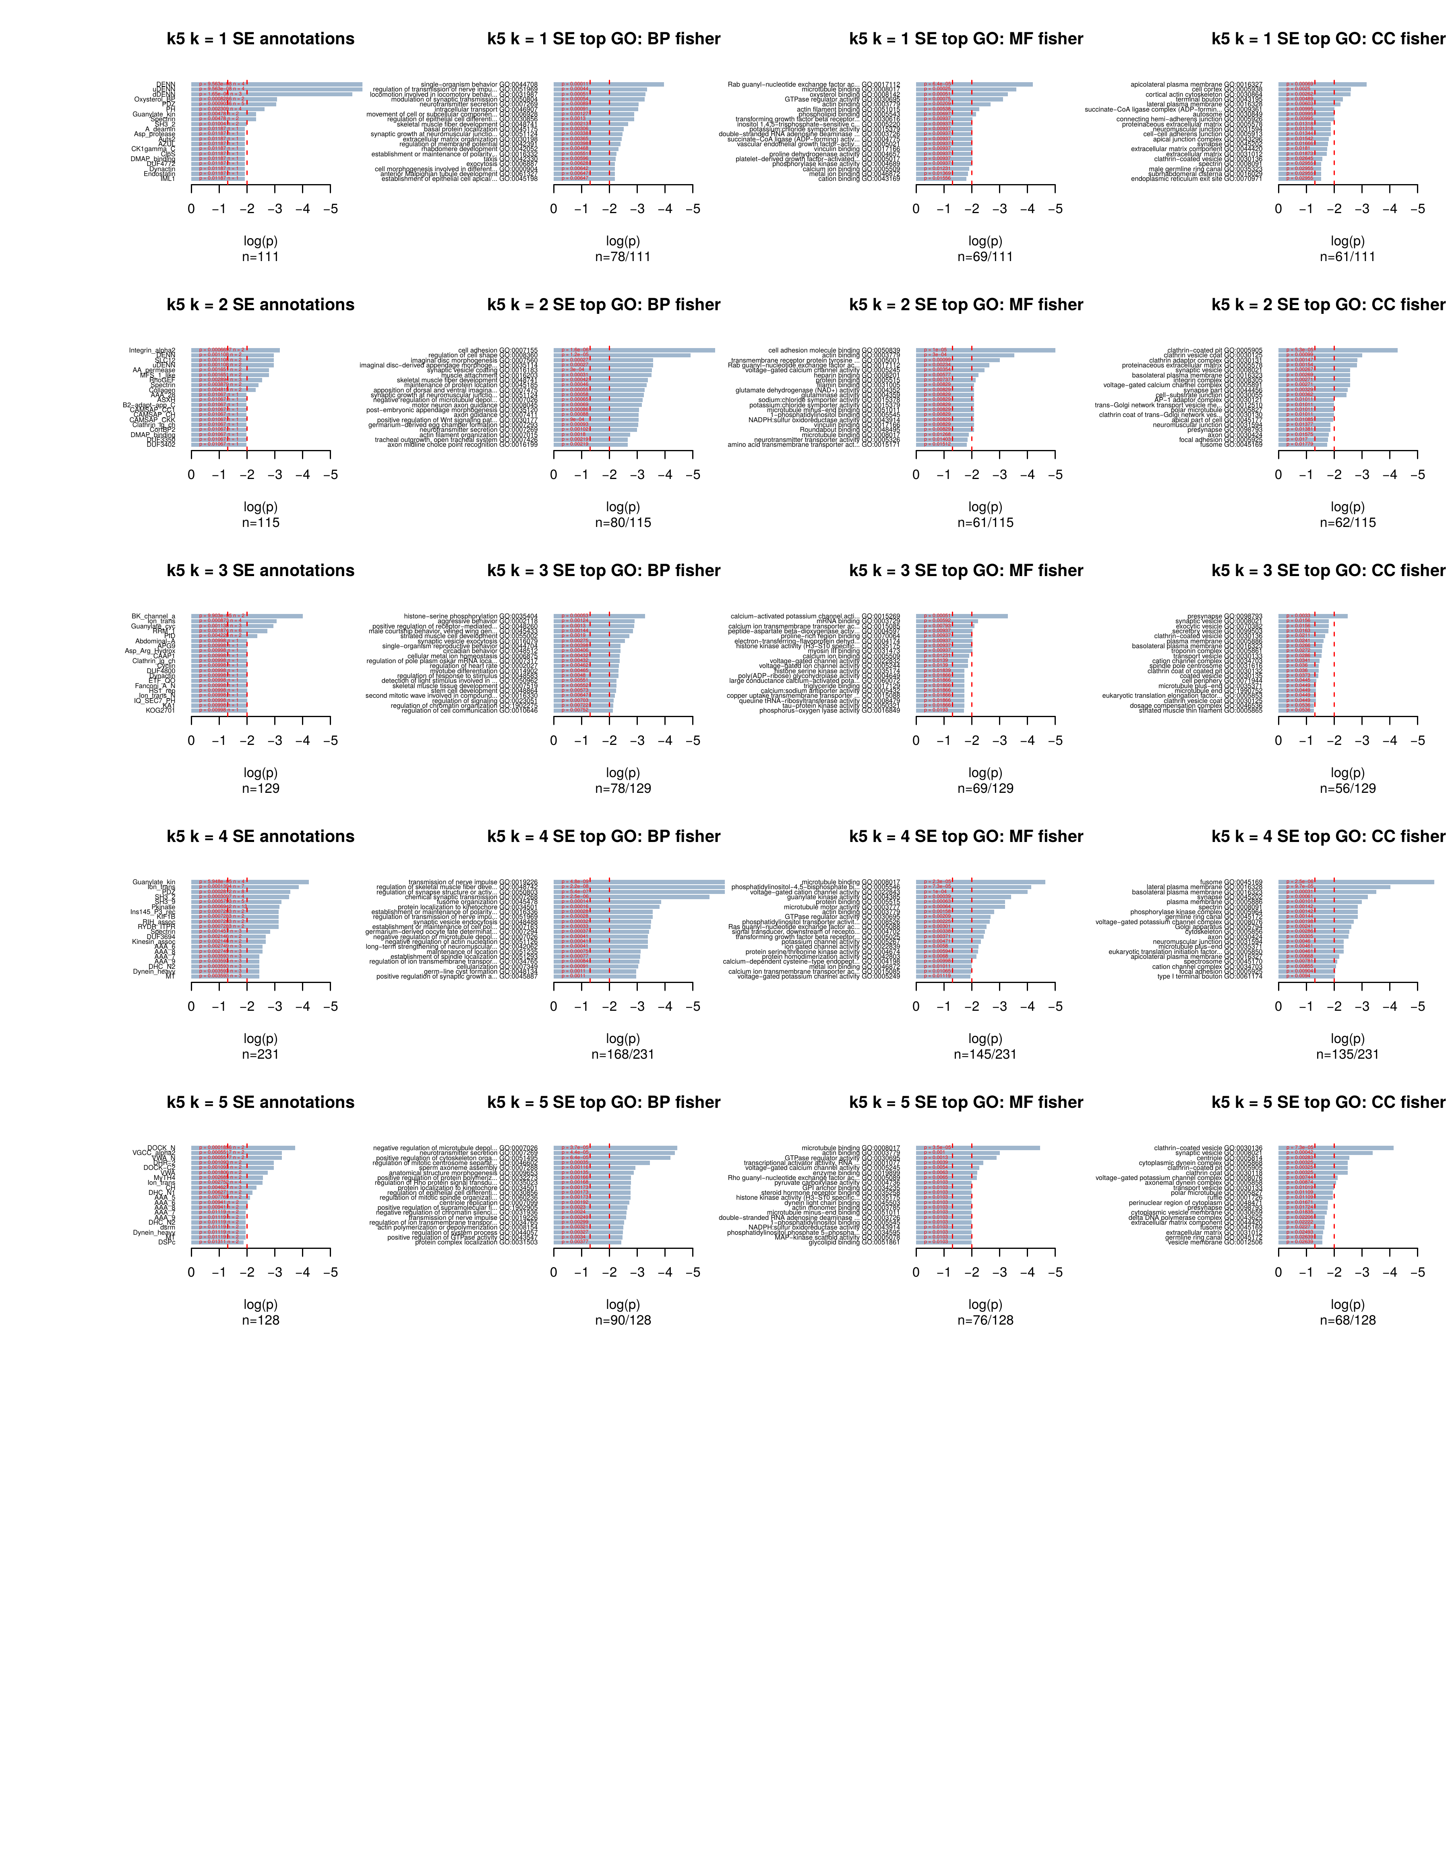

Clustering of intron retention events using k-means – PSI values of intron retention also used to find k-clusters at various values of k. Here, the ‘default’ state is exclusion (PSI=0).
At k6, we see these clusters:
- k=1 are introns that are included in resistant samples
- k=2 are introns that are usually excluded (big group, a normal situation)
- k=3 are introns that are frequently included, but with a somewhat lower frequency in resistant samples
- k=4 are an interesting group of exons that are more frequently included in exposed resistant samples (effect of stress, down-regulation of genes via RI+NMD?).
- k=5 are ~50%-PSI introns, with a slight increase in susceptible samples
- k=6 are a bunch of introns that are almost constitutively included, which is odd (false annotations? Very short introns?)
The most interesting groups are k=1 and k=4 (resistant-specific introns), and k=3 (susceptible-specific introns).
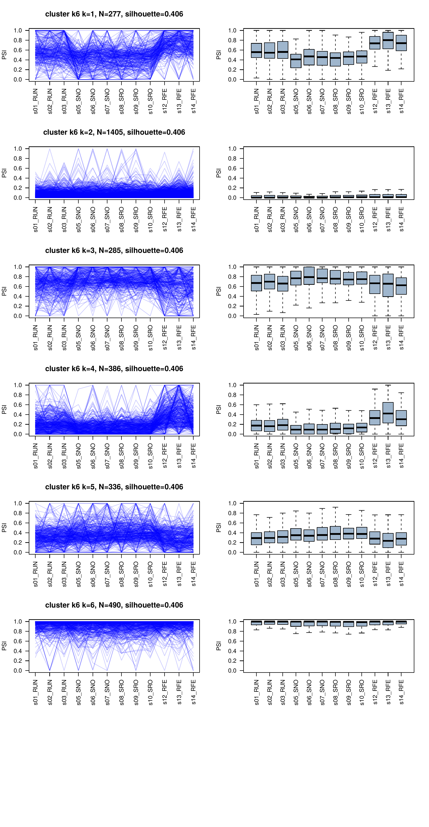
Functional enrichments – functions of the genes harbouring the introns belonging to each cluster:
- k1,k4 (introns included in resistant): Some more small G-protein regulators, Staufen (Staufen_C) is a protein involved in RNA transport in neuronal tissues, etc (not very clear)
- k2 (introns included in susceptible): unclear
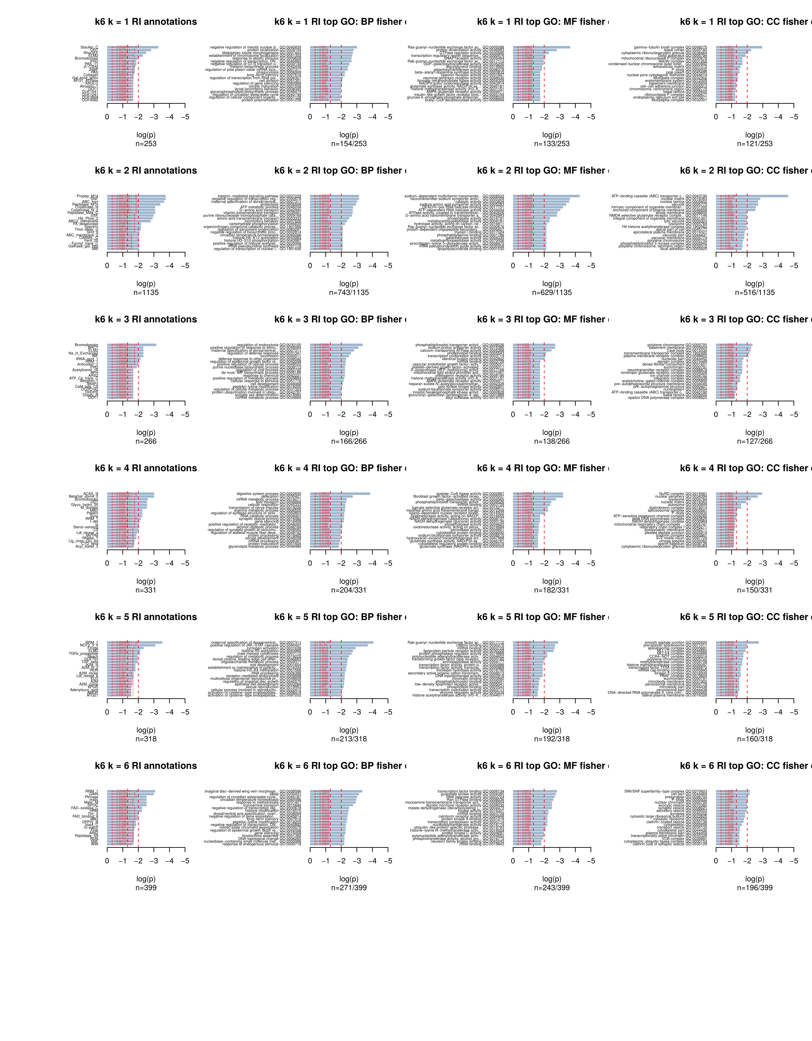
All in all, enrichment analyses in AS genes do not show a very clear connection with the annotations found in the list of DE genes. Transcriptome-wide patterns seem to reflect other phenomena (noise, stress, nothing…). So, the best way of analysing patterns of AS will be to come up with lists of genes of interest using DE analyses, and then examine AS profiles there in detail.
For example, these plot summarises exon skipping events in cuticle proteins that have a probability of differential splicing of at least 90% (using empirical pseudo p-value<0.1) and more than 20% difference in PSI in either sense. It can uncover short lists of specific exons that are differentially spliced, e.g. two exons that are skipped in exposed individuals.


