Aedes aegypti transcriptome: resistance to fenitrothion
Xavier Grau-Bové

Experimental setup
12 samples divided in 4 groups (3 identical replicates per group). 6 fenitrothion-resistant samples from Angola (3 have been exposed to fenitrothion, 3 unexposed). 6 susceptible samples from laboratory strains (3 from New Orleans, 3 from Rockefeller). Sample classification:
Sample name | Sample group | Phenotype | Exposure | Location
s01_RUN | ResUnex | Res | Unex | Angola
s02_RUN | ResUnex | Res | Unex | Angola
s03_RUN | ResUnex | Res | Unex | Angola
s05_SNO | SusNewO | Sus | Unex | NewOrl
s06_SNO | SusNewO | Sus | Unex | NewOrl
s07_SNO | SusNewO | Sus | Unex | NewOrl
s08_SRO | SusRock | Sus | Unex | Rockef
s09_SRO | SusRock | Sus | Unex | Rockef
s10_SRO | SusRock | Sus | Unex | Rockef
s12_RFE | ResFeex | Res | Feex | Angola
s13_RFE | ResFeex | Res | Feex | Angola
s14_RFE | ResFeex | Res | Feex | Angola

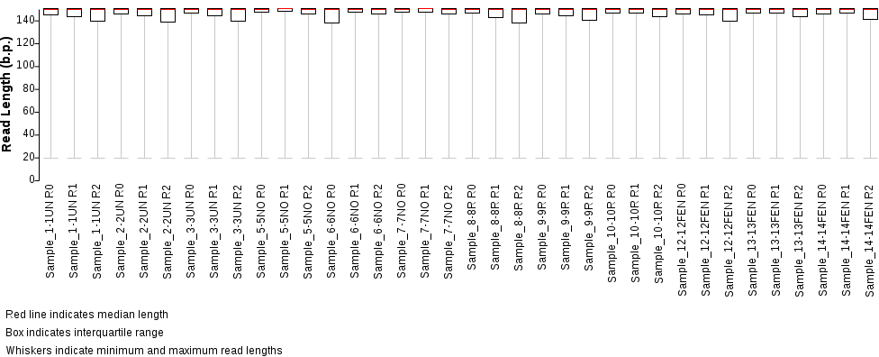
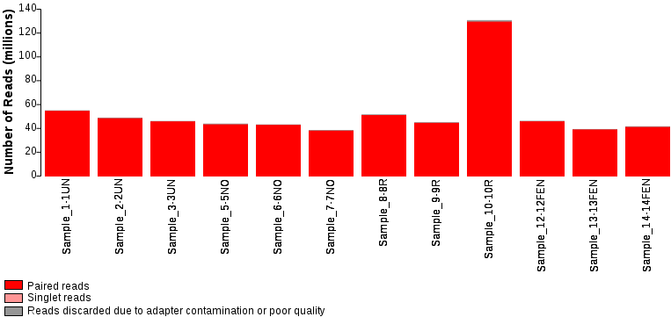
Excess of reads in s10 due to miscalculation of RNA concentration prior to library preparation. It does not seem to have an effect on final results.
Comparisons for all analyses – these:
- Independent comparisons of susceptible strains (SRO, SNO) to resistant-unexposed (RUN), to uncover genes that are constitutively differentially expressed in the resistant background (independently from specific exposure conditions).
- Analyse overlap of DE genes between SRO-RUN and SNO-RUN – same genes should appear.
- Compare resistant unexposed (RUN) – resistant exposed (RFE), to find genes that are DE upon exposure.
Insecticide info – Fenitrothion is an organophosphate. Insecticide resistance should be due to increased expression of detoxification enzymes (p450, GSTs?), or changes in acetylcholine receptors, etc.

Quantification: DE & AS
For gene expression levels: (i) maping of all RNA-seq samples with hisat; and (ii) quantification of expression levels of longest isoform per gene using salmon (TPM); then (iii) TPM matrix is loaded onto Deseq to produce matrix of normalized transcript counts, log2 fold-change between sample groups. For alternative splicing analyses: (i) same hisat mapping; (ii) assembly of sample-specific transcriptomes with isoforms using stringtie, followed by creation of pan-sample consensus assembly; (iii) quantification of expression levels using salmon (TPMs) using both all isoforms and longest isoform per gene; (iv) construction of sample-specific isoform and AS event catalogues using suppa; and (v) quantification of AS events using suppa too.

Gene expression: clustering of all samples
PCA analysis – Using the matrix of normalized transcript counts from Deseq, calculating Euclidean distances between samples. Good within-replicate clustering. An analogous PCoA shows the exact same overall clustering (using Pearson correlation-derived distances + Ward clustering), with some more intra-replicate differences.
PC1 separates susceptible from resistant samples and is by far the most important. PC2 separates exposed from non-exposed. Oddly, RFE seems to be closer to susceptible samples than RUN, along PC1. PC3 highlights differences between SRO and SNO and it is not very relevant (not the focus of this analysis, although it can help contextualize the overlap differences in SRO/SNO-RUN comparisons),
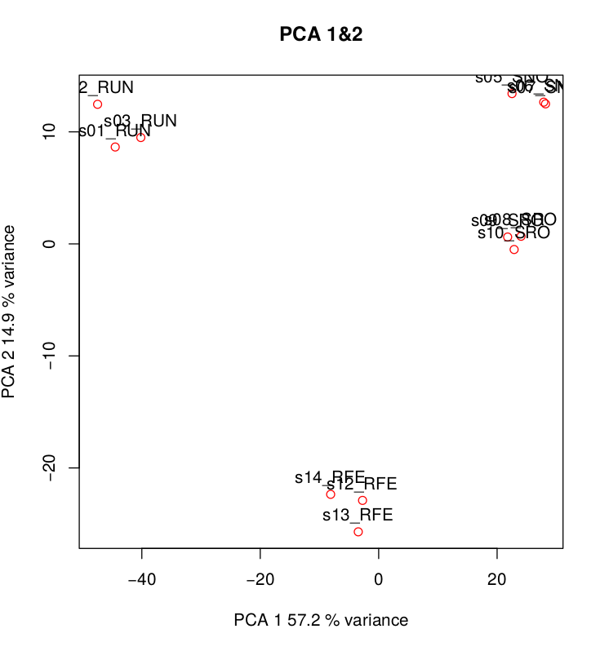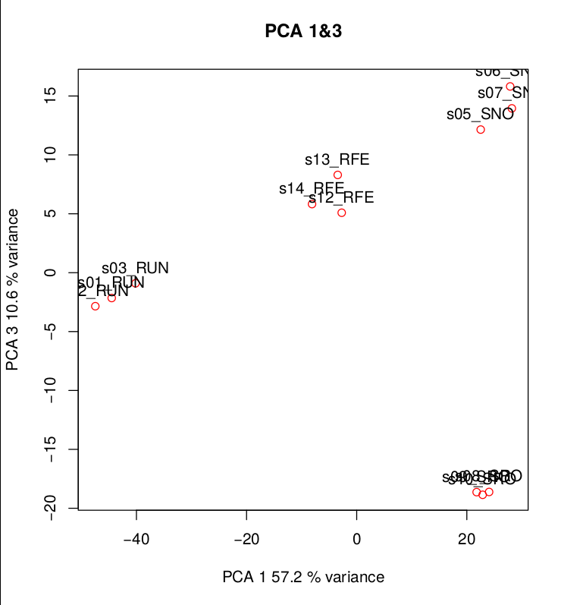
Clustering – Heatmap of log10 normalized transcript counts, clustering samples and transcripts by common gene expression profile (Pearson correlation-derived distances + Ward clustering). Similar to PCAs: it recovers RUN samples as being the most distant (it mostly reflects the same tendencies as PC1).
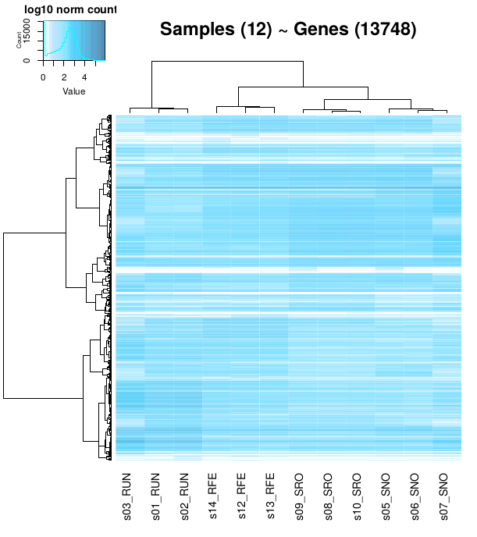
All in all, results make sense. Note that S10 (which had an excess of reads) does not seem to be weird in any analysis.

Comparison of oenocytes v. bulk in males and females, separately
Comparing oenocytes v. bulk in males, we see a high number of DE genes at p<0.001 (as in all other DE comparisons; left): more than 3,000 DE genes, with ~50% being overexpressed in each category. This is not extremely informative, there are way too many things to look at.
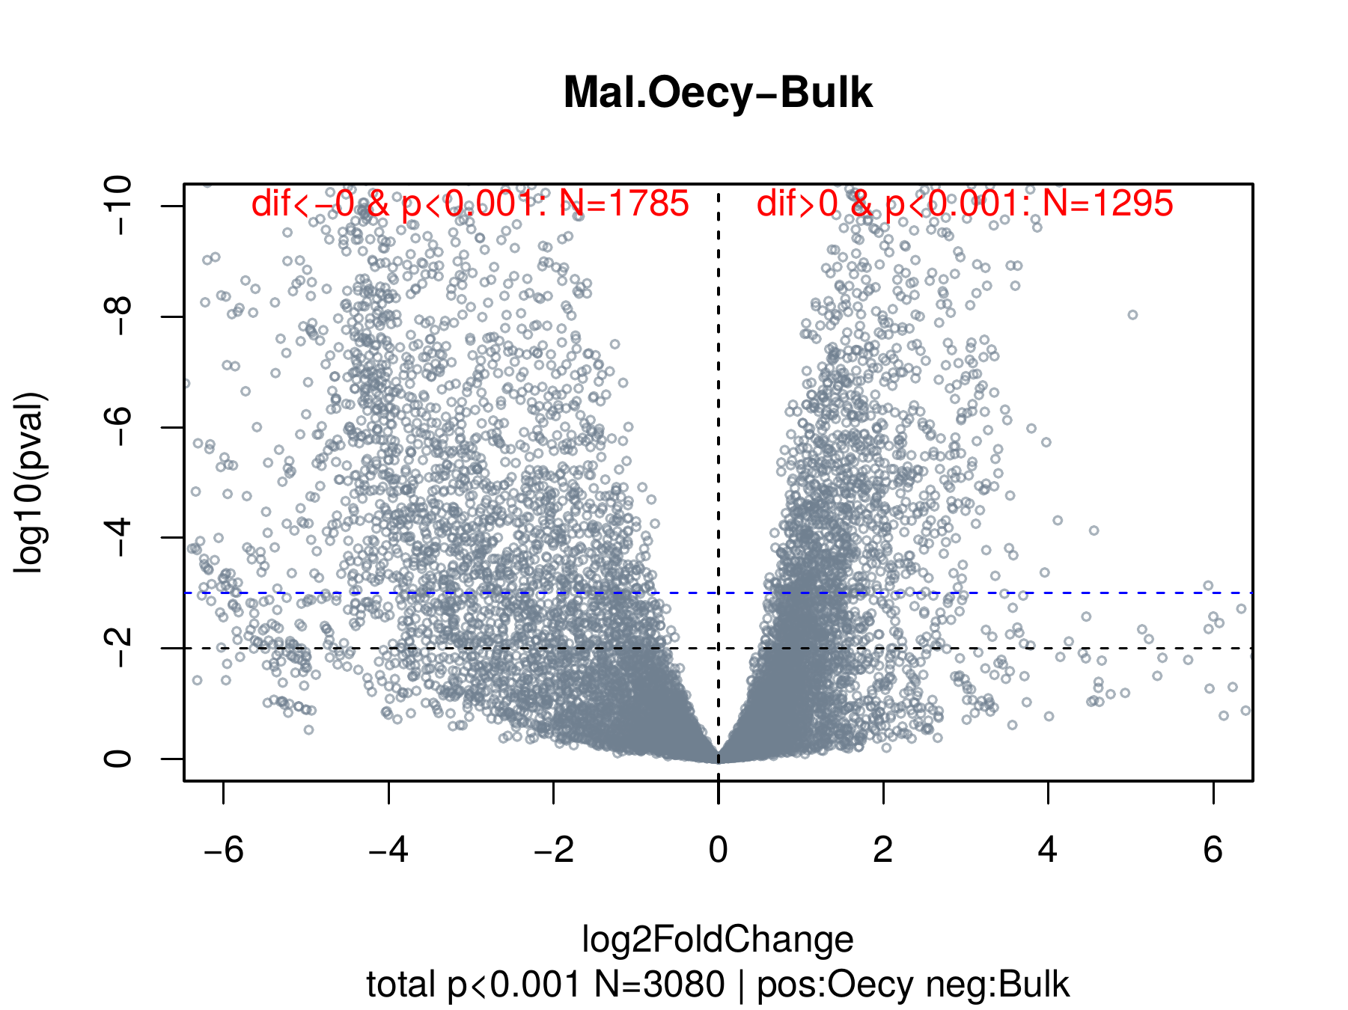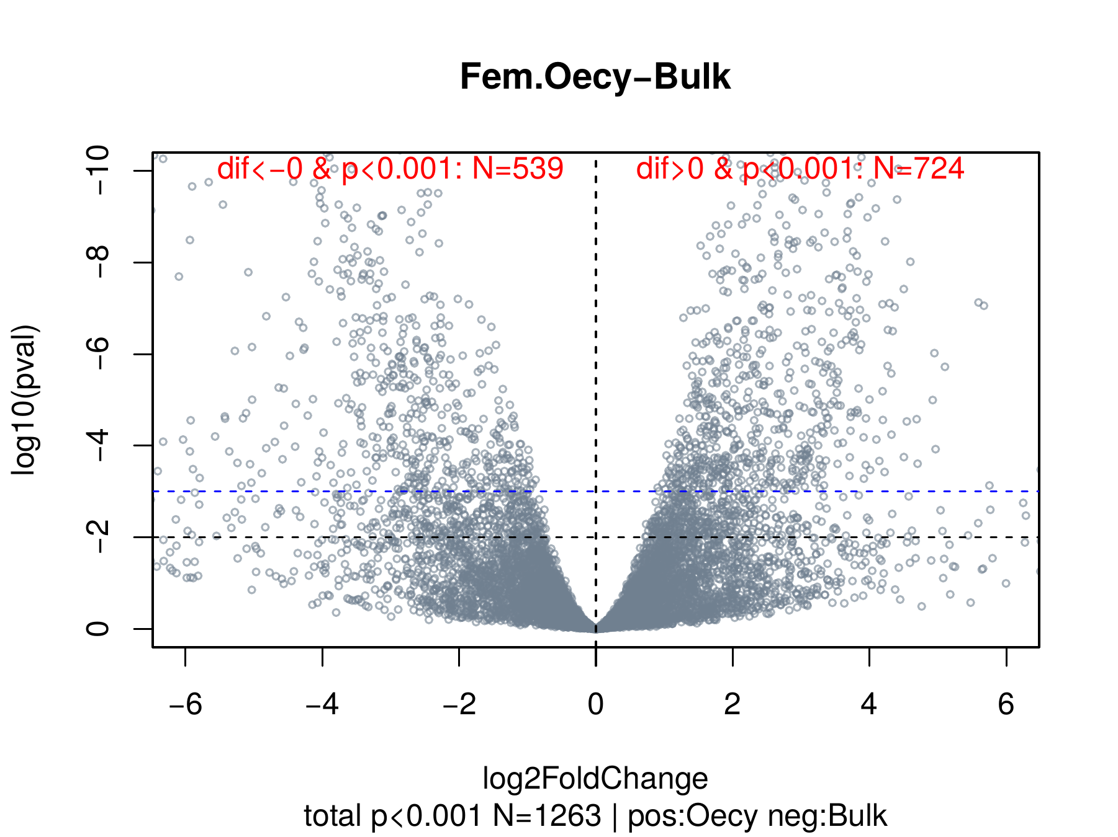
The same comparison within females (right) shows a lower number of DE genes than in males (~1200 DE genes in total; ~40/60% being overexpressed in each category). This lower number reflects the fact that bulk female controls appear to be closer to female (or male) oenocytes in the PCA analysis than male bulk samples.
A joint analysis of female+male oenoctytes v. female+male bulk shows an intermediate result (~2000 DE genes).
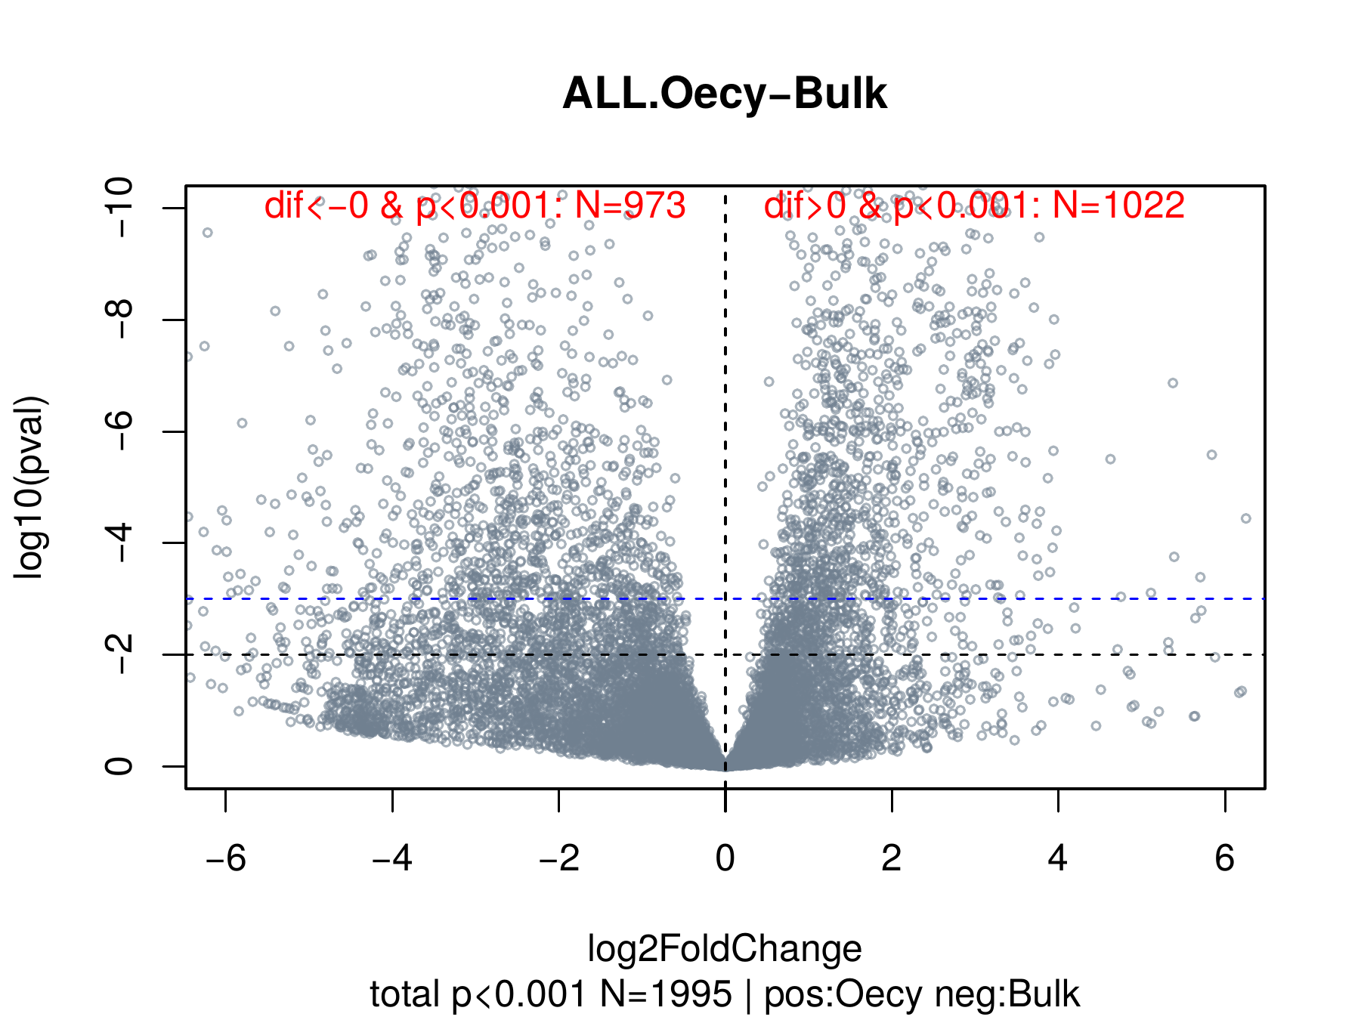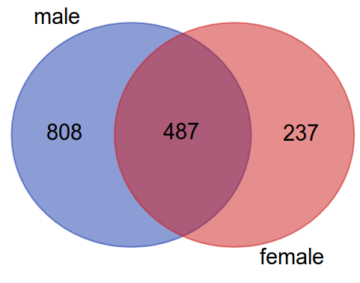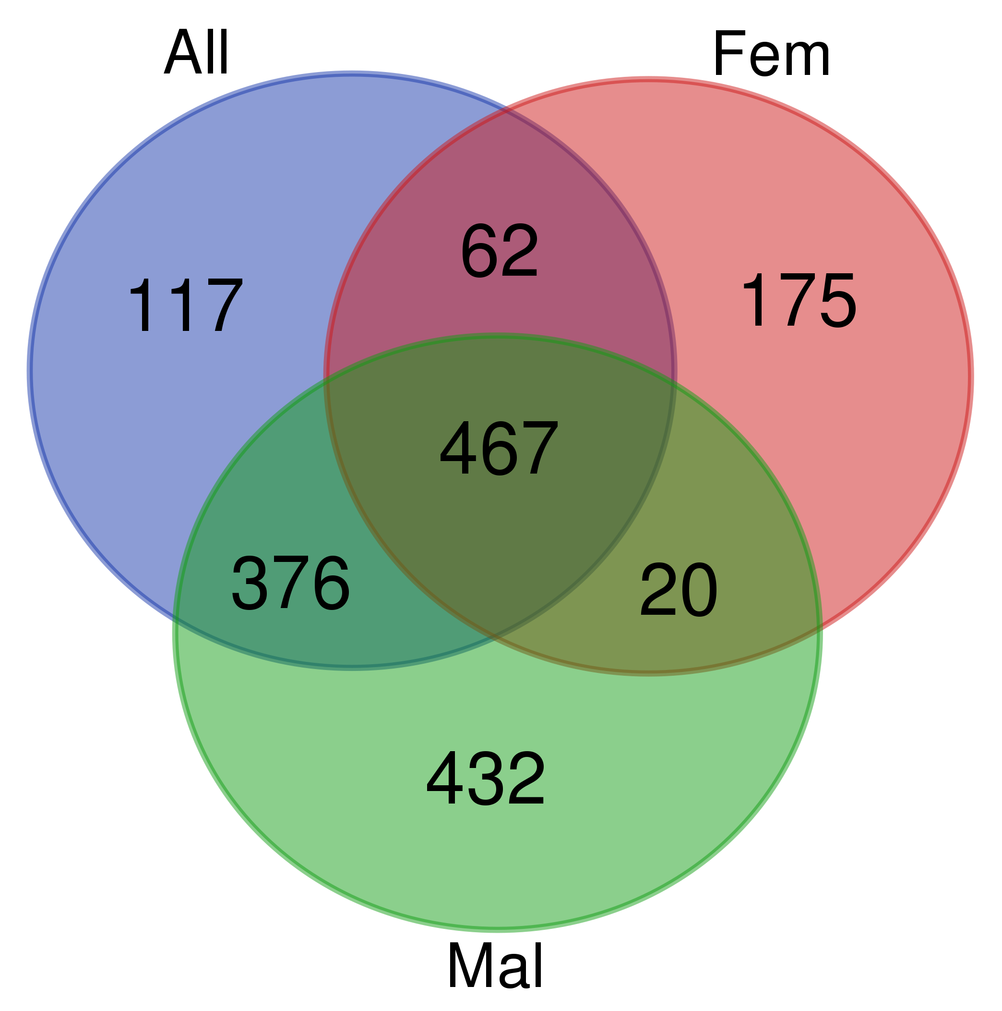
In total, there 1532 unique genes over-expressed in either male or female oenocytes. Out of these, only 487 genes are overexpressed in both female and male oenocytes (and male oenocytes have 808 exclusive genes). If we want to identify oenocyte-biased genes, this overlap analysis is more conservative and yields a more manageable list of genes.

Now: what are these 487 oenocyte-biased genes? A quick look with Pfam domain enrichment (hypergeometric test) to see whether there are over-represented gene families within the oenocyte-biased genes. This reveals a few obvious things:
- 9 fatty acid elongases (ELO domain long chain fatty acid elongation): AGAP001097, AGAP003195, AGAP003196, AGAP003197, AGAP004372, AGAP005512, AGAP007264, AGAP013094, AGAP013219
- 3 Ketoacyl synthases (with a series of common domains: ADH_zinc_N, Kasynt_C_assoc, ketoacyl-synt, Ketoacyl-synt_C, KR, PP-binding, PS-DH, Thioesterase): AGAP001899 (with Acyl_transf_1 too), AGAP008468, AGAP028049.
- 5 fatty acid reductases (with NAD_binding_4+Sterile domains, like D. melanogaster?): AGAP004784, AGAP004787, AGAP005984, AGAP005985, AGAP005986
- Fatty acid hydroxylase (not “enriched”, but important; FA_hydroxylase; superfamily includes fatty acid and carotene hydroxylases and sterol desaturases) (AGAP000092)
- 6 p450 carboxylase (not “enriched”, but important): AGAP000877, AGAP001076, AGAP002862, AGAP004665, AGAP008206, AGAP013128
- ...
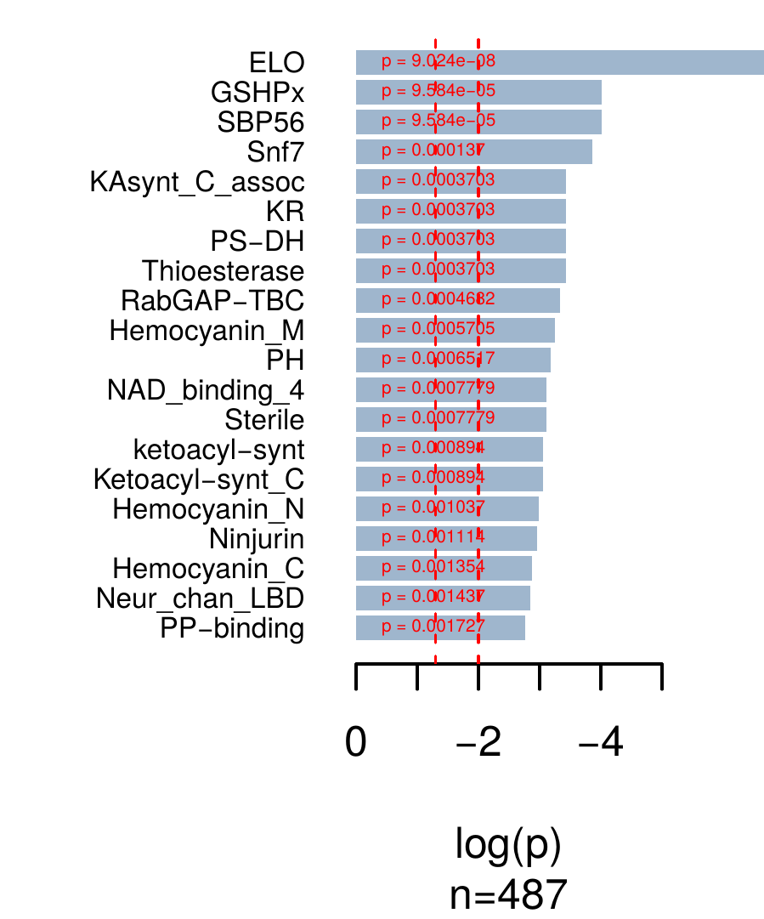
In total, there are 9+3+5+1+6=24 putatively interesting genes.
Another possibility is GO enrichment (not working!)

Comparison of female oenocytes v. male oenocytes
Sex-specific signal within oenocyte samples only became visible in PC3, so it is understandable that differences are not as strong as in other comparisons. In this case, there are 248 differentially expressed genes, with a ~2x bias towards over-expression in male oenocytes.
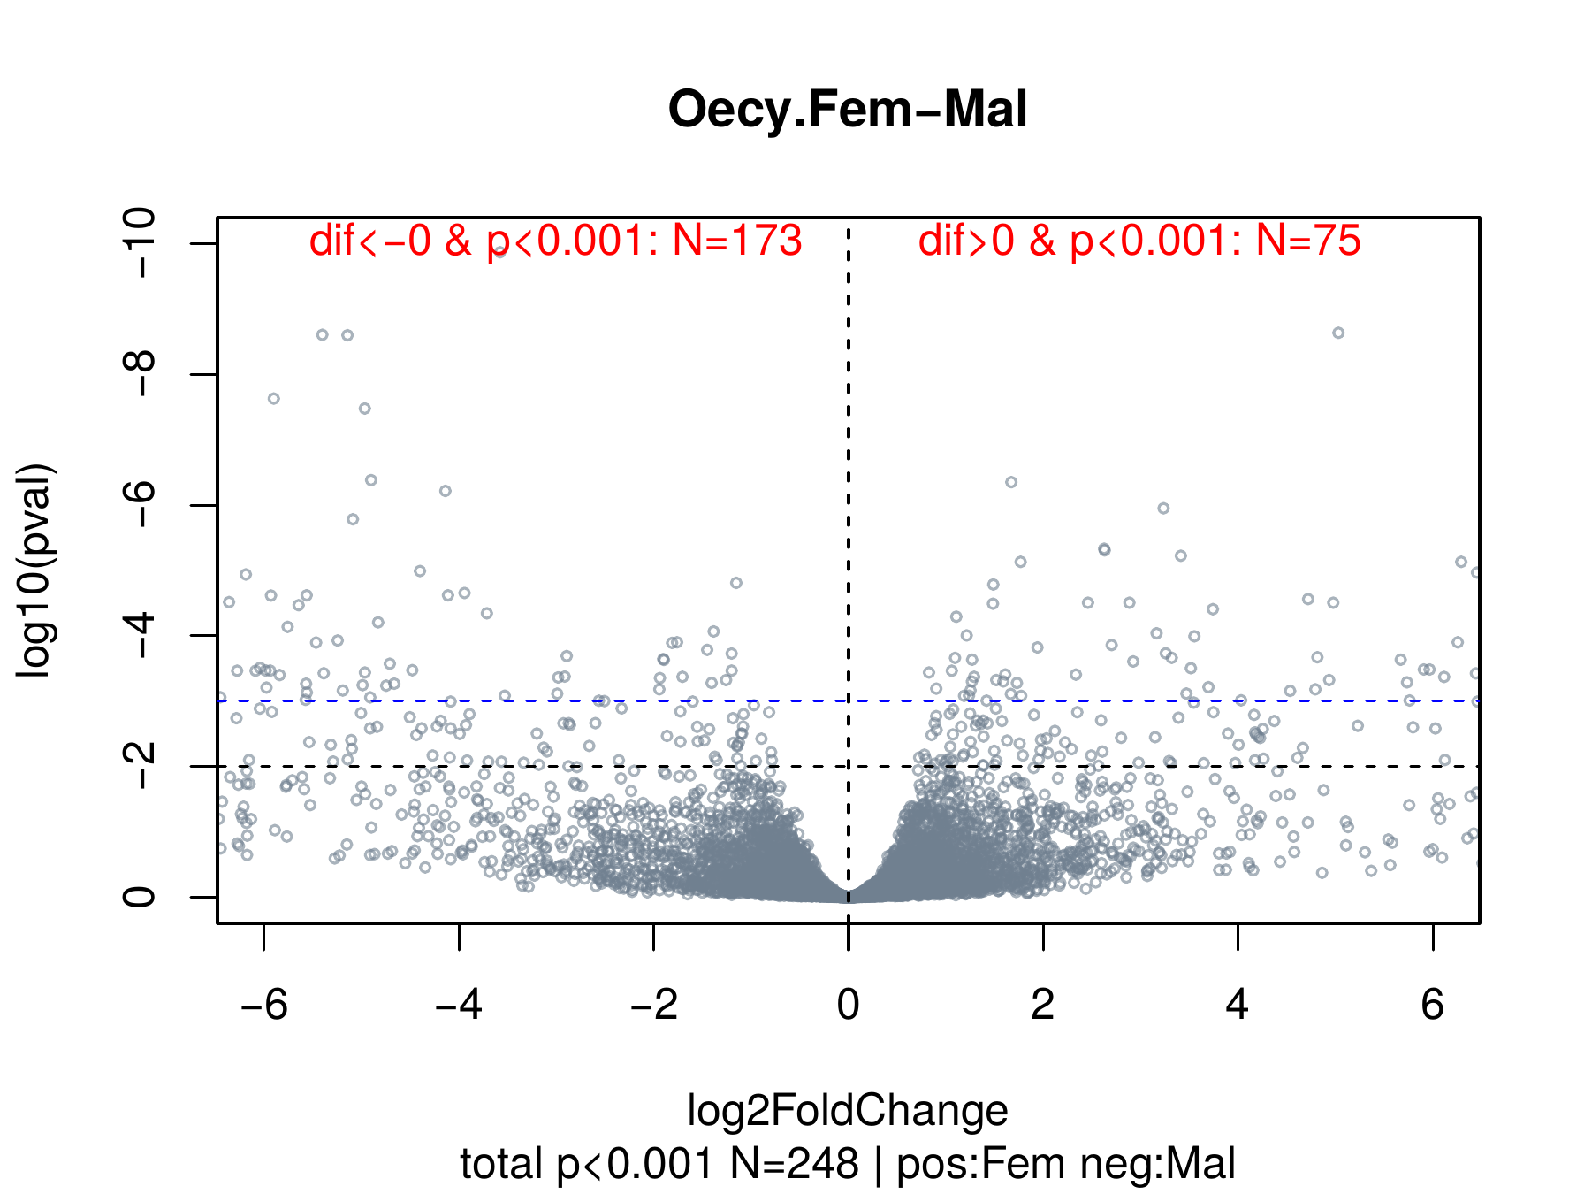
Is this important at all?

Alternative splicing patterns
Globally, AS patterns seem to follow the same pattern of similarity as gene expression, which means that they differences recovered here are not noisy and might be meaningful. For examples, PCAs produced using the PSI of AS events (percent spliced-in) have the same overall look that PCAs from transcript expression counts (above). I include two PCAs: PSIs of intron retention (left; all events included) and exon skipping events (right; only in-frame events are included):
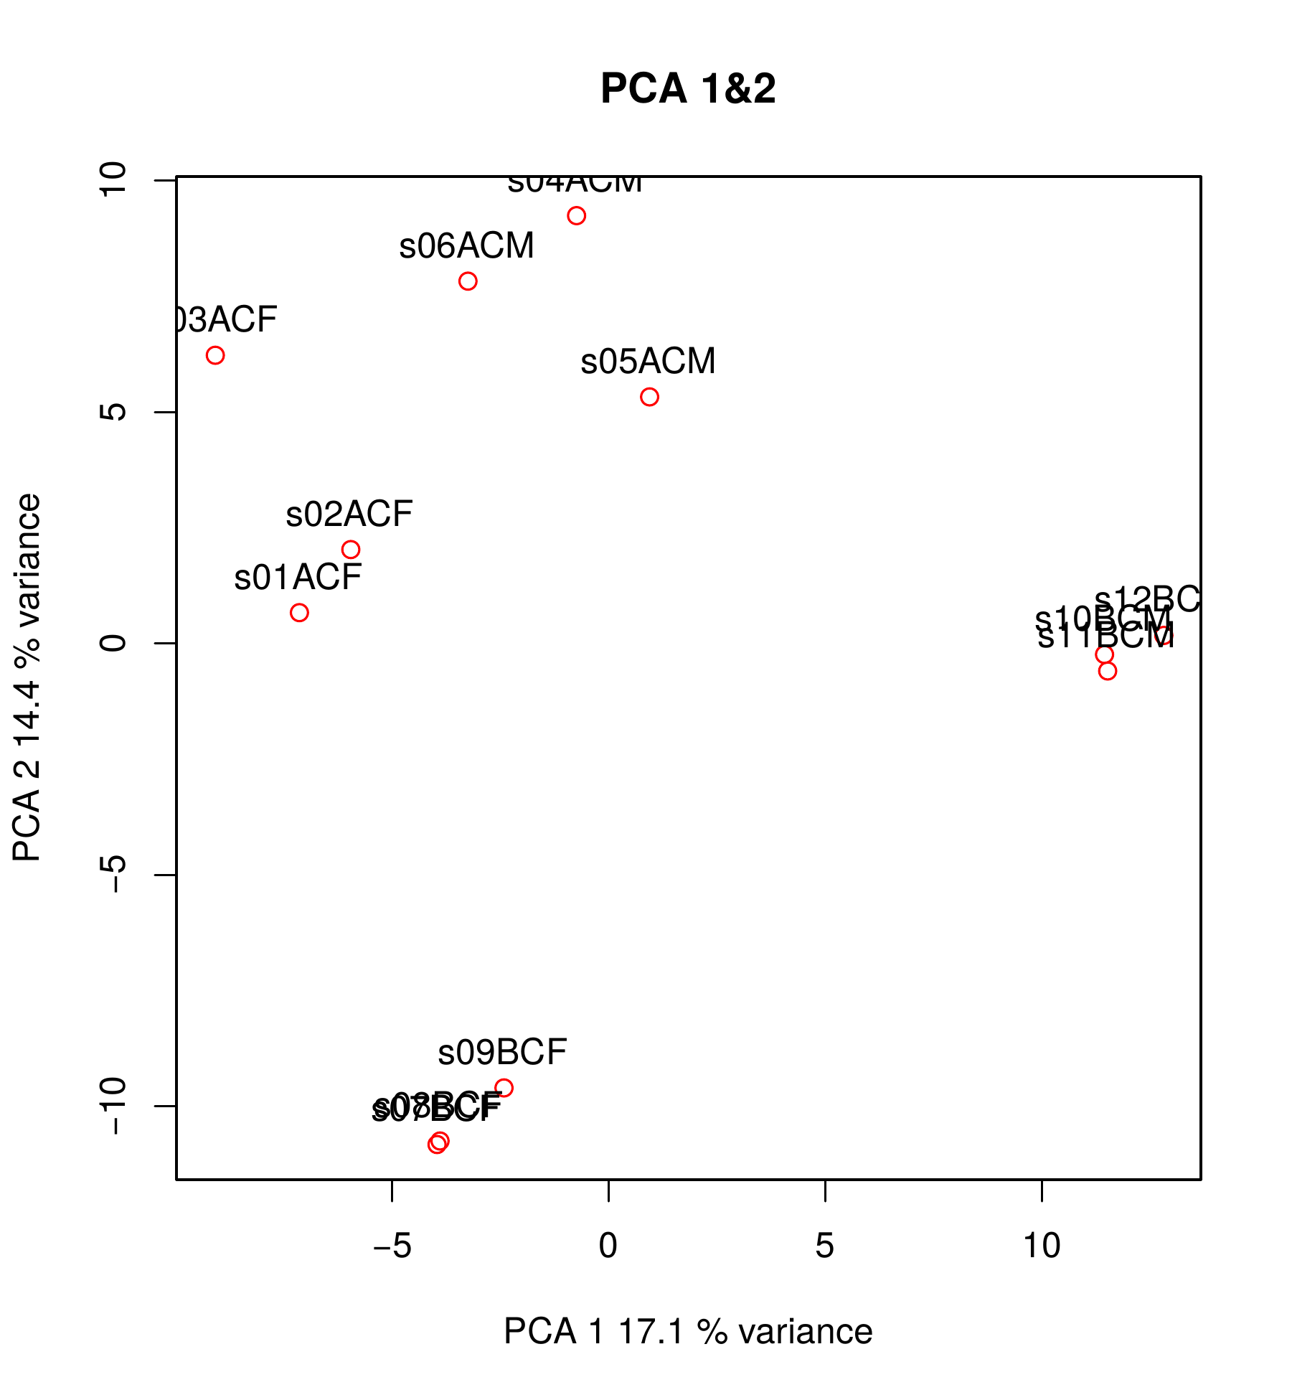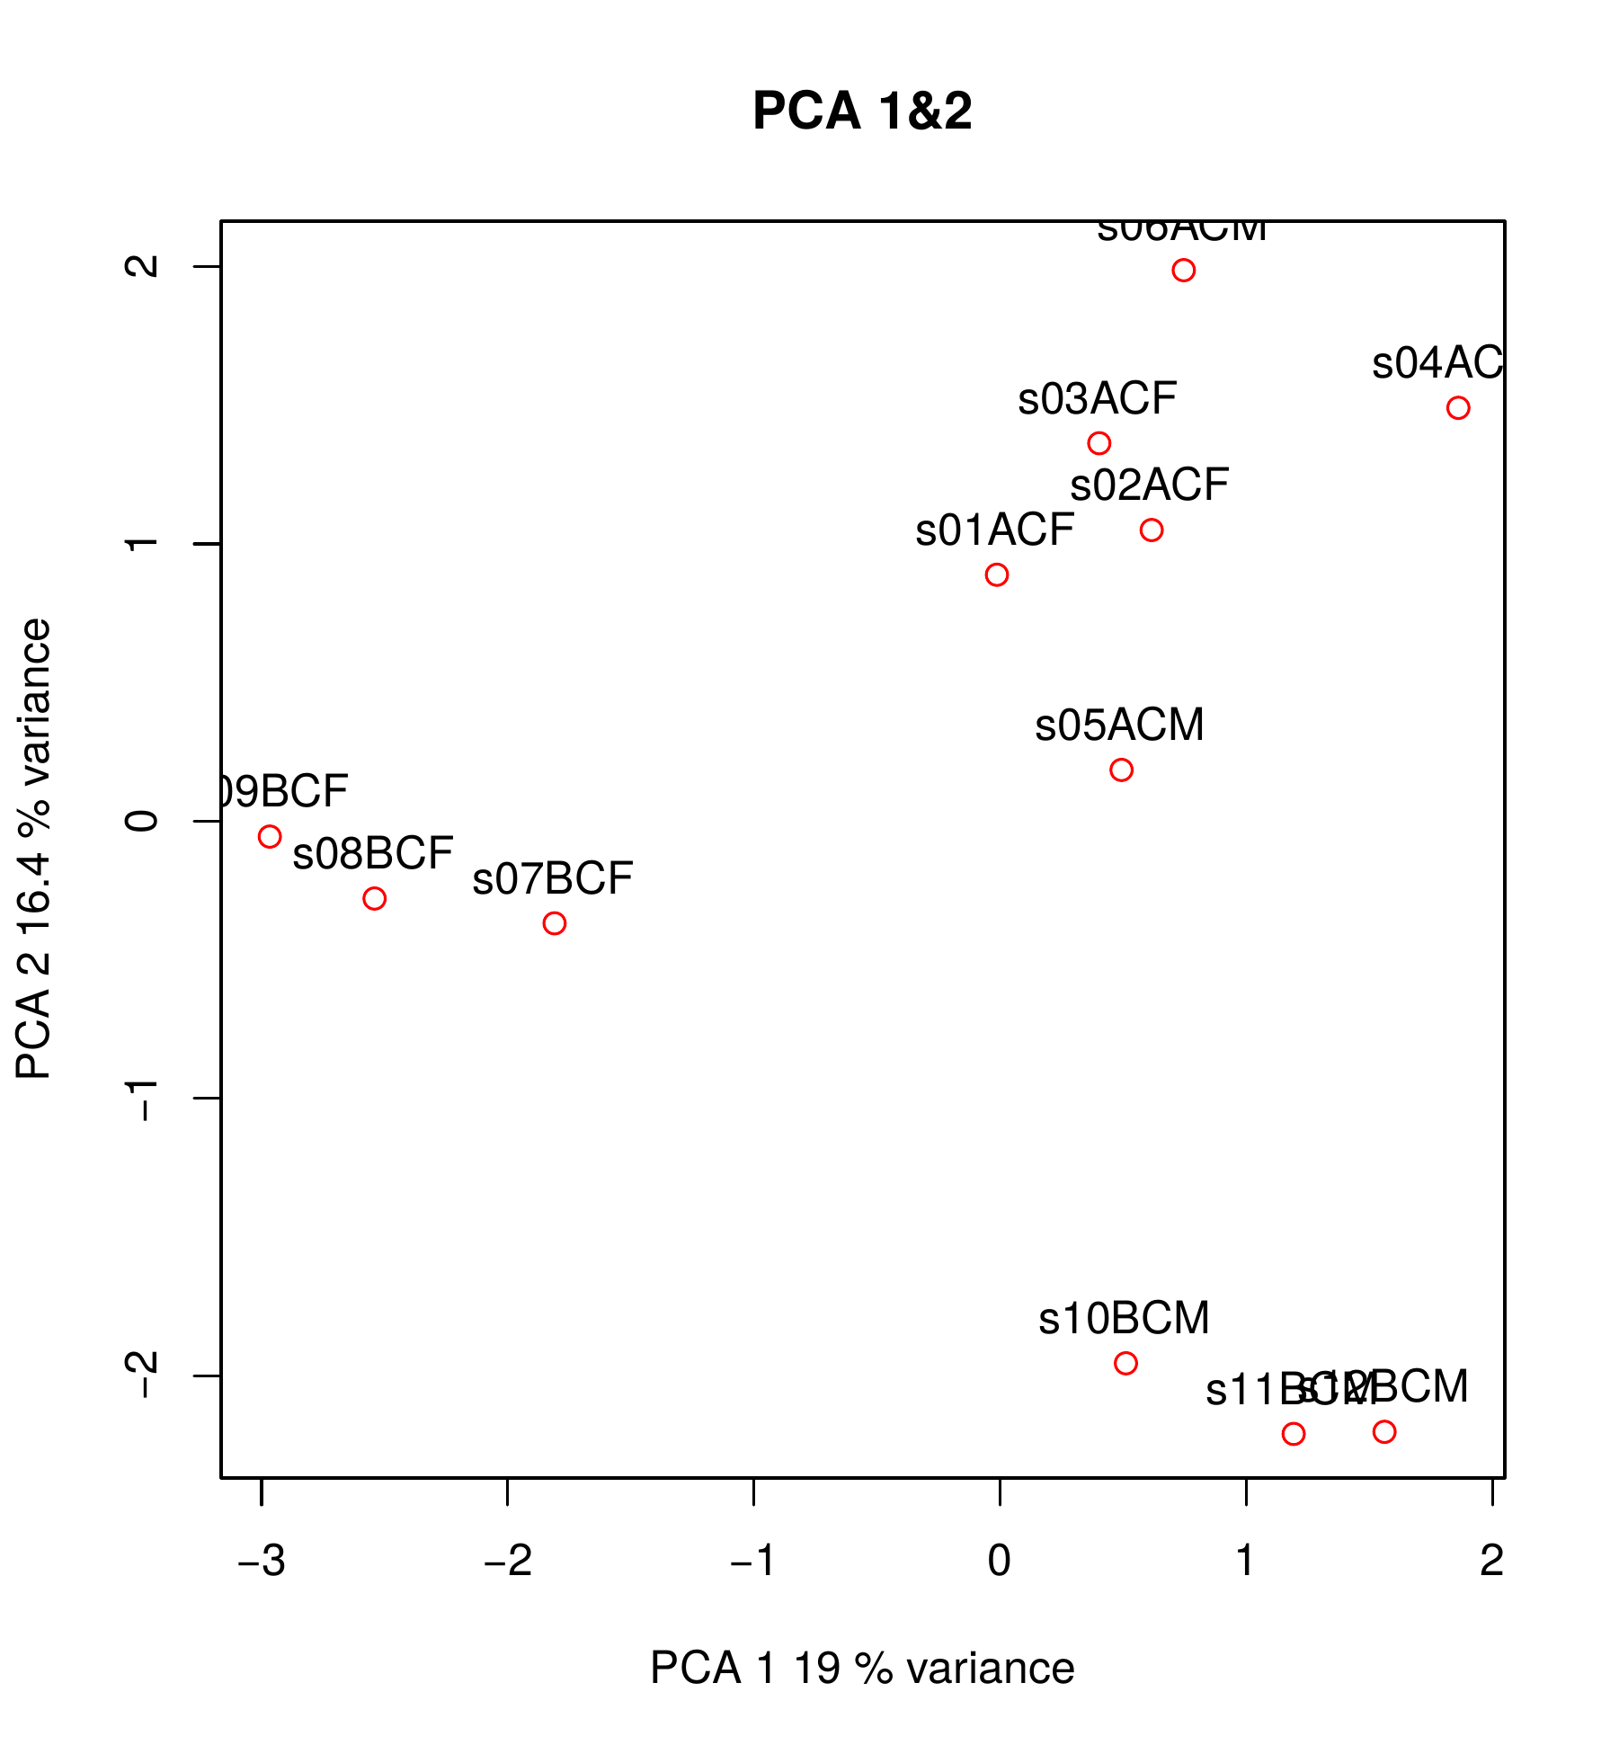
If we take a look at the effects that different types of AS have on the final transcript, we see that skipped exons (SE) and mutually exclusive exons (MX) are enriched in frame-preserving events; whereas retained introns and alternative splice sites (RI, A3, A5) are tend to disrupt the ORF.
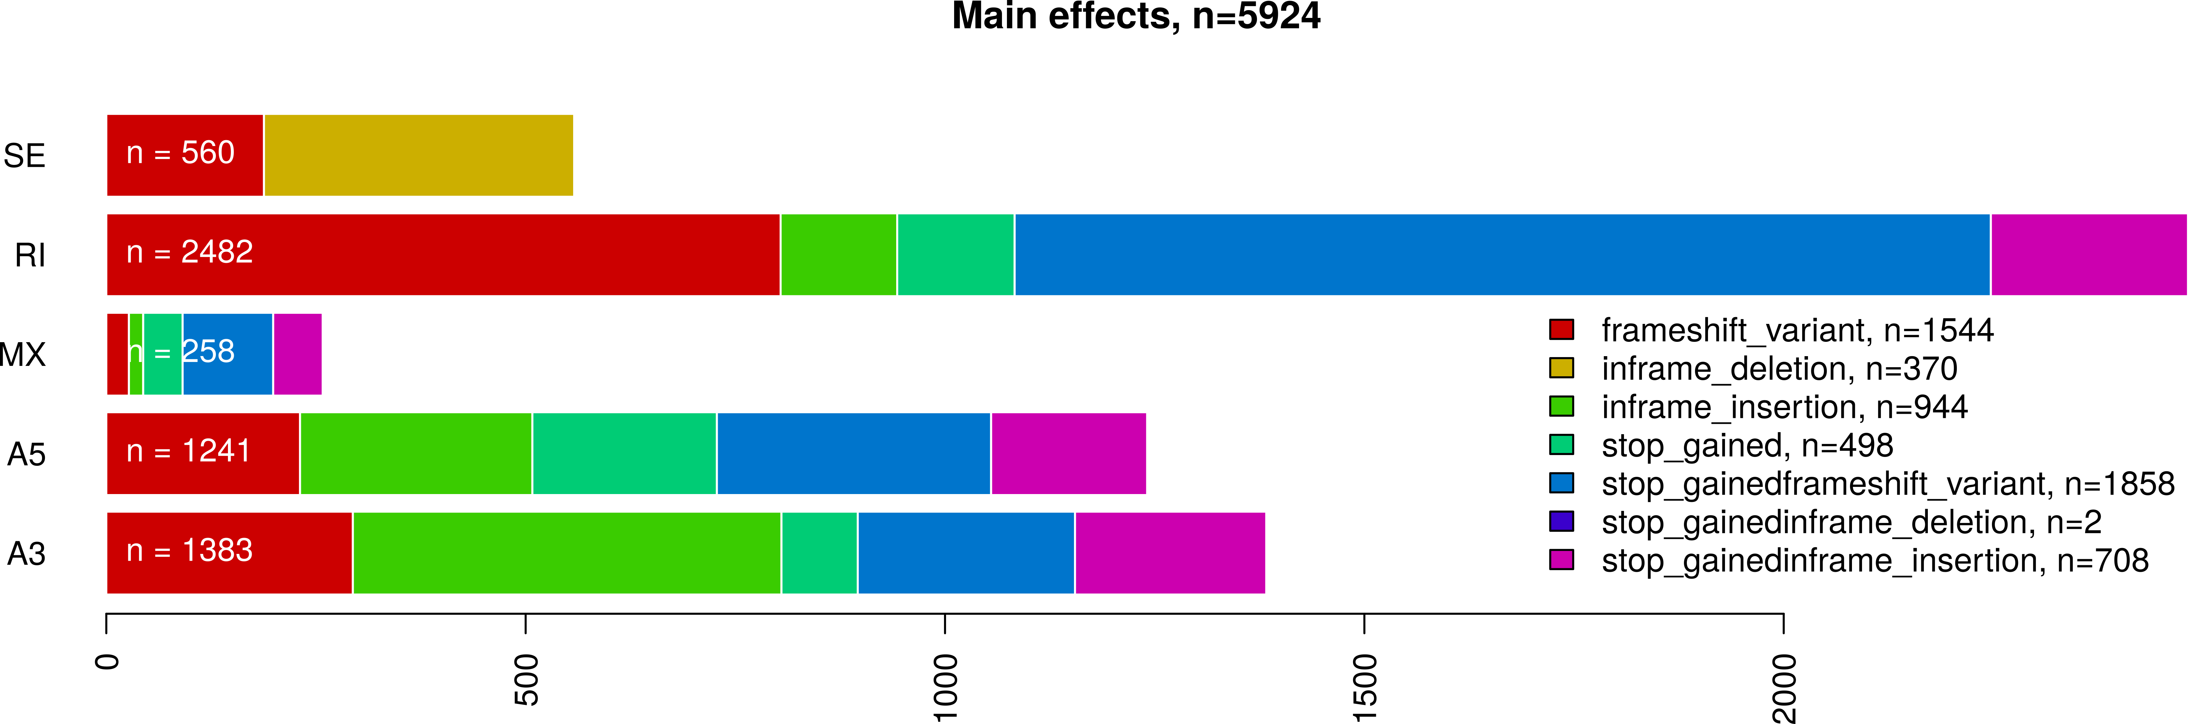
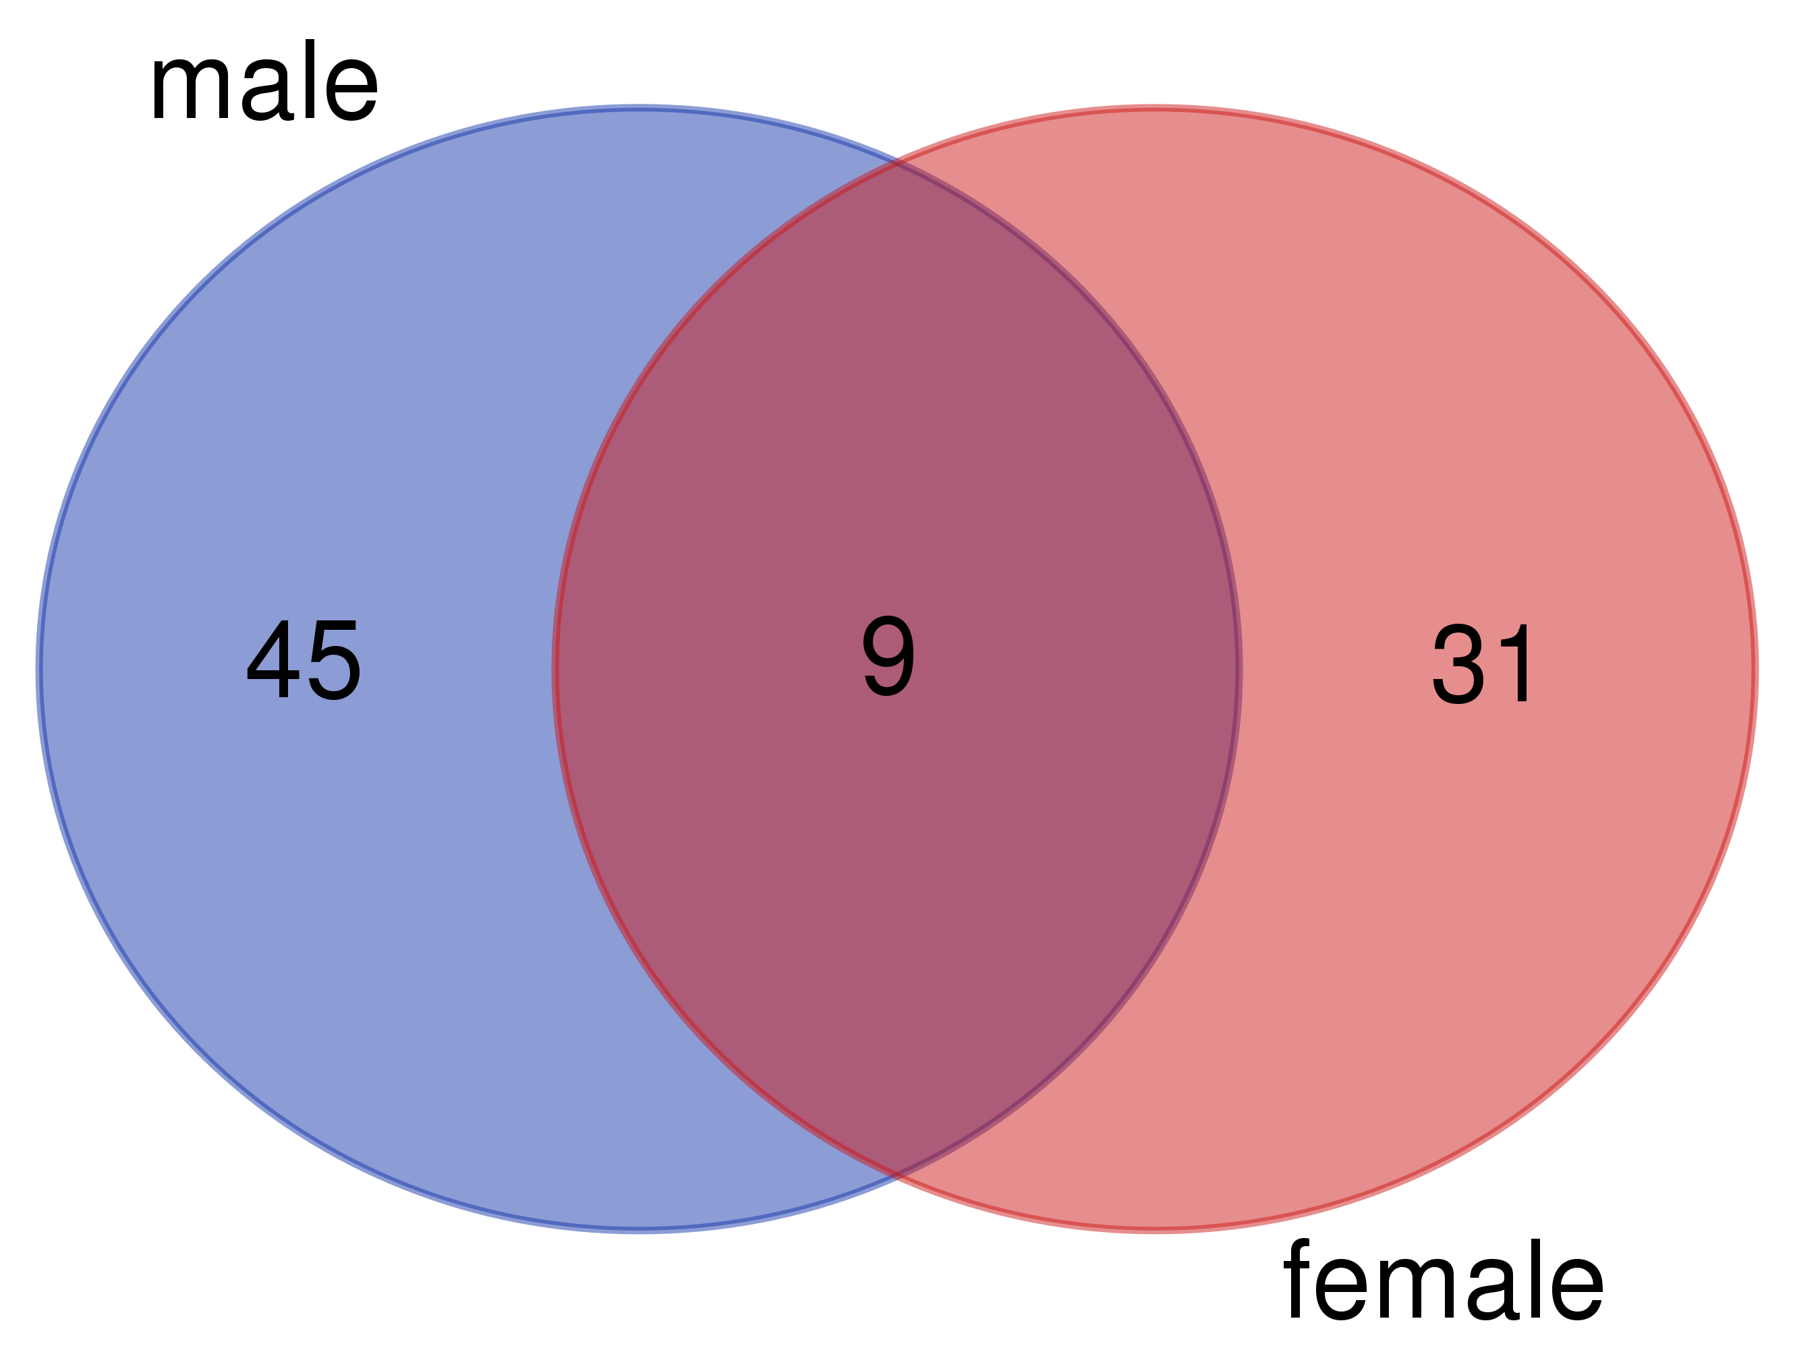
If we focus on events of exons that biased towards being included only in oenocytes of both males and females, we find that i) sadly, the list of genes with alternatively spliced exons in females and males is not terribly long (9 genes...); ii) shows a poor overlap; but iii) 6 out of these 9 events are frame-preserving and overlap protein domains, which could mean that they are functional.

