Aedes aegypti transcriptome: resistance to fenitrothion
12 samples divided in 4 groups (3 identical replicates per group). 6 fenitrothion-resistant samples from Angola (3 have been exposed to fenitrothion, 3 unexposed). 6 susceptible samples from laboratory strains (3 from New Orleans, 3 from Rockefeller). Sample classification:
Sample name | Sample group | Phenotype | Exposure | Location
s01_RUN | ResUnex | Res | Unex | Angola
s02_RUN | ResUnex | Res | Unex | Angola
s03_RUN | ResUnex | Res | Unex | Angola
s05_SNO | SusNewO | Sus | Unex | NewOrl
s06_SNO | SusNewO | Sus | Unex | NewOrl
s07_SNO | SusNewO | Sus | Unex | NewOrl
s08_SRO | SusRock | Sus | Unex | Rockef
s09_SRO | SusRock | Sus | Unex | Rockef
s10_SRO | SusRock | Sus | Unex | Rockef
s12_RFE | ResFeex | Res | Feex | Angola
s13_RFE | ResFeex | Res | Feex | Angola
s14_RFE | ResFeex | Res | Feex | Angola

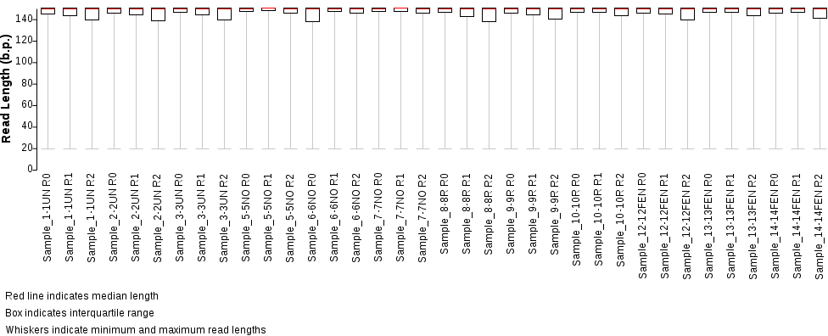
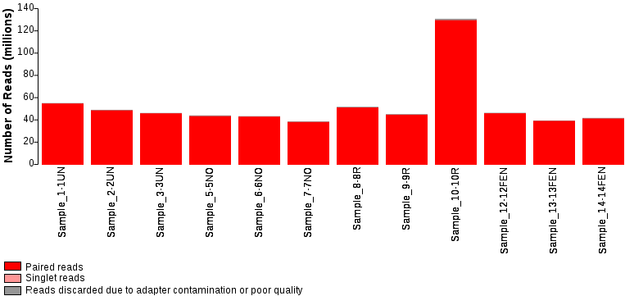
PCA analysis – Using the matrix of normalized transcript counts from Deseq, calculating Euclidean distances between samples. Good within-replicate clustering.
PC1 separates susceptible from resistant samples and is by far the most important. PC2 separates exposed from non-exposed. Oddly, RFE seems to be closer to susceptible samples than RUN, along PC1. PC3 highlights differences between SRO and SNO and it is not very relevant (not the focus of this analysis, although it can help contextualize the overlap differences in SRO/SNO-RUN comparisons),
