# Table of bioclims used:

|  |  |  |  |  |  |  |  |  |  |  |  |  |  |  |
| --- | --- | --- | --- | --- | --- | --- | --- | --- | --- | --- | --- | --- | --- | --- |
| Site | bio12 | bio13 | bio14 | bio15 | bio18 | bio19 | bio2 | bio3 | bio6 | bio7 | bio4 | bio5 | bio8 | bio9 |
| KG | 1918.0 | 302.0 | 79.0 | 45.0 | 436.0 | 306.0 | 103.0 | 83.0 | 153.0 | 124.0 | 525.0 | 277.0 | 219.0 | 208.0 |
| OT | 1312.0 | 194.0 | 17.0 | 51.0 | 134.0 | 447.0 | 129.0 | 79.0 | 165.0 | 163.0 | 1015.0 | 328.0 | 222.0 | 245.0 |
| MS | 1330.0 | 174.0 | 33.0 | 41.0 | 186.0 | 388.0 | 119.0 | 81.0 | 166.0 | 146.0 | 795.0 | 312.0 | 223.0 | 238.0 |
| NB | 1322.0 | 202.0 | 40.0 | 40.0 | 214.0 | 310.0 | 121.0 | 82.0 | 166.0 | 147.0 | 691.0 | 313.0 | 234.0 | 238.0 |

bio2 = Mean Diurnal Range (Mean of monthly (max temp - min temp))  
bio3 = Isothermality (BIO2/BIO7) (* 100)  
bio4 = Temperature Seasonality (standard deviation *100)  
bio5 = Max Temperature of Warmest Month  
bio6 = Min Temperature of Coldest Month  
bio7 = Temperature Annual Range (BIO5-BIO6)  
bio8 = Mean Temperature of Wettest Quarter  
bio9 = Mean Temperature of Driest Quarter  
bio12 = Annual Precipitation  
bio13 = Precipitation of Wettest Month  
bio14 = Precipitation of Driest Month  
bio15 = Precipitation Seasonality (Coefficient of Variation)  
bio18 = Precipitation of Warmest Quarter  
bio19 = Precipitation of Coldest Quarter

Temperature values are in degrees C * 10.  
Precipitation values are in mm.

# Principal components of bioclim data:

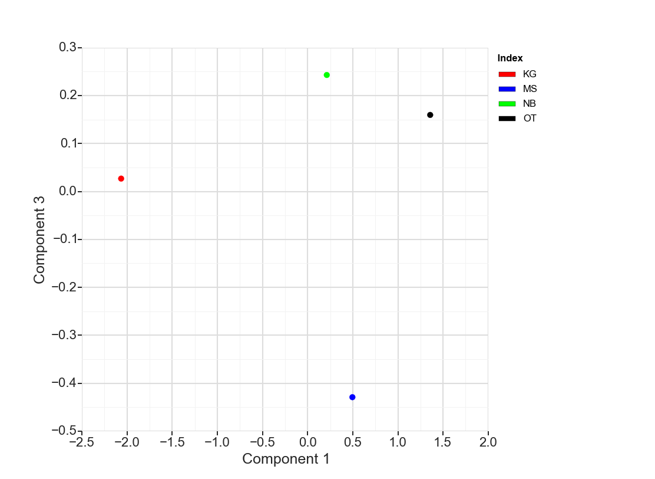

**Principal components one and three.** Principal components one and three. Components one and three plotted against each other illustrate that the MS site groups apart from the others along component three’s axis. Investigation of component three’s loading values reveals that the bioclims most responsible for this are bio8, bio15. and bio13.