Tsetse R01 Progress Report

Sampling and Databasing

Robert Opiro, Augustine Dunn

October 14, 2014

# Sampling

## Study sites

The surveys were done in the districts of Kole, Oyam, Nwoya, Amuru, Adjumani, Moyo and Arua in northern/Northwest Uganda. Additional information on tsetse population distribution was obtained from the District Entomology Offices of the relevant districts.

## Data collection

Trapping for tsetse flies were carried out using biconicals traps (Challier, A and Laveissiere 1973). The coordinates for each trap site were taken using a hand-held GPS. Vegetation types and human activities at the trapping sites were also recorded. Each village is at least 5km apart; a single village is taken to be a trapping site (with a number of traps deployed in each).

## Dissection and examination

Trapped flies were identified, sexed, counted, recorded and transported to a field dissection site. Live flies were dissected and examined microscopically to determine the presence/absence of trypanosomes in the midguts/salivary glands. The midguts, fly carcass, reproductive parts, and heads were then preserved in parafilm-sealed and labeled cryo-tubes in either 90% ethanol or RNA-preservation solution for further molecular studies.

# Results

## Kole District (2014-03-22 to 2014-03-30)

Five villages were surveyed (Olepo [OLE], Mwanya [MWA], Akayo-debe [AKA], Aputu-Lwaa [APU], and Ocala [OCA]) with a total of 40 traps. 1227 *Gff* were captured (564 M and 663 F) and yielded five infected individuals (1.2% estimated infection rate).

## Oyam District (2014-05-17 to 2014-05-22)

Nine villages were surveyed (Ocala [OCA], Odworo [OD], Alege [ALE], Acankoma [ACA], Oguk [OGU], Agoba B [AG], Abok[ABO], Ocol [OCL] and Opuyu [OPU]) with 32 traps. 715 *Gff* were captured (298 M and 417 F) and yielded 10 infected individuals (3.0% estimated infection rate).

## Oyam and Kole Districts (2014-07-14 to 2014-07-21)

This survey targeted sites that produced infected flies from the previous surveys. The field team deployed 27 traps across four villages that were divided between the two districts:

**Oyam:**

* Ocala [OCA]
* Odworo [OD]
* Acankoma [ACA]

**Kole:**

* Akayodebe [AKA]

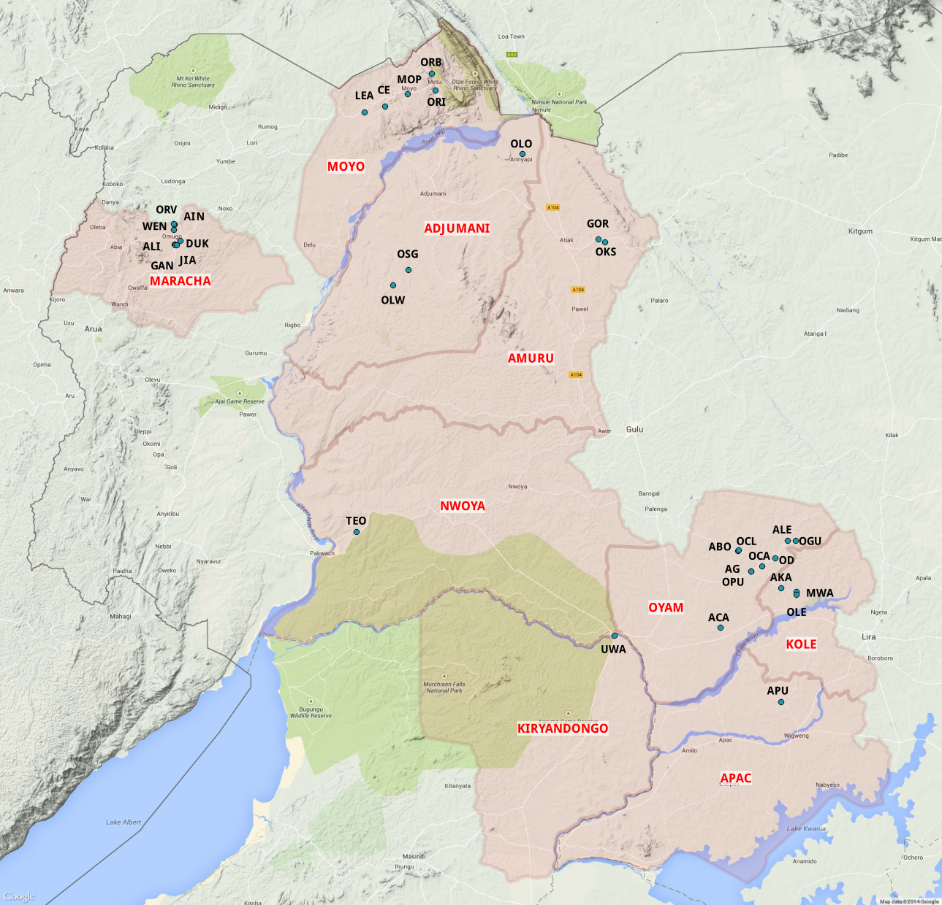{#id}

# References

Challier, A and Laveissiere, C. 1973. “Un nouveau pie’ge pour la capture des glossines (Glossina: Diptera, Muscidae): description et essais sur le terrain.” *Cah ORSTOM Ser Ent Med Parasitol* 11: 251–62.