**Proposal for EIE 4512 Final Project 2023**

**Names & IDs:**

Yuhang Huang 122040082 Boshi Xu 122040075 Yiwei Huang 120090800

**Title:** Handwritten digit and signal recognition for children

**Description:**

*(Brief statement of your problem: what the task is; how does previous work solve it and their potential drawback; in what aspect you want to build upon previous work (aka, novelty/motivation/pipeline); other misc: datasets, which deep learning system will be used, etc.)*

* **Introduction**

Handwritten mathematical expression recognition and verification is a critical area in the field of digital image processing and artificial intelligence. This project focuses on developing a system to verify the correctness of handwritten arithmetic expressions involving addition, subtraction, multiplication, and division with numbers ranging from 0 to 9. The aim is to automatically process images of handwritten equations, recognize the digits and operators, evaluate the expression, and determine if the provided answer is correct.

* **Task and goal**
* **Dataset and experiment**

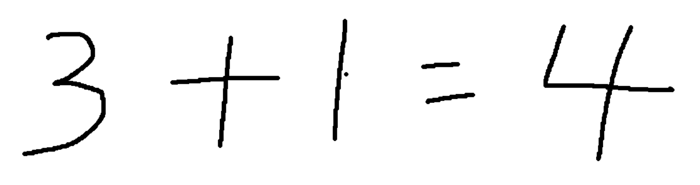The dataset for this project consists of handwritten images of arithmetic expressions. Each image includes a complete equation involving numbers between 0 and 9 and basic arithmetic operators (addition, subtraction, multiplication, division). The data is collected and labeled to train the model effectively.

The initial algorithms consists of the following 4 steps.

First, read the image from the frontend's handwriting board.

Next, the image detection is divided into several parts, including:

1. Image pre-processing: Convert the image to grayscale, apply Gaussian blur, use the Canny edge detector to detect edges, and perform dilation and erosion operations.

2. Contour detection: Retrieve the contours in the image, calculate their area, extract the image of the region, and adjust the image boundaries to obtain the output image.

Both first and second step use the library *OpenCV*.

Then, use the pre-trained CNN model to classify the extracted image regions.

Finally, output the recognition results to the frontend for display.

We will use this algorithm to connect with the frontend of our project, to complete a basic programme with GUI to provide a completed, electronic devices based teaching software.

* **Expected results**

**Tentative Timeline/To-do lists:**

* Nov 14 – Nov 17: Investigation
* Nov xx: Build up codebase and get down to datasets
* Nov xx: develop xx idea
* Dec xx: experiments
* Dec xx: paper writing

**[STOP. Maximum length of your proposal is One-page.]**