**Data Visualization Final Project**

Xiao Han

The dataset I’m using for the final project is about plastic pollution around the world. The main data source is here: <https://jambeck.engr.uga.edu/landplasticinput>, plus some supportive data I had before. I choose this dataset because my practicum is about ocean plastic pollution, an area where very limited data can be found, especially in the microplastic pollutions subarea. Plastic pollution has already become a major concern of environmental scientists, and it’s influencing every human being on the earth. So it will be interesting to see any data we have in this area and think about what we should do in the future to better protect our planet from being buried under plastic waste.

**I. Global Plastic Fate**

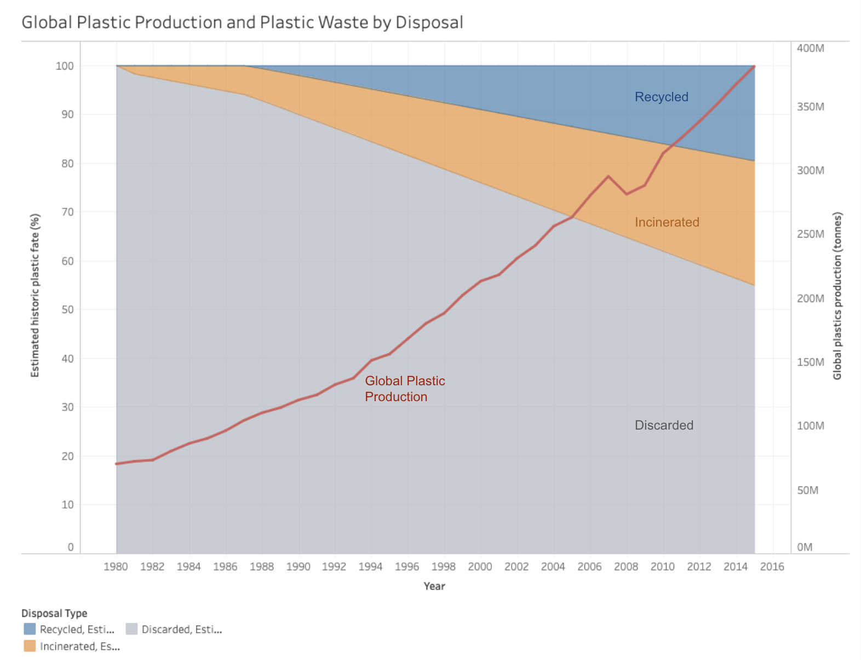

The plot above shows the trend of global plastic production and waste. The line is showing total global plastic production from 1980 to 2015, while the area chart shows the percentage of three disposal types. We can see that although more and more plastic waste is being recycled, the major proportion is still being discarded, which would definitely cause a huge problem for our environment.

**II. Global Plastic by Sector**

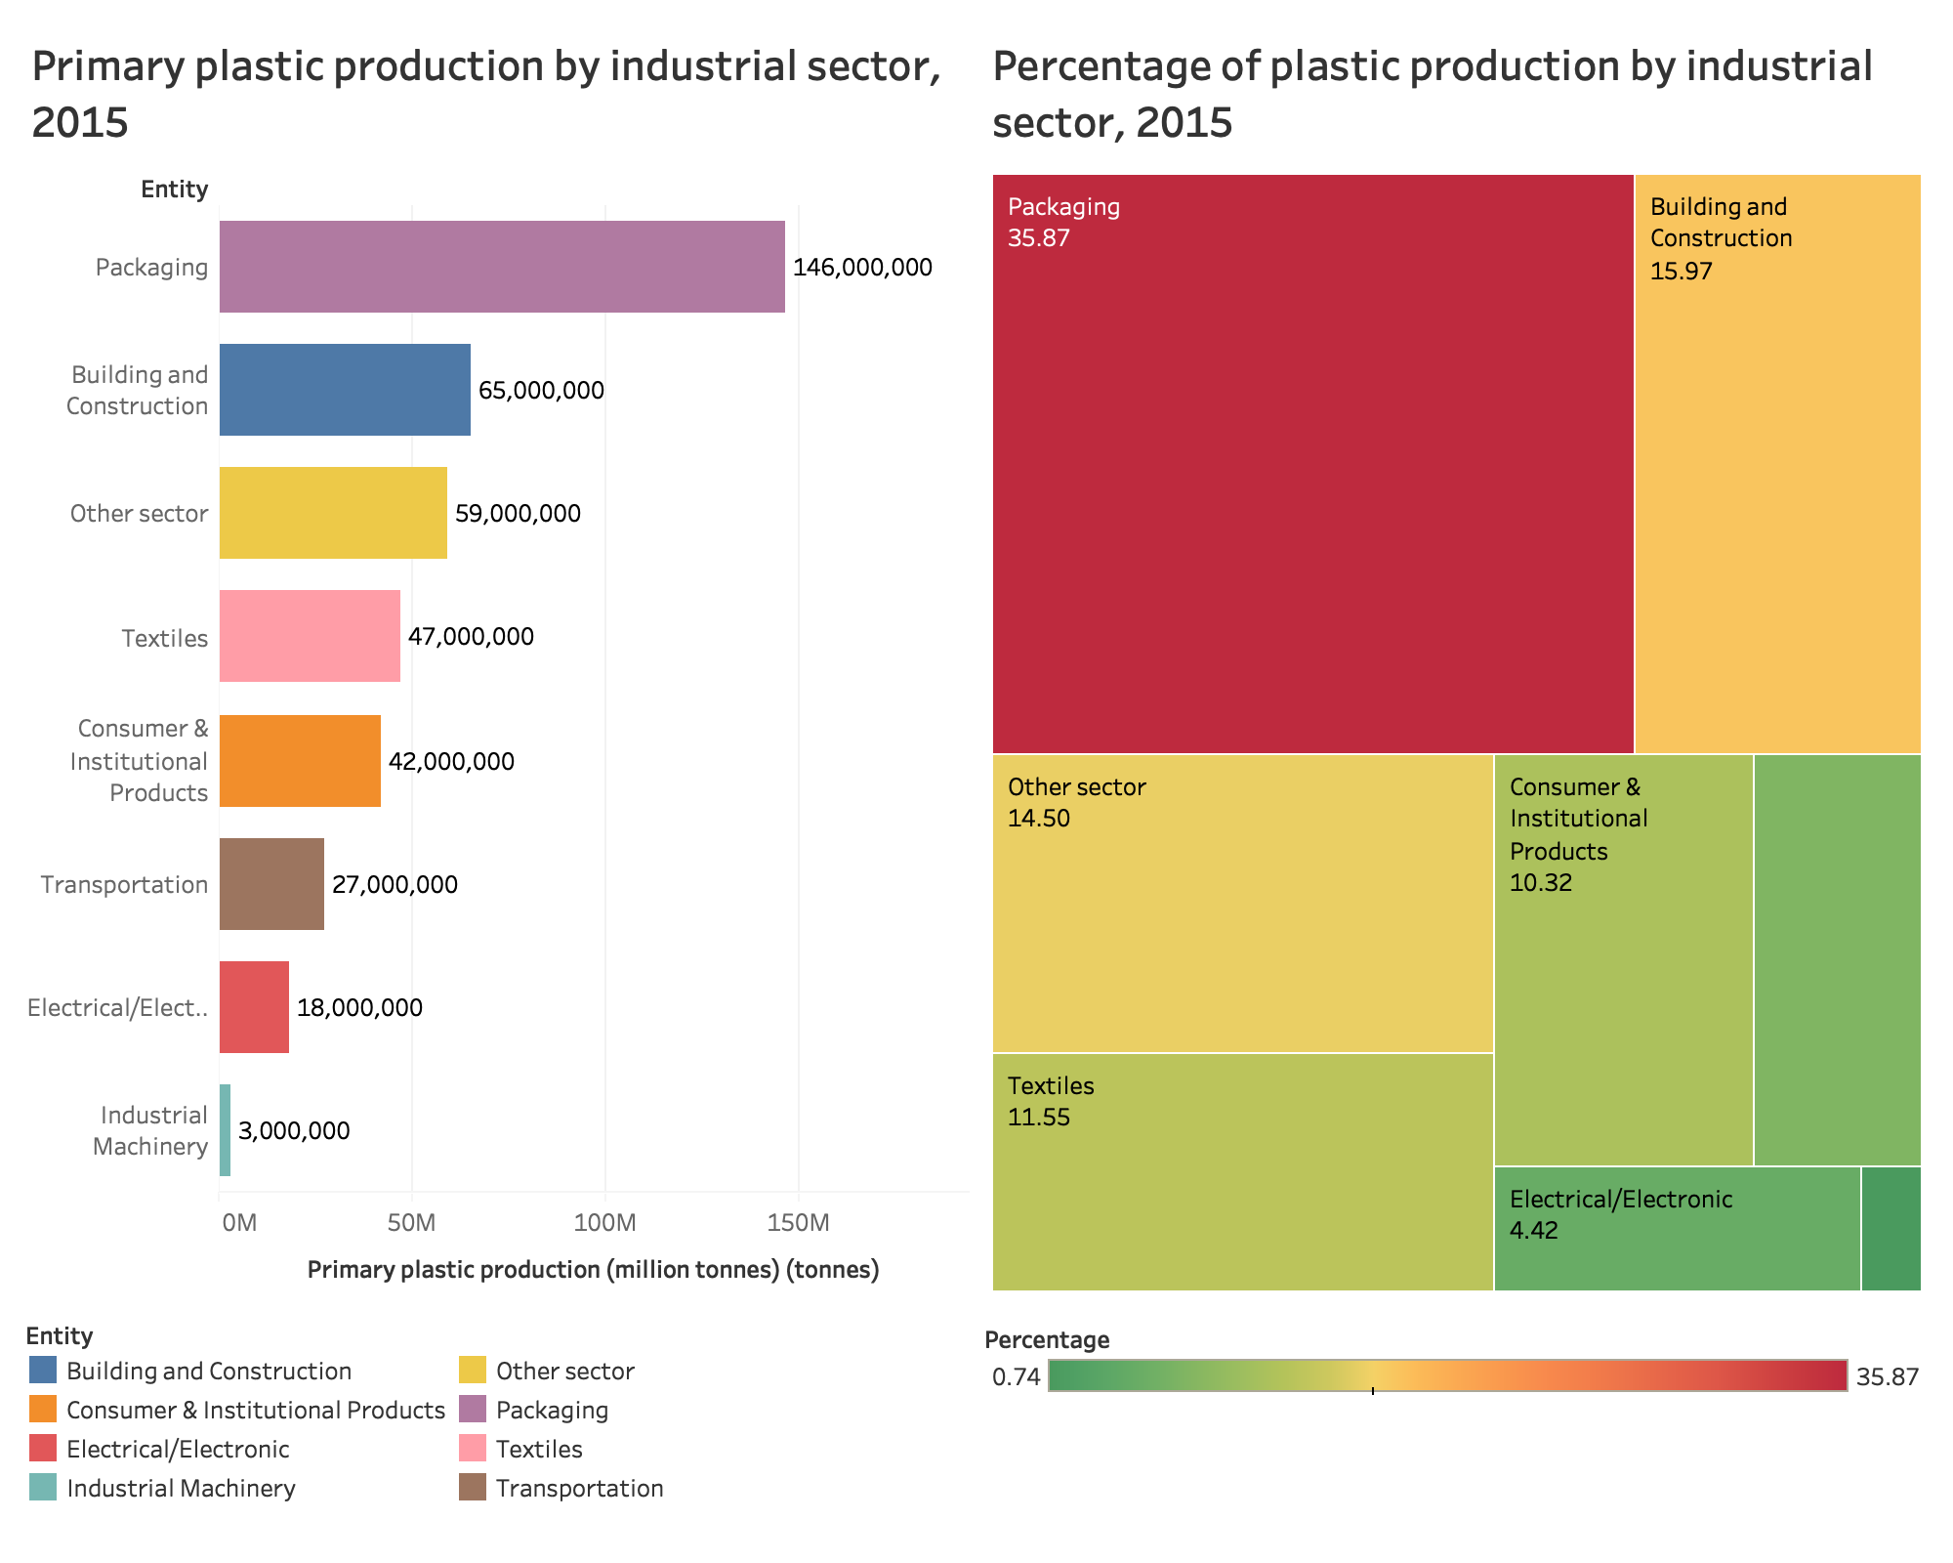

Now let’s see the data for plastic production by sectors in 2015. The graph on the left shows the total volume of plastic production, and the grid graph on the right shows their percentages. From the visualization, we can see that packaging is the major sector plastic products are produced, which totally makes sense, and it counts for 35% of total plastic production. I didn’t realize that the building and construction sector will exceed textiles.

This is just a peek of my final project because obviously, this part of data will be more interesting when compared with the total waste amount by sector so that we can see which sector should be blamed most for plastic pollution.

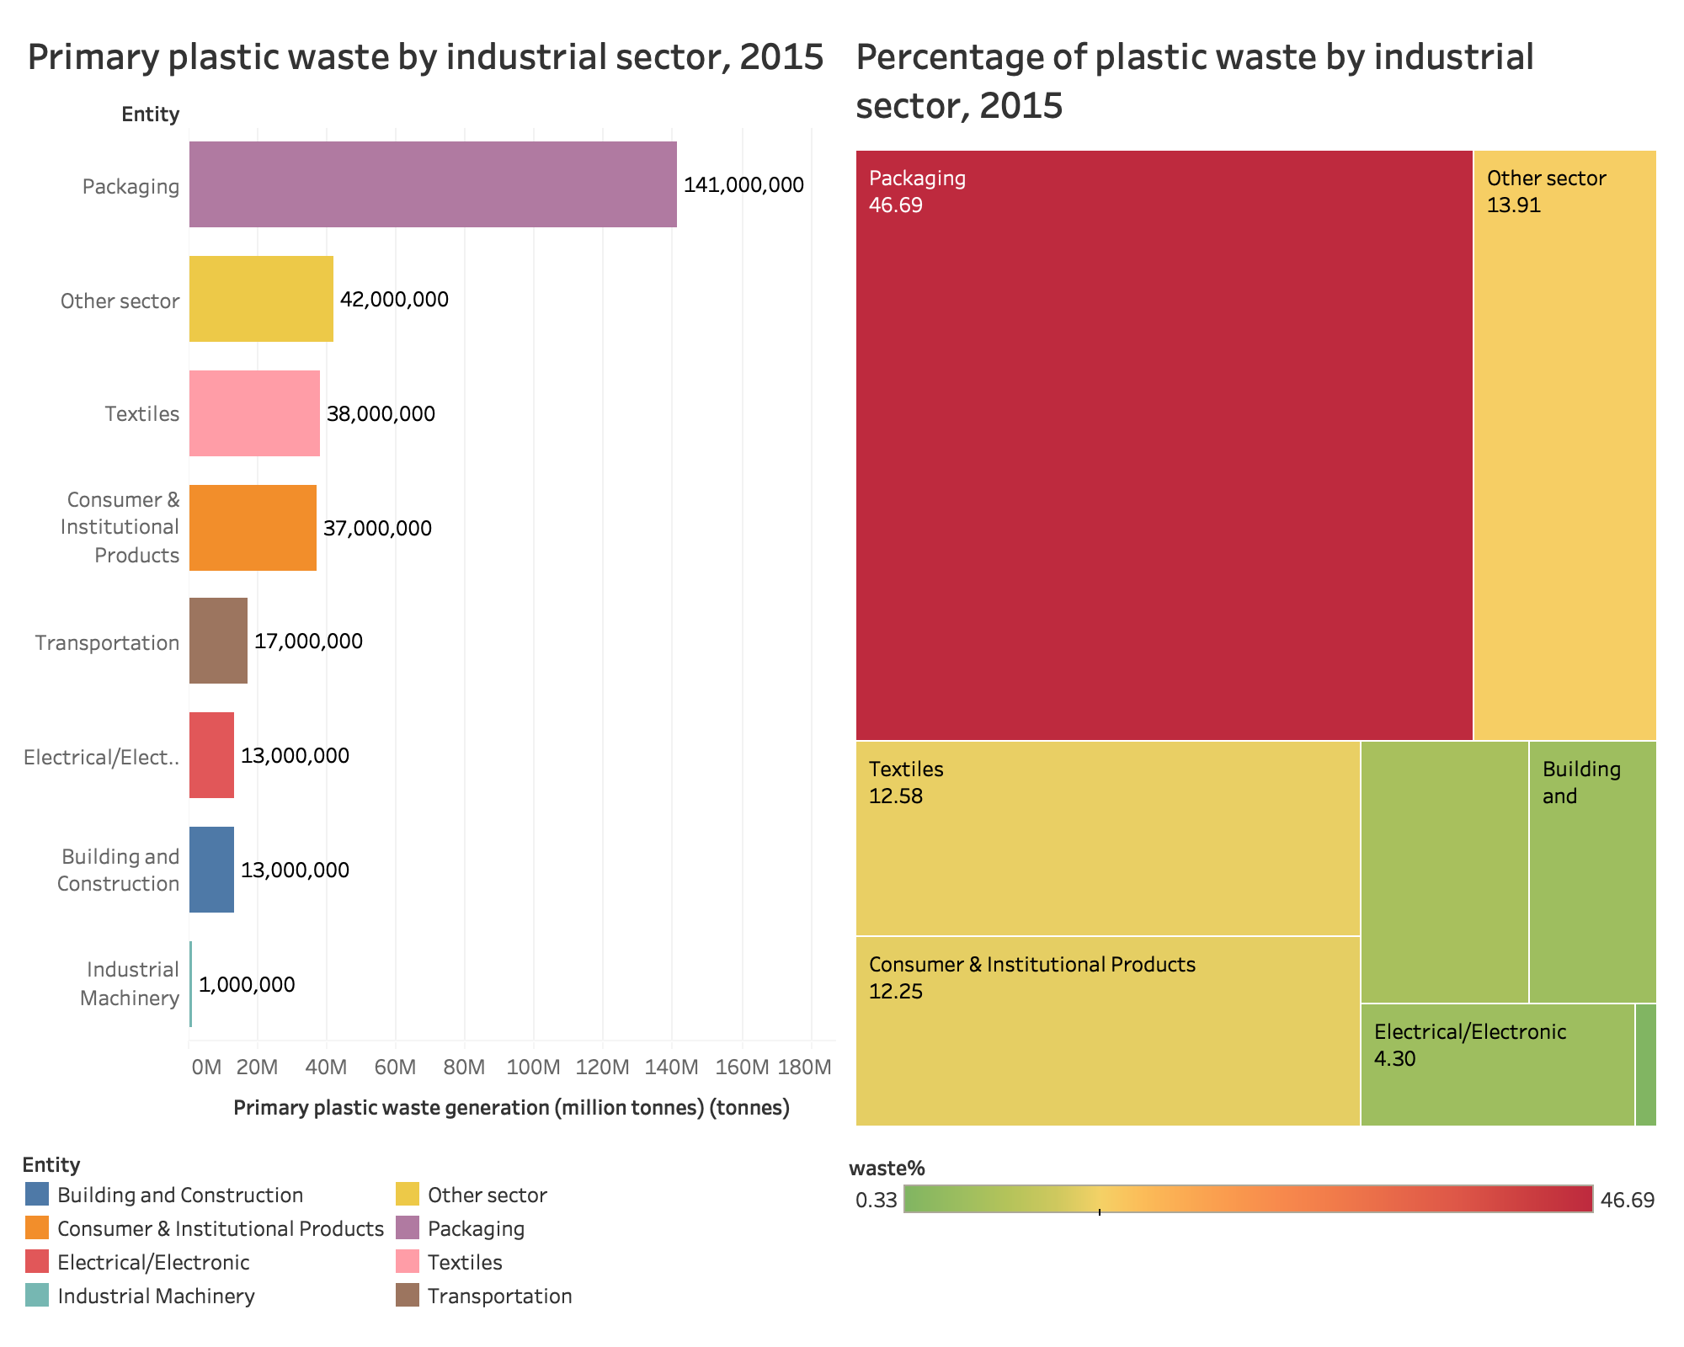

Above are the plots showing the plastic waste by sector in 2015. Combined with the two plots above, we can see that the packaging industry should be the major industry to blame for both plastic production and plastic waste.

**III. Plastic Waste Generation Across the World**

In the chart below we see the total plastic waste generation by country in 2010, measured in tonnes per year. This, therefore, takes account of per capita waste generation and population size.

With the largest population, China produced the largest quantity of plastic, at nearly 60 million tonnes. This was followed by the United States at 38 million, Germany at 14.5 million and Brazil at 12 million tonnes.

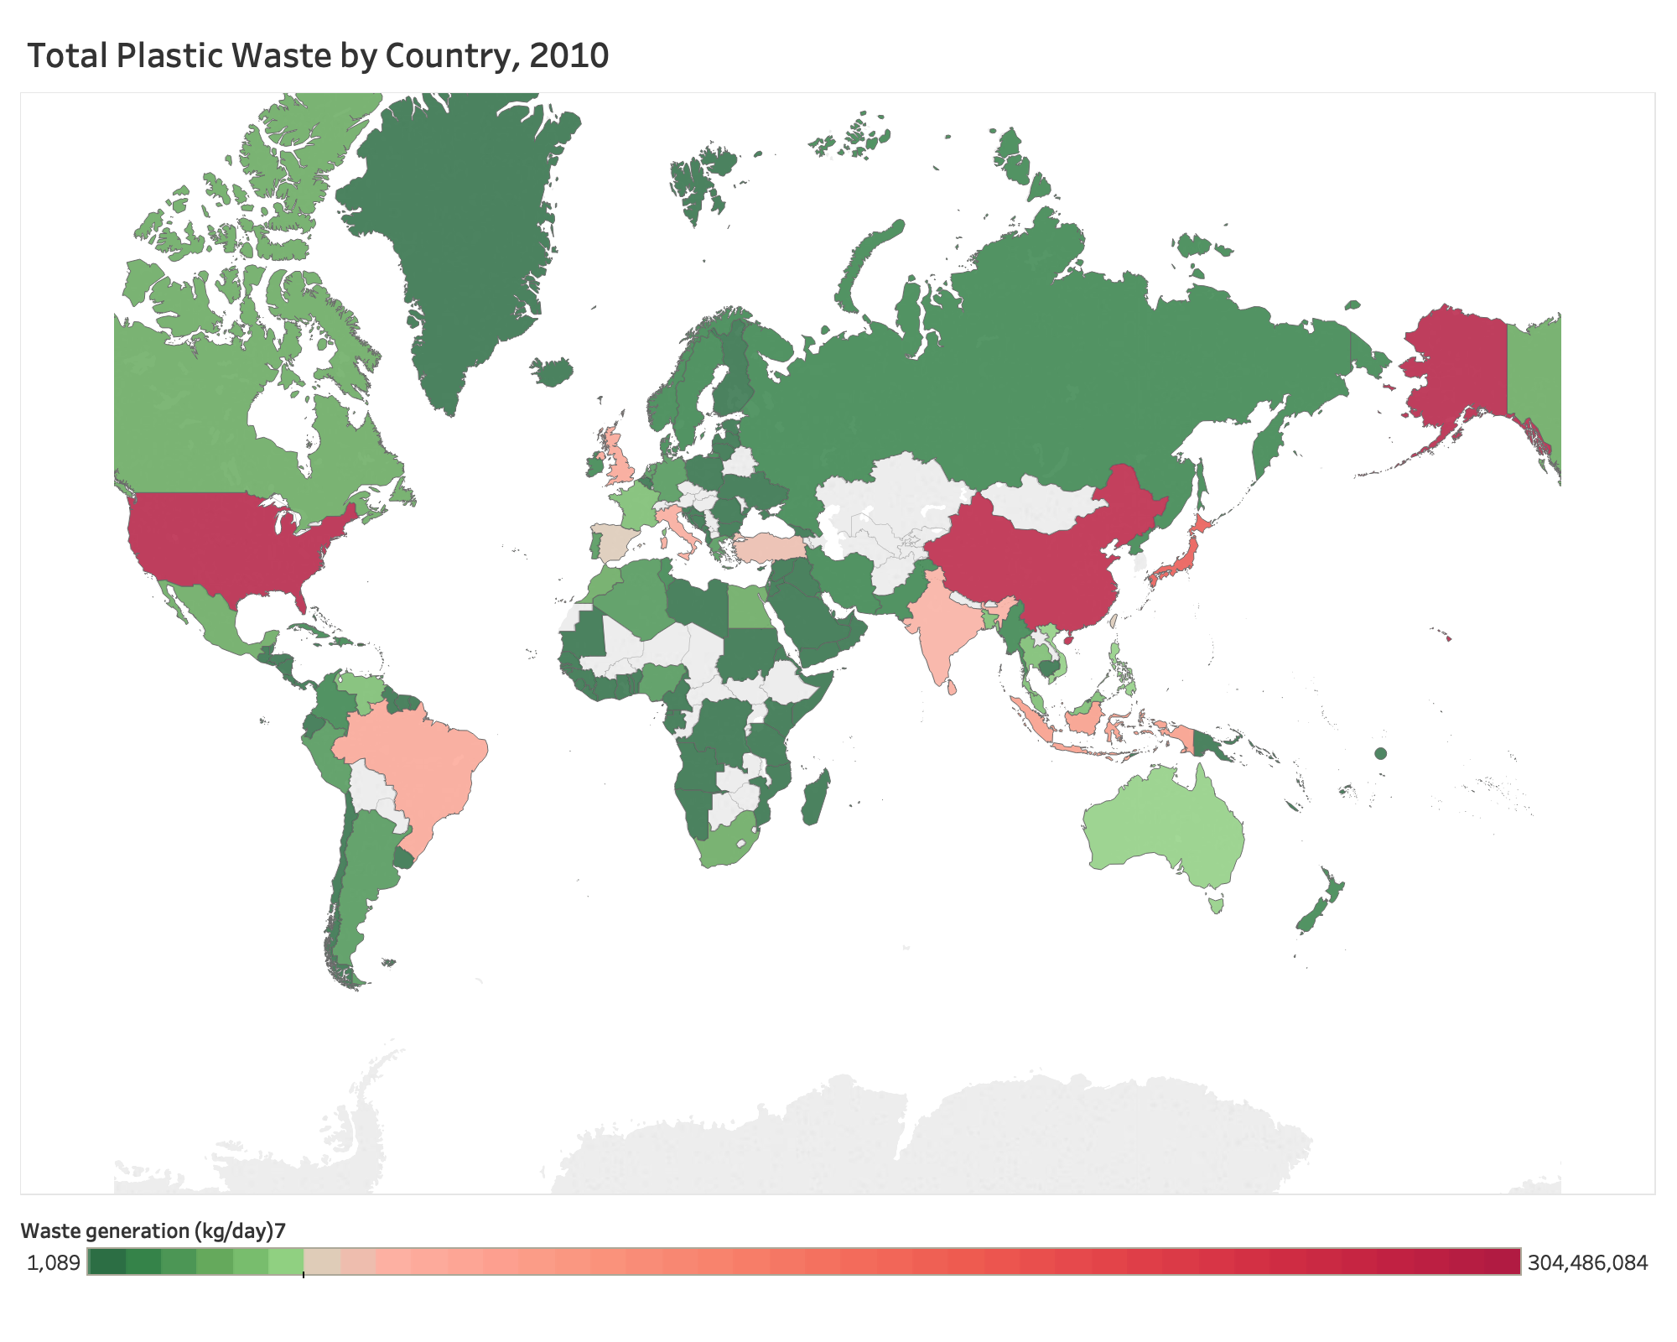

In the chart below we see the per capita rate of plastic waste generation, measured in kilograms per person per day. Here we see differences of around an order of magnitude: daily per capita plastic waste across the highest countries – Kuwait, Guyana, Germany, Netherlands, Ireland, the United States – is more than ten times higher than across many countries such as India, Tanzania, Mozambique, and Bangladesh.

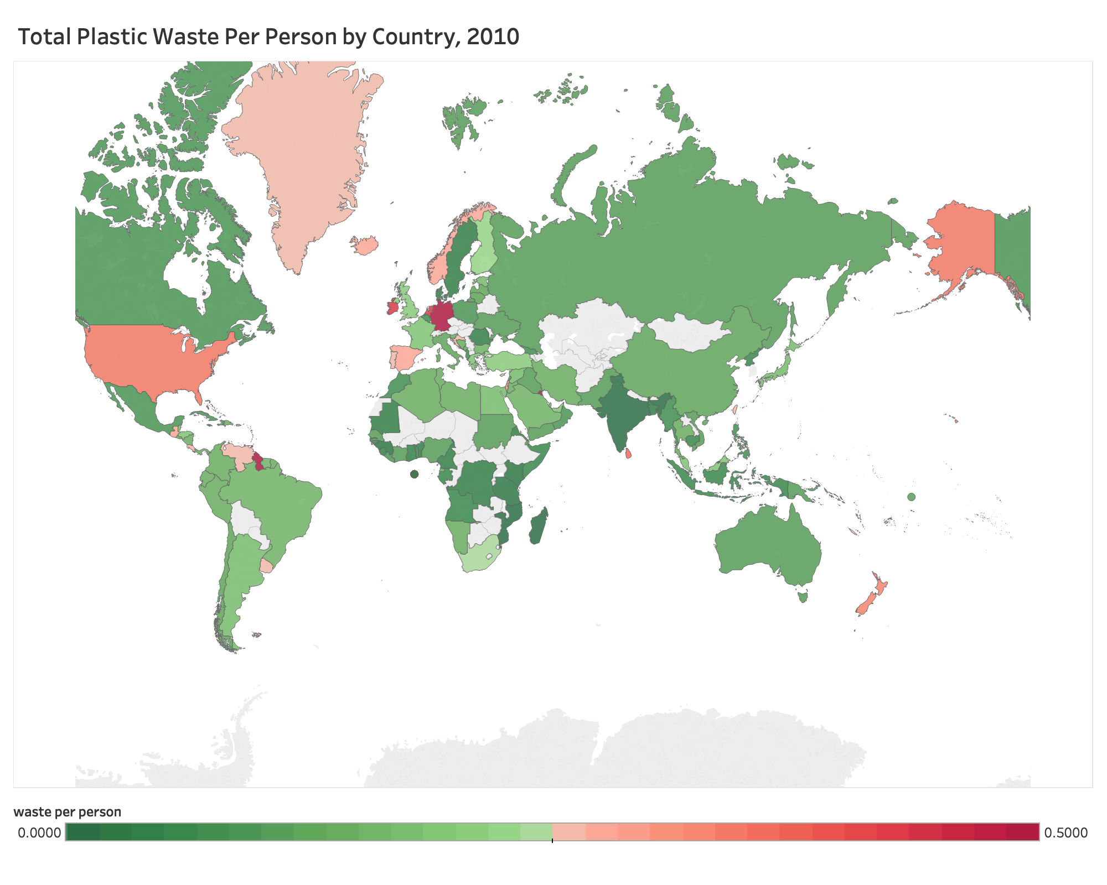

**VI. Plastic Waste by Country Economics Status**

The chart below shows the total plastic waste volume by country economics status. We can see that the better the country’s economic status, the more plastic waste the country would generate. Unfortunately, we don’t have the total plastic waste percentage data by country, or it will be even more interesting to see whether the wealthier country has a higher percentage of plastic waste.

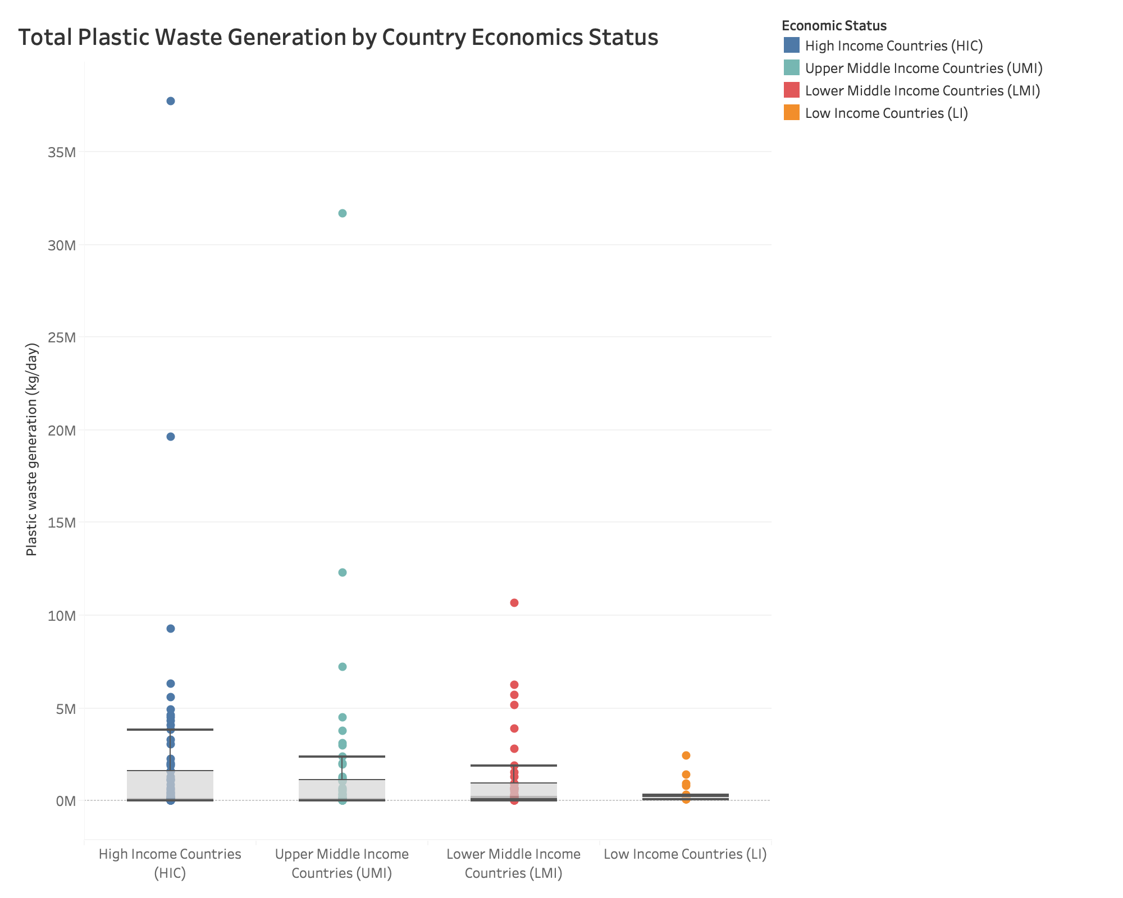

**V. Mismanaged Plastic Waste**

Whilst the global picture of total plastic waste tells an important story, it does not necessarily help us to understand the ocean plastic problem. To understand the sources of ocean plastic pollution we must take into account that, not all of the plastic waste we generate is at high risk of entering the oceans; in fact, for many countries, the quantity which does end up as ocean pollution is very small.

The chart below shows the corrected version of the share of global mismanaged plastic waste by country by Jambeck et al. (2015). We can see that Sri Lanka does the worst in managing plastic waste in 2010 - around 30% of the plastic waste is mismanaged.

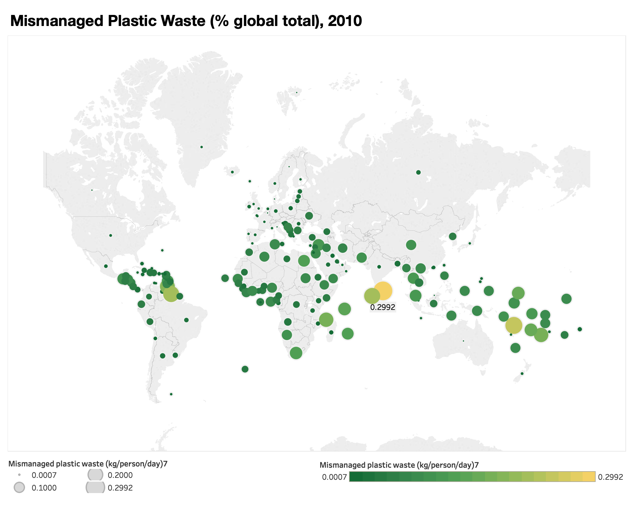

**\* VI. Other Plots**

This section contains only the geographical heatmap as required by the assignment requirements, but they are not part of the storyline. I will skip the connection map because the data I have for this topic cannot generate a connection map that would make sense.

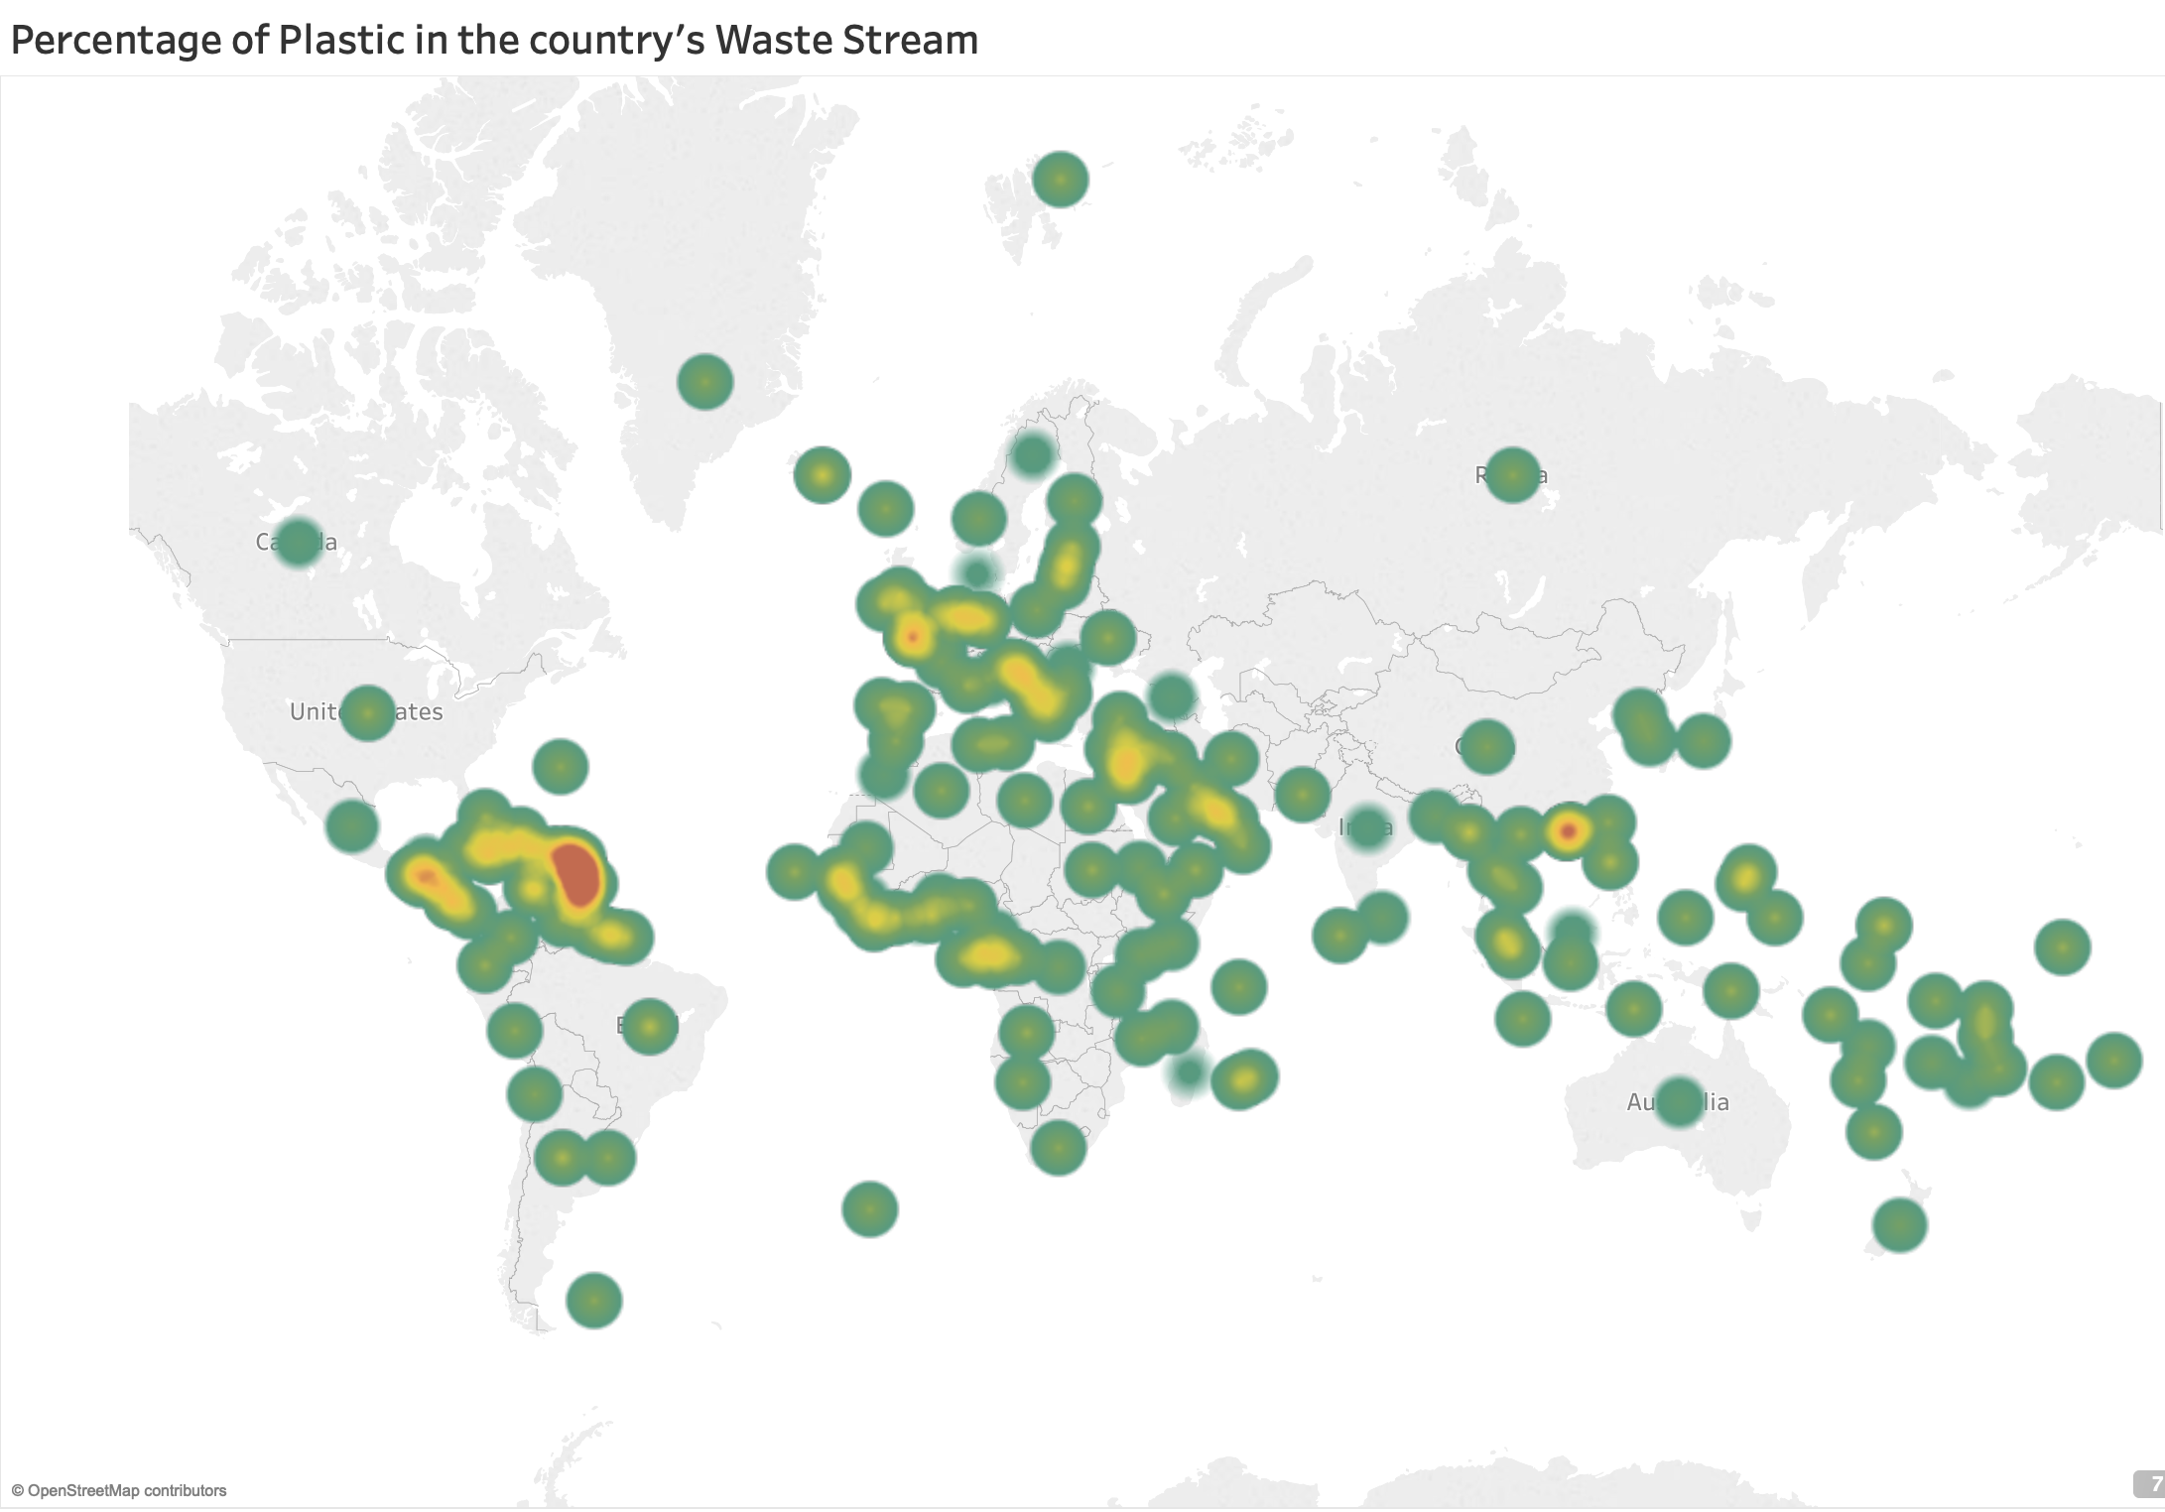

**VII. Conclusion**

We can see from the above plots that human are producing increasing volume of plastic waste over the past 40 years, and there’s a large proportion of the plastic products are not managed appropriately. There’s still a long way to go in the battle against plastic pollution. On the other hand, although wealthy countries tend to produce more plastic waste, they generally do better in dealing with those harmful waste. So cooperation among countries is also important in tackling the plastic problem.

**Reference:**

[1] Plastic Pollution, Hannah Ritchie and Max Roser, <https://ourworldindata.org/plastic-pollution#>

[2] Plastic waste inputs from land into the ocean, By Jenna R. Jambeck, Roland Geyer, Chris Wilcox, Theodore R. Siegler, Miriam Perryman, Anthony Andrady, Ramani Narayan, Kara Lavender Law, SCIENCE13 FEB 2015: 768-771

**Appendix:**

*All charts are generated in Tableau. No code could be provided.

**GitHub link:**

<https://github.com/xhan0909/data_viz_final>