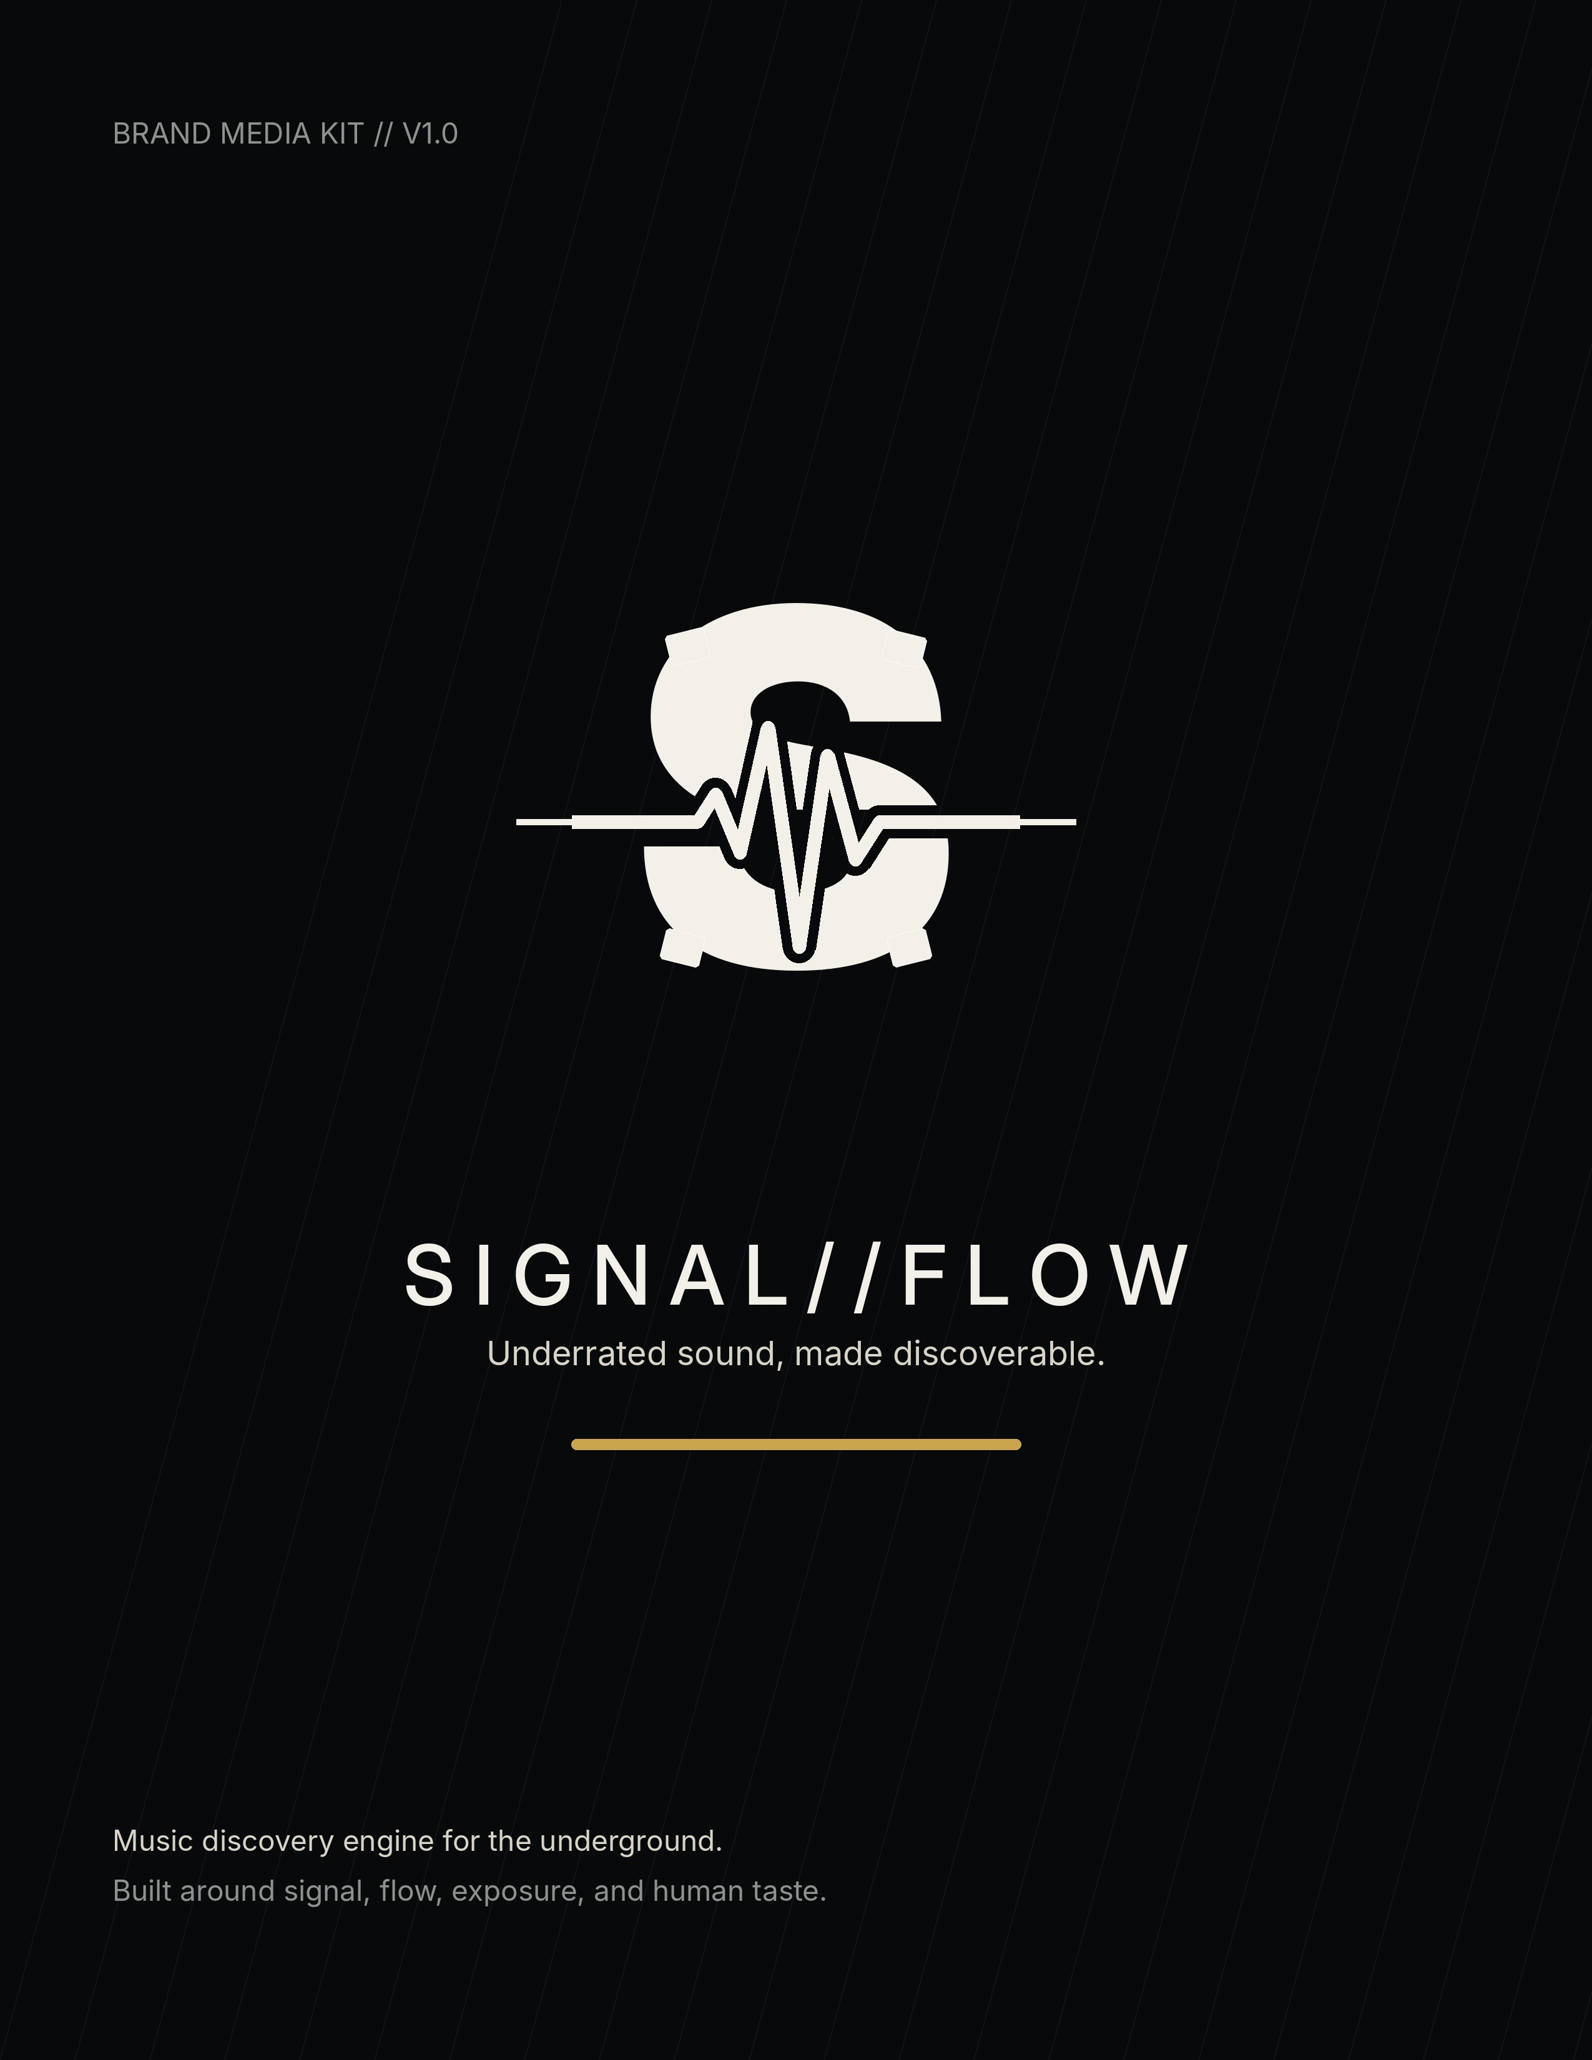

BRAND SNAPSHOT
CORE POSITIONING
SIGNAL//FLOW is an AI-assisted music discovery engine built to surface underrated artists, translate uploads into useful taste signals, and help listeners find what the mainstream algorithm missed.
One-line description
SIGNAL//FLOW turns hidden music into discoverable signal.
Mission
Give overlooked artists a smarter path to visibility by matching music to the right listeners, curators, scenes, and communities - without making discovery feel generic or pay-to-play.
Audience
- Listeners who want fresh talent before it breaks.
- Independent artists uploading new music and looking for signal, feedback, and exposure.
- Curators, DJs, playlist builders, tastemakers, labels, and creative communities searching for undiscovered sound.
- Mekhane ecosystem fans who connect with lore, machinery, signal, and underground culture.
Brand pillars
Pillar | Meaning
Signal | Taste data, audio intelligence, quality detection, meaningful recommendations.
Flow | Movement through scenes, genres, moods, creators, and cultural lanes.
Exposure | Visibility for artists who have skill but not reach.
Machine soul | A tech platform with human taste, community, and underground respect.

LOGO SYSTEM
The selected direction is intentionally stripped down: a bold S, one clean waveform, and minimal mechanical detailing. The gear idea should be implied through machined geometry, not a busy literal gear.
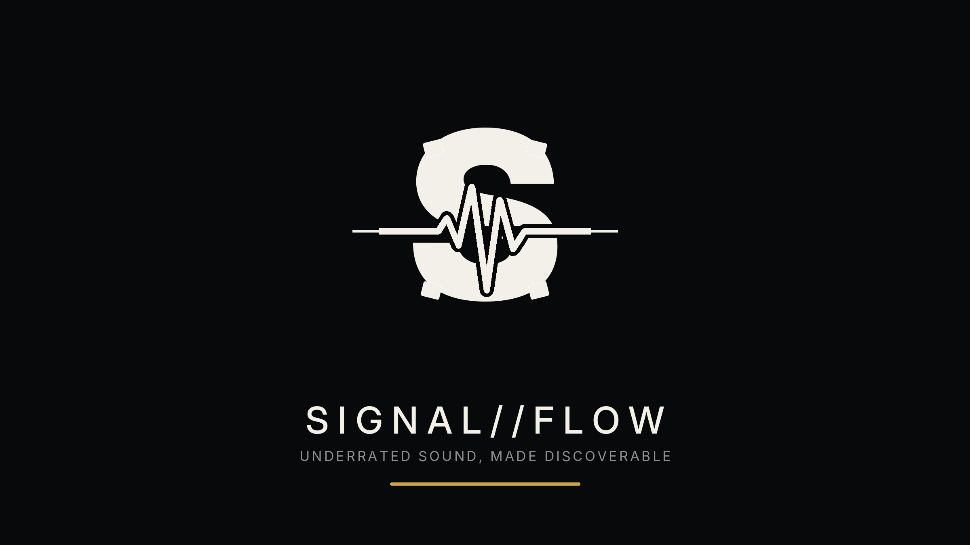 | 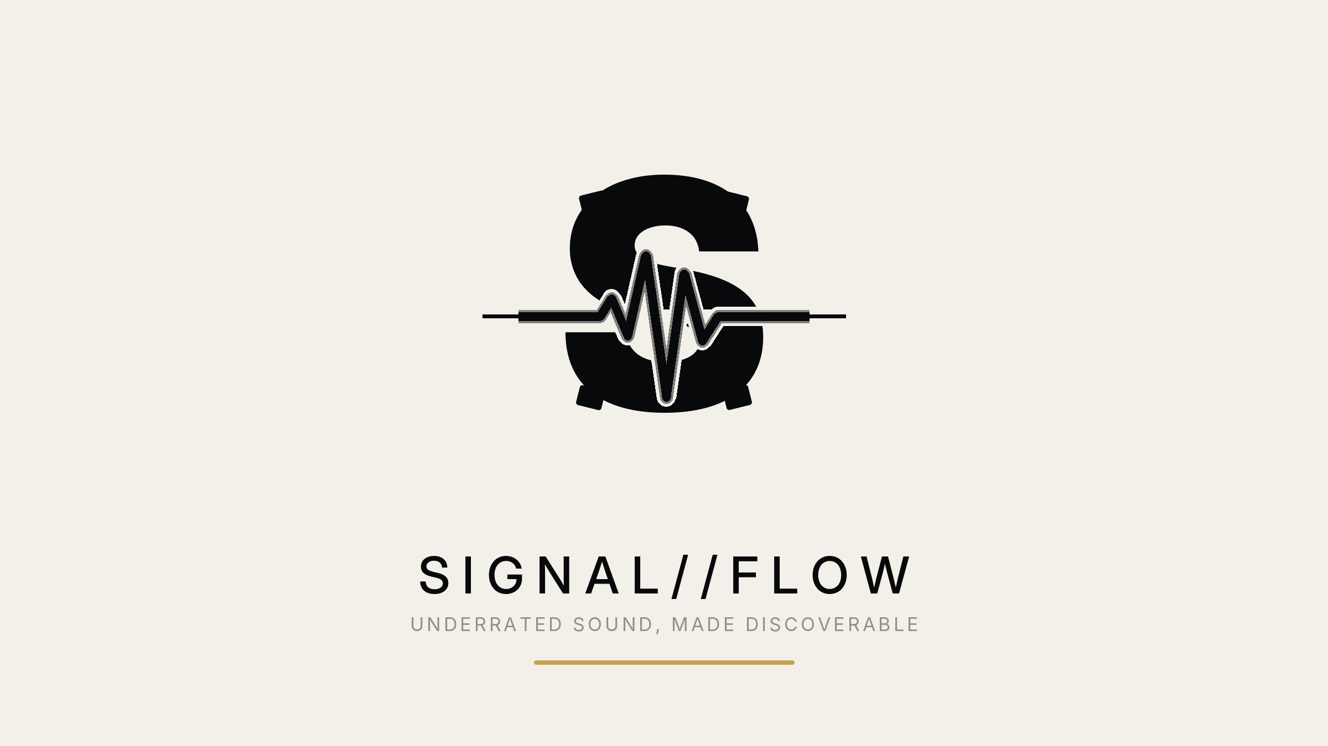
Logo anatomy
- S mark: shorthand for SIGNAL//FLOW and a fast app-icon read at small sizes.
- Waveform cut: the audio signal and the data pulse running through the brand.
- Gear language: restricted to squared terminals, machined cuts, sparse teeth, or circular motion. Do not build a full complex gear around the mark.
- Exposure cue: one optional glint, beam, pulse ring, or gold accent in campaign graphics - never all at once.
Clear space and scale
- Clear space: keep at least the height of the waveform peak around all sides of the icon or wordmark.
- Minimum digital icon size: 32 px. Use the icon only under 96 px; use the full lockup above 240 px wide.
- Minimum print width: icon 0.35 in; full lockup 1.5 in.
- Use the dark lockup first. Use the light lockup when a white or editorial layout is required.
Do not
- Do not add extra waveforms, full lens flares, sound bars, gears, and beams in the same lockup.
- Do not stretch, skew, outline, bevel, or add drop shadows to the mark.
- Do not write the name as Signal Flow, SignalFlow, SIGNAL FLOW, or Signal//Flow in official headers.
- Do not place the mark on chaotic photographs without a dark overlay or clear negative space.

COLOR PALETTE
The palette should feel dark, premium, industrial, and music-native. Use off-white and black as the core. Use gold for exposure moments and aqua only as a digital signal accent.
Swatch | Name | Hex | Use
 | Signal Black | #08090B | Primary background, app UI, hero panels.
 | Charcoal Machine | #111318 | Secondary dark surface, cards, overlays.
 | White Noise | #F2F0E8 | Primary logo/light text on dark backgrounds.
 | Flow Silver | #D8D5C8 | Subheads, dividers, inactive UI, metallic accents.
 | Gear Steel | #8E928F | Utility text, technical notes, UI chrome.
 | Exposure Gold | #C9A44D | CTA highlights, featured artist badges, launch moments.
 | Waveform Aqua | #68F5D2 | Rare digital accent for discovery pulses and active states.
Color rules
- Default combination: Signal Black background with White Noise logo/text.
- Gold should mean exposure, feature, reveal, spotlight, or priority - not general decoration.
- Aqua should appear only in digital/product moments where signal or matching is active.
- Avoid rainbow gradients; this brand is strongest when it feels focused and controlled.
Suggested gradients
- Black to Charcoal Machine for app surfaces and hero backgrounds.
- Signal Black with faint Flow Silver waveform overlays for launch graphics.
- Exposure Gold as a narrow underline, glint, badge, or progress pulse.

TYPOGRAPHY AND GRAPHIC LANGUAGE
Type system
Role | Preferred | Fallback
Headlines | Inter Display Black / Space Grotesk Bold | Arial Black / Aptos Display Bold
Body | Inter Regular / Sora Regular | Aptos / Arial
Technical labels | IBM Plex Mono / JetBrains Mono | Consolas / DejaVu Sans Mono
Typography rules
- Use uppercase for short labels, headers, and interface moments.
- Use generous letter spacing on the wordmark and campaign headers.
- Keep body copy plain and readable. Let the logo carry the style, not every sentence.
- Use slashes intentionally: SIGNAL//FLOW, ARTIST//SIGNAL, DROP//SCAN, FLOW//INDEX.
Graphic motifs
- Waveform: one clean centerline or pulse; avoid walls of audio bars.
- Gear: minimal teeth, machined notches, circular UI loaders, or mechanical crop marks.
- Flow: S-curves, double-slash transitions, motion trails, queue/list movement.
- Exposure: spotlight cone, glint, reveal mask, featured badge, or signal ring.
Image direction
- Dark studio scenes, underground venues, laptop/audio gear, microphones, hands, cables, and crowd silhouettes.
- Artist-first portraits with real texture, not glossy stock-photo perfection.
- High contrast, shallow depth of field, monochrome base with rare gold/aqua accents.
- Use overlays to make space for the logo; do not place text directly on busy faces or stage lights.

MESSAGING SYSTEM
Primary taglines
- Find what the algorithm missed.
- Underrated sound, made discoverable.
- Turn the underground into signal.
- Upload the sound. Unlock the signal.
- Signal boost the unseen.
Brand voice
Voice trait | How it sounds
Direct | No hype for hype sake. Say what the product does.
Underground-aware | Respect scenes, genres, and artists. Do not talk down to creators.
Technical but human | AI helps the search; humans decide what matters.
Premium minimal | Short, sharp, confident lines. Avoid clutter.
Avoid
- Calling artists "content" as the default word.
- Overpromising fame, virality, label deals, or guaranteed playlist placement.
- Sounding like a generic AI startup. Lead with music, taste, and discovery.
- Too many cyberpunk adjectives in one line. Keep the energy clean.
Core product copy
HOMEPAGE HERO
Discover the artists the algorithm keeps missing. Upload, scan, and follow the flow of underground music before it breaks.
ARTIST VALUE PROP
Upload your track and get matched with listeners, curators, and scenes that actually fit your sound.
LISTENER VALUE PROP
Follow signals from real songs, not popularity charts. Find new artists by sound, scene, energy, and taste.

BOILERPLATE COPY
25-word version
SIGNAL//FLOW is an AI-assisted music discovery platform built to surface underrated artists and help listeners find the sounds mainstream algorithms miss.
50-word version
SIGNAL//FLOW helps listeners discover underrated music through an AI-assisted upload and recommendation engine. Artists can share tracks, generate useful taste signals, and reach listeners or curators aligned with their sound. The platform is built around signal, flow, exposure, and human-first discovery.
100-word version
SIGNAL//FLOW is a music discovery platform for underrated talent. Built around AI-assisted listening, audio signals, and human taste, SIGNAL//FLOW helps artists upload tracks and get mapped toward listeners, scenes, and curators that fit their sound. For listeners, it creates a way to move through new music by energy, genre, mood, and emerging talent instead of popularity alone. The brand combines a minimalist S mark, a waveform pulse, and subtle machine-inspired gear language to represent music moving through a discovery engine. SIGNAL//FLOW exists to turn hidden sound into discoverable signal.
Mekhane connection
Optional public line: SIGNAL//FLOW is part of the Mekhane creative universe - a system where machinery, sound, signal, and lore connect into tools for artists and listeners.
Use this line only when the audience already understands Mekhane or when the brand story is the focus. For app store, press, and product pages, keep SIGNAL//FLOW as the front-facing name.
Founder/press placeholders
- Press contact: [add email]
- Website or waitlist: [add URL]
- Main CTA: https://linktr.ee/mekhaneproductions
- Company/studio credit: Mekhane Productions, if applicable.

SOCIAL AND LAUNCH KIT
Social bios
Use | Copy
Short bio | AI-assisted music discovery for underrated artists. Find what the algorithm missed.
Artist-facing bio | Upload your sound. Find your signal. SIGNAL//FLOW connects underrated artists with listeners and curators who fit.
Listener-facing bio | Fresh music before it breaks. Follow the flow of hidden artists, scenes, and signals.
Launch post templates
LAUNCH TEASE
The underground has a signal. SIGNAL//FLOW is being built to help you find it.
ARTIST CTA
Upload the track. Let the right listeners find the signal. SIGNAL//FLOW is for underrated artists ready to be heard.
LISTENER CTA
Stop waiting for the algorithm to catch up. Find what it missed with SIGNAL//FLOW.
LORE-STYLE
A machine for hidden sound. A current for the underground. SIGNAL//FLOW begins.
WAITLIST
Early access is coming. Follow the flow and get ready to discover artists before they break.
Hashtag bank
#SIGNALFLOW #SignalFlow #UnderratedArtists #NewMusicDiscovery #IndieArtists #MusicTech #ArtistDiscovery #UndergroundMusic #AIForArtists

MEDIA ASSET SPECS
Use this checklist when exporting launch graphics, app assets, social content, and press materials.
Asset | Spec
App icon | 1024 x 1024 PNG. Use icon only, dark background, centered S-wave mark.
Social avatar | 1080 x 1080 PNG. Use icon with subtle rings. Avoid small wordmark text.
Social square post | 1080 x 1080 PNG/JPG. One headline, one motif, one CTA.
Story/Reel cover | 1080 x 1920 PNG/JPG. Keep logo in top or bottom safe area.
X/Twitter header | 1500 x 500 PNG/JPG. Use wordmark, tagline, and wide waveform line.
YouTube banner | 2560 x 1440 PNG/JPG. Keep critical content in 1546 x 423 center safe area.
Press logo | Transparent PNG, SVG/PDF vector after final design pass.
Press image | High-res product or brand mockup, 3000 px wide minimum for editorial use.
Included v1 assets
- Primary logo on dark and light backgrounds.
- Transparent light and dark icon marks.
- Dark-background icon for app/social usage.
- Wordmark assets for dark and light layouts.
- Social avatar concept and source concept SVG.
Before public release
- Rebuild the final logo as clean vector art in Illustrator, Figma, or Affinity Designer.
- Run trademark and domain checks for SIGNAL//FLOW and close variants.
- Finalize website, waitlist, contact email, and press contact.
- Export final logo pack: SVG, PDF, PNG transparent, PNG on dark, PNG on light.
- Create a one-page press release when the build has a launch date.
Primary asset preview


