Contribution Title[1]

First Author

Second Author

Third Author

The abstract should briefly summarize the contents of the paper in 15–250 words.

# 1 First Section

## 1.1 A Subsection Sample

Please note that the first paragraph of a section or subsection is not indented. The first paragraph that follows a table, figure, equation etc. does not need an indent, either.

Subsequent paragraphs, however, are indented.

### 1.1.1 Sample Heading (Third Level)

Only two levels of headings should be numbered. Lower level headings remain unnumbered; they are formatted as run-in headings.

#### 1.1.1.1 Sample Heading (Fourth Level)

The contribution should contain no more than four levels of headings. Table 1 gives a summary of all heading levels.

Table : Table captions should be placed above the tables.

| Heading level | Example | Font size and style |
| --- | --- | --- |
| Title (centered) | **Lecture Notes** | 14 point, bold |
| 1st-level heading | **1 Introduction** | 12 point, bold |
| 2nd-level heading | **2.1 Printing Area** | 10 point, bold |
| 3rd-level heading | **Run-in Heading in Bold.** Text follows | 10 point, bold |
| 4th-level heading | *Lowest Level Heading.* Text follows | 10 point, italic |

Displayed equations are centered and set on a separate line. As shown in Equation [equ:add].

|  |  |
| --- | --- |
| $$x+y=z$$ | $$\left(1\right)$$ |

Please try to avoid rasterized images for line-art diagrams and schemas. Whenever possible, use vector graphics instead (see Fig. 1).

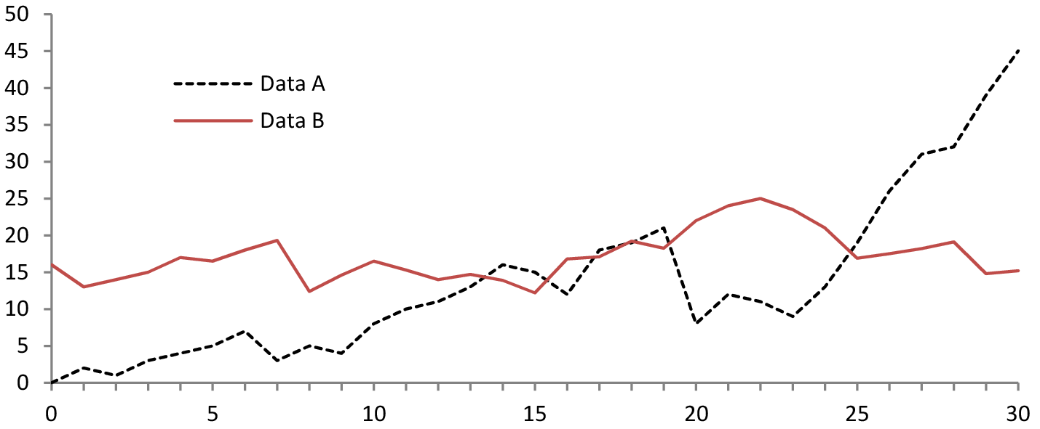

Figure : A figure caption is always placed below the illustration. Please note that short captions are centered, while long ones are justified by the macro package automatically.

This is a sample theorem. The run-in heading is set in bold, while the following text appears in italics. Definitions, lemmas, propositions, and corollaries are styled the same way.

*Proof.* Proofs, examples, and remarks have the initial word in italics, while the following text appears in normal font. ◻

For citations of references, we prefer the use of square brackets and consecutive numbers. Citations using labels or the author/year convention are also acceptable. Also, please note the following:

* Depending on the citation manager you use, extra care needs to be exercised with respect to “extra” (in *Zotero*) or “note” field. For example, an *incorrectly* formatted citation like the one for [3]. Be sure to clear the “note” of your .bib from such entries. There are very few cases where the “note” field is used, two examples are [1] and [2].
* If exporting the .bib file from an app like *Zotero*, it is desirable to export it as UTF-8-encoded BibTeX (*not* BibLaTeX).

# Reference

1. Ozernyi, D.M.: Linguistic transfer, or there and back again: A chronological study of terminological meandering. Presented at the January (2022). https://doi.org/[10.13140/RG.2.2.27507.86560](https://doi.org/10.13140/RG.2.2.27507.86560).

2. Ozernyi, D.M.: The rise and fall of linguistic transfer. Manuscript. Northwestern University. Presented at the (2022). https://doi.org/[10.5281/zenodo.6237257](https://doi.org/10.5281/zenodo.6237257).

3. Sankoff, D., Poplack, S.: A formal grammar for code‐switching. Paper in Linguistics. 14, 1, 3–45 (1981). https://doi.org/[10.1080/08351818109370523](https://doi.org/10.1080/08351818109370523).

1. Supported by organization x.