Digital Skills Academy

Fundamentals of Programming – Java

Lab4.1 – Area of a Triangle

Donnchadh O h-Ainle

D11128288

[donnchadh.oh-ainle@gmail.com](mailto:donnchadh.oh-ainle@gmail.com)

1 Task/program objective 1

2 Problem Definition 2

3 Design 2

4 Implementation 4

4.1 Empty App class with App constructor 4

4.2 App class with JavaBook windows 4

4.3 Empty Triangle class 4

4.4 Triangle class with attributes and methods 4

4.5 Final App, instantiating a Triangle object and using its functionality 4

5 Test Definition 4

6 Test Recording 4

7 Code 4

8 Screens 4

9 Documentation 4

10 References 4

# Task/program objective

The application should calculate the area of a triangle based on the basic necessary input from a user. It should have a separate triangle class to carry out the area calculation. This should be called from the main app class at runtime.

# Problem Definition

The area of a triangle is given by the formula Area = (base*height)/2, see Figure 1 Triangle dimensions, base, height[1]. The program must have the ability to request the two values, store them as variables, compute the solution and present the solution to the user.

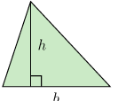

Figure 1 Triangle dimensions, base, height

# Design

A main app class will be created for the main() function. In a separate file the Triangle class will be created with the attributes and methods as seen I the following class diagram.

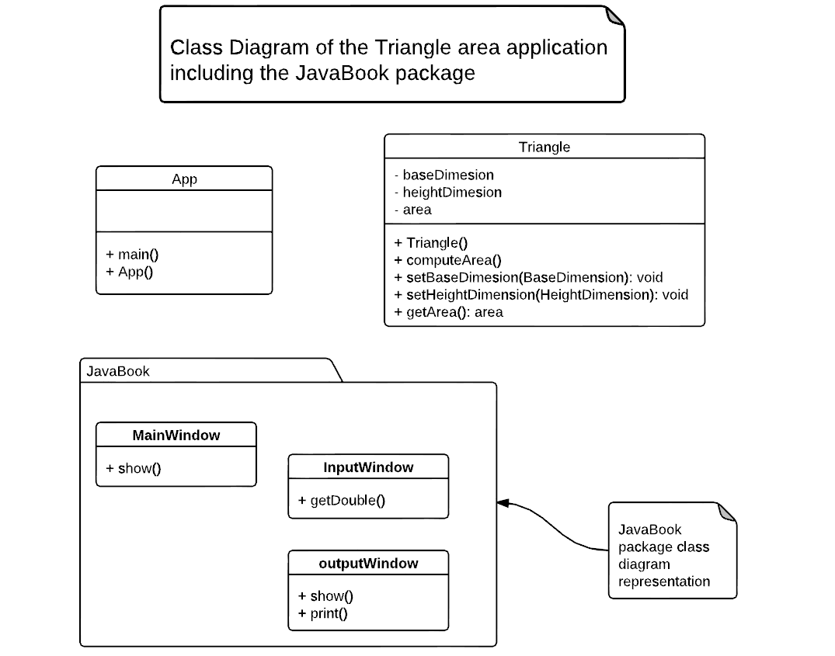

Figure 2 Class Diagram

The program will require a way to request and accept input from the user. The JavaBook library[2] will be used to generate the GUI dialogs for this. There are 3 JavaBook classes that provide the functionality require for the GUI part of the program;

* MainWidow: All other GUI items will reside in this widow
* InputBox: A dialog which provides an input filed for the user to enter the dimensions
* OutputBox: A dialog which can present the results to the user

The calculation can be carried out in a method which will use two variables, which will be populated with input from the user (base and height dimension).

The operation of the program is captured in the following state diagram.

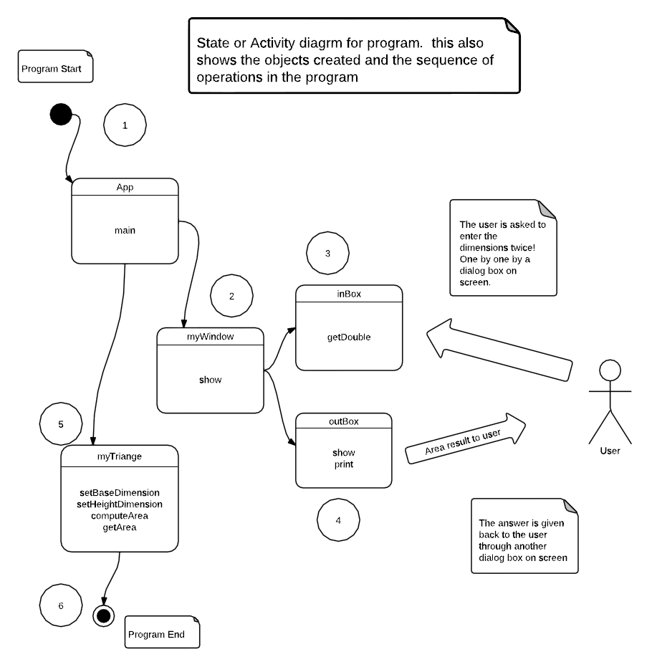

Figure 3 State/Activity Diagram

# Implementation

The code was developed I stages, eventually matching the class diagram in the design section. This was done to aid in the debugging of the program. It also meant there were a number of running versions of the program up to the final version with all the desired features. The stages are listed below.

## Setup the development environment

* Java development Kit JDK 7
* Add path to javac, java by adding the following to the PATH environment variable
  + C:\Program Files\Java\jdk1.7.0_04\bin
* Create a run.bat file to compile and run code from the cmd.exewith
  + javac App.java
  + java App
* Open the command prompt, navigate to code dir and run
  + %DirPath%\>run

## Empty App class with App constructor

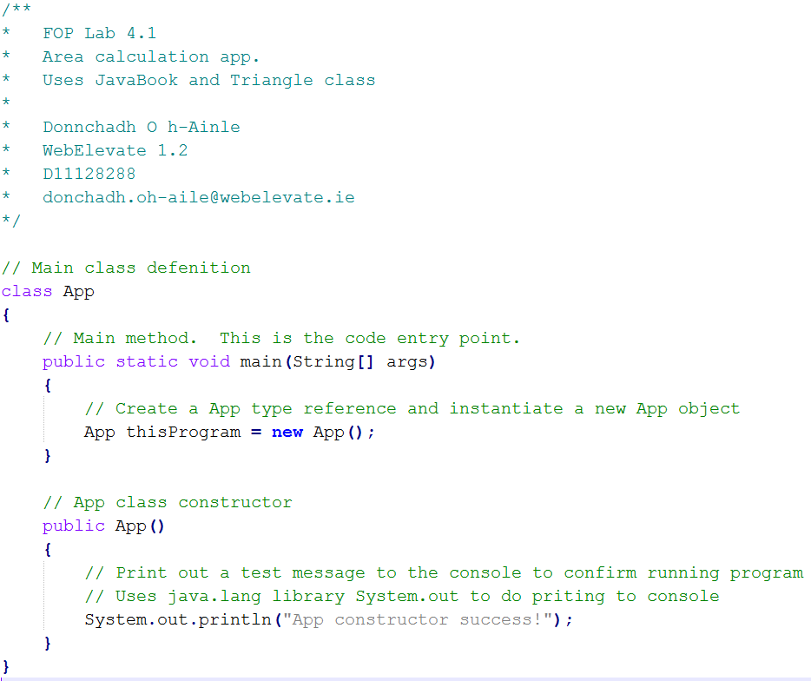

This code only prints “App constructor success!” to the command prompt.

## App class with JavaBook windows and method variables

Here only the App() constructor is shown as it is the only code changed since the last.

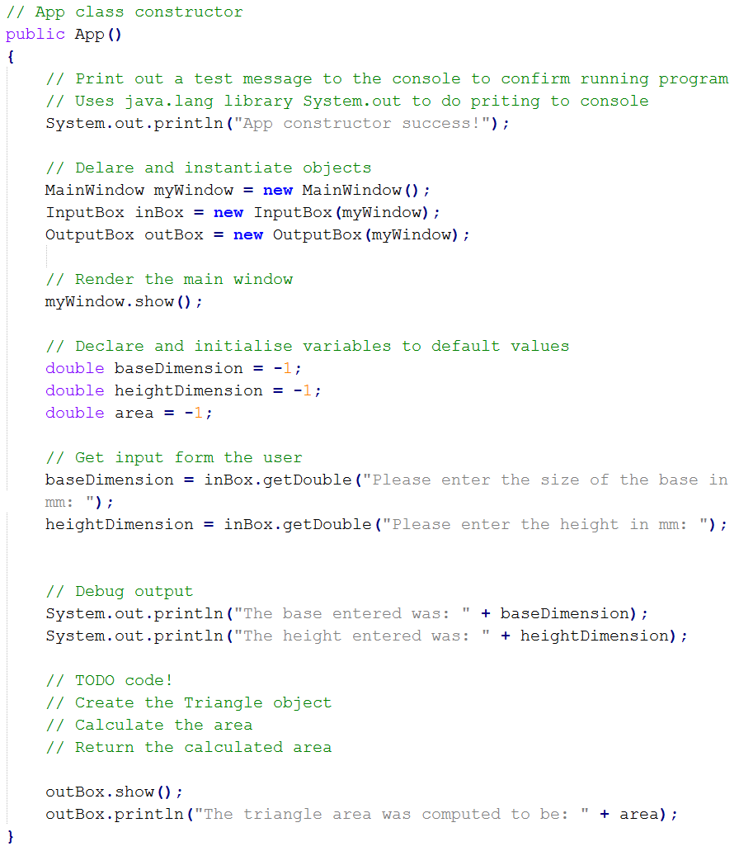

The output of the code can be seen I the following images.

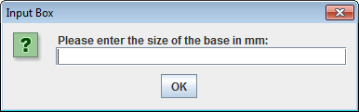

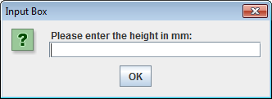

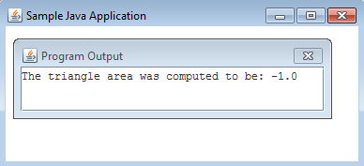

## Empty Triangle class

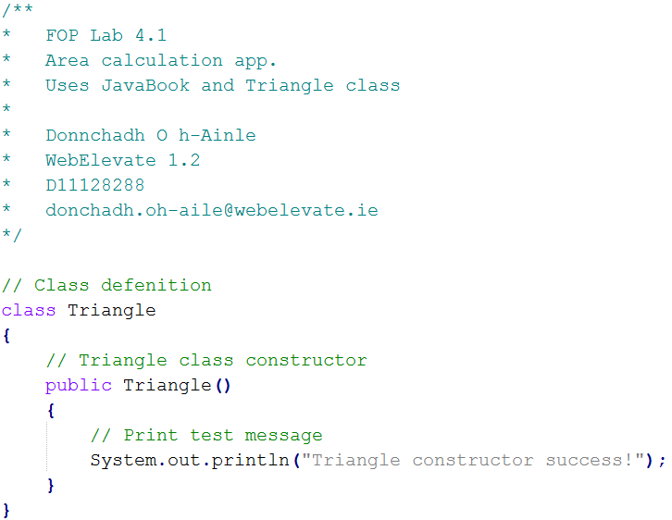

Output when run:

**App constructor success!**

**The base entered was: 22.0**

**The height entered was: 12.0**

**Triangle constructor success!**

## Triangle class with attributes and methods

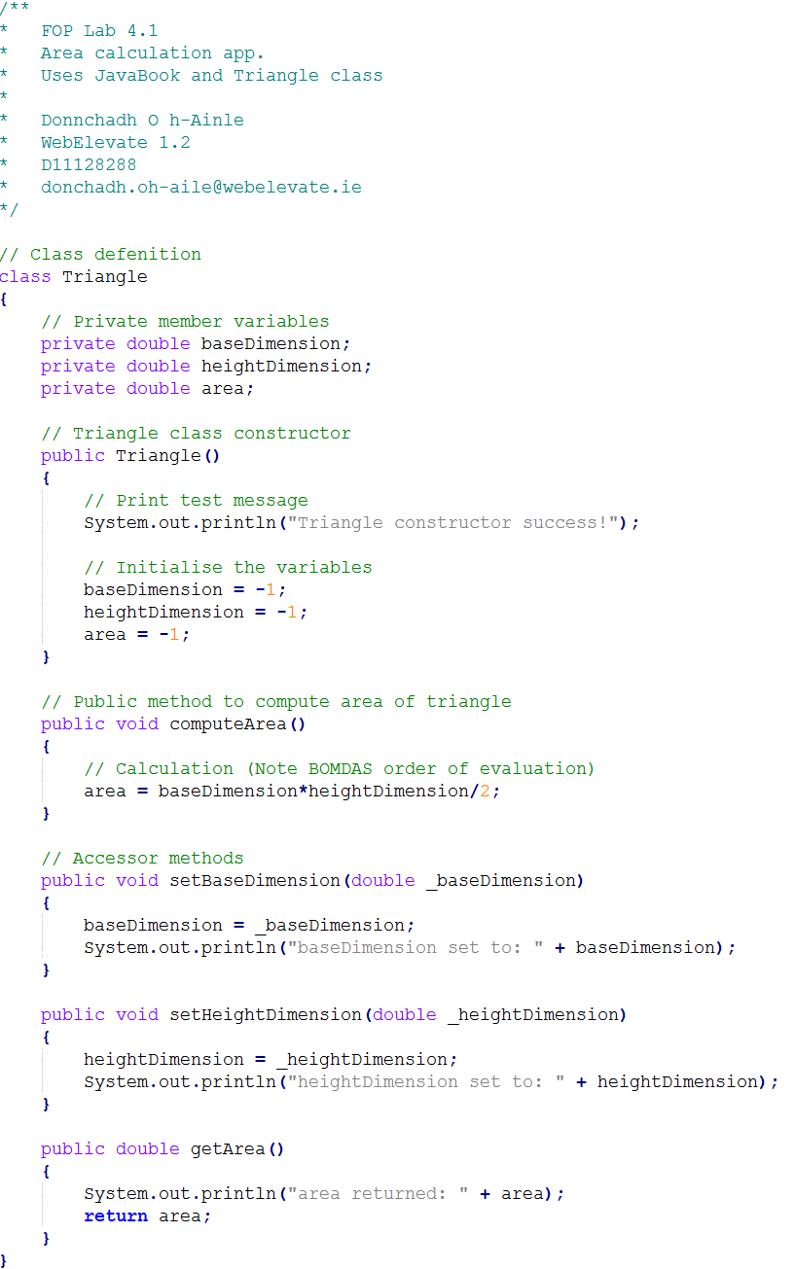

Output when run:

**App constructor success!**

**The base entered was: 123.0**

**The height entered was: 321.0**

**Triangle constructor success!**

**baseDimension set to: 22.0**

**heightDimension set to: 22.0**

**area returned: -1.0**

## Final App, instantiating a Triangle object and using its functionality

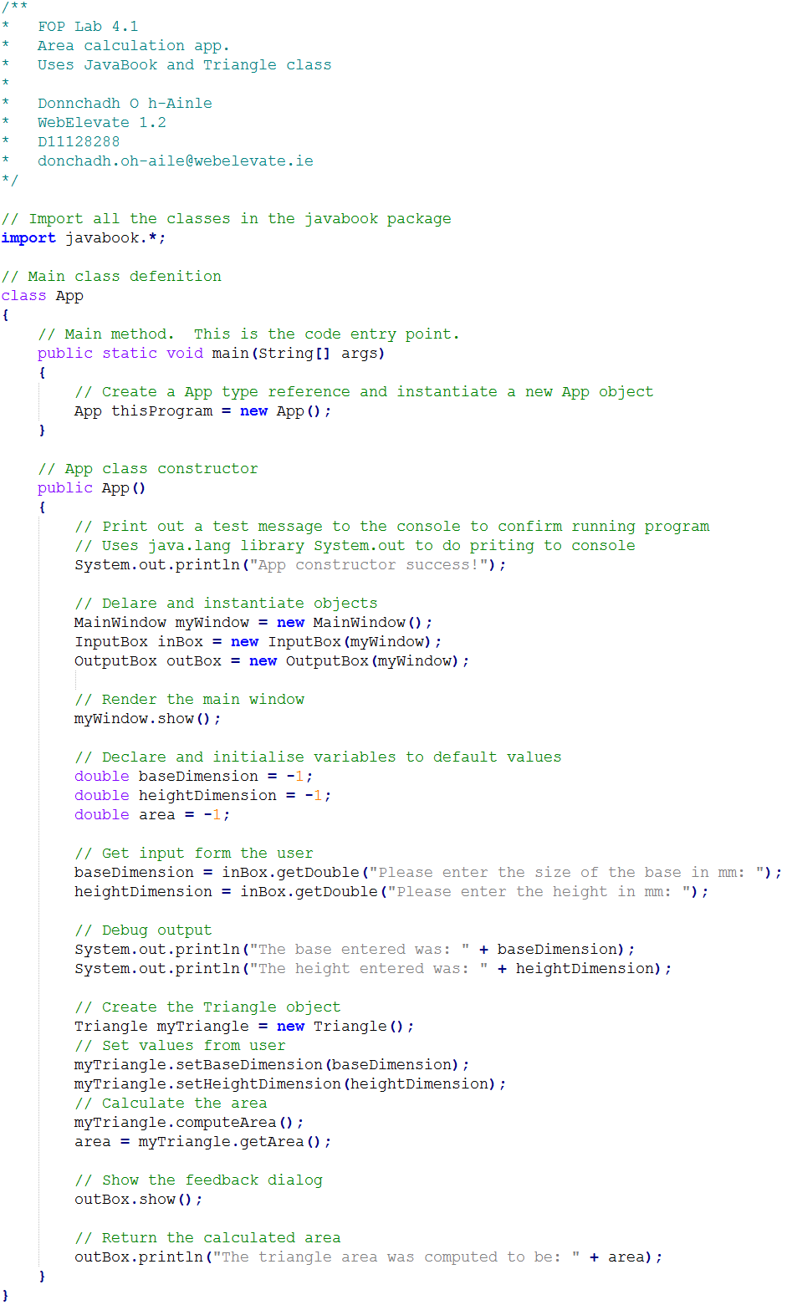

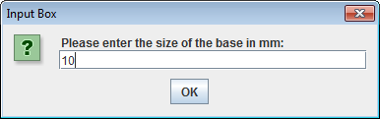

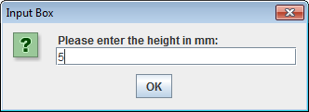

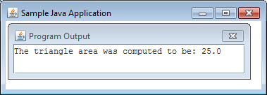

# Test Definition

The testing for this lab was carried out manually by inputting a number of known inputs and comparing the output to expected values.

# Code

## App.java

/**

* FOP Lab 4.1

* Area calculation app.

* Uses JavaBook and Triangle class

*

* Donnchadh O h-Ainle

* WebElevate 1.2

* D11128288

* donchadh.oh-aile@webelevate.ie

*/

// Import all the classes in the javabook package

import javabook.*;

// Main class defenition

class App

{

// Main method. This is the code entry point.

public static void main(String[] args)

{

// Create a App type reference and instantiate a new App object

App thisProgram = new App();

}

// App class constructor

public App()

{

// Print out a test message to the console to confirm running program

// Uses java.lang library System.out to do priting to console

System.out.println("App constructor success!");

// Delare and instantiate objects

MainWindow myWindow = new MainWindow();

InputBox inBox = new InputBox(myWindow);

OutputBox outBox = new OutputBox(myWindow);

// Render the main window

myWindow.show();

// Declare and initialise variables to default values

double baseDimension = -1;

double heightDimension = -1;

double area = -1;

// Get input form the user

baseDimension = inBox.getDouble("Please enter the size of the base in mm: ");

heightDimension = inBox.getDouble("Please enter the height in mm: ");

// Debug output

System.out.println("The base entered was: " + baseDimension);

System.out.println("The height entered was: " + heightDimension);

// Create the Triangle object

Triangle myTriangle = new Triangle();

// Set values from user

myTriangle.setBaseDimension(baseDimension);

myTriangle.setHeightDimension(heightDimension);

// Calculate the area

myTriangle.computeArea();

area = myTriangle.getArea();

// Show the feedback dialog

outBox.show();

// Return the calculated area

outBox.println("The triangle area was computed to be: " + area);

}

}

## Triangle.java

/**

* FOP Lab 4.1

* Area calculation app.

* Uses JavaBook and Triangle class

*

* Donnchadh O h-Ainle

* WebElevate 1.2

* D11128288

* donchadh.oh-aile@webelevate.ie

*/

// Class defenition

class Triangle

{

// Private member variables

private double baseDimension;

private double heightDimension;

private double area;

// Triangle class constructor

public Triangle()

{

// Print test message

System.out.println("Triangle constructor success!");

// Initialise the variables

baseDimension = -1;

heightDimension = -1;

area = -1;

}

// Public method to compute area of triangle

public void computeArea()

{

// Calculation (Note BOMDAS order of evaluation)

area = baseDimension*heightDimension/2;

System.out.println("area calculated to be: " + area);

}

// Accessor methods

public void setBaseDimension(double _baseDimension)

{

baseDimension = _baseDimension;

System.out.println("baseDimension set to: " + baseDimension);

}

public void setHeightDimension(double _heightDimension)

{

heightDimension = _heightDimension;

System.out.println("heightDimension set to: " + heightDimension);

}

public double getArea()

{

System.out.println("area returned: " + area);

return area;

}

}

# Screens







# Documentation

To run use the command line and

* java App
* Enter the base and height dims in mm when prompted

# References

* Course notes
* <http://docs.oracle.com/javase/7/docs/api/>
* See footnotes.

1. Computing the area of a triangle - <http://en.wikipedia.org/wiki/Triangle>
2. A group of classes in a package from Wu, Thomas. "An Introduction to Object-Oriented Programming with Java".