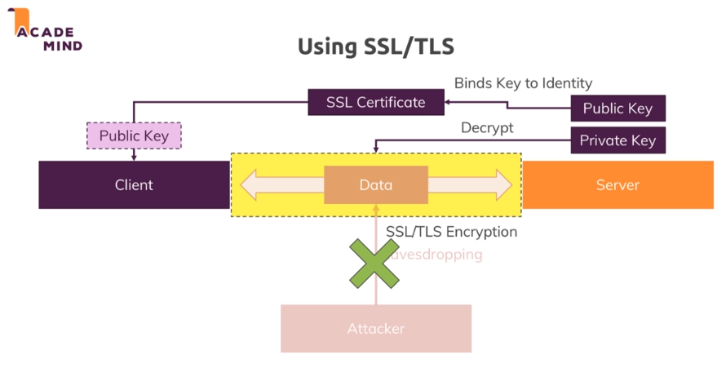

**openssl req -nodes -new -x509 -keyout server.key -out server.cert**

