功能模块相关资料
目录
1 料场平面图查询 2
系统界面 2
查询语句 2
2 料场平面图查询_弹出窗口 3
系统界面 3
查询语句 3
前台界面字段 3
3 入库作业查询_船板 16
系统界面 16
查询语句 16
前台界面字段 16
4 码名转换(具体开发时沟通) 29
查询语句 29
5 用户权限表 30
系统界面 30
查询语句 30
判断登陆用户和权限 30
判断菜单权限 30

1 料场平面图查询

系统界面
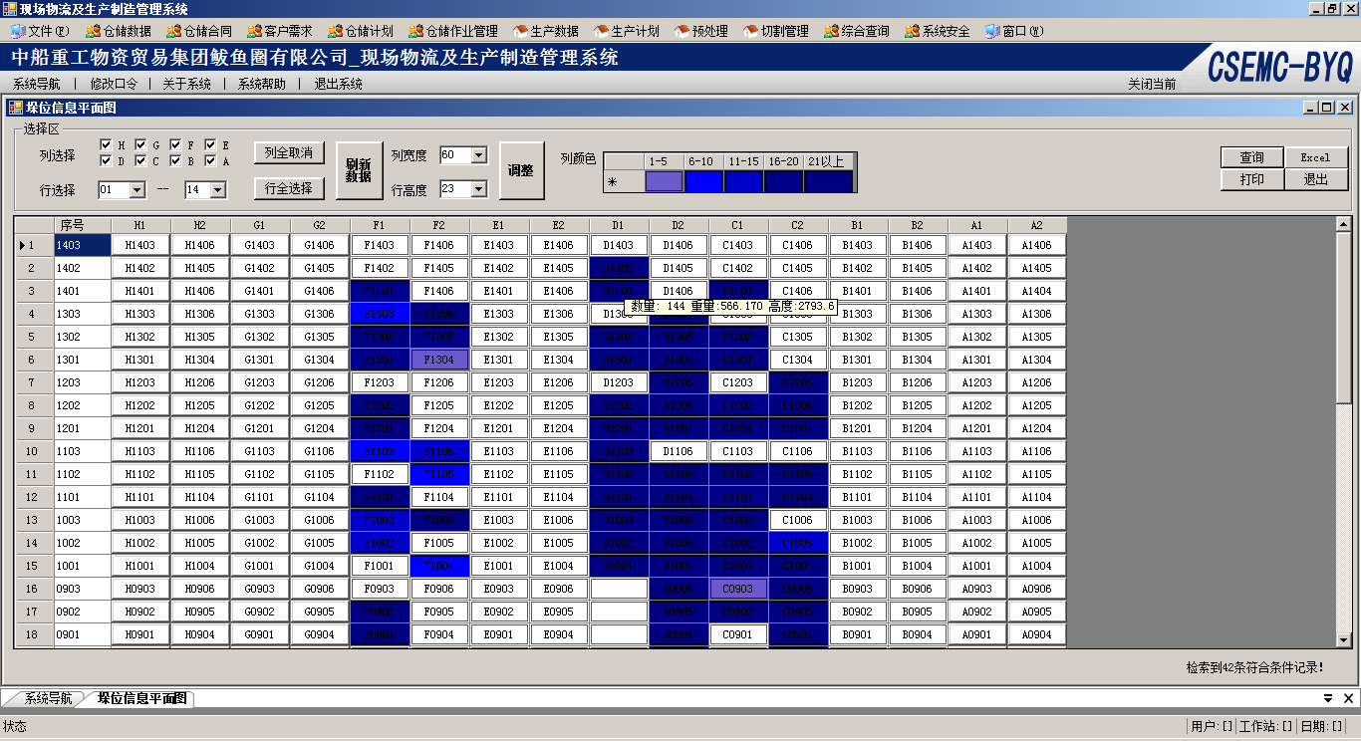

查询语句
SELECT
H1
,H2
,G1
,G2

,F1
,F2
,E1
,E2

,D1
,D2
,C1
,C2

,B1
,B2
,A1
,A2
,LSH1
,LSH
FROM IM_KWXXP
WHERE (IM_KWXXP.LSH1>='01') And (IM_KWXXP.LSH1<='14')
ORDER BY LSH DESC

2 料场平面图查询_弹出窗口

系统界面
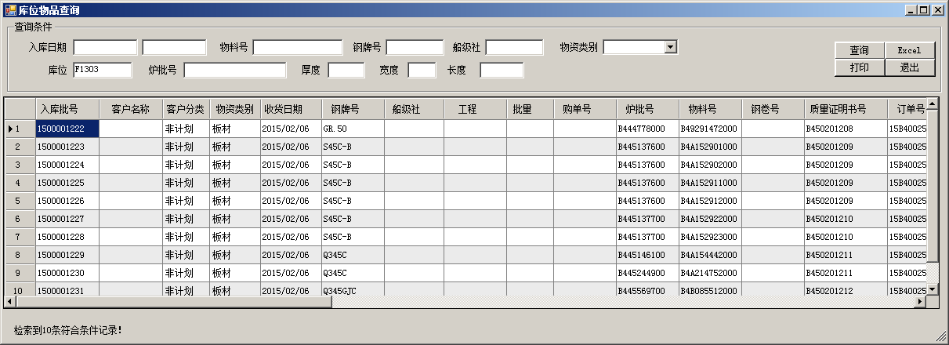

查询语句
Select *
FROM IM_CKWPKWP
WHERE (IM_CKWPKWP.KWH='F1303')
ORDER BY IM_CKWPKWP.NBSBM

前台界面字段
<?xml version="1.0" encoding="utf-8"?>
<UI>
<WinForm>
<DataGridViews>
<DataGridView Name="krDataGridViewDetail" Memo="DetailDataGridView">
<!--<Column>
<Type>ComboBoxColumn</Type>
<Name>ckh</Name>
<HeaderText>仓库</HeaderText>
<Width>70</Width>
<DisplayIndex>10</DisplayIndex>
<Visible>True</Visible>
<DataPropertyName>ckh</DataPropertyName>
</Column>-->
<Column>
<Type>TextBoxColumn</Type>
<Name>nbsbm</Name>
<HeaderText>入库批号</HeaderText>
<Width>81</Width>
<DisplayIndex>3</DisplayIndex>
<Visible>True</Visible>
<DataPropertyName>nbsbm</DataPropertyName>
</Column>
<Column>
<Type>ComboBoxColumn</Type>
<Name>wpsyz</Name>
<HeaderText>客户名称</HeaderText>
<Width>81</Width>
<DisplayIndex>10</DisplayIndex>
<Visible>True</Visible>
<DataPropertyName>wpsyz</DataPropertyName>
</Column>
<Column>
<Type>ComboBoxColumn</Type>
<Name>KHFL</Name>
<HeaderText>客户分类</HeaderText>
<Width>60</Width>
<DisplayIndex>9</DisplayIndex>
<Visible>True</Visible>
<DataPropertyName>KHFL</DataPropertyName>
</Column>
<Column>
<Type>ComboBoxColumn</Type>
<Name>WPFLM</Name>
<HeaderText>物资类别</HeaderText>
<Width>65</Width>
<DisplayIndex>9</DisplayIndex>
<Visible>True</Visible>
<DataPropertyName>WPFLM</DataPropertyName>
</Column>
<Column>
<Type>TextBoxColumn</Type>
<Name>rkrq</Name>
<HeaderText>收货日期</HeaderText>
<Width>78</Width>
<DisplayIndex>2</DisplayIndex>
<Visible>True</Visible>
<DataPropertyName>rkrq</DataPropertyName>
</Column>
<!--<Column>
<Type>TextBoxColumn</Type>
<Name>wpxh</Name>
<HeaderText>材质</HeaderText>
<Width>99</Width>
<DisplayIndex>1</DisplayIndex>
<Visible>True</Visible>
<DataPropertyName>wpxh</DataPropertyName>
</Column>-->
<Column>
<Type>TextBoxColumn</Type>
<Name>WPGPH</Name>
<HeaderText>钢牌号</HeaderText>
<Width>80</Width>
<DisplayIndex>4</DisplayIndex>
<Visible>True</Visible>
<DataPropertyName>WPGPH</DataPropertyName>
</Column>
<Column>
<Type>TextBoxColumn</Type>
<Name>WPCJS</Name>
<HeaderText>船级社</HeaderText>
<Width>76</Width>
<DisplayIndex>4</DisplayIndex>
<Visible>True</Visible>
<DataPropertyName>WPCJS</DataPropertyName>
</Column>
<Column>
<Type>TextBoxColumn</Type>
<Name>dc_ch</Name>
<HeaderText>工程</HeaderText>
<Width>80</Width>
<DisplayIndex>1</DisplayIndex>
<Visible>True</Visible>
<DataPropertyName>dc_ch</DataPropertyName>
</Column>
<!--<Column>
<Type>TextBoxColumn</Type>
<Name>DC_PL</Name>
<HeaderText>批量</HeaderText>
<Width>60</Width>
<DisplayIndex>2</DisplayIndex>
<Visible>True</Visible>
<DataPropertyName>DC_PL</DataPropertyName>
</Column>-->
<Column>
<Type>TextBoxColumn</Type>
<Name>dc_fd</Name>
<HeaderText>购单号</HeaderText>
<Width>80</Width>
<DisplayIndex>1</DisplayIndex>
<Visible>True</Visible>
<DataPropertyName>dc_fd</DataPropertyName>
</Column>
<Column>
<Type>TextBoxColumn</Type>
<Name>lph</Name>
<HeaderText>炉批号</HeaderText>
<Width>80</Width>
<DisplayIndex>2</DisplayIndex>
<Visible>True</Visible>
<DataPropertyName>lph</DataPropertyName>
</Column>
<Column>
<Type>TextBoxColumn</Type>
<Name>GHSWPH</Name>
<HeaderText>物料号</HeaderText>
<Width>80</Width>
<DisplayIndex>2</DisplayIndex>
<Visible>True</Visible>
<DataPropertyName>GHSWPH</DataPropertyName>
</Column>
<Column>
<Type>TextBoxColumn</Type>
<Name>JBGJH</Name>
<HeaderText>钢卷号</HeaderText>
<Width>80</Width>
<DisplayIndex>2</DisplayIndex>
<Visible>True</Visible>
<DataPropertyName>JBGJH</DataPropertyName>
</Column>
<Column>
<Type>TextBoxColumn</Type>
<Name>ZJH</Name>
<HeaderText>质量证明书号</HeaderText>
<Width>106</Width>
<DisplayIndex>2</DisplayIndex>
<Visible>True</Visible>
<DataPropertyName>ZJH</DataPropertyName>
</Column>
<Column>
<Type>TextBoxColumn</Type>
<Name>cgddh</Name>
<HeaderText>订单号</HeaderText>
<Width>80</Width>
<DisplayIndex>1</DisplayIndex>
<Visible>True</Visible>
<DataPropertyName>cgddh</DataPropertyName>
</Column>
<Column>
<Type>TextBoxColumn</Type>
<Name>cgddxh</Name>
<HeaderText>子项</HeaderText>
<Width>56</Width>
<DisplayIndex>1</DisplayIndex>
<Visible>True</Visible>
<DataPropertyName>cgddxh</DataPropertyName>
</Column>
<!--<Column>
<Type>TextBoxColumn</Type>
<Name>wpgg</Name>
<HeaderText>规格</HeaderText>
<Width>117</Width>
<DisplayIndex>1</DisplayIndex>
<Visible>True</Visible>
<DataPropertyName>wpgg</DataPropertyName>
</Column>-->
<Column>
<Type>TextBoxColumn</Type>
<Name>B1</Name>
<HeaderText>厚度</HeaderText>
<Width>206</Width>
<DisplayIndex>3</DisplayIndex>
<Visible>True</Visible>
<Alignment>MiddleRight</Alignment>
<Format>##.0</Format>
<DataPropertyName>B1</DataPropertyName>
</Column>
<Column>
<Type>TextBoxColumn</Type>
<Name>T1</Name>
<HeaderText>宽度</HeaderText>
<Width>60</Width>
<DisplayIndex>3</DisplayIndex>
<Visible>True</Visible>
<Alignment>MiddleRight</Alignment>
<Format>##</Format>
<DataPropertyName>T1</DataPropertyName>
</Column>
<Column>
<Type>TextBoxColumn</Type>
<Name>T2</Name>
<HeaderText>长度</HeaderText>
<Width>70</Width>
<DisplayIndex>3</DisplayIndex>
<Visible>True</Visible>
<Alignment>MiddleRight</Alignment>
<Format>##</Format>
<DataPropertyName>T2</DataPropertyName>
</Column>
<Column>
<Type>TextBoxColumn</Type>
<Name>qxkcl</Name>
<HeaderText>数量</HeaderText>
<Width>56</Width>
<DisplayIndex>2</DisplayIndex>
<Visible>True</Visible>
<Alignment>MiddleRight</Alignment>
<Format>##.00</Format>
<DataPropertyName>qxkcl</DataPropertyName>
</Column>
<Column>
<Type>TextBoxColumn</Type>
<Name>qxkcl1</Name>
<HeaderText>重量</HeaderText>
<Width>60</Width>
<DisplayIndex>2</DisplayIndex>
<Visible>True</Visible>
<Alignment>MiddleRight</Alignment>
<Format>##.000</Format>
<DataPropertyName>qxkcl1</DataPropertyName>
</Column>
<Column>
<Type>TextBoxColumn</Type>
<Name>kwh</Name>
<HeaderText>库位</HeaderText>
<Width>60</Width>
<DisplayIndex>2</DisplayIndex>
<Visible>True</Visible>
<DataPropertyName>kwh</DataPropertyName>
</Column>
<Column>
<Type>TextBoxColumn</Type>
<Name>cfcs1</Name>
<HeaderText>层数</HeaderText>
<Width>40</Width>
<DisplayIndex>2</DisplayIndex>
<Visible>True</Visible>
<DataPropertyName>cfcs1</DataPropertyName>
</Column>
<!--<Column>
<Type>TextBoxColumn</Type>
<Name>zych</Name>
<HeaderText>需求项目</HeaderText>
<Width>80</Width>
<DisplayIndex>2</DisplayIndex>
<Visible>True</Visible>
<DataPropertyName>zych</DataPropertyName>
</Column>-->
<!--<Column>
<Type>ComboBoxColumn</Type>
<Name>zylx</Name>
<HeaderText>流向</HeaderText>
<Width>60</Width>
<DisplayIndex>2</DisplayIndex>
<Visible>True</Visible>
<DataPropertyName>zylx</DataPropertyName>
</Column>-->
<!--<Column>
<Type>TextBoxColumn</Type>
<Name>pwwz</Name>
<HeaderText>抛丸位置</HeaderText>
<Width>60</Width>
<DisplayIndex>2</DisplayIndex>
<Visible>True</Visible>
<DataPropertyName>pwwz</DataPropertyName>
</Column>-->
<Column>
<Type>TextBoxColumn</Type>
<Name>YSCH</Name>
<HeaderText>车号</HeaderText>
<Width>80</Width>
<DisplayIndex>2</DisplayIndex>
<Visible>True</Visible>
<DataPropertyName>YSCH</DataPropertyName>
</Column>
<Column>
<Type>TextBoxColumn</Type>
<Name>JSR</Name>
<HeaderText>收货人</HeaderText>
<Width>80</Width>
<DisplayIndex>2</DisplayIndex>
<Visible>True</Visible>
<DataPropertyName>JSR</DataPropertyName>
</Column>
<Column>
<Type>TextBoxColumn</Type>
<Name>fhphh</Name>
<HeaderText>配货计划号</HeaderText>
<Width>93</Width>
<DisplayIndex>2</DisplayIndex>
<Visible>True</Visible>
<DataPropertyName>fhphh</DataPropertyName>
</Column>
<Column>
<Type>TextBoxColumn</Type>
<Name>fhzfh</Name>
<HeaderText>准发计划号</HeaderText>
<Width>94</Width>
<DisplayIndex>2</DisplayIndex>
<Visible>True</Visible>
<DataPropertyName>fhzfh</DataPropertyName>
</Column>
<Column>
<Type>TextBoxColumn</Type>
<Name>fhzzh</Name>
<HeaderText>装载号</HeaderText>
<Width>80</Width>
<DisplayIndex>2</DisplayIndex>
<Visible>True</Visible>
<DataPropertyName>fhzzh</DataPropertyName>
</Column>
<Column>
<Type>TextBoxColumn</Type>
<Name>fhzt</Name>
<HeaderText>状态</HeaderText>
<Width>67</Width>
<DisplayIndex>2</DisplayIndex>
<Visible>True</Visible>
<DataPropertyName>fhzt</DataPropertyName>
</Column>
<Column>
<Type>TextBoxColumn</Type>
<Name>fhrq</Name>
<HeaderText>发货日期</HeaderText>
<Width>80</Width>
<DisplayIndex>2</DisplayIndex>
<Visible>True</Visible>
<DataPropertyName>fhrq</DataPropertyName>
</Column>
<Column>
<Type>TextBoxColumn</Type>
<Name>fhch</Name>
<HeaderText>发货车号</HeaderText>
<Width>80</Width>
<DisplayIndex>2</DisplayIndex>
<Visible>True</Visible>
<DataPropertyName>fhch</DataPropertyName>
</Column>
<Column>
<Type>TextBoxColumn</Type>
<Name>fhr</Name>
<HeaderText>发货人</HeaderText>
<Width>80</Width>
<DisplayIndex>2</DisplayIndex>
<Visible>True</Visible>
<DataPropertyName>fhr</DataPropertyName>
</Column>
<Column>
<Type>TextBoxColumn</Type>
<Name>XSHTH</Name>
<HeaderText>销售合同号</HeaderText>
<Null>Y</Null>
<Width>96</Width>
<DisplayIndex>1</DisplayIndex>
<Visible>True</Visible>
<DataPropertyName>XSHTH</DataPropertyName>
</Column>
<Column>
<Type>ComboBoxColumn</Type>
<Name>yjxqf</Name>
<HeaderText>收货单位</HeaderText>
<Width>100</Width>
<DisplayIndex>10</DisplayIndex>
<Visible>True</Visible>
<DataPropertyName>yjxqf</DataPropertyName>
</Column>
<!--<Column>
<Type>TextBoxColumn</Type>
<Name>yjjhdd</Name>
<HeaderText>预计交货地点</HeaderText>
<Width>105</Width>
<DisplayIndex>1</DisplayIndex>
<Visible>True</Visible>
<DataPropertyName>yjjhdd</DataPropertyName>
</Column>-->
<Column>
<Type>TextBoxColumn</Type>
<Name>tmxx</Name>
<HeaderText>条码</HeaderText>
<Width>108</Width>
<DisplayIndex>2</DisplayIndex>
<Visible>True</Visible>
<DataPropertyName>tmxx</DataPropertyName>
</Column>
<Column>
<Type>TextBoxColumn</Type>
<Name>bz</Name>
<HeaderText>备注</HeaderText>
<Width>97</Width>
<DisplayIndex>4</DisplayIndex>
<Visible>True</Visible>
<DataPropertyName>bz</DataPropertyName>
</Column>
<!--<Column>
<Type>ComboBoxColumn</Type>
<Name>wpzt</Name>
<HeaderText>物品状态</HeaderText>
<Width>60</Width>
<DisplayIndex>10</DisplayIndex>
<Visible>True</Visible>
<DataPropertyName>wpzt</DataPropertyName>
</Column>

<Column>
<Type>ComboBoxColumn</Type>
<Name>wpsx</Name>
<HeaderText>物品属性</HeaderText>
<Width>60</Width>
<DisplayIndex>10</DisplayIndex>
<Visible>True</Visible>
<DataPropertyName>wpsx</DataPropertyName>
</Column>-->
<!--<Column>
<Type>TextBoxColumn</Type>
<Name>ylzd1</Name>
<HeaderText>剩余修改人员</HeaderText>
<Width>110</Width>
<DisplayIndex>5</DisplayIndex>
<Visible>True</Visible>
<DataPropertyName>ylzd1</DataPropertyName>
</Column>

<Column>
<Type>TextBoxColumn</Type>
<Name>ylzd2</Name>
<HeaderText>剩余修改日期</HeaderText>
<Width>110</Width>
<DisplayIndex>5</DisplayIndex>
<Visible>True</Visible>
<DataPropertyName>ylzd2</DataPropertyName>
</Column>

<Column>
<Type>TextBoxColumn</Type>
<Name>xgr</Name>
<HeaderText>剩余审批人员</HeaderText>
<Width>110</Width>
<DisplayIndex>5</DisplayIndex>
<Visible>True</Visible>
<DataPropertyName>xgr</DataPropertyName>
</Column>

<Column>
<Type>TextBoxColumn</Type>
<Name>xgrq</Name>
<HeaderText>剩余审批日期</HeaderText>
<Width>110</Width>
<DisplayIndex>5</DisplayIndex>
<Visible>True</Visible>
<DataPropertyName>xgrq</DataPropertyName>
</Column>

<Column>
<Type>TextBoxColumn</Type>
<Name>ylzd3</Name>
<HeaderText>利库修改人员</HeaderText>
<Width>110</Width>
<DisplayIndex>5</DisplayIndex>
<Visible>True</Visible>
<DataPropertyName>ylzd3</DataPropertyName>
</Column>

<Column>
<Type>TextBoxColumn</Type>
<Name>ylzd4</Name>
<HeaderText>利库修改日期</HeaderText>
<Width>110</Width>
<DisplayIndex>5</DisplayIndex>
<Visible>True</Visible>
<DataPropertyName>ylzd4</DataPropertyName>
</Column>-->
<!--<Column>
<Type>TextBoxColumn</Type>
<Name>wph</Name>
<HeaderText>物品号</HeaderText>
<Width>186</Width>
<DisplayIndex>1</DisplayIndex>
<Visible>True</Visible>
<DataPropertyName>wph</DataPropertyName>
</Column>
<Column>
<Type>TextBoxColumn</Type>
<Name>wpmc</Name>
<HeaderText>物品名称</HeaderText>
<Width>110</Width>
<DisplayIndex>2</DisplayIndex>
<Visible>True</Visible>
<DataPropertyName>wpmc</DataPropertyName>
</Column>
<Column>
<Type>TextBoxColumn</Type>
<Name>ddh</Name>
<HeaderText>入库单号</HeaderText>
<Width>79</Width>
<DisplayIndex>3</DisplayIndex>
<Visible>True</Visible>
<DataPropertyName>ddh</DataPropertyName>
</Column>
<Column>
<Type>TextBoxColumn</Type>
<Name>ddxh</Name>
<HeaderText>项号</HeaderText>
<Width>38</Width>
<DisplayIndex>10</DisplayIndex>
<Visible>True</Visible>
<Alignment>MiddleRight</Alignment>
<Format>##</Format>
<DataPropertyName>ddxh</DataPropertyName>
</Column>-->
<!--
public string { get; set; }
public string YJJHDD { get; set; }
public string { get; set; }-->
<GUID>FF08FF27-D240-4666-A391-B356E1B3A145</GUID>
</DataGridView>
</DataGridViews>
</WinForm>
</UI>

3 入库作业查询_船板

系统界面
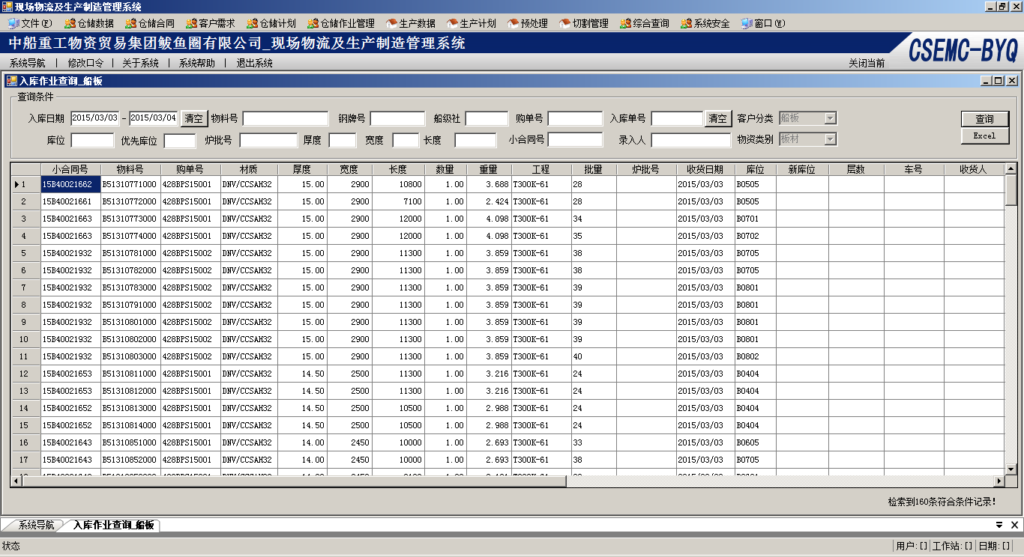

查询语句
SELECT *
FROM IM_CKWPKWP
WHERE (IM_CKWPKWP.KHFL='01') And (IM_CKWPKWP.WPFLM='B') And (IM_CKWPKWP.RKRQ>='2015/03/04') And (IM_CKWPKWP.RKRQ<='2015/03/03')
ORDER BY IM_CKWPKWP.NBSBM

前台界面字段
<?xml version="1.0" encoding="utf-8"?>
<UI>
<WinForm>
<DataGridViews>
<DataGridView Name="krDataGridViewDetail" Memo="DetailDataGridView">
<!--<Column>
<Type>ComboBoxColumn</Type>
<Name>ckh</Name>
<HeaderText>仓库</HeaderText>
<Width>70</Width>
<DisplayIndex>10</DisplayIndex>
<Visible>True</Visible>
<DataPropertyName>ckh</DataPropertyName>
</Column>-->
<!--<Column>
<Type>ComboBoxColumn</Type>
<Name>KHFL</Name>
<HeaderText>客户分类</HeaderText>
<Width>74</Width>
<DisplayIndex>0</DisplayIndex>
<Visible>True</Visible>
<DataPropertyName>KHFL</DataPropertyName>
</Column>-->
<!--<Column>
<Type>ComboBoxColumn</Type>
<Name>WPFLM</Name>
<HeaderText>物资类别</HeaderText>
<Width>65</Width>
<DisplayIndex>0</DisplayIndex>
<Visible>True</Visible>
<DataPropertyName>WPFLM</DataPropertyName>
</Column>-->
<Column>
<Type>TextBoxColumn</Type>
<Name>cgddh</Name>
<HeaderText>小合同号</HeaderText>
<Width>80</Width>
<DisplayIndex>1</DisplayIndex>
<Visible>True</Visible>
<DataPropertyName>cgddh</DataPropertyName>
</Column>
<Column>
<Type>TextBoxColumn</Type>
<Name>GHSWPH</Name>
<HeaderText>物料号</HeaderText>
<Width>80</Width>
<DisplayIndex>2</DisplayIndex>
<Visible>True</Visible>
<DataPropertyName>GHSWPH</DataPropertyName>
</Column>
<Column>
<Type>TextBoxColumn</Type>
<Name>dc_fd</Name>
<HeaderText>购单号</HeaderText>
<Width>80</Width>
<DisplayIndex>1</DisplayIndex>
<Visible>True</Visible>
<DataPropertyName>dc_fd</DataPropertyName>
</Column>
<!--<Column>
<Type>TextBoxColumn</Type>
<Name>JBGJH</Name>
<HeaderText>钢卷号</HeaderText>
<Width>80</Width>
<DisplayIndex>2</DisplayIndex>
<Visible>True</Visible>
<DataPropertyName>JBGJH</DataPropertyName>
</Column>-->
<!--<Column>
<Type>TextBoxColumn</Type>
<Name>cgddxh</Name>
<HeaderText>子项</HeaderText>
<Width>56</Width>
<DisplayIndex>1</DisplayIndex>
<Visible>True</Visible>
<DataPropertyName>cgddxh</DataPropertyName>
</Column>-->
<Column>
<Type>TextBoxColumn</Type>
<Name>WPCJS</Name>
<HeaderText>材质</HeaderText>
<Width>76</Width>
<DisplayIndex>4</DisplayIndex>
<Visible>True</Visible>
<DataPropertyName>WPCJS</DataPropertyName>
</Column>
<Column>
<Type>TextBoxColumn</Type>
<Name>B1</Name>
<HeaderText>厚度</HeaderText>
<Width>66</Width>
<DisplayIndex>3</DisplayIndex>
<Visible>True</Visible>
<Alignment>MiddleRight</Alignment>
<Format>##.00</Format>
<DataPropertyName>B1</DataPropertyName>
</Column>
<Column>
<Type>TextBoxColumn</Type>
<Name>T1</Name>
<HeaderText>宽度</HeaderText>
<Width>60</Width>
<DisplayIndex>3</DisplayIndex>
<Visible>True</Visible>
<Alignment>MiddleRight</Alignment>
<Format>##</Format>
<DataPropertyName>T1</DataPropertyName>
</Column>
<Column>
<Type>TextBoxColumn</Type>
<Name>T2</Name>
<HeaderText>长度</HeaderText>
<Width>70</Width>
<DisplayIndex>3</DisplayIndex>
<Visible>True</Visible>
<Alignment>MiddleRight</Alignment>
<Format>##</Format>
<DataPropertyName>T2</DataPropertyName>
</Column>
<Column>
<Type>TextBoxColumn</Type>
<Name>qxkcl</Name>
<HeaderText>数量</HeaderText>
<Width>56</Width>
<DisplayIndex>2</DisplayIndex>
<Visible>True</Visible>
<Alignment>MiddleRight</Alignment>
<Format>##.00</Format>
<DataPropertyName>qxkcl</DataPropertyName>
</Column>
<Column>
<Type>TextBoxColumn</Type>
<Name>qxkcl1</Name>
<HeaderText>重量</HeaderText>
<Width>60</Width>
<DisplayIndex>2</DisplayIndex>
<Visible>True</Visible>
<Alignment>MiddleRight</Alignment>
<Format>##.000</Format>
<DataPropertyName>qxkcl1</DataPropertyName>
</Column>
<!--<Column>
<Type>TextBoxColumn</Type>
<Name>WPGPH</Name>
<HeaderText>钢牌号</HeaderText>
<Width>80</Width>
<DisplayIndex>4</DisplayIndex>
<Visible>True</Visible>
<DataPropertyName>WPGPH</DataPropertyName>
</Column>-->
<!--<Column>
<Type>TextBoxColumn</Type>
<Name>wpxh</Name>
<HeaderText>材质</HeaderText>
<Width>99</Width>
<DisplayIndex>1</DisplayIndex>
<Visible>True</Visible>
<DataPropertyName>wpxh</DataPropertyName>
</Column>-->
<Column>
<Type>TextBoxColumn</Type>
<Name>dc_ch</Name>
<HeaderText>工程</HeaderText>
<Width>80</Width>
<DisplayIndex>1</DisplayIndex>
<Visible>True</Visible>
<DataPropertyName>dc_ch</DataPropertyName>
</Column>
<Column>
<Type>TextBoxColumn</Type>
<Name>DC_PL</Name>
<HeaderText>批量</HeaderText>
<Width>60</Width>
<DisplayIndex>2</DisplayIndex>
<Visible>True</Visible>
<DataPropertyName>DC_PL</DataPropertyName>
</Column>
<!--<Column>
<Type>TextBoxColumn</Type>
<Name>JBGJH</Name>
<HeaderText>钢卷号</HeaderText>
<Width>80</Width>
<DisplayIndex>2</DisplayIndex>
<Visible>True</Visible>
<DataPropertyName>JBGJH</DataPropertyName>
</Column>-->
<Column>
<Type>TextBoxColumn</Type>
<Name>lph</Name>
<HeaderText>炉批号</HeaderText>
<Width>80</Width>
<DisplayIndex>2</DisplayIndex>
<Visible>True</Visible>
<DataPropertyName>lph</DataPropertyName>
</Column>
<!--<Column>
<Type>TextBoxColumn</Type>
<Name>JYPH</Name>
<HeaderText>检验批号</HeaderText>
<Width>106</Width>
<DisplayIndex>2</DisplayIndex>
<Visible>True</Visible>
<DataPropertyName>JYPH</DataPropertyName>
</Column>-->
<Column>
<Type>TextBoxColumn</Type>
<Name>rkrq</Name>
<HeaderText>收货日期</HeaderText>
<Width>78</Width>
<DisplayIndex>2</DisplayIndex>
<Visible>True</Visible>
<DataPropertyName>rkrq</DataPropertyName>
</Column>
<Column>
<Type>TextBoxColumn</Type>
<Name>kwh</Name>
<HeaderText>库位</HeaderText>
<Width>55</Width>
<DisplayIndex>2</DisplayIndex>
<Visible>True</Visible>
<DataPropertyName>kwh</DataPropertyName>
</Column>
<Column>
<Type>TextBoxColumn</Type>
<Name>lkwh</Name>
<HeaderText>新库位</HeaderText>
<Width>70</Width>
<DisplayIndex>2</DisplayIndex>
<Visible>True</Visible>
<DataPropertyName>lkwh</DataPropertyName>
</Column>
<Column>
<Type>TextBoxColumn</Type>
<Name>cfcs1</Name>
<HeaderText>层数</HeaderText>
<Width>74</Width>
<DisplayIndex>2</DisplayIndex>
<Visible>True</Visible>
<DataPropertyName>cfcs1</DataPropertyName>
</Column>
<!--<Column>
<Type>TextBoxColumn</Type>
<Name>wpgg</Name>
<HeaderText>规格</HeaderText>
<Width>117</Width>
<DisplayIndex>1</DisplayIndex>
<Visible>True</Visible>
<DataPropertyName>wpgg</DataPropertyName>
</Column>-->
<!--<Column>
<Type>TextBoxColumn</Type>
<Name>zych</Name>
<HeaderText>需求项目</HeaderText>
<Width>80</Width>
<DisplayIndex>2</DisplayIndex>
<Visible>True</Visible>
<DataPropertyName>zych</DataPropertyName>
</Column>-->
<!--<Column>
<Type>ComboBoxColumn</Type>
<Name>zylx</Name>
<HeaderText>流向</HeaderText>
<Width>60</Width>
<DisplayIndex>2</DisplayIndex>
<Visible>True</Visible>
<DataPropertyName>zylx</DataPropertyName>
</Column>-->
<!--<Column>
<Type>TextBoxColumn</Type>
<Name>pwwz</Name>
<HeaderText>抛丸位置</HeaderText>
<Width>60</Width>
<DisplayIndex>2</DisplayIndex>
<Visible>True</Visible>
<DataPropertyName>pwwz</DataPropertyName>
</Column>-->
<Column>
<Type>TextBoxColumn</Type>
<Name>YSCH</Name>
<HeaderText>车号</HeaderText>
<Width>80</Width>
<DisplayIndex>2</DisplayIndex>
<Visible>True</Visible>
<DataPropertyName>YSCH</DataPropertyName>
</Column>
<Column>
<Type>TextBoxColumn</Type>
<Name>JSR</Name>
<HeaderText>收货人</HeaderText>
<Width>80</Width>
<DisplayIndex>2</DisplayIndex>
<Visible>True</Visible>
<DataPropertyName>JSR</DataPropertyName>
</Column>
<!--<Column>
<Type>TextBoxColumn</Type>
<Name>fhphh</Name>
<HeaderText>配货计划号</HeaderText>
<Width>93</Width>
<DisplayIndex>2</DisplayIndex>
<Visible>True</Visible>
<DataPropertyName>fhphh</DataPropertyName>
</Column>-->
<!--<Column>
<Type>TextBoxColumn</Type>
<Name>fhzzh</Name>
<HeaderText>装载号</HeaderText>
<Width>80</Width>
<DisplayIndex>2</DisplayIndex>
<Visible>True</Visible>
<DataPropertyName>fhzzh</DataPropertyName>
</Column>-->
<Column>
<Type>TextBoxColumn</Type>
<Name>ZJH</Name>
<HeaderText>质量证明书号</HeaderText>
<Width>105</Width>
<DisplayIndex>2</DisplayIndex>
<Visible>True</Visible>
<DataPropertyName>ZJH</DataPropertyName>
</Column>
<Column>
<Type>TextBoxColumn</Type>
<Name>fhzfh</Name>
<HeaderText>准发计划号</HeaderText>
<Width>94</Width>
<DisplayIndex>2</DisplayIndex>
<Visible>True</Visible>
<DataPropertyName>fhzfh</DataPropertyName>
</Column>
<Column>
<Type>TextBoxColumn</Type>
<Name>fhzt</Name>
<HeaderText>状态</HeaderText>
<Width>57</Width>
<DisplayIndex>0</DisplayIndex>
<Visible>True</Visible>
<DataPropertyName>fhzt</DataPropertyName>
</Column>
<!--<Column>
<Type>ComboBoxColumn</Type>
<Name>wpsyz</Name>
<HeaderText>客户名称</HeaderText>
<Width>81</Width>
<DisplayIndex>10</DisplayIndex>
<Visible>True</Visible>
<DataPropertyName>wpsyz</DataPropertyName>
</Column>
<Column>
<Type>ComboBoxColumn</Type>
<Name>yjxqf</Name>
<HeaderText>收货单位</HeaderText>
<Width>100</Width>
<DisplayIndex>10</DisplayIndex>
<Visible>True</Visible>
<DataPropertyName>yjxqf</DataPropertyName>
</Column>-->
<!--<Column>
<Type>TextBoxColumn</Type>
<Name>yjjhdd</Name>
<HeaderText>预计交货地点</HeaderText>
<Width>105</Width>
<DisplayIndex>1</DisplayIndex>
<Visible>True</Visible>
<DataPropertyName>yjjhdd</DataPropertyName>
</Column>-->
<Column>
<Type>TextBoxColumn</Type>
<Name>bz</Name>
<HeaderText>备注</HeaderText>
<Width>97</Width>
<DisplayIndex>4</DisplayIndex>
<Visible>True</Visible>
<DataPropertyName>bz</DataPropertyName>
</Column>
<Column>
<Type>TextBoxColumn</Type>
<Name>tmxx</Name>
<HeaderText>条码</HeaderText>
<Width>108</Width>
<DisplayIndex>0</DisplayIndex>
<Visible>True</Visible>
<DataPropertyName>tmxx</DataPropertyName>
</Column>
<Column>
<Type>TextBoxColumn</Type>
<Name>nbsbm</Name>
<HeaderText>入库批号</HeaderText>
<Width>81</Width>
<DisplayIndex>0</DisplayIndex>
<Visible>True</Visible>
<DataPropertyName>nbsbm</DataPropertyName>
</Column>
<!--<Column>
<Type>ComboBoxColumn</Type>
<Name>wpzt</Name>
<HeaderText>物品状态</HeaderText>
<Width>60</Width>
<DisplayIndex>10</DisplayIndex>
<Visible>True</Visible>
<DataPropertyName>wpzt</DataPropertyName>
</Column>

<Column>
<Type>ComboBoxColumn</Type>
<Name>wpsx</Name>
<HeaderText>物品属性</HeaderText>
<Width>60</Width>
<DisplayIndex>10</DisplayIndex>
<Visible>True</Visible>
<DataPropertyName>wpsx</DataPropertyName>
</Column>-->
<!--<Column>
<Type>TextBoxColumn</Type>
<Name>ylzd1</Name>
<HeaderText>剩余修改人员</HeaderText>
<Width>110</Width>
<DisplayIndex>5</DisplayIndex>
<Visible>True</Visible>
<DataPropertyName>ylzd1</DataPropertyName>
</Column>

<Column>
<Type>TextBoxColumn</Type>
<Name>ylzd2</Name>
<HeaderText>剩余修改日期</HeaderText>
<Width>110</Width>
<DisplayIndex>5</DisplayIndex>
<Visible>True</Visible>
<DataPropertyName>ylzd2</DataPropertyName>
</Column>

<Column>
<Type>TextBoxColumn</Type>
<Name>xgr</Name>
<HeaderText>剩余审批人员</HeaderText>
<Width>110</Width>
<DisplayIndex>5</DisplayIndex>
<Visible>True</Visible>
<DataPropertyName>xgr</DataPropertyName>
</Column>

<Column>
<Type>TextBoxColumn</Type>
<Name>xgrq</Name>
<HeaderText>剩余审批日期</HeaderText>
<Width>110</Width>
<DisplayIndex>5</DisplayIndex>
<Visible>True</Visible>
<DataPropertyName>xgrq</DataPropertyName>
</Column>

<Column>
<Type>TextBoxColumn</Type>
<Name>ylzd3</Name>
<HeaderText>利库修改人员</HeaderText>
<Width>110</Width>
<DisplayIndex>5</DisplayIndex>
<Visible>True</Visible>
<DataPropertyName>ylzd3</DataPropertyName>
</Column>

<Column>
<Type>TextBoxColumn</Type>
<Name>ylzd4</Name>
<HeaderText>利库修改日期</HeaderText>
<Width>110</Width>
<DisplayIndex>5</DisplayIndex>
<Visible>True</Visible>
<DataPropertyName>ylzd4</DataPropertyName>
</Column>-->
<!--<Column>
<Type>TextBoxColumn</Type>
<Name>wph</Name>
<HeaderText>物品号</HeaderText>
<Width>186</Width>
<DisplayIndex>1</DisplayIndex>
<Visible>True</Visible>
<DataPropertyName>wph</DataPropertyName>
</Column>
<Column>
<Type>TextBoxColumn</Type>
<Name>wpmc</Name>
<HeaderText>物品名称</HeaderText>
<Width>110</Width>
<DisplayIndex>2</DisplayIndex>
<Visible>True</Visible>
<DataPropertyName>wpmc</DataPropertyName>
</Column>-->
<Column>
<Type>TextBoxColumn</Type>
<Name>ddh</Name>
<HeaderText>入库单号</HeaderText>
<Width>79</Width>
<DisplayIndex>3</DisplayIndex>
<Visible>True</Visible>
<DataPropertyName>ddh</DataPropertyName>
</Column>
<Column>
<Type>TextBoxColumn</Type>
<Name>ddxh</Name>
<HeaderText>项号</HeaderText>
<Width>38</Width>
<DisplayIndex>10</DisplayIndex>
<Visible>True</Visible>
<Alignment>MiddleRight</Alignment>
<Format>##</Format>
<DataPropertyName>ddxh</DataPropertyName>
</Column>
<Column>
<Type>TextBoxColumn</Type>
<Name>xgr</Name>
<HeaderText>录入人</HeaderText>
<Width>70</Width>
<DisplayIndex>0</DisplayIndex>
<Visible>True</Visible>
<DataPropertyName>xgr</DataPropertyName>
</Column>
<Column>
<Type>TextBoxColumn</Type>
<Name>xgrq</Name>
<HeaderText>录入日期</HeaderText>
<Width>83</Width>
<DisplayIndex>0</DisplayIndex>
<Visible>True</Visible>
<DataPropertyName>xgrq</DataPropertyName>
</Column>
<Column>
<Type>TextBoxColumn</Type>
<Name>ybgr</Name>
<HeaderText>条码扫描人</HeaderText>
<Width>91</Width>
<DisplayIndex>5</DisplayIndex>
<Visible>True</Visible>
<DataPropertyName>ybgr</DataPropertyName>
</Column>
<Column>
<Type>TextBoxColumn</Type>
<Name>ybgrq</Name>
<HeaderText>条码扫描日期</HeaderText>
<Width>106</Width>
<DisplayIndex>5</DisplayIndex>
<Visible>True</Visible>
<DataPropertyName>ybgrq</DataPropertyName>
</Column>
<GUID>FF08FF27-D240-4666-A391-B356E1B3A145</GUID>
</DataGridView>
</DataGridViews>
</WinForm>
</UI>

4 码名转换(具体开发时沟通)

查询语句
SELECT
RTRIM(DM_ZHBMP.BM) AS BM ,
RTRIM(DM_ZHBMP.BMSM) AS BMSM
FROM DM_ZHBMP WHERE DM_ZHBMP.BMLB = 'CGHT'

5 用户权限表

系统界面
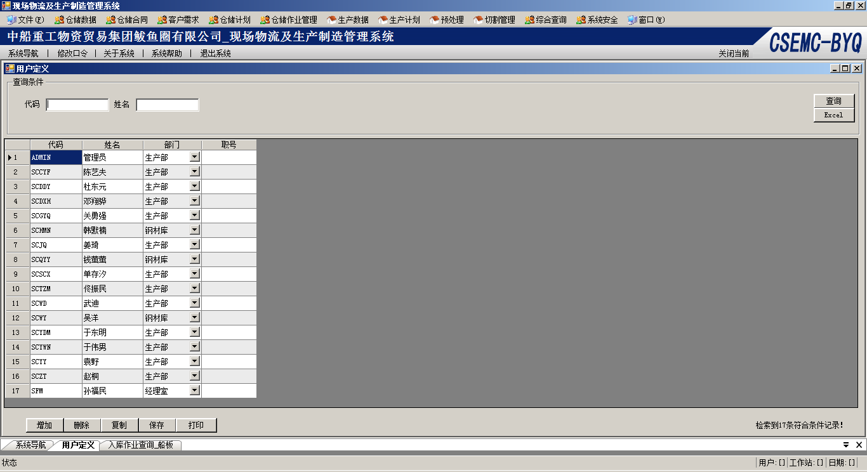

查询语句
Select *
FROM SYUSERP

判断登陆用户和权限
( 暂用,将来会修改为MD5方式)
select count(yhdm) as yhdm from syuserp where yhdm = 'admin' and pwd = 'byq'

判断菜单权限
SELECT DISTINCT RTRIM(SYIFRP.MS) AS MS
FROM SYUIRP,SYIFRP
WHERE SYUIRP.GWDM = SYIFRP.GWDM
AND SYUIRP.YHDM = 'sccyf'

