Recently I suddenly found that Training with Pytorch on our GPU sever is much faster than that with Keras,

so I tried to install Torch on my own win10 desktop for code debugging.

For my win10 desktop, I have installed: python3.5, keras+tensorflow+cuda v9.0 . I use pycharm for python coding.

My objective is to install another python3.7 with Torch on it, such that I would have two deep learning package environment.

My successful steps are:

(1) follow the steps shown in https://www.cnblogs.com/thunderLL/p/6643022.html to make sure two pythons working compatible in win10

------the key 1) add python installing path to system environmental variables, see the following picture

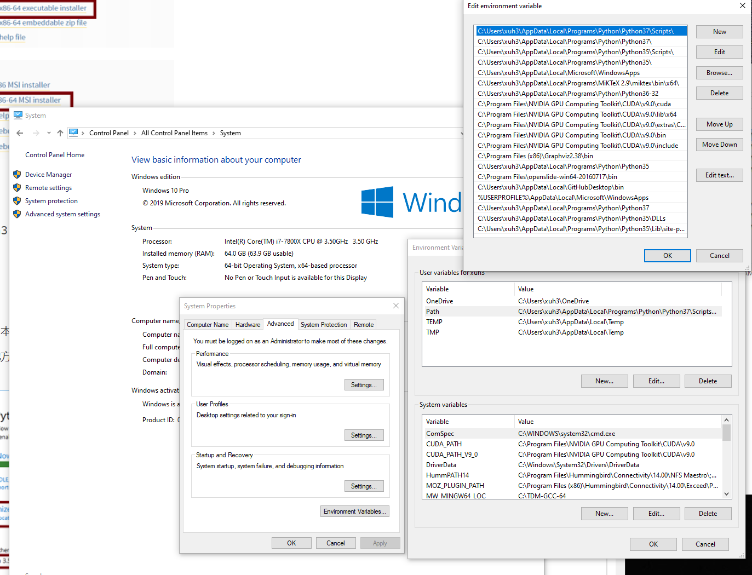

The key 2) is: find the python install folder: C:\Users\xuh3\AppData\Local\Programs\Python\Python35,

Change python and pythonw to python3.5 and pythonw3.5

Similarly, also change python37 as: python->python3.7, python->pythonw3.7

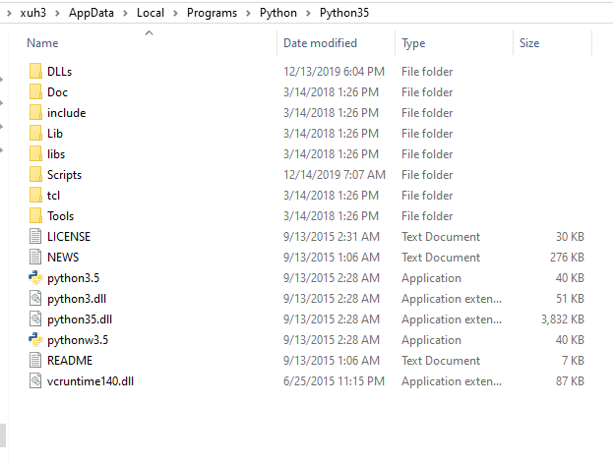

The key 3) is: go to win10 command prompt, setting pip for two different pythons.

e.g., python3.5 -m pip install --upgrade pip --force-reinstall

python3.7 -m pip install --upgrade pip --force-reinstall

Once success, you can use: pip3.5, or pip3.7 to install packages for corresponding pythons.

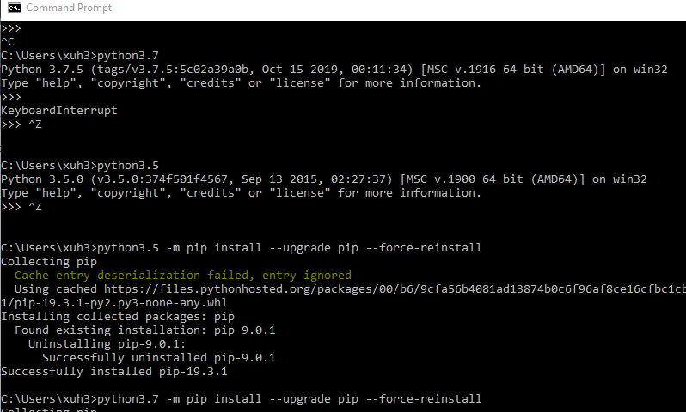

(2) Torch Installation with pip:

Step 1) select suitable torch for your system

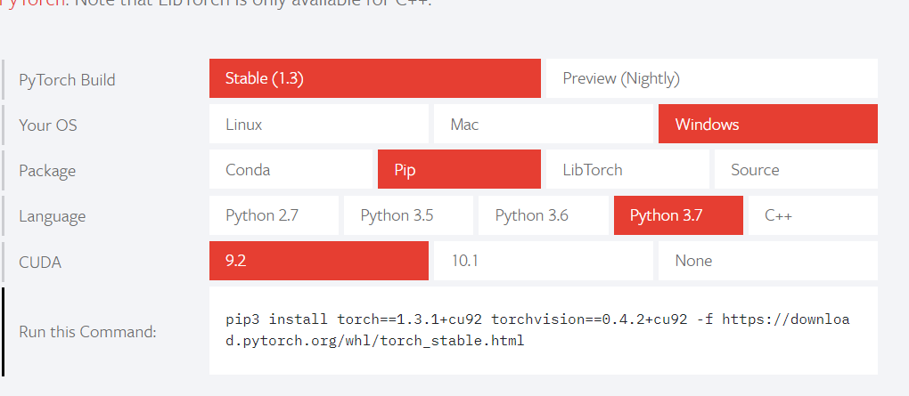

Step 2) install it now: 

(3) after installation, you can test ‘import torch’ in your python program, you may encounter the issue: 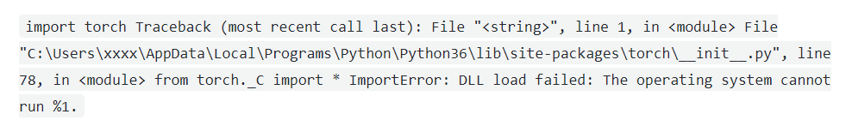

In my case, I replace the existing numpy with: numpy-1.17.4+mkl-cp37-cp37m-win_amd64.whl

1. Go to download suitable version from: <https://www.lfd.uci.edu/~gohlke/pythonlibs/#numpy>
2. Then install it from your local machine as: 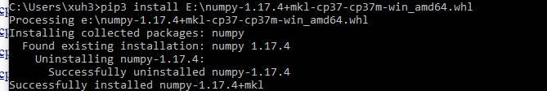

The last error I encounter is multi-processing on win10 with torch. It should be noted that:

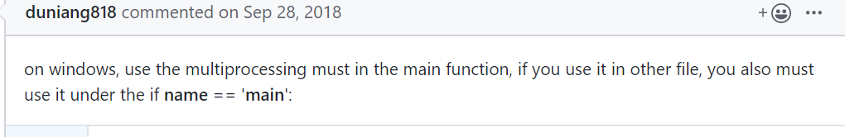

See here: <https://github.com/pytorch/pytorch/issues/5858>