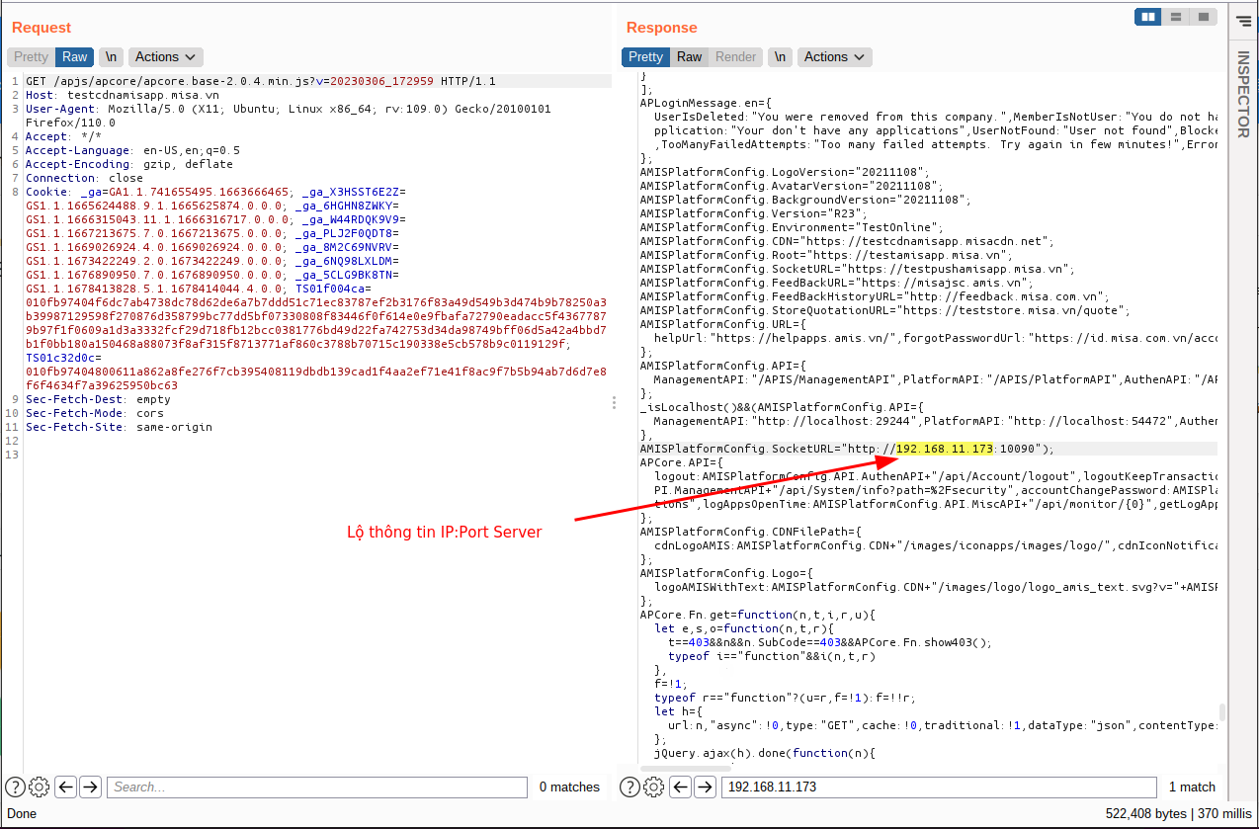
S

https://testesignadminv1.misa.vn/500
https://testesignadminv1.misa.vn/Certificate/detail
https://testesignadminv1.misa.vn/ConnectESign
https://testesignadminv1.misa.vn/Home/Dashboard
https://testesignadminv1.misa.vn/Home/Error
https://testesignadminv1.misa.vn/Request/ConfirmReceivedHardProfile
https://testesignadminv1.misa.vn/Role/Roles
https://testesignadminv1.misa.vn/Setting/ProfileCode
https://testesignadminv1.misa.vn/account/login
https://testesignadminv1.misa.vn/api/dashboard/caOverView
https://testesignadminv1.misa.vn/api/dashboard/caProfiles
https://testesignadminv1.misa.vn/api/dashboard/customerHopper
https://testesignadminv1.misa.vn/api/dashboard/document
https://testesignadminv1.misa.vn/api/dashboard/numberOfFileConfirm
https://testesignadminv1.misa.vn/api/dashboard/numsOfCaGranted
https://testesignadminv1.misa.vn/api/dashboard/numsOfCert
https://testesignadminv1.misa.vn/api/esign-auth-url
https://testesignadminv1.misa.vn/api/role/update
https://testesignadminv1.misa.vn/backcheck
https://testesignadminv1.misa.vn/report-detail-quarterty
https://testesignadminv1.misa.vn/report/category
https://testesignadminv1.misa.vn/report/exportNeacFile
https://testesignadminv1.misa.vn/request/check-registration-form
https://testesignadminv1.misa.vn/request/contact
https://testesignadminv1.misa.vn/request/dashboard
https://testesignadminv1.misa.vn/request/detail
https://testesignadminv1.misa.vn/request/quickfilter
https://testesignadminv1.misa.vn/requests
https://testesignadminv1.misa.vn/api/staff/clearSession
https://testesignadminv1.misa.vn/requests/employees
https://testesignadminv1.misa.vn/
https://testesignadminv1.misa.vn/Account/Login
https://testesignadminv1.misa.vn/Request/BusinessConfirm
https://testesignadminv1.misa.vn/User/Users
https://testesignadminv1.misa.vn/api/connect-esign
https://testesignadminv1.misa.vn/report/exportCertProfileFile
https://testesignadminv1.misa.vn/report/exportCertProfileFileByListNumberAndSerial
https://testesignadminv1.misa.vn/report
https://testesignadminv1.misa.vn/Account/Logout
https://testesignadminv1.misa.vn/AddNoteForAdminHistory
https://testesignadminv1.misa.vn/Certificate
https://testesignadminv1.misa.vn/ConfirmSentUsb
https://testesignadminv1.misa.vn/GetAllRequest
https://testesignadminv1.misa.vn/Report/ReportCertActivation
https://testesignadminv1.misa.vn/Report/ReportReviewerEfficency
https://testesignadminv1.misa.vn/Report/ReportSituationHandleRequest
https://testesignadminv1.misa.vn/Report/ReportSupportCorrection
https://testesignadminv1.misa.vn/Report/ReportSupportGuestHadPayment
https://testesignadminv1.misa.vn/Request/AddReplicaProfile
https://testesignadminv1.misa.vn/Request/ChangeStateUsb
https://testesignadminv1.misa.vn/Request/DeleteRequestHasNotBeenApprove
https://testesignadminv1.misa.vn/Request/DownloadFileAttachment
https://testesignadminv1.misa.vn/Request/RemindUserByNotifycation
https://testesignadminv1.misa.vn/Request/RequestUpdateProfile
https://testesignadminv1.misa.vn/Request/UpdateProfileUser
https://testesignadminv1.misa.vn/RequestListUSBToken
https://testesignadminv1.misa.vn/inspection
https://testesignadminv1.misa.vn/report/exportCertProfileFileByListSerial
https://testesignadminv1.misa.vn/report/exportReportDetailInfo
https://testesignadminv1.misa.vn/request/AddRequestChangeStateUsb
https://testesignadminv1.misa.vn/request/ChangeStatus
https://testesignadminv1.misa.vn/request/DeclineRequest
https://testesignadminv1.misa.vn/request/RequestEditProfile
https://testesignadminv1.misa.vn/request/StorageProfile
https://testesignadminv1.misa.vn/request/TimeAdjournSubmitHardProfile
https://testesignadminv1.misa.vn/request/dashboard/listRequest
https://testesignadminv1.misa.vn/webdev/api/admin-file/api/v2/files/GetStreamObject
https://testesignappv1.misa.vn/webdev/api/file/api/v1/certificates/by-userid
https://testesignappv1.misa.vn/webdev/api/file/api/v1/clients/basic
https://testesignappv1.misa.vn/webdev/api/file/api/v1/signing-history
https://testesignappv1.misa.vn/webdev/api/file/api/v1/signing-history/count
https://testesignappv1.misa.vn/webdev/api/file/api/v1/signing-history/dashboard
https://testesignappv1.misa.vn/webdev/api/file/api/v1/survey
https://testesignappv1.misa.vn/webdev/api/file/api/v1/users/devices/all-state
https://testesignappv1.misa.vn/webdev/api/management/api/v1/requests/agreement
https://testesignappv1.misa.vn/webdev/api/auth/api/v1/auth/callback
https://testesignappv1.misa.vn/webdev/api/auth/api/v1/auth/login
https://testesignappv1.misa.vn/webdev/api/auth/api/v1/auth/logout
https://testesignappv1.misa.vn/webdev/api/auth/api/v1/auth/loginpopup
https://testesignappv1.misa.vn/403
https://testesignappv1.misa.vn/webdev/api/file/api/v1/certificates/certs/by-userid
https://testesignappv1.misa.vn/webdev/api/file/api/v1/certificates/certs/get-list-cert-by-userid

