Project Proposal On

Suicide Prevention

Suman Khadka

00162827

Computing Project

Level 5 Diploma in Computing

Softwarica College of IT and E-Commerce

Kathmandu, Nepal

April 9, 2017

Contents

Chapter 1 3

Introduction 3

List of main features 3

Aims 3

Objectives 4

Development methods 4

Chapter 2 5

Project Plan 5

Work Breakdown Structure (WBS) and Time Estimate 5

Milestones 6

Schedule 6

Chapter 3 7

Risk Management 7

Chapter 4 8

Configuration Management 8

Chapter 5 8

Conclusion 8

Bibliography 9

# Chapter 1

## Introduction

Suicide is the act of taking own life knowingly. It is the common cause of death. In fact, it is the 10th leading cause of death over the world. Many organizations are working together to stop people from committing suicides. Organizations have started awareness programs and helpline centers. Recent surveys have shown that talking with someone may suppress suicidal thoughts of a person. So, there needs to be some means so that people can talk to each other. The aim of this project is to be able to help suicidal people seek emergency help immediately via chat or voice call. People are adopting the world of technology by leaving behind traditional methods. Some people might feel ease while sharing their problems online rather than having actual conversation. So, the application will be created on the basis of this belief.

According to WHO, Nepal is ranked 7th by suicide rate globally. In my opinion, there needs to be platform for those who seek help and who wants to help to these people. The main goal of the project is to minimize the rate of suicide as much as possible by providing every kind of help possible. The project aims to aid the victims by allowing them to communicate with people who can help their condition. They can also read and study helpful posts posted by others who have experienced such situations. The project helps to make them believe that they are not alone in this horrendous journey. Every individual may experience such feelings at any age. Most of the suicides occur due to misbeliefs about suicide. Public think people with suicidal thoughts are mentally disabled which is completely inaccurate. This project aims to aware these people and make them responsible citizen by providing platform to help someone in need.

The application will be created in an android platform. As android is the most popular mobile platform around the globe, the application has greater scope to reach wider audience. The android API will help to create User Interface and functionality. Android API is written in Java programming language. Android Studio will be used as IDE for development. The database for the application will be firebase. Firebase provides real-time database along with authentication features and many more features. Firebase database stores data as JSON object. In this way, the application will be ready for release.

## List of main features

The main features of application are:

1. People with suicidal thoughts can chat to get help from willing person.
2. People with suicidal thoughts can call the person to get help.
3. Willing person can create account and help the users.
4. Users can post awareness messages and news to aware other users
5. Users can report who use disturbing languages or go against the policy of application.
6. Users can give reviews to post of other users in the form of stars (1 being not-helpful and 5 being helpful).

## Aims

To build android application that aims to build a platform for users who wishes to help people or get help from others in context to suicidal thoughts.

## Objectives

The main objectives of the application are:

1. To perform analysis on people with suicidal thoughts.
2. To perform research on development of social media application.
3. To perform research on preventing people from committing suicide.
4. Gather user requirements.
5. Generate big data from user issues to minimize the suicide incidents.
6. Test the working system.
7. Releasing the application on market.
8. Documenting project for further changes and updates.

## Development methods

Object Oriented Analysis and Design(OOAD) is used as a development methodology in the project. Object Oriented Analysis helps to create objects by analyzing real world problems. This approach helps in communication between stakeholders and obtain a quality product. As our system is based on real-time communication, object oriented technology is suitable for development process. The object-oriented analysis and design involves following steps:

1. Requirements Acquisition
2. Initiation
3. Analysis
4. Design
5. Implementation
6. Verification
7. Maintenance

The above method follows traditional Waterfall approach in which all the requirements are captured once and proceeded to other illustrated steps.

# Chapter 2

## Project Plan

### Work Breakdown Structure (WBS) and Time Estimate

A Work Breakdown Structure helps to illustrate the tasks that must be performed to complete the project completely. It is also merged with time estimate in the form of table. Each task take certain amount of time. So, the time taken by each of them is estimated and kept in a tabular form below.

|  |  |  |
| --- | --- | --- |
| **WBS** | **Task Name** | **Days** |
| **0.** | **Suicide Prevention** | **92** |
| **1** | **Project Management** | **92** |
| 1.1 | Scoping | 5 |
| 1.2 | Planning | 5 |
| 1.3 | Monitoring & Controlling | 82 |
| **2** | **Analysis** | **14** |
| 2.1 | Gathering Requirements | 7 |
| 2.2 | Use cases | 4 |
| 2.3 | Architecture | 3 |
| **3** | **Design** | **32** |
| 3.1 | Structural model | 7 |
| 3.2 | Behavior model | 7 |
| 3.2.1 | Activity Diagram | 3 |
| 3.2.2 | Sequential Diagram | 4 |
| 3.3 | User Interface design | 18 |
| 4. | **Implementation** | **30** |
| 4.1 | Coding | 30 |
| **5** | **Testing** | **12** |
| 5.1 | Unit Testing | 6 |
| 5.2 | Integration Testing | 6 |
| **6** | **Documentation** | **5** |
| 6.1 | User Help Manual | 2 |
| 6.2 | Final Documentation | 2 |
| 6.3 | Presentation | 1 |

Fig. Work Breakdown Structure with time estimation

### Milestones

Milestones determine the key dates of project development. It helps to determine how well the project is ongoing. The expected milestones are as follow:

|  |  |
| --- | --- |
| **Milestones** | **Date** |
| Project Proposal | April 9, 2017 |
| Analysis specification | April 23, 2017 |
| Design specification | May 24, 2017 |
| Implementation | June 14, 2017 |
| Final Report | July 11, 2017 |

Fig. Milestones

### Schedule

Scheduling is important in project development. Working hours have to be estimated. Following screenshots are obtained.

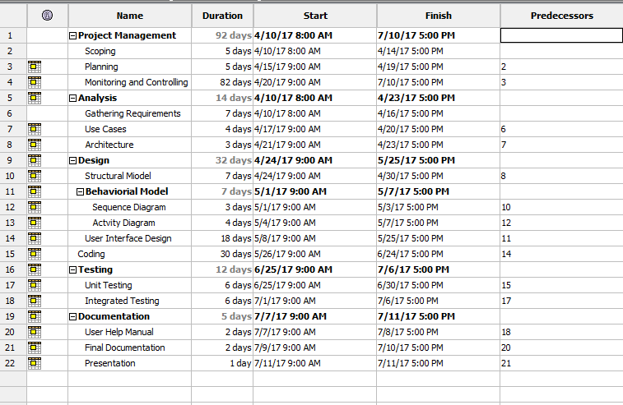

Fig. Gantt Chart Schedule

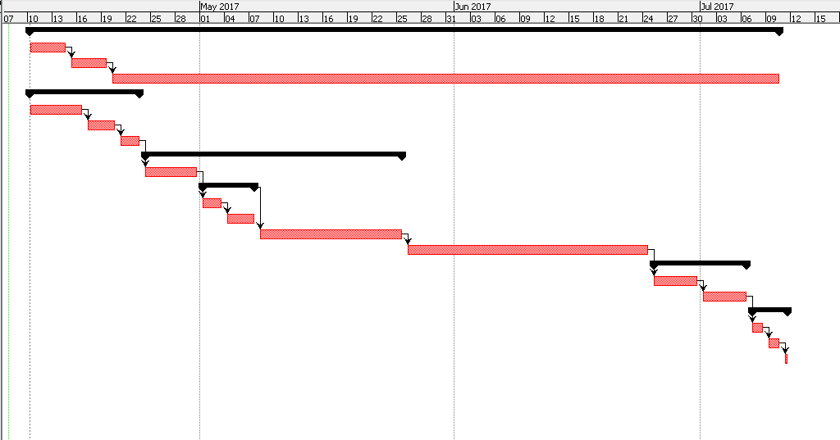

Fig. Gantt Chart

# Chapter 3

## Risk Management

Risk tend to disturb the flow of project development. They cause several problems in the project. They disturb the estimated time and result in project failures. So, they have to be evaluated early and precautions should be applied. Risk Assessment is performed by evaluating likelihood, consequences of the risk. The following table help to analyze the risk management.

|  |  |
| --- | --- |
| **Likelihood** | **Value** |
| Low | 1 |
| Medium | 2 |
| High | 3 |

The five choices of risk consequence are given bellow:

|  |  |
| --- | --- |
| **Consequences** | **Value** |
| Very low | 1 |
| Low | 2 |
| Medium | 3 |
| High | 4 |
| Very high | 5 |

Impact is the product of Likelihood and Consequences.

Mathematically,

Impact = Likelihood * Consequences.

Impact determines how it is going to affect the overall project.

The risks are determined below along with their management.

|  |  |  |  |  |
| --- | --- | --- | --- | --- |
| **Risk** | **Likelihood** | **Consequence** | **Impact** | **Action** |
| Hardware Failure | 1 | 4 | 4 | Prepare backup hardware |
| Data Loss | 1 | 4 | 4 | Backup data |
| Memory Consumption | 2 | 2 | 4 | Code should be re-evaluated. |
| Natural Disaster | 1 | 5 | 5 | Regional Backups should be performed. Cloud backups should be done. |
| Bug in SDK | 2 | 2 | 4 | Help should be pleaded for developers of SDK. |

# Chapter 4

## Configuration Management

The project has to be coordinated and controlled with project artifacts. Configuration management helps to manage and store the artefacts efficiently. It helps to analyze what changes are made to previous version of the application. The bug fixes and improvements can be analyzed carefully. It helps to display simple directory structure of the project. Git is used as configuration management to maintain versions and code structure.

# Chapter 5

## Conclusion

The project will help people who have suicidal thoughts. It aims to minimize the rate of suicide throughout the world. The project will be completed with the help of Firebase SDK, Android API and Sinch API. The project will be prepared by taking care of risk assessment. The project will take approximately the time illustrated in WBS and Gantt chart.

## Bibliography

C.W. Dawson. Projects in Computing and Information Systems: A Student’s Guide. Addison-Wesley, 2005. ISBN 9780321263551. URL http://books.google.com.np/books?id=EAfUdoRsjQ0C.

P.L. Weaver. Success in your project: a guide to student system development projects. Prentice Hall, 2004. ISBN 9780273678090. URL http://books.google.com.np/books?id=LKZQAAAAMAAJ.