Medians and Order Statistics & Elementary Data Structures

Xhon Pelushi
University of the Cumberlands
MSCS-532-M20: Algorithms and Data Structures
Assignment 6
Dr. Michael Solomon
June 19, 2026

Abstract
Selecting the k-th smallest element of an array looks at first like it should cost exactly as much as sorting the whole array, yet both algorithms built for this assignment finish in linear time by recursing into only one side of a partition instead of two. The deterministic version chooses its pivot by recursively finding the median of the medians of consecutive groups of five elements, a procedure that guarantees the pivot falls within the middle 30 percent of the current range no matter how the input is arranged, which is what lets it claim a worst-case Theta(n) bound rather than merely an expected one. The randomized version instead draws its pivot uniformly at random and reaches the same asymptotic class in expectation, with a substantially smaller constant factor in practice because it skips the recursive pivot-finding step entirely. The same comparison-based code that finds a median underlies the second half of this paper, which turns to four elementary data structures built from scratch: a dynamic array, an array-backed stack and queue, a singly linked list, and an optional rooted tree using the left-child/right-sibling linked representation. Benchmarks measuring indexed access, front-of-structure insertion, and queue draining confirm that the array and the linked list are near-exact mirror images of each other's strengths, and that a circular-buffer queue recovers the O(1) dequeue a naive array-shift queue gives up.

Medians and Order Statistics & Elementary Data Structures
Finding the median of an unsorted array is, on its face, a smaller problem than sorting it — a median is one number, not an ordering of every number — yet a naive approach (sort, then index into the middle) still pays the full Theta(n log n) cost of a general-purpose sort to answer a question that asks for far less. Both algorithms in Part 1 below answer it in Theta(n) instead, by reusing the same partition step Quicksort relies on but discarding, at every level, whichever side of the partition does not contain the rank being searched for. That one change — recursing into one side instead of two — is the entire reason selection can be asymptotically faster than sorting.
Part 1 covers both selection algorithms: a deterministic version whose pivot comes from recursively computing a median of medians, guaranteeing Theta(n) even in the worst case, and a randomized version whose pivot is drawn uniformly at random, reaching the same bound in expectation with a smaller constant. Part 2 turns to elementary data structures — arrays, matrices, array-backed stacks and queues, singly linked lists, and an optional rooted tree — implemented from scratch and benchmarked against each other to make their complementary trade-offs concrete rather than purely theoretical.
Part 1: Implementation and Analysis of Selection Algorithms
Implementation
Shared Partition Routine
Both selection algorithms route through the same _partition_around_front function used for the Quicksort implementations in Assignment 5: it treats values[lo] as the pivot, scans once from lo + 1 to hi, and swaps every element smaller than the pivot into a growing block immediately after lo, finishing with one swap that drops the pivot into the boundary between that block and everything else. The function returns the pivot's final index, which is exactly the information a selection algorithm needs next: comparing that index against the target rank tells it which side, if either, still needs to be searched.
Deterministic Selection: Median of Medians
deterministic_select narrows a working copy of the array toward the target rank with a while loop, not two-sided recursion: at each iteration it calls _median_of_medians_index to choose a pivot, partitions around it, and then either returns the pivot's index (if it matches the target rank exactly), narrows hi to search only the left side, or narrows lo and adjusts the rank to search only the right side. No call ever recurses into the side that cannot contain the answer.
def _select_mom(values, lo, hi, rank, counters):
while True:
if lo == hi:
return lo
pivot_index = _median_of_medians_index(values, lo, hi, counters)
values[lo], values[pivot_index] = values[pivot_index], values[lo]
split = _partition_around_front(values, lo, hi, counters)
local_rank = split - lo
if rank == local_rank:
return split
elif rank < local_rank:
hi = split - 1
else:
rank -= local_rank + 1
lo = split + 1
Choosing that pivot is the one piece of real work this algorithm adds beyond Quicksort's partition: _median_of_medians_index splits the current range into consecutive groups of five elements, insertion-sorts each group (a fixed-size operation, O(1) regardless of n), and swaps each group's median into a contiguous prefix starting at lo. Once every group's median occupies that prefix, the function calls _select_mom again — recursively, on this much smaller medians-only range — to find the median of those medians, and that index is what gets returned as the pivot.
def _median_of_medians_index(values, lo, hi, counters):
n = hi - lo + 1
if n <= 5:
_insertion_sort(values, lo, hi, counters)
return lo + (n - 1) // 2
num_groups = 0
group_start = lo
while group_start <= hi:
group_end = min(group_start + 4, hi)
_insertion_sort(values, group_start, group_end, counters)
median_index = group_start + (group_end - group_start) // 2
slot = lo + num_groups
values[slot], values[median_index] = values[median_index], values[slot]
num_groups += 1
group_start += 5
mid_rank = (num_groups - 1) // 2
return _select_mom(values, lo, lo + num_groups - 1, mid_rank, counters)
Working with indices rather than values throughout — swapping the chosen group-median into place rather than searching for a matching value afterward — keeps the implementation correct even when the array contains many duplicate elements: there is never a need to ask which copy of a repeated value is the median, because every operation tracks a specific array position instead.
Randomized Selection: Randomized Quickselect
randomized_select follows the identical shrink-toward-the-rank loop, with pivot selection replaced by a single uniform random draw, exactly as Assignment 5's Randomized Quicksort replaced its deterministic counterpart's fixed-pivot rule.
def _rselect(values, lo, hi, rank, counters):
while True:
if lo == hi:
return lo
choice = random.randint(lo, hi)
values[lo], values[choice] = values[choice], values[lo]
split = _partition_around_front(values, lo, hi, counters)
local_rank = split - lo
if rank == local_rank:
return split
elif rank < local_rank:
hi = split - 1
else:
rank -= local_rank + 1
lo = split + 1
No grouping, no insertion sort, and no recursive sub-selection are needed to pick this pivot — the entire cost of choosing it is one call to random.randint. Both public functions (deterministic_select and randomized_select) validate k against the array's length first, raising ValueError on an empty sequence and IndexError on an out-of-range rank, then operate on a private copy of the input so neither one mutates the caller's array — the only conceptual difference between the two from the caller's point of view is which one finishes faster, addressed in the next two sections.

Performance Analysis
Time Complexity
Selection's recurrence differs from sorting's in exactly one place: after a partition step of size n produces two sides of size k and n - k - 1, a selection algorithm recurses into at most one of them rather than both, because the target rank can only live on one side (or, if it equals the pivot's rank, nowhere further). Written generally, T(n) = T(side containing the rank) + O(n), and which side that is — and how large it is — depends entirely on how the pivot was chosen.
Deterministic worst case — Theta(n). Within any group of five sorted elements, the group's median is, by definition, larger than two of its four group-mates and smaller than the other two. Once half of all the groups (rounding down) have a median at least as large as the overall median of medians, each of those groups contributes at least three elements (its median and the two above it) that are provably greater than or equal to the pivot — and the symmetric argument holds for elements below it. That guarantees at least roughly 3n/10 elements fall on each side of the pivot regardless of how the input is arranged, which caps the larger side at roughly 7n/10. Selecting the pivot itself costs T(n/5) (finding the median of roughly n/5 group medians) plus O(n) for the grouping and insertion sorts, and the partition plus single-sided recursion costs T(7n/10) plus O(n). The full recurrence is therefore T(n) <= T(n/5) + T(7n/10) + O(n); because 1/5 + 7/10 = 9/10 is strictly less than 1, the work shrinks by a fixed fraction at every level no matter which elements landed where, and the recurrence resolves to Theta(n) — a genuine worst-case guarantee, not an average.
Randomized expected case — Theta(n). A randomly drawn pivot lands, with probability 1/2, somewhere in the middle half of the current range by rank — strictly between the 25th and 75th percentile — which is enough to guarantee the remaining side has at most 3n/4 elements. Call a partition step that achieves this a success; because each independent draw succeeds with probability at least 1/2, the expected number of draws needed for a success is at most 2, so the expected work across draws at a given size n is O(n) (covering both the wasted partition work from failed draws and the one that succeeds). Summing that O(n) expected cost across levels that shrink by a factor of at most 3/4 each time produces a geometric series, O(n) + O(3n/4) + O(9n/16) + ..., which totals O(n) just as it does for Randomized Quicksort's single-sided cost — the only difference from Quicksort's own Theta(n log n) average case is that selection never pays for the side it discards, so the series collapses to a constant multiple of n rather than to n log n.
The qualitative difference between the two bounds is what each one is actually guaranteeing. The deterministic version's Theta(n) bound holds for every possible input, with no exceptions and no probability attached — an adversary with full knowledge of the algorithm cannot construct an input that defeats it, because the median-of-medians argument above depends only on the structure of groups of five elements, never on their order. The randomized version's O(n) bound is an expectation taken over its own internal random choices; a run that draws an extreme value as its pivot at every single level remains technically possible and would produce Theta(n^2) behavior, but — exactly as in Assignment 5's randomization argument — that probability collapses exponentially as n grows, so in practice it is never observed.
Space Complexity and Overhead
Both functions copy the input array once, an O(n) allocation that exists purely so neither algorithm mutates the caller's data; everything after that copy operates in place. The narrowing-toward-the-rank loop in both _select_mom and _rselect is written as a while loop rather than as tail recursion, so it consumes no call-stack space at all regardless of how many shrink steps it takes — a deliberate implementation choice, since the textbook presentation of SELECT is usually written recursively.
The one place real recursion remains is _median_of_medians_index's call back into _select_mom to find the median of the current group-medians, which operates on a range of only about n/5 elements. Because that sub-call's own group-medians range is again roughly n/25, and so on, the recursion depth for the deterministic version is bounded by O(log5 n) — a small constant number of frames even at the largest sizes tested here. The randomized version makes no recursive sub-call of any kind, so its auxiliary space beyond the initial O(n) copy is O(1).
That recursive median-finding step is also where the deterministic version's extra overhead comes from. The instrumentation built for this assignment counts every partition round performed, including each nested call _median_of_medians_index makes back into _select_mom — at n = 16,000 on random input, the deterministic version needed 565.0 total rounds against the randomized version's 20.6, roughly 27 times as many. None of that shows up in the asymptotic class — both are still Theta(n) — but it is exactly the kind of constant-factor cost an asymptotic bound is silent about, and Part 1.3 below measures its effect on actual wall-clock time directly.

Empirical Analysis
Both algorithms were benchmarked finding the median (k = ceil(n / 2)) of arrays ranging from n = 2,000 to n = 16,000, across four input shapes: random (sampled without replacement from a range ten times the size of n), sorted (ascending), reverse-sorted (descending), and repeated (drawn from a narrow range of size n/10, producing many duplicate values). Wall-clock time was averaged over five runs per configuration; comparisons and partition rounds were instrumented and likewise averaged over five runs, since the randomized version's counts vary by which pivots happened to be drawn.
Distribution | Algorithm | n=2,000 | n=4,000 | n=8,000 | n=16,000
Random | Median of Medians | 1.204 ms | 2.653 ms | 5.366 ms | 12.399 ms
Random | Rand. Quickselect | 0.271 ms | 0.777 ms | 1.223 ms | 2.781 ms
Sorted | Median of Medians | 1.257 ms | 2.302 ms | 4.552 ms | 10.228 ms
Sorted | Rand. Quickselect | 0.287 ms | 0.612 ms | 1.021 ms | 2.220 ms
Reverse | Median of Medians | 1.239 ms | 2.601 ms | 5.367 ms | 11.643 ms
Reverse | Rand. Quickselect | 0.330 ms | 0.595 ms | 1.689 ms | 2.553 ms
Repeated | Median of Medians | 1.293 ms | 2.924 ms | 5.759 ms | 11.617 ms
Repeated | Rand. Quickselect | 0.327 ms | 0.743 ms | 1.696 ms | 3.795 ms
Table 1. Mean wall-clock time to find the median, averaged over five runs per configuration.
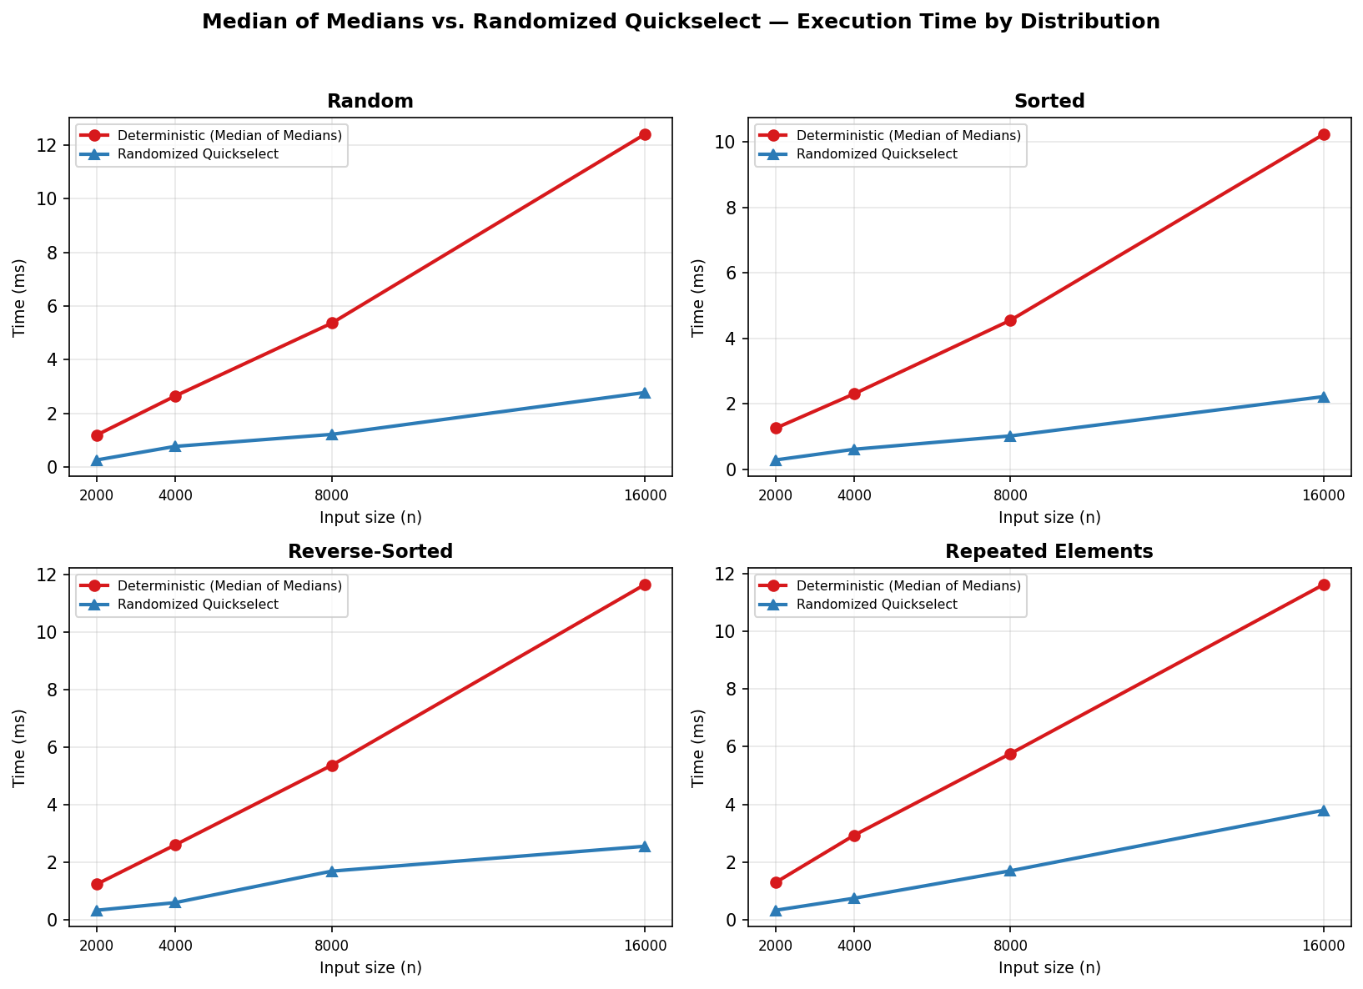
Measured median-selection time, in milliseconds, for both algorithms as n grows from 2,000 to 16,000, broken out by input shape.
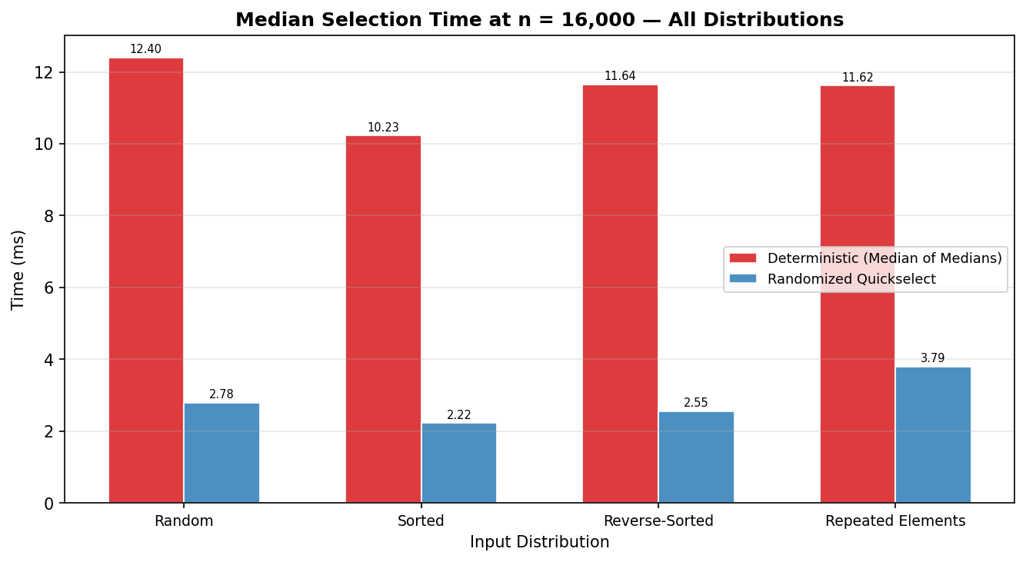
The same n = 16,000 measurements collapsed onto a single chart across all four input shapes.
Discussion of Timing Results
The headline result is what does not happen: unlike Assignment 5's deterministic Quicksort, whose fixed first-element pivot produced a 100- to 200-times slowdown specifically on sorted and reverse-sorted input, neither selection algorithm here shows any comparable distribution-dependent blowup. At n = 16,000 the deterministic version is roughly 4.5x slower than the randomized version on random input, 4.6x on sorted, 4.6x on reverse-sorted, and 3.1x on repeated elements — a consistently sized gap rather than a gap that opens dramatically on certain inputs. That consistency is exactly what the worst-case argument in Part 1.2 predicts: the median-of-medians pivot choice examines the actual values within each group of five, not a fixed position, so no particular input ordering can degrade it the way a fixed-position pivot rule could be degraded.
The gap itself is the constant-factor overhead of the grouping, insertion-sorting, and recursive median-of-medians computation, none of which the randomized version performs. That overhead is the price the deterministic version pays for trading an expected guarantee for an unconditional one — a trade Part 1.2 already characterized as adding work without changing the asymptotic class, and the timing data confirms that the added work is real and measurable, not merely a theoretical footnote.
Comparison Counts and Partition Rounds
Distribution | Algorithm | Comparisons | Partition rounds
Random | Median of Medians | 129,669 | 565.0
Random | Rand. Quickselect | 59,989 | 20.6
Sorted | Median of Medians | 108,254 | 563.0
Sorted | Rand. Quickselect | 58,833 | 17.2
Reverse | Median of Medians | 124,427 | 412.0
Reverse | Rand. Quickselect | 51,888 | 20.4
Repeated | Median of Medians | 65,952 | 205.0
Repeated | Rand. Quickselect | 73,417 | 15.8
Table 2. Comparisons and total partition rounds at n = 16,000, averaged over five runs (partition rounds include every nested median-of-medians sub-selection for the deterministic version).
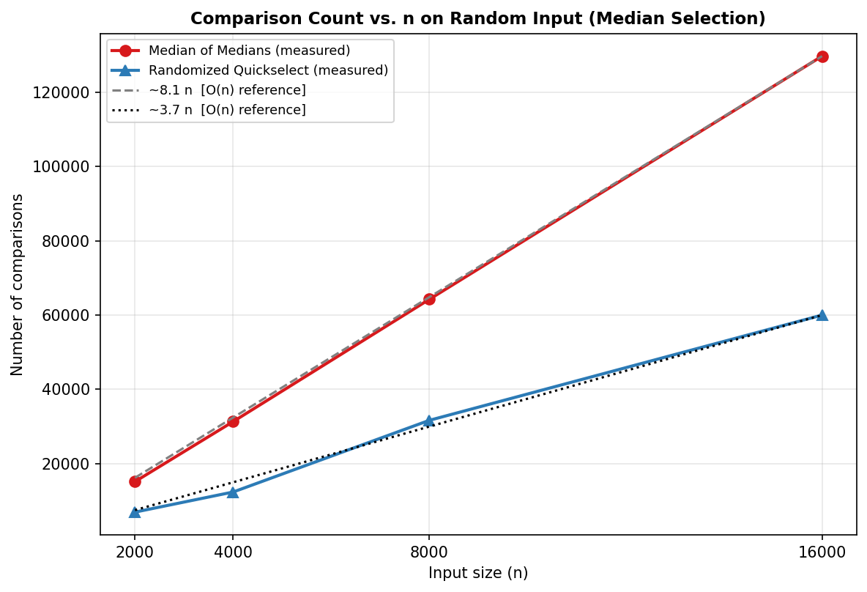
Comparison counts against n on random input, overlaid with a linear reference line fit to each algorithm's own largest-n measurement.
Comparison counts confirm the same story with numbers untouched by machine noise: at n = 16,000 on random input the deterministic version performed 129,669 comparisons against the randomized version's 59,989 — a ratio of 2.2x — while both chart lines remain straight rather than curving upward, the visual signature of Theta(n) rather than anything super-linear. Partition rounds tell the overhead story even more starkly: the deterministic version needed 565.0 rounds to the randomized version's 20.6, almost entirely attributable to the recursive sub-selections required to find each level's median of medians, work the randomized version's single random draw never has to do.
Across all four distributions, neither algorithm's comparison count at n = 16,000 varies by more than a modest margin from its own value on random input — a sharp contrast with Assignment 5's deterministic Quicksort, whose comparison count on sorted input matched the closed-form worst-case formula n(n-1)/2 exactly. No equivalent worst-case formula applies here because no input arrangement can force this pivot rule into its worst case in the first place.

Part 2: Elementary Data Structures Implementation and Discussion
Implementation
Arrays and Matrices
DynamicArray wraps a fixed-capacity Python list used purely as raw storage — no built-in insert, pop, or slicing helpers — so that capacity growth and element shifting are both written out explicitly rather than borrowed from the language. access(index) is a single lookup, O(1). append adds at the next free slot, O(1) amortized, growing the backing store by doubling its capacity whenever it fills, exactly as Python's own list does internally. insert(index, value) and delete(index) both have to shift every element from index onward by one slot to open or close a gap, an O(n) operation in the worst case (inserting or deleting near the front) and O(1) at the very end.
Matrix stores a 2D grid as a list of row lists. get and set index directly into a specific row and column, O(1). insert_row and delete_row shift whole row references rather than individual elements — moving a reference costs O(1) regardless of how many columns that row has — so both operations cost O(rows), with row construction itself adding O(cols) when a new row is supplied.
Stacks and Queues
ArrayStack is backed directly by a Python list and only ever touches the last element: push appends, pop removes from the end, and peek reads the last element without removing it. All three are O(1) (push amortized over the list's own doubling), because a stack's only active end is also an array's cheapest end to modify.
A queue's two active ends — insert at the back, remove from the front — do not share that property with a plain array, so ArrayQueue is implemented as a circular buffer: head and tail are tracked as indices into a fixed-capacity array, advanced with modular arithmetic so they wrap back to 0 after reaching the end, and the capacity doubles (amortized O(1), copying live elements into a fresh, larger buffer starting at index 0) whenever the buffer fills. Because removing the front element only moves the head index forward rather than shifting any other element, both enqueue and dequeue are O(1) amortized.
def dequeue(self):
if self._size == 0:
raise IndexError("dequeue from an empty queue")
value = self._store[self._head]
self._store[self._head] = None
self._head = (self._head + 1) % self._capacity
self._size -= 1
return value
NaiveListQueue exists only as a deliberate point of comparison: it is backed by a plain Python list with enqueue appending to the end (O(1) amortized, identical to the circular buffer) but dequeue implemented as list.pop(0), which removes the front element by shifting every remaining element left by one slot — O(n) per call. Part 2.3 below measures exactly how much that single implementation choice costs.
Singly Linked Lists
SinglyLinkedList maintains both a head and a tail pointer, so insertion at either end — insert_front or insert_back — is O(1): insert_front simply makes the new node the head, and insert_back attaches the new node after the current tail and re-points the tail to it. Without a maintained tail pointer, insert_back would require walking the entire list to find its end, turning an O(1) operation into an O(n) one; keeping the tail pointer is a small, fixed bookkeeping cost that avoids that entirely. access(index), search(value), and delete(value) all have no choice but to walk the pointer chain from the head, since a linked list offers no random access — each is O(n) in the worst case. delete_front, like insert_front, touches only the head pointer and is O(1).
Optional: Rooted Trees
RootedTree represents a general (unbounded branching factor) tree using the left-child, right-sibling scheme: rather than giving each node a list of children, every node stores only two pointers — first_child and next_sibling — so a node's full set of children is reached by walking next_sibling links starting from first_child. This collapses an n-ary tree onto the same two-pointer-per-node shape as a binary tree, at the cost of making add_child O(k) in a node's current number of children (the new child is linked in after walking to the end of the existing sibling chain) rather than O(1), a trade-off a tail pointer per node could remove but was left out here to keep the structure as close as possible to its textbook presentation. preorder traversal exploits the same two-pointer symmetry: visiting a node, then recursing into its first child's subtree, then into its own next sibling, covers the entire tree with one recursive function and no separate iteration over a children list, in O(n) total.

Performance Analysis
Time Complexity of Basic Operations
Structure | Operation | Time Complexity
DynamicArray | access(i) | O(1)
DynamicArray | append | O(1) amortized
DynamicArray | insert(i, v) / delete(i) | O(n)
Matrix | get(r, c) / set(r, c, v) | O(1)
Matrix | insert_row / delete_row | O(rows)
ArrayStack | push / pop / peek | O(1) (push amortized)
ArrayQueue (circular) | enqueue / dequeue | O(1) amortized
NaiveListQueue | enqueue | O(1) amortized
NaiveListQueue | dequeue | O(n)
SinglyLinkedList | insert_front / delete_front | O(1)
SinglyLinkedList | insert_back | O(1) (tail pointer)
SinglyLinkedList | access(i) / search(v) / delete(v) | O(n)
RootedTree | add_child | O(k), k = current child count
RootedTree | preorder | O(n)
Table 3. Time complexity of each implemented operation, n = number of elements (or nodes) already present.
Array vs. Linked List: The Trade-off
DynamicArray and SinglyLinkedList are near-exact mirror images of each other. An array stores elements contiguously, so any index can be converted directly into a memory offset — O(1) access — but inserting in the middle (or at the front) means physically relocating every following element, O(n). A linked list stores elements wherever memory happens to allocate them, connected only by pointers, so there is no arithmetic shortcut from an index to a node — reaching position i costs O(n) — but splicing a new node into a known position (the front, or anywhere a pointer is already held) touches only that node's neighbors, O(1). Neither structure is simply better: which one wins depends entirely on whether the dominant operation in a given workload is indexed access or front/middle insertion, a question Part 2.3 answers with direct measurements rather than just the complexity classes above.
The same trade-off reappears, in a narrower form, for stacks and queues specifically. A stack's single active end matches an array's cheap end, so an array-backed stack loses nothing to a linked-list-backed one — both are O(1). A naive array-backed queue's active ends do not match (the front is expensive to modify in a plain array), which is exactly the gap the circular buffer closes by decoupling logical position from physical storage location through modular arithmetic. A linked-list-backed queue, with a maintained tail pointer, reaches the same O(1) result through a completely different route, without ever needing a capacity or a resize step — at the cost of one extra pointer per element and the weaker cache locality that scattered node allocation brings, against the array's contiguous memory layout.

Empirical Trade-offs
Three trade-offs were measured directly: indexed access (array vs. linked list), front-of-structure insertion (array vs. linked list), and queue draining (naive list-shift queue vs. circular-buffer ArrayQueue). Each was timed across structure sizes from n = 1,000 to n = 16,000, reporting microseconds per operation.
Structure | n=1,000 | n=2,000 | n=4,000 | n=8,000 | n=16,000
Array (access) | 0.053 us | 0.039 us | 0.037 us | 0.038 us | 0.042 us
Linked List (access) | 4.470 us | 9.514 us | 21.230 us | 45.133 us | 84.321 us
Table 4. Mean time per indexed access, array vs. linked list.
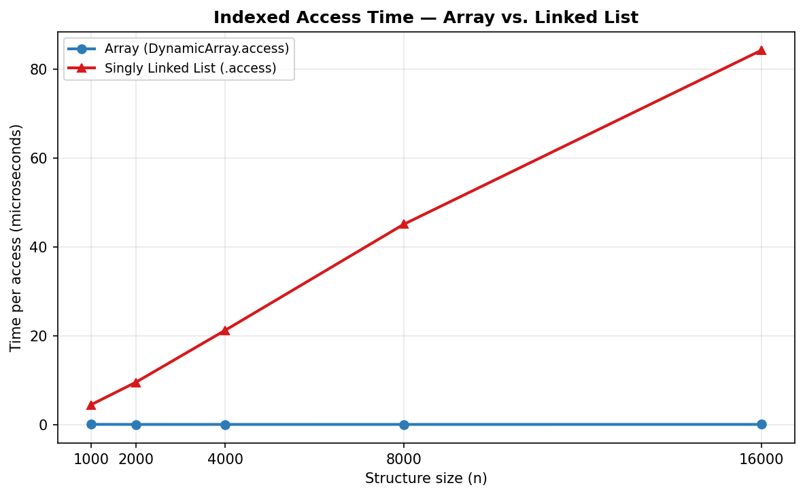
Indexed access time as structure size grows: the array stays flat near zero while the linked list grows linearly with n.
At n = 16,000, an array access took 0.042 microseconds against the linked list's 84.321 — roughly 2,028 times slower — and the linked list's curve grows visibly linearly with n while the array's stays essentially flat, the direct empirical signature of O(n) against O(1).
Structure | n=1,000 | n=2,000 | n=4,000 | n=8,000 | n=16,000
Array (insert at front) | 25.150 us | 52.838 us | 105.041 us | 205.214 us | 412.678 us
Linked List (insert_front) | 0.124 us | 0.192 us | 0.109 us | 0.106 us | 0.258 us
Table 5. Mean time per front insertion, array vs. linked list.
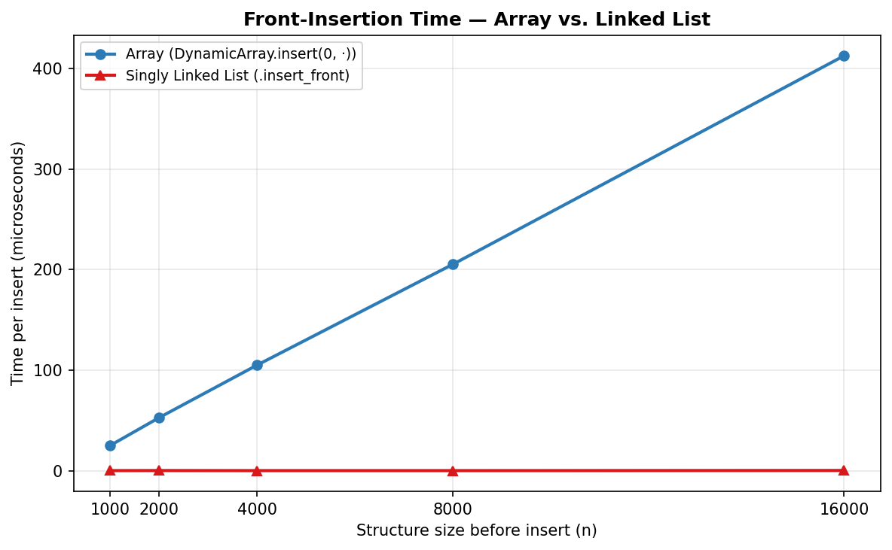
Front-insertion time as structure size grows: the winner flips relative to the access chart above — the linked list now stays flat while the array grows linearly with n.
Front insertion inverts the previous result exactly as the complexity analysis predicts: at n = 16,000 the array needed 412.678 microseconds to shift every existing element over to make room, against the linked list's 0.258 — roughly 1,598 times faster — because attaching one new node to the front never touches any existing node at all. Read together, the two charts show the same pair of structures trading the win back and forth depending on which single operation is being measured, which is the practical content behind calling them asymptotic mirror images of one another.
Queue implementation | n=1,000 | n=2,000 | n=4,000 | n=8,000 | n=16,000
Naive list.pop(0) | 0.102 us | 0.118 us | 0.175 us | 0.413 us | 0.890 us
Circular-buffer ArrayQueue | 0.119 us | 0.105 us | 0.109 us | 0.109 us | 0.098 us
Table 6. Mean time per dequeue while draining a full queue of size n.
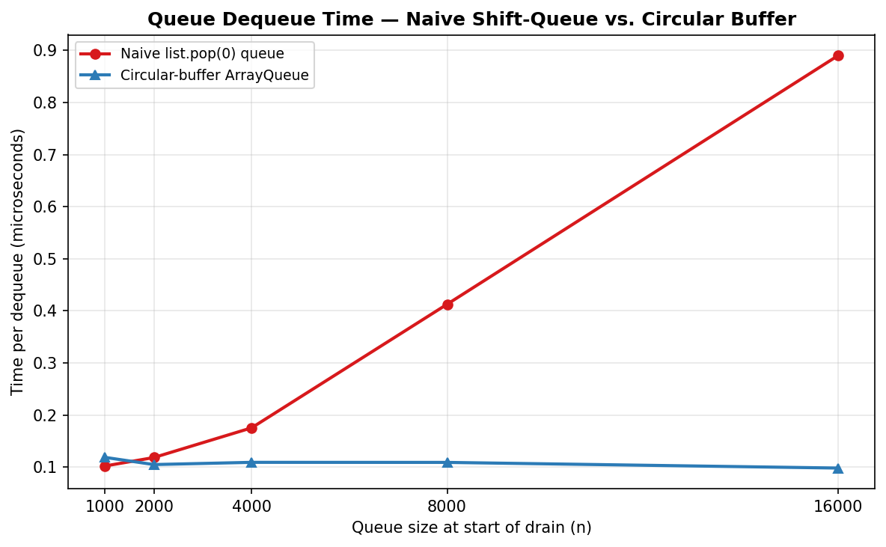
Dequeue time while draining a queue of size n: the naive list-shift queue grows with n while the circular buffer stays flat.
The naive queue's per-dequeue cost grew from 0.102 microseconds at n = 1,000 to 0.890 at n = 16,000, while the circular buffer stayed within a narrow band the entire time (0.119 to 0.098 microseconds) — confirming that the circular buffer's modular-arithmetic trick recovers the O(1) dequeue that a plain array, used naively, gives up the moment removal happens at the front rather than the back.

Discussion of Practical Applications
Arrays and matrices fit any workload dominated by indexed access or numerical computation over a fixed or slowly-changing layout — image and grid data, dense linear algebra, and the binary-heap-backed priority queue built for Assignment 4, which depended on O(1) access to compute a node's parent and children by index arithmetic alone. Their contiguous memory layout is also what makes sequential iteration fast in practice beyond what the complexity class alone implies, since consecutive elements tend to already be loaded into cache together.
Stacks model any process where the most recently added item must be the first one removed: function call frames, undo history, and the recursive descent this very implementation relies on for both _median_of_medians_index's nested calls and RootedTree's preorder traversal, which uses the language's own call stack as an implicit ArrayStack. Queues model the opposite ordering — first added, first removed — and underlie task scheduling, breadth-first graph search, and producer-consumer buffering, any of which would silently degrade from O(1) to O(n) per operation if implemented as a naive array-shift queue instead of a circular buffer or a linked-list-backed one.
Linked lists earn their place wherever the final size is unknown in advance and insertions or deletions happen often at positions other than a known end — adjacency lists for graphs, and the building block for more specialized structures such as an LRU cache's doubly linked eviction order — but should be avoided wherever random access or cache-friendly sequential iteration matters more than insertion flexibility, since the per-node pointer overhead and scattered allocation pattern actively work against both. Rooted trees, finally, are the natural fit whenever branching factor varies from node to node and is not known ahead of time — file system directories, parse trees, and DOM trees are the standard examples — which is precisely the case the left-child/right-sibling representation was designed to handle without requiring a separately sized children array at every single node.
Choosing among these structures in practice comes down to matching the dominant operation in the actual workload against the complexity table in Part 2.2: memory overhead favors arrays (contiguous, no per-element pointer cost) over linked structures; raw speed favors whichever structure's cheap end lines up with the operation being performed most often; and implementation simplicity often favors linked structures specifically because they need no capacity planning or resize logic at all, growing or shrinking one node at a time by construction.

Conclusion
Both halves of this assignment make the same underlying point from different directions: an asymptotic bound describes a class of growth, not a specific running time, and the gap between a guaranteed bound and an expected one — or between two structures that share the same complexity class for a different operation — is exactly where the practical engineering decisions live. The deterministic selection algorithm's Theta(n) worst-case guarantee and the randomized algorithm's O(n) expected bound belong to the identical asymptotic class, yet the benchmarks in Part 1.3 measured a consistent multi-fold gap between them, driven entirely by the recursive median-of-medians computation's constant-factor overhead — the cost of buying a guarantee instead of a probability.
Part 2's array-versus-linked-list comparison made the same kind of point with an even sharper edge: the two structures are not simply better or worse than each other, they are mirror images, each winning the exact operation the other one loses, as the access and front-insertion charts demonstrated by literally swapping which line sits on top. The circular-buffer queue closed a gap of that same shape entirely, recovering through modular arithmetic the O(1) dequeue that a naive array-shift implementation gives away for free. None of these conclusions required abandoning the theoretical bounds derived earlier in either part — every measurement confirmed them — but the specific sizes of the gaps, and which structure or algorithm wins for a given workload, only became visible once the implementations were actually run. The implementation, benchmarks, and this report are available in the repository at: https://github.com/xhon-pelushi/2026-Summer-Algorithms-and-Data-Structures-MSCS-532-M20

References
Blum, M., Floyd, R. W., Pratt, V., Rivest, R. L., & Tarjan, R. E. (1973). Time bounds for selection. Journal of Computer and System Sciences, 7(4), 448–461. https://doi.org/10.1016/S0022-0000(73)80033-9
Cormen, T. H., Leiserson, C. E., Rivest, R. L., & Stein, C. (2022). Introduction to algorithms (4th ed.). MIT Press.
Hoare, C. A. R. (1961). Algorithm 65: Find. Communications of the ACM, 4(7), 321–322. https://doi.org/10.1145/366622.366647
Knuth, D. E. (1998). The art of computer programming: Vol. 3. Sorting and searching (2nd ed.). Addison-Wesley.
Motwani, R., & Raghavan, P. (1995). Randomized algorithms. Cambridge University Press.
Sedgewick, R., & Wayne, K. (2011). Algorithms (4th ed.). Addison-Wesley Professional.

