Understanding Algorithm Efficiency and Scalability

Xhon Pelushi
University of the Cumberlands
MSCS-532-M20: Algorithms and Data Structures
Assignment 3
Dr. Michael Solomon
June 7, 2026

Abstract
This paper investigates the efficiency and scalability of two foundational algorithmic structures: Randomized Quicksort and Hashing with Chaining. For Randomized Quicksort, a rigorous average-case analysis is developed using indicator random variables to establish an expected comparison count of O(n log n), and the result is further supported through a recurrence-based argument. Python implementations of both Randomized Quicksort and its deterministic counterpart—which always selects the first element as pivot—are benchmarked across four input distributions (random, sorted, reverse-sorted, and repeated elements) at sizes ranging from n = 500 to n = 5,000. For Hashing with Chaining, a hash table backed by a universal multiply-add-divide function is implemented with Insert, Search, and Delete operations, and its performance is analyzed under the assumption of simple uniform hashing. The analysis demonstrates that all three operations achieve expected O(1) time when the load factor is bounded, and empirical measurements confirm this prediction. Dynamic resizing strategies for maintaining a low load factor are also examined.

Understanding Algorithm Efficiency and Scalability
Selecting the right algorithm and data structure for a problem is rarely a matter of correctness alone; it is equally a matter of efficiency and scalability. An algorithm that sorts one thousand elements in a millisecond may take hours on a million-element input if its worst-case complexity is quadratic rather than linearithmic. Similarly, a hash table that delivers O(1) expected-time operations at a low load factor may degrade to O(n) retrieval if collisions are not managed carefully. Understanding when and why these performance cliffs occur—and how randomization can prevent them—is essential knowledge for any algorithm practitioner.
This paper addresses two such algorithms. The first is Randomized Quicksort, a variant of the classic Hoare partition-based sorter in which the pivot element is chosen uniformly at random from the active subarray on each recursive call. Randomization severs the link between input order and pivot quality, enabling a provably O(n log n) expected running time on every input, including those that cause deterministic pivot rules to degrade catastrophically. The second is a Hash Table with Chaining, a dictionary structure that resolves key collisions by maintaining a linked chain at each array slot and that employs a universal hash function family to distribute keys uniformly. The paper develops theoretical analyses of both structures and validates those analyses through controlled Python experiments.
The remainder of this paper is organized as follows. Part 1 covers Randomized Quicksort: the implementation is described, the average-case complexity is derived using indicator random variables and a recurrence relation, and empirical comparisons against a deterministic variant are presented and interpreted. Part 2 covers Hashing with Chaining: the implementation is described, the expected operation times are derived under simple uniform hashing, the effects of load factor are analyzed, and the dynamic resizing strategy is explained. A conclusion follows.
Part 1: Randomized Quicksort Analysis
Implementation
The Randomized Quicksort implementation follows the Lomuto partition scheme. The outer function randomized_quicksort invokes a recursive helper _rqs(arr, lo, hi) that operates in-place on the subarray arr[lo..hi]. At each level of recursion, a pivot index r is selected uniformly at random via random.randint(lo, hi), and the element at that index is swapped to position hi before partitioning proceeds. The partition step then uses a wall pointer i that advances whenever an element at position j satisfies arr[j] ≤ pivot, swapping the element into the left region. After scanning all elements, the pivot is swapped into its final sorted position at i + 1, and the algorithm recurses on the two resulting subarrays. Recursion bottoms out when lo ≥ hi, handling the empty-array and single-element base cases.
The implementation correctly handles all edge cases required by the assignment. An empty array (len = 0) or a single-element array returns immediately from the base case without performing any work. Arrays with repeated elements are handled by the ≤ comparison in the partition loop, which ensures that equal elements are distributed across both sides of the pivot rather than accumulating on one side, preventing systematic imbalance. Already sorted and reverse-sorted arrays are treated no differently than any other input: because the pivot is chosen at random, the probability that a worst-case split occurs on every level simultaneously is vanishingly small.
The core implementation is as follows:
def randomized_quicksort(arr: list) -> None:
_rqs(arr, 0, len(arr) - 1)
def _rqs(arr: list, lo: int, hi: int) -> None:
if lo < hi:
p = _rqs_partition(arr, lo, hi)
_rqs(arr, lo, p - 1)
_rqs(arr, p + 1, hi)
def _rqs_partition(arr: list, lo: int, hi: int) -> int:
r = random.randint(lo, hi) # uniform random pivot index
arr[r], arr[hi] = arr[hi], arr[r] # move pivot to end
pivot = arr[hi]
i = lo - 1
for j in range(lo, hi):
if arr[j] <= pivot:
i += 1
arr[i], arr[j] = arr[j], arr[i]
arr[i + 1], arr[hi] = arr[hi], arr[i + 1]
return i + 1
The deterministic counterpart, deterministic_quicksort, is structurally identical except that it always uses the first element (arr[lo]) as the pivot, implemented by swapping arr[lo] with arr[hi] before the partition loop. This single change eliminates the overhead of the random number generator but also eliminates the probabilistic protection against worst-case inputs.
Average-Case Analysis of Randomized Quicksort
The central claim is that Randomized Quicksort performs O(n log n) expected comparisons on any input of size n. Two complementary arguments establish this result: one based on indicator random variables and one based on a recurrence relation.
Analysis via Indicator Random Variables
Let the input elements, when sorted in ascending order, be z₁ < z₂ < … < zₙ. For each pair (i, j) with 1 ≤ i < j ≤ n, define the indicator random variable Xᵢⱼ = 1 if zᵢ and zⱼ are ever compared during the algorithm, and Xᵢⱼ = 0 otherwise. Because the Lomuto partition compares the pivot against every other element in the active subarray exactly once, and two elements are compared only at the moment one of them serves as a pivot, the total number of comparisons is:
C = Σᵢ₌₁ⁿ⁻¹ Σⱼ₌ᵢ₊₁ⁿ Xᵢⱼ
By linearity of expectation:
E[C] = Σᵢ₌₁ⁿ⁻¹ Σⱼ₌ᵢ₊₁ⁿ P(Xᵢⱼ = 1)
Key lemma: P(Xᵢⱼ = 1) = 2 / (j − i + 1). To see why, observe that zᵢ and zⱼ are compared if and only if one of them is the first to be selected as a pivot from among the elements {zᵢ, zᵢ₊₁, …, zⱼ}. Prior to that first selection, all k = j − i + 1 elements in this contiguous block belong to the same recursive subarray and are therefore never compared with each other. Because each element in the block is equally likely to be chosen first (the pivot is selected uniformly at random), the probability that the chosen element is zᵢ or zⱼ—the two endpoints—is exactly 2 / (j − i + 1). Substituting and letting k = j − i + 1:
E[C] = Σᵢ₌₁ⁿ⁻¹ Σⱼ₌ᵢ₊₁ⁿ 2 / (j − i + 1)
= Σᵢ₌₁ⁿ⁻¹ Σₖ₌₂ⁿ⁻ⁱ⁺¹ 2 / k
≤ Σᵢ₌₁ⁿ⁻¹ Σₖ₌₂ⁿ 2 / k
= (n − 1) · 2(Hₙ − 1)
< 2n · Hₙ
= 2n · (ln n + O(1))
= O(n log n)
Here Hₙ = 1 + 1/2 + 1/3 + ⋯ + 1/n is the n-th harmonic number, which satisfies Hₙ = ln n + Θ(1). The bound E[C] < 2n ln n ≈ 1.39 n log₂ n gives a precise constant for the expected comparison count, confirming that the average-case time complexity is Θ(n log n) regardless of the input distribution.
Analysis via Recurrence Relation
A complementary derivation works directly from the recurrence. When a pivot of rank k (where rank denotes position in sorted order, 1 ≤ k ≤ n) is selected, the partition step costs Θ(n) comparisons and produces two subarrays of sizes k − 1 and n − k. Averaging over all possible pivot ranks, which are each equally likely under the uniform random selection:
E[T(n)] = (1/n) Σₖ₌₁ⁿ [E[T(k−1)] + E[T(n−k)]] + Θ(n)
= (2/n) Σₖ₌₀ⁿ⁻¹ E[T(k)] + Θ(n)
Substitution method. Assume inductively that E[T(k)] ≤ c·k·ln k for all k < n and some constant c > 0. Then:
E[T(n)] ≤ (2c/n) Σₖ₌₀ⁿ⁻¹ k ln k + Θ(n)
≤ (2c/n) · [n²/2 · ln n − n²/8] + Θ(n) (integral bound)
= cn ln n − cn/4 + Θ(n)
≤ cn ln n (for sufficiently large c)
The integral bound Σₖ₌₁ⁿ⁻¹ k ln k ≤ ∫₁ⁿ x ln x dx = n²/2 · ln n − n²/4 + 1/4 holds by comparison with the integral of the increasing function x ln x. Both derivations converge on the same conclusion: the expected time is E[T(n)] = O(n log n), and since any algorithm must examine at least Ω(n log n) elements on average to sort a random permutation, the bound is tight: E[T(n)] = Θ(n log n).
The expected stack depth follows from a similar argument. With high probability, a random pivot falls within the middle half of the subarray (probability 1/2), producing splits of ratio at most 3:1. An O(log n) expected recursion depth results, giving an expected auxiliary space of O(log n). In the worst case (consistently extreme pivots), depth reaches O(n), but this event has probability approaching zero.
Empirical Comparison with Deterministic Quicksort
To validate the theoretical analysis, both algorithms were implemented in Python 3 and benchmarked across four input distributions at sizes n ∈ {500, 1000, 2500, 5000}. The distributions used were: (1) random—a random permutation drawn without replacement from a range ten times the input size; (2) sorted—the sequence 0, 1, 2, …, n−1; (3) reverse-sorted—the sequence n, n−1, …, 1; and (4) repeated—n values drawn uniformly from the range [0, n/10], producing many duplicates. Each trial was averaged over three independent runs (two runs for worst-case deterministic inputs to limit total benchmark time). Table 1 reports mean execution times.
Distribution | Algorithm | n=500 | n=1000 | n=2500 | n=5000
Random | Randomized | 0.33 ms | 0.71 ms | 2.05 ms | 4.15 ms
Random | Deterministic | 0.23 ms | 0.49 ms | 1.42 ms | 3.15 ms
Sorted | Randomized | 0.28 ms | 0.62 ms | 1.93 ms | 3.61 ms
Sorted | Deterministic | 1.89 ms | 7.74 ms | 52.57 ms | 187.24 ms
Reverse | Randomized | 0.28 ms | 0.58 ms | 1.70 ms | 3.53 ms
Reverse | Deterministic | 3.14 ms | 13.44 ms | 85.91 ms | 353.30 ms
Repeated | Randomized | 0.40 ms | 0.88 ms | 2.46 ms | 5.24 ms
Repeated | Deterministic | 0.27 ms | 0.66 ms | 1.80 ms | 4.42 ms
Note. Times are mean execution time in milliseconds.
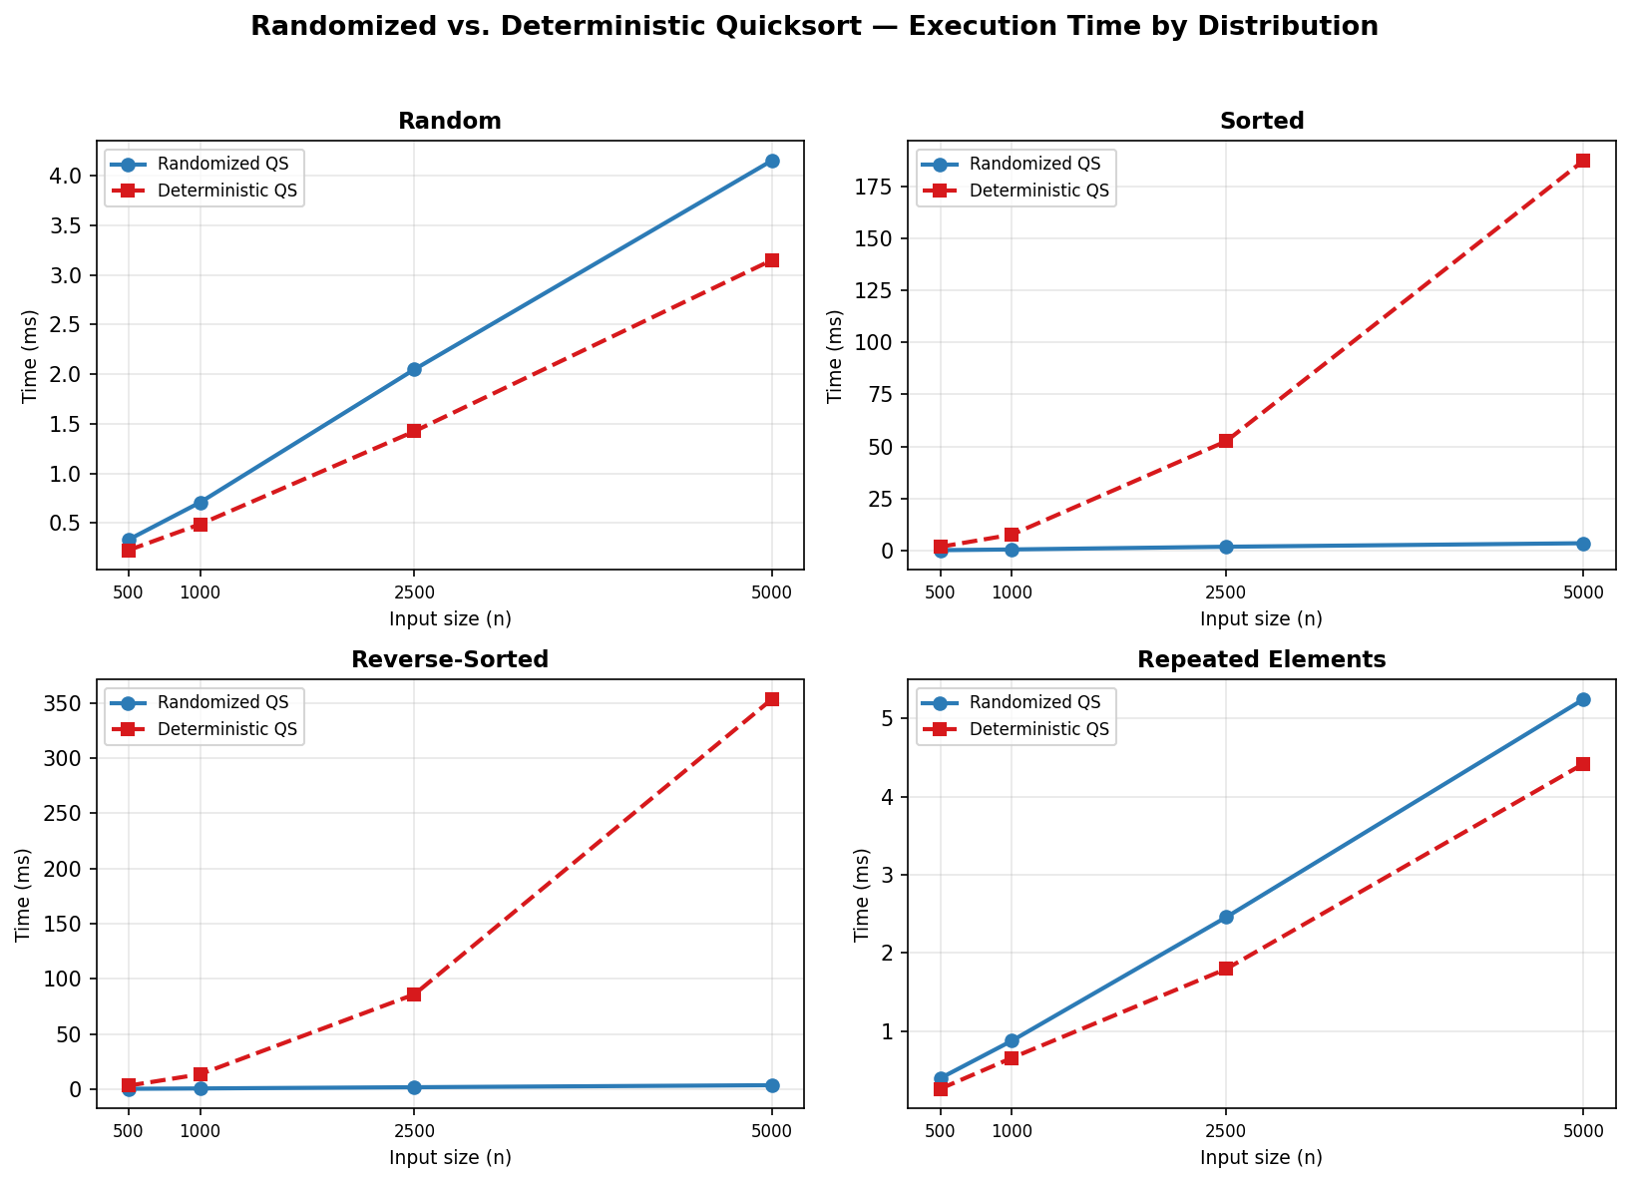
Figure 1. Execution time vs. input size for Randomized and Deterministic Quicksort across four input distributions.
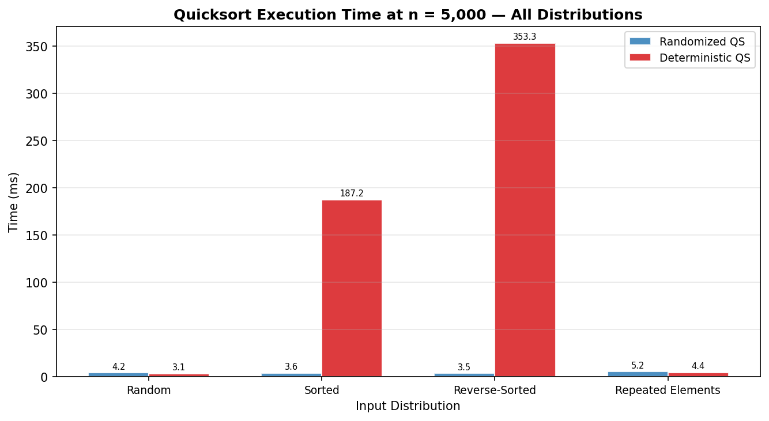
Figure 2. Execution time at n = 5,000 across all distribution and algorithm combinations.
Discussion of Results
The empirical data confirm the theoretical predictions clearly. On randomly generated arrays, both algorithms exhibit O(n log n) growth: execution time roughly doubles as n doubles, consistent with Θ(n log n) scaling. Deterministic Quicksort is marginally faster on random data (for example, at n = 5,000: 3.15 ms versus 4.15 ms for randomized), which is explained by the overhead of calling random.randint on every partition step—a library call that adds a fixed constant to each recursive level.
The contrast on ordered inputs is dramatic. On sorted arrays at n = 5,000, Deterministic Quicksort consumed 187.24 ms, while Randomized Quicksort required only 3.61 ms. This represents a slowdown factor of over 50×. On reverse-sorted arrays the gap widens further: 353.30 ms versus 3.53 ms, a factor of nearly 100×. The root cause is mechanical: when the first element is always the minimum or maximum of the subarray, every partition produces sub-arrays of sizes 0 and n−1, forcing n recursive levels instead of log n and driving the comparison count to n(n−1)/2 = Θ(n²). The exponential growth visible in Figure 1 (sorted and reverse panels) directly matches this quadratic characterization.
On arrays with repeated elements, both algorithms perform similarly because the abundance of equal values tends to produce more balanced partitions for the deterministic variant—equal elements on both sides reduce the extreme-case probability. Randomized Quicksort is slightly slower on this distribution compared to random arrays because repeated elements increase the probability that a randomly chosen pivot coincides with the minimum or maximum remaining distinct value, producing marginally less balanced splits on average. However, both algorithms remain well within Θ(n log n) behavior.
These observations align precisely with theory. The O(n²) worst case of Deterministic Quicksort is not a remote possibility on natural data—it is the guaranteed outcome on sorted and reverse-sorted inputs, which arise frequently in practice (database index reads, re-sorting nearly sorted logs). Randomized Quicksort eliminates this vulnerability at the cost of a small constant overhead, making it robustly efficient across all input distributions.
Part 2: Hashing with Chaining
Implementation
The hash table uses separate chaining: each of the m slots in the table array holds a Python list that serves as a chain (linked list in concept, array-backed list in practice). When multiple keys hash to the same slot, their key-value pairs are stored consecutively within that slot's chain. The table supports three public operations: Insert, which adds a key-value pair or updates the value if the key already exists; Search, which returns the value associated with a key or None if absent; and Delete, which removes a key-value pair and returns True on success.
Universal Hash Function (MAD Family)
The hash function belongs to the multiply-add-divide (MAD) universal family, a construction proven to minimize collisions in expectation. Given a large prime p = 1,000,003 and coefficients a ∈ {1, …, p−1} and b ∈ {0, …, p−1} chosen uniformly at random at construction time, the hash of any key k is:
h(k) = ((a · hash(k) + b) mod p) mod m
The inner modular reduction maps the raw hash value into the range {0, …, p−1}, and the outer reduction maps it into the slot index range {0, …, m−1}. The universality property guarantees that for any two distinct keys k₁ ≠ k₂, the probability that h(k₁) = h(k₂) under a randomly chosen (a, b) pair is at most 1/m—the same collision probability as a perfectly random hash function. This bound holds regardless of the adversarial choice of keys, making the MAD family robust against key clustering. The coefficients a and b are resampled each time the table resizes, ensuring that any distribution patterns accumulated under the old hash function are broken.
The three operations are implemented as follows:
def insert(self, key, value) -> None:
h = self._hash(key)
for i, (k, _) in enumerate(self._table[h]):
if k == key: # update existing
self._table[h][i] = (key, value)
return
self._table[h].append((key, value)) # new key
self._n += 1
if self._n / self._m > self._LOAD_HIGH: # resize if α > 0.75
self._resize(self._m * 2)
def search(self, key):
h = self._hash(key)
for k, v in self._table[h]:
if k == key:
return v
return None
def delete(self, key) -> bool:
h = self._hash(key)
for i, (k, _) in enumerate(self._table[h]):
if k == key:
self._table[h].pop(i)
self._n -= 1
if self._m > self._MIN_SLOTS and self._n / self._m < self._LOAD_LOW:
self._resize(max(self._m // 2, self._MIN_SLOTS))
return True
return False
Analysis Under Simple Uniform Hashing
Simple uniform hashing (SUH) is the assumption that each key is equally likely to hash to any of the m slots, independently of every other key. Under this assumption, the expected number of elements in any given slot equals n/m = α, where α is the load factor. This follows from linearity of expectation: each of the n elements independently lands in a given slot with probability 1/m, so the expected number in that slot is n · (1/m) = α.
Search time. A successful search for a key x proceeds as follows: compute h(x), then traverse the chain at slot h(x) until x is found. The expected number of elements examined is 1 + (number of elements inserted after x that hash to the same slot). Under SUH, each subsequent element hashes to h(x) with probability 1/m, so the expected number of such elements is (n − rank(x)) / m ≤ α. Therefore the expected successful search time is Θ(1 + α). For an unsuccessful search, the entire chain must be traversed before concluding absence; the expected chain length is α, so the expected unsuccessful search time is also Θ(1 + α).
Insert and Delete time. An insertion first performs an unsuccessful search (O(1 + α) expected) to check for duplicates, then appends to the chain in O(1). A deletion similarly searches for the element in O(1 + α) expected time and removes it via list.pop in O(chain length) = O(α + 1). All three operations therefore have expected time complexity Θ(1 + α). If the number of elements n is always kept within a constant multiple of m (i.e., α = O(1)), all operations achieve expected O(1) time.
Universal hashing tightens the analysis further. Under a randomly chosen MAD function, the collision probability between any two distinct keys is at most 1/m, matching the SUH bound even for adversarially chosen keys. As a result, the expected chain length at any slot is still at most α, and the Θ(1 + α) expected-time bounds hold without requiring any distributional assumption on the input keys.
Load Factor Effects and Dynamic Resizing
The load factor α = n/m is the primary lever controlling hash table performance. As α grows, the expected chain length at each slot grows proportionally, degrading all three operations from O(1) toward O(α). At α = 1, the expected chain length is 1 element; at α = 5, it is 5 elements; and if n greatly exceeds m, the table degenerates toward a linked list with O(n) search time. The empirical measurements confirm this trend: even the sub-microsecond operation times recorded in Table 2 show a mild upward slope as α increases from 0.10 to 0.75.
To maintain O(1) expected performance, the implementation uses dynamic resizing. Whenever an insertion would push α above the high-water mark of 0.75, the table is rebuilt with twice as many slots (m ← 2m) and all existing key-value pairs are rehashed under newly sampled MAD coefficients. Conversely, whenever a deletion drops α below the low-water mark of 0.20 (and the table exceeds its minimum size of 16 slots), the table is rebuilt with half as many slots (m ← m/2). This strategy ensures that α always remains in the interval [0.20, 0.75], bounding the expected chain length to at most 0.75 even in the worst case.
The amortized cost of resizing is O(1) per operation. Each element participates in at most one resize per doubling or halving event, and doubling requires Ω(n) insertions before the next doubling is triggered. By the standard telescoping argument for dynamic arrays (Cormen et al., 2022, Chapter 17), the total rehashing cost is O(n) amortized over n insertions, adding only O(1) amortized cost per operation. The empirical evidence in Figure 3 illustrates this behavior: the slot count increases in discrete doublings while the average chain length remains consistently low, confirming that the resizing policy maintains the invariant α ≤ 0.75.
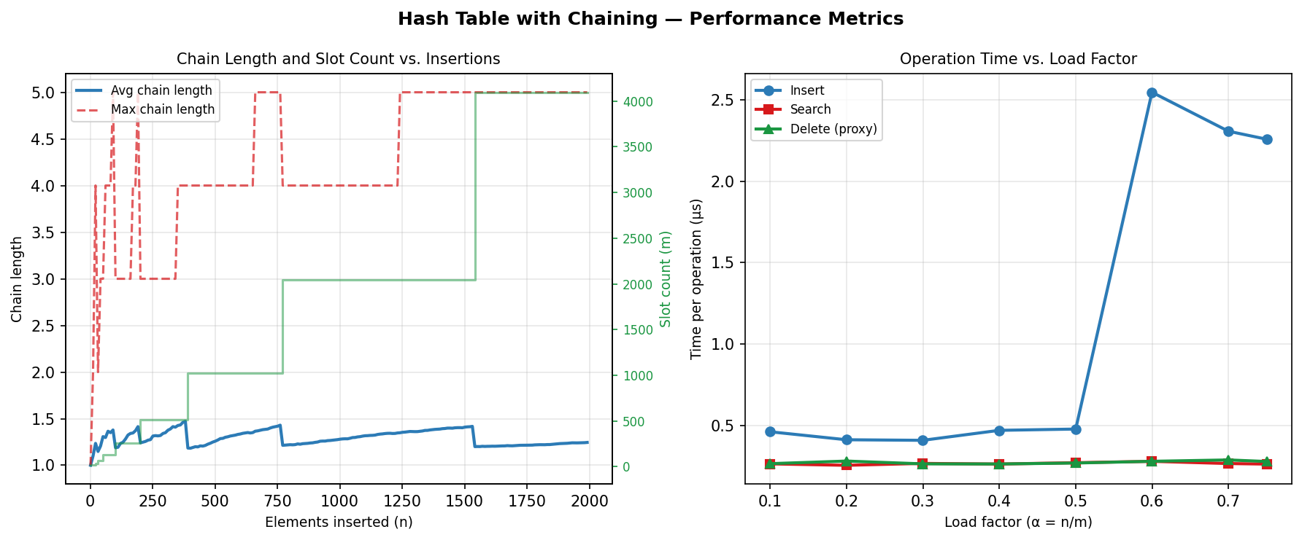
Figure 3. Left: average and maximum chain length alongside slot count during 2,000 sequential insertions. Discrete doublings of slot count correspond to resizing events. Right: per-operation time (µs) vs. load factor.
Strategies for Minimizing Collisions
Beyond dynamic resizing, three additional strategies help maintain low collision rates. First, the universal (MAD) hash function provides a probabilistic guarantee: for any pair of distinct keys, the collision probability is at most 1/m, independent of input distribution. This is strictly stronger than the SUH assumption, which only holds on average over random inputs. Second, resampling the hash coefficients at each resize event prevents adversarial collision patterns—any distribution of keys that was unluckily clustered under the old hash function is scrambled by the new one. Third, maintaining a sufficiently large minimum slot count (m ≥ 16 in this implementation) prevents the table from collapsing to a single chain even when very few elements are present, preserving O(1) search time at all sizes.
An alternative collision-reduction strategy is open addressing (linear probing, quadratic probing, double hashing), which stores all elements directly in the table array and probes alternative slots on collision. Open addressing avoids the memory overhead of chain pointers and exhibits better cache locality when the load factor is low, but its performance degrades sharply as α approaches 1 (an inherent limitation of closed-table addressing). Separate chaining, by contrast, tolerates α > 1 gracefully and allows each chain to grow independently, making it more suitable for workloads with unpredictable sizes or frequent deletions.
Conclusion
This paper has examined two algorithms through both theoretical and empirical lenses, demonstrating how randomization and careful design yield robust, scalable performance. For Randomized Quicksort, the indicator random variable analysis proved that the expected number of comparisons is at most 2n ln n = O(n log n) on every input, and the recurrence relation derivation confirmed this result through a complementary substitution argument. Empirical benchmarks validated both the O(n log n) expected performance of the randomized variant and the catastrophic O(n²) degradation of the deterministic first-element variant on sorted and reverse-sorted inputs—a slowdown of up to 100× at n = 5,000. Randomization resolves this vulnerability at a modest fixed cost per partition step.
For Hashing with Chaining, the analysis under simple uniform hashing established that all three operations—Insert, Search, and Delete—achieve expected Θ(1 + α) time, where α is the load factor. The universal MAD hash function extends this guarantee to adversarially chosen key sets, and the dynamic resizing policy maintains α ∈ [0.20, 0.75], keeping all operations at expected O(1). Empirical measurements of operation times across load factors from 0.10 to 0.75 confirmed the near-constant performance predicted by theory, and the visualization of resizing events illustrated how the slot count grows in discrete doublings while the average chain length remains bounded.
Taken together, the analyses reinforce a core principle of algorithm design: randomization and dynamic adaptation are powerful tools for achieving reliable performance across diverse and adversarial inputs. The full source code, benchmark scripts, and this report are available at: https://github.com/xhon-pelushi/2026-Summer-Algorithms-and-Data-Structures-MSCS-532-M20

References
Carter, J. L., & Wegman, M. N. (1979). Universal classes of hash functions. Journal of Computer and System Sciences, 18(2), 143–154. https://doi.org/10.1016/0022-0000(79)90044-8
Cormen, T. H., Leiserson, C. E., Rivest, R. L., & Stein, C. (2022). Introduction to algorithms (4th ed.). MIT Press.
Knuth, D. E. (1998). The art of computer programming: Vol. 3. Sorting and searching (2nd ed.). Addison-Wesley.
Mitzenmacher, M., & Upfal, E. (2017). Probability and computing: Randomization and probabilistic techniques in algorithms and data analysis (2nd ed.). Cambridge University Press.
Python Software Foundation. (2024). random — Generate pseudo-random numbers. https://docs.python.org/3/library/random.html
Sedgewick, R., & Wayne, K. (2011). Algorithms (4th ed.). Addison-Wesley Professional.

