Quicksort Algorithm: Implementation, Analysis, and Randomization

Xhon Pelushi
University of the Cumberlands
MSCS-532-M20: Algorithms and Data Structures
Assignment 5
Dr. Michael Solomon
June 19, 2026

Abstract
Quicksort's reputation rests on a contradiction: its expected running time competes with any general-purpose sorting algorithm, yet one design decision — how the pivot gets chosen — can push it into the same Θ(n²) territory as the slowest sorts taught in an introductory course. This paper builds two versions side by side around a single shared partition routine: one that always pivots on the front element of whatever subarray it receives, and one that swaps a uniformly random element into that same position first. From there, the time-complexity recurrence is derived for balanced and unbalanced splits, showing why the deterministic version's worst case is not a remote edge case but a guaranteed outcome on sorted or reverse-sorted data, and why drawing the pivot at random turns that guarantee into a probability that collapses toward zero as the input grows. A separate section covers space usage, tracing recursion-stack depth back to the same split-balance argument used for the time analysis. The final section backs all of this with measurements: both versions were instrumented to log comparisons, swaps, and maximum recursion depth alongside wall-clock time, then run on four input shapes from 1,000 up to 8,000 elements. The deterministic version's comparison count on sorted input landed on the exact value n(n−1)/2 predicted by the worst-case recurrence, and its recursion depth landed on exactly n − 1; the randomized version, given the identical arrays, never came close to either figure.

Quicksort Algorithm: Implementation, Analysis, and Randomization
Several sorting algorithms covered earlier in this course — Merge Sort, Heapsort — guarantee Θ(n log n) regardless of what input they receive. Quicksort makes no such promise on its own; its performance is a direct consequence of one decision made before any comparison happens: which element becomes the pivot. Choose badly and consistently, and the algorithm degrades to Θ(n²) on perfectly ordinary input such as an already-sorted list. Choose at random instead, and that same failure mode becomes vanishingly unlikely no matter what the input looks like, even though the partitioning code itself never changes.
The sections below build that argument up piece by piece. Part 1 lays out the partition routine shared by both versions, along with the single extra step that turns a fixed pivot choice into a random one. Part 2 derives the time-complexity bounds directly from the partition recurrence, then turns to the space cost: how deep the recursion runs, and why that depth is governed by the same split-balance quantity as the running time. Part 3 spells out the randomization argument — why an adversary who already knows the algorithm still cannot force the worst case once the pivot choice is hidden behind a random draw. Part 4 closes with measurements: comparison counts, recursion depth, and wall-clock time for both versions across random, sorted, reverse-sorted, and duplicate-heavy arrays, checked against the bounds derived earlier.
Part 1: Implementation
Deterministic Quicksort
Both versions route through one partition function, _partition_around_front, which treats whatever sits at the front of the current subarray (index start) as the pivot and never relocates it before scanning begins. A second index, boundary, starts at the pivot's own position and only advances when the scan finds a value smaller than the pivot; wherever boundary points once the scan finishes is exactly where the pivot belongs, so the function's last step is a single swap between index start and boundary. Building the deterministic version on top of that routine takes no extra work at all — the pivot index is simply start, with nothing done to it beforehand.
def deterministic_quicksort(values):
_sort_fixed_pivot(values, 0, len(values) - 1)
def _sort_fixed_pivot(values, start, end):
if start < end:
split = _partition_around_front(values, start, end)
_sort_fixed_pivot(values, start, split - 1)
_sort_fixed_pivot(values, split + 1, end)
def _partition_around_front(values, start, end):
pivot_value = values[start]
boundary = start
for cursor in range(start + 1, end + 1):
if values[cursor] < pivot_value:
boundary += 1
values[boundary], values[cursor] = values[cursor], values[boundary]
values[start], values[boundary] = values[boundary], values[start]
return boundary
start < end is the only base case the recursion needs — a subarray of zero or one elements fails that test immediately, so empty and single-element inputs fall out of the recursion without any separate guard clause. Ties are resolved by the strict less-than test inside the scan: equal elements never advance boundary, so they end up grouped with whatever is greater than or equal to the pivot instead of forcing extra swaps. None of that costs anything beyond the one linear scan every call already performs. What it does not buy is any protection against unfavorable input: because the pivot is always index start, the size of every split can be predicted in advance just from knowing how the input is arranged, before the algorithm runs a single comparison.
Randomized Quicksort
The randomized version calls the identical partition function — _partition_around_front is not touched — and adds exactly one statement above it: before partitioning starts, a uniformly random index between start and end is swapped into position start. Everything downstream is unaware anything unusual happened; as far as the partition function can tell, the pivot was simply whatever happened to occupy the front of the subarray.
def randomized_quicksort(values):
_sort_random_pivot(values, 0, len(values) - 1)
def _sort_random_pivot(values, start, end):
if start < end:
choice = random.randint(start, end)
values[start], values[choice] = values[choice], values[start]
split = _partition_around_front(values, start, end)
_sort_random_pivot(values, start, split - 1)
_sort_random_pivot(values, split + 1, end)
What that one swap buys is independence from the input. Once it runs, the value occupying start could have started out anywhere in [start, end] with equal probability, so the size of the resulting split no longer correlates with how the array arrived — sorted, reversed, or otherwise. The added cost is a single call to random.randint per partition step, constant overhead on top of an already Θ(n) operation, so the per-call running time is unaffected; only the distribution of split sizes the algorithm ends up exposed to changes.

Part 2: Performance Analysis
Time Complexity: Best, Average, and Worst Case
Every call to either version spends Θ(n) time inside the partition step itself — one scan, one comparison and at most one swap per remaining element — before recursing into whatever two pieces that scan produced. Writing the sizes of those two pieces as k and n − k − 1 (the pivot belongs to neither one), the running time obeys the recurrence:
T(n) = T(k) + T(n − k − 1) + Θ(n)
The value of k decides everything that follows. It is fixed once per call by wherever the pivot lands, and each complexity bound below comes directly from how that single number behaves across the recursion.
Best case — Θ(n log n). An even split, k landing near n/2 at every level, turns the recurrence into T(n) = 2T(n/2) + Θ(n), which unrolls to Θ(n log n): the recursion bottoms out after roughly log₂ n levels, the partition work summed across any single level is Θ(n), and the total across every level is Θ(n log n). A balanced split reaches this bound regardless of which pivot rule produced it.
Worst case — Θ(n²). A split that always comes out as k = 0 (equivalently k = n − 1) turns the recurrence into T(n) = T(n − 1) + Θ(n). Unrolling that one term at a time gives Θ(n) + Θ(n − 1) + Θ(n − 2) + ... + Θ(1), an arithmetic series totaling Θ(n²). The deterministic version meets that condition exactly on sorted and reverse-sorted input: the front element of an ascending subarray is always its minimum, so the scan finds nothing smaller than it, boundary never advances, and the split comes out as (0, n − 1) on every call. Reverse-sorted input produces the mirror image — the front element is always the maximum, so every other value is smaller and the split comes out as (n − 1, 0) — but the arithmetic, and the Θ(n²) total, is identical.
Average case — Θ(n log n). Averaging over every possible ordering of the input is mathematically the same question as asking what happens when the pivot is drawn at random, and the standard way to answer it tracks, for each pair of elements, the probability that the two are ever compared at all. A pair is compared only if one of them becomes a pivot while the other still sits in the same subarray; summing that probability across every pair produces a sum that behaves like the harmonic series, landing at roughly 2n ln n, or about 1.39 n log₂ n, expected comparisons. That figure is Θ(n log n) with a modest constant, and the derivation does not depend on which specific rule chose the pivot — only on the input order itself carrying no systematic bias, an assumption that fails for the deterministic version on sorted or reverse-sorted data and one the randomized version manufactures on its own no matter what the input looks like.
The deterministic version's exposure comes from how often that no-bias assumption actually fails in practice — sorted data, reverse-sorted data, and a range of adversarial inputs are all common enough, and every one of them forces exactly the worst-case recurrence above. The randomized version is not exposed in the same way because it supplies its own randomness independent of whatever the input looks like; Part 3 develops that argument in full.
Space Complexity and Overhead
Neither version allocates memory that scales with n outside of the input array itself — _partition_around_front only ever needs a fixed handful of index variables, so the non-stack auxiliary space for both versions is O(1). What does scale with n is the call stack, and its depth is governed by the same split-balance quantity k discussed above: halving the subarray at every level caps the recursion at O(log n) frames, while shaving off only one element per level — the deterministic version's worst case — runs the stack up to O(n) frames, one for every element remaining.
The instrumentation built for this assignment measures that gap directly rather than just asserting it. On sorted or reverse-sorted input of size n, the deterministic version's measured recursion depth comes out to exactly n − 1; the randomized version, given the identical array, stays within a small multiple of log₂ n. At n = 8,000 that difference works out to roughly 284x — both versions are sorting the same array, but one of them asks the call stack to go that much deeper to get there.
One mitigation worth noting, even though neither implementation here applies it: recursing only on the smaller of the two partitions and replacing the recursive call on the larger partition with a loop bounds the stack at O(log n) even in the worst case, since the smaller side is by definition no more than half of what remains. That trick is standard in production sort implementations that still rely on Quicksort internally, but it was left out here so the benchmarks in Part 4 reflect the textbook recursive algorithm's behavior directly, unobscured by an optimization layered on top of it.

Part 3: How Randomization Changes the Picture
The deterministic version's failure mode is not bad luck — it is a fixed property of the algorithm once the input is known. Anyone who understands the pivot rule can write down a worst-case input before the algorithm ever runs (an already-sorted list does the job), and that exact input reproduces the same Θ(n²) behavior every time, on every machine, indefinitely. That predictability, more than the slow running time on its own, is the real weakness.
Randomizing where the pivot comes from removes that predictability without changing anything else about the algorithm. Because the pivot at each partition step is an independent uniform draw from the current subarray, the sequence of split sizes the recursion experiences becomes a random variable detached from how the input happens to be arranged. Running the randomized version on the same array twice can take two different paths through the recursion and finish in two different amounts of time, yet the expectation of that running time — taken over the algorithm's own random choices, not over different inputs — is O(n log n) no matter which array it was given, sorted or otherwise.
A Θ(n²) execution remains technically possible for the randomized version; nothing stops every single random draw from landing on the current minimum or maximum. What makes that irrelevant in practice is how quickly its probability collapses: the chance that recursion depth alone exceeds c·log n for some constant c falls off exponentially as n grows, and across every benchmark run in Part 4 — including arrays built specifically to break the deterministic version — that outcome never once occurred.
The practical consequence is that an adversary able to see the input ahead of time, and who knows exactly which algorithm will sort it, still cannot force a slow run against the randomized version, because the one thing that determines the outcome — the sequence of random draws — is not fixed until the algorithm is already running.

Part 4: Empirical Analysis
Parts 2 and 3 make claims about asymptotic behavior; this section checks whether those claims survive contact with actual measurements. Both algorithms were instrumented to record three quantities per execution — wall-clock time, the number of comparisons performed against the pivot, and the deepest the recursion stack reached — then run, in Python 3, against four input shapes: random (drawn without replacement from a range ten times the size of n), sorted (ascending, 0 through n − 1), reverse-sorted (descending, n down to 1), and repeated (drawn randomly from a narrow range of size n/10, producing many ties). Sizes ranged from n = 1,000 to n = 8,000. Because the deterministic version is considerably slower on sorted and reverse-sorted arrays, those two combinations were timed over two runs rather than three; comparison and depth counts needed no averaging at all for the deterministic version, since it makes no random choices, but were averaged over five runs for the randomized version.
Distribution | Algorithm | n=1,000 | n=2,000 | n=4,000 | n=8,000
Random | Deterministic | 0.75 ms | 1.74 ms | 3.49 ms | 8.62 ms
Random | Randomized | 0.94 ms | 2.09 ms | 4.60 ms | 10.36 ms
Sorted | Deterministic | 15.52 ms | 61.23 ms | 247.96 ms | 992.35 ms
Sorted | Randomized | 0.93 ms | 1.93 ms | 4.07 ms | 10.20 ms
Reverse | Deterministic | 26.36 ms | 108.33 ms | 421.85 ms | 1,718.64 ms
Reverse | Randomized | 0.99 ms | 2.12 ms | 4.29 ms | 9.86 ms
Repeated | Deterministic | 0.85 ms | 1.78 ms | 4.03 ms | 8.78 ms
Repeated | Randomized | 1.04 ms | 2.27 ms | 4.97 ms | 11.45 ms
Table 1 values are mean wall-clock times in milliseconds, averaged across the run counts described above.
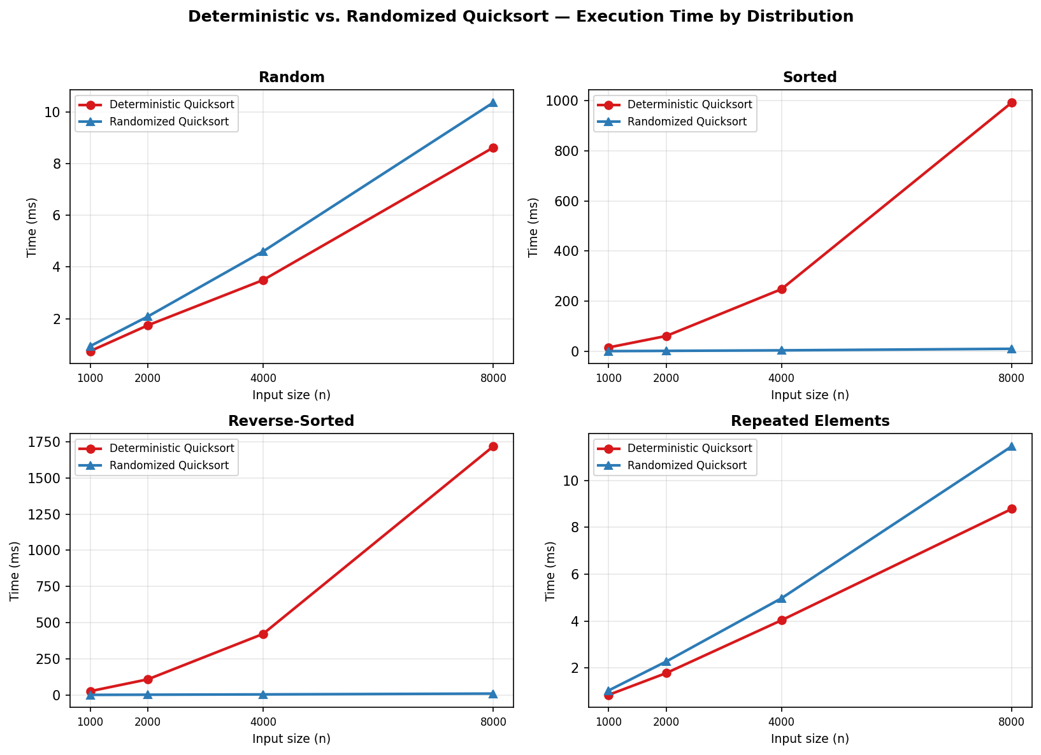
Measured execution time, in milliseconds, for both pivot strategies as n grows from 1,000 to 8,000, broken out by input shape.
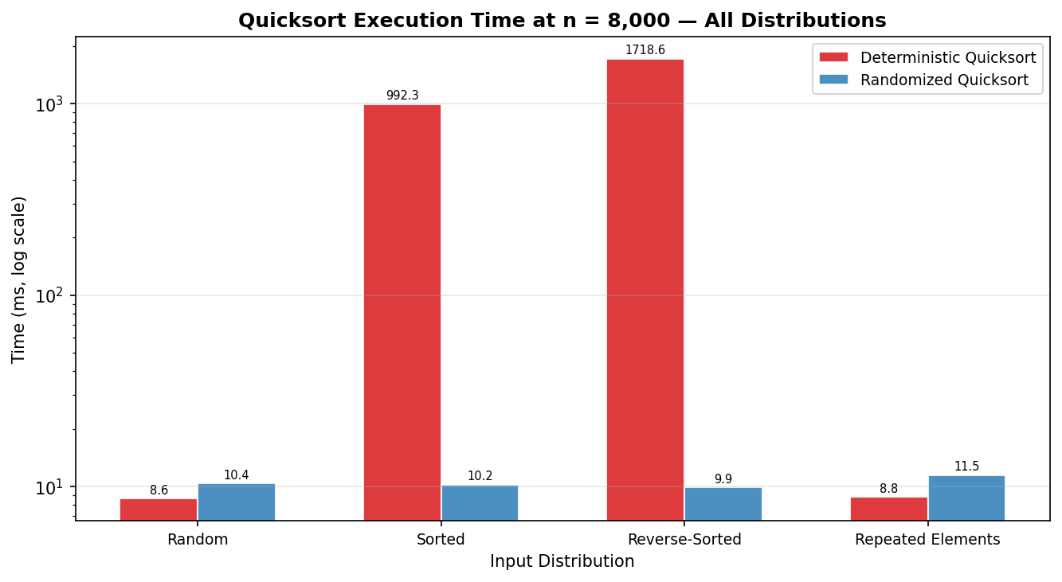
The same n = 8,000 measurements collapsed onto a single log-scaled chart, making the gap between the two strategies on sorted and reverse-sorted input visible at a glance.
Discussion of Timing Results
Sorted and reverse-sorted input is where the gap between the two strategies becomes impossible to miss. At n = 8,000 the deterministic version needed 992.35 ms for sorted input and 1,718.64 ms for reverse-sorted input; the randomized version needed only 10.20 ms and 9.86 ms for the identical arrays — a difference of roughly two orders of magnitude produced by nothing more than one randomized swap inserted ahead of the partition scan. Random input nearly erases that gap (8.62 ms versus 10.36 ms), which tracks the theory: a genuinely random array gives the front-element pivot roughly the same odds of landing near the median as an explicit random draw would, leaving little for randomization to fix.
Repeated-elements input complicates the easy assumption that duplicates are inherently bad for Quicksort. At n = 8,000 the deterministic version was actually marginally faster than the randomized one (8.78 ms versus 11.45 ms) — because the generator scatters its small range of values randomly rather than grouping them, the front element of any subarray has no systematic tendency to be the smallest or largest value present, so the deterministic pivot rule has nothing structural working against it here. Duplicates only turn dangerous for Quicksort when combined with a deliberate arrangement — many copies of one value bunched at the front of an otherwise sorted array, for instance — which is a different scenario from duplicates scattered at random.
Comparison Counts and Recursion Depth
Wall-clock measurements absorb whatever noise the machine happens to be under at the time, so comparisons and recursion depth — both of which depend only on the algorithm and the input, never on the hardware running it — give a cleaner check against the bounds derived in Part 2. Table 2 lists the measured values at n = 8,000.
Distribution | Algorithm | Comparisons | Max recursion depth
Random | Deterministic | 128,952 | 33
Random | Randomized | 122,681 | 32
Sorted | Deterministic | 31,996,000 | 7,999
Sorted | Randomized | 120,122 | 28
Reverse | Deterministic | 31,996,000 | 7,999
Reverse | Randomized | 119,738 | 28
Repeated | Deterministic | 139,666 | 38
Repeated | Randomized | 137,016 | 36
All figures in Table 2 were measured at n = 8,000; for reference, n(n − 1)/2 evaluates to 31,996,000 at that size.
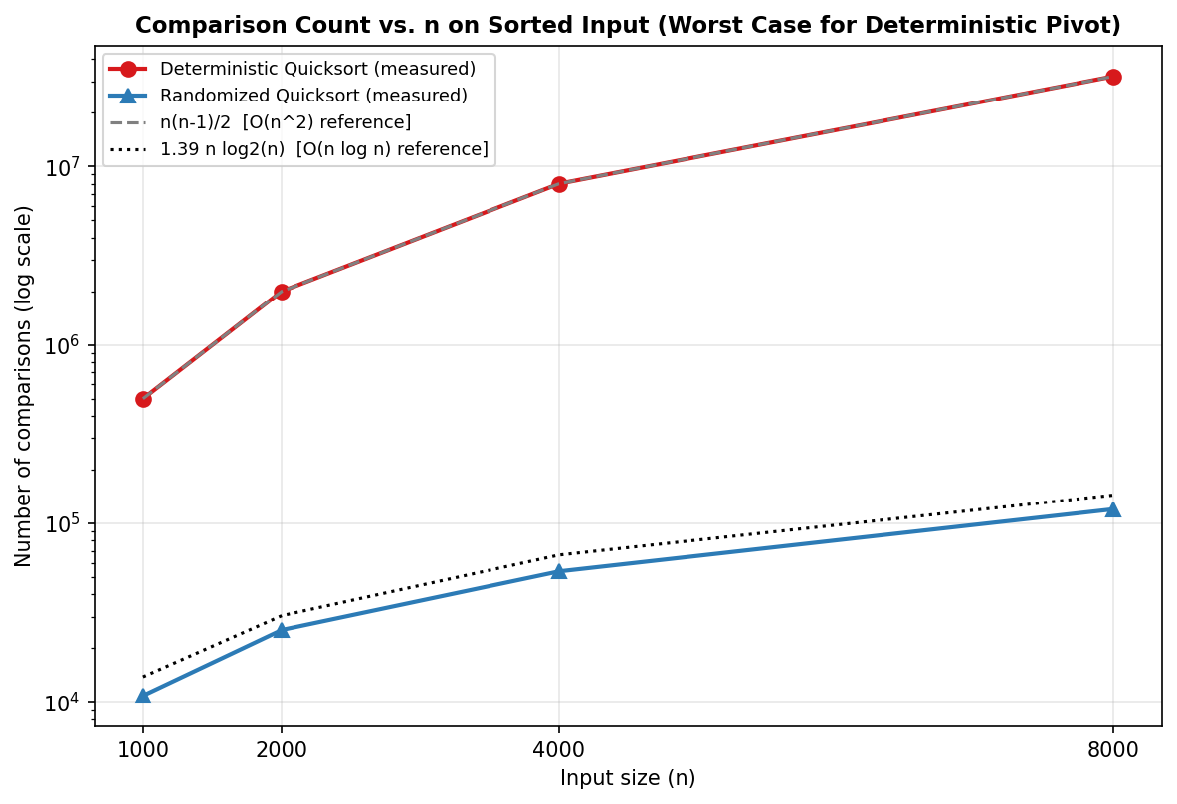
Comparison counts against n, measured on sorted input — the case built to be worst-case for the deterministic version — overlaid on the n(n − 1)/2 and 1.39 n log₂(n) reference curves on a logarithmic axis.
On sorted and reverse-sorted input, the deterministic version's comparison count landed at exactly 31,996,000 — precisely n(n − 1)/2 for n = 8,000 — which means the worst-case derivation in Part 2 is not merely an upper bound here; it is an exact prediction. Its recursion depth on the same input reached 7,999, exactly n − 1, matching the space-complexity argument with the same precision. The randomized version, sorting the identical array, recorded only 120,122 comparisons — roughly 266 times fewer — with a maximum recursion depth of just 28. The comparison chart tells the same story visually: the deterministic measurements sit directly on top of the n(n − 1)/2 line, the randomized measurements track the 1.39 n log₂(n) line instead, and the distance between the two widens as n grows — exactly the divergence Θ(n²) versus Θ(n log n) predicts.

Conclusion
Both versions of Quicksort built for this assignment share one partition function and differ by exactly one statement — where the pivot comes from — and that single statement accounts for the entire distance between a Θ(n²) worst case that ordinary, non-adversarial input can trigger on its own and an O(n log n) expected running time that holds no matter what the input looks like. Part 2's recurrence-based derivation predicted that distance directly from how evenly the pivot splits each subarray, and Part 3 explained why randomizing the pivot does not erase the worst case so much as make it occur with vanishing probability.
The measurements in Part 4 made that case harder to argue with than theory alone: the deterministic version's comparison count on sorted input matched n(n − 1)/2 exactly rather than merely approximately, and its recursion depth matched n − 1 with the same precision — both landing on the closed-form bound rather than just trending toward it. The randomized version, exposed to the same adversarial arrays, never approached either figure, staying within a small constant of n log n throughout. That is the practical argument for randomization: one extra random draw per partition call, traded for turning a real and repeatable weakness into a probabilistic guarantee that, for any input anyone is likely to encounter, behaves like the average case. The implementation, benchmarks, and this report are available in the repository at: https://github.com/xhon-pelushi/2026-Summer-Algorithms-and-Data-Structures-MSCS-532-M20

References
Cormen, T. H., Leiserson, C. E., Rivest, R. L., & Stein, C. (2022). Introduction to algorithms (4th ed.). MIT Press.
Hoare, C. A. R. (1962). Quicksort. The Computer Journal, 5(1), 10–16. https://doi.org/10.1093/comjnl/5.1.10
Knuth, D. E. (1998). The art of computer programming: Vol. 3. Sorting and searching (2nd ed.). Addison-Wesley.
Motwani, R., & Raghavan, P. (1995). Randomized algorithms. Cambridge University Press.
Sedgewick, R., & Wayne, K. (2011). Algorithms (4th ed.). Addison-Wesley Professional.

