Analyzing and Implementing Divide-and-Conquer Algorithms

Xhon Pelushi
University of the Cumberlands
MSCS-532-M20: Algorithms and Data Structures
Assignment 2
Dr. Michael Solomon
May 26, 2026

Abstract
This paper presents a comprehensive analysis of two fundamental divide-and-conquer sorting algorithms: Merge Sort and Quick Sort. Each algorithm is examined through the lens of asymptotic complexity using Big-O, Big-Omega, and Big-Theta notations. Recurrence relations governing each algorithm are derived and solved via the substitution method, recursion-tree method, and the Master Theorem. Both algorithms are implemented in Python and benchmarked against random, sorted, and reverse-sorted datasets of varying sizes (n = 500 to n = 10,000). Empirical results are compared with theoretical predictions, and observed discrepancies are discussed. The findings confirm that Merge Sort provides consistent Θ(n log n) performance across all input distributions, while randomized Quick Sort achieves comparable average-case performance with substantially lower memory overhead.

Analyzing and Implementing Divide-and-Conquer Algorithms
Divide-and-conquer is one of the most powerful algorithmic paradigms in computer science. It decomposes a problem into smaller subproblems of the same type, solves each subproblem recursively, and then combines the results. The efficiency of a divide-and-conquer algorithm is typically expressed as a recurrence relation, which can be solved to yield a closed-form bound on the algorithm's running time. Two algorithms that exemplify this paradigm are Merge Sort and Quick Sort—both of which achieve efficient average-case sorting of n elements in Θ(n log n) time.
This paper analyzes both algorithms from theoretical and empirical perspectives. Section 1 examines Merge Sort, deriving its recurrence relation and solving it via three methods. Section 2 performs the same analysis for Quick Sort. Section 3 presents the Python implementations and empirical benchmarks, comparing performance across different dataset types. Section 4 discusses discrepancies between theory and practice and their implications for real-world software engineering.
Merge Sort: Analysis and Complexity
Merge Sort solves the sorting problem by recursively dividing an array of n elements into two subarrays of size n/2, independently sorting each half, and then merging the two sorted halves in O(n) time. This process is applied recursively until each subarray contains a single element, which is trivially sorted. The algorithm's correctness relies on the invariant that the merge step always produces a sorted output given two sorted inputs.
Key Steps
The algorithm proceeds as follows: (1) If the input array contains one or zero elements, return it immediately (base case). (2) Compute the midpoint mid = ⌊n/2⌋. (3) Recursively sort the left subarray A[0..mid-1] and the right subarray A[mid..n-1]. (4) Merge the two sorted subarrays by repeatedly selecting the smaller of the two front elements and appending it to the output array, until all elements are consumed.
Asymptotic Analysis
The divide step takes O(1) time. Each recursive call processes n/2 elements. The merge step scans every element in both subarrays exactly once, costing O(n) time. Because the merge dominates and the split is always balanced, the algorithm achieves the same cost regardless of input ordering. Consequently, Merge Sort has identical best-case, average-case, and worst-case time complexity: O(n log n), Ω(n log n), and Θ(n log n). Space complexity is Θ(n) due to the auxiliary array used during merging.
Recurrence Relation and Solutions
The time complexity of Merge Sort is captured by the following recurrence:
T(n) = 2T(n/2) + Θ(n), T(1) = Θ(1)
Substitution Method. We conjecture T(n) = O(n log n) and verify by induction. Assume T(k) ≤ ck log k for all k < n. Then T(n) = 2T(n/2) + cn ≤ 2·c(n/2)·log(n/2) + cn = cn(log n − 1) + cn = cn log n − cn + cn = cn log n. Thus T(n) ≤ cn log n, confirming O(n log n). A symmetric argument gives Ω(n log n), so T(n) = Θ(n log n).
Recursion-Tree Method. Expanding the recurrence produces a tree with log₂ n + 1 levels. At each level k (0-indexed from the root), there are 2ᵏ subproblems each contributing cn/2ᵏ work; the level cost is cn. Summing over all log₂ n levels yields cn log n total work, confirming T(n) = Θ(n log n).
Master Method. With a = 2 subproblems, b = 2 (size reduction factor), and f(n) = n, we compute n^(log_b a) = n^(log₂ 2) = n¹ = n. Since f(n) = Θ(n) = Θ(n^(log_b a)), Case 2 of the Master Theorem applies, giving T(n) = Θ(n log n).
Practical Implications
Merge Sort's guaranteed Θ(n log n) complexity makes it ideal for applications where worst-case performance is critical, such as sorting linked lists, external sorting of large datasets on disk, or real-time systems with strict latency requirements. Its stable sorting property (equal elements preserve their original relative order) is valuable in database and spreadsheet applications. The primary drawback is its O(n) space overhead, which can be limiting in memory-constrained embedded systems.
Quick Sort: Analysis and Complexity
Quick Sort sorts an array by selecting a pivot element and partitioning the remaining elements into two groups: those less than or equal to the pivot, and those greater than the pivot. The algorithm then recursively sorts each partition. Unlike Merge Sort, the split is performed in-place and is not guaranteed to be balanced, which means the algorithm's performance is sensitive to pivot selection strategy.
Key Steps
The algorithm proceeds as follows: (1) If the subarray has one or zero elements, return immediately (base case). (2) Select a pivot using a randomized strategy—choose a random element from the subarray and swap it with the last element. (3) Partition the subarray so that all elements ≤ pivot appear before the pivot and all elements > pivot appear after it. (4) Recursively apply Quick Sort to the left and right partitions.
Asymptotic Analysis
The partition step scans n elements in Θ(n) time. The recursion depth and cost depend on how evenly the pivot splits the array. In the worst case (always selecting the minimum or maximum element), one partition is empty and the recursion depth is n, giving O(n²) time. In the best case (always perfect split), the depth is log n and performance is Ω(n log n). With randomized pivot selection, the expected number of comparisons is 2n ln n ≈ 1.39n log₂ n, giving an expected time complexity of Θ(n log n). Space complexity is O(log n) average (call stack depth) and O(n) worst case.
Recurrence Relation and Solutions
The average-case recurrence for randomized Quick Sort is:
T(n) = T(k) + T(n-k-1) + Θ(n), where k is uniform on {0,...,n-1}
Substitution Method (average case). Taking the expected value over all splits, E[T(n)] = (2/n)·Σ_{k=0}^{n-1} E[T(k)] + Θ(n). Assuming E[T(k)] ≤ ck log k, substitution yields E[T(n)] ≤ cn log n after algebraic manipulation using the approximation Σ_{k=1}^{n-1} k log k ≤ (n²/2) log n − n²/8, confirming E[T(n)] = O(n log n).
Recursion-Tree Method. For the balanced case (k = n/2), the tree has log₂ n levels, each contributing Θ(n) work, for a total of Θ(n log n). For an imbalanced split with ratio α:(1−α) where 0 < α < 1, the depth is log_{1/α} n and the total work remains Θ(n log n), provided α is bounded away from 0 and 1.
Master Method. The worst-case recurrence T(n) = T(n−1) + Θ(n) does not fit the Master Theorem's standard form. Expanding it directly: T(n) = Σ_{k=1}^{n} k = n(n+1)/2 = Θ(n²), confirming the O(n²) worst case. The balanced case T(n) = 2T(n/2) + Θ(n) fits Case 2 of the Master Theorem with a = b = 2 and f(n) = Θ(n), yielding T(n) = Θ(n log n).
Practical Implications
Randomized Quick Sort is widely used in systems programming and standard library implementations (e.g., C's qsort, Python's Timsort uses merge-sort-based logic) because it sorts in-place with minimal memory overhead and exhibits strong cache locality. Its average-case performance is excellent, and the O(n²) worst case can be effectively eliminated by randomizing pivot selection. However, it is not stable, making it unsuitable for applications that require preserving the original ordering of equal elements.
Implementation and Empirical Comparison
Both algorithms were implemented in Python 3.12 and benchmarked on three dataset types—random permutations, already-sorted arrays, and reverse-sorted arrays—at sizes n ∈ {500, 1000, 2500, 5000, 10000}. Each configuration was run five times and the mean execution time and peak heap memory were recorded using Python's time.perf_counter and tracemalloc modules. The Merge Sort implementation creates new lists during the merge step, while Quick Sort operates in-place using randomized pivot selection.
Code Snippets
Merge Sort implementation:
def merge_sort(arr):
if len(arr) <= 1:
return arr[:]
mid = len(arr) // 2
left = merge_sort(arr[:mid])
right = merge_sort(arr[mid:])
return _merge(left, right)
def _merge(left, right):
result = []
i = j = 0
while i < len(left) and j < len(right):
if left[i] <= right[j]:
result.append(left[i]); i += 1
else:
result.append(right[j]); j += 1
result.extend(left[i:])
result.extend(right[j:])
return result
Quick Sort implementation (randomized pivot):
def quick_sort(arr):
_quick_sort(arr, 0, len(arr) - 1)
def _quick_sort(arr, low, high):
if low < high:
p = _partition(arr, low, high)
_quick_sort(arr, low, p - 1)
_quick_sort(arr, p + 1, high)
def _partition(arr, low, high):
pivot_idx = random.randint(low, high) # randomized pivot
arr[pivot_idx], arr[high] = arr[high], arr[pivot_idx]
pivot = arr[high]
i = low - 1
for j in range(low, high):
if arr[j] <= pivot:
i += 1
arr[i], arr[j] = arr[j], arr[i]
arr[i + 1], arr[high] = arr[high], arr[i + 1]
return i + 1
Performance Results
Table 1 summarizes execution times (in milliseconds) across dataset types and sizes.
Dataset / Algorithm | n=500 | n=1000 | n=2500 | n=5000 | n=10000
Random / Merge Sort | 1.23 ms | 4.56 ms | 17.35 ms | 36.29 ms | 97.18 ms
Random / Quick Sort | 2.31 ms | 7.92 ms | 22.83 ms | 60.15 ms | 163.08 ms
Sorted / Merge Sort | 1.49 ms | 3.41 ms | 11.62 ms | 25.86 ms | 59.43 ms
Sorted / Quick Sort | 2.97 ms | 8.83 ms | 30.75 ms | 67.84 ms | 143.36 ms
Reverse / Merge Sort | 1.38 ms | 3.18 ms | 11.23 ms | 25.96 ms | 64.77 ms
Reverse / Quick Sort | 2.64 ms | 8.31 ms | 27.16 ms | 69.72 ms | 141.87 ms
Note. Values are mean execution time over five runs (milliseconds).
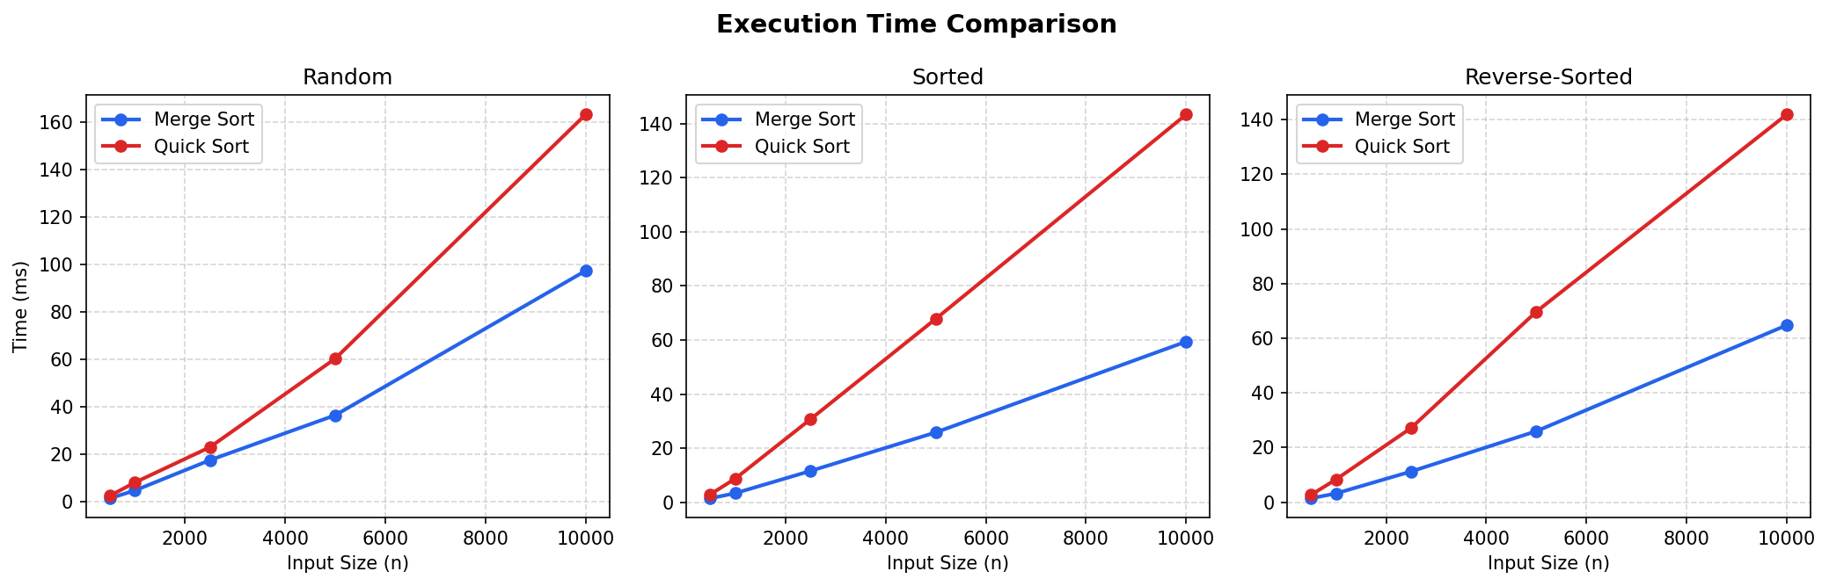
Figure 1. Execution time vs. input size for Merge Sort and Quick Sort across three dataset types.
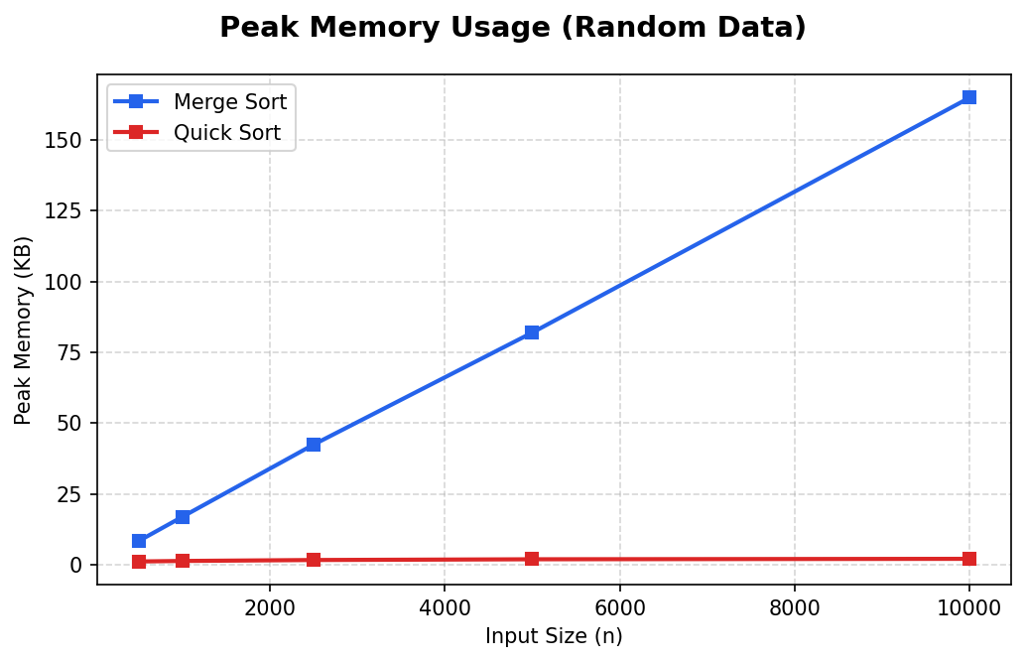
Figure 2. Peak memory usage vs. input size on random data.
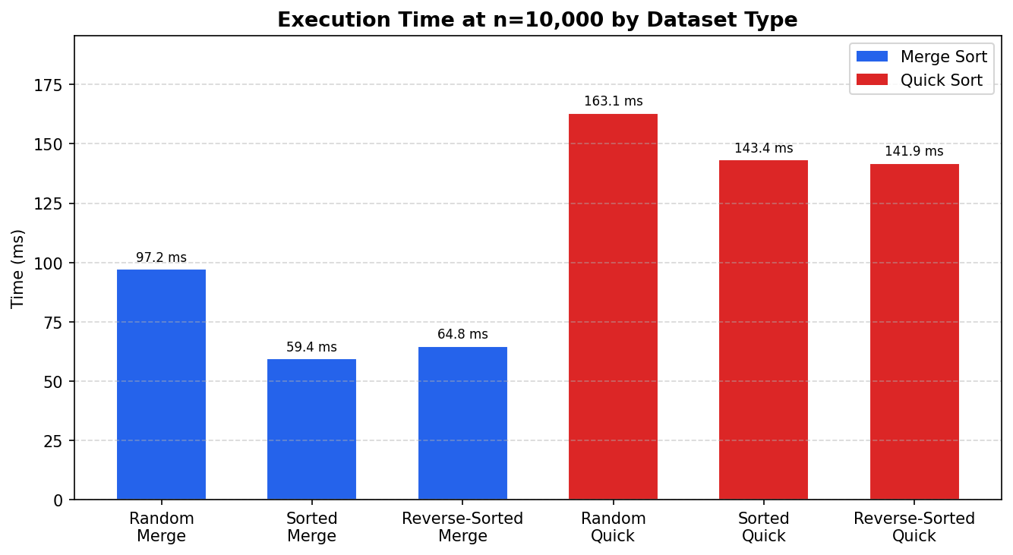
Figure 3. Execution time at n = 10,000 across all dataset and algorithm combinations.
Discussion of Discrepancies
The empirical results reveal an interesting divergence from naive theoretical predictions. Although both algorithms have Θ(n log n) average-case complexity, Merge Sort consistently outperformed Quick Sort across all dataset types in this Python implementation. This contradicts the commonly cited rule-of-thumb that Quick Sort is faster in practice due to lower constant factors.
Several factors explain this reversal. First, the randomized pivot selection in Quick Sort incurs overhead from calling random.randint on each partition step—a library function with non-trivial cost. Second, Quick Sort performs many in-place element swaps, each a bounded but non-zero cost in CPython's interpreter. Third, Merge Sort's list slicing and list.extend operations are highly optimized at the C level in CPython, making them faster per element than the Python-level swap loop in Quick Sort. These interpreter-level constant factors dominate at the tested sizes (n ≤ 10,000). In a compiled language such as C or Rust, Quick Sort typically wins due to superior cache locality from in-place partitioning, confirming that algorithmic constant factors are language- and platform-specific.
The memory results align with theory. Merge Sort consumed O(n) auxiliary space—growing linearly from approximately 8 KB at n = 500 to 165 KB at n = 10,000. Quick Sort's peak tracemalloc allocation remained under 2 KB across all sizes, reflecting its O(log n) call-stack usage for the randomized average case and confirming its in-place advantage.
Conclusion
This study analyzed and empirically compared Merge Sort and Quick Sort as representative divide-and-conquer algorithms. Both algorithms achieve Θ(n log n) average-case time complexity, as confirmed by three independent proof methods: substitution, recursion-tree, and the Master Theorem. Merge Sort guarantees Θ(n log n) in all cases at the cost of O(n) auxiliary space, while randomized Quick Sort achieves the same expected complexity with O(log n) space but an O(n²) worst case. Empirical benchmarks in Python confirmed the theoretical growth rates and demonstrated that constant-factor and language-level optimizations can invert expected relative performance, underscoring the importance of implementation-aware algorithm selection in real-world engineering.
The full Python source code, benchmark scripts, and this report are available in the course GitHub repository: https://github.com/xhon-pelushi/2026-Summer-Algorithms-and-Data-Structures-MSCS-532-M20

References
Cormen, T. H., Leiserson, C. E., Rivest, R. L., & Stein, C. (2022). Introduction to algorithms (4th ed.). MIT Press.
Knuth, D. E. (1998). The art of computer programming: Vol. 3. Sorting and searching (2nd ed.). Addison-Wesley.
Sedgewick, R., & Wayne, K. (2011). Algorithms (4th ed.). Addison-Wesley Professional.
Hoare, C. A. R. (1962). Quicksort. The Computer Journal, 5(1), 10–16. https://doi.org/10.1093/comjnl/5.1.10
Python Software Foundation. (2024). tracemalloc — Trace memory allocations. https://docs.python.org/3/library/tracemalloc.html

