Heap Data Structures: Implementation, Analysis, and Applications

Xhon Pelushi
University of the Cumberlands
MSCS-532-M20: Algorithms and Data Structures
Assignment 4
Dr. Michael Solomon
June 9, 2026

Abstract
This paper works through the binary heap from two angles: as a sorting engine and as the backbone of a priority queue used for scheduling. I implement Heapsort in Python around the usual build-max-heap and sift-down (max-heapify) routines, then walk through why its running time lands at Θ(n log n) no matter whether the input is best-, average-, or worst-case, and why the algorithm needs only O(1) extra memory beyond the array being sorted. To see how that holds up in practice, I time Heapsort against Merge Sort and Randomized Quicksort on random, sorted, reverse-sorted, and duplicate-heavy arrays at sizes from 1,000 up to 10,000 elements and compare what actually happens against what the theory predicts. The second half of the paper builds a max-heap priority queue, backed by a Python list, that stores Task objects carrying an ID, a priority value, an arrival time, and an optional deadline. I implement and analyze insert, extract_max, increase_key, decrease_key, and is_empty, showing each runs in O(log n) or O(1) time thanks to a small index map that can find any task in the heap in O(1). The queue is then put to work in a single-server scheduler with priority aging, and I measure how the cost of each operation scales with queue size, which lines up with the expected logarithmic growth.

Heap Data Structures: Implementation, Analysis, and Applications
What makes the binary heap worth a whole paper on its own is that it gets two jobs done with one idea. Store a complete binary tree in a flat array so that every parent is at least as large as its children, and you get an in-place sort that never degrades, plus a priority queue that can insert, remove the most urgent item, and re-prioritize anything already inside it — all in logarithmic time. Heapsort takes advantage of the array layout to rearrange the input in place, and unlike Quicksort, it does not need randomness to avoid a quadratic worst case; the Θ(n log n) bound comes for free from the shape of the tree. Add a small lookup table on the side, and the same array becomes a priority queue that can locate, insert, or re-rank any task in O(log n).
The rest of the paper splits into two pieces. Part 1 walks through the Heapsort implementation, derives its time and space bounds for the best, average, and worst cases, and then checks those bounds against measured running times for Merge Sort and Randomized Quicksort on four kinds of input — random, sorted, reverse-sorted, and arrays full of repeats. Part 2 turns the same heap into a priority queue for scheduling Task objects: I justify the array-based max-heap design, go through insert, extract_max, increase_key, decrease_key, and is_empty one at a time with their complexity, and finish with a small scheduler simulation that shows priority aging in action. A conclusion wraps everything up.
Part 1: Heapsort Implementation and Analysis
Implementation
Nothing in this implementation leaves the input array — the array itself is treated as a binary tree, where the element sitting at index i has its children at 2i + 1 and 2i + 2. There are two passes. The first, build_max_heap, turns the raw array into a max-heap by running max_heapify on every internal node, starting from the last one (index n // 2 − 1) and working back toward the root. The second pass does the actual sorting: the root — which is guaranteed to hold the largest remaining value — gets swapped with the last element of the unsorted region, the heap shrinks by one, and max_heapify fixes the root again. Repeat that n − 1 times and the array ends up sorted from smallest to largest.
max_heapify itself relies on one assumption: the two subtrees hanging off index i are already valid heaps, so the only place the heap property might be broken is at i. The function looks at arr[i] and both of its children, figures out which of the three is largest, and if it's a child rather than i, swaps them and repeats the check one level lower. Each call only ever moves down a single path from root to leaf, so on a subtree with m nodes it costs O(log m).
Here's how that looks in code:
def max_heapify(arr, n, i):
largest = i
left, right = 2 * i + 1, 2 * i + 2
if left < n and arr[left] > arr[largest]:
largest = left
if right < n and arr[right] > arr[largest]:
largest = right
if largest != i:
arr[i], arr[largest] = arr[largest], arr[i]
max_heapify(arr, n, largest)
def build_max_heap(arr):
n = len(arr)
for i in range(n // 2 - 1, -1, -1):
max_heapify(arr, n, i)
def heapsort(arr):
n = len(arr)
build_max_heap(arr)
for end in range(n - 1, 0, -1):
arr[0], arr[end] = arr[end], arr[0]
max_heapify(arr, end, 0)
I didn't have to write any special-case code for empty or single-element arrays — the loop ranges take care of it on their own. With n = 0 or n = 1, both the build_max_heap loop and the sorting loop simply iterate zero times, so the array comes back exactly as it went in, which is correct since a list of zero or one elements is already sorted. Duplicates are also a non-issue: max_heapify only swaps on a strict greater-than, so equal keys never get moved unnecessarily. The one thing worth flagging is that Heapsort is not stable — two equal elements can swap relative order during the heap operations — but the final array is still sorted correctly.
Analysis of Time and Space Complexity
Building the heap. The lazy way to bound build_max_heap is to say: it makes O(n) calls to max_heapify, each one costs O(log n), so the total is O(n log n). That bound is correct but loose. The cost of any single max_heapify call is really tied to the height of the subtree it's fixing, not to log n of the whole array — and most subtrees are short. At height h, there are at most about n / 2^(h+1) nodes, so adding up (count of nodes at height h) × (cost O(h)) over every height gives a sum proportional to n times the series Σ h / 2^h, and that series converges to 2. So the whole build phase collapses to Θ(n).
That's a nicer result than it looks at first — half the nodes in the heap are leaves and need zero work, a quarter are one level up and need at most one swap, and so on, so the total work stays linear even though there are n/2 calls to a routine that can in principle cost O(log n).
Sorting phase. Once the heap is built, the algorithm runs n − 1 extraction steps. Each step swaps the current maximum out to its final position and re-heapifies a tree of size at most n − 1, which is O(log n) per step, for O(n log n) overall. What's notable is that this bound doesn't budge based on the data. The heap is always a complete binary tree with height ⌊log₂ n⌋, fixed by n alone, and every extraction step potentially has to sink the replacement element from the root all the way down — so there's no input arrangement that lets the algorithm skip work.
Worst case — Θ(n log n). Take an array that's already sorted in increasing order: after build_max_heap, every extraction pulls the maximum out and replaces the root with whatever is currently the smallest remaining value, which then has to sink all the way down to a leaf. That's a full O(log n) re-heapify on every single one of the n − 1 steps.
Best case — Θ(n log n). Even on inputs that look favorable going into build_max_heap, the extraction loop doesn't get any easier. The element that lands in the root after each swap is essentially the last leaf of the array, which has no particular relationship to the rest of the heap, so it generally still needs to sink close to the bottom. There isn't an input shape that lets the n − 1 re-heapify calls drop below O(log n) each.
Average case — Θ(n log n). Averaging over all n! orderings doesn't change the picture either. Any comparison sort needs Ω(n log n) comparisons in the average case, and the upper bound derived above is O(n log n), so the average case is squeezed into the same Θ(n log n) range — and in practice the constants for random inputs are close to the worst case anyway.
Pulling that together: Heapsort's Θ(n log n) bound shows up in all three cases for the same underlying reason — the heap is a complete binary tree whose height (⌊log₂ n⌋) and number of extraction steps (n − 1) are fixed by n alone and never by the data. Quicksort doesn't get this guarantee because its recursion depth depends on how the pivots happen to split the array, which is exactly what lets its worst case blow up to Θ(n²).
Space. Everything happens inside the input array — max_heapify and build_max_heap only need a handful of scratch variables for indices and swaps, so the auxiliary space is O(1). The one caveat is that max_heapify is written recursively here, which adds up to O(log n) stack frames in the worst case; rewriting it as a while loop would get rid of even that and make the whole algorithm O(1) space, full stop. That's a real advantage over Merge Sort, which always needs Θ(n) extra space for the merge buffers.
Empirical Comparison with Merge Sort and Quicksort
To check whether any of this holds up outside of asymptotic notation, I ran all three algorithms — Heapsort, Merge Sort, and Randomized Quicksort, all in Python 3 — on four kinds of input at sizes n = 1,000, 2,500, 5,000, and 10,000. The four input types were: random (a random sample without replacement from a range ten times larger than n), sorted (0 through n−1 in order), reverse-sorted (n down to 1), and repeated (n values drawn from a much smaller range, [0, n/10], so lots of ties). Each combination was timed three times and averaged; Table 1 has the results.
Distribution | Algorithm | n=1,000 | n=2,500 | n=5,000 | n=10,000
Random | Heapsort | 1.04 ms | 2.85 ms | 6.55 ms | 14.00 ms
Random | Merge Sort | 0.82 ms | 2.14 ms | 4.79 ms | 10.20 ms
Random | Randomized QS | 0.69 ms | 1.94 ms | 4.45 ms | 9.16 ms
Sorted | Heapsort | 1.03 ms | 2.98 ms | 6.38 ms | 14.02 ms
Sorted | Merge Sort | 0.61 ms | 1.70 ms | 3.57 ms | 7.57 ms
Sorted | Randomized QS | 0.69 ms | 1.81 ms | 3.72 ms | 7.91 ms
Reverse | Heapsort | 0.83 ms | 2.46 ms | 5.64 ms | 12.08 ms
Reverse | Merge Sort | 0.57 ms | 1.63 ms | 3.64 ms | 8.02 ms
Reverse | Randomized QS | 0.65 ms | 1.77 ms | 3.78 ms | 7.80 ms
Repeated | Heapsort | 0.90 ms | 2.68 ms | 6.18 ms | 13.49 ms
Repeated | Merge Sort | 0.70 ms | 2.00 ms | 5.07 ms | 10.60 ms
Repeated | Randomized QS | 0.88 ms | 2.34 ms | 5.07 ms | 11.05 ms
Note. Times are mean execution time in milliseconds.
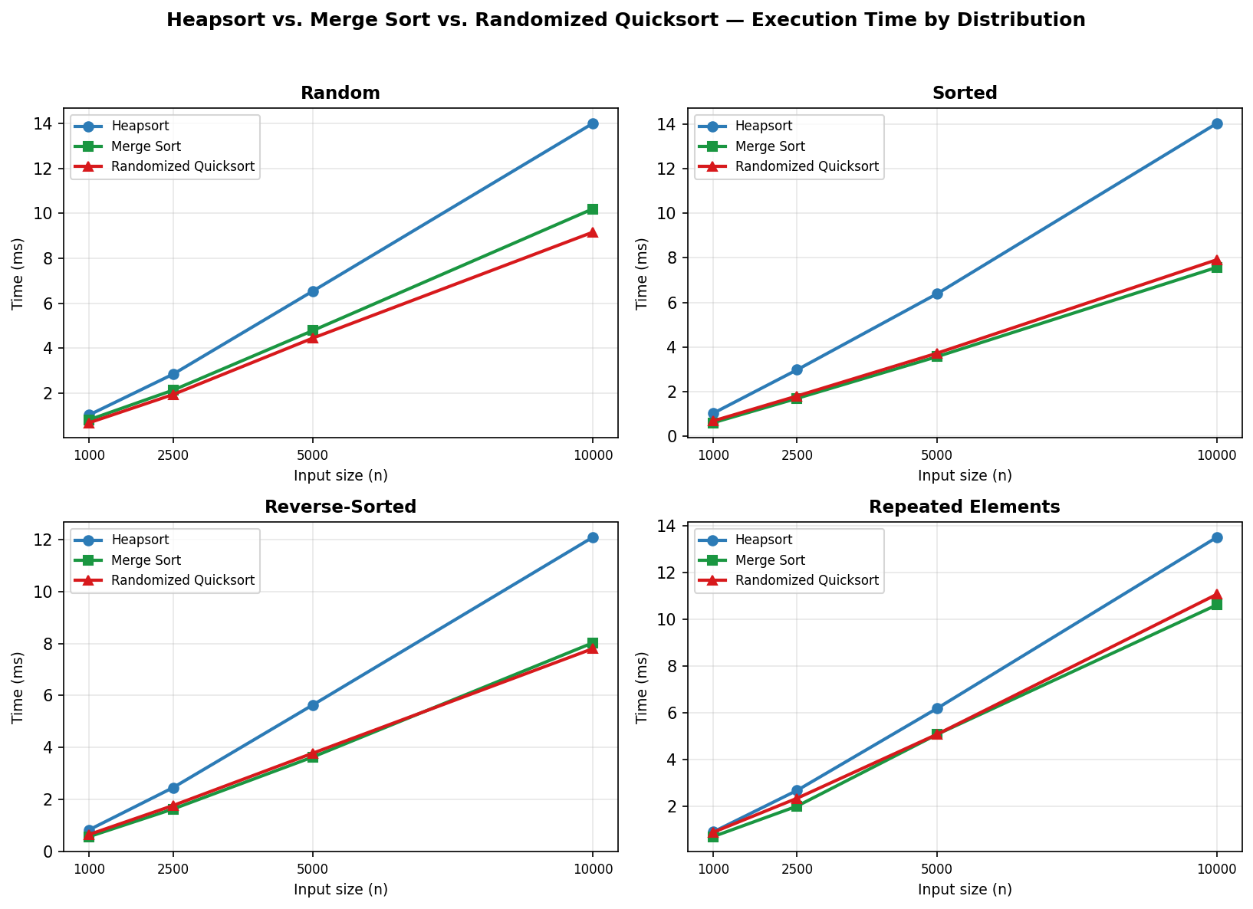
Figure 1. Execution time vs. input size for Heapsort, Merge Sort, and Randomized Quicksort across four input distributions.
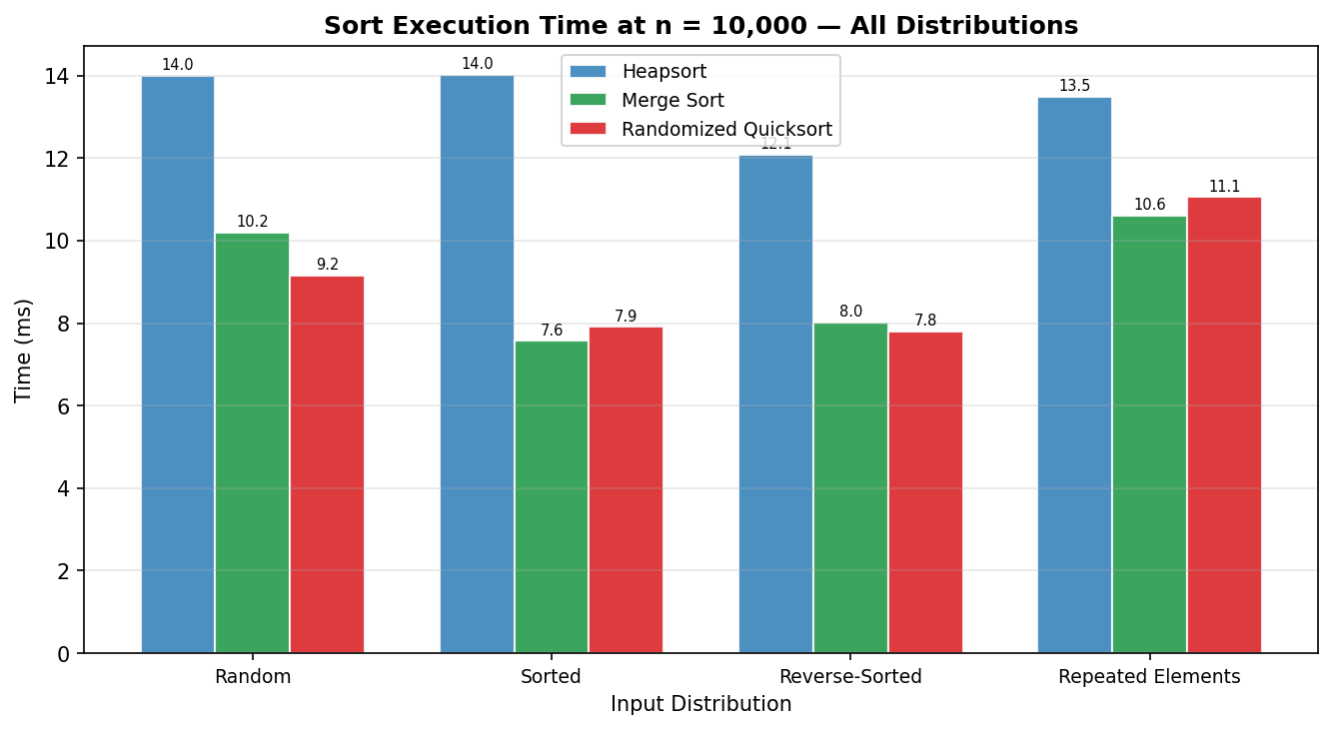
Figure 2. Execution time at n = 10,000 across all distribution and algorithm combinations.
Discussion of Results
The first thing that jumps out of Table 1 is that nothing falls apart. Every algorithm's time roughly tracks n log n as n grows from 1,000 to 10,000 — there's no sign of the kind of quadratic blow-up you'd see from a non-randomized Quicksort on sorted input. That's exactly what the theory predicts: Heapsort and Merge Sort are Θ(n log n) no matter what, and Randomized Quicksort is O(n log n) on average regardless of how the input is arranged.
Heapsort, though, is the slowest of the three on every single distribution. At n = 10,000 on random data it took 14.00 ms, compared to 10.20 ms for Merge Sort and 9.16 ms for Randomized Quicksort. None of this changes the asymptotic story — it's purely constant-factor overhead. Part of it comes from max_heapify doing two comparisons and a possible swap at every level it walks down, and part of it is that jumping between indices i, 2i+1, and 2i+2 scatters memory accesses around in a way that Merge Sort's mostly-sequential merging and Quicksort's partitioning don't. On top of that, Heapsort spends time on the Θ(n) build-heap pass before it even starts extracting elements, which the other two algorithms simply don't have an equivalent of.
Where Heapsort does come out ahead is consistency. At n = 10,000 its time only moves between 12.08 ms (reverse-sorted) and 14.00 ms (random) — under a 20% spread across every distribution I tried. Merge Sort is similarly steady, since merging doesn't care what the values are. Randomized Quicksort is the one with real variance: it's fastest on sorted and reverse-sorted input (7.91 ms and 7.80 ms) and slowest on the repeated-elements case (11.05 ms), which makes sense — with so many duplicate keys, a random pivot is more likely to land on a value that splits the array unevenly.
So what do you actually get for Heapsort's roughly 30-40% overhead? Two things the other two can't both offer at once: a worst case that's Θ(n log n) with zero dependence on luck or randomness, and O(1) extra memory. Merge Sort matches the time bound but needs Θ(n) of scratch space for merging. Randomized Quicksort stays in place but its O(n log n) is only an expectation — there's still a (very unlikely) Θ(n²) case lurking. If memory is tight or you need a hard guarantee on the worst case — think real-time systems — Heapsort is the one that delivers both.

Part 2: Priority Queue Implementation and Applications
Part A: Priority Queue Design
Underlying Data Structure
For the priority queue, I went with the same array-backed binary heap idea as Heapsort — a plain Python list (self._heap) holding the tasks. A few reasons drove that decision. The most obvious is that I'd already worked out the parent/child index math (parent = (i−1)//2, children = 2i+1 and 2i+2) for Heapsort, so the sift-up and sift-down logic carries over directly without needing any node/pointer bookkeeping. There's also a performance angle: a list keeps elements contiguous in memory, which is friendlier to the cache, and Python's list already gives amortized O(1) appends and pops from the end. A linked, pointer-based tree with explicit left/right/parent references would add memory overhead and pointer chasing without making any operation faster. And finally, a binary heap is always a complete binary tree, which means the array never has gaps — the length of the list alone tells you the shape of the tree, with nothing extra to track.
The other piece of the design is self._pos, a dictionary mapping each task's task_id to its current index inside self._heap. Without it, increase_key and decrease_key would have to scan the whole array — O(n) — just to find the task before they could even start the O(log n) sift. Instead, every swap performed by sift_up or sift_down goes through one shared _swap helper that updates self._pos as part of the swap, so the map is always accurate. That turns increase_key and decrease_key into an O(1) lookup followed by an O(log n) re-heapify, instead of an O(n) search plus O(log n).
The Task Class
Each unit of work in the queue is a small Task object:
class Task:
__slots__ = ("task_id", "priority", "arrival_time", "deadline")
def __init__(self, task_id, priority, arrival_time=0.0, deadline=None):
self.task_id = task_id
self.priority = priority # higher value == higher priority
self.arrival_time = arrival_time # simulation time the task became ready
self.deadline = deadline # optional time by which it must finish
task_id is what the index map keys on, so it has to be unique. priority is what the heap actually sorts by. arrival_time tells the scheduler when a task became available, which controls admission order in the simulation. deadline isn't used by the current scheduler logic, but it's there as a hook — a more advanced scheduler could read it to compute an urgency score and feed that back into increase_key. I used __slots__ mainly to keep memory overhead per task down, since the queue can hold thousands of these objects at once.
Why a Max-Heap
I went with a max-heap, so the root — and whatever extract_max returns — is always the task with the highest priority number. That matches how most people think about priorities: a task with priority 10 should run before one with priority 1. A min-heap would do the exact same job if every priority were negated first (max-heaps and min-heaps convert into each other that way), but negating values on every comparison felt like an unnecessary step. Going with a max-heap directly lets "higher number = more urgent" mean exactly what it says, which is the convention I wanted for the scheduler simulation.
Core Operations and Complexity Analysis
is_empty() just checks len(self._heap) == 0 — one comparison, O(1).
insert(task) appends the task to the end of the list, which is O(1) amortized for a Python list, then calls _sift_up starting from that new last position. _sift_up walks up toward the root, swapping the new element with its parent whenever the element's priority is greater, and stops as soon as that's no longer true (or it reaches index 0). Since the tree's height is ⌈log₂(n+1)⌉, that's at most O(log n) swaps — so insert is O(log n) overall.
def insert(self, task):
self._heap.append(task)
i = len(self._heap) - 1
self._pos[task.task_id] = i
self._sift_up(i)
extract_max() relies on the heap invariant that index 0 always holds the highest-priority task. To remove it, I pop the last element off the list, drop it into index 0, shrink the heap, and call _sift_down(0) to push that element down until the heap property holds again — swapping with whichever child has the larger priority at each step. Same logic as insert in reverse: bounded by the tree height, so O(log n).
def extract_max(self):
top = self._heap[0]
last = self._heap.pop()
del self._pos[top.task_id]
if self._heap:
self._heap[0] = last
self._pos[last.task_id] = 0
self._sift_down(0)
return top
increase_key and decrease_key share the same shape. self._pos gives an O(1) lookup for where the task currently sits, its priority field gets overwritten in place, and then the heap is repaired — _sift_up if the priority went up (it might now beat its parent) or _sift_down if it went down (it might now lose to a child). Either way that's O(1) for the lookup plus O(log n) for the sift, so O(log n) total. I added a direction check to each — increase_key raises ValueError if you pass it a smaller priority, and decrease_key raises if you pass it a larger one — mostly to catch the case where I (or future code) calls the wrong one by mistake.
def increase_key(self, task_id, new_priority):
i = self._pos[task_id]
if new_priority < self._heap[i].priority:
raise ValueError("new_priority must be >= current priority")
self._heap[i].priority = new_priority
self._sift_up(i)
def decrease_key(self, task_id, new_priority):
i = self._pos[task_id]
if new_priority > self._heap[i].priority:
raise ValueError("new_priority must be <= current priority")
self._heap[i].priority = new_priority
self._sift_down(i)
Table 2 puts all of these together for reference.
Operation | Time Complexity | Notes
is_empty() | O(1) | Single list-length check
peek() | O(1) | Return self._heap[0] without removal
insert(task) | O(log n) | Amortized O(1) append + O(log n) sift-up
extract_max() | O(log n) | O(1) pop + O(log n) sift-down
increase_key(id, p) | O(log n) | O(1) index lookup + O(log n) sift-up
decrease_key(id, p) | O(log n) | O(1) index lookup + O(log n) sift-down
Note. n is the number of tasks currently in the queue.
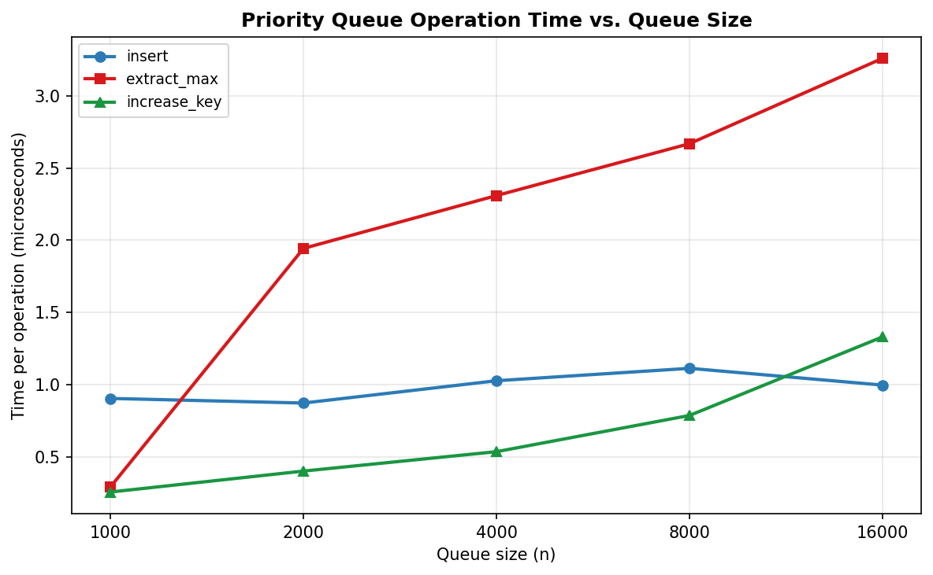
Figure 3. Mean per-operation time (µs) for insert, extract_max, and increase_key as queue size n grows from 1,000 to 16,000.
Figure 3 is where the O(log n) claim either holds up or it doesn't, and it does. Going from a queue of 1,000 tasks to 16,000 — a 16x increase — insert only moves from 0.905 µs to 0.997 µs per call, extract_max from 0.291 µs to 3.260 µs, and increase_key from 0.257 µs to 1.332 µs. If any of these were O(n), I'd expect roughly a 16x jump in the per-operation time too. Instead they barely move, which lines up with log₂ n only growing by about 4 over that same range. One pattern worth pointing out: extract_max is consistently the most expensive of the three. That's because the element that gets moved into the root after a pop is whatever was last in the array — essentially unrelated to where it needs to end up — so it tends to sift all the way down. A freshly inserted element, on the other hand, is often already close to where it belongs and stops sifting up after just a step or two.
Scheduler Simulation
To see the queue actually doing something useful, run_scheduler_simulation models a single server working through a list of tasks. Each task joins the queue once its arrival_time arrives, and at every step the server pulls whichever ready task currently has the highest priority and "runs" it. The catch with pure priority-based scheduling is starvation — a low-priority task can sit forever if higher-priority work keeps arriving. To deal with that, every aging_interval steps the simulation bumps the priority of everything still waiting by aging_boost, using increase_key directly.
def run_scheduler_simulation(tasks, aging_interval=3, aging_boost=1):
pq = PriorityQueue()
arrivals = sorted(tasks, key=lambda t: t.arrival_time)
order, step, next_arrival = [], 0, 0
while next_arrival < len(arrivals) or not pq.is_empty():
while next_arrival < len(arrivals) and arrivals[next_arrival].arrival_time <= step:
pq.insert(arrivals[next_arrival])
next_arrival += 1
if pq.is_empty():
step += 1
continue
if step > 0 and step % aging_interval == 0:
for task in pq._heap:
if task.priority < 10:
pq.increase_key(task.task_id, task.priority + aging_boost)
order.append(pq.extract_max().task_id)
step += 1
return order
I ran a small example with five tasks, given as (priority, arrival_time, deadline): T1 = (2, 0, 10), T2 = (5, 0, 4), T3 = (1, 1, 20), T4 = (3, 2, 8), and T5 = (1, 2, 15). Walking through it step by step — at step 0, T1 and T2 are the only tasks that have arrived, and T2 (priority 5) wins, so it runs first. At step 1, T3 shows up but T1's priority of 2 is still higher, so T1 goes next. At step 2, both T4 and T5 arrive, and T4 (priority 3) is now the most urgent thing in the queue, so it runs third. Step 3 is where aging kicks in (3 is a multiple of the aging interval), so the two remaining tasks — T3 and T5, both at priority 1 — both get bumped to priority 2. With the tie broken by heap order, T5 runs fourth and T3 last. Putting it all together, the execution order comes out to [T2, T1, T4, T5, T3], which is also checked by an assertion in the test code.
What this example really shows is why increase_key matters in practice. Without it, aging would mean pulling every waiting task back out and reinserting it with a new priority — O(n log n) every time aging fires. With increase_key, each task's position gets fixed up in O(log n), so aging stays cheap even with a large queue. Zoom out a bit and the whole scheduler is really just three operations working together: insert handles arrivals, extract_max handles dispatch, and increase_key handles aging — and together they give you a scheduling policy where nothing waits forever.

Conclusion
Working through both halves of this assignment reinforced the same idea from two different directions: the binary heap earns its keep both as a sort and as a priority queue, and both uses come from the same array-as-tree trick. On the sorting side, build_max_heap turning out to be Θ(n) rather than O(n log n) was the part that surprised me most going in — it works out because most of the n/2 calls to max_heapify are near the bottom of the tree and barely do anything. The extraction loop afterward costs O(log n) per step regardless of input, which is why Heapsort's Θ(n log n) bound holds in the best, average, and worst cases without exception — something neither Merge Sort nor Quicksort can claim in quite the same unconditional way. The benchmarks backed this up: Heapsort tracked the predicted Θ(n log n) curve but ran consistently slower in absolute terms than Merge Sort and Randomized Quicksort, which is the price for a guarantee that doesn't depend on randomness and doesn't need extra memory.
The priority queue in Part 2 is built on the same array-based heap, with one addition — the index map — that turns increase_key and decrease_key from an O(n) search into an O(1) lookup plus an O(log n) fix-up. Combined with O(log n) insert and extract_max and O(1) is_empty, that's everything a scheduler needs. The simulation showed those pieces working together: insert for arrivals, extract_max for dispatch, and increase_key for aging, which together avoid starvation. And the timing measurements across queue sizes from 1,000 to 16,000 matched the O(log n) prediction — operation costs barely moved even as the queue grew 16x. Between the two halves, it's clear why the heap keeps showing up across algorithm courses: one array, one ordering rule, and you get a fast in-place sort with worst-case guarantees and a priority queue that scales logarithmically. The code, benchmarks, and this report are all in the repository linked here: https://github.com/xhon-pelushi/2026-Summer-Algorithms-and-Data-Structures-MSCS-532-M20

References
Cormen, T. H., Leiserson, C. E., Rivest, R. L., & Stein, C. (2022). Introduction to algorithms (4th ed.). MIT Press.
Knuth, D. E. (1998). The art of computer programming: Vol. 3. Sorting and searching (2nd ed.). Addison-Wesley.
Sedgewick, R., & Wayne, K. (2011). Algorithms (4th ed.). Addison-Wesley Professional.
Silberschatz, A., Galvin, P. B., & Gagne, G. (2018). Operating system concepts (10th ed.). Wiley.
Williams, J. W. J. (1964). Algorithm 232: Heapsort. Communications of the ACM, 7(6), 347–348. https://doi.org/10.1145/512274.512284

