Multi-Paradigm Problem Solving: Mean, Median, and Mode
in C, OCaml, and Python

Xhon Pelushi
University of the Cumberlands
MSCS-632-M30: Advanced Programming Languages
Dr. Jay Thom
July 28, 2026

Multi-Paradigm Problem Solving
This assignment implements the same three descriptive statistics—mean, median, and mode—over a shared list of integers in C, OCaml, and Python so that each language can illustrate a different programming paradigm. The C program is written procedurally as a single file of free functions that operate on an array; the OCaml program is written functionally with immutable lists and higher-order list operations; and the Python program is written in an object-oriented style behind a StatisticsCalculator class whose methods each compute one statistic. Running all three programs against the same sample input produced identical numeric results, which made the comparison focus on how each paradigm organizes the solution rather than on whether the formulas were correct (Sebesta, 2019).
The procedural C version made control flow and memory ownership explicit. Mean is a straight accumulation loop, median sorts a malloc’d copy of the array so the caller’s data stays intact, and mode walks a sorted copy twice to find the peak frequency and then collect every value that reaches it. The main challenge was the absence of built-in collections: frequency counting and multi-mode collection had to be coded by hand, and every temporary buffer had to be freed. That discipline is the strength of the procedural approach—the programmer sees exactly when storage is allocated and released—but it also adds bookkeeping that the other two languages hide (Kernighan & Ritchie, 1988).
The functional OCaml version replaced that bookkeeping with list pipelines. Mean is a fold over the list, median sorts a fresh list and indexes the middle, and mode composes unique, map, fold, and filter so that frequencies are derived without updating a table in place. Avoiding mutable state forced a different habit of thought: instead of mutating counters, each step produced a new list or pair that the next function consumed. The resulting code is short and easy to reason about locally, but the cost is that intermediate lists are reallocated freely and that learners must become comfortable with recursion and higher-order functions before the solution feels natural (Minsky et al., 2018).
The object-oriented Python version centered the design on a class that owns the data and exposes mean, median, and mode as methods. Encapsulation kept the backing list private behind a defensive copy, and a dictionary-based Counter made mode trivial to express. Relative to C and OCaml, Python required the least ceremony: lists and dictionaries already provide the storage shapes the algorithms need, and the class boundary mainly documents where the statistics belong rather than fighting the language. The trade-off is that the paradigm’s value shows up more in larger systems—where many objects collaborate—than in a three-method calculator, so the OOP structure here is a clear demonstration of principle more than a necessity of scale (Sebesta, 2019).
Across the three implementations, the key difference was not the mathematics but the unit of organization: procedures and manually managed arrays in C, pure functions over immutable lists in OCaml, and methods on an encapsulated object in Python. Procedural code made memory and algorithms visible; functional code made data transformation visible; object-oriented code made responsibility visible. Choosing among them for a real system depends on whether the priority is control, composition, or modular ownership—but for this statistics problem, each paradigm proved capable of expressing a correct, readable solution.
Source Code
The complete source code for the C, OCaml, and Python implementations is available in the public GitHub repository: https://github.com/xhon-pelushi/MSCS-632-Advanced-Programming-Languages/tree/main/Assignment-7
References
Kernighan, B. W., & Ritchie, D. M. (1988). The C programming language (2nd ed.). Prentice Hall.
Minsky, Y., Madhavapeddy, A., & Hickey, J. (2018). Real World OCaml: Functional programming for the masses (2nd ed.). O'Reilly Media.
Sebesta, R. W. (2019). Concepts of programming languages (12th ed.). Pearson.

Appendix: Screenshots
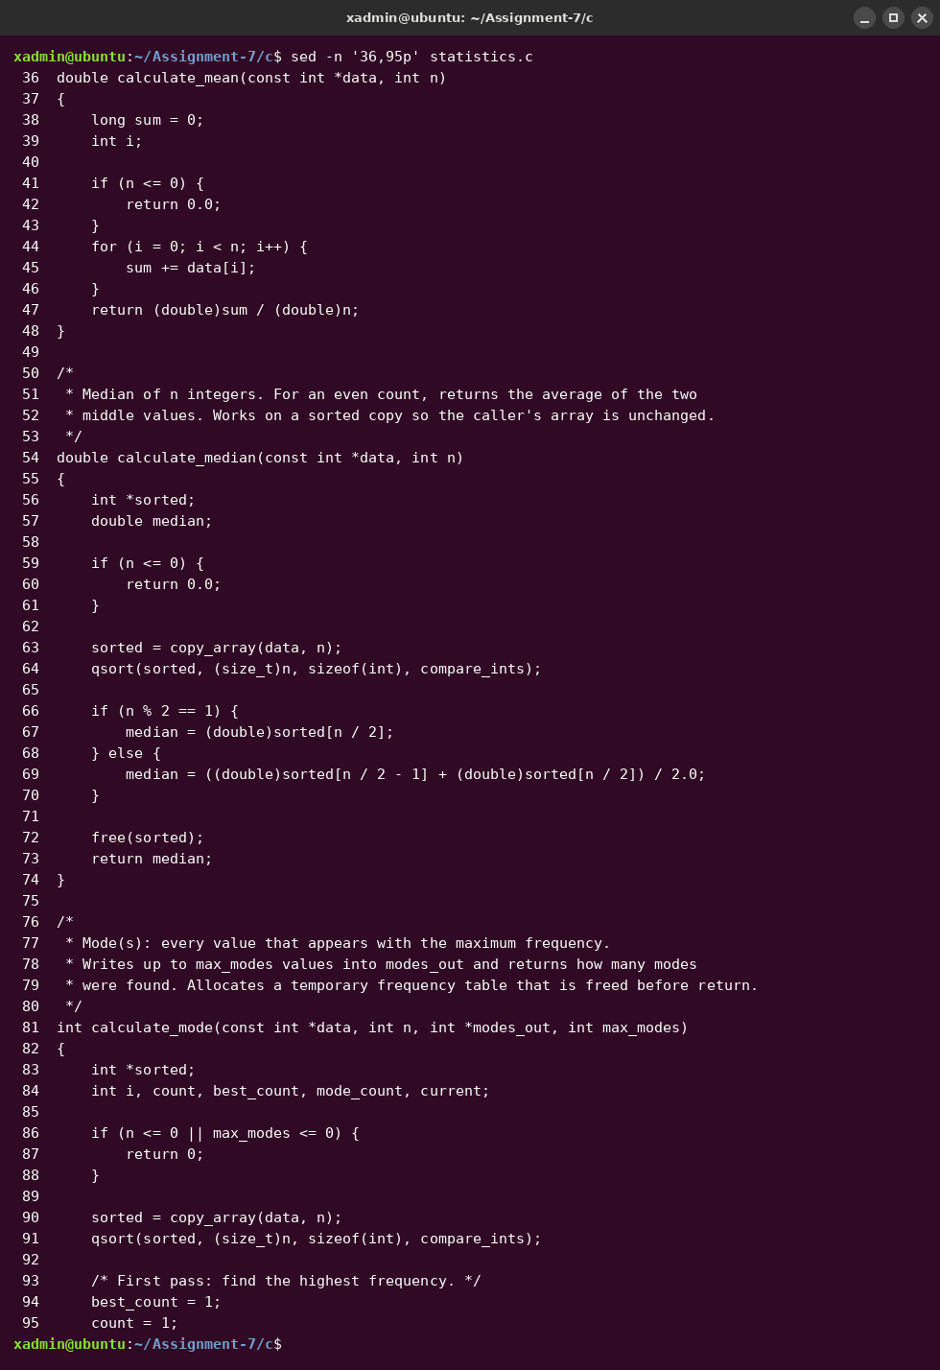
Figure 1. C (procedural) source excerpt — calculate_mean, calculate_median, and calculate_mode with manual array copies.
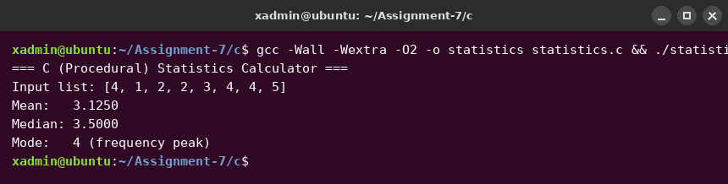
Figure 2. C program sample output for input [4, 1, 2, 2, 3, 4, 4, 5].
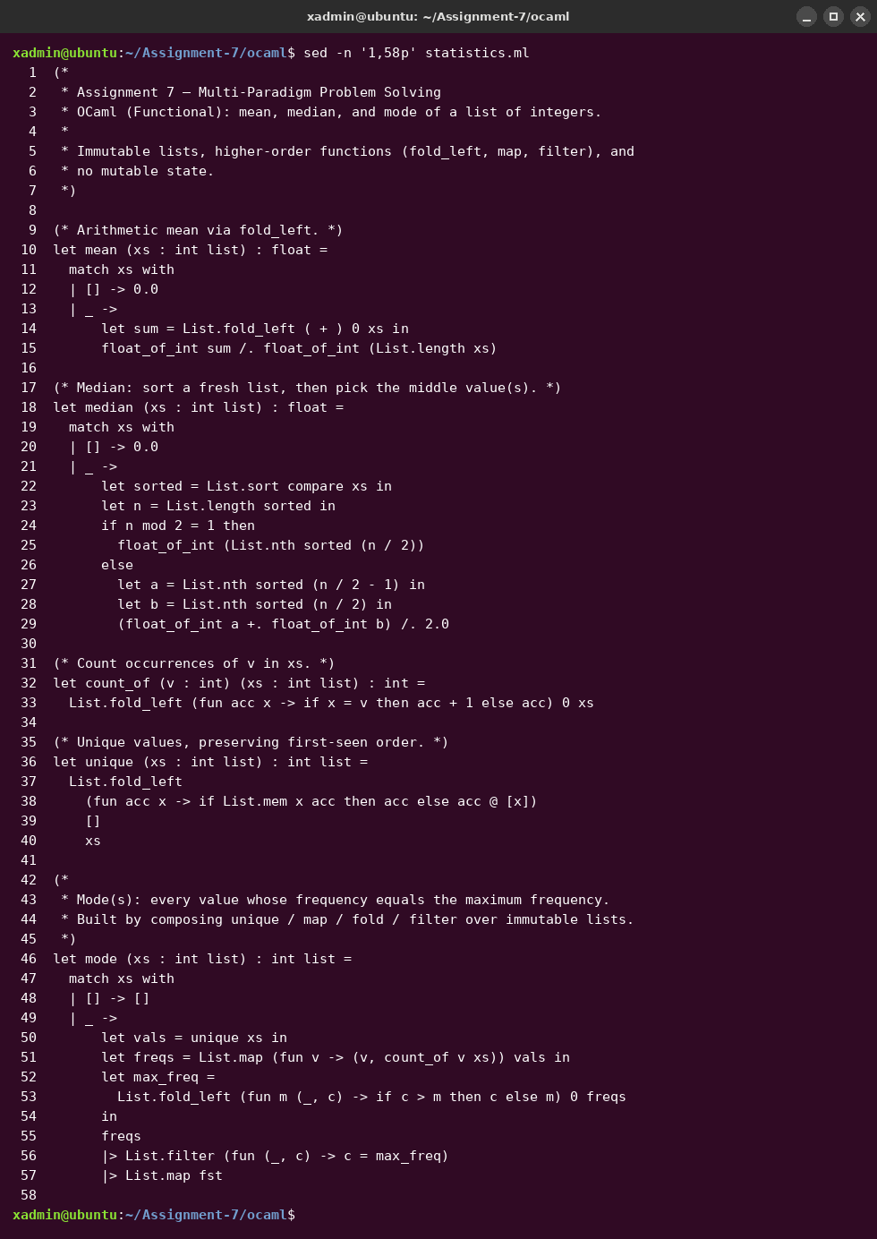
Figure 3. OCaml (functional) source — mean, median, and mode using fold, map, and filter over immutable lists.
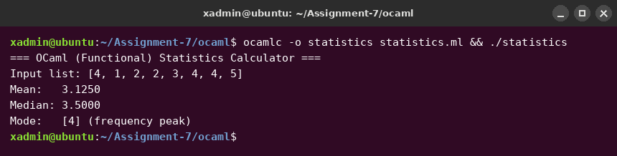
Figure 4. OCaml program sample output for the same input list.
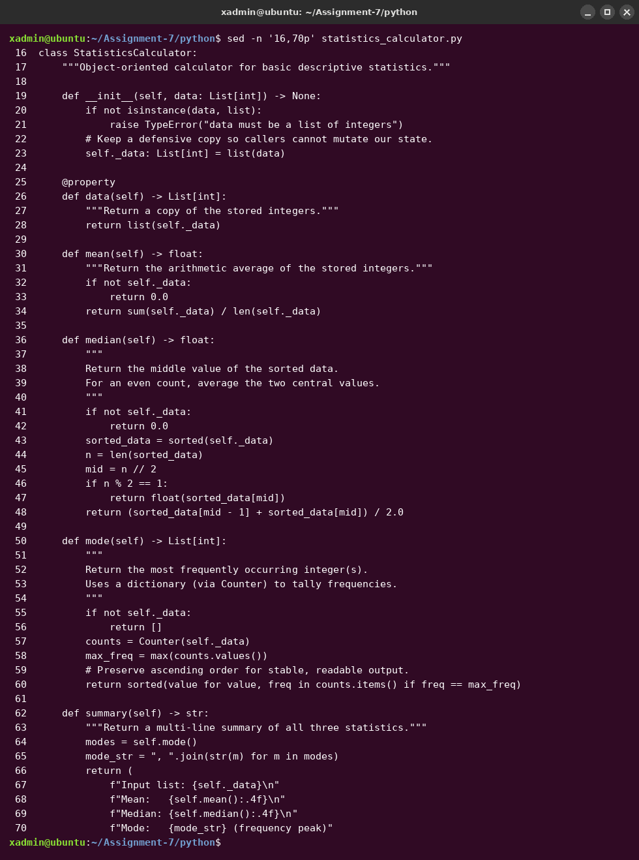
Figure 5. Python (object-oriented) StatisticsCalculator class with mean, median, and mode methods.
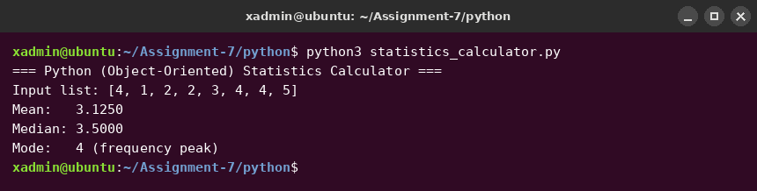
Figure 6. Python program sample output for the same input list.

