Multi-threaded Data Processing System in Java and Go

Xhon Pelushi
University of the Cumberlands
MSCS-632-M30: Advanced Programming Languages
Dr. Jay Thom
July 28, 2026

Overview
This report describes a multi-threaded data processing system implemented independently in Java and Go. The system models a ride-trip fare processor: twelve trip records are placed on a shared task queue, four worker threads (or goroutines) retrieve those tasks in parallel, each worker simulates computational work with a short delay, and completed fare results are written to a shared in-memory list and a CSV output file. Both implementations synchronize access to shared resources, log worker lifecycle events and errors, and shut down cleanly once the queue is drained. The goal is to compare Java's shared-memory concurrency model with Go's communicating sequential processes style while meeting the same functional requirements (Goetz et al., 2006; Donovan & Kernighan, 2015).
Java Concurrency and Exception Handling
The Java implementation centers on a TaskQueue class whose addTask() and getTask() methods are guarded by a ReentrantLock and a Condition. Workers that find the queue empty call await() on the condition and are woken when a producer enqueues a task or when close() signals that no further work will arrive. Using an explicit lock and condition avoids busy-waiting and prevents the classic mistake of checking the empty-queue predicate outside a synchronized region (Goetz et al., 2006). Worker threads themselves are managed through Executors.newFixedThreadPool(4), which reuses a fixed set of threads and returns a Future for each Worker Callable so the main thread can wait for completion without joining threads manually.
A separate ResultStore holds the shared results list and a BufferedWriter to the CSV file. Every write acquires the same ReentrantLock, so concurrent workers cannot interleave CSV lines or corrupt the ArrayList. Exception handling follows Java's checked-exception model: getTask() declares InterruptedException and workers catch it, restore the interrupt flag, and exit; ResultStore catches IOException on write failures and logs them without crashing sibling workers; the main method wraps file construction in try-with-resources so the writer is closed even if an error occurs, and the executor is shut down in a finally block with awaitTermination() followed by shutdownNow() if workers do not finish in time. Logging records when each worker starts, completes a trip, exits on an empty closed queue, or encounters an error.
Go Concurrency and Error Handling
The Go implementation uses a buffered channel of Task values as the shared queue. The main goroutine sends twelve trip records into the channel and then closes it; four worker goroutines range over the channel until it is drained and closed, which is Go's idiomatic safe-termination pattern (Donovan & Kernighan, 2015). Because channel send and receive are already concurrency-safe, the program does not need an explicit mutex around the task queue itself. A sync.WaitGroup tracks outstanding workers so main blocks until every goroutine has called Done().
Shared output still requires synchronization: ResultStore protects its results slice and CSV writer with a sync.Mutex, and Add() uses defer mu.Unlock() so the lock is released even when a write error is returned. Go's error model is explicit rather than exception-based. NewResultStore and Add return error values that callers check immediately; a failure to open the results file is fatal via log.Fatalf, while a per-row write failure is logged by the worker and processing continues for remaining tasks. The results file is closed in a deferred function in main so cleanup runs on both success and failure paths. Each worker logs start, per-task completion, write errors, and a final processed count.
Concurrency Model Differences
The two languages embody different concurrency philosophies. Java treats threads as schedulable units that share heap memory, so correctness depends on the programmer applying locks, conditions, and careful shutdown of an ExecutorService around every shared structure. That model is powerful and familiar, but it places the burden of avoiding race conditions and deadlocks on explicit synchronization discipline (Goetz et al., 2006). Go favors communication over shared mutable state: channels carry tasks between goroutines, closing a channel broadcasts completion, and the language runtime multiplexes many goroutines onto fewer OS threads (Donovan & Kernighan, 2015). Mutexes still appear where shared memory is unavoidable, such as the results file, but the primary coordination mechanism is the channel rather than a lock-protected LinkedList.
Error handling diverges in a related way. Java's try-catch and try-with-resources concentrate cleanup and recovery around exception types such as InterruptedException and IOException. Go returns errors as ordinary values and uses defer for cleanup, which makes failure paths visible at each call site instead of in a distant catch block. In practice both programs processed all twelve trips with four workers, wrote matching fare results to CSV, and terminated without deadlock; the difference is which tool each language makes the default for expressing that coordination.
Conclusion
Implementing the same multi-threaded data processing system in Java and Go showed that shared queues, worker pools, synchronized result writing, logging, and orderly shutdown can be achieved in both languages, but the idioms differ. Java relies on ReentrantLock, Condition, and Executors with try-catch around interruptions and I/O. Go relies on goroutines, channels, WaitGroup, mutex-guarded file writes, and defer-based cleanup with explicit error checks. Choosing between them is less about capability and more about whether a project prefers shared-memory locking or message-passing coordination.
Source Code
The complete source code for both implementations is available in the public GitHub repository: https://github.com/xhon-pelushi/MSCS-632-Advanced-Programming-Languages/tree/main/Assignment-6
References
Donovan, A. A. A., & Kernighan, B. W. (2015). The Go programming language. Addison-Wesley.
Goetz, B., Peierls, T., Bloch, J., Bowbeer, J., Holmes, D., & Lea, D. (2006). Java concurrency in practice. Addison-Wesley.

Appendix: Screenshots
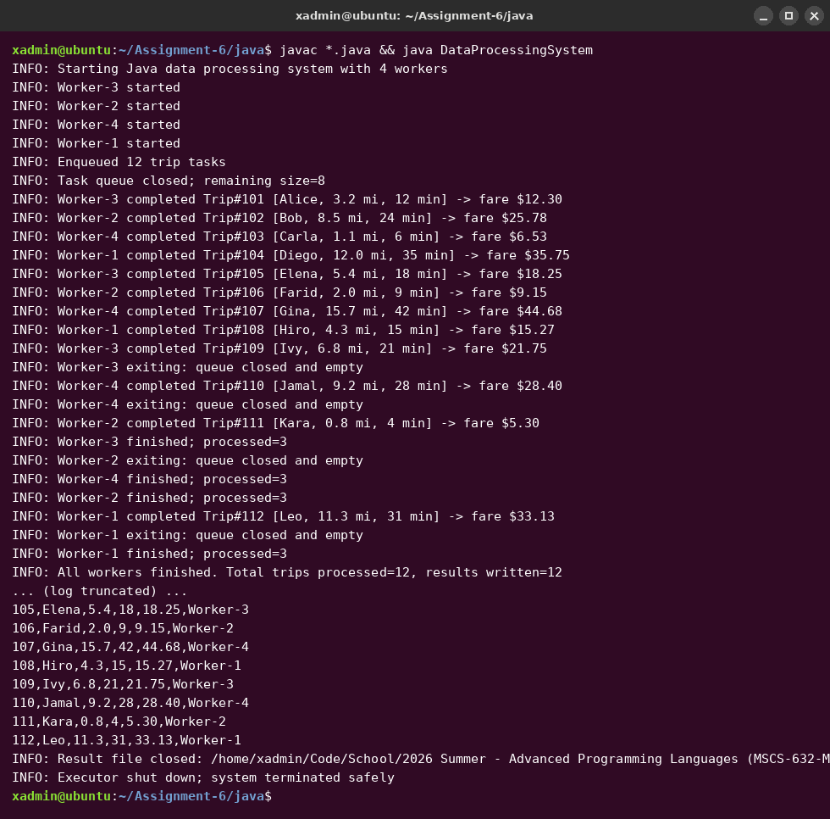
Figure 1. Java run: four workers process twelve trip tasks and write results_java.csv.
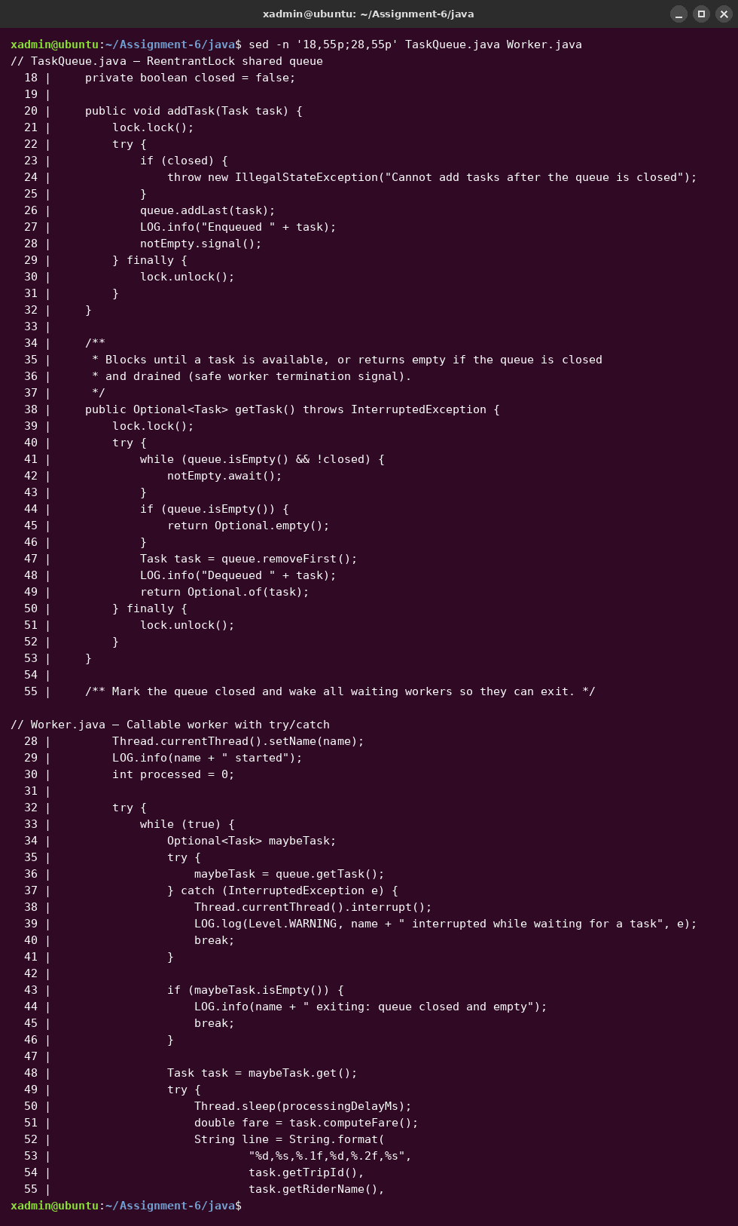
Figure 2. Java source excerpt: ReentrantLock TaskQueue and Worker try/catch processing loop.
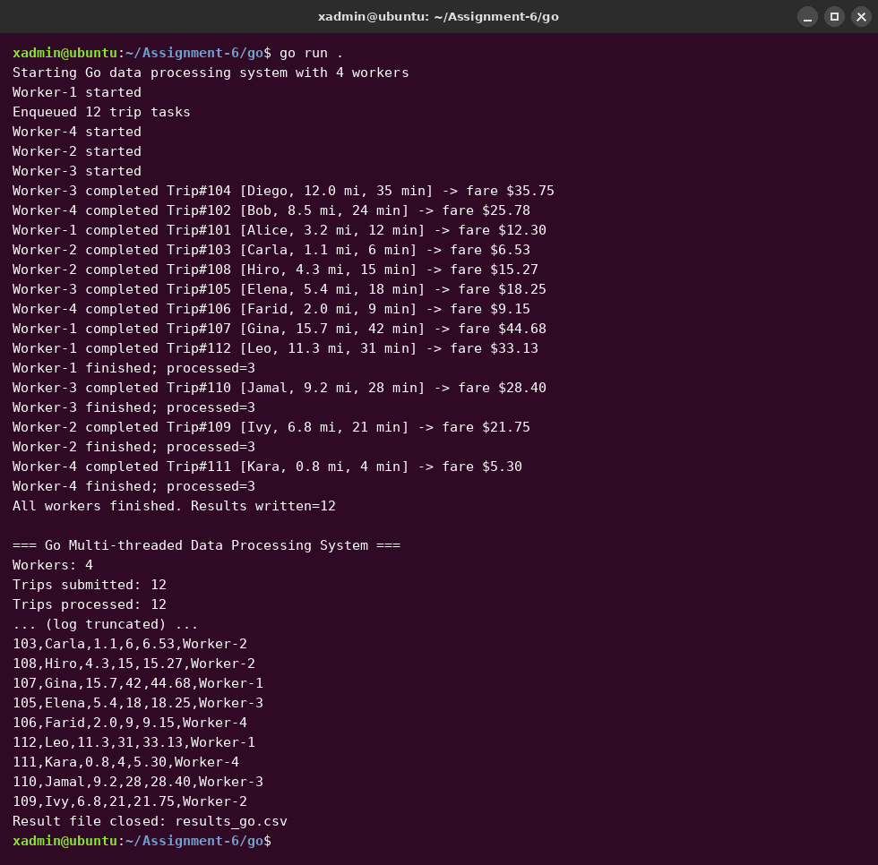
Figure 3. Go run: four goroutines drain a task channel and write results_go.csv.
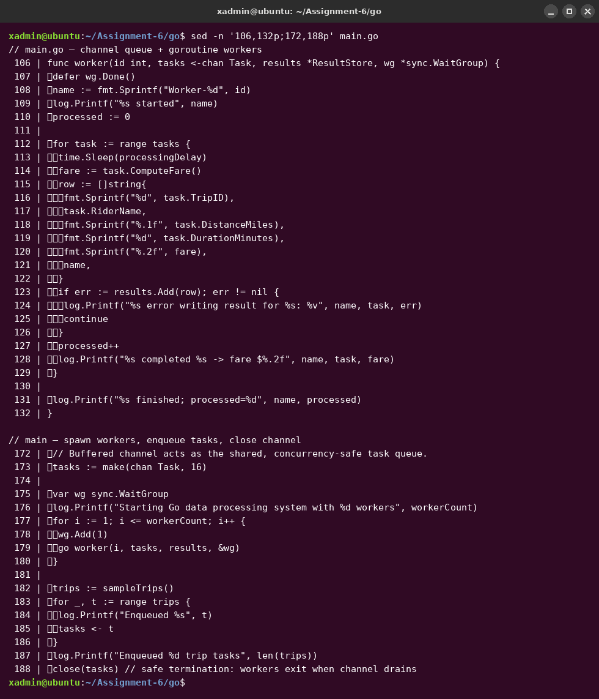
Figure 4. Go source excerpt: channel-based workers, WaitGroup, and deferred result-file close.

