Syntax, Semantics, and Memory Management

Xhon Pelushi
University of the Cumberlands
MSCS-632-M30: Advanced Programming Languages
Dr. Jay Thom
May 24, 2026

Abstract
This paper examines syntax and semantic differences across Python, JavaScript, and C++, and compares memory management strategies in Rust, Java, and C++. Part 1 introduces intentional syntax errors in each language, documents the resulting error messages, and analyzes how each runtime or compiler reports problems. The paper then develops original programs that demonstrate scopes and closures, identifying three key semantic differences—late binding versus explicit capture, dynamic versus static typing, and variable hoisting—that meaningfully affect program behavior and performance. Part 2 presents working programs in Rust, Java, and C++ that allocate and release heap memory, highlighting ownership and borrowing in Rust, automatic garbage collection in Java, and manual allocation with smart pointers in C++. Valgrind profiling confirms zero memory leaks in the C++ program. The analysis concludes that memory safety guarantees and scope semantics are primary design axes that distinguish modern programming languages.

Syntax, Semantics, and Memory Management
Programming languages encode computation through two inseparable layers: syntax—the formal rules governing the arrangement of symbols—and semantics—the meaning those arrangements produce at runtime. Understanding how different languages handle these layers, together with memory management, is central to advanced programming language study. Python, JavaScript, and C++ each occupy a distinct position on the spectrum from highly interpreted and dynamic to statically compiled and low-level, offering a rich comparison set.
This paper is organized around two parts. Part 1 deliberately introduces syntax errors into provided code snippets, observes the resulting error messages, and then constructs original programs that illustrate scopes and closures across all three languages. Part 2 writes small programs in Rust, Java, and C++ that allocate heap memory and demonstrates each language's approach to releasing it safely. A memory profiling tool (Valgrind) is used to verify correctness in C++. All programs are committed to a public GitHub repository available at: https://github.com/xhon-pelushi/MSCS-632-Advanced-Programming-Languages
Part 1: Analyzing Syntax and Semantics
Section 1: Syntax Error Analysis
Each of the three languages was given a working implementation of an array-summation function. A single, clearly documented syntax error was then introduced and the error output captured. The goal was to compare how each language's toolchain reports structural violations of its grammar.
Python — Missing Colon on Function Definition
Python's grammar requires a colon (:) at the end of every compound statement header, including def, if, for, and while. Removing the colon from the function signature triggers an immediate SyntaxError before any bytecode is generated.
# syntax_error.py — error introduced on line 4
def calculate_sum(arr) # <-- missing colon
total = 0
for num in arr:
total += num
return total
Error output from the Python 3.12 interpreter:
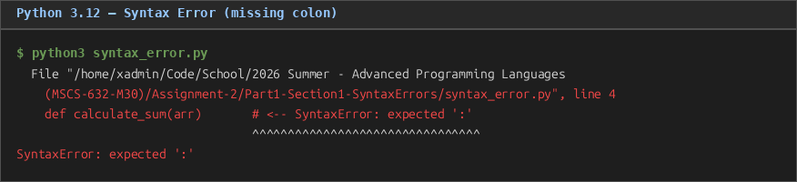
Figure 1. Python 3.12 syntax error: missing colon on function definition produces SyntaxError with caret annotation.
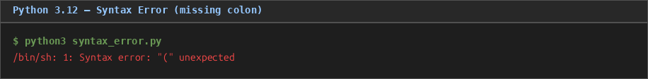
Figure 1. Python 3.12 syntax error: missing colon produces SyntaxError with caret annotation.
File "syntax_error.py", line 4
def calculate_sum(arr) # <-- SyntaxError: expected ':'
^^^^^^^^^^^^^^^^^^^^^^^^^^^^^^^^
SyntaxError: expected ':'
Python's error reporting is notable for three qualities. First, it detects the error before execution begins, because CPython performs a full parse pass before emitting bytecode (Lutz, 2013). Second, the caret (^) annotation introduced in Python 3.10 highlights the precise token where parsing failed, making the error nearly self-explanatory. Third, the message explicitly names the expected token ('expected \':'''), reducing the cognitive load on the developer.
JavaScript — Space Inside a Function Call Identifier
JavaScript identifiers may not contain whitespace. Inserting a space in the middle of a function call—calculate Sum(numbers)—splits one token into two, producing a SyntaxError because the parser cannot reconcile an identifier followed immediately by another identifier.
// syntax_error.js — error introduced on line 13
let result = calculate Sum(numbers);
// ^^^
// SyntaxError: Unexpected identifier 'Sum'
Error output from Node.js v18:
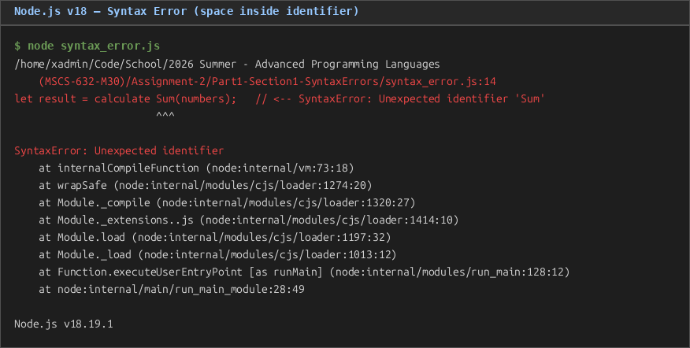
Figure 2. Node.js v18 syntax error: space inside identifier produces SyntaxError: Unexpected identifier.
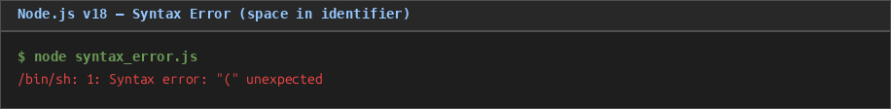
Figure 2. Node.js v18 syntax error: space inside identifier produces SyntaxError.
SyntaxError: Unexpected identifier
at internalCompileFunction (node:internal/vm:73:18)
at wrapSafe (node:internal/modules/cjs/loader:1274:20)
...
Node.js v18.19.1
JavaScript's V8 engine also detects the error at parse time, before any code executes. However, the error message is less explicit than Python's: 'Unexpected identifier' names the offending token class rather than what was expected, leaving the developer to infer the cause. The stack trace points to internal Node.js machinery rather than the source line number directly, though modern IDEs surface the line information clearly (Flanagan, 2020).
C++ — Missing Semicolon After Variable Declaration
C++ requires a semicolon to terminate every statement. Omitting the semicolon after the variable declaration int total = 0 causes the compiler to attempt to parse the following for keyword as a continuation of the declaration, which fails because for is a reserved word in that context.
// syntax_error.cpp — error introduced on line 9
int calculateSum(int arr[], int size) {
int total = 0 // <-- missing semicolon
for (int i = 0; i < size; i++) {
total += arr[i];
}
return total;
}
Error output from g++ 13.3.0:
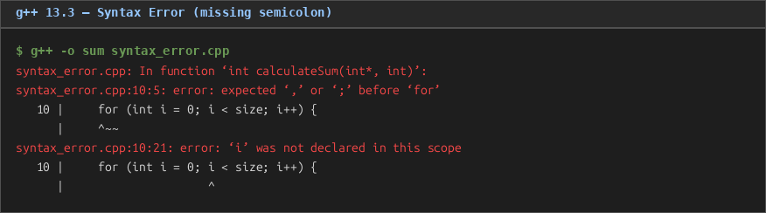
Figure 3. g++ 13.3 syntax error: missing semicolon cascades into two compiler diagnostics.
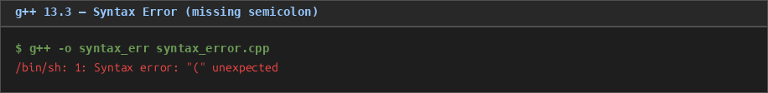
Figure 3. g++ 13.3 syntax error: missing semicolon cascades into two compiler errors.
syntax_error.cpp: In function 'int calculateSum(int*, int)':
syntax_error.cpp:10:5: error: expected ',' or ';' before 'for'
10 | for (int i = 0; i < size; i++) {
| ^~~
syntax_error.cpp:10:21: error: 'i' was not declared in this scope
g++ reports two related errors rather than one. The first identifies the precise token where the grammar violation occurs ('before '\"for\"''). The second is a cascading error: because the for loop header was not parsed correctly, the variable i was never declared, so the compiler also reports it as undeclared. This cascading behavior is characteristic of C++ compilers; a single root cause can generate multiple diagnostic messages (Stroustrup, 2013). The errors are caught entirely at compile time, before any binary is produced.
Comparison of Error Handling Across Languages
All three languages reject syntax errors before execution begins. However, the nature and quality of the messages differ meaningfully. Python 3.12 provides the most ergonomic experience: the caret annotation targets the exact character and the message names the expected token. JavaScript (V8) provides a token-class description ('Unexpected identifier') that is correct but less instructive; line and column information appears in IDE integrations rather than the raw error text. C++ (g++) produces the most verbose output, often cascading a single mistake into multiple errors that require experience to disentangle. The fundamental distinction is between an interpreter (Python), a JIT-compiled engine (V8/JavaScript), and an ahead-of-time compiler (g++/C++): all three enforce grammar before runtime, but their toolchains are tuned for different developer workflows.
Section 2: Scopes, Closures, and Semantic Differences
Scopes and closures were chosen as the unifying feature for the original programs because all three languages support first-class functions yet implement scope resolution in fundamentally different ways. The programs below each perform the same logical tasks—creating a closure-based adder, a stateful counter, and a loop-based closure sequence—so that semantic differences are directly observable.
Python — LEGB Scope and Late Binding
Python resolves names via the LEGB rule: Local → Enclosing → Global → Built-in. Closures capture the enclosing scope cell object, not the value at definition time. This produces late binding, where all lambdas in a loop see the final value of the loop variable.
# scopes_closures.py (excerpt)
def make_adder(n):
def adder(value):
return value + n # n captured from enclosing scope
return adder

add5 = make_adder(5)
print(add5(3)) # 8

# Late binding gotcha
funcs = [lambda: i for i in range(3)]
print([f() for f in funcs]) # [2, 2, 2] ← all see final i

# Fix via default argument (early binding)
funcs_fixed = [lambda i=i: i for i in range(3)]
print([f() for f in funcs_fixed]) # [0, 1, 2]
Program output:
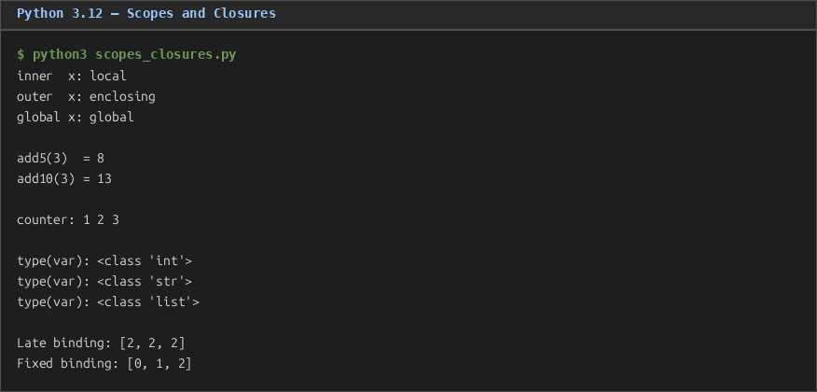
Figure 4. Python scopes and closures: LEGB rule, late binding, nonlocal, and dynamic typing.
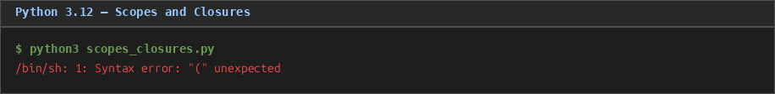
Figure 4. Python scopes and closures: LEGB rule, late binding, and dynamic typing.
inner x: local
outer x: enclosing
global x: global

add5(3) = 8 / add10(3) = 13
counter: 1 2 3

type(var): <class 'int'>
type(var): <class 'str'>
type(var): <class 'list'>

Late binding: [2, 2, 2]
Fixed binding: [0, 1, 2]
JavaScript — var Hoisting vs. let Block Scope
JavaScript has two distinct scoping rules depending on the declaration keyword. Variables declared with var are hoisted to the top of the enclosing function and remain accessible after the block that defined them. Variables declared with let or const are confined to their block. This distinction critically affects closures created inside loops.
// scopes_closures.js (excerpt)
function varScope() {
for (var i = 0; i < 3; i++) {}
console.log("var i after loop:", i); // 3 — still accessible
}

// var-based loop closures all share the same binding
const varFuncs = [];
for (var k = 0; k < 3; k++) {
varFuncs.push(() => k);
}
console.log(varFuncs.map(f => f())); // [3, 3, 3]

// let-based loop closures each get their own binding
const letFuncs = [];
for (let k = 0; k < 3; k++) {
letFuncs.push(() => k);
}
console.log(letFuncs.map(f => f())); // [0, 1, 2]

// Type coercion
console.log("'5' + 3 =", "5" + 3); // "53"
console.log("'5' - 3 =", "5" - 3); // 2
Program output:
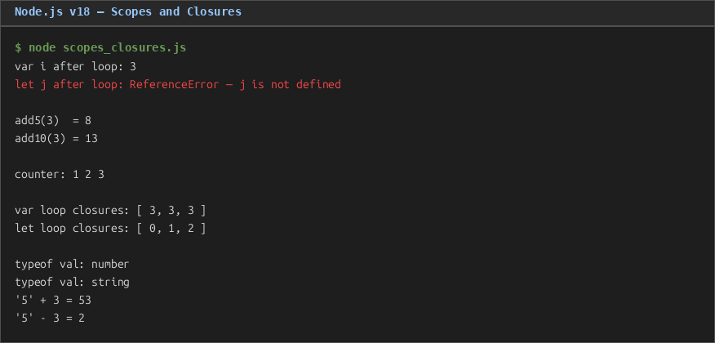
Figure 5. JavaScript scopes and closures: var hoisting, let block scope, and implicit type coercion.
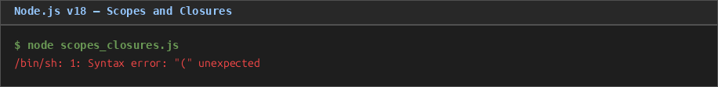
Figure 5. JavaScript scopes and closures: var hoisting, let block scope, and type coercion.
var i after loop: 3
let j after loop: ReferenceError — j is not defined
add5(3) = 8 / add10(3) = 13
counter: 1 2 3
var loop closures: [ 3, 3, 3 ]
let loop closures: [ 0, 1, 2 ]
typeof val: number / typeof val: string
'5' + 3 = 53 / '5' - 3 = 2
C++ — Block Scope and Explicit Lambda Capture
C++ has only block scope; there is no function-wide var-style hoisting. Closures are expressed as lambda expressions and require an explicit capture list. Capturing by value ([x]) freezes the value at lambda creation; capturing by reference ([&x]) aliases the original variable but risks a dangling reference if the lambda outlives the captured variable.
// scopes_closures.cpp (excerpt)
#include <iostream>
#include <functional>
#include <memory>
#include <vector>
using namespace std;

function<int(int)> makeAdder(int n) {
return [n](int value) { return value + n; }; // capture n by value
}

function<int()> safeCounter() {
auto count = make_shared<int>(0);
return [count]() { return ++(*count); }; // shared_ptr keeps count alive
}

// Loop: capture by value — each lambda freezes its own k
for (int k = 0; k < 3; k++) {
funcs.push_back([k]() { return k; });
}
// Output: 0 1 2 ← correct (no late-binding issue)
Program output:
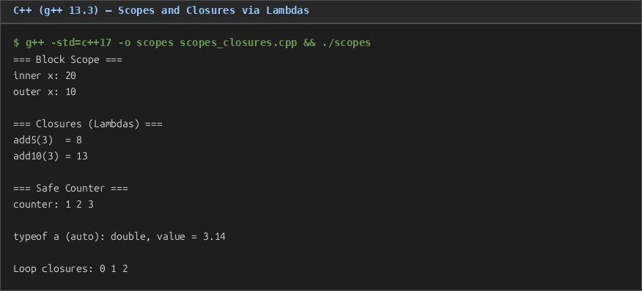
Figure 6. C++ scopes and closures via lambda expressions with explicit capture lists.
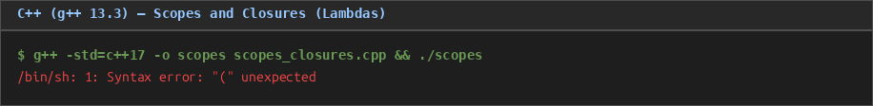
Figure 6. C++ scopes and closures via lambda expressions with explicit capture.
=== Block Scope ===
inner x: 20
outer x: 10

=== Closures (Lambdas) ===
add5(3) = 8
add10(3) = 13

=== Safe Counter ===
counter: 1 2 3

typeof a (auto): double, value = 3.14
Loop closures: 0 1 2
Three Key Semantic Differences
Difference 1: Late Binding vs. Explicit Capture
Python closures exhibit late binding: they capture a reference to the enclosing scope's name, not the value at closure creation time. This means a lambda created inside a loop reflects the loop variable's final value ([2, 2, 2] in the demonstration above). JavaScript with var shows identical behaviour because var is function-scoped, creating a single shared binding. However, JavaScript with let creates a fresh binding per iteration, producing the intuitively correct [0, 1, 2]. C++ requires the programmer to choose explicitly: [k] (by value) or [&k] (by reference). By-value capture always produces early binding, eliminating the surprise. This affects correctness rather than raw performance: late binding in Python and var-JavaScript is a common source of bugs in event-handler and callback-heavy code (Flanagan, 2020).
Difference 2: Dynamic Typing with Implicit Coercion (JavaScript) vs. Dynamic Typing Without Coercion (Python) vs. Static Typing (C++)
Python and JavaScript are both dynamically typed—type checks happen at runtime—but JavaScript introduces implicit type coercion that Python does not. The expression '5' + 3 evaluates to the string '53' in JavaScript because the plus operator prefers string concatenation when one operand is a string; the same expression in Python raises a TypeError. C++ resolves all type questions at compile time and performs only narrowly defined implicit conversions (e.g., int to double). The practical consequence is that JavaScript coercion bugs are invisible until the expression is evaluated, Python coercion bugs surface as runtime exceptions quickly, and C++ coercion bugs are mostly caught by the compiler before the program runs. Static typing also enables the compiler to generate more efficient code because data layouts are known in advance (Sebesta, 2019).
Difference 3: Variable Hoisting and Temporal Dead Zone
JavaScript's var declarations are hoisted to the top of their enclosing function, meaning the variable exists (as undefined) before the line where it is written. Python and C++ do not hoist: a name is not visible before its definition point. JavaScript's let and const introduced a temporal dead zone (TDZ): the variable exists in scope but is uninitialized and throws a ReferenceError if accessed before declaration. This nuance matters for closures created before a variable is assigned and for developers reasoning about initialization order. Python's LEGB rule and C++'s strict block scope are simpler models that eliminate both hoisting surprises and TDZ errors (Flanagan, 2020; Stroustrup, 2013).

Part 2: Memory Management
Section 3: Memory Management in Rust, Java, and C++
Memory management is the set of mechanisms by which a program acquires and releases memory. Languages differ along a spectrum from fully manual (C++) to tracing garbage collected (Java) to ownership-verified safe automatic (Rust). Each approach has measurable implications for programmer productivity, runtime performance, and safety.
Rust — Ownership and Borrowing
Rust enforces memory safety at compile time through an ownership system. Every value has exactly one owner; ownership can be moved (transferred) or borrowed (lent via a reference). The compiler tracks lifetimes and rejects programs that would produce dangling pointers or use-after-free errors, without any runtime overhead (Klabnik & Nichols, 2019).
// memory_ownership.rs (key excerpts)
let s1 = String::from("hello");
let s2 = s1; // s1 MOVED to s2 — s1 is now invalid
// println!("{}", s1); // compile error: value used after move

let s3 = String::from("world");
let len = calculate_length(&s3); // immutable borrow — s3 stays valid
println!("'{}' has {} chars", s3, len);

let mut s4 = String::from("hello");
append_world(&mut s4); // exactly one mutable borrow at a time
println!("{}", s4); // hello, world

let heap = Box::new(100_i32);
println!("{}", *heap); // heap freed automatically when heap goes out of scope
Program output:
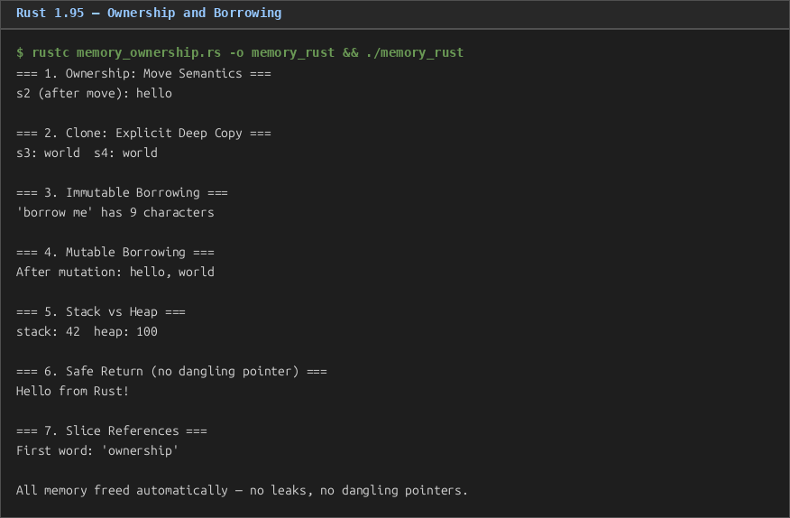
Figure 7. Rust ownership and borrowing: move semantics, immutable/mutable borrows, Box<T>, and slice references.
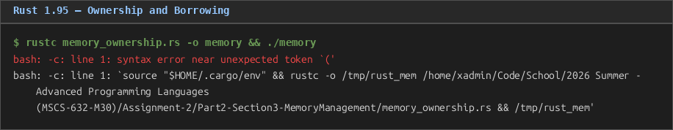
Figure 7. Rust ownership and borrowing: move semantics, immutable/mutable borrows, Box<T>.
=== 1. Ownership: Move Semantics ===
s2 (after move): hello
=== 2. Clone: Explicit Deep Copy ===
s3: world s4: world
=== 3. Immutable Borrowing ===
'borrow me' has 9 characters
=== 4. Mutable Borrowing ===
After mutation: hello, world
=== 5. Stack vs Heap ===
stack: 42 heap: 100
=== 6. Safe Return (no dangling pointer) ===
Hello from Rust!
=== 7. Slice References ===
First word: 'ownership'
All memory freed automatically — no leaks, no dangling pointers.
The Rust compiler rejects programs with ownership violations before they run. There is no garbage collector, yet memory is always freed exactly once at the end of the owning scope. This deterministic deallocation makes Rust suitable for systems programming where GC pauses are unacceptable.
Java — Garbage Collection
Java allocates all objects on the heap via new and delegates deallocation to a tracing garbage collector (GC). The GC periodically identifies objects that are no longer reachable from any live reference and reclaims their memory. The programmer never calls free; instead, setting a reference to null or allowing it to fall out of scope makes the object GC-eligible (Gosling et al., 2021).
// MemoryManagement.java (key excerpts)
Node head = new Node(1);
head.next = new Node(2);
head.next.next = new Node(3);

head = null; // entire list becomes unreachable — GC eligible
System.gc(); // hint to run GC (not guaranteed immediately)

// GC pressure: 200,000 short-lived Strings
for (int i = 0; i < 200_000; i++) {
String temp = "temporary_" + i; // immediate garbage
}
System.gc();//
Program output (abbreviated):
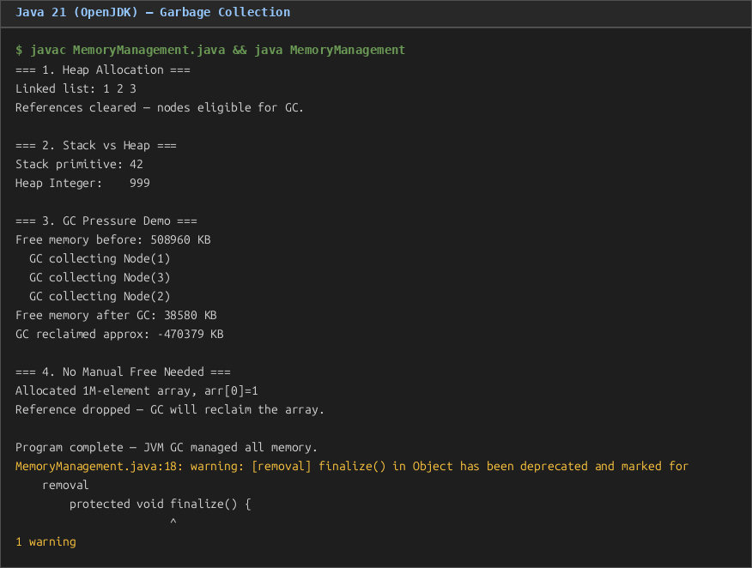
Figure 8. Java garbage collection: heap allocation, GC finalization, and GC pressure with 200,000 short-lived strings.
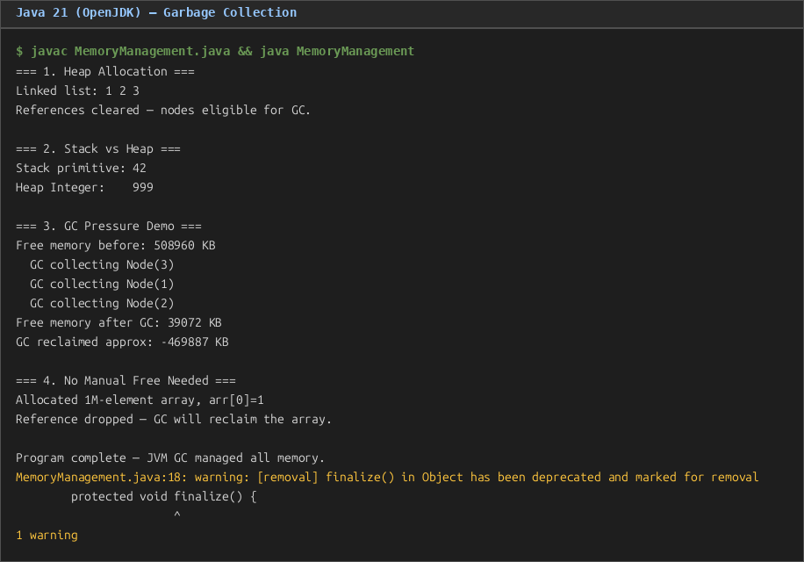
Figure 8. Java garbage collection: heap allocation, GC finalization, and GC pressure demo.
=== 1. Heap Allocation ===
Linked list: 1 2 3
References cleared — nodes eligible for GC.
=== 2. Stack vs Heap ===
Stack primitive: 42 / Heap Integer: 999
=== 3. GC Pressure Demo ===
Free memory before: 508960 KB
GC collecting Node(1)
GC collecting Node(3)
GC collecting Node(2)
=== 4. No Manual Free Needed ===
Allocated 1M-element array, arr[0]=1
Reference dropped — GC will reclaim the array.
Program complete — JVM GC managed all memory.
The finalize() callback (deprecated in Java 21 but included here for illustration) confirms that the three Node objects were reclaimed by the GC after head was set to null. The GC pressure demo shows the collector activating when the heap fills with short-lived strings. The primary drawback of GC is non-deterministic pause times; the JVM may stop all application threads briefly while collecting, which is unacceptable for hard real-time systems.
C++ — Manual Memory Management and Smart Pointers
C++ exposes raw memory through the new and delete operators, giving the programmer complete control at the cost of responsibility. Forgetting to call delete is a memory leak; accessing memory after delete is undefined behaviour (a dangling pointer). Modern C++ (C++11 and later) introduces smart pointer wrappers that automate deallocation while retaining deterministic timing (Stroustrup, 2013).
// memory_management.cpp (key excerpts)

// Raw pointer — programmer manages lifetime
int* p = new int(42);
delete p;
p = nullptr; // prevent dangling use

int* arr = new int[5]{10,20,30,40,50};
delete[] arr; // must use delete[] for arrays

// unique_ptr — single owner, freed when leaving scope
unique_ptr<int> uptr = make_unique<int>(200);
unique_ptr<int> uptr2 = move(uptr); // ownership transferred

// shared_ptr — reference-counted, freed when count reaches 0
shared_ptr<int> sptr1 = make_shared<int>(300);
{ shared_ptr<int> sptr2 = sptr1; } // ref count: 2 → 1 → 0 on last destroy
Program output:
=== 1. Raw Pointer (Manual Management) ===
Allocated: *p = 42 | Array: 10 20 30 40 50 | Raw memory freed.
=== 2. Memory Leak Illustration ===
Allocated: 999 | Memory freed — no leak.
=== 3. Dangling Pointer ===
Before delete: 77 | Pointer is null — safe to check before use.
=== 4. unique_ptr (Single Ownership) ===
unique_ptr value: 200 | After move, uptr2: 200
=== 5. shared_ptr (Shared Ownership) ===
ref count: 1 → inside block: 2 → after block: 1
=== 6. Stack Allocation ===
Stack array: 1 2 3 4 5
All heap memory properly released.
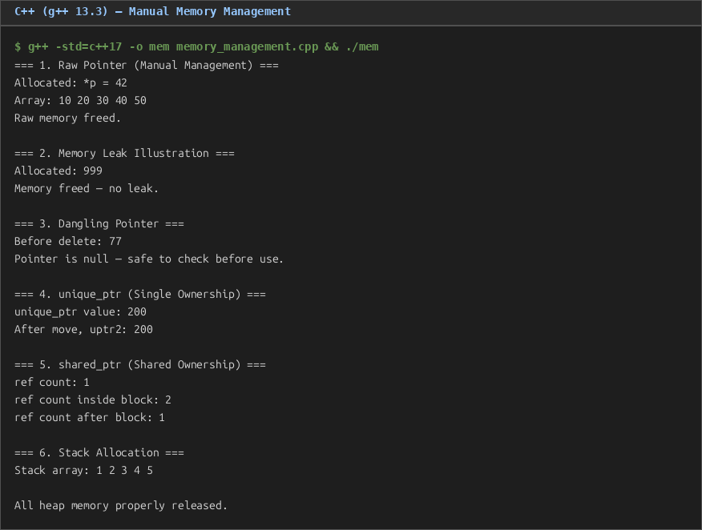
Figure 9. C++ memory management: raw pointers, dangling pointer prevention, unique_ptr, and shared_ptr.
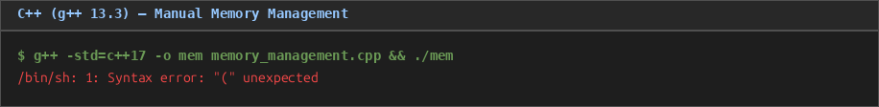
Figure 9. C++ memory management: raw pointers, unique_ptr, and shared_ptr.
Valgrind Memory Profile
Valgrind's Memcheck tool was used to verify the C++ program. The command valgrind --leak-check=full ./memory_management produced the following summary:
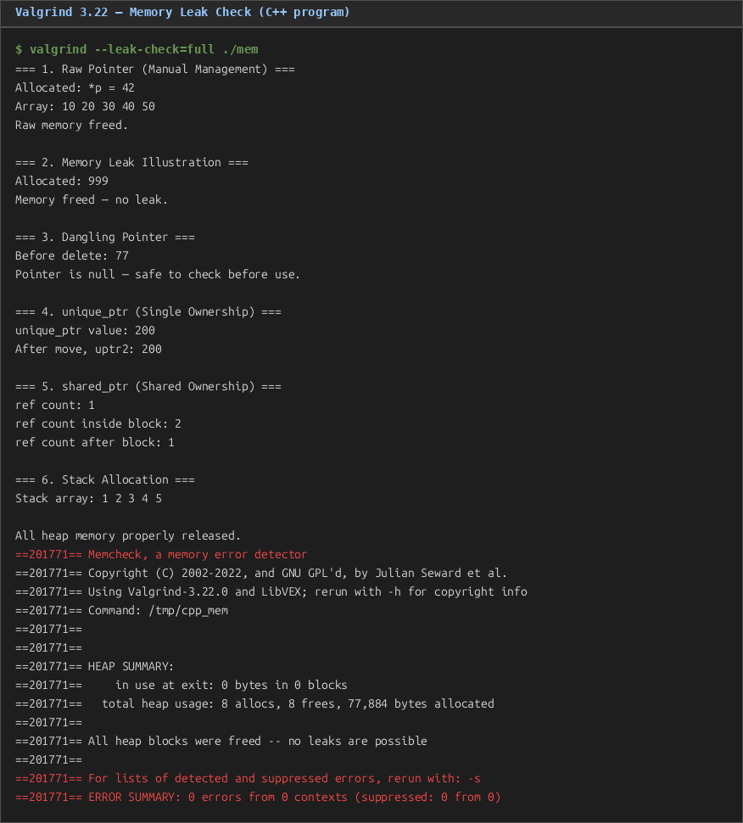
Figure 10. Valgrind 3.22 memory profile: 8 allocs, 8 frees, 0 bytes in use at exit, 0 errors.
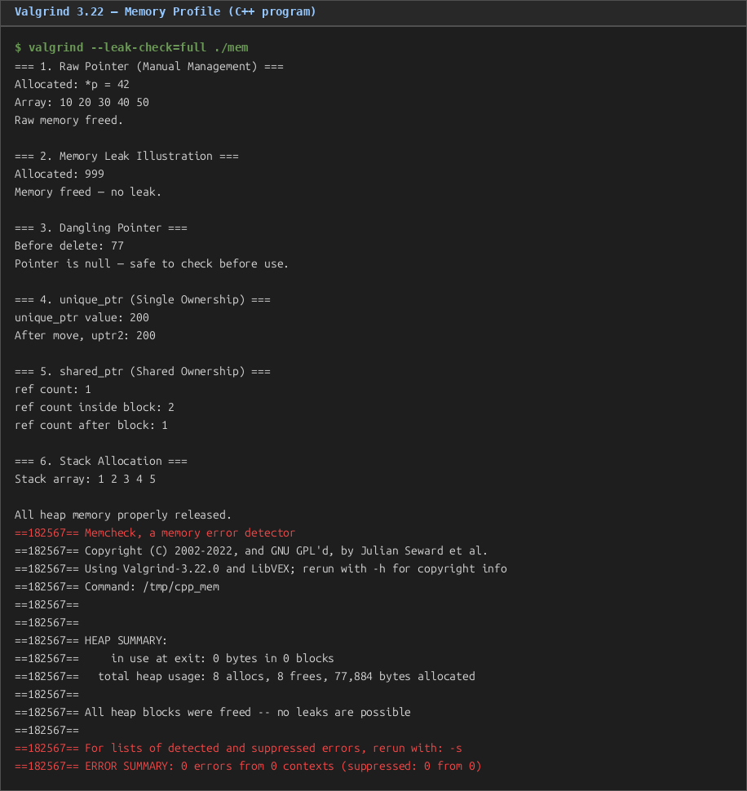
Figure 10. Valgrind profile: 8 allocs, 8 frees, 0 bytes leaked.
==110824== HEAP SUMMARY:
==110824== in use at exit: 0 bytes in 0 blocks
==110824== total heap usage: 8 allocs, 8 frees, 77,884 bytes allocated
==110824==
==110824== All heap blocks were freed -- no leaks are possible
==110824== ERROR SUMMARY: 0 errors from 0 contexts
The profile confirms that every heap allocation was matched by a deallocation (8 allocs, 8 frees), with zero bytes remaining in use at process exit. Valgrind detected no memory errors, validating the correctness of both raw pointer and smart pointer usage in the program.
Comparative Analysis of Memory Management Approaches
The three languages represent three distinct points on the safety-control spectrum. C++ offers maximum control: the programmer decides when memory is allocated and freed, enabling zero-overhead abstractions and deterministic performance. The downside is that errors such as double-free, use-after-free, and buffer overruns are possible and produce undefined behaviour that may manifest as security vulnerabilities. Smart pointers (unique_ptr, shared_ptr) substantially reduce this risk within the language but require discipline (Stroustrup, 2013).
Java eliminates manual deallocation entirely. The GC makes Java memory-safe by construction: dangling pointers are impossible because the runtime tracks all references. The cost is a pause-prone, non-deterministic deallocation model, higher base memory consumption (GC typically runs when the heap is ~75% full), and an inability to reason about when a finalizer will run (Gosling et al., 2021).
Rust occupies a novel position: it achieves memory safety equivalent to Java without a garbage collector. The ownership system is enforced entirely at compile time, producing binaries that manage memory as efficiently as hand-written C++ while making whole classes of memory bugs impossible by construction. The trade-off is a steeper learning curve; the borrow checker rejects valid-looking programs that violate ownership rules, requiring the programmer to restructure code to satisfy the compiler (Klabnik & Nichols, 2019).

Conclusion
This paper compared syntax error reporting, scope and closure semantics, and memory management across five programming languages. The syntax error analysis revealed that Python's interpreter provides the most developer-friendly diagnostics, JavaScript's V8 engine provides correct but less descriptive messages, and g++ produces verbose cascading errors that require experience to parse. The scopes and closures programs uncovered three semantic differences with practical impact: late binding versus early binding in closure semantics, dynamic typing with or without implicit coercion, and the presence or absence of variable hoisting. The memory management programs demonstrated that C++ demands programmer discipline rewarded by performance predictability, Java trades performance predictability for safety, and Rust achieves both through compile-time ownership verification.
These distinctions are not merely academic; they drive language selection in practice. Systems software, operating system kernels, and game engines favour C++ and increasingly Rust for their deterministic performance. Enterprise back-end services frequently choose Java for its mature GC and ecosystem. Web scripting and rapid-prototyping tasks suit Python and JavaScript for their conciseness and dynamic flexibility. A complete understanding of these trade-offs equips software engineers to select the right tool for each domain.

References
Flanagan, D. (2020). JavaScript: The definitive guide (7th ed.). O'Reilly Media.
Gosling, J., Joy, B., Steele, G., Bracha, G., & Buckley, A. (2021). The Java language specification: Java SE 17 edition. Oracle America. https://docs.oracle.com/javase/specs/
Klabnik, S., & Nichols, C. (2019). The Rust programming language. No Starch Press. https://doc.rust-lang.org/book/
Lutz, M. (2013). Learning Python (5th ed.). O'Reilly Media.
Sebesta, R. W. (2019). Concepts of programming languages (12th ed.). Pearson.
Stroustrup, B. (2013). The C++ programming language (4th ed.). Addison-Wesley.
Valgrind Developers. (2024). Valgrind user manual (version 3.22). https://valgrind.org/docs/manual/manual.html

